**Module** 6

Abi Whitford

Design Explanation for Design Compositions

General Layout

My overall layout is very simplistic. I knew I wanted side borders on my page so that my main column could roll down. Each page has the same layout, with variation only in the content of each page. I modeled my work piece page after Jessica Hische’s work page (<http://jessicahische.is/working>). I loved how she shows snippets of each design and then gives a full description after you click on them.

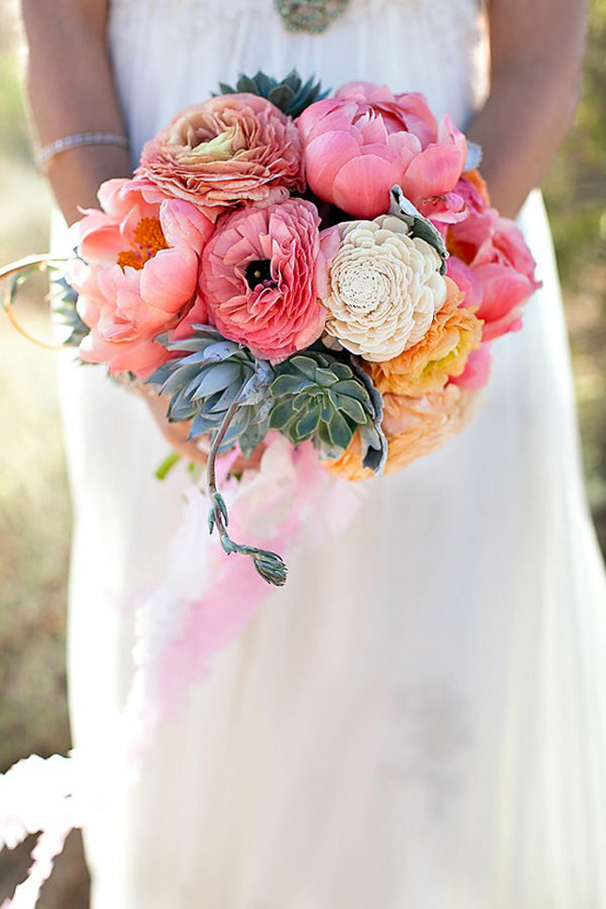

Color

I actually chose my colors from the bouquet of flowers on the right. I used the eyedropper tool in photoshop to find the colors I liked. I am a fan of pastel colors and felt that they portrayed my personality the best out of all the color values. I tried to stick to a combination that wasn’t too overwhelming or distracting from the content of the website.

Typography

For my typography, I ended up only using Avenir. I like this san-serif font because it fits the simplistic style of my website and it’s not difficult to read. I felt that by using all caps for headings and navigation, and lowercase for paragraphs and everything else it provided enough contrast that I didn’t have to use another font.

Images

I really wanted to use images that I created for my website. Since I am interested in graphic design, I thought using the website as a canvas would be a smart move for people viewing my website to show that I can code and design. I created my designs in illustrator, using basic patterns and the same color scheme for each one to keep consistency in the designs.

For the work piece page I used snippets of each art piece, trying to get enough of the image in to entice viewers to click and read more. The full work image is displayed once the viewer clicks on the icon, but I wanted to keep the snippet in the left corner as a sort of drop cap.

Finally, I used a picture of myself on the landing/home page and the contact page. The picture is clean and professional, but still friendly. I wanted to make sure I appeared amiable, but not “party-crazy” as some college students appear.