**Initial Database Connection**

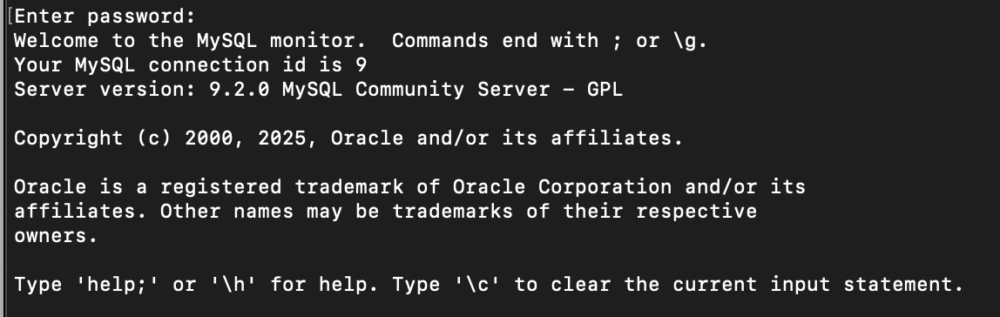

**Show Databases Output**

