**CURRENT_DATE**

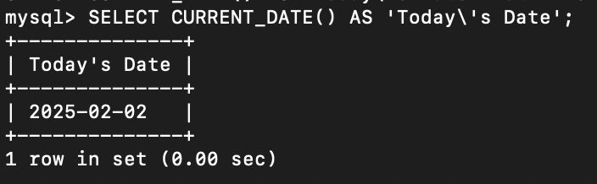

**NOW**

Useful for logging timestamps when inserting or updating records in a database.

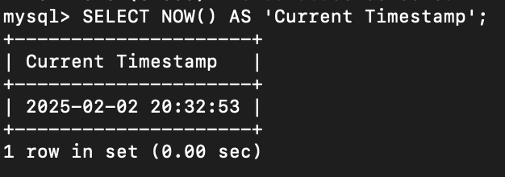

**LENGTH**

Used to check the length of a string, helpful for validating input sizes (e.g., usernames, passwords).

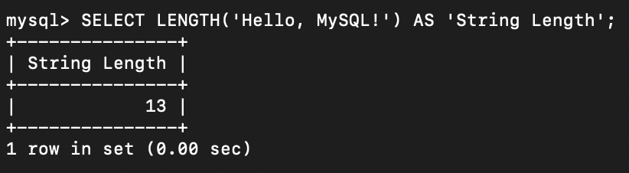

**UPPER**

Converts text to uppercase, useful for formatting or case-insensitive comparisons.

