Run SQL Script: **SHOW TABLES**

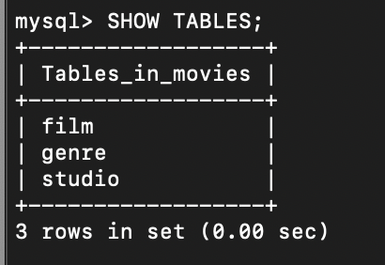

Run Python Script

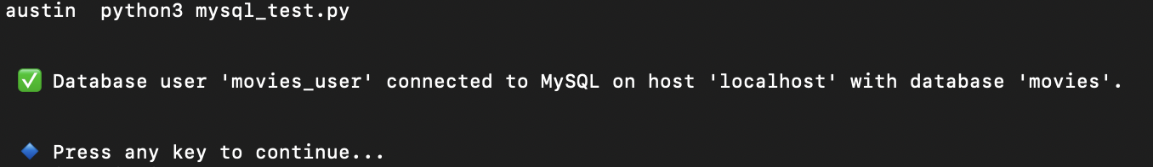

Mysql_test.py

