**Screenshot 1 -** Variables listed at the first breakpoint at ticker = input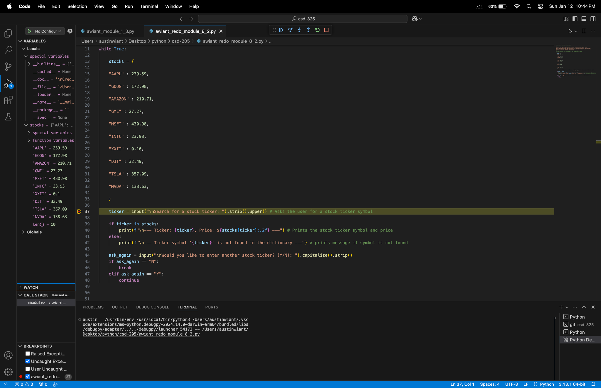

**Screenshot 2 -** Step into command, Ticker entered and the price of the stock was displayed and variables updated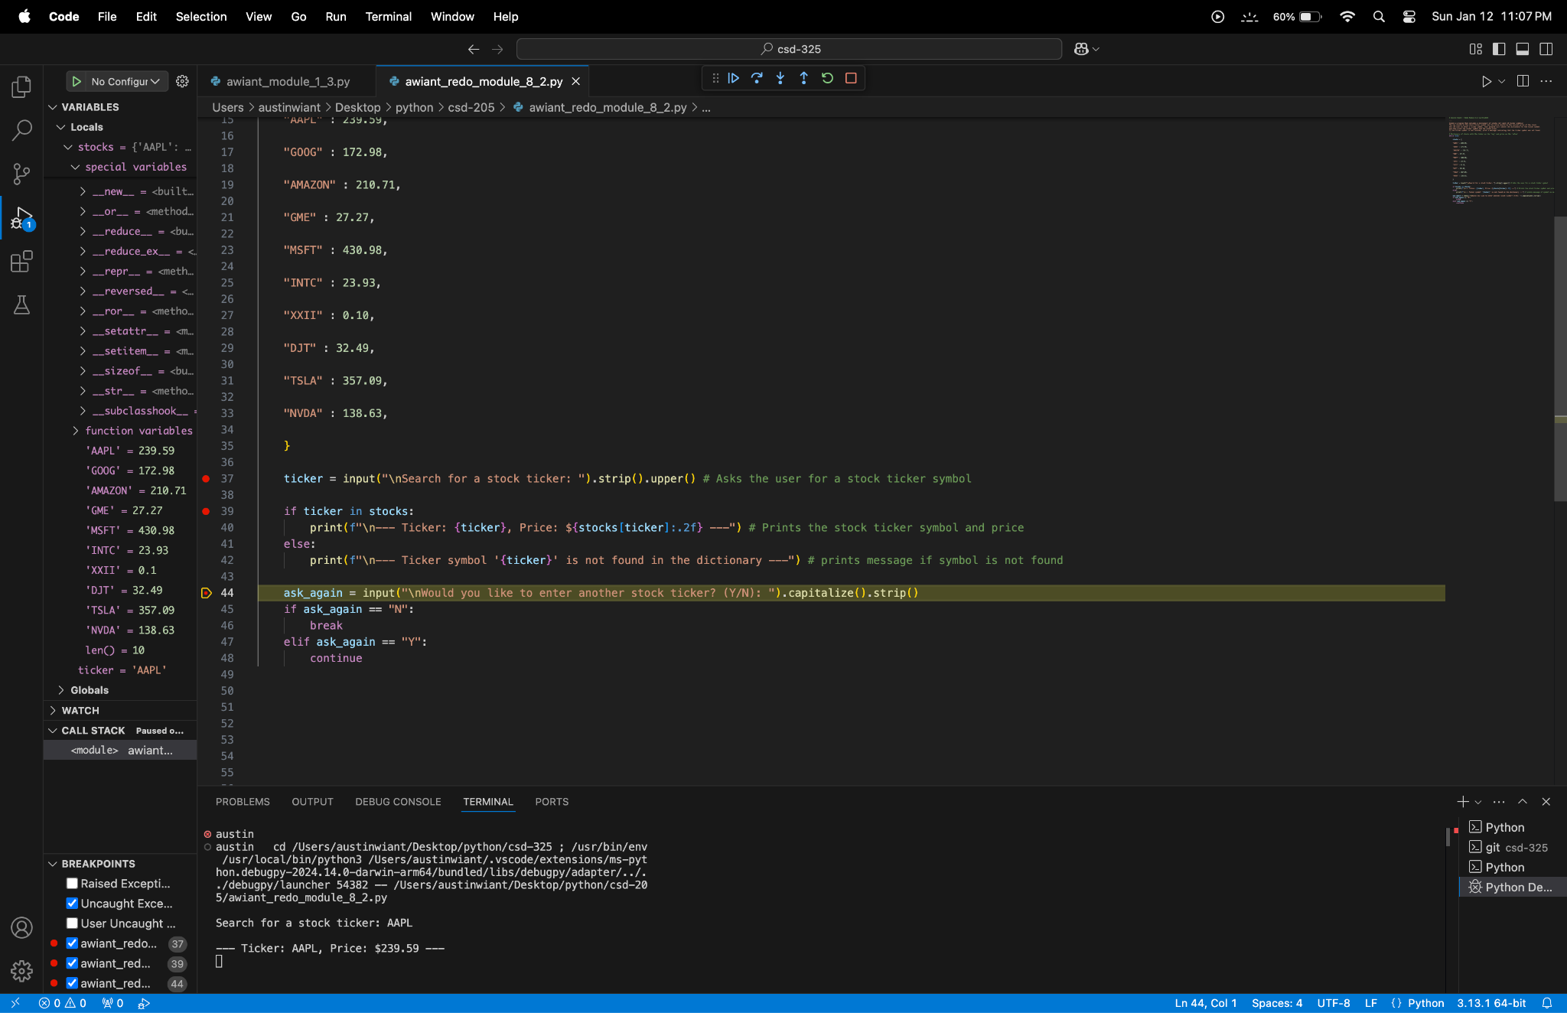

**Screenshot 3 -** Progression through the program

