city_functions.py

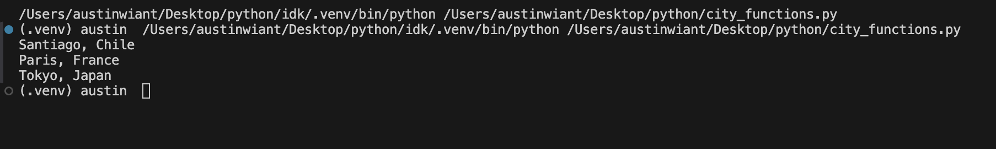

test.cities.py

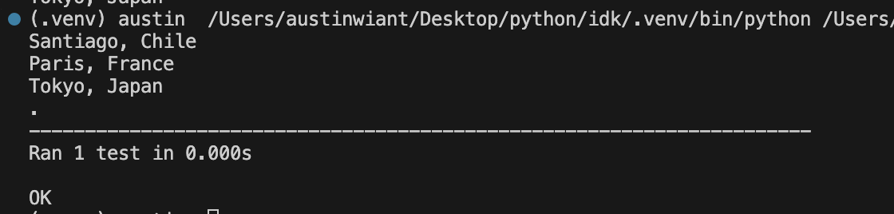

Run test_cities.py again fail

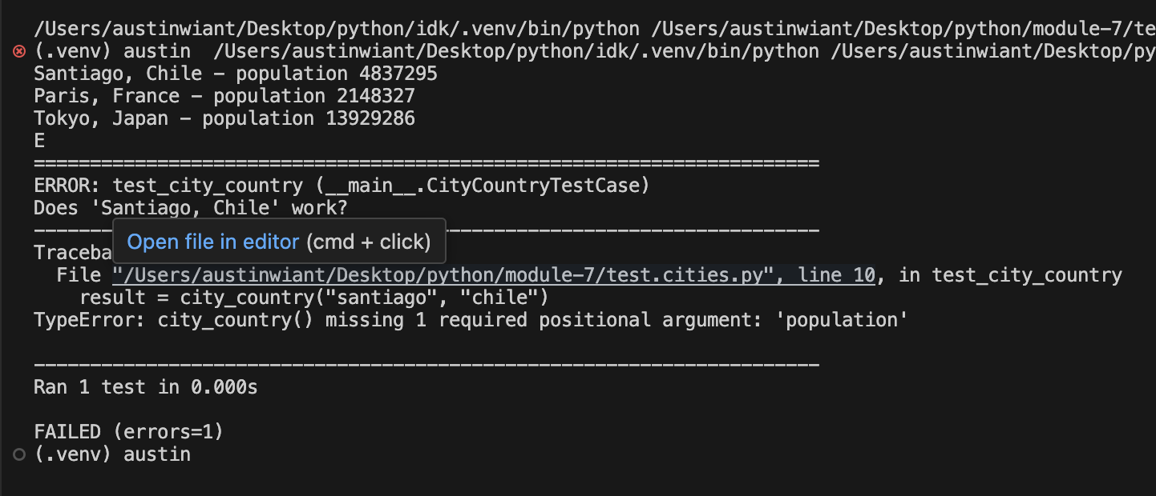

Optional population - updated passed

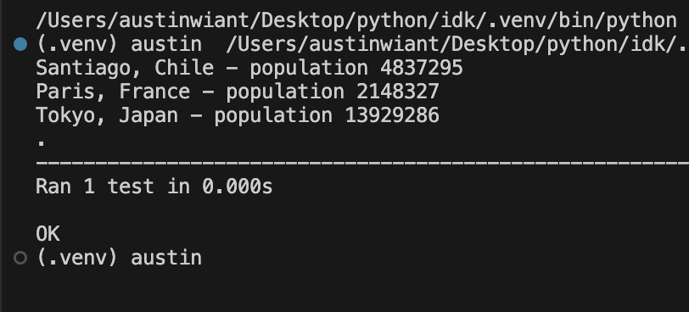

With the language

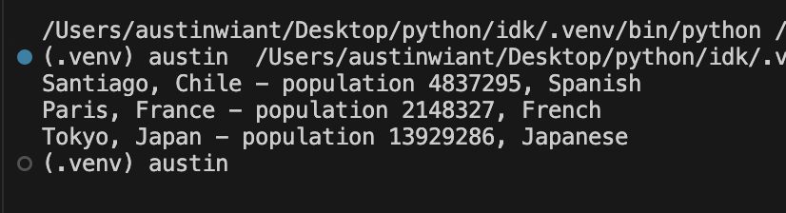

Language is optional

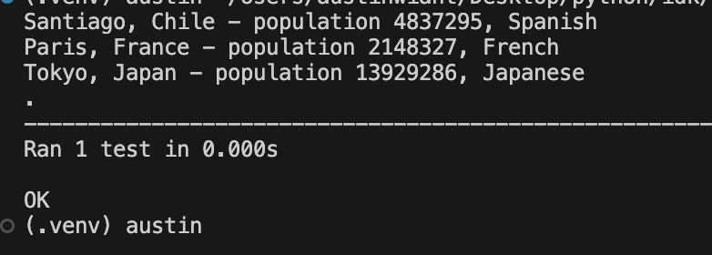

Final 