Before:

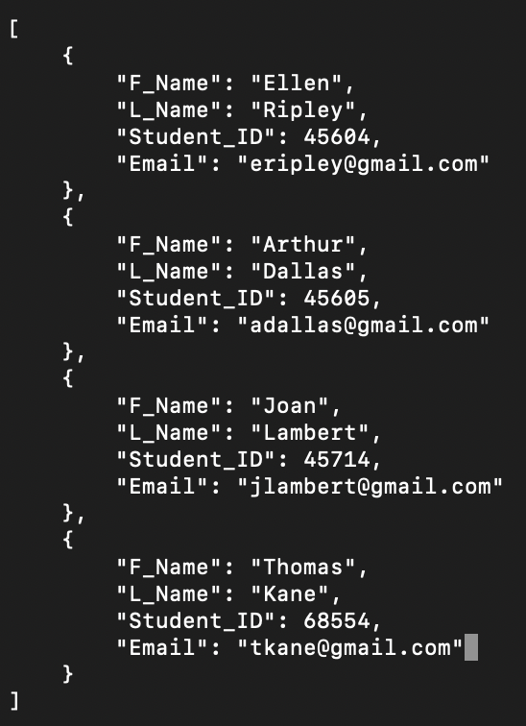

After:

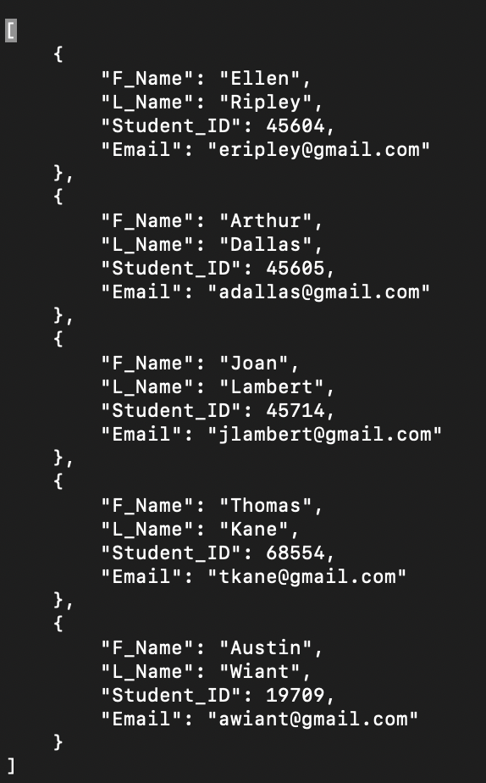

This is the JSON file opened in the terminal after the Python program was run.

[

{

"F_Name": "Ellen",

"L_Name": "Ripley",

"Student_ID": 45604,

"Email": "eripley@gmail.com"

},

{

"F_Name": "Arthur",

"L_Name": "Dallas",

"Student_ID": 45605,

"Email": "adallas@gmail.com"

},

{

"F_Name": "Joan",

"L_Name": "Lambert",

"Student_ID": 45714,

"Email": "jlambert@gmail.com"

},

{

"F_Name": "Thomas",

"L_Name": "Kane",

"Student_ID": 68554,

"Email": "tkane@gmail.com"

},

{

"F_Name": "Austin",

"L_Name": "Wiant",

"Student_ID": 19709,

"Email": "awiant@gmail.com"

}

]

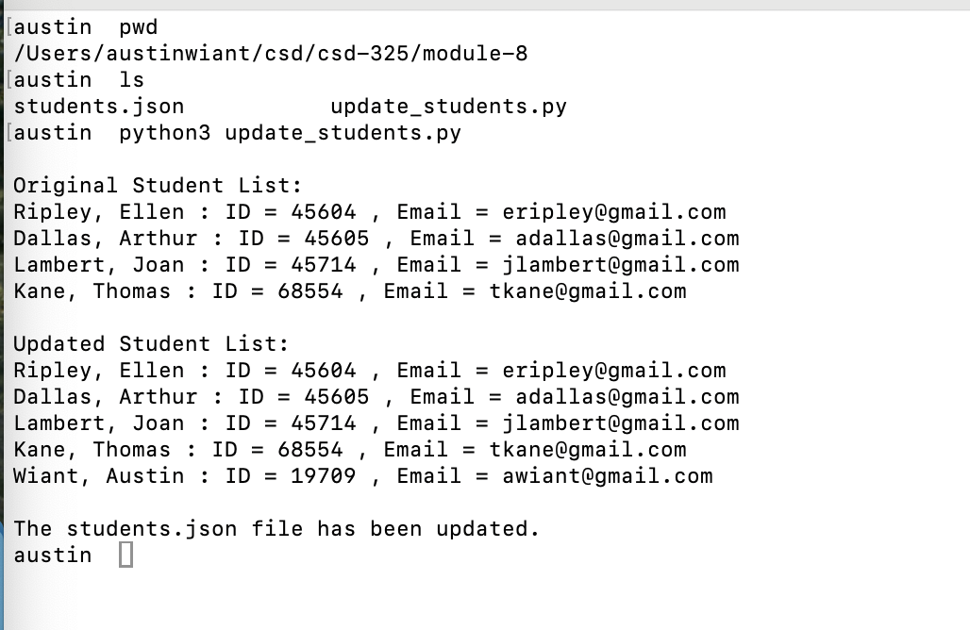

When running the program, I was not able to get any notification to show up asking me if I wanted to save the changes or not