<https://awiant85.github.io/csd-340/>

<https://github.com/awiant85/csd-340.git>

Validation HTML Results

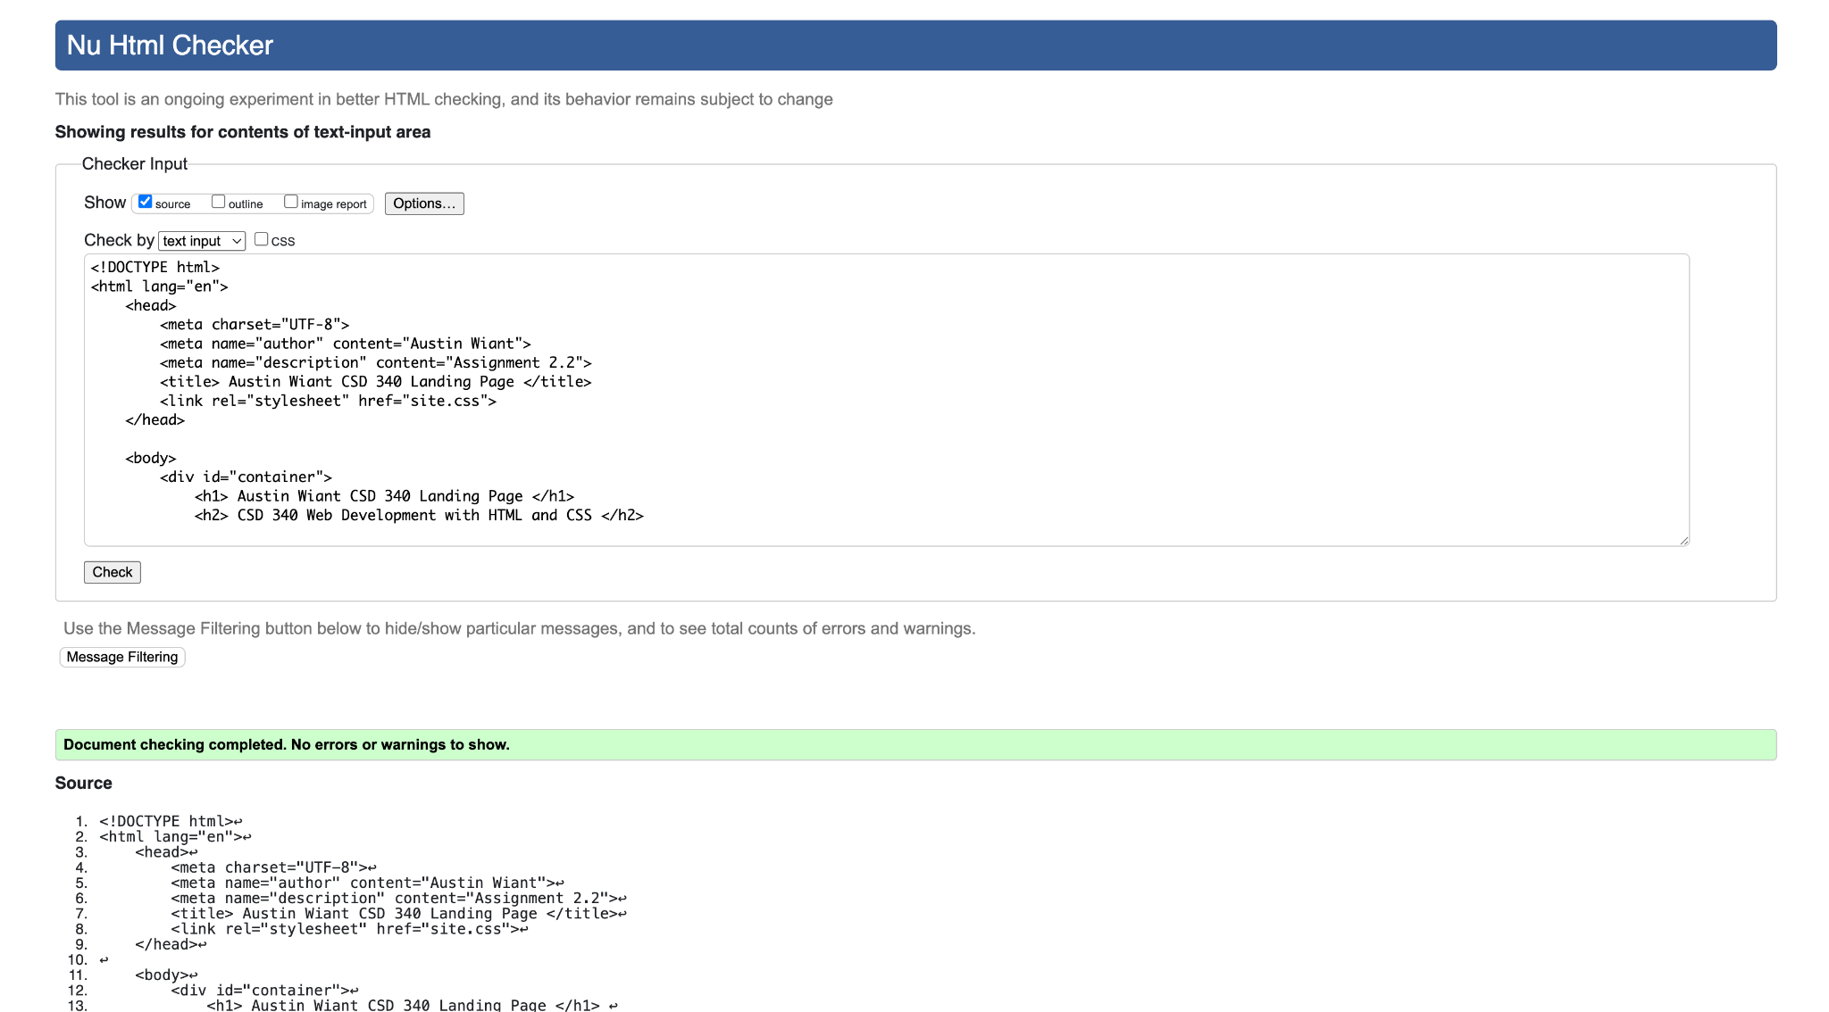

Validation CSS Results

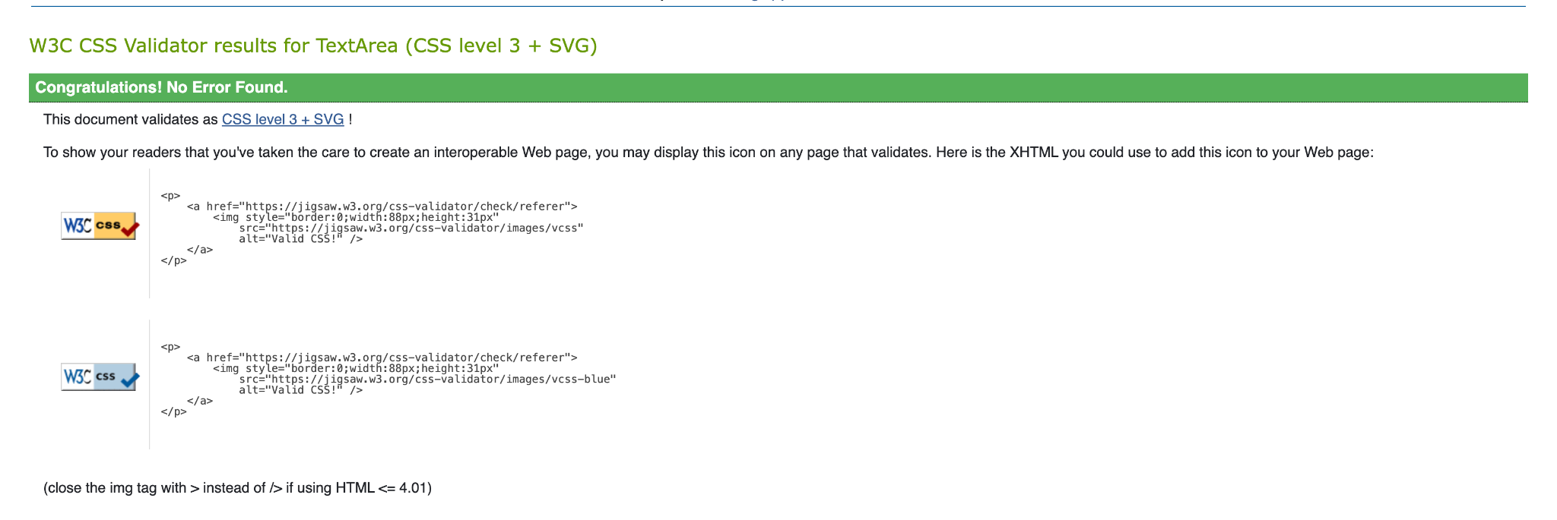

Web Page/ Landing Page in Browser

