RPA AA360 Bot Operations Runbook – Return From Leave Reconciliation

Title: Bot Operations Runbook – Return From Leave Reconciliation
Version: BOR_RFL_V1.0
Date: 12-03-2025
Owner: Daniel Teeter
Approvers:

Use Case Name: Return From Leave Reconciliation
Business Unit: Finance
Priority:
Environments Covered: <DEV | UAT | PROD>

1) Run-at-a-Glance

- Run Window: 3:00 AM to 9:00 AM PT
- Trigger: Scheduled every weekday (Monday – Friday) at 3:00 AM
- Bot Name: ReturnFromLeaveReconciliation
- Bot Path in Control Room: Public > UCPATH > Finance > Return From Leave
- Bot User Account: ucpc-rpa-ec2-bot-runner-2
- EC2 environment: UCPAAPRD02
- Bot Agent/Device: UCPAAPRD02
- Average Duration for Bot: Avg 30 minutes for 15 Transactions
- Average Duration for Business User: 20 minutes for 1 Transactions
- Expected Volume: 100 transactions/day
- Inputs: Excel RFL input file
- Outputs: RPA Pending reports, zipped archive folders with logs, reports in Box.

Green Path:
1. Bot downloads RFL input file workbook from BOX through API.
2. Bot logs into PeopleSoft > Job Data page, enters each emplid in input file and searches job data record(s).
3. Bot extracts Payroll Status, Job Indicator, and Pay Group from Job Data record.
4. Bot navigates to Peoplesoft > Arrears, enters each emplid in input file and searches arrear balance on arrears record(s).
5. Bot logs into Peoplesoft > Query Viewer, searches for FIN001 query viewer, enters each Recon-ready emplid and extracts FIN001 report
6. Bot formats all extracted FIN001 report into RPA pending validation report
7. Bot logs into Oracle Cloud Financials, enters each Recon-ready emplid and extracts payments and transaction register (TRA) reports.
8. Bot formats extracted payments and TRA reports and merges both reports into RPA pending validation report
9. Bot zips up RPA pending validation reports and sends to Finance Box and UCPC-RPA Box
10. Bot sends email notification to the business indicating process completion

2) Contacts & RACI

Role | Name | Contact | Responsibilities
Process Owner | Daniel Teeter | daniel.teeter@ucop.edu | Business decisions, SLA sign-off
Run Operator (L1) | Daniel Teeter/ Laura Doyle | daniel.teeter@ucop.edu; laura.doyle@ucop.edu | Monitor runs, basic triage
Support (L2) | Ari Widjaja | ari.widjaja@ucop.edu | Bot fixes, config, reruns
Platform Admin (AA360) | Sean Martin/ Jeff MacCharles | Sean.martin@ucop.edu; jeff.maccharles@ucop.edu | Runners, creds, HA/DR
App Owner – PeopleSoft | SCI, PS Admins/Devs, Automation Anywhere, OCF | <ENTER> | Access, downtime comms
Storage Owner – Box | Sean Martin, Joe Pueschel | <ENTER> | Folders, permissions

RACI Matrix (key operations)
Responsible (R), Accountable (A), Consulted (C), and Informed (I)
Activity | Run Operator | L2 Support | Platform Admin | Process Owner | App Owners
Scheduling | R | C | A | I | I
Credential Mgmt | I | C | A | I | I
Run Execution | R | A | C | I | I
Incident Mgmt | R | A | C | C | C
Change Mgmt | I | C | C | A | C

3) System Architecture (high-level)

Components: AA360 Control Room, Bot Runners, Box, Excel files, PeopleSoft, Email (SMTP), Python scripts, OCF
Network/Firewall: (e.g., Allow outbound to Box/PeopleSoft; CR/Runners mutual reachability).
Proxy/MFA: API for Box, Using Native PeopleSoft via service account; conditional access exceptions as approved.

4) Environments & URLs

ENV | Control Room URL | Peoplesoft URLs | OCF URLs | EC2
DEV | https://ucopdev.my.automationanywhere.digital/ | https://ucphrdev.ps.universityofcalifornia.edu/psp/ucphrdev/EMPLOYEE/HRMS/ | N/A | UCPAADEV02
UAT | https://ucopdev.my.automationanywhere.digital/ | https://ucphrut1.ps.universityofcalifornia.edu/psp/ucphrut1/EMPLOYEE/HRMS/ | https://elda-test.fa.us2.oraclecloud.com/ | UCPAADEV02
PROD | https://ucop.my.automationanywhere.digital/ | https://ucphrprd.ps.universityofcalifornia.edu/psp/ucphrprd/EMPLOYEE/HRMS/ | https://elda.fa.us2.oraclecloud.com/ | UCPAAPRD02

5) Schedules, Triggers & Calendars

ENV | Schedule/CRON | Timezone | Skip/Holiday Rules | Dependencies (jobs/windows)
PROD | Scheduled every weekday at 3:00 AM | PT | N/A | Avoid system update.

6) Inputs, Outputs

- Location: \Box\#UCPC-RPA\PROD\Return From Leave Reconciliation\Production File Drop\
INPUTS
Column | Type | Required | Example
Business Unit | string | ✓ | IRCMP, BKCMP
EEID | string | ✓ | 10001111
Employee Name | date | ✓ | Doe, John
Payroll Status | string | ✓ | Active, Inactive
Pay Status | int | ✓ | M
Pay Group | string | ✓ | MONTHLY, BIWEEKLY
Current Date | number | ✓ | 2025-01-01
Action Date | date | ✓ | 2025-01-01
Elig Fld 1 | date | ✓ | A
Elig Fld 2 | number | ✓ | A
Empl Record | number | ✓ | 0,1,2..n
Job Indicator | number | ✓ | Primary Job, Secondary Job
UID | string | ✓ | 12334567

OUTPUTS
- Paysheets Output Report
- Action Log
- Exception Log
- Post-Run Email: Summary, links to logs & outputs.

7) Credentials & Locker (AA360)

Purpose | Locker | Credential Name | Access Level | Rotation | Owner | AA Role | Attributes
Box Secret* | UCPATH | UCP-PRODUCTION-RFL-BOX | Consumer | <ENTER> | Locker Admin | Create Role to access specific UCPATH folder | Secret
PeopleSoft  Service Account* | UCPATH | UCP-PRODUCTION-RFL-PSFT | Consumer | <ENTER> | Locker Admin | Create Role to access specific UCPATH folder | - Username  - Password
Oracle Cloud Financial Service Account** | UCPATH | UCP-PRODUCTION-RFL-OCF | Consumer | <ENTER> | Locker Admin | Create Role to access specific UCPATH folder | - Username  - Password
* credentials refresh need to be determined.
** credentials refresh is every 3 months

8) Configuration, Parameters, Global Values

- Config file is included within task bot package.
- Google Chrome Settings: enable ‘Ask where to save each file before downloading’ option in Google Chrome Settings > Downloads
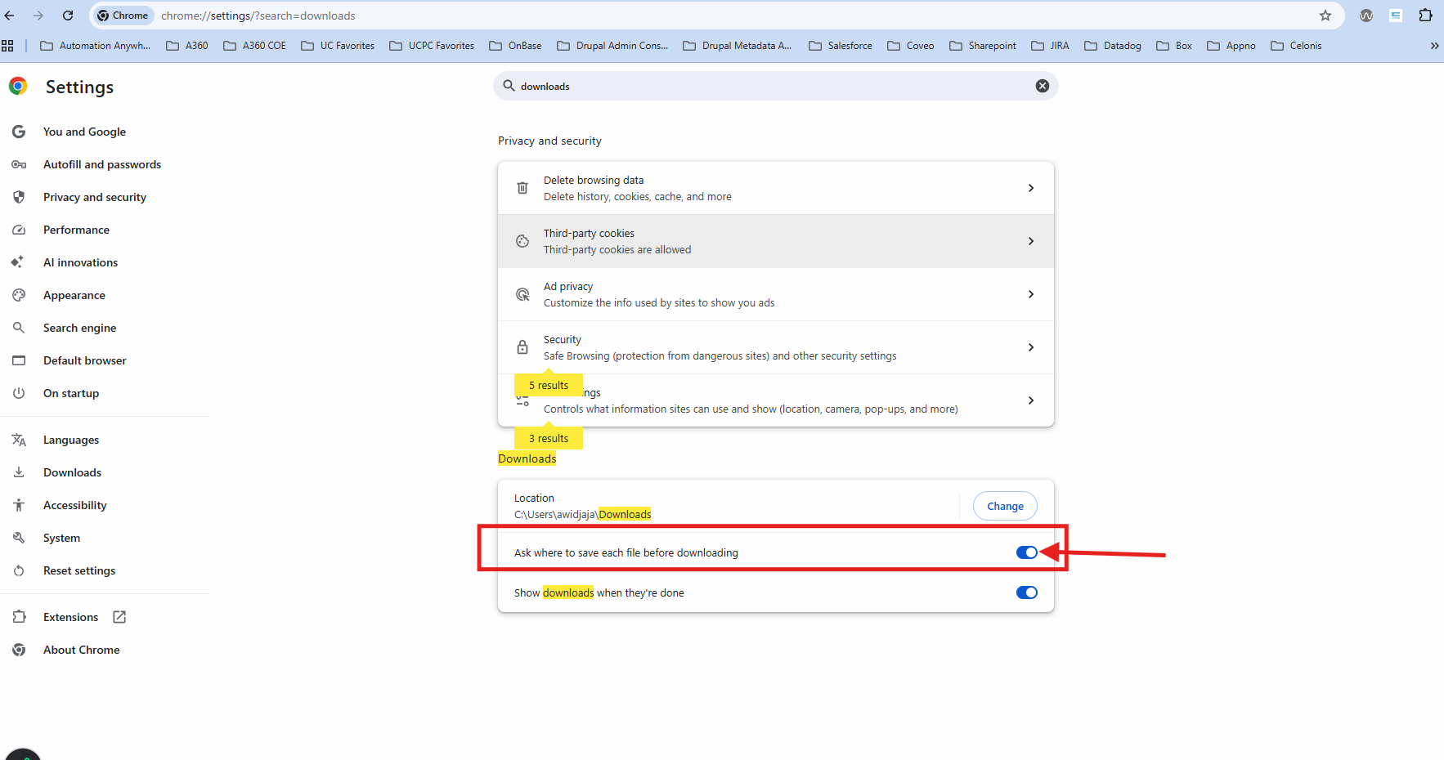
Global Variables:
Note: The following Global Variables are no longer needed. All global Variables attributes below are stored in Config file.
Key | Value | ENV Overrides | Description
EmailSMTPHost | ucpath-smtp-prod-6944b56a029cc8b8.elb.us-west-2.amazonaws.com | DEV/UAT/PROD | SMTP Host will be used across all automations to send email from the bot
SMTPPort | 587 | DEV/UAT/PROD | SMTP Port will be used across all automations to send email from the bot
UCPathFromEmail | UCPC-IT-RPA@ucop.edu | DEV/UAT/PROD | This will be the email Bot will send emails through

9) Bot Package Information

Type | Name | Path | Operations Performed
Task Bot | ReturnFromLeaveReconciliation | Bots\UCPath\Production\Off Cycle Manual Paysheet | -Determines environment variable  -Creates log folders in C:\ProgramData\AutomationAnywhere\Bots\Logs\  -Run 1.0_Main task bot
Task Bot | 1.0_Main | Bots\UCPath\Production\Off Cycle Manual Paysheet | -Reads Config-Utilities.json (in Bots\UCPath\Utilities\) for email properties  -Run 1.1_Read_Config task bot to read Config-RFL.json to get all properties, nodes, URLs, etc. for the environment  - Run RFL-1-InitiateTransaction task bot  - Run RFL-2-ProcessTransaction task bot  - Run RFL-3-CheckArrears task bot  - Run RFL-4-RetrieveFIN001 task bot  - Run RFL-5-DataProcessFIN001 task bot  - Run RFL-6-LogintoOCF task bot  - Run RFL-7-ProcessOCFReportsandCompileAllReports task bot  - Run RFL-8- Transfer Reports to Box task bot  - At the end, it runs Utils- Zip Folder – Transfer to Box- Delete Folder task bot
Task Bot | 1.1_Read_Config | Bots\UCPath\Production\Off Cycle Manual Paysheet | - Reads Config-RFL.json into dConfigMain dictionary for environment-related attributes and properties.
Task Bot | RFL-1-InitiateTransaction | Bots\UCPath\Production\Off Cycle Manual Paysheet | - Downloads input file (Excel) from #UCPC-RPA/DEV/RFL/Dev File Drop into C:\ProgramData\AutomationAnywhere\Bots\Logs\RFL-UCPath\Input  - Reads the data from the downloaded input file into tInputTable data table  - Returns tInputTable
Task Bot | RFL-2-ProcessTransaction | Bots\UCPath\Production\Off Cycle Manual Paysheet | - Logs in to Peoplesoft (PS) Job Data  - Iterates through the list of EEID in tInputTable and captures Payroll Status, Job Indicator, and Pay Group in Job Data in PS.  - Returns tInputTable with captured Job Data attributes
Task Bot | RFL-3-CheckArrears | Bots\UCPath\Production\Off Cycle Manual Paysheet | - Filter EEIDs into exception data table  - Iterates through the list of EEID in tInputTable and captures Arrears balance  - Filter EEIDs into exception data table if EEID has Arrear balance  - Returns tInputTable with captured Arrears balance, exception data table
Task Bot | RFL-4-RetrieveFIN001 | Bots\UCPath\Production\Off Cycle Manual Paysheet | - Logs in to PS Query Viewer  - Iterates through the list of EEID in tInputTable and downloads FIN001 report from PS Query Viewer into C:\\ProgramData\\AutomationAnywhere\\Bots\\Logs\\RFL-UCPATH\\ProcessLogs\FIN001
Task Bot | RFL-5-DataProcessFIN001 | Bots\UCPath\Production\Off Cycle Manual Paysheet | - Iterates through the list of downloaded FIN001 report and run ReturnFromLeave-FinalReport.py Python script to format reports  - Returns tEEIDandFilenames data table
Task Bot | RFL-6-LogintoOCF | Bots\UCPath\Production\Off Cycle Manual Paysheet | - Logs into OCF (Test environment)  - Iterates through the list of EEID in tEEIDandFilenames and downloads payment report into C:\\ProgramData\\AutomationAnywhere\\Bots\\Logs\\RFL-UCPATH\\ProcessLogs\OCF-Payments  - Iterates through the list of EEID in tEEIDandFilenames and downloads TRA report into C:\\ProgramData\\AutomationAnywhere\\Bots\\Logs\\RFL-UCPATH\\ProcessLogs\OCF-TransactionRegisterAnalysis  - Returns the updated tEEIDandFilenames data table
Task Bot | RFL-7-ProcessOCFReportsandCompileAllReports | Bots\UCPath\Production\Off Cycle Manual Paysheet | - Iterates through the list of downloaded OCF payment and TRA reports and run ReturnFromLeave-Processing.py Python script to format and combine reports.  - Returns the updated tEEIDandFilenames data table
Task Bot | RFL-8- Transfer Reports to BOX | Bots\UCPath\Production\Off Cycle Manual Paysheet | - Zips and sends the combined reports (pending recon reports) to Finance BOX  - Sends zipped folder to #UCPC-RPA/DEV/RFL/Output
Task Bot | Utils- Zip Folder- Transfer to Box- Delete Folder | Bots\UCPath\Production\Off Cycle Manual Paysheet | - Zip the entire RFL-UCPath folder and subfolders in EC2 and copy into V: drive  - Delete the entire RFL-UCPath folder and zipped

9) Dependencies

- Upstream: Input file; PeopleSoft pages: Job Data, Arrears, Query Viewers; Oracle Cloud Financials
- Maintenance/Blackouts: PeopleSoft patch windows; Box outages; Oracle Cloud Financials maintenance windows; Automation Anywhere maintenance windows; AWS maintenance windows.
- Pre-requisites: PeopleSoft service account, Oracle Cloud Financials service account, Box apps service account, Box folder access, V: drive access.

10) Pre-Run Checklist (operator)

- [ ] Control Room healthy (**status link**).
- [ ] Runner(s) online; Bot Package = `<ENTER VERSION>`.
- [ ] Lockers accessible; credentials valid (no imminent expiry).
- [ ] Box Package installed.
- [ ] Box PPE folder reachable; expected file(s) present/valid.
- [ ] PeopleSoft available; **off-cycle pages in Calculated**.
- [ ] Capacity headroom Bot runner
- [ ] No change freeze/blackout in effect.
- [ ] Server Name to schedule the bot in Production control room
- [ ] Enable in Google Chrome: Ask where to save each file before downloading
- [ ] V: drive – RFL folder inside V: drive available. The zipped post-run folder containing artifacts, logs, and output is saved in V:\RFL\

11) Standard Run Procedure

1. **Navigate:** CR → Bots → `<Folder/Task>` → **Run**.
2. **Parameters:** `ENV=<ENTER>`, `DateRange=<ENTER>`, `DryRun=<true/false>`.
3. **Milestones (expected logs):**
- `INGEST_START/END` (Box → Excel)
- `PS_VALIDATE_PAGE` (highest page; +1 applied)
- `PS_CREATE` (By Paysheet)
- `PS_POPULATE` (earnings rows)
- `SUMMARY_SENT` (email)
4. **Completion validation:** Paysheets exist; counts match; logs archived.
5. **Post-run:** Archive input; persist Action/Exception Logs; send summary.

12) Logging & Observability

- Run ID: Include in all logs, artifacts, emails, and file names.
- Log fields: Action Logs, Exception Logs
- Locations: Box

13) Monitoring & Alerts

- Monitored: Control Room
- Alert Channels: Email

**Email Template**
- **Subject:** `[<ENTITY>][<ENV>] <USECASE> RUNID <RUN_ID>`
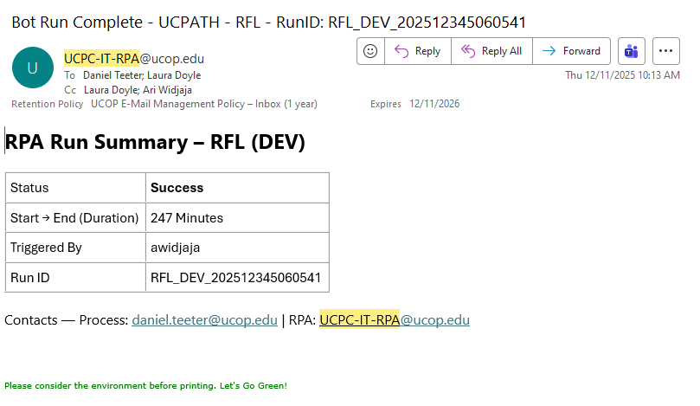

14) Maintenance & Change Management

- **Patch windows:** <ENTER>
- **Package upgrades/deps:** Versioned; rollback plan documented.
- **Change requests:** Template + approvals before PROD.

15) Testing & Validation

- **Pre-prod gates:** Access checks; smoke tests; sample PPE data.
- **Test data mgmt:** Synthetic rows for edge cases (missing ER, invalid PPED).
- **UAT sign-off:** <ENTER>
- **Post-deployment checklist:** Run on window; verify email summary; audit logs populated.

16) Appendix

**Links (dashboards, CR folders, repo, SOPs, PDD):**
- Process Design Document – *Return From Leave Reconciliation*
- Control Room Folder: `<ENTER>`
- Run Dashboard: `<ENTER>`
- SOP – Manual Fallback: `<ENTER>`

**Change Log**

Date | Version | Change | By
<ENTER> | <ENTER> | Initial release | <ENTER>

