EAST AFRICA UNIVERSITY – GAROWE
FACULTY OF TECHNOLOGY AND ENGINEERING
DEPARTMENT OF COMPUTER SCIENCE

BEECIYE: A WEB-BASED SECOND-HAND MARKET PLATFORM
FOR BUYING AND SELLING USED GOODS

[STUDENT FULL NAME]
[STUDENT ID NUMBER]

Supervisor: [SUPERVISOR FULL NAME]

A THESIS SUBMITTED TO THE FACULTY OF TECHNOLOGY AND ENGINEERING IN PARTIAL FULFILMENT OF THE REQUIREMENTS FOR THE AWARD OF BACHELOR'S DEGREE IN COMPUTER SCIENCE OF EAST AFRICA UNIVERSITY

Garowe, Somalia
[MONTH, YEAR OF SUBMISSION]

CERTIFICATION
This is to certify that the thesis titled “BEECIYE: A WEB-BASED SECOND-HAND MARKET PLATFORM FOR BUYING AND SELLING USED GOODS” has been prepared and submitted by [STUDENT FULL NAME], bearing student identification number [STUDENT ID NUMBER], in partial fulfilment of the requirements for the award of the Degree of Bachelor of Science in Computer Science at East Africa University, Garowe. The work embodies the results of the candidate’s own investigation and has been carried out under my supervision.

Supervisor's Name: [SUPERVISOR FULL NAME]
Signature: _______________________ Date: _______________________

Head of Department: [HOD FULL NAME]
Signature: _______________________ Date: _______________________

DECLARATION
I hereby declare that this thesis is my own original work and that it has not been presented, in whole or in part, for the award of any other degree or academic qualification in this or any other university. All sources of information used in this study have been duly acknowledged by means of complete references, in accordance with the academic integrity policy of East Africa University.

Student's Name: [STUDENT FULL NAME]
Signature: _______________________ Date: _______________________

APPROVAL PAGE
This thesis has been examined and approved as meeting the requirements of the Faculty of Technology and Engineering, East Africa University, Garowe, for the award of the Degree of Bachelor of Science in Computer Science.

Internal Examiner: ___________________________ Signature: ___________ Date: ___________
External Examiner: ___________________________ Signature: ___________ Date: ___________
Dean, Faculty of Technology and Engineering: ___________________________ Signature: ___________ Date: ___________

ACKNOWLEDGEMENT
First and foremost, I give thanks to Allah for granting me the strength, patience and opportunity to complete this study. I extend my sincere gratitude to my supervisor, [SUPERVISOR FULL NAME], for the invaluable guidance, constructive criticism and continuous encouragement provided throughout the course of this research and system development.
I am also grateful to the Faculty of Technology and Engineering, East Africa University, Garowe, for providing the academic environment and resources that made this work possible. My appreciation further extends to my family, friends and classmates, whose moral support and encouragement sustained me through the demands of this project. Finally, I acknowledge everyone who, directly or indirectly, contributed insight, feedback or assistance during the design, development and testing of the Beeciye platform.

ABSTRACT
The growth of electronic commerce has transformed the way goods are bought and sold worldwide, yet in many local markets, including Garowe, Somalia, the trading of second-hand goods such as electronics, furniture and clothing continues to rely on informal channels such as word of mouth and unstructured social media groups. These channels lack organised product categorisation, reliable order history, and transparent payment tracking, making it difficult for buyers and sellers to transact with confidence and for any overseeing authority to monitor activity. This study addressed that problem by designing and implementing Beeciye, a web-based, role-based second-hand marketplace platform that allows registered users to both buy and sell used goods within a single, unified account, while an administrator role maintains oversight of the entire system.
The system was developed using an iterative, design-based methodology, implemented with ASP.NET Core 9 MVC, Entity Framework Core 9 for data access, and Microsoft SQL Server as the relational database engine, with ASP.NET Core Identity providing authentication and role-based authorisation. The platform was built incrementally across a series of development rounds, beginning with a core scaffold of models and authentication, followed by full CRUD functionality for products, shopping cart, checkout and order management, a visual redesign to a navy-and-gold dashboard theme, consolidation of the seller and customer roles into a single “User” role, a multi-image product gallery, and a correction of the order-to-payment relationship from one-to-one to one-to-many to properly support partial and repeated payments.
The resulting system supports user registration and login, category-based product browsing and search, a shopping cart with a “Buy Now” shortcut, checkout with a choice of Cash on Delivery or Mobile Money, order history, a seller dashboard with Chart.js-based sales analytics, and a comprehensive administrator dashboard for managing users, products, categories, orders and payments. The platform was tested end-to-end through iterative manual and integration testing covering registration, authentication, stock validation, cart and checkout workflows, multi-payment recording and role-based access control, with all core objectives verified as functioning correctly on a local development deployment. The study concludes that a structured, role-based web platform can meaningfully improve the reliability and transparency of second-hand trading in a local market context, and recommends future enhancements including real payment-gateway integration, a seller rating and review system, and a dedicated mobile application.

TABLE OF CONTENTS
CERTIFICATION ii
DECLARATION ii
APPROVAL PAGE ii
ACKNOWLEDGEMENT iii
ABSTRACT iii
TABLE OF CONTENTS iv
LIST OF TABLES vi
LIST OF FIGURES vi
CHAPTER ONE: INTRODUCTION 1
1.1 Background of the Study 1
1.2 Problem Statement 1
1.3 Objectives of the Study 2
1.3.1 General Objective 2
1.3.2 Specific Objectives 2
1.4 Scope and Limitations of the Study 2
1.5 Significance of the Study 3
1.6 Organization of the Thesis 3
CHAPTER TWO: LITERATURE REVIEW 5
2.1 Review of Related Studies 5
2.2 Analysis of Existing Systems 5
2.3 Research Gap 6
2.4 Conceptual Framework 6
CHAPTER THREE: METHODOLOGY 8
3.1 Research Methodology 8
3.2 Tools and Technologies Used 8
3.3 Data Collection Methods 8
3.4 Data Analysis Techniques 9
3.5 System Design Approach 9
CHAPTER FOUR: SYSTEM ANALYSIS AND DESIGN 11
4.1 Requirements Specification 11
4.2 System Architecture 12
4.3 Database Design 12
4.4 Use Case Diagram 13
4.5 Implementation of Modules 14
4.6 User Interface Design 15
CHAPTER FIVE: SYSTEM IMPLEMENTATION AND TESTING 16
5.1 Introduction 16
5.2 Testing 16
5.3 Screenshots and Explanation 17
5.3.1 Authentication Pages 17
5.3.2 Registered User Module 18
5.3.3 Administrator Module 24
5.4 Discussion of Results 28
CHAPTER SIX: CONCLUSION AND RECOMMENDATIONS 29
6.1 Conclusion 29
6.2 Summary of Findings 29
6.3 Recommendations and Suggestions 29
6.4 Future Enhancements 30
6.5 References 30
APPENDIX A: SELECTED SOURCE CODE SNIPPETS 32
A.1 Product Entity (Models/Product.cs) 32
A.2 Order-to-Payment Relationship (Data/ApplicationDbContext.cs) 32
A.3 Checkout Stock Validation (Controllers/OrderController.cs) 32
APPENDIX B: ENTITY FRAMEWORK CORE MIGRATIONS 33
APPENDIX C: DEMONSTRATION ACCOUNTS 34
APPENDIX D: USER REQUIREMENTS QUESTIONNAIRE 35

LIST OF TABLES
• Table 4.1: Functional Requirements of the Beeciye System .......................................................... 11
• Table 4.2: Non-Functional Requirements of the Beeciye System .......................................................... 11
• Table 5.1: Sample Test Cases and Results .......................................................... 16

LIST OF FIGURES
• Figure 4.1: Three-Tier System Architecture of Beeciye .......................................................... 12
• Figure 4.2: Entity Relationship Diagram (ERD) of the Beeciye Database .......................................................... 13
• Figure 4.3: Use Case Diagram of the Beeciye System .......................................................... 14
• Figure 5.1: Login Page .......................................................... 17
• Figure 5.2: Register Page .......................................................... 18
• Figure 5.3: Registered User Dashboard .......................................................... 18
• Figure 5.4: Browse Products Page .......................................................... 19
• Figure 5.5: Product Details Page .......................................................... 20
• Figure 5.6: Shopping Cart Page .......................................................... 20
• Figure 5.7: Checkout Page .......................................................... 21
• Figure 5.8: My Orders Page .......................................................... 21
• Figure 5.9: Seller Dashboard .......................................................... 22
• Figure 5.10: Add Product Page .......................................................... 22
• Figure 5.11: My Products Page .......................................................... 23
• Figure 5.12: Sales Reports Page (User) .......................................................... 23
• Figure 5.13: Profile Page .......................................................... 24
• Figure 5.14: Administrator Dashboard .......................................................... 24
• Figure 5.15: Admin – Manage Users Page .......................................................... 25
• Figure 5.16: Admin – Manage Products Page .......................................................... 26
• Figure 5.17: Admin – Manage Orders Page .......................................................... 26
• Figure 5.18: Admin – Manage Categories Page .......................................................... 27
• Figure 5.19: Admin – Payments Page .......................................................... 27
• Figure 5.20: Admin – System Reports Page .......................................................... 28

CHAPTER ONE: INTRODUCTION

1.1 Background of the Study
Electronic commerce has fundamentally changed how goods and services are exchanged, enabling buyers and sellers to transact beyond the constraints of physical location and business hours. Within this broader transformation, the second-hand or “re-commerce” economy has grown into a distinct and significant segment, as consumers increasingly seek to extend the useful life of goods rather than discard them (Yrjölä et al., 2021). Globally, Consumer-to-Consumer (C2C) platforms such as eBay, Mercari and Xianyu have demonstrated that a well-designed digital marketplace can connect individual sellers of used goods directly with buyers, creating economic value while supporting more sustainable consumption patterns.
In Garowe, Somalia, and similar local markets, the trade of second-hand items such as mobile phones, laptops, furniture and clothing remains largely informal. Sellers typically advertise items through personal social media accounts, unstructured Facebook groups, or simple word-of-mouth referrals. While these channels are accessible, they lack organised categorisation, searchable product listings, reliable transaction history, and any structured mechanism for recording payments or resolving disputes. Buyers cannot easily compare similar items across sellers, and there is no central authority able to oversee the volume, nature or integrity of transactions taking place. This study was motivated by the recognition that a dedicated, structured web platform, purpose-built for the local second-hand market, could address these shortcomings while remaining simple enough for non-technical users to adopt.

1.2 Problem Statement
Individuals in Garowe who wish to buy or sell second-hand goods currently have no dedicated digital platform suited to this purpose. Existing informal channels present four specific shortcomings. First, product discovery is inefficient, since listings are scattered across personal profiles and group posts with no consistent categorisation or search capability. Second, there is no reliable order or transaction history, so buyers and sellers alike have no durable record of what was agreed, ordered or paid. Third, payment handling is entirely manual and undocumented, creating a risk of disputes over whether or how much has been paid, particularly where partial payments are involved. Fourth, no administrative or oversight mechanism exists to monitor sellers, moderate listings, or intervene when problems arise. Beeciye was conceived and developed to resolve these problems through a structured, role-based web platform combining classifieds-style browsing with an integrated cart, checkout, order and payment-tracking workflow, together with an administrative layer for system-wide oversight.

1.3 Objectives of the Study

1.3.1 General Objective
The general objective of this study was to design, develop and test a web-based second-hand marketplace platform, named Beeciye, that enables registered users to buy and sell used goods within a single account while providing administrators with full oversight of users, products, orders and payments.

1.3.2 Specific Objectives
• To design a relational database schema capable of representing users, product categories, products with multiple images, shopping cart items, orders, order line items and payments, including support for multiple payment records per order.
• To implement secure user authentication and role-based authorisation distinguishing between an Administrator role and a general User role.
• To implement product listing functionality, including category-based browsing, search, and a multi-image product gallery for sellers.
• To implement a complete purchase workflow comprising a shopping cart, a direct “Buy Now” option, and a checkout process supporting Cash on Delivery and Mobile Money as payment methods.
• To implement role-specific dashboards, including a seller dashboard with sales analytics and an administrator dashboard for managing users, products, categories, orders and payments.
• To test the resulting system end-to-end to confirm that the core buying, selling and administrative workflows function correctly.

1.4 Scope and Limitations of the Study
The scope of this study covers the design, implementation and testing of a web-based marketplace application accessible through a standard desktop or mobile web browser. The system supports a single combined “User” role capable of both buying and selling, alongside a separate “Administrator” role. Functional coverage includes registration and login, category-based product browsing and search, a multi-image product gallery, a shopping cart and checkout workflow, order history, seller sales reporting, and comprehensive administrative management of users, products, categories, orders and payments.
The study is subject to the following limitations. The system does not integrate with a live third-party payment gateway; Cash on Delivery and Mobile Money are recorded as payment methods within the platform but no real financial transaction is processed through an external provider. The platform does not include a seller rating or review mechanism, nor a real-time chat feature between buyers and sellers. It operates on a single currency and was developed and tested within a local development environment rather than deployed to a public production server. Finally, uploaded product images are not subject to automated content moderation.

1.5 Significance of the Study
This study is significant to several groups of stakeholders. For buyers, Beeciye offers a structured, searchable alternative to informal trading channels, together with a durable order history. For sellers, the platform provides dedicated tools for listing products, tracking sales, and viewing performance through visual reports. For administrators, the system provides comprehensive oversight of users, listings, orders and payments, supporting accountability that is largely absent from informal trading arrangements. Academically, the project demonstrates the practical application of the Model-View-Controller architectural pattern, Entity Framework Core object-relational mapping, and role-based security in the design of a real-world e-commerce system, contributing a concrete, locally grounded case study to the broader literature on second-hand and C2C commerce platforms (Zhang & Meng, 2022). More broadly, by facilitating the reuse and redistribution of second-hand goods, the platform supports the extension of product life cycles, aligning with the economic and environmental value of the second-hand economy identified in prior research (Yrjölä et al., 2021).

1.6 Organization of the Thesis
This thesis is organised into six chapters. Chapter One has introduced the background, problem statement, objectives, scope, limitations and significance of the study. Chapter Two reviews related literature on second-hand and C2C commerce platforms, compares existing systems and technologies, and identifies the research gap addressed by this study. Chapter Three describes the research methodology, the tools and technologies used, and the system development approach. Chapter Four presents the system analysis and design, including requirements specification, system architecture, database design and use case analysis. Chapter Five documents the system implementation and testing process, including test cases and annotated screenshots of the working system. Chapter Six presents the conclusion, a summary of findings, recommendations and suggestions for future enhancement, followed by the list of references and appendices.

CHAPTER TWO: LITERATURE REVIEW

2.1 Review of Related Studies
Yrjölä et al. (2021) examined the second-hand economy from a business-model perspective and proposed a typology of second-hand business models classified by the degree of control exercised over transactions, the revenue mechanism employed, and the level of seller selection and support provided. Within this typology, the “connector” model, in which the platform provider primarily facilitates the connection between independent buyers and sellers who manage their own transactions, closely resembles the structure adopted by Beeciye, which enables individual users to list and sell items directly to other users while the platform provides the supporting infrastructure of search, cart, checkout and payment recording.
Moriuchi and Takahashi (2022) investigated the role of perceived value, trust and engagement in consumers' intention to reuse a C2C secondary marketplace, finding that trust in both the individual seller and the platform itself mediates the relationship between perceived value and repeat usage intention. This finding informed the design emphasis in Beeciye on maintaining a visible order history, seller attribution on every product and order line item, and transparent payment status, all of which are mechanisms through which an unfamiliar platform can build user trust. In a related study, Jang and Kim (2023) identified specific factors influencing user trust and loyalty on C2C second-hand marketplace platforms, reinforcing the importance of transaction transparency and platform reliability as design priorities that were carried into the development of Beeciye's order and payment tracking features.
On the technical implementation side, Zhang and Meng (2022) described the design and implementation of an intelligent campus second-hand trading platform built on the Model-View-Controller architectural pattern with a SQL Server database, demonstrating the practical viability of the MVC and relational-database combination for second-hand commerce systems at a manageable scale; this precedent directly supports the architectural choices made for Beeciye, which similarly adopts an MVC framework (ASP.NET Core) together with Microsoft SQL Server. Ahmed et al. (2024) presented ShareSpace, a localised e-commerce platform enabling students within a defined campus community to exchange pre-owned items in order to address affordability constraints and promote economical sharing. Like Beeciye, ShareSpace targets a bounded local community rather than a global consumer base, illustrating that smaller, purpose-built second-hand platforms remain a relevant and actively researched category of system, distinct from large international marketplaces.

2.2 Analysis of Existing Systems
Several established platforms currently serve second-hand trade in the wider region, most notably OLX, Jiji and Facebook Marketplace. These platforms function primarily as online classifieds: sellers post a listing with a description, price and photograph, and interested buyers contact the seller directly, typically through phone calls, SMS or in-platform messaging, to negotiate and arrange payment and delivery independently. This model is simple and has achieved wide adoption, but it leaves the entire transaction, including price negotiation, payment and delivery, outside the platform itself, meaning no order history, payment record or administrative oversight exists within the system.
Table 2.1: Feature Comparison of Existing Platforms and Beeciye
Feature | OLX / Jiji | Facebook Marketplace | Beeciye
Category-based listing and search | Yes | Yes | Yes
Integrated shopping cart | No | No | Yes
In-platform checkout and order record | No | No | Yes
Multiple / partial payment tracking | No | No | Yes
Seller dashboard with sales analytics | No | No | Yes
Centralised administrative oversight | No | Limited (platform-level only) | Yes

2.3 Research Gap
The reviewed literature demonstrates substantial research interest in the behavioural dimensions of C2C second-hand commerce, particularly trust, perceived value and re-use intention (Moriuchi & Takahashi, 2022; Jang & Kim, 2023), and confirms the technical feasibility of MVC-based second-hand trading systems (Zhang & Meng, 2022; Ahmed et al., 2024). However, this body of work is concentrated either on large international platforms studied primarily for consumer-behaviour insight, or on systems built for a specific bounded community such as a university campus. Locally accessible platforms serving Garowe and comparable Somali markets, namely OLX, Jiji and Facebook Marketplace, remain limited to classifieds-style listing without any integrated cart, checkout, payment-tracking or administrative oversight functionality, as summarised in Table 2.1. A gap therefore exists for an integrated, locally relevant, role-based second-hand marketplace that combines the accessibility of classifieds-style listing with genuine in-platform order and payment management. Beeciye was developed specifically to address this gap.

2.4 Conceptual Framework
The conceptual framework underlying Beeciye treats the platform as a cycle of inputs, processes and outputs mediated by continuous administrative oversight. Inputs consist of user registration data and seller-submitted product listings, including images, prices, categories and stock quantities. These inputs are processed through search and category filtering, cart management, and a checkout process that validates stock availability and records the selected payment method. The resulting outputs are a confirmed order, one or more associated payment records, and updated stock levels, which in turn feed into seller sales reports and administrator-level system reports. Throughout this cycle, the Administrator role provides an oversight loop, with the ability to inspect, correct or directly manage users, products, categories, orders and payments at any stage. This framework is realised technically through the three-tier architecture presented in Figure 4.1 in Chapter Four.

CHAPTER THREE: METHODOLOGY

3.1 Research Methodology
This study adopted a design-based, developmental research methodology, in which the research problem is addressed directly through the design, construction and evaluation of a working software artefact, rather than through the testing of a formal hypothesis alone. The methodology combined an initial descriptive phase, involving informal review of local second-hand trading practices and existing platforms, with an iterative system-building phase in which the Beeciye platform was designed, implemented and progressively refined.

3.2 Tools and Technologies Used
The Beeciye platform was developed using the following tools and technologies:
• C# 13 and .NET 9 as the primary programming language and runtime.
• ASP.NET Core 9 MVC as the web application framework, providing the Model-View-Controller architectural structure.
• Entity Framework Core 9 as the object-relational mapping (ORM) layer, using a code-first approach with migrations to manage the database schema (Microsoft, 2026a; Microsoft, 2026b).
• Microsoft SQL Server as the relational database management system.
• ASP.NET Core Identity for authentication, password hashing and role-based authorisation.
• Razor Views, Bootstrap 5 and custom CSS for the presentation layer, and Chart.js for sales-report visualisations.
• Visual Studio Code and the .NET CLI for development, and Git for source-code version control.

3.3 Data Collection Methods
Requirements for the system were gathered through informal interviews and discussions with prospective buyers and sellers of second-hand goods in Garowe, direct observation of how existing informal channels, including Facebook groups and OLX-style listings, are used in practice, and structured review of comparable existing platforms as a form of document and system analysis. In addition, the development process itself incorporated an iterative feedback loop: a visual mockup of the intended dashboard interface was reviewed against the evolving implementation across several development rounds, and observed mismatches were treated as a further source of requirements refinement.
To complement these qualitative methods, a structured questionnaire (reproduced in Appendix D) was administered to a purposive sample of thirty prospective buyers and sellers of second-hand goods in Garowe. The instrument combined closed-ended items and five-point Likert-scale statements covering respondent profile, current buying and selling habits, challenges encountered with informal channels, and the perceived importance of candidate platform features, providing quantifiable data that complemented the interview and observation findings.

3.4 Data Analysis Techniques
Information gathered through interviews, observation and platform comparison was analysed qualitatively and translated directly into functional and non-functional requirements, presented in Table 4.1 and Table 4.2 of Chapter Four. Comparative analysis of existing platforms, summarised in Table 2.1, was used to identify specific functional gaps, such as the absence of integrated checkout and payment tracking, that Beeciye was designed to close. Usability feedback obtained by comparing the running system against the supplied interface mockup was analysed informally and used to guide iterative interface refinements, including layout, colour scheme and navigation adjustments.

3.5 System Design Approach
Beeciye was developed using an Agile, iterative and incremental system development life cycle (SDLC), in preference to a strict Waterfall model, in order to accommodate evolving requirements and continuous feedback throughout development. The system evolved through a documented sequence of development rounds, summarised below, each of which added or refined a coherent unit of functionality and was followed by manual smoke testing before the next round began.
• Round 1 – Core scaffold: initial data models, database context and seed data were established.
• Round 2 – Core functionality: authentication, product browsing and management, shopping cart, checkout and order processing, and an administrative dashboard were implemented and end-to-end tested.
• Round 3 – Visual redesign: the interface was restyled to match a supplied navy-and-gold dashboard mockup, including a dedicated dashboard sidebar layout for authenticated users.
• Round 4 – Role simplification: the separate Seller and Customer roles were consolidated into a single “User” role capable of both buying and selling, simplifying navigation and access control.
• Round 5 – Feature completion: a multi-image product gallery, additional administrative create and edit workflows, and clickable dashboard statistics were added to bring parity between “Add” and “Edit” capabilities across all managed entities.
• Round 6 – Data-model correction: the Order-to-Payment relationship was corrected from one-to-one to one-to-many after testing revealed that the original design made the administrative “Add Payment” feature unreachable under normal use, properly enabling partial and multiple payments per order.
• Round 7 – Final verification: the complete system was exercised end-to-end across all roles to confirm correct operation prior to documentation.
• Round 8 – Guest listing: unregistered visitors were enabled to submit product listings by supplying a contact name and phone number in place of an account, extending participation beyond registered users.
• Round 9 – Purchase and inventory refinement: a one-click “Buy Now” purchase path was added, sold-out listings were made to automatically deactivate and disappear from Browse Products, and a soft-delete mechanism was introduced so that sellers can remove listings without destroying associated order history.
• Round 10 – Dynamic pricing: product pricing was reworked so that the price entered at listing time represents the total value of the initial quantity, from which a fixed per-unit charge is derived and the displayed remaining value shrinks proportionally as stock is sold.
• Round 11 – Profile picture: registered users were enabled to upload and display a profile picture, shown on the profile page and the dashboard sidebar avatar.
This iterative approach allowed design flaws, such as the Order-to-Payment cardinality issue addressed in Round 6, to be identified through real usage and testing rather than through upfront analysis alone, which is consistent with the practical, evolving nature of design-based research.

CHAPTER FOUR: SYSTEM ANALYSIS AND DESIGN

4.1 Requirements Specification
Requirements for the Beeciye system were classified into functional requirements, describing specific behaviours the system must perform, and non-functional requirements, describing the quality attributes the system must exhibit. These are presented in Table 4.1 and Table 4.2 respectively.
Table 4.1: Functional Requirements of the Beeciye System
ID | Requirement
FR1 | The system shall allow a visitor to register a new account and log in using an email address and password.
FR2 | The system shall enforce role-based authorisation, distinguishing between the Administrator role and the general User role.
FR3 | The system shall allow users to browse, search and filter products by category.
FR4 | The system shall display full product details, including a multi-image gallery, condition, price, quantity and seller.
FR5 | The system shall allow a user to add a product to a shopping cart, adjust quantity, or purchase immediately via a “Buy Now” action.
FR6 | The system shall provide a checkout process capturing shipping details and a choice of payment method (Cash on Delivery or Mobile Money).
FR7 | The system shall maintain and display a user's order history.
FR8 | The system shall allow a user to create, edit and delete their own product listings, including uploading multiple images.
FR9 | The system shall provide a sales report to sellers, including totals and a chart of sales over time.
FR10 | The system shall allow a user to view and update their own profile information.
FR11 | The system shall allow an Administrator to manage all users, products, categories, orders and payments in the system.
FR12 | The system shall allow an Administrator to create users, products, orders and payments on behalf of any user.
FR13 | The system shall allow more than one payment record to be associated with a single order, to support partial or repeated payments.
FR14 | The system shall allow an unregistered visitor to submit a product listing by providing a contact name and phone number in place of a registered account.
FR15 | The system shall allow a registered user to complete an immediate “Buy Now” purchase using their saved profile shipping details, without completing the standard cart checkout form.
FR16 | The system shall derive a fixed per-unit price from the total price and quantity entered at listing time, and display the proportional value of the remaining stock as units are sold.
FR17 | The system shall automatically deactivate and hide a product listing from the Browse Products page once its stock quantity reaches zero.
FR18 | The system shall preserve historical order records when a seller deletes a previously sold product, by deactivating the listing rather than permanently removing it from the database.
FR19 | The system shall allow a registered user to upload and display a profile picture.

Table 4.2: Non-Functional Requirements of the Beeciye System
Category | Requirement
Usability | The interface shall present a role-aware dashboard with sidebar navigation appropriate to the logged-in user's role.
Security | Passwords shall be hashed using ASP.NET Core Identity, protected actions shall require authorisation, and forms shall be protected against cross-site request forgery.
Performance | Product listings shall be paginated, and database access shall use asynchronous Entity Framework Core queries.
Maintainability | The system shall follow the Model-View-Controller pattern with a code-first, migration-managed database schema to ease future modification.
Portability | The system shall run against any standard Microsoft SQL Server instance without code changes, controlled through configuration.
Reliability | Server-side data validation shall be enforced through model annotations, independent of client-side validation.
Accessibility | The system shall allow core listing functionality to be used by unregistered visitors, lowering the barrier to first-time participation in the marketplace.

4.2 System Architecture
Beeciye follows a three-tier architecture that separates presentation, application logic and data storage, consistent with the Model-View-Controller pattern implemented by ASP.NET Core. Figure 4.1 illustrates the client browser communicating over HTTPS with the ASP.NET Core MVC web layer, which delegates business logic to a set of controllers and ASP.NET Core Identity, which in turn access the database exclusively through the Entity Framework Core data access layer backed by Microsoft SQL Server.
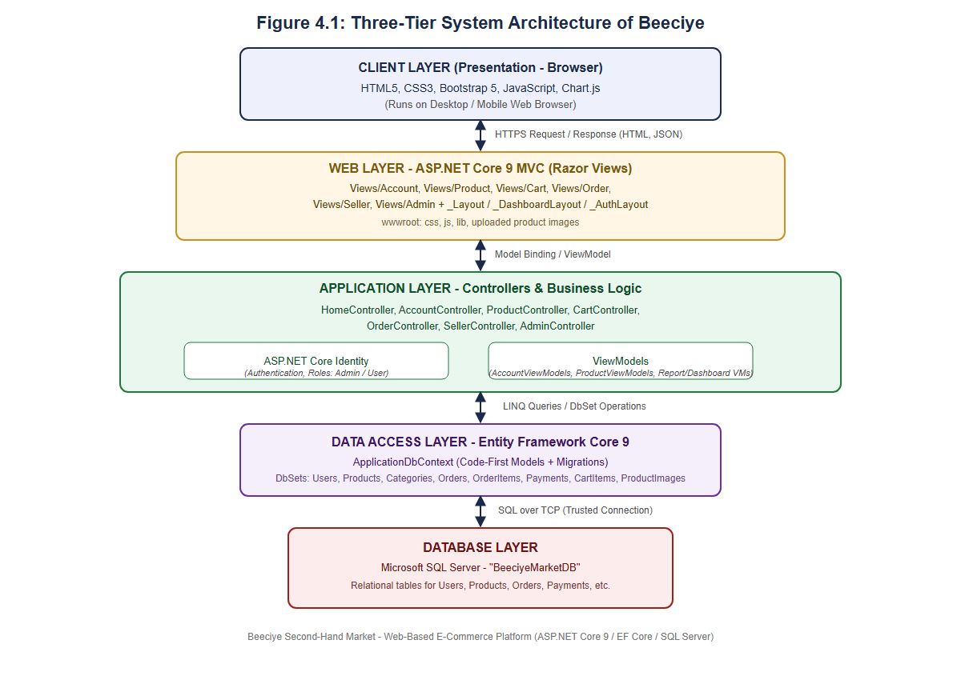
Figure 4.1: Three-Tier System Architecture of Beeciye

4.3 Database Design
The Beeciye database was designed using a code-first Entity Framework Core approach, in which the C# entity classes define the schema and migrations apply the corresponding changes to Microsoft SQL Server. The database centres on the ApplicationUser entity, which extends ASP.NET Core Identity's user model with a full name, address, city and account-creation timestamp. Each Product belongs to one Category and one seller (an ApplicationUser), and may have many associated ProductImage records supporting the multi-image gallery. A CartItem links a user to a product with a quantity, while an Order captures shipping details, status and payment method, and owns many OrderItem records, each referencing the product and seller involved. Each Order can be associated with one or more Payment records, a deliberate one-to-many relationship that allows partial or repeated payments to be recorded against a single order, corrected during Round 6 of development as described in Chapter Three. The complete entity relationship diagram is presented in Figure 4.2.
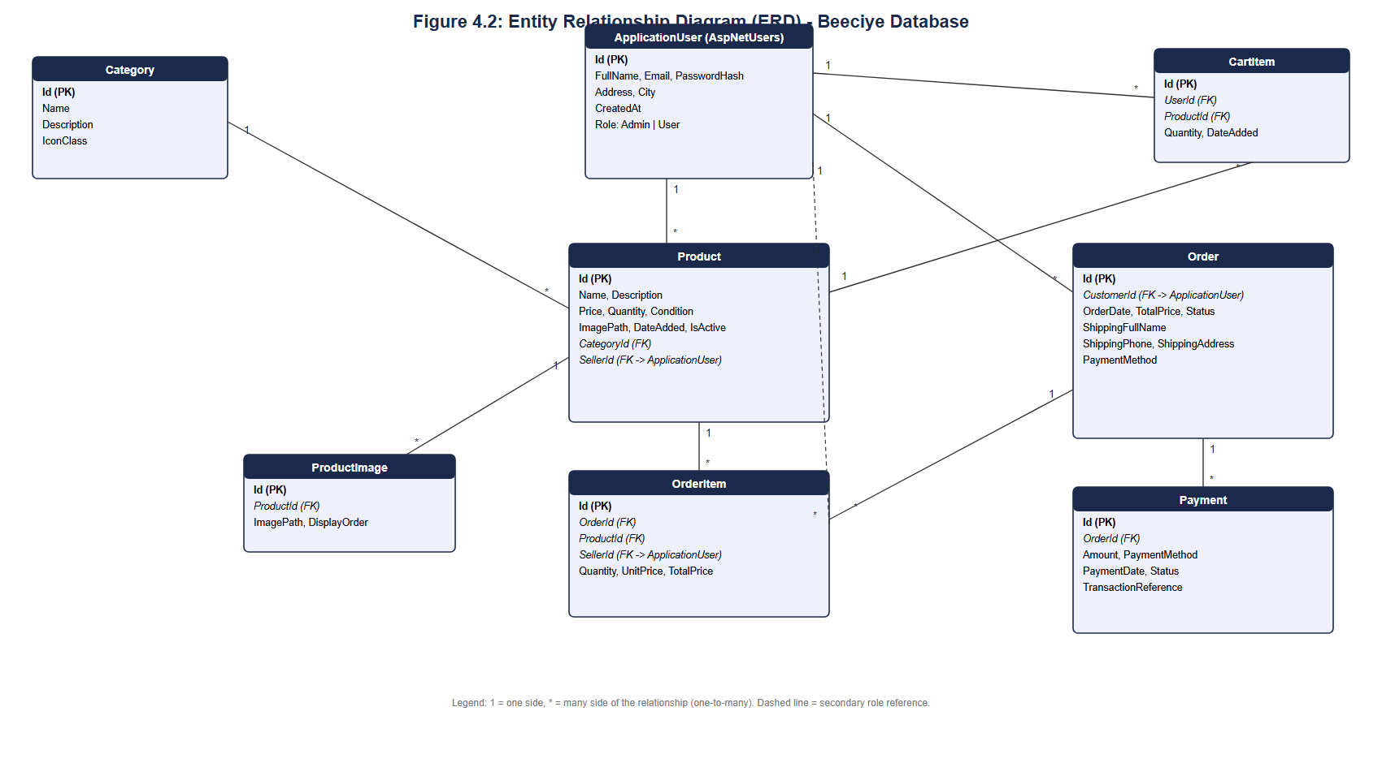
Figure 4.2: Entity Relationship Diagram (ERD) of the Beeciye Database

4.4 Use Case Diagram
Figure 4.3 presents the use case diagram for Beeciye, showing three actors: a Guest or Visitor who may register, log in, browse products, and submit a basic product listing with contact details, all without creating an account; a Registered User who, once logged in, can additionally add products to a cart, check out, view order history, list and manage their own products, view sales reports and manage their profile; and an Administrator who can additionally manage users, products, categories, orders and payments, and view system-wide reports. Because Beeciye merges the buyer and seller roles into a single User account, the same actor participates in both buying-related and selling-related use cases, reflecting the system's unified dashboard design described in Chapter Three.
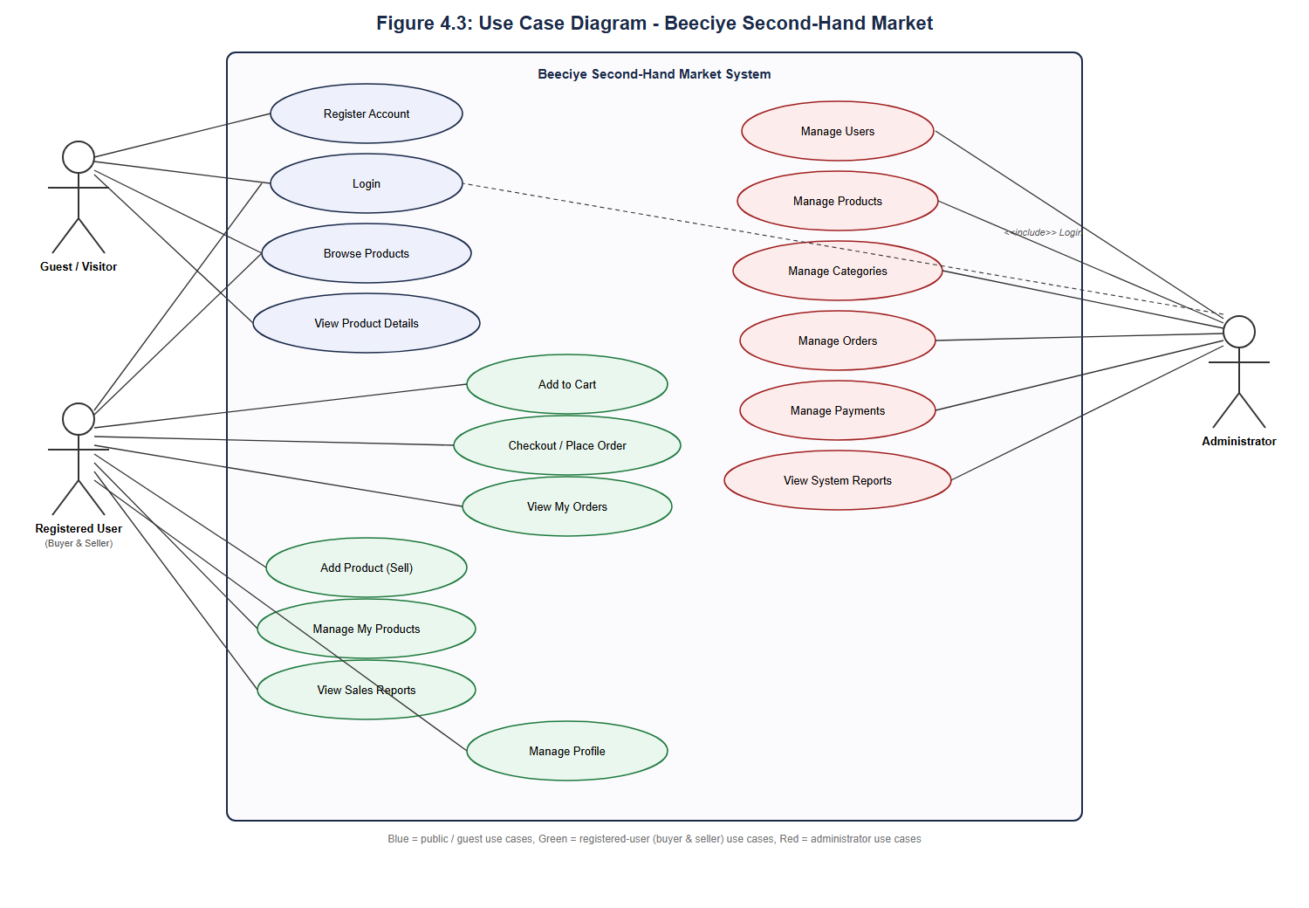
Figure 4.3: Use Case Diagram of the Beeciye System

4.5 Implementation of Modules
The application logic of Beeciye is organised into seven controllers, each responsible for a coherent area of functionality.
• HomeController acts as a role-based landing dispatcher: anonymous visitors are redirected to the login page, Administrators are redirected to the Admin dashboard, and other authenticated users are redirected to their dashboard.
• AccountController implements registration, login, logout and profile management using ASP.NET Core Identity.
• ProductController implements product browsing and detail views for all users, together with create, edit, delete and multi-image gallery management restricted to the product's own seller.
• CartController implements adding, updating and removing shopping-cart items, as well as the “Buy Now” shortcut that adds an item to the cart and redirects directly to checkout.
• OrderController implements the checkout process, including stock validation and payment creation, together with order history for buyers and a sales view for sellers.
• SellerController implements the seller dashboard and a sales report view, including a date-range filter and a Chart.js bar chart of sales over time.
• AdminController implements the administrator dashboard and full management of users, products, categories, orders and payments, including the ability to create records directly on behalf of any user.

4.6 User Interface Design
The Beeciye interface follows a consistent navy-and-gold visual theme. Unauthenticated visitors see a dedicated two-column authentication layout for the login and registration pages, comprising a form on the left and an illustrated marketplace graphic on the right. Once authenticated, users interact with the system through a shared dashboard shell consisting of a fixed navy sidebar, listing navigation links appropriate to the user's role, and a light content area on the right. Status information, such as order status and payment status, is communicated through coloured badges, and product condition (New, Good or Used) is shown as a coloured tag beneath the product name. The complete set of interface screens is presented and explained in Chapter Five.

CHAPTER FIVE: SYSTEM IMPLEMENTATION AND TESTING

5.1 Introduction
This chapter presents the outcome of implementing the design described in Chapter Four, together with the testing performed to verify that the Beeciye system operates correctly. Section 5.2 describes the testing approach and presents a sample of the test cases executed. Section 5.3 presents annotated screenshots of the working system captured directly from a running instance of the application, organised by user role. Section 5.4 discusses the results of testing and implementation.

5.2 Testing
Beeciye was tested using a combination of manual unit-level verification of individual controller actions, integration testing of complete workflows spanning registration, browsing, cart, checkout and order confirmation, and repeated smoke testing after each development round described in Chapter Three, in place of a formal automated test suite. Table 5.1 presents a representative sample of the test cases executed against the completed system.
Table 5.1: Sample Test Cases and Results
Test ID | Description | Expected Result | Result
TC01 | Register a new account with a valid email and password. | Account is created and the user is redirected to log in. | Pass
TC02 | Attempt to add an out-of-stock product (quantity = 0) to the cart. | The “Add to Cart” button is disabled and the item cannot be added. | Pass
TC03 | Add an in-stock product to the cart and proceed to checkout. | Cart and checkout pages correctly display the product, quantity and computed total. | Pass
TC04 | Complete checkout with Cash on Delivery. | An order and an associated payment record are created and appear in order history. | Pass
TC05 | A non-administrator attempts to access an /Admin route directly. | Access is denied and the user is redirected away from the administrative area. | Pass
TC06 | Administrator attempts to remove Administrator rights from the sole remaining Admin account. | The action is blocked with an error message preventing the system from being left without an administrator. | Pass
TC07 | Administrator adds a second payment record to an order that already has one. | Both payment records are saved and displayed in the order's payment history with a combined paid amount. | Pass
TC08 | Seller views the Sales Reports page after completing at least one sale. | Total sales, order count and a bar chart of sales over time are displayed correctly. | Pass
TC09 | An unregistered visitor submits a product listing via the public “Sell an item without an account” form, providing a name and phone number. | The listing is created without an owning account and appears in Browse Products showing the submitted contact name and phone number. | Pass
TC10 | A registered user clicks “Buy Now” on a product's details page. | An order is created immediately using the user's saved profile name, phone and address, without requiring the standard checkout form to be completed. | Pass
TC11 | A product's stock quantity is reduced to zero through a purchase. | The listing is automatically deactivated and no longer appears on the Browse Products page. | Pass
TC12 | A seller deletes a product that already has at least one associated order. | The listing is removed from “My Products” and Browse Products, while the existing order and payment records remain intact and viewable in order history. | Pass
TC13 | A seller lists a product with a total price of $15 for a quantity of 3, then a buyer purchases one unit. | The product details page shows a per-unit price of $5.00, the buyer is charged $5.00, and the displayed remaining value falls to $10.00 for the two remaining units. | Pass
TC14 | A registered user uploads an image on the Profile page and saves. | The uploaded image is stored, displayed on the profile page, and shown as the user's avatar in the dashboard sidebar. | Pass

5.3 Screenshots and Explanation
This section presents the working Beeciye system through screenshots captured directly from a running instance of the application, organised into authentication pages, the registered User module, and the Administrator module.

5.3.1 Authentication Pages

Figure 5.1: Login Page
The login page uses the dedicated two-column authentication layout described in Section 4.6, with the sign-in form on the left and an illustrated marketplace graphic and tagline on the right. Existing users authenticate here using their registered email address and password.

Figure 5.2: Register Page
The registration page shares the same authentication layout and allows a new visitor to create an account. Every new account is created with the general User role, which grants both buying and selling capability, consistent with the unified role model adopted in Round 4 of development.

5.3.2 Registered User Module
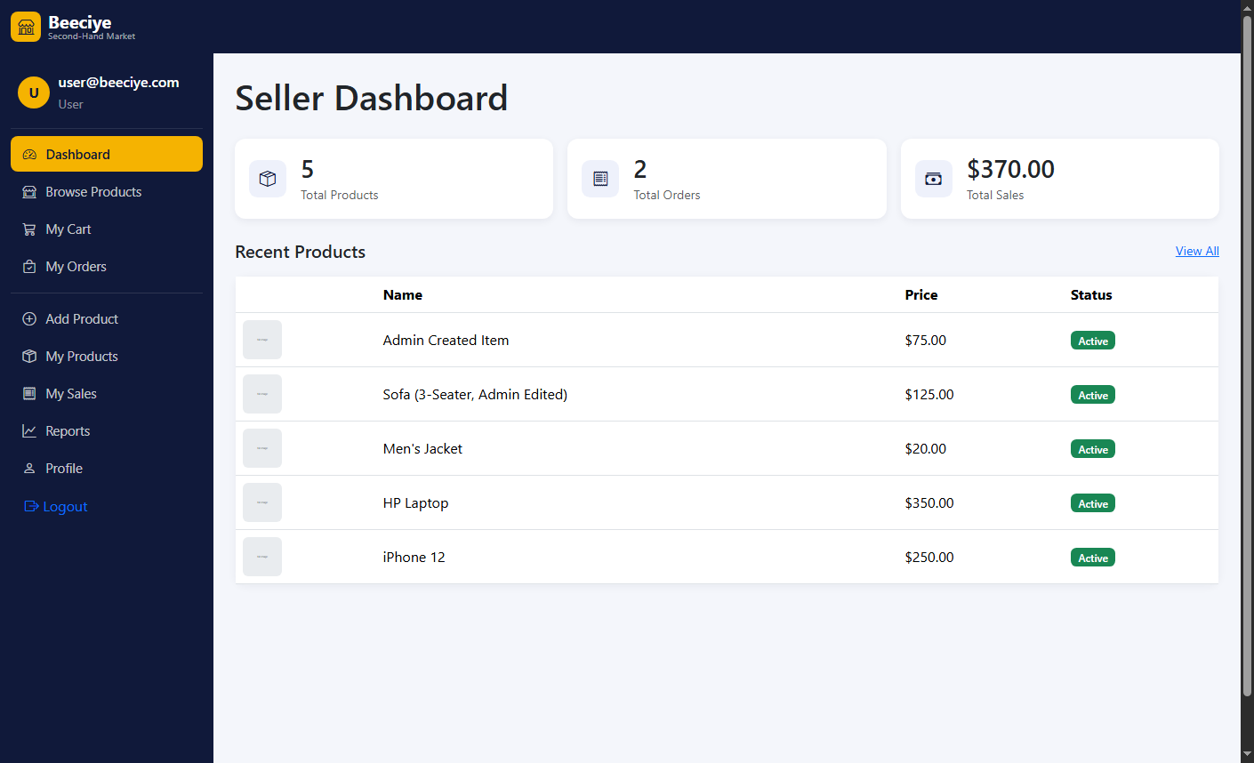
Figure 5.3: Registered User Dashboard
After logging in, a User is presented with the dashboard shell and sidebar described in Section 4.6, providing navigation to both buying-related sections (Browse Products, My Cart, My Orders) and selling-related sections (Add Product, My Products, My Sales, Reports), reflecting the unified account model.
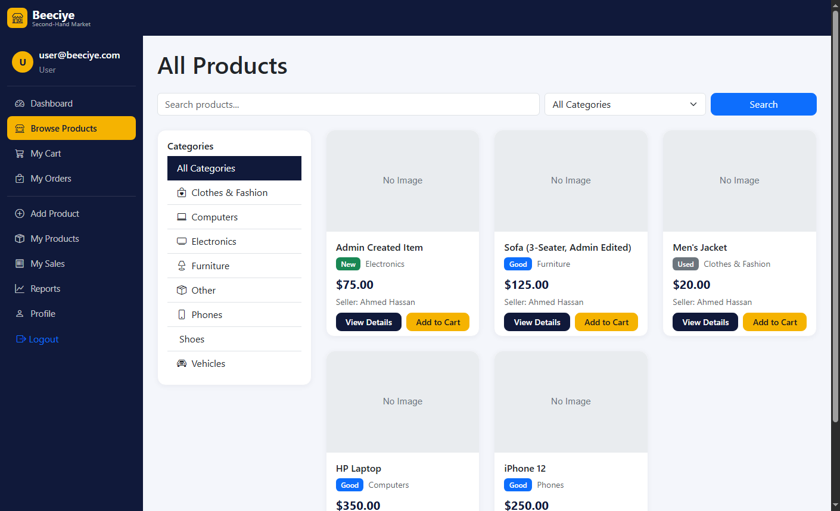
Figure 5.4: Browse Products Page
The product listing page allows a user to browse all active products, filter by category using the sidebar, and search by keyword, addressing functional requirement FR3.
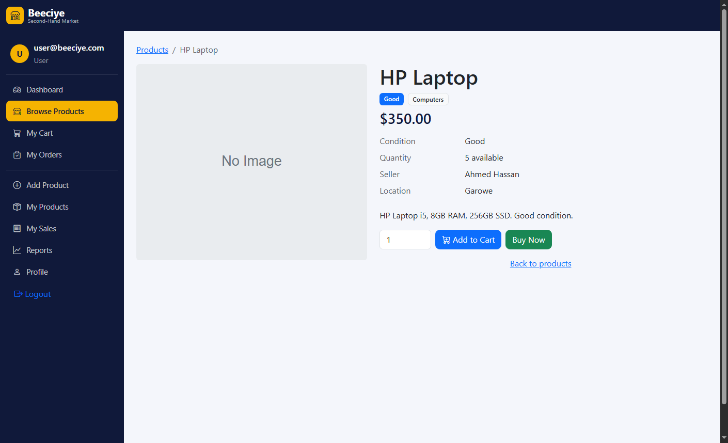
Figure 5.5: Product Details Page
The product details page displays the selected product's condition, quantity, seller and location, along with an “Add to Cart” and a “Buy Now” action. As shown, the “Add to Cart” control is disabled whenever the available quantity is zero, which was confirmed directly during testing (see TC02 in Table 5.1).
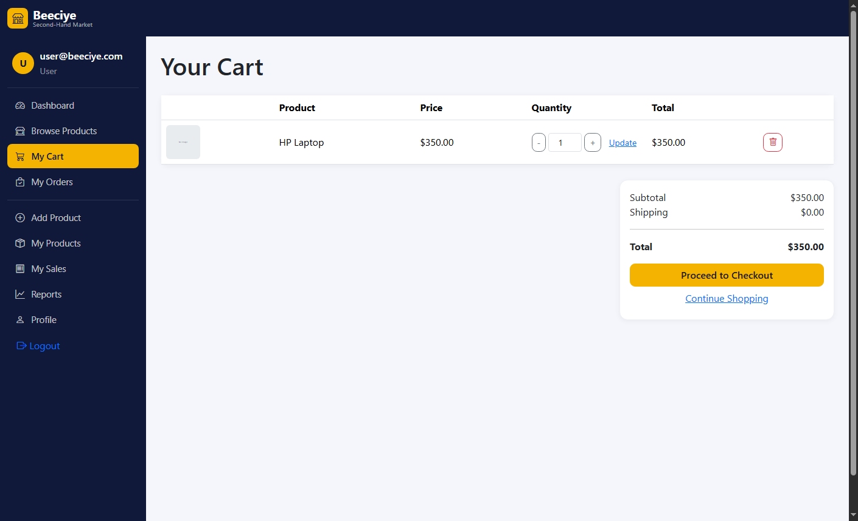
Figure 5.6: Shopping Cart Page
The cart page lists every item a user has added, allows the quantity of each item to be adjusted or removed, and calculates a running subtotal and total before checkout.
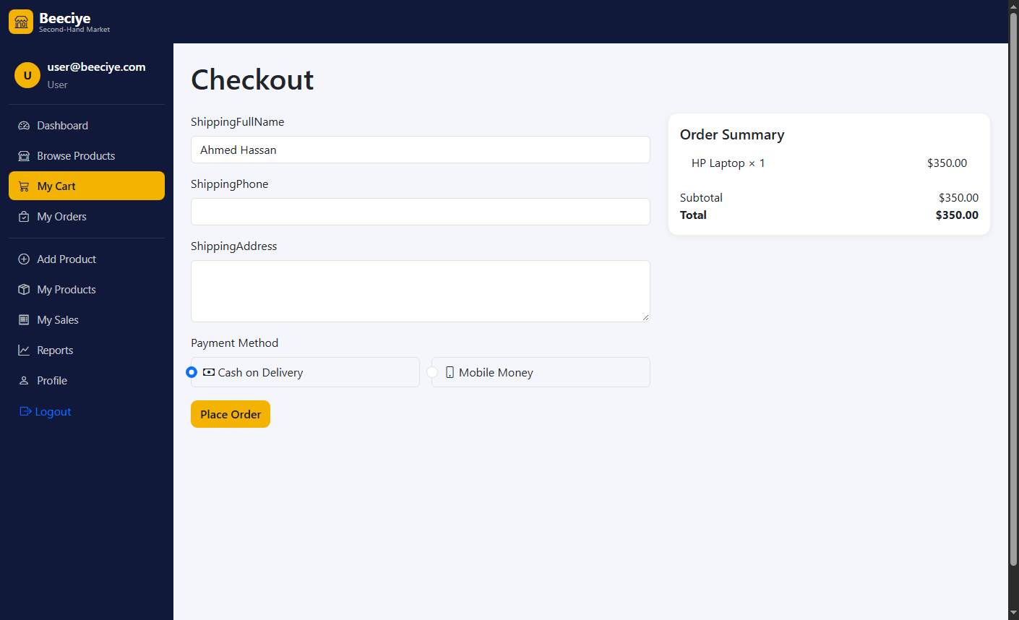
Figure 5.7: Checkout Page
The checkout page captures the shipping name, phone number and address, together with a choice between Cash on Delivery and Mobile Money, and displays an order summary drawn from the current cart contents before the order is placed.

Figure 5.8: My Orders Page
The order history page lists every order placed by the logged-in user together with its current status, satisfying functional requirement FR7.
Figure 5.9: Seller Dashboard
The seller-facing side of the same User dashboard provides quick access to the product and sales management tools available to every registered user.
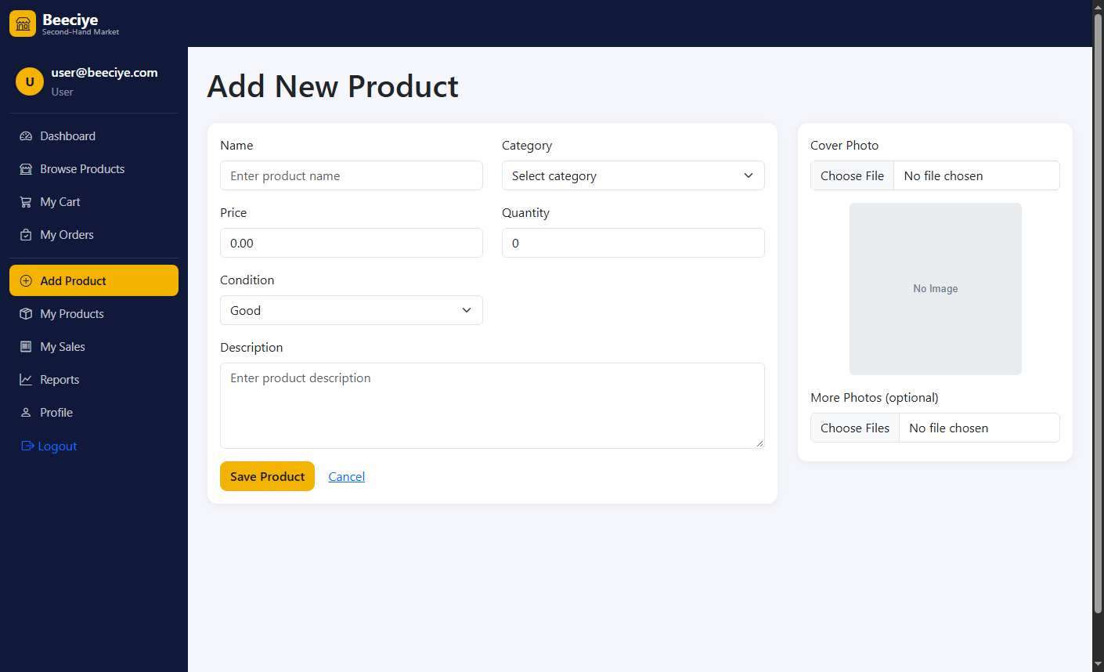
Figure 5.10: Add Product Page
The Add Product form allows a user to list a new item, specifying its name, description, category, price, quantity and condition, together with a cover photo and an additional multi-image gallery, addressing functional requirement FR8.
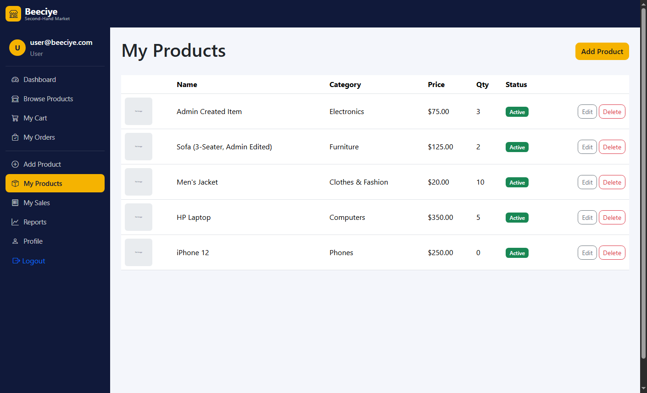
Figure 5.11: My Products Page
This page lists every product the logged-in user has listed for sale, with links to edit or remove each listing.
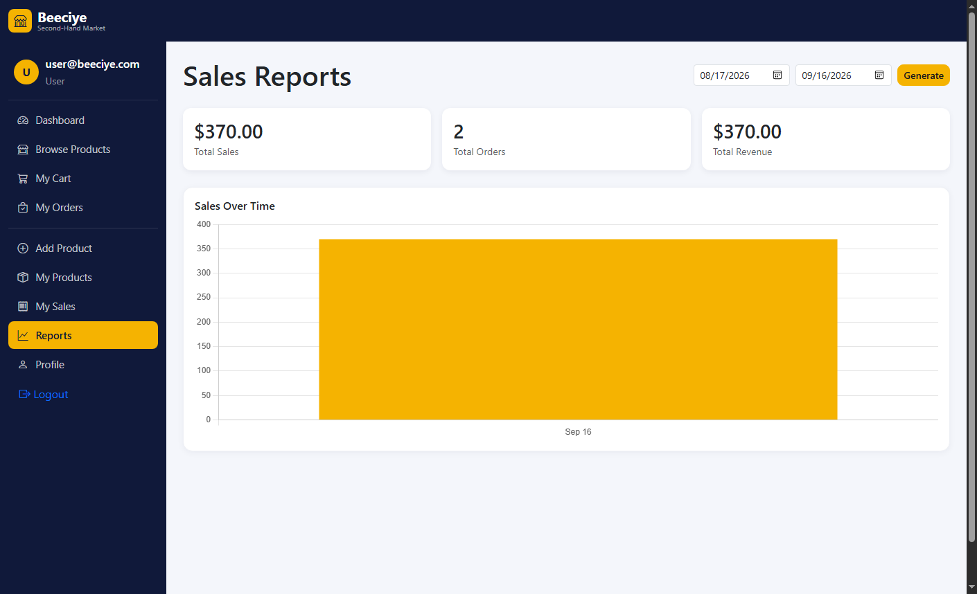
Figure 5.12: Sales Reports Page (User)
The Sales Reports page, addressing functional requirement FR9, displays total sales, total orders and total revenue for a selectable date range, together with a Chart.js bar chart of sales over time.
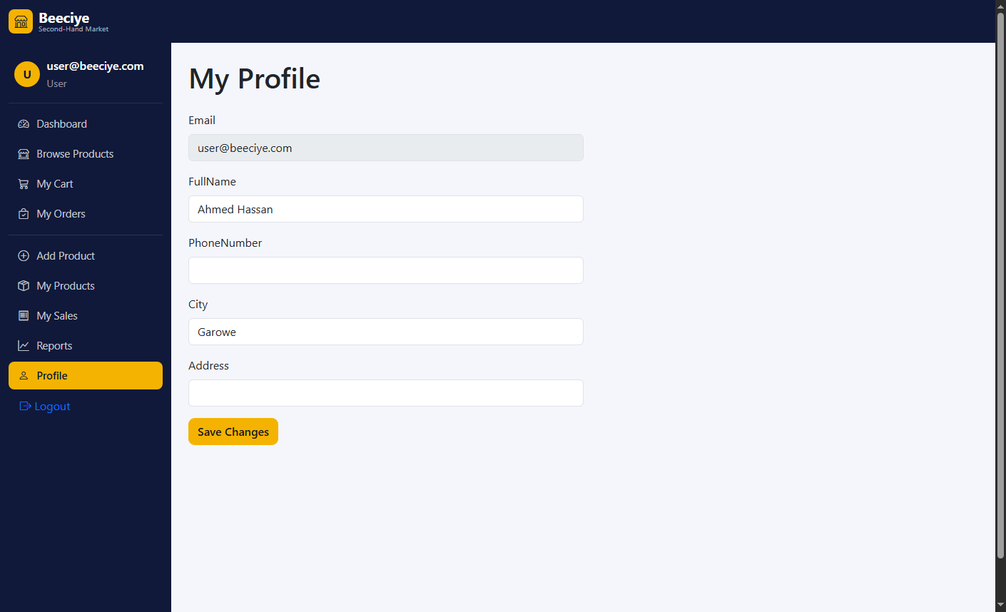
Figure 5.13: Profile Page
The profile page, shared between the public site and the dashboard, allows a user to view and update their personal information, addressing functional requirement FR10.

5.3.3 Administrator Module
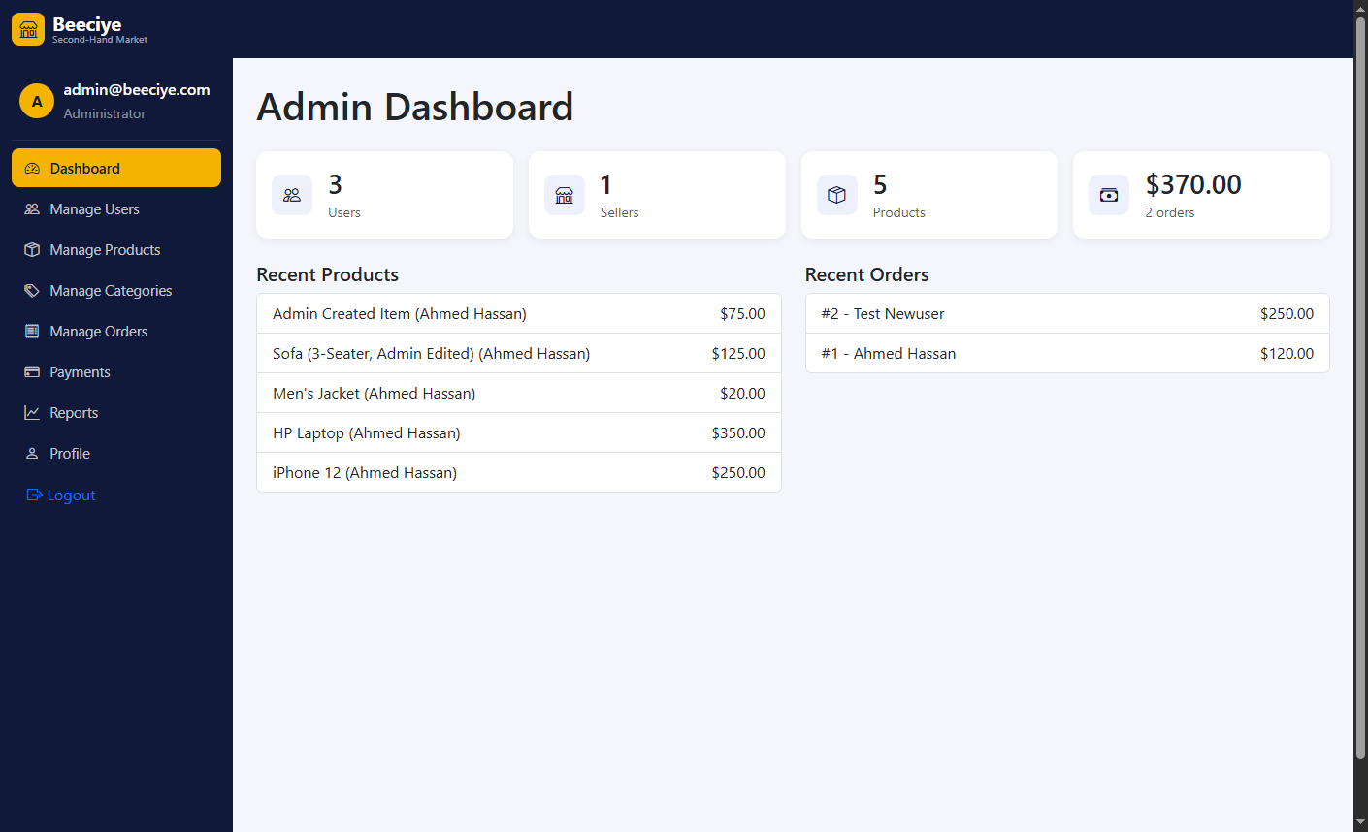
Figure 5.14: Administrator Dashboard
The Administrator dashboard presents system-wide statistics, namely total users, sellers, products and sales, together with clickable lists of recent products and recent orders that link directly to their respective management pages.
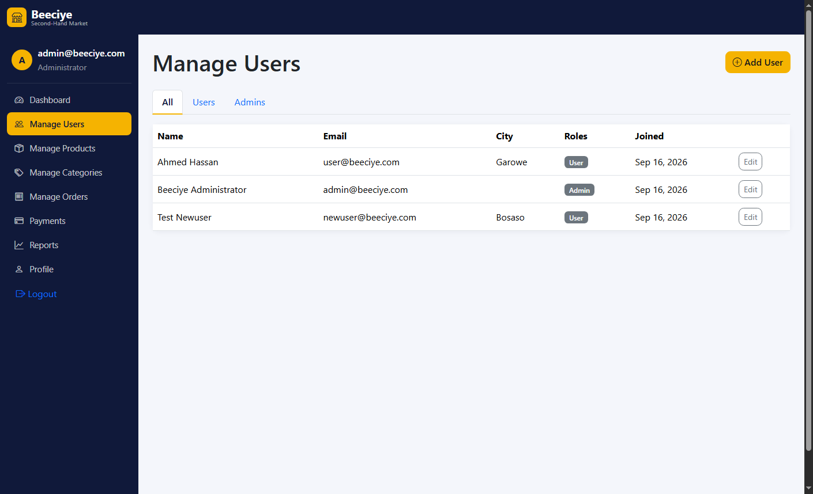
Figure 5.15: Admin – Manage Users Page
This page allows the Administrator to view, filter, create and edit every user account in the system, including the ability to grant or revoke Administrator rights, subject to the safeguard confirmed in test case TC06.
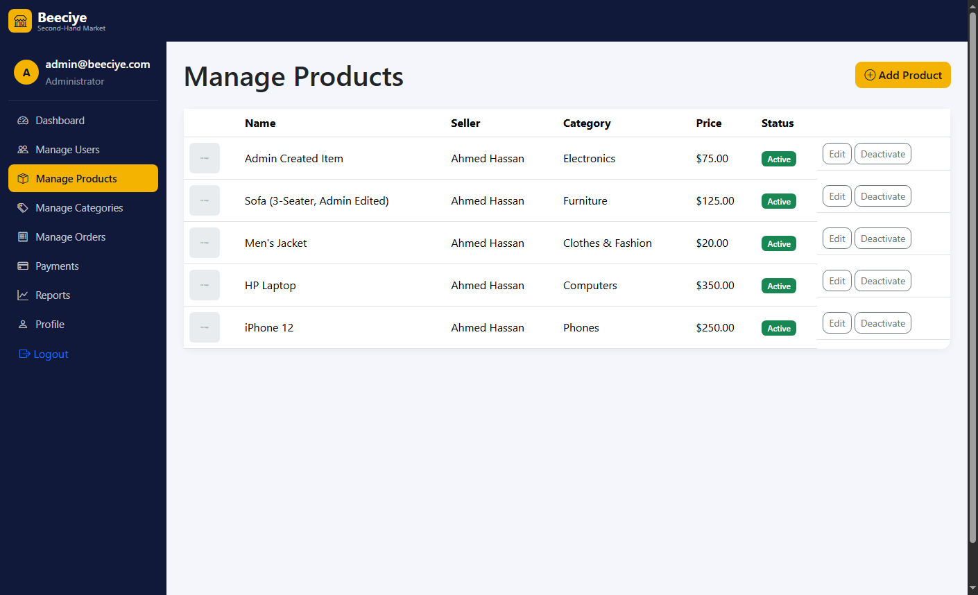
Figure 5.16: Admin – Manage Products Page
The Administrator can view, create and edit any product in the system regardless of which user originally listed it, supporting correction or moderation of listings.
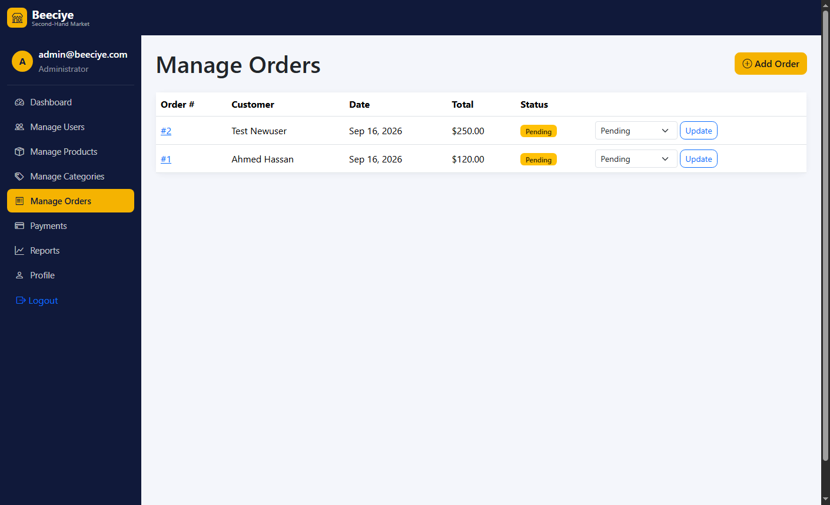
Figure 5.17: Admin – Manage Orders Page
This page lists every order placed in the system, with a link through to a detailed order view showing line items, shipping information and payment history.
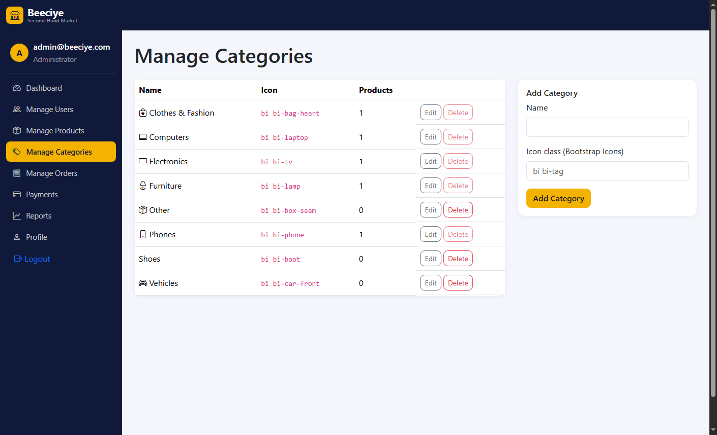
Figure 5.18: Admin – Manage Categories Page
The Administrator can add, edit and remove the product categories used throughout the browsing and listing pages.
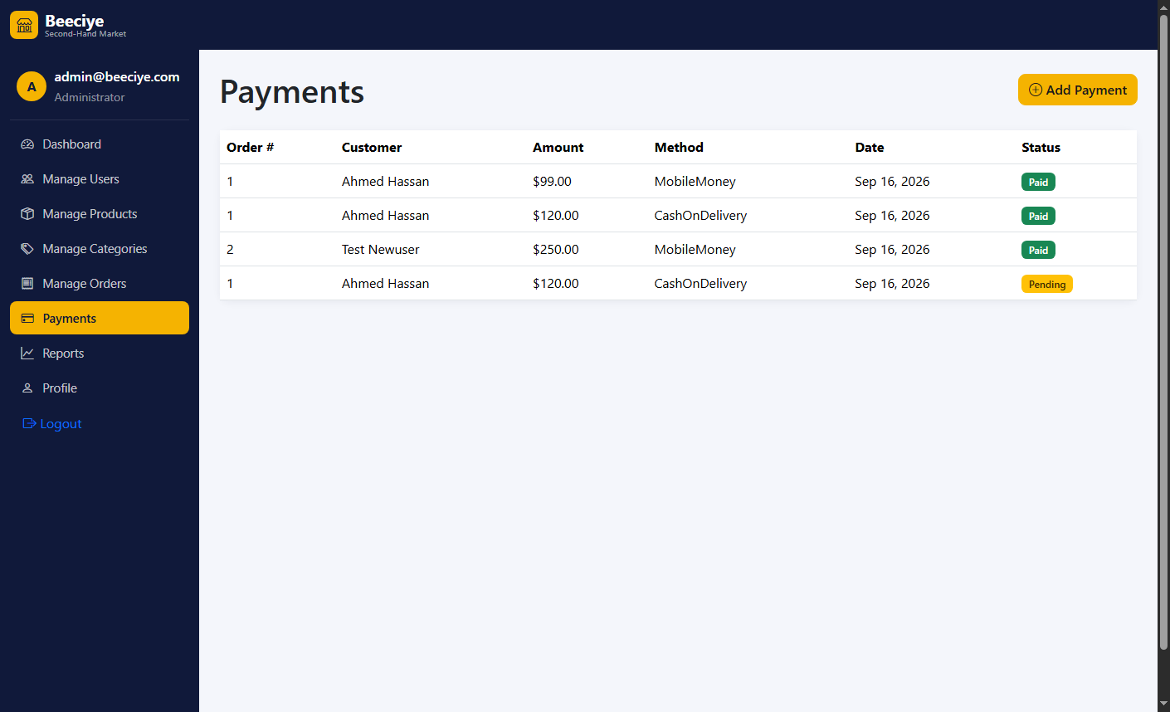
Figure 5.19: Admin – Payments Page
This page lists every payment record in the system across all orders. As shown, a single order (Order #1) has more than one associated payment record, directly demonstrating the one-to-many Order-to-Payment relationship corrected in Round 6 of development and verified in test case TC07.
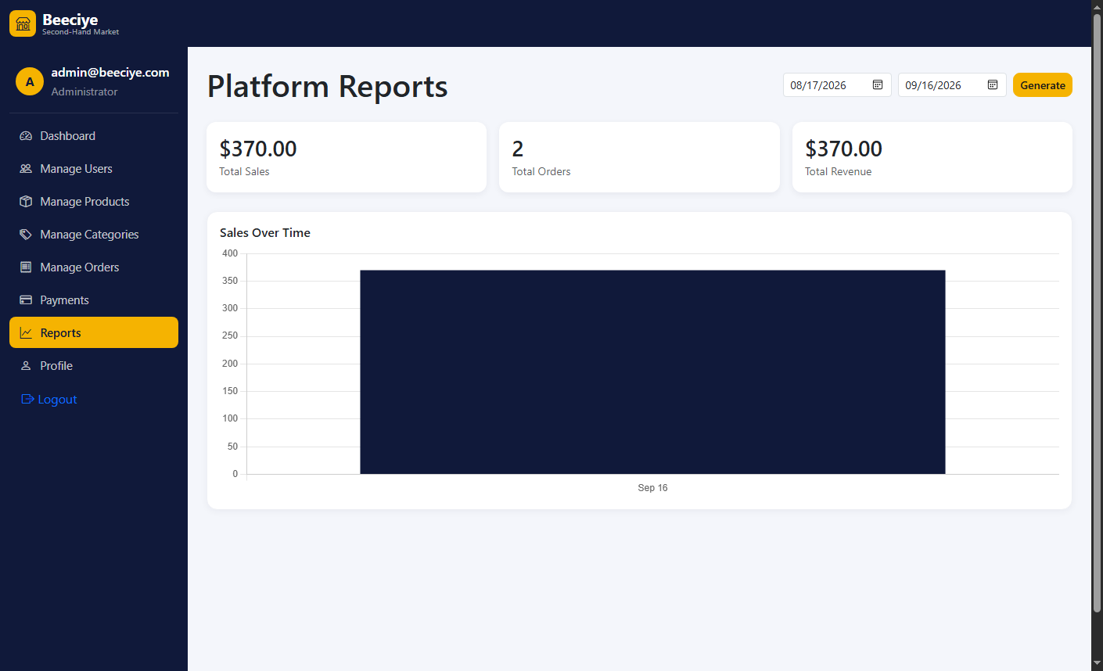
Figure 5.20: Admin – System Reports Page
The System Reports page provides the Administrator with an aggregate, platform-wide view of sales activity, complementing the individual seller-level reports shown in Figure 5.12.

5.4 Discussion of Results
Testing confirmed that all specific objectives stated in Section 1.3.2 were achieved: the database schema correctly represents users, products, orders and multiple payments per order (Figure 4.2); authentication and role-based authorisation correctly restrict administrative routes to Administrators (TC05); the complete browse-to-checkout workflow functions correctly, including stock validation (TC02, TC03, TC04); and both the seller and administrator reporting dashboards render correctly (TC08, Figures 5.12 and 5.20). Testing also surfaced a minor interface refinement opportunity that had not been previously identified: the checkout form in Figure 5.7 displays raw field names, such as “ShippingFullName”, rather than humanised labels such as “Full Name”, because explicit display labels were not set on the corresponding view model properties. This finding is carried forward as a recommendation in Chapter Six. No formal load or stress testing was performed, as the system was evaluated on a local development deployment with a small demonstration dataset rather than a production-scale environment; this is noted as a limitation of the present study.
The guest-listing, dynamic pricing, instant purchase, automatic sold-out removal, soft-delete and profile-picture features added in Rounds 8 to 11 were subsequently verified through manual end-to-end testing (TC09–TC14), each confirmed to behave as specified without regressing the previously tested checkout, reporting and administrative workflows.

CHAPTER SIX: CONCLUSION AND RECOMMENDATIONS

6.1 Conclusion
This study set out to design, develop and test Beeciye, a web-based, role-based second-hand marketplace platform intended to address the lack of a structured digital trading channel for used goods in Garowe. Through an iterative, design-based development process using ASP.NET Core 9 MVC, Entity Framework Core 9 and Microsoft SQL Server, a fully functional system was produced that supports registration, authentication, category-based browsing, a complete cart-to-checkout purchase workflow, multi-payment order tracking, and dedicated dashboards for both general users and administrators. End-to-end testing, summarised in Chapter Five, confirmed that the system meets the objectives established in Chapter One. The study concludes that a purpose-built, role-based web platform of this kind can meaningfully improve the structure, transparency and accountability of second-hand trading in a local market context, relative to the informal channels it is intended to complement or replace.

6.2 Summary of Findings
• A relational database schema was successfully designed and implemented to represent users, categories, products with multiple images, cart items, orders, order items and payments, including a corrected one-to-many Order-to-Payment relationship supporting partial payments.
• Secure authentication and role-based authorisation were successfully implemented using ASP.NET Core Identity, restricting administrative functionality to the Administrator role.
• A complete purchase workflow, comprising browsing, cart, checkout and order history, was implemented and verified to function correctly, including stock-level validation.
• Role-specific dashboards were implemented, including a seller sales report with chart-based visualisation and a comprehensive administrator dashboard covering users, products, categories, orders and payments.
• End-to-end and case-based testing confirmed correct operation of all core workflows, while also identifying a minor interface labelling issue for future correction.

6.3 Recommendations and Suggestions
• The checkout form should be updated to display humanised field labels (for example, “Full Name” rather than “ShippingFullName”) by adding explicit Display attributes to the relevant view model properties, addressing the issue identified in Section 5.4.
• A password-reset and account-recovery email flow should be implemented, as none currently exists.
• A seller rating and review mechanism should be introduced to further strengthen buyer trust, in line with the findings of Moriuchi and Takahashi (2022) and Jang and Kim (2023) regarding the importance of trust in C2C platform adoption.
• An automated unit and integration test suite (for example, using xUnit) should be introduced to complement the manual testing conducted in this study and to guard against regressions as the system evolves.
• The system should be deployed to a public hosting environment and evaluated under realistic load, since the present study was limited to a local development deployment.

6.4 Future Enhancements
• Integration with a real mobile-money payment gateway to process live transactions rather than recording payment method as a reference field only.
• Development of a dedicated mobile application or progressive web application to complement the existing browser-based interface.
• Introduction of automated content moderation for uploaded product images.
• Support for multiple languages, particularly Somali and English, within the user interface.
• Expansion of the reporting module with additional analytics, such as category-level sales trends and seller performance comparison.

6.5 References
Ahmed, F., Jha, N. K., & Faizan, M. (2024). Design and development of a localized e-commerce solution for students focussing on economical sharing. arXiv. https://arxiv.org/abs/2411.11527
Jang, Y., & Kim, S. (2023). The factors influencing users' trust in and loyalty to consumer-to-consumer secondhand marketplace platform. Behavioral Sciences, 13(3), 242. https://doi.org/10.3390/bs13030242
Microsoft. (2026a). ASP.NET Core documentation. Microsoft Learn. https://learn.microsoft.com/aspnet/core
Microsoft. (2026b). Entity Framework Core documentation. Microsoft Learn. https://learn.microsoft.com/ef/core
Moriuchi, E., & Takahashi, I. (2022). The role of perceived value, trust and engagement in the C2C online secondary marketplace. Journal of Business Research, 148, 76–88. https://doi.org/10.1016/j.jbusres.2022.04.029
Yrjölä, M., Hokkanen, H., & Saarijärvi, H. (2021). A typology of second-hand business models. Journal of Marketing Management, 37(7–8), 761–791. https://doi.org/10.1080/0267257X.2021.1880465
Zhang, S., & Meng, X. (2022). Design and implementation of intelligent second-hand platform based on big data MVC architecture and information processing. In Proceedings of the 7th International Conference on Cyber Security and Information Engineering (ICCSIE 2022). Association for Computing Machinery. https://doi.org/10.1145/3558819.3565183

APPENDIX A: SELECTED SOURCE CODE SNIPPETS
The following excerpts are drawn directly from the Beeciye source code to illustrate key implementation details discussed in Chapter Four.

A.1 Product Entity (Models/Product.cs)
public class Product
{
public int Id { get; set; }
[Required, StringLength(150)]
public string Name { get; set; } = string.Empty;
[Column(TypeName = "decimal(18,2)")]
public decimal Price { get; set; }
public int Quantity { get; set; }
public ProductCondition Condition { get; set; } = ProductCondition.Good;
public int CategoryId { get; set; }
public string SellerId { get; set; } = string.Empty;
public ICollection<ProductImage> Images { get; set; } = new List<ProductImage>();
}

A.2 Order-to-Payment Relationship (Data/ApplicationDbContext.cs)
builder.Entity<Payment>()
.HasOne(p => p.Order)
.WithMany(o => o.Payments)
.HasForeignKey(p => p.OrderId)
.OnDelete(DeleteBehavior.Cascade);

A.3 Checkout Stock Validation (Controllers/OrderController.cs)
foreach (var item in cartItems)
{
if (item.Product == null || item.Quantity > item.Product.Quantity)
{
ModelState.AddModelError(string.Empty,
$"'{item.Product?.Name}' no longer has enough stock.");
}
}

APPENDIX B: ENTITY FRAMEWORK CORE MIGRATIONS
The Beeciye database schema was evolved through the following Entity Framework Core migrations, applied in sequence:
• 20260916063051_InitialCreate – created the initial schema (users, categories, products, cart items, orders, order items, payments).
• 20260916080053_AddProductImages – added the ProductImage entity and its foreign-key relationship to Product, supporting the multi-image gallery.
• 20260917004052_AllowMultiplePaymentsPerOrder – changed the Order-to-Payment relationship from one-to-one to one-to-many, removing the unique constraint on the Payments.OrderId foreign key.

APPENDIX C: DEMONSTRATION ACCOUNTS
The following seeded accounts were used throughout development and testing to demonstrate the system's role-based behaviour. These credentials are for local demonstration purposes only and should be changed or removed before any public deployment.
Table C.1: Seeded Demonstration Accounts
Role | Email | Password
Administrator | admin@beeciye.com | Admin@123
User | Abdikafi4455@gmail.com | User@123

APPENDIX D: USER REQUIREMENTS QUESTIONNAIRE
This questionnaire was administered, in person and by telephone, to a purposive sample of thirty prospective buyers and sellers of second-hand goods in Garowe, as part of the data collection process described in Section 3.3. Participation was voluntary and responses were used for academic purposes only.
Section A: Respondent Profile
A1. What is your age group? (Under 18 / 18–25 / 26–35 / 36–45 / Above 45)
A2. What is your gender? (Male / Female)
A3. What is your current occupation?
A4. Have you previously bought or sold second-hand goods? (Yes / No)
A5. If yes, which category of goods have you bought or sold most often? (Electronics / Phones / Computers / Clothes / Shoes / Furniture / Vehicles / Other)
Section B: Current Buying and Selling Practices
B1. How do you currently find second-hand goods to buy? (Facebook groups / word of mouth / physical markets / other, please specify)
B2. How do you currently advertise goods that you want to sell?
B3. How often do you buy or sell second-hand goods? (Weekly / Monthly / Occasionally / Rarely)
B4. What challenges, if any, have you faced when buying or selling second-hand goods through informal channels?
Section C: Challenges and Platform Requirements
Please rate your agreement with each statement below, where 1 = Strongly Disagree and 5 = Strongly Agree.
Table D.1: Likert-Scale Statements
Statement | 1 | 2 | 3 | 4 | 5
C1. It is difficult to find trustworthy sellers or buyers through informal channels.
C2. I have been scammed, or nearly scammed, when buying or selling used goods informally.
C3. It is difficult to track orders and payments when buying or selling informally.
C4. Facebook groups and similar channels are not well organised for browsing by category or price.
C5. A dedicated website would make it easier to browse products by category.
C6. Being able to search and filter listings by price and condition is important to me.
C7. Secure checkout and payment tracking would increase my trust in an online platform.
C8. Clear seller and buyer contact information should be displayed on each listing.
C9. Being able to track order history and order status is important to me.
C10. The platform should be usable comfortably on a mobile phone.

Section D: Additional Comments
D1. What features, if any, would you like to see in an online second-hand marketplace for Garowe that are not covered above?
Thank you for taking the time to complete this questionnaire.

