**Allison Adams and Laith Alani**

**Final Project – Design your own website**

**(Due Date: July 29, 2020)**

**Total Points: 100**

**(Team member evaluation: 40%, Instructor Evaluation: 60%)**

**Important Notices:**

* **The file structures, coding styles, and documentation are required (the same as you did in your projects).**
* **Html and css files should pass validator tests**
* **The website will be presented and evaluated on 7/29**

In the project, you will use what you learn in this course to design a website.

You should follow the Design **Phases below to complete your website development:**

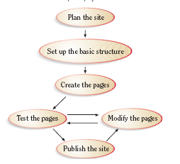

**Extra Points: 10**

**Phase 1: Plan your web site**

Answer all Questions below:

* Who is the target audience? People of all ages targeting people with eating restrictions

* How can I tailor the site to reach that audience? Make it clear that we have something for every one including KETO, Gluten Free, Paleo ect
* What are the goals for the website? The goals is to give people information about Custom Pizza Co and gain new business
* How will I gather the information? We Will gather the information by collaborating on what we want our pizza company to look like.
* What is my budget? The budget is $400
* What is the timeline? 3 weeks
* Who is on my project team? Allison Adams and Laith Alani
* How often should the site be updated? Every week
* Who will update the site? The Owner

**Create Wireframes**

You need to create at least 5 web pages based on the wireframe below

Web Page 2 and Web Page 3 should be named based on what your website is designed for.

* Design webpage layout

Your web page layout and design should be consistent throughout the site

**Requirements**:

* + Use HTML/CSS to create a “**template**” page to present the Webpage layout.
  + Create all Web Pages based on the “**template**” page.

**Phase 2: Set up the basic structures**

In your website, the following basic elements **MUST** be included:

* Contents
* Images and background images
* Menu bar (navigation bar)
* Header (Banner and/or logo)
* Footer (address and/or copyright)
* List
* Table
* Form
* audio
* <class> and <id>

The following **HTML5** **Structural Elements** should be included**. You can design a layout that matches your website’s needs.**

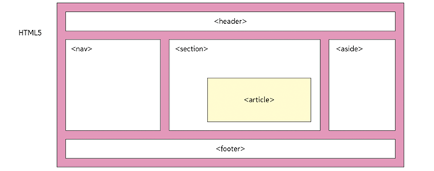

**Phase 3: Create Web Pages**

Create your website/Web Pages.

**Requirements:**

* Researching websites on internet, and see what should be included in the “**Index.html**” and “**aboutUs.html**” pages.
* Using Microsoft Word to create contents for each page.
* Preparing images and banner/logo that meet the needs of your webpage.
* Creating a template page (**template.html**)
  + Creating a **main.css** file to define CSS rules for predefined tags **<p>, <h1>, <h2>, <nav>** etc and for “**class**” and/or “**id**” defined by you.
  + Using HTML code and **main.css** to create a “**template.html**” that includes “header (logo)”, “menu bar (navigation bar)”, “section (dummy)”, and “footer” parts.
  + Creating “empty” WebPages based on the **template.html and wireframe**
  + Adding and testing hyperlinks of WebPages
* Adding required contents and elements to each webpage. If necessary, add extra external CSS files for formatting them properly

**Note:**

**Special requirements** for “**ContactUs.html**” Page (see the following figure as reference)

* Creating interface to gather visitor info in “**ContactUs.html**”. The “**First Name**”, “**Last Name**”, “**Phone Number**”, “**Emai**l”, and “**Comments**” are **required** input info.
* The pattern strings are needed to validate “**phone number**” and **email**.
* “**Please send me monthly newsletter**” is a checkbox
* Add **JavaScript** code to implement buttons “**Send**” and “**Reset**”
  1. When “Send” button is hit, a Summary page that shows “First Name”, “Last Name”, “Phone Number”, and “email” will be pup-up.
  2. When “Reset” button is hit, all input entered in current page will be cleared.

**Note: Using the following figure as a reference**.

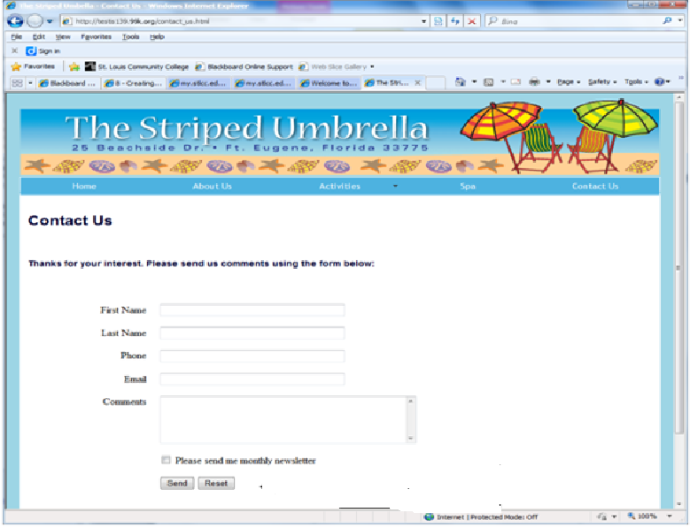

**Phase 4: Test your website in two different Browsers (Internet Explorer and Firefox or Chrome)**

**Phase 5: Modify your website and fix any bugs found during test phase.**

**Phase 6: Publish the website to internet (optional: Extra Points: 10) – It is a self-learn part. You can Google to find a web server, which can FREE publish your website, and follow the instructions described on this site to upload your files to the web server. Post your url link on the Discussion Board for 10 points.**