从零实现ffmpeg添加去雾filter

-- 摄像头采集图像，并通过web播放去雾后的视频流（一）
5. nodejs服务器端以及网页播放器的编写配置
5.1nodejs的部署与安装
sudo apt install nodejs-legacy
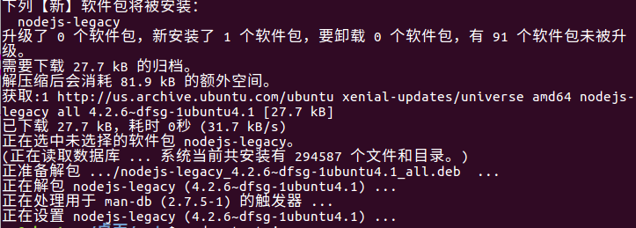
5.2 服务器端代码及网页代码
start.js
var http = require('./http/HttpServer');

http.start();

start为启动模块，启动命令为node start.js

HttpServer.js

module.exports = (function(){

"use strict";

console.time('[HttpServer][Start]');

//http协议模块

var http = require('http');

//url解析模块

var url = require('url');

//文件系统模块

var fs = require("fs");

//路径解析模块

var path = require("path");

return {

//启动服务

start:function(){

var port = this.config.port;

var ip = this.config.ip;

//创建一个服务

var httpServer = http.createServer(this.processRequest.bind(this));

//在指定的端口监听服务

httpServer.listen(port,function(){

console.log("[HttpServer][Start]","runing at http://"+ip+":"+port+"/");

console.timeEnd("[HttpServer][Start]");

});

httpServer.on("error", function(error) {

console.error(error);

});

},

/**

* 请求处理

* @param request

* @param response

*/

processRequest:function(request,response){

var hasExt = true;

var requestUrl = request.url;

var pathName = url.parse(requestUrl).pathname;

//对请求的路径进行解码，防止中文乱码

pathName = decodeURI(pathName);

//如果路径中没有扩展名

if(path.extname(pathName) === ''){

//如果不是以/结尾的，加/并作301重定向

if (pathName.charAt(pathName.length-1) != "/"){

pathName += "/";

var redirect = "http://"+request.headers.host + pathName;

response.writeHead(301, {

location:redirect

});

response.end();

}

//添加默认的访问页面,但这个页面不一定存在,后面会处理

pathName += "index.html";

hasExt = false; //标记默认页面是程序自动添加的

}

//获取资源文件的相对路径

var filePath = path.join("http/webroot",pathName);

//获取对应文件的文档类型

var contentType = this.getContentType(filePath);

//如果文件名存在

fs.exists(filePath,function(exists){

if(exists){

response.writeHead(200, {"content-type":contentType});

var stream = fs.createReadStream(filePath,{flags:"r",encoding:null});

stream.on("error", function() {

response.writeHead(500,{"content-type": "text/html"});

response.end("<h1>500 Server Error</h1>");

});

//返回文件内容

stream.pipe(response);

}else { //文件名不存在的情况

if(hasExt){

//如果这个文件不是程序自动添加的，直接返回404

response.writeHead(404, {"content-type": "text/html"});

response.end("<h1>404 Not Found</h1>");

}else {

//如果文件是程序自动添加的且不存在，则表示用户希望访问的是该目录下的文件列表

var html = "<head><meta charset='utf-8'></head>";

try{

//用户访问目录

var filedir = filePath.substring(0,filePath.lastIndexOf('\\'));

//获取用户访问路径下的文件列表

var files = fs.readdirSync(filedir);

//将访问路径下的所以文件一一列举出来，并添加超链接，以便用户进一步访问

for(var i in files){

var filename = files[i];

html += "<div><a href='"+filename+"'>"+filename+"</a></div>";

}

}catch (e){

html += "<h1>您访问的目录不存在</h1>"

}

response.writeHead(200, {"content-type": "text/html"});

response.end(html);

}

}

});

},

/**

* 获取文档的内容类型

* @param filePath

* @returns {*}

*/

getContentType:function(filePath){

var contentType = this.config.mime;

var ext = path.extname(filePath).substr(1);

if (contentType.hasOwnProperty(ext)){

return contentType[ext];

}else {

return contentType.default;

}

},

///配置信息

config:{

port:8080,

ip:'127.0.0.1',

mime:{

html:"text/html",

js:"text/javascript",

css:"text/css",

gif:"image/gif",

jpg:"image/jpeg",

png:"image/png",

ico:"image/icon",

txt:"text/plain",

json:"application/json",

default:"application/octet-stream"

}

}

}

})();

网页播放器端代码：

index.html

<!DOCTYPE html>
<html>
<head>
<script type="text/javascript" src="flowplayer.min.js"></script>
<title>RTMP Sample Player FlowPlayer</title>
</head>

<body>
<h1>RTMP Sample Player FlowPlayer</h1>

<p>Lei Xiaohua<br/>
<a href="http://blog.csdn.net/leixiaohua1020">http://blog.csdn.net/leixiaohua1020</a><br/>
leixiaohua1020@126.com</p>

<!-- this A tag is where your Flowplayer will be placed. it can be anywhere -->
<a
href="#"
style="display:block;width:520px;height:330px"
id="player">
</a>
<!-- this will install flowplayer inside previous A- tag. -->
<script>
flowplayer("player", "flowplayer-3.2.8.swf",{
clip: {
url: 'hks',
provider: 'rtmp',
live: true,
},
plugins: {
rtmp: {
url: 'flowplayer.rtmp-3.2.8.swf',
netConnectionUrl: 'rtmp://127.0.0.1/live'
}
}
});
</script>

<p>
去雾直播流rtmp工程
</p>

</body>
</html>

5.3 去雾流效果图
