The Green Revolution

When the car first arrived on the market, 2 types of automobile were fighting for control

of public distribution. They were the fuel cell model, which was slower, but ran longer, was

more reliable and less volatile, and the gas model, which was faster, but consumed gas at an

astronomical rate, then exhaled noxious fumes directly onto the streets. Since this type of car

was bigger, more powerful and had more potential for income through oil and banking intrests,

big players such as GM stifled the production of the fuel cell car by propagandizing the people

against these designs and cutting supply lines needed to build the cells. Now, the CIA forbids

the production of alternatively fueled vehicles and continues to jail people who use this

technology. However, magnetism is being researched, utilized and used to produce higher

technology in other countries. <http://outraged.chattablogs.com/archives/064371.html>

ARTIFICIAL PHOTOSYNTHESIS

A detergent (tween-20) is introduced to a variety of naturally occurring chemical compounds

such as Nicotinamide-adenine-dinucleotide-phosphate-hydride (NADPH), Adenocine-

triphosphate (ATP), and various other proteins. One such protein has been christened

ranaspumin 2 which has been derived from the foam produced naturally by Engystomops

Postulosis which is a type of frog that uses this device to build its nests. Upon studying this

foam, researchers discovered that it was receptive to photons, transforming and releasing its

constitution through various chemical reactions. It does this using a rather simplistic ATP

complex featuring Polymervesikeln, which is a more stable version of the common cell

membrane. This complex builds two proteins. Bacteriorhodopsin pumps light into the second

protein along with phosphate and ADP to from ATP. The ATP catalyzes the reaction between

carbon dioxide and ribulose to substrate ribulose biphosphate carboxylate. The final product is

glucose. (1) This chemical system provides ten times the output of chlorophyll based

photosynthesis. It is also cheaper. The process may be genetically introduced into any plant

today to produce ways of tapping more sunlight, producing more biofuels and generating more

electricity. (2)

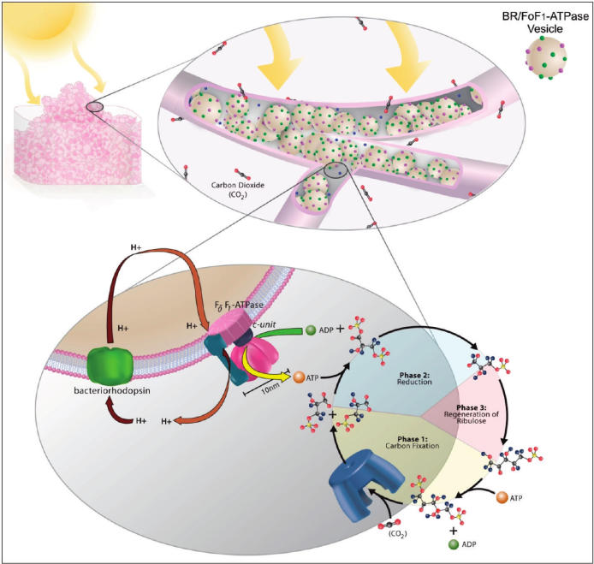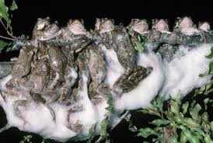

Polymervesikeln reaction sequence, E. Postulosis colony in nest.

NANOPORES

Silicon or carbon atoms are arranged into wells at the atomic scale. This is meant to be better

than the cell at facilitating the production of certain chemicals. The pores are specified to

certain conditions depending on the ­­materials they are supposed to manipulate. Dendrils on

the pores attract certain enzymes that line up inside the nanopores. They are made to do this in

the right orientation so that substrate may be metabolized and products may be released. Since

they are mechanically forced to fit inside the pore due to the magnetic action of the dendriles

and the stability of the pore walls, enzymes may renature and function in environments

otherwise impractical for their mechinations. This allows researchers to build artificial

environments that enable the enzymes to line up inside the pore and produce product at

extreme speed. The pores do not metabolize, so they use no energy. The structure of the pores

themselves allow for the production of enzymes and products. This allows for a drastic

decrease in energy consumption since they need not maintain this artificial cell. The pores can

be built and tweaked to cater to different aspects enzyme and product production, naturation,

and speed. The pores allow for both forward and reverse reactions in density that would

otherwise be toxic to a normal cell. This concept will enhance the invention, production, and

delivery of drugs and poisons for larger machines like animals or microbes.

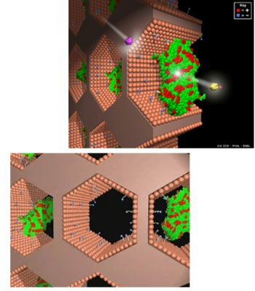 Nano carbon silica pores orienting enzymes for product production. Pnnl.org (3).

Type: “Enzyme Immobilization:

Nanobiotechnology: Putting Molecular Machines to Work” into youtube.com.

QUANTUM COMPUTING

Light enters a circuit where it changes the output signals of transistors. This signal

comes in the form of qubits, which are bits of information super positioned onto itself and

other signals to create a more dynamic operating sequence. This computer does not need as

much material to produce signals. It can be made the size of a vacuum tube and still be

comparable to a standard desktop computer. Also, its ability to compute in more dynamic ways

allows it to function with faulty hardware and software better than a normal computer with the

same hinderances. The multiphase transistor is now a single atom that has the ability to switch

poles in order to receive and emit information. Most other components on this computer can

be expressed as single atoms under the influence of other atoms in a dynamical quantum

system.(5) These arrangements allow this computer to be extremely small, light, fast powerful and

convenient. It is powered by an olivine capacitor that reacts lithium in order to deliver photons

to transmit information throughout the computing cell.(4) The quantum computer does not

overheat and needs 1/100,000 the energy of a normal computer to function in optimal

conditions. A nano computer tower can be worth at least 10 million dollars. They can deliver

billions of times the computing power of digital computers their size.(6)

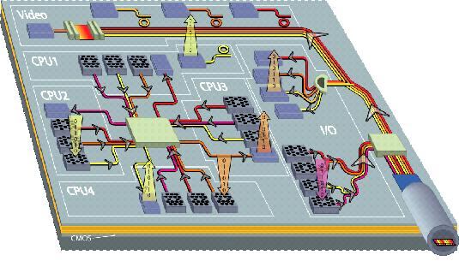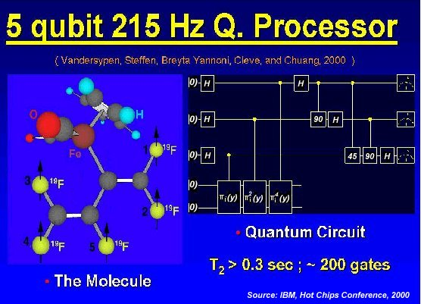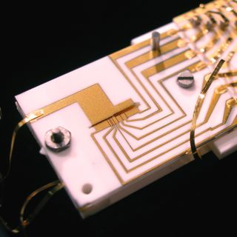

An optical nanochip, a quantum circuit, and an integrated nanoprocessor. Note that not all

features described are featured in all nanocomputers.

OLIVINE ULTRACAPACITOR

The lack of progress in terms of battery technology has allowed the Chinese to invest

heavily in this field. They have done this by devising a battery with compact, but porous

electrodes that can quickly charge and discharge great amounts of power. It does this with

readily available, nontoxic materials and can last much longer than the more expensive lithium

ion battery.(7) Also, the olivine battery is superior to the lithium ion battery because it has a

low volatility. It will not secrete acid or explode if placed in fire. The olivine battery is a

prototype for the ultracapacitor, which uses even less materials and does not even rely on

chemical reactions to discharge more energy faster and more often.(8) The olivine

ultracapaictor features an olivine lattice anode, which is arranged as 2 metal atoms bonded to a

nonmetal atom bonded to 4 oxygen atoms (M2nO4) immersed in a dense electron repulsive

electrolyte, and a graphite carbon lattice cathode immersed in dense attractive electrolyte.(7)

These two individual capacitors are separated by a bioelectric polymer membrane. The highly

reversible process is made possible by the polarization of an electrolytic solution store and

release energy electrostatically, which allows the battery to be efficient and powerful enough

to power a tank.(9)

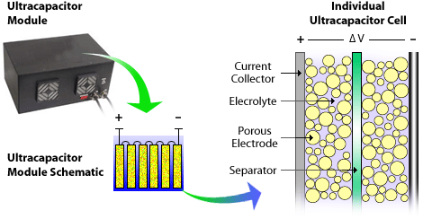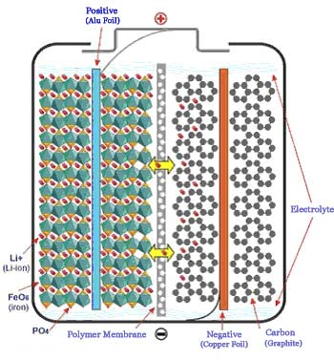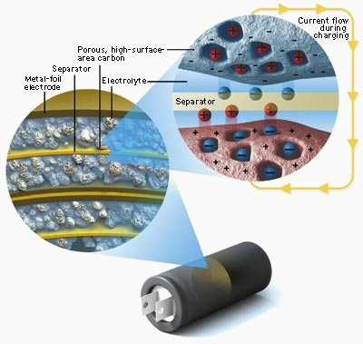

Links to pics 7,8, and 9 in annotations below.

MAGNETIC GEAR

By allowing magnetism to supply the power otherwise provided by other means, a

company called Magnomatics has produced a gear that can also be used as a generator, a rotor,

an engine and many other devices needed to run a drivetrain. It does this using both

permanent and electromagnetic rings, rods and tori. The outer shell encases a set of electrical

oval coils that amplify the magnetic potential of the inner components. The static outer

magnetic shell drives and inner shell that is disrupted by a set of permanent magnetic rods in

order to increase its efficiency. The only moving component of the magnet is responsible for

turning the axel in order to run the drivetrain system. This machine has the capacity for

extreme torque at high speed. It needs no maintenance or lubrication, the motor will never

wear down. It is the strongest, most reliable motor, engine, generator, gear known to man.(9)

This motor uses less than half the energy and material required to run a drivetrain system and

can be calibrated without actually handling the inner components of the device, unlike a

mechanical gear that supplies no energy otherwise. Best used for tanks and naval ships.(10)

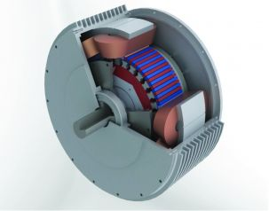

Magnomatics pseudo direct drive.

Magnetic gearing enables compact electric propulsion motors. (9)

EVACUATED TUBE TRANSPORT

The conventional way to travel is by plane. The plane uses explosive power to run loud,

powerful but extremely vulnerable turbines that drag the plane through the air high above the

ground. There are many problems with this system. No matter how safe we try to make it, we

are still launching a projectile into the air. The air causes drag, which is a waste of energy. All

failures in the air are catastrophic and lead to disasters where the plane either crashes in the

middle of nowhere, or in very crowded areas causing several casualties. This allows the plane to

be easily sabotaged. At the same time, the train in relatively quiet and does not use as much

energy to propel it forward. Current technologies allow the train to become the authority of

transport. A new type of train called the maglev train needs no engine. It is surrounded by a

tunnel that features rails of electromagnets that repel the holsters so that the train can be

propelled forward. This allows millions of passengers worldwide to travel 4000 miles an hour on

the energy it takes to run all the appliances of a 1/25 of a jumbo jet for one hour. At this speed,

the internet will be a real physical thing, where a man can travel halfway across the world to his

home apartment in less than one hour. When the train docks in port, the magnets keep it in

place so that it does not move. It moves to attach itself to a small tunnel so that passengers

may board the system. The doors shut on both the end of the tunnel and the train. The

passenger may not enter the actual tunnel because it is an airless vacuum that disallows drag

and terrorist activities on the train. (If the seals are compromised, everybody dies. Spacesuits

would be rather obvious.) The rails repel the train to the center of the tunnel and the magnets

push the train to up to 4000 miles per hour. The air in the train ensures that the passengers do

not feel the effects of a moving train or differences in air pressure. Many trains can move

through the tunnel system with ease allowing great numbers of passengers from all over the

world. A new unified language system may have to be invented. No humans in the tunnel

means the tunnel stays completely clean. Since the entire system is automated, a ticket will be

no more that the scan of a credit card and infared and ultraviolet optical scanning may occur at

any time. A security office will ensure that all people who enter the train are registered. The

train system will be underground and completely quiet. The train can be built as large as

necessary since it is not being dragged through air, but skated through a vacuum. Also, in case

the train enters the surface or an aerated environment, the train may come with optional

ground effect fins and turbines to fly above the ground without touching it. Such technology

will produce a global force for good greater than the efforts of all armies, walls and politicians

in the world. This bridge will allowed unprecedented trade and communication that will allow

global influence for many countries. It is the greatest effort we can muster in the name of world

peace. In this way, it is the internet of the real world. At this velocity, the train may be shot

through a ramp into space, but without the actual ramp going into space.

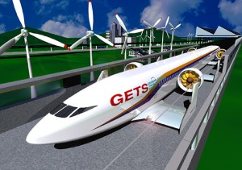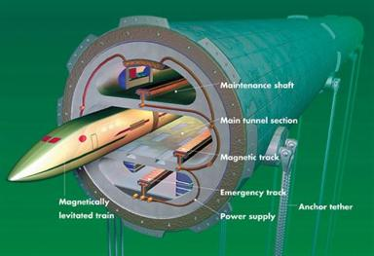

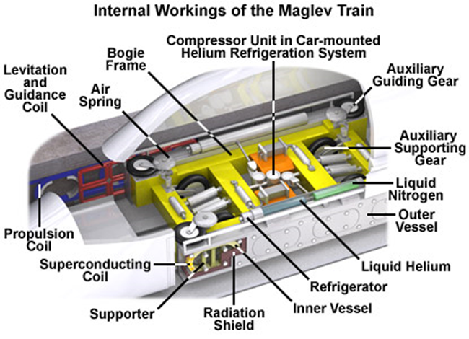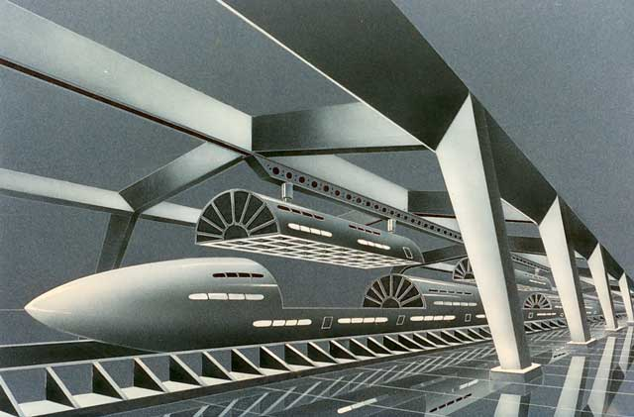

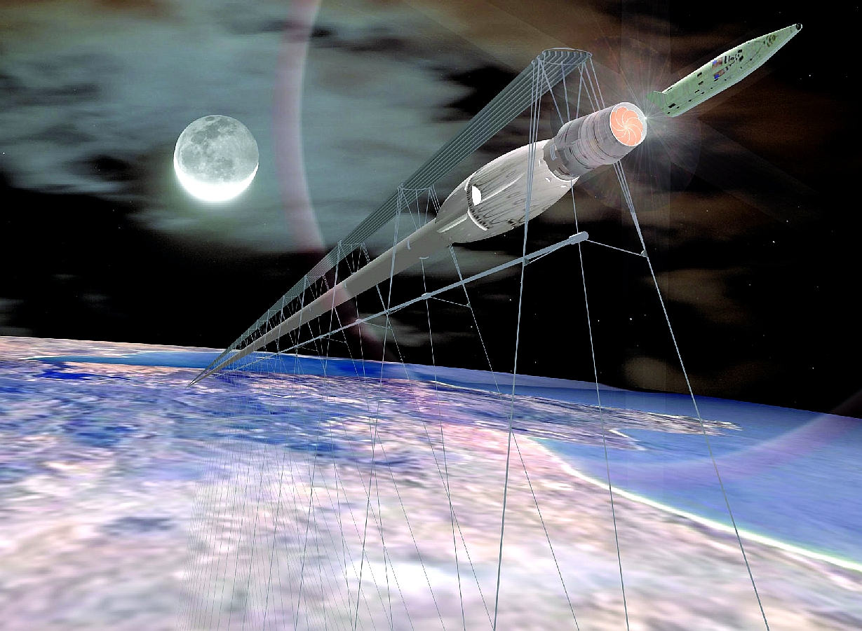

Links to pics 15, 16, 17, 18, and 19 in annotations below.

ANNOTATIONS

1. Mathematical Forums

<http://www.mathematik-forum.de/forum/showthread.php?p=2684699120>

1. zurück | weiter blättern Künstliche Photosynthese mit Frosch-Schaumvon. Lars Fischer, 17. März 2010, 14:57<http://www.wissenslogs.de/wblogs/blog/fischblog/biochemie-und-molekularbiologie/2010-03-17/k-nstliche-photosynthese-mit-frosch-schaum>

(1 and 2 translated from german.)

1. Pnnl.org.
2. John Matson Small-Scale Quantum Processor Gets Its Act Together: Researchers

demonstrate reliability and information transport in a quantum device, but scaling up will be a challenge. August 6, 2009. <http://www.scientificamerican.com/article.cfm?id=quantum-computer-nist>

1. Elizabeth Connor. Qubits and The Number 42: 12th Annual Hot Chips Conference in Palo Alto. 1:03 PM - September 1, 2000. <http://www.tomshardware.com/reviews/qubits-number-42,239.html>
2. Three different types of the ultracapacitor. The NREL ultracapacitor

(<http://www.nrel.gov/vehiclesandfuels/energystorage/ultracapacitors.html>),

1. the Chinese olivine prototype (<http://www.pedaily.cn/Item/194151.aspx>),

and the MIT battery

1. (<http://www.ultracapacitors.org/index.php?option=com_content&Itemid=77&id=106&task=view>), respectively. Also, see Ecotech: Future Fuels on youtube.
2. Magnomatics.com.
3. <http://www.maritimejournal.com/features101/vessel-build-and-maintenance/power-and-propulsion/magnetic-gearing-enables-compact-electric-propulsion-motors>. Also, watch
4. <http://www.youtube.com/watch?v=PyBTE5cjGDY> and
5. <http://www.youtube.com/watch?v=ludLU4_6ZDM&feature=related> and
6. <http://www.youtube.com/watch?v=QD6tpiAtCPw&feature=related>.
7. <http://3.bp.blogspot.com/vxBJFRMLUfE/TeQ7E6WyWRI/AAAAAAAALng/egv7vbgHBTM/s1600/Startramgeneration2.jpg>
8. <http://www.forcedgreen.com/2009/09/zero-emission-aero-train/>.
9. <http://www.et3.com>.
10. <http://rj3sp.blogspot.com/2008/07/trans-atlantic-maglev-magnetically.html>
11. <http://www.ecotrainphuket.org/research.html>

All pics listed in the order of the paper and are cited. Some have no formal description.