DATA SCIENCE ANALYSIS OF INFINITESSIMALS
Methods for analyzing the most absolute forms of data.
Armani Willis 10.4.3.17

A. It is known that previous statistical methods for analysing streams of data center about each data
point and attempt to draw shapes of degrees of linearity out of its clustered form.

However, a very simple notion to have that is heavily dismissed in statistics is that often in nature, when several things are cluttered together, the different objects must be sorted into positions, locations,
and categories in order to make more sense.

So in the case where an entire building has been demolished for instance, it would be better to use
bigger machines to haul away scraps made of similar materials (plastic, wood fiber, steel...), rather than
to have people sort through each individual rubble particle (or parameter).

For this reason, I have rewritten the current statistical equations for determining the ABSOLUTE TREND of a sorted data set, this method will make finding trends in any sort of statistical data much
easier, and it may also serve usefulness in statistical forensics and congruency.

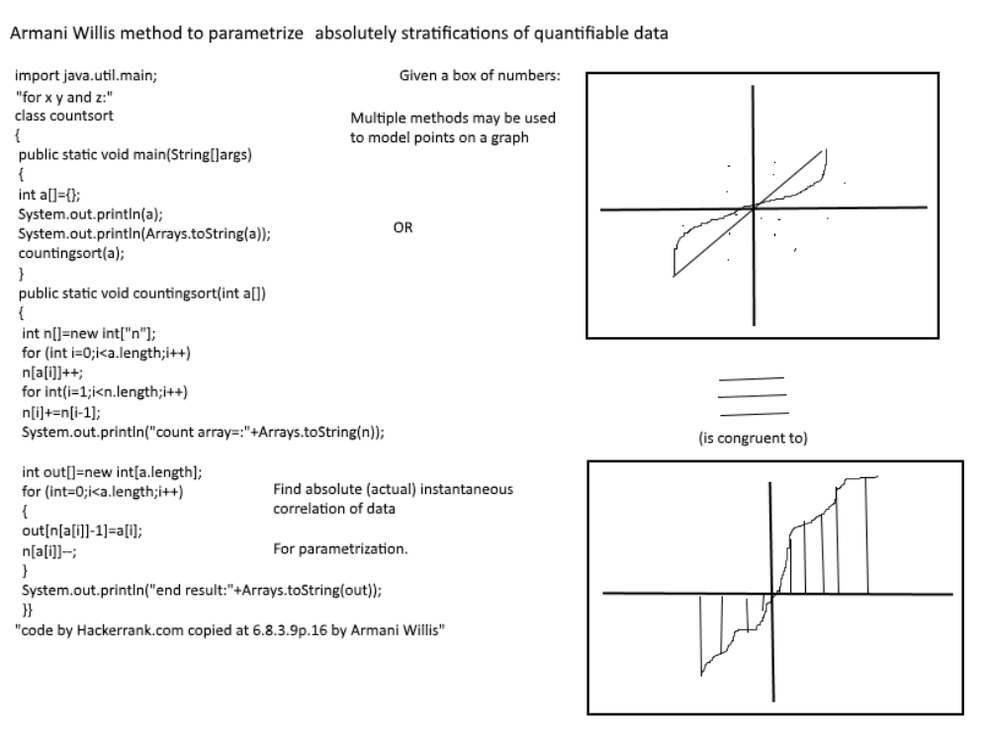
B. The Given Data must first be sorted into a new 3d plane before modern statistical observations can
take place.

- A mathematical model of the data must then be drawn by finding the parametric average of the given data set: for k: F(t)=kSf(b-a)(n)dt, k(n)/n=(Sfdf)/(Sydt).
This equation depends on the differences between f and y in the differential equation.

- Basic statistical operations can now be performed on this differentiated data curve:
- Quadratic Loss:E(xi-c)^2=E(x)E(c)(xi-c)^2=S[(x-c)^2]d(c,x).

Absolute Loss: first take the limit of E|xi-c| to get lim(c->oo)lim(x->oo)E(c)E(x)|x-c|dxidci
to get S|x-c|d(x,c).

Binary Loss: S(I(x=c))d(x,c).

Mean Absolute Deviation: first sets all values positive. Then determines the difference from the sum of
each point. [S|x-c|d(x,c)]/n.

Mean Squared Deviation: Sets all values to + by squaring, then sums the difference between each point
and the variable c. [S((x-c)^2)d(x,c)]/n.

E. Equations like those used to find the sum of squares require a more intuitive preparation before they can be performed. In order for trucks to come in and sort the data, the trucks must be built and then
operated first.

The sum of squares: [S(x-m(x))^2]/n+1, where m(x)=[E(xi)]/i, lim(E)=Sfdx/L(f)

to find the arc length of the improvised curve: L=S(1+(f')^2)^(1/2)d{}, thus sum E(s)=
[[Sx-(Sfdx)/(Srad(1+f'f')dx) *dx]^2]/n-1.

And the equation for the standard deviation of f would be [E(s)]^(1/2).

F. A categorical observation: Notice that the Sx-((Sfdx)/Srad(1+f'f')dx)dx can be simplified to produce

3 * (x^2) - [(f^(-2)) / [(1+f'f')*(rad(1+(f'f'))(f'''+(13/5)(f''f''))]].

k Sxdx SSfdxdx expanded double integral for arc length.

The whole idea of doing statistical operations in this way, is to prepare the data for better categorical
visualization as a curve rather than as a cluster. To a sufficiently realised operator of integrands, the categorized shape of any cluster of data should be clear in your mind in accordance to this equation.
If a professional really wanted to identify the form of the curve really was, she must first learn that: the form of the function really depends on the different slopes of the function, and E(xi-m(x))^2~Sxdx+c;

If p was a proportion of n, and m=np, E(xi-m(x))^2=m(1-(m/n)), where n=L(x)=S(1+(f'^2))^(1/2)dx,
and m (not m(x), which is the mean) =%L(x), this pL(x)(1-%)~Sxdx, np(1-p).

G. The sum of squares by group: E(i,j)(xi-m(x))^2 = S(xx-xm(x)+(m(x))^2)d(i,j)

=[S(x-m(xj)^2) + kS((m(xj)+ m(x))^2)]d(ji): Again converting from solid to liquid,
Within different groups, between different groups of data,
Notice that after the data is sorted in step 1, the clustering may be different in the new configuration.
Variants of points in a space: finding the centroid, or center of mass: of a sorted data set:

given any point p in a space, for a space with 4 axes: S[(p-m(w))^2 + (p-m(x))^2 + (p-m(y))^2 +p-m(z))^2]d(wxyz), or in short: S[(p-m(d))^2]d(i=4).

The sum of cross products: f(x,y)=E(x-c(x))(y-c(y))=SN(p(i)-c(p(i)))di, where N is the geometric sum of a function.

For (i=2), Sxy-xc(y)-yc(x)-c(xy)d(x,y), df/dc(x)=-Sy(n(c)+1)dy, 0=-Df.

Covariance: [SN(pi-m(pi)di]/(n-1)

Correlation: [S(pi-m(p)di]/[S((pi-m(p))^2)di]^(1/2)

Minimization (of Covariance): given that R is the covariance of points on a flat sheet:

E[c(x-m(x))-(y-m(y))]^2 = (c^2)E[(x-m(x))^2]-2c, E(y-m(y))(x-m(x))+E(y-m(y))^2, t(y)=0,

R'(c)=2xE[(x-m(x))^2]-2E[(y-m(y))(x-m(x))=0. cS[(x-m(x))^2]dx=S(y-m(y))(x-m(x))d(x,y).

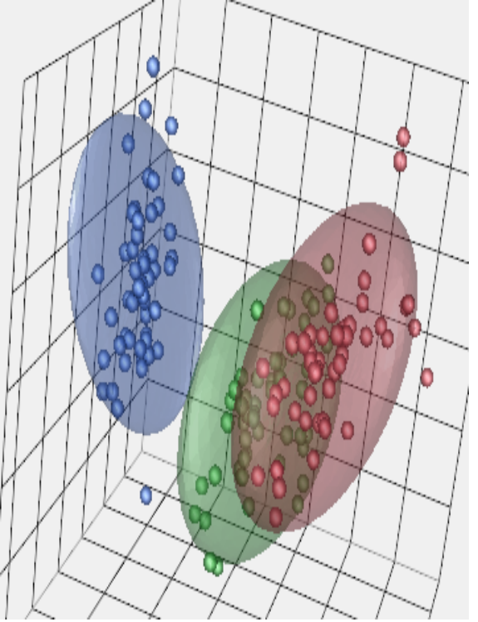
-c^2 = S[(y-m(y))^2]dy, c=S(x-m(x))dx/S(y-m(y))dy. [SN(p-m(p))di]^2/[NS(p-m(p))di]^2=<1.
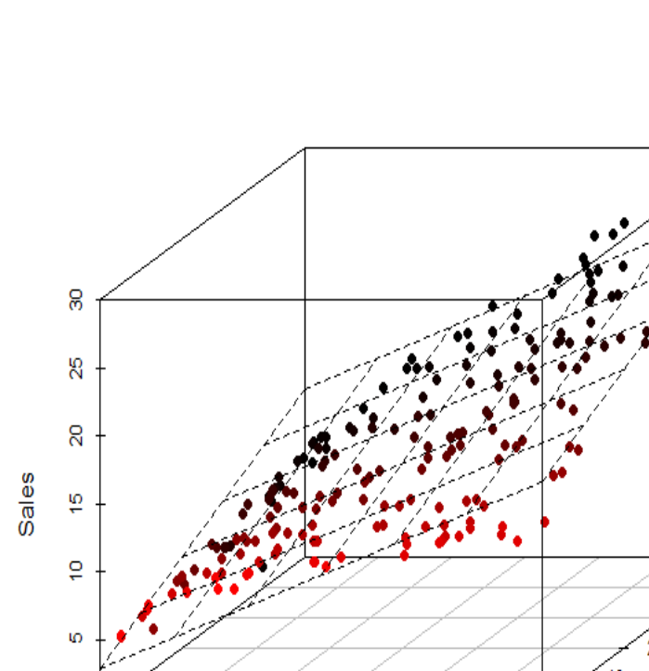
Clustered Data Set => Sorted Data Set

