Protocol for the Examination of Specimens From Patients With Hepatocellular Carcinoma
Version: Hepatocellular 4.0.0.0 | Protocol Posting Date: June 2017

Includes pTNM requirements from the 8th Edition, AJCC Staging Manual

For accreditation purposes, this protocol should be used for the following procedures AND tumor types:
Procedure | Description
Resection | Includes specimens designated hepatic resection, partial or complete
Tumor Type | Description
Carcinoma | Hepatocellular carcinoma and fibrolamellar carcinoma

This protocol is NOT required for accreditation purposes for the following:
Procedure
Biopsy
Primary resection specimen with no residual cancer (eg, following presurgical therapy)
Cytologic specimens

The following tumor types should NOT be reported using this protocol:
Tumor Type
Poorly differentiated neuroendocrine carcinoma (consider the Intrahepatic Bile Ducts protocol)
Well-differentiated neuroendocrine tumor
Hepatoblastoma (consider the Hepatoblastoma protocol)
Lymphoma (consider the Hodgkin or non-Hodgkin Lymphoma protocols)
Sarcoma (consider the Soft Tissue protocol)

Authors
Sanjay Kakar, MD*; Chanjuan Shi, MD, PhD*; Patrick L. Fitzgibbons, MD; Wendy L. Frankel, MD; Alyssa M. Krasinskas, MD; Mari Mino-Kenudson, MD; Timothy Pawlik,, MD, MPH, PhD; Jean-Nicolas Vauthey, MD; Mary K. Washington, MD, PhD

With guidance from the CAP Cancer and CAP Pathology Electronic Reporting Committees.
* Denotes primary author. All other contributing authors are listed alphabetically.

Accreditation Requirements
This protocol can be utilized for a variety of procedures and tumor types for clinical care purposes. For accreditation purposes, only the definitive primary cancer resection specimen is required to have the core and conditional data elements reported in a synoptic format.
- Core data elements are required in reports to adequately describe appropriate malignancies. For accreditation purposes, essential data elements must be reported in all instances, even if the response is “not applicable” or “cannot be determined.”
- Conditional data elements are only required to be reported if applicable as delineated in the protocol. For instance, the total number of lymph nodes examined must be reported, but only if nodes are present in the specimen.
- Optional data elements are identified with “+” and although not required for CAP accreditation purposes, may be considered for reporting as determined by local practice standards.
The use of this protocol is not required for recurrent tumors or for metastatic tumors that are resected at a different time than the primary tumor. Use of this protocol is also not required for pathology reviews performed at a second institution (ie, secondary consultation, second opinion, or review of outside case at second institution).

Synoptic Reporting
All core and conditionally required data elements outlined on the surgical case summary from this cancer protocol must be displayed in synoptic report format. Synoptic format is defined as:
- Data element: followed by its answer (response), outline format without the paired "Data element: Response" format is NOT considered synoptic.
- The data element must be represented in the report as it is listed in the case summary. The response for any data element may be modified from those listed in the case summary, including “Cannot be determined” if appropriate.
- Each diagnostic parameter pair (Data element: Response) is listed on a separate line or in a tabular format to achieve visual separation. The following exceptions are allowed to be listed on one line:
  - Anatomic site or specimen, laterality, and procedure
  - Pathologic Stage Classification (pTNM) elements
  - Negative margins, as long as all negative margins are specifically enumerated where applicable
- The synoptic portion of the report can appear in the diagnosis section of the pathology report, at the end of the report or in a separate section, but all Data element: Responses must be listed together in one location
Organizations and pathologists may choose to list the required elements in any order, use additional methods in order to enhance or achieve visual separation, or add optional items within the synoptic report. The report may have required elements in a summary format elsewhere in the report IN ADDITION TO but not as replacement for the synoptic report i.e. all required elements must be in the synoptic portion of the report in the format defined above.

CAP Laboratory Accreditation Program Protocol Required Use Date: March 2018*

* Beginning January 1, 2018, the 8th edition AJCC Staging Manual should be used for reporting pTNM.

CAP Hepatocellular Protocol Summary of Changes

The following data elements were modified:
Pathologic Stage Classification (pTNM, AJCC 8th Edition)
Tumor Focality
Histologic Type
Histologic Grade
Tumor Extension
Lymph-Vascular Invasion
Microscopic Invasion
Perineural Invasion
Additional Pathological Findings

The following data elements were added:
Tumor Characteristics
Satellitosis

The following data element was deleted:
Tumor Size
Clinical History

Surgical Pathology Cancer Case Summary

Protocol posting date: June 2017

Hepatocellular Carcinoma:

Select a single response unless otherwise indicated.

Procedure (select all that apply) (Note A)
___ Wedge resection
___ Partial hepatectomy
+ ___ Major hepatectomy (3 segments or more)
+ ___ Minor hepatectomy (less than 3 segments)
___ Total hepatectomy
___ Other (specify): ____________________________
___ Not specified

Tumor Characteristics (Note B)

Tumor Focality
___ Solitary
___ Multiple

For multiple tumors, repeat the following 4 elements (Tumor Site, Tumor Size, Treatment Effect, and Satellitosis) for up to 5 largest tumor nodules

Tumor Site
___ Right lobe
___ Left lobe
___ Caudate lobe
___ Quadrate lobe
___ Segmental location (specify): ____________________________
___ Other (specify): ____________________________

Tumor Size
Greatest dimension of viable tumor (centimeters): ___ cm
+ Additional dimensions (centimeters): ___ x ___ cm
+ Greatest dimension of tumor on gross exam (centimeters): ___ cm

Treatment Effect
___ No known presurgical therapy
___ Complete necrosis (no viable tumor)
___ Incomplete necrosis (viable tumor present)
+ Percentage tumor necrosis: ____%
___ No necrosis
___ Cannot be determined (explain): _____________________________

+ Satellitosis
+ ___ Not identified
+ ___ Present
+ ___ Cannot be determined

Histologic Type (Note C)
___ Hepatocellular carcinoma
___ Fibrolamellar carcinoma
___ Other histologic type not listed (specify): ___________________________
___ Carcinoma, type cannot be determined

Histologic Grade (Note D)

Note: For multiple tumors, select the worst grade.
___ G1: Well differentiated
___ G2: Moderately differentiated
___ G3: Poorly differentiated
___ G4: Undifferentiated
___ Other (specify): ____________________________
___ GX: Cannot be assessed
___ Not applicable

Tumor Extension (select all that apply)
___ No evidence of primary tumor
___ Tumor confined to liver
___ Tumor involves a major branch of the portal vein
___ Tumor involves hepatic vein(s)
___ Tumor involves (perforates) visceral peritoneum
___ Tumor directly invades gallbladder
___ Tumor directly invades diaphragm
___ Tumor directly invades other adjacent organs (specify):_______________________
___ Cannot be assessed

Margins (Note E)

Parenchymal Margin
___ Cannot be assessed
___ Uninvolved by invasive carcinoma
Distance of invasive carcinoma from margin (millimeters or centimeters): ___ mm or ___ cm
___ Involved by invasive carcinoma
___ Not applicable

Other Margin (required only if applicable)
Specify margin: ____________________________
___ Cannot be assessed
___ Uninvolved by invasive carcinoma
___ Involved by invasive carcinoma

Vascular Invasion (Note F)
___ Not identified
___ Present
+ ___ Small vessel invasion
+ ___ Large vessel invasion (major branch of hepatic vein or portal vein)
+ Specify tumor nodule(s) (if applicable): _______________________
___ Cannot be determined

+ Perineural Invasion
+ ___ Not identified
+ ___ Present
+ Specify tumor nodule(s) (if applicable): _______________________
+ ___ Cannot be determined

Regional Lymph Nodes

___ No lymph nodes submitted or found

Lymph Node Examination (required only if lymph nodes are present in the specimen)

Number of Lymph Nodes Involved: ____
___ Number cannot be determined (explain): ______________________

Number of Lymph Nodes Examined: ____
___ Number cannot be determined (explain): ______________________

Pathologic Stage Classification (pTNM, AJCC 8th Edition) (Note G)
Note: Reporting of pT, pN, and (when applicable) pM categories is based on information available to the pathologist at the time the report is issued. Only the applicable T, N, or M category is required for reporting; their definitions need not be included in the report. The categories (with modifiers when applicable) can be listed on 1 line or more than 1 line.

TNM Descriptors (required only if applicable) (select all that apply)
___ m (multiple primary tumors)
___ r (recurrent)
___ y (posttreatment)

Primary Tumor (pT)
___ pTX: Primary tumor cannot be assessed
___ pT0: No evidence of primary tumor
___ pT1: Solitary tumor <2 cm, or >2 cm without vascular invasion
___ pT1a: Solitary tumor ≤2 cm
___ pT1b: Solitary tumor >2 cm without vascular invasion
___ pT2: Solitary tumor >2 cm with vascular invasion, or multiple tumors, none >5 cm
___ pT3: Multiple tumors, at least one of which is >5 cm
___ pT4: Single tumor or multiple tumors of any size involving a major branch of the portal vein or hepatic vein, or tumor(s) with direct invasion of adjacent organs other than the gallbladder or with perforation of visceral peritoneum

Regional Lymph Nodes (pN)
___ pNX: Regional lymph nodes cannot be assessed
___ pN0: No regional lymph node metastasis
___ pN1: Regional lymph node metastasis

Distant Metastasis (pM) (required only if confirmed pathologically in this case)
___ pM1: Distant metastasis
+ Specify site(s), if known: ____________________________

+ Additional Pathologic Findings (select all that apply) (Note H)
+ ___ None identified
+ ___ Fibrosis (specify extent, providing name of the scheme and assessment scale used): ________________
+ ___ Cirrhosis
+ ___ Low-grade dysplastic nodule
+ ___ High-grade dysplastic nodule
+ ___ Steatosis
+ ___ Steatohepatitis
+ ___ Iron overload
+ ___ Chronic hepatitis (specify etiology): ____________________________
+ ___ Other (specify): ____________________________

+ Ancillary Studies
+ Specify: ___________________________________

+ Comment(s)

Explanatory Notes

A. Application
This protocol applies only to hepatic resection specimens containing hepatocellular carcinoma including fibrolamellar carcinoma. Carcinomas of the intrahepatic bile ducts (cholangiocarcinomas) are staged using a separate TNM system.¹ This scheme is also not used for combined HCC-cholangiocarcinoma, sarcomas, and metastatic tumors.

Tumor Characteristics: Location, Focality, Histologic Sampling, Response to Therapy
The segmental anatomy of the liver is shown in Figure 1. Although these divisions are useful for anatomic localization of tumors, it is often not possible to assign segmental location on resection specimens, and such information is best provided by the surgeon. Tumor location can be recorded as right or left lobe, and more specific information about the segmental location can be included if provided.

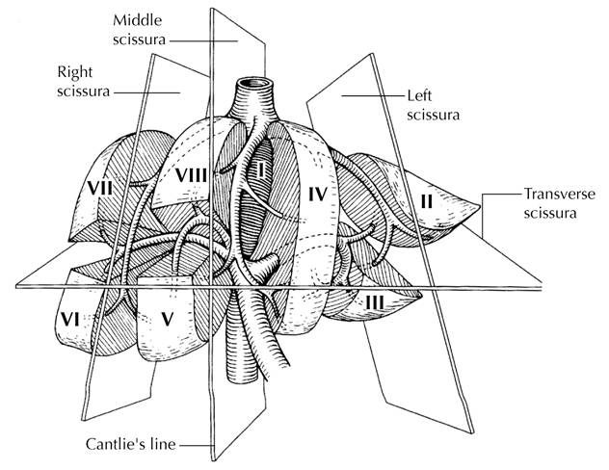
Figure 1. Segmental anatomy of the liver. From Greene et al.²⁹ Used with permission of the American Joint Committee on Cancer (AJCC), Chicago, Illinois. The original source for this material is the AJCC Cancer Staging Atlas (2006) published by Springer Science and Business Media LLC, www.springerlink.com.

Sections should be prepared from each major tumor nodule, with representative sampling of smaller nodules. For multiple tumors, size and pathologic parameters can be provided for the five largest tumors, while size range and location can be provided for the rest. If there are differences in tumor characteristics such as differentiation, satellitosis, lymphovascular invasion, margin status, etc, in individual tumor nodules, this can be recorded using optional features in the synoptic. Further details about any differences in tumor nodules can be added as a separate comment, if necessary. Cirrhotic nodules appreciably larger than the surrounding background liver should also be sampled, because such nodules may harbor dysplastic changes.² For purposes of staging, satellite nodules, multifocal primary hepatocellular carcinomas, and intrahepatic metastases are considered to be multiple tumors.

For tumors treated with radiofrequency ablation or transarterial chemo-embolization, the extent of necrosis on pathologic evaluation can provide valuable for correlation with down-staging observed on imaging.³ The extent of necrosis that would correlate with outcome is not known.⁴ Hence there are no definite guidelines for pathologic assessment of the specimen and how to assess the extent of necrosis. The entire tumor should be examined microscopically, when possible, especially for tumors up to 2 cm. For larger tumors, an additional section for each 1 cm is recommended, with additional sampling as necessary from the periphery of the tumor or areas that appear viable. The overall extent of necrosis is determined by a combination of gross and microscopic findings, and should be reported in up to 5 of the largest tumour nodules.⁵ Both gross size and size of viable tumor for each focus (up to 5) can be provided, and only size of viable tumor should be used for staging.

The United Network for Organ Sharing (UNOS) requires reporting of satellite HCC lesions in explanted livers. There is no universally accepted definition for satellitosis, and different criteria have been used in different studies. The definition suggested by International Collaboration on Cancer Reporting (ICCR) is recommended: HCC nodule smaller than the primary tumor, within 2 cm of the primary tumor, but separated by nontumor tissue. Tumor within a vascular structure should be categorized as lymphatic/vascular invasion and not as satellitosis.

C. Histologic Type
The protocol recommends the following modified classification of the World Health Organization (WHO).⁶ In the United States, almost 70% of the primary malignant tumors of the liver are hepatocellular carcinomas.

WHO Classification of Carcinomas of the Liver
Hepatocellular carcinoma
Fibrolamellar carcinoma
Undifferentiated carcinoma

Fibrolamellar carcinoma has distinct morphologic features, and occurs predominantly in young adults. CK7 and CD68 are positive in nearly all fibrolamellar carcinomas but are not specific as a subset of classical HCC can be positive for these markers.⁷ Earlier studies reported a relatively favorable outcome of fibrolamellar carcinoma compared to HCC,⁸ but several recent studies have shown that the outcome is similar to classical HCC in noncirrhtoic liver. ⁹⁻¹¹ Recently, a ~400 bp deletion on chromosome 19 has been described in fibrolamellar carcinoma, which leads to fusion of DNAJB1 and PRKACA genes, and a novel DNAJB1-PRKACA fusion transcript.¹² This can be detected by reverse transcription polymerase chain reaction (RT-PCR) or fluorescence in situ hybridization (FISH) break-apart probes.¹³ This alteration is seen in 80% to 100% of FLM cases and has not been reported in classical HCC. For cases showing borderline features of fibrolamellar carcinoma, the diagnosis can be confirmed by 1 of these molecular techniques. Scirrhous and sarcomatoid HCC are separately listed in the AJCC 8th edition but are considered histologic variants of HCC and not as distinct entities in the WHO 2010 classification.

D. Histologic Grade

Grading of Hepatocellular Carcinoma
A variety of grading systems including Edmondson and Steiner¹⁴ and WHO 2010 scheme⁶ have been advocated. The former is based on nuclear features, while the latter is based on differentiation. AJCC Cancer Staging Manual, 8th edition¹ advocates a 4-tier grading scheme:

G1: Well-differentiated
G2: Moderately differentiated
G3: Poorly differentiated
G4: Undifferentiated

Well-differentiated tumors closely resemble normal liver and have minimal to mild cytologic atypia, limited reticulin loss and relatively thin cell plates. Moderately differentiated HCC show thick cell plates with mild to moderate nuclear atypia and more prominent loss of reticulin. Poorly differentiated tumors show marked nuclear atypia and/or high mitotic activity; the hepatocellular nature in some of these tumors may not be clearly evident on morphology. Undifferentiated category is rarely used and is reserved for tumors that do not show obvious hepatocellular or other differentiation on morphology or immunohistochemistry. It is more appropriate to categorize these as undifferentiated carcinomas rather than a subgroup of HCC. This protocol does not preclude the use of other grading systems. The grading system used should be specified.

Histologic grade has been shown to have a relationship to tumor size, tumor presentation, and metastatic rate.¹⁵ Grade has been shown to be an independent predictor of outcome in many studies.^{16,17}

E. Margins
The evaluation of margins for total or partial hepatectomy specimens depends on the method and extent of resection. It is recommended that the surgeon be consulted to determine the critical foci within the margins that require microscopic evaluation. The transection margin of a partial hepatectomy may be large, rendering it impractical for complete examination. In this setting, grossly positive margins should be microscopically confirmed and documented. If the margins are grossly free of tumor, judicious sampling of the cut surface in the region closest to the nearest identified tumor nodule is indicated. In selected cases, adequate random sampling of the cut surface may be sufficient. If the neoplasm is found near the surgical margin, the distance from the margin should be reported. For multiple tumors, the distance from the nearest tumor should be reported. Tumor within 1 mm of the resection margin may have increased risk of recurrence,^{18,19} but several studies have reported that a minimal surgical margin in the liver is sufficient for HCC. ²⁰

F. Venous and Small Vessel Invasion
Vascular invasion includes gross as well as microscopic invasion of vessels. Macroscopic venous invasion is generally accompanied by microscopic invasion.²¹ Both are associated with lower survival post resection. Larger tumors (greater than 5 cm) or multiple tumors are more likely to exhibit vascular invasion than single small lesions.²² The presence of a portal vein tumor thrombus should be included in the report due to its adverse impact on outcome.¹

Microscopic vascular invasion is defined by tumor within a vascular space lined by endothelium, identified only on microscopy in the capsule or noncapsular fibrous septa, or liver tissue surrounding the tumor.²³ Attachment of the tumor to vessel wall or presence of smooth muscle/elastic lamina (for larger vessels) helps in confirming vascular invasion. Elastic stain or immunohistochemistry for smooth muscle can be helpful in challenging situations, but their routine use is not advocated. The outcome may be worse with increasing number of foci with lymph-vascular invasion (LVI), but further subclassification based on extent of LVI is not supported by current data.²⁴

G. Pathologic Stage Classification
The TNM staging system of the American Joint Committee on Cancer (AJCC) and the International Union Against Cancer (UICC) applies to hepatocellular carcinomas.¹ It does not apply to hepatic sarcomas or to metastatic tumors of the liver. The T classification depends on the number of tumor nodules, the size of the largest nodule, and the presence or absence of blood vessel invasion. The TNM classification does not discriminate between multiple independent primary tumors or intrahepatic metastasis from a single primary hepatic carcinoma. Vascular invasion includes either the gross or the histologic involvement of vessels. Portal vein invasion is an important adverse prognostic factor and should be reported.

According to AJCC/UICC convention, the designation “T” refers to a primary tumor that has not been previously treated. The symbol “p” refers to the pathologic classification of the TNM, as opposed to the clinical classification, and is based on gross and microscopic examination. pT entails a resection of the primary tumor or biopsy adequate to evaluate the highest pT category, pN entails removal of nodes adequate to validate lymph node metastasis, and pM implies microscopic examination of distant lesions. Clinical classification (cTNM) is usually carried out by the referring physician before treatment during initial evaluation of the patient or when pathologic classification is not possible.

Pathologic staging is usually performed after surgical resection of the primary tumor. Pathologic staging depends on pathologic documentation of the anatomic extent of disease, whether or not the primary tumor has been completely removed. If a biopsied tumor is not resected for any reason (eg, when technically infeasible) and if the highest T and N categories or the M1 category of the tumor can be confirmed microscopically, the criteria for pathologic classification and staging have been satisfied without total removal of the primary cancer.

The T categories for HCC are based on tumor size, number and vascular invasion.²⁵ Since some studies showed lack of adverse prognostic impact of vascular invasion in tumors less than 2 cm, these tumors have been classified under the T1 category.²⁶ For treated tumors, the size of the viable tumor used for assigning the T category. Tumors with major vascular invasion are now categorized as T4 as they have a similar outcome compared to T4 tumors defined by extrahepatic or peritoneal involvement. Major vascular invasion is defined by involvement of branches of main portal vein (right or left, excluding sectoral and segmental branches), hepatic veins (right, middle or left) or main branches of hepatic artery (right or left).¹ Involvement of falciform or other ligaments is not considered T4, and should be categorized as T1-T3 based on other parameters. Direct invasion into diaphragm is considered as T4.

TNM Descriptors
For identification of special cases of TNM or pTNM classifications, the “m” suffix and “y,” “r,” and “a” prefixes are used. Although they do not affect the stage grouping, they indicate cases needing separate analysis.

The “m” suffix indicates the presence of multiple primary tumors in a single site and is recorded in parentheses: pT(m)NM.

The “y” prefix indicates those cases in which classification is performed during or after initial multimodality therapy (ie, neoadjuvant chemotherapy, radiation therapy, or both chemotherapy and radiation therapy). The cTNM or pTNM category is identified by a “y” prefix. The ycTNM or ypTNM categorizes the extent of tumor actually present at the time of that examination. The “y” categorization is not an estimate of tumor before multimodality therapy (ie, before initiation of neoadjuvant therapy).

The “r” prefix indicates a recurrent tumor when staged after a documented disease-free interval and is identified by the “r” prefix: rTNM.

The “a” prefix designates the stage determined at autopsy: aTNM.

T Category Considerations

T categories are illustrated in Figures 2 through 5.

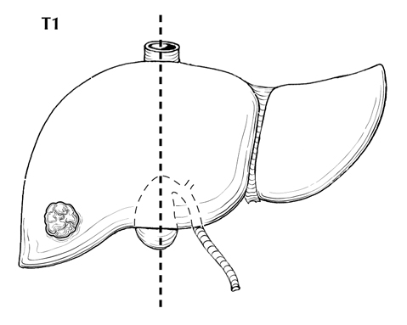
Figure 2. T1 is defined as a solitary tumor ≤2 cm irrespective of vascular invasion or >2 cm without vascular invasion. From Greene et al.²⁹ Used with permission of the American Joint Committee on Cancer (AJCC), Chicago, Illinois. The original source for this material is the AJCC Cancer Staging Atlas (2006) published by Springer Science and Business Media LLC, www.springerlink.com.

A. B.
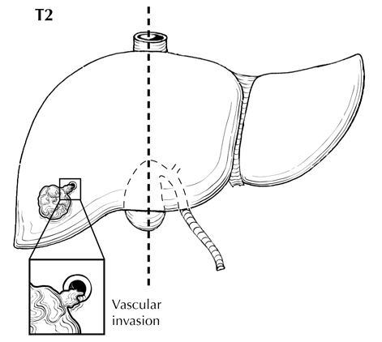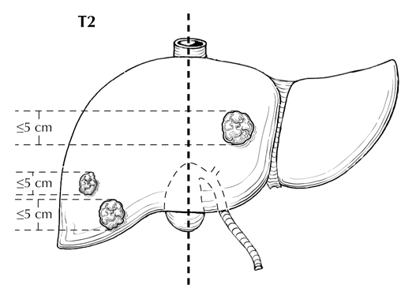
Figure 3. A. Solitary tumors >2 cm with vascular invasion are classified as T2. B. Multiple tumors, none measuring 5 cm or greater in greatest dimension, are also classified as T2. From Greene et al.²⁹ Used with permission of the American Joint Committee on Cancer (AJCC), Chicago, Illinois. The original source for this material is the AJCC Cancer Staging Atlas (2006) published by Springer Science and Business Media LLC, www.springerlink.com.

A. B.
T4
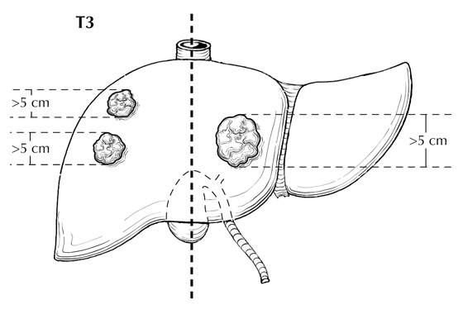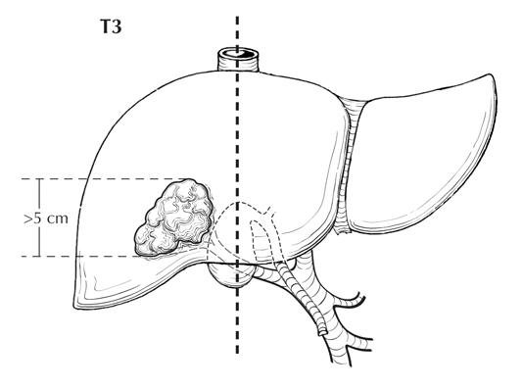
Figure 4. A. Multiple tumors, any more than 5 cm, are classified as T3. B. Tumor involving a major branch of the portal or hepatic vein(s) is classified as T4. From Greene et al.²⁹ Used with permission of the American Joint Committee on Cancer (AJCC), Chicago, Illinois. The original source for this material is the AJCC Cancer Staging Atlas (2006) published by Springer Science and Business Media LLC, www.springerlink.com.

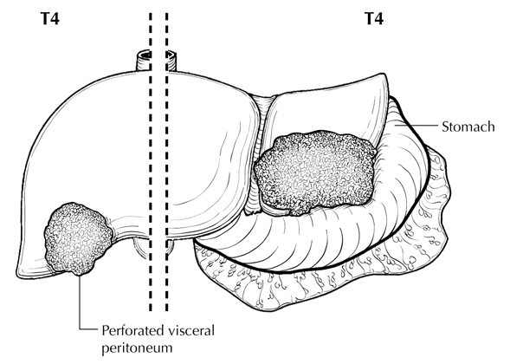
Figure 5. Tumor with direct invasion of adjacent organs other than gallbladder or with perforation of the visceral peritoneum is also classified as T4. From Greene et al.²⁹ Used with permission of the American Joint Committee on Cancer (AJCC), Chicago, Illinois. The original source for this material is the AJCC Cancer Staging Atlas (2006) published by Springer Science and Business Media LLC, www.springerlink.com.

Stage Groupings
Stage IA T1a N0 M0
Stage IB T1b N0 M0
Stage II T2 N0 M0
Stage IIIA T3 N0 M0
Stage IIIB T4 N0 M0
Stage IVA any T N1 M0
Stage IVB any T any N M1

Lymph Nodes
The regional lymph nodes for the liver include hilar, hepatoduodenal ligament, inferior phrenic, caval, common hepatic artery and portal vein lymph nodes.

H. Additional Pathologic Findings

Fibrosis
The extent of fibrosis should be reported because cirrhosis or advanced fibrosis have an adverse effect on outcome.²⁷ The scoring system described by Ishak²⁸ is recommended by the AJCC Cancer Staging Manual, 8th edition,¹ but other commonly used schemes (Batts-Ludwig, Metavir) can be used. The name of the staging scheme and its scale should be included.

Dysplastic Nodules
High-grade dysplastic nodules are considered to be the precursors of hepatocellular carcinoma. The criteria outlined by the International Working Party are recommended,² although difficulties in assessment of these lesions and variation in interobserver agreement are recognized. Low-grade dysplastic nodules are difficult or impossible to distinguish from large regenerative nodules, and their inclusion in the report is not necessary.

Hepatocellular Adenomas
In noncirrhotic liver, hepatocellular carcinoma may arise in hepatocellular adenoma. In this setting, the size of the heptocellular adenoma and the hepatocellular carcinoma should both be conveyed in the report. Only the hepatocellular carcinoma size is used for staging purposes. Subtyping of hepatocellular adenoma can be considered but is not required.

Underlying Liver Disease
Specific types of underlying disease, such as viral hepatitis or hemochromatosis, should be evaluated and assigned a grade and stage, if appropriate.

References
1. Amin MB, Edge SB, Greene FL, et al, eds. AJCC Cancer Staging Manual. 8th ed. New York, NY: Springer; 2017.
2. International Working Party. Terminology of nodular hepatocellular lesions. Hepatology. 1995;22:983-993.
3. Yao FY, Kerlan RK Jr, Hirose R, et al. Excellent outcome following down-staging of hepatocellular carcinoma prior to liver transplantation: an intention-to-treat analysis. Hepatology. 2008;48(3):819-827.
4. Cotoi CG, Khorsandi SE, Plesea IE, Quaglia A. Histological aspects of post-TACE hepatocellular carcinoma. Rom J Morphol Embryol. 2012;53(3 Suppl):677-682.
5. Pomfret EA, Washburn K, Wald C, et al. Report of a national conference on liver allocation in patients with hepatocellular carcinoma in the United States. Liver Transpl. 2010;16(3):262-278.
6. Bosman FT, Carneiro F, Hruban RH, Theise ND, eds. WHO Classification of Tumours of the Digestive System. Geneva, Switzerland: WHO Press; 2010.
7. Ross HM, Daniel HD, Vivekanandan P, et al. Fibrolamellar carcinomas are positive for CD68. Mod Pathol. 2011;24(3):390-395.
8. Stipa F, Yoon SS, Liau KH, et al. Outcome of patients with fibrolamellar hepatocellular carcinoma. Cancer. 2006;106(6):1331-1338.
9. Kakar S, Burgart LJ, Batts KP, Garcia J, Jain D, Ferrell LD. Clinicopathologic features and survival in fibrolamellar carcinoma: comparison with conventional hepatocellular carcinoma with and without cirrhosis. Mod Pathol. 2005;18(11):1417-1423.
10. Njei B, Konjeti VR, Ditah I. Prognosis of Patients With Fibrolamellar Hepatocellular Carcinoma Versus Conventional Hepatocellular Carcinoma: A Systematic Review and Meta-analysis. Gastrointest Cancer Res. 2014;7(2):49-54.
11. Mayo SC, Mavros MN, Nathan H, et al. Treatment and prognosis of patients with fibrolamellar hepatocellular carcinoma: a national perspective. J Am Coll Surg. 2014;218(2):196-205.
12. Honeyman JN, Simon EP, Robine N, et al. Detection of a recurrent DNAJB1-PRKACA chimeric transcript in fibrolamellar hepatocellular carcinoma. Science. 2014;343(6174):1010-1014.
13. Graham RP, Jin L, Knutson DL, et al. DNAJB1-PRKACA is specific for fibrolamellar carcinoma. Mod Pathol. 2015;28(6):822-9.
14. Edmonson HA, Steiner PE. Primary carcinoma of the liver. Cancer. 1954;7:462-503.
15. Lauwers GY, Terris B, Balis UJ, et al. Prognostic histologic indicators of curatively resected hepatocellular carcinomas: a multi-institutional analysis of 425 patients with definition of a histologic prognostic index. Am J Surg Pathol. 2002;26:23-34.
16. Spolverato G, Kim Y, Alexandrescu S, et al. Is hepatic resection for large or multifocal intrahepatic cholangiocarcinoma justified?: results from a multi-institutional collaboration. Ann Surg Oncol. 2015;22(7):2218-2225.
17. Hyder O, Marques H, Pulitano C, et al. A nomogram to predict long-term survival after resection for intrahepatic cholangiocarcinoma: an Eastern and Western experience. JAMA Surg. 2014;149(5):432-438.
18. Gluer AM, Cocco N, Laurence JM, et al. Systematic review of actual 10-year survival following resection for hepatocellular carcinoma. HPB (Oxford). 2012;14(5):285-290.
19. Kumar AM, Fredman ET, Coppa C, El-Gazzaz G, Aucejo FN, Abdel-Wahab M. Patterns of cancer recurrence in localized resected hepatocellular carcinoma. Hepatobiliary Pancreat Dis Int. 2015;14(3):269-275.
20. Shindoh J, Hasegawa K, Inoue Y, et al. Risk factors of post-operative recurrence and adequate surgical approach to improve long-term outcomes of hepatocellular carcinoma. HPB (Oxford). 2013;15(1):31-39.
21. Tsai T-J, Chau G-Y, Lui W-Y, et al. Clinical significance of microscopic tumor venous invasion in patients with resectable hepatocellular carcinoma. Surgery. 2000;127:603-608.
22. Pawlik TM, Delman KA, Vauthey J-N, et al. Tumor size predicts vascular invasion and histologic grade: implications for expanding the criteria for hepatic transplantation. Liver Transpl. 2005;11(9):1086-1092.
23. Fan L, Mac MT, Frishberg DP, et al. Interobserver and intraobserver variability in evaluating vascular invasion in hepatocellular carcinoma. J Gastroenterol Hepatol. 2010;25(9):1556-1561.
24. Iguchi T, Shirabe K, Aishima S, et al. New pathologic stratification of microvascular invasion in hepatocellular carcinoma: predicting prognosis after living-donor liver transplantation. Transplantation. 2015;99(6):1236-1242.
25. Vauthey JN, Lauwers GY, Esnaola NF, et al. Simplified staging for hepatocellular carcinoma. J Clin Oncol. 2002;20(6):1527-1536.
26. Shindoh J, Andreou A, Aloia TA, et al. Microvascular invasion does not predict long-term survival in hepatocellular carcinoma up to 2 cm: reappraisal of the staging system for solitary tumors. Ann Surg Oncol. 2013;20(4):1223-1229.
27. Bilmoria MM, Lauwers GY, Doherty DA, et al. Underlying liver disease, not tumor factors, predicts long-term survival after resection of hepatocellular carcinoma. Arch Surg. 2001;136:528-535.
28. Ishak K, Baptista A, Bianchi L, et al. Histologic grading and staging of chronic hepatitis. J Hepatol. 1995;22:696-699.
29. Greene FL, Compton, CC, Fritz AG, et al, eds. AJCC Cancer Staging Atlas. New York: Springer; 2006.

