1. Tuliskan pseudocode dari program berikut:

Input: “melamar posisi software architect di MST”

Output: “MST di architect software posisi melamar”

JAWABAN:

|  |
| --- |
| string sentence = ‘melamar posisi software architect di MST’;  array words = split(sentence, ‘ ’);  int range = words.length;  string swap;  int mid;    if (words.length % 2 == 0 ) then:  mid = range / 2;  else:  mid = (range + 1) / 2;    for (int i=0;i++;i<=mid):  swap = words[i];  words[i] = words[range - i];  words[range - i] = words[swap];    return words.join(' '); |

1. Tuliskan query untuk soal berikut:  
   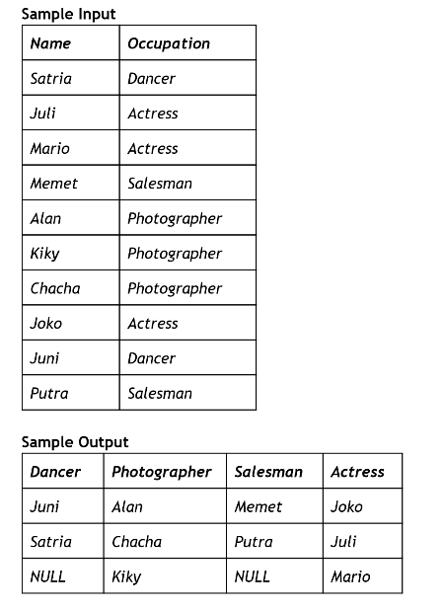

**JAWABAN:**

|  |
| --- |
| CREATE TABLE mst  ([name] char(15), [hobi] char(15))  ;    insert into mst ([name], [hobi]) values  ('Satria', 'Dancer'),  ('Juli', 'Actress'),  ('Mario', 'Actress'),  ('Memet', 'Salesman'),  ('Alan', 'Photographer'),  ('Kiky', 'Photographer'),  ('Chacha', 'Photographer'),  ('Joko', 'Actress'),  ('Juni', 'Dancer'),  ('Putra', 'Salesman');      -------------------------------------------------------------    DECLARE @cols AS NVARCHAR(MAX)  DECLARE @query AS NVARCHAR(MAX)    SELECT @cols = STUFF((SELECT DISTINCT ', ' + QUOTENAME(hobi)  FROM mst  FOR XML PATH(''), TYPE  ).value('.', 'NVARCHAR(MAX)'), 1, 1, '')    set @query = 'select ' + @cols + ' from (  select  hobi, name, row_number() over (partition by [hobi] ORDER BY [name]) as rn  from mst  ) src  pivot(  MAX([name])  for [hobi] in (' + @cols + ')  ) result'    execute(@query);  <http://sqlfiddle.com/#!18/4350d/25> |

1. Pilih salah satu:
   1. Gambarkan architecture untuk Big Data Platform dengan asumsi data source SQL Server, MySQL, social media, file server dan ending nya executive dashboard dan *recommendation system.*

JAWABAN:

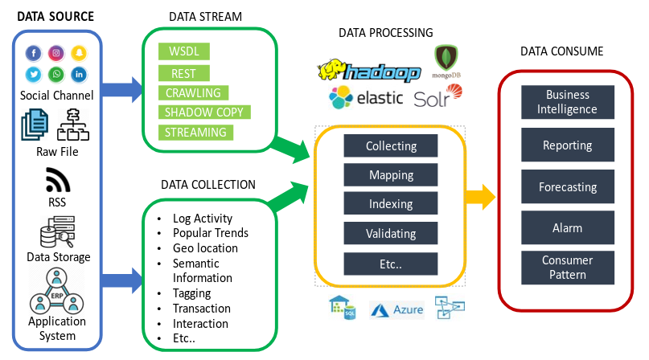

* 1. Gambarkan architecture untuk aplikasi e-commerce yang terintegrasi dengan system dari supplier.
  2. Gambarkan architecture jika kita menggunakan Sharepoint (2010/2013) sebagai employee portal, sedangkan kita memiliki aplikasi HRIS dan Procurement diluar.

Note: pilih salah satu cloud provider untuk pilihan (Google Cloud Platform, AWS, atau Azure)