Graph:
-> Elements(n) vs No. Operations
As N Increases , No. Operation wil also increase

References:
- https://www.bigocheatsheet.com/
- https://medium.com/@pnandhiniofficial/time-and-space-complexity-a-beginners-guide-88d617d29d01
- https://www.w3schools.com/dsa/dsa_timecomplexity_bblsort.php

What is Time Complexity?
Time complexity is a way of expressing how the running time of an algorithm increases as the size of the input (n) increases.
- It is measured using Big-O notation.
- Big-O gives the upper bound (worst-case growth rate).
- Example: If an algorithm takes c*n steps for input n, time complexity = O(n).
Think of it as: How fast does the runtime grow when input grows?

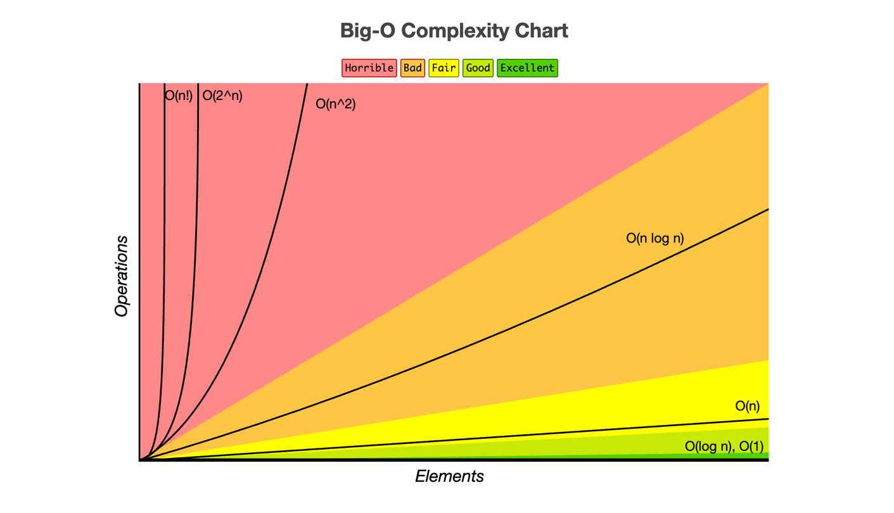
- Big O Notation (O-notation): This is used to describe the upper bound of an algorithm’s running time. It tells you how the runtime scales with the size of the input.
- O(1): Constant time. The running time doesn’t change with the input size. Example: Accessing an array element by index.
- O(log n): Logarithmic time. The running time increases logarithmically as the input size increases. Example: Binary search in a sorted array.
- O(n): Linear time. The running time increases linearly with the input size. Example: Iterating through an array.
- O(n log n): Log-linear time. Common in efficient sorting algorithms like mergesort and quicksort.
- O(n²): Quadratic time. The running time grows quadratically with the input size. Example: Nested loops, such as in bubble sort.
- O(2^n): Exponential time. The running time doubles with each additional input element. Example: Recursive algorithms solving the Towers of Hanoi.
- O(n!): Factorial time. The running time grows factorially with the input size. Example: Brute-force solutions to the traveling salesman problem.

Key Points:
- Best Case: The scenario where the algorithm performs the minimum number of steps.
- Worst Case: The scenario where the algorithm performs the maximum number of steps.
- Average Case: The expected scenario, considering all possible inputs.

2. Space Complexity
Space complexity measures the amount of memory an algorithm uses as a function of the input size.
- Big O Notation for Space Complexity: Just like time complexity, space complexity can be expressed in Big O notation.
- O(1): Constant space. The algorithm uses a fixed amount of memory regardless of input size. Example: Variables storing sums or counters.
- O(n): Linear space. The memory usage grows linearly with the input size. Example: Storing an additional array or list.
- O(n²): Quadratic space. The memory usage grows quadratically with the input size. Example: Storing a 2D matrix.
Key Points:
- Auxiliary Space: The extra space or temporary space used by an algorithm.
- In-place Algorithm: An algorithm that uses a constant amount of extra space, typically O(1).

3. Analyzing Time and Space Complexity for Code
Let’s take a simple example:

int sumArray(int arr[], int n) {
int sum = 0; // O(1) space
for (int i = 0; i < n; i++) { // O(n) time
sum += arr[i]; // O(1) time
}
return sum; // O(1) time
}
- Time Complexity:
  - The loop runs n times, so the time complexity is O(n).
  - Inside the loop, addition and access operations are O(1).
  - Overall, time complexity: O(n).
- Space Complexity:
  - The only additional space used is the sum variable, which is O(1).
  - Overall, space complexity: O(1).

4. Interview Perspective
When asked about time and space complexity in an interview:
- Understand the Code: Break it down into loops, recursive calls, and space usage.
- Identify Key Operations: Focus on loops, recursive functions, and how data structures (arrays, lists, etc.) grow.
- Express in Big O Notation: Clearly state the time and space complexity using Big O notation.
- Compare Alternatives: If possible, discuss more efficient alternatives or why a particular complexity is necessary.

5. Big O Notation in Detail
- Upper Bound: Big O gives the worst-case scenario (maximum time taken).
- Ignore Constants: In Big O notation, coefficients and lower-order terms are ignored because they don’t significantly impact growth rates as input size increases.
- For example, O(2n + 5) simplifies to O(n).

6. Common Patterns:
- Single Loop: O(n) time, O(1) space.
- Nested Loop: O(n²) time, O(1) space.
- Recursive Calls: Depends on the depth and breadth of recursion. Often O(2^n) or O(n!).

7. Practice and Application
- Start Simple: Analyze basic algorithms like linear search, binary search, and simple recursive functions.
- Practice: Try analyzing the time and space complexity of different algorithms (sorting, searching, etc.).
- Mock Interviews: Practice explaining time and space complexity during mock interviews to gain confidence.

8. Conclusion
Time and space complexity are critical concepts for assessing algorithm efficiency. Understanding Big O notation allows you to express these complexities succinctly, which is essential in interviews and practical coding scenarios. With practice, you’ll be able to analyze and explain the complexity of any code you encounter.
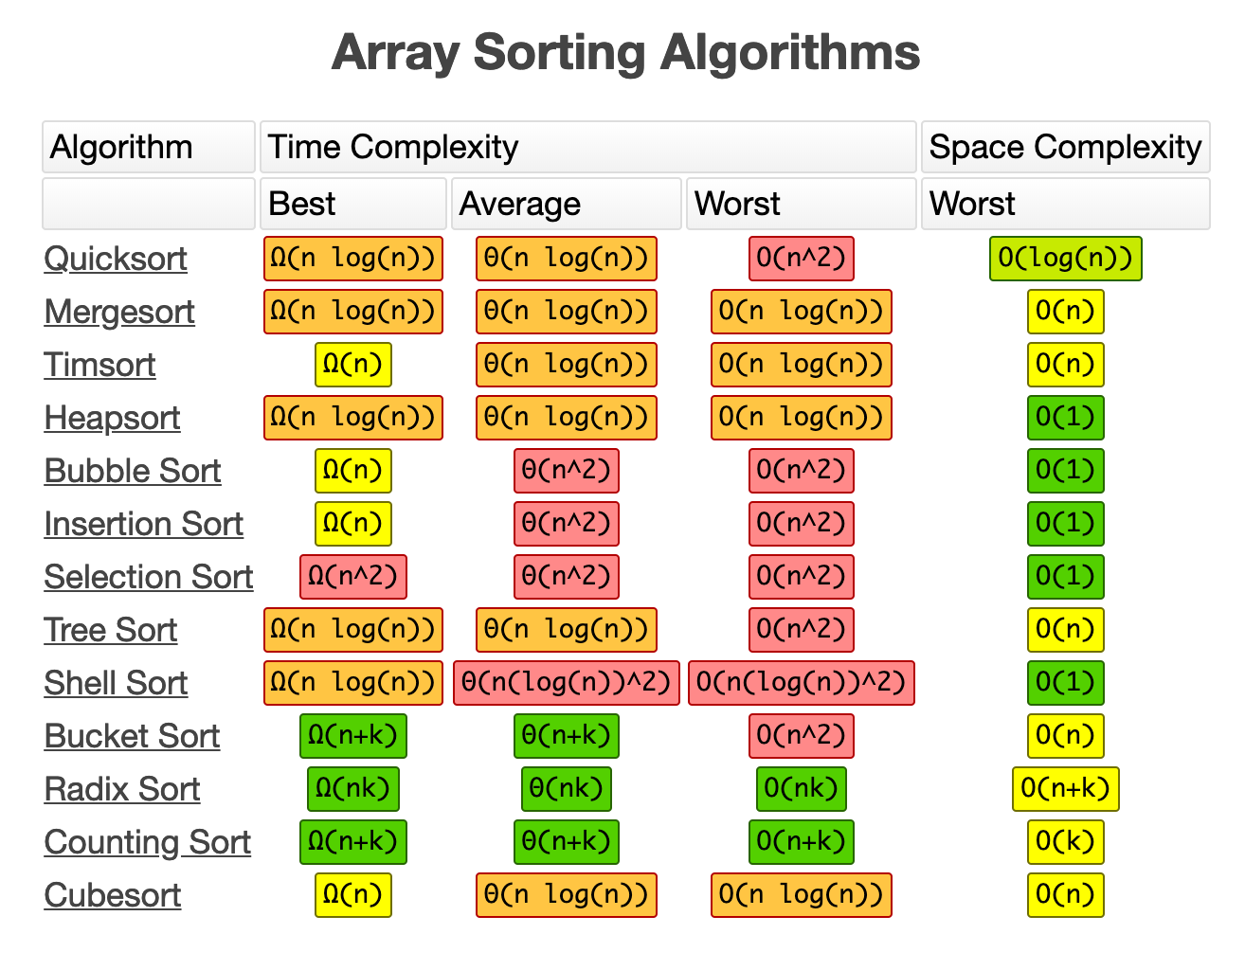

PRACTICE PROBLEMS
Here are some practice problems that will help you analyze and determine the time and space complexity of various algorithms. These problems range from simple to more complex, giving you a wide range of scenarios to practice with.

1. Linear Search
Problem: Given an array of integers and a target value, find the index of the target value in the array. If the target is not present, return -1
int linearSearch(int arr[], int n, int target) {
for (int i = 0; i < n; i++) {
if (arr[i] == target) {
return i; // Target found
}
}
return -1; // Target not found
}
Time Complexity: O(n)
Space Complexity: O(1)

2. Binary Search
Problem: Given a sorted array of integers and a target value, find the index of the target value using binary search. If the target is not present, return -1
int binarySearch(int arr[], int n, int target) {
int left = 0, right = n - 1;
while (left <= right) {
int mid = left + (right - left) / 2;
if (arr[mid] == target) {
return mid; // Target found
}
if (arr[mid] < target) {
left = mid + 1;
} else {
right = mid - 1;
}
}
return -1; // Target not found
}
Time Complexity: O(log n)
Space Complexity: O(1)

3. Find Maximum in an Array
Problem: Given an array of integers, find the maximum element in the array.
int findMax(int arr[], int n) {
int maxVal = arr[0];
for (int i = 1; i < n; i++) {
if (arr[i] > maxVal) {
maxVal = arr[i];
}
}
return maxVal;
}
Time Complexity: O(n)
Space Complexity: O(1)

4. Sum of All Subsets
Problem: Given an array of integers, find the sum of all possible subsets.

static int sumOfSubsets(int arr[], int n) {
int totalSum = 0;
int numOfSubsets = 1 << n; // 2^n subsets

for (int i = 0; i < numOfSubsets; i++) {
int subsetSum = 0;
for (int j = 0; j < n; j++) {
if ((i & (1 << j)) != 0) { // check if j-th bit is set
subsetSum += arr[j];
}
}
totalSum += subsetSum;
}
return totalSum;
}
Time Complexity: O(n * 2^n)
Space Complexity: O(1)

5. Bubble Sort
Problem: Sort an array of integers using the bubble sort algorithm.

void bubbleSort(int arr[], int n) {
for (int i = 0; i < n - 1; i++) {
for (int j = 0; j < n - i - 1; j++) {
if (arr[j] > arr[j + 1]) {
swap(arr[j], arr[j + 1]);
}
}
}
}
Time Complexity: O(n²)
Space Complexity: O(1)

6. Fibonacci Sequence (Recursive)
Problem: Find the nth Fibonacci number using a recursive approach.
int fibonacci(int n) {
if (n <= 1) {
return n;
}
return fibonacci(n - 1) + fibonacci(n - 2);
}
Time Complexity: O(2^n)
Space Complexity: O(n) (due to the call stack)

7. Fibonacci Sequence (Dynamic Programming)
Problem: Find the nth Fibonacci number using dynamic programming to optimize the recursive approach.
int fibonacciDP(int n) {
int fib[n + 1];
fib[0] = 0;
fib[1] = 1;
for (int i = 2; i <= n; i++) {
fib[i] = fib[i - 1] + fib[i - 2];
}
return fib[n];
}
Time Complexity: O(n)
Space Complexity: O(n)

8. Find the First Non-Repeating Character
Problem: Given a string, find the first non-repeating character.
char firstNonRepeatingChar(string s) {
int charCount[256] = {0}; // Assuming ASCII
for (int i = 0; i < s.length(); i++) {
charCount[s[i]]++;
}
for (int i = 0; i < s.length(); i++) {
if (charCount[s[i]] == 1) {
return s[i];
}
}
return '\0'; // No non-repeating character found
}
Time Complexity: O(n)
Space Complexity: O(1) (Fixed array size)

9. Reverse a Linked List
Problem: Given a singly linked list, reverse the list.
class Node {
int data;
Node next;

Node(int data) {
this.data = data;
this.next = null;
}
}

static Node reverseLinkedList(Node head) {
Node prev = null;
Node current = head;
Node next = null;

while (current != null) {
next = current.next; // store next
current.next = prev; // reverse link
prev = current; // move prev one step
current = next; // move current one step
}

return prev; // new head
}

Time Complexity: O(n)
Space Complexity: O(1)

10. Merge Two Sorted Arrays
Problem: Given two sorted arrays, merge them into a single sorted array.
void mergeArrays(int arr1[], int arr2[], int n1, int n2, int arr3[]) {
int i = 0, j = 0, k = 0;
while (i < n1 && j < n2) {
if (arr1[i] < arr2[j]) {
arr3[k++] = arr1[i++];
} else {
arr3[k++] = arr2[j++];
}
}
while (i < n1) {
arr3[k++] = arr1[i++];
}
while (j < n2) {
arr3[k++] = arr2[j++];
}
}
Time Complexity: O(n1 + n2)
Space Complexity: O(n1 + n2)

11. Find All Permutations of a String
Problem: Given a string, find all possible permutations.
void permute(string s, int l, int r) {
if (l == r) {
cout << s << endl;
} else {
for (int i = l; i <= r; i++) {
swap(s[l], s[i]);
permute(s, l + 1, r);
swap(s[l], s[i]); // backtrack
}
}
}
Time Complexity: O(n!)
Space Complexity: O(n) (due to the call stack)

12. Count the Number of Set Bits
Problem: Given an integer, count the number of set bits (1s) in its binary representation.
int countSetBits(int n) {
int count = 0;
while (n > 0) {
count += n & 1;
n >>= 1;
}
return count;
}
Time Complexity: O(log n)
Space Complexity: O(1)

13. Check if a String is a Palindrome
Problem: Given a string, check if it is a palindrome
bool isPalindrome(string s) {
int left = 0, right = s.length() - 1;
while (left < right) {
if (s[left] != s[right]) {
return false;
}
left++;
right--;
}
return true;
}
Time Complexity: O(n)
Space Complexity: O(1)

14. Find the Intersection of Two Arrays
Problem: Given two arrays, find the elements that are common between them.
vector<int> intersection(int arr1[], int arr2[], int n1, int n2) {
unordered_set<int> set(arr1, arr1 + n1);
vector<int> result;
for (int i = 0; i < n2; i++) {
if (set.find(arr2[i]) != set.end()) {
result.push_back(arr2[i]);
set.erase(arr2[i]); // Ensure unique elements in the result
}
}
return result;
}
Time Complexity: O(n1 + n2)
Space Complexity: O(n1) (due to the unordered set)

15. Rotate an Array
Problem: Rotate an array by k positions to the right.
void rotateArray(int arr[], int n, int k) {
k = k % n;
reverse(arr, arr + n);
reverse(arr, arr + k);
reverse(arr + k, arr + n);
}
Time Complexity: O(n)
Space Complexity: O(1)
These practice problems will help you sharpen your skills in determining time and space complexities, as well as prepare you for coding interviews. Make sure to go through each problem, understand the logic, and then try to analyze the complexities on your own before checking the answers.
---------------------------------------------------------------------------------------------------------------------
Here’s a step-by-step guide to help you determine the time and space complexity of any code. This approach will allow you to systematically break down a problem and analyze its efficiency.

Step 1: Understand the Code Structure
Before analyzing complexity, thoroughly understand what the code is doing. Look at the loops, recursive calls, and data structures involved.

Step 2: Identify Key Operations
Identify the key operations that will determine the time complexity:
- Loops: Check how many times each loop runs.
- Conditionals: Consider how often different branches of if statements are executed.
- Recursion: Determine how deep the recursion goes and how many calls are made.
- Data Structure Operations: Look for operations on data structures like arrays, lists, hash maps, etc.

Step 3: Calculate Time Complexity
- Constant Time Operations: Any single operation like assignment, arithmetic operation, comparison, etc., has O(1) time complexity.
int x = 5; // O(1)
- Loops:
- Single Loop: The time complexity is generally O(n), where n is the number of iterations.
for (int i = 0; i < n; i++) {
// O(1) operation
}
// Total time complexity: O(n)
- Nested Loops: Multiply the complexities of nested loops.
for (int i = 0; i < n; i++) { // O(n)
for (int j = 0; j < n; j++) // O(n)
{
// O(1) operation
}
} // Total time complexity: O(n) * O(n) = O(n^2)
- Conditional Statements: Analyze each branch of the condition.
- if (condition) {
- // O(1) } else { // O(n) } // Choose the maximum complexity branch: O(n)
- Recursion: Analyze the recurrence relation. For example:
- int fib(int n) { if (n <= 1) return n; return fib(n - 1) + fib(n - 2); }
- The recurrence relation is T(n) = T(n-1) + T(n-2), leading to O(2^n) time complexity.
- Operations on Data Structures: Consider the time complexity for operations on different data structures.
- Array Access: O(1)
- Array Insertion/Deletion: O(n)
- Hash Map Access: O(1)
- Hash Map Insertion/Deletion: O(1)

Step 4: Calculate Space Complexity
- Variables: Every primitive data type (int, char, float) occupies O(1) space.
int x; // O(1)
- Arrays and Containers:
- 1D Array: Space complexity is O(n).
int arr[n]; // O(n)
- 2D Array: Space complexity is O(n*m).
int arr[n][m]; // O(n*m)
- Auxiliary Space: Space used by variables, arrays, or any other structures inside the algorithm.
int sum = 0; // O(1)
- Recursive Call Stack: Each recursive call adds a new frame to the stack.
int factorial(int n) {
if (n == 0) return 1;
return n * factorial(n - 1);
} // Space complexity: O(n) due to the call stack

Step 5: Simplify the Big O Expression
- Ignore constants and lower-order terms:
- Example: O(2n + 5) simplifies to O(n).
- Example: O(n² + n) simplifies to O(n²).

Step 6: Consider Best, Worst, and Average Case
- Best Case: The scenario where the algorithm performs the minimum number of steps.
- Worst Case: The scenario where the algorithm performs the maximum number of steps.
- Average Case: The expected scenario, considering all possible inputs.

Step 7: Practice with Examples
- Simple Loop Example:
for (int i = 0; i < n; i++) { // O(1) operation }
Time Complexity: O(n)
Space Complexity: O(1)
2. Nested Loop Example:
for (int i = 0; i < n; i++) { for (int j = 0; j < n; j++) { // O(1) operation } }
Time Complexity: O(n²)
Space Complexity: O(1)
3. Binary Search:
int binarySearch(int arr[], int n, int target) {
int left = 0, right = n - 1;
while (left <= right) {
int mid = left + (right - left) / 2;
if (arr[mid] == target) {
return mid;
}
if (arr[mid] < target) {
left = mid + 1;
} else {
right = mid - 1;
}
}
return -1;
}
Time Complexity: O(log n)
Space Complexity: O(1)
4. Merge Two Sorted Arrays:
void mergeArrays(int arr1[], int arr2[], int n1, int n2, int arr3[]) {
int i = 0, j = 0, k = 0;
while (i < n1 && j < n2) {
if (arr1[i] < arr2[j]) {
arr3[k++] = arr1[i++];
} else {
arr3[k++] = arr2[j++];
}
}
while (i < n1) {
arr3[k++] = arr1[i++];
}
while (j < n2) {
arr3[k++] = arr2[j++];
}
}
Time Complexity: O(n1 + n2)
Space Complexity: O(n1 + n2)

Final Tips:
- Practice: Regularly practice analyzing code snippets.
- Break Down the Code: Always break down the code into smaller parts to analyze.
- Explain Out Loud: In interviews, explain your thought process as you calculate complexities.
- Seek Patterns: Over time, recognizing common patterns in loops, recursion, and data structures will help you quickly identify complexities.

