Table of Contents
Java Core Concepts 3
Instance Initialization Block Vs Static Initialization Block 3
Instance Initialization Block 3
Static Initialization Block 3
public static void main(String[] args 4
Java is pass-by-value 4
equals() and hashCode() in Java 5
Why Override Both? 5
Important Rules 5
Serialization and Deserialization 5
Serialization 5
Deserialization 6
How to Serialize an Object 6
What is serialVersionUID? 6
Serialization in Modern Frameworks (Spring Boot, REST, etc.) 6
Immutable Class? 7
Rules to Create an Immutable Class 7
Why Make a Class Immutable? 7
What is the String Pool? 8
2. Why String Pool Exists? 8
3. Example — String Pool Behavior 9
String Interning 9
Why Immutability Enables Pooling 9
Java Memory Model — String Pool Visualization 10
Step-by-Step Explanation 10
Java Memory Management 11
Stack Memory (Thread Memory) 11
Heap Memory (Object Memory) 11
Method Area (Metaspace in Java 8+) 14
Object Oriented Programming 14
Constructor 14
Default Constructor 14
Parameterized Constructor 14
Private Constructor 14
Constructor Chaining 14
Access Modifiers (Access Specifiers) in Java 15
Access Hierarchy: 15
Protected Access Modifier in Java 16
Protected Top-Level Class in Same Package 16
Protected Top-Level Class Across Packages 16
Abstraction 17
Definition 17
Key Points 17
Example Concept: Contracts 17
Real Java Example: Map Interface 17
Encapsulation 17
Key Points 18
Example 2: Password Encoding/Decoding 18
Reference 18
Important Notes 18
Inheritance 19
IS-A relationship: 19
Observation 19
Important Notes 19
Reference 19
Types of Polymorphism 19
Compile-time Polymorphism (Static Binding / Method Overloading) 19
Runtime Polymorphism (Dynamic Binding / Method Overriding) 20
Operator Overloading 20
Interface vs Abstract Class 20
Core Purpose 20
Evolution Timeline 20
Feature Comparison Table 20
Abstract Class vs Interface — When to Use What 21
Mnemonics to Remember 22
Multiple Inheritance 22
Why Java Disallows Multiple Class Inheritance 23
How Java Supports Multiple Inheritance via Interfaces 23
1. Constants (Static Final Variables) 23
2. Abstract Methods 24
3. Default Methods 24
4. Static Methods 25
Reference 25
Enums In Java 25
Basic Example 25
Enum with Fields, Constructor, and Methods 26
How It Works Internally 26
Key Internal Points: 27
Reference: 27
When to use Enum Vs Inheritance 28
Exception Handling in Java 28
How to Explain in Interview (Concise Spoken Version) 28
Types of Exceptions 29
Checked Exceptions 29
Unchecked Exceptions (Runtime Exceptions) 29
Errors 29
Errors Vs Exception 30
What happens if finally block throws an exception? 30
Collections 32
Java Collections Framework 32
List 33
ArrayList vs LinkedList vs CopyOnWriteArrayList 33

Java Core Concepts
In Java, variables are broadly classified based on where and how they are declared inside a class:
Type | Where Declared | Belongs To | Lifetime | Access Method
Instance variable / Non Static Variables | Inside a class, but outside any method | An object (instance) | Created when an object is created | Accessed via object reference
Static variable/  Class Variables | Inside a class with the static keyword | The class itself (shared by all objects) | Created when the class is loaded | Accessed via class name or object
Local variable | Inside a method or constructor | Exists only during method execution | Created when the method starts | Accessed only within the method

Instance Initialization Block Vs Static Initialization Block

Instance Initialization Block
- All initializers are executed automatically in textual order for every object we create.
- Code for all instance initializers are executed before any constructor.
- An instance initializer cannot have a return statement.

Static Initialization Block
- An instance initializer is executed once per object whereas a static initializer is executed only oncefor a class when the class definition is loaded into JVM.
- All static initializers are executed in textual order in which they appear,and execute before any instance initializers.

Refer
- InstanceInitialization.java
- StaticInstanceInitialization.java

public static void main(String[] args
- public → It must be public so that the JVM can access it from anywhere outside the class.
If it were private, protected, or default, the JVM would not be able to invoke it.
- static → The main method is static so it can be called without creating an object of the class.
If it weren’t static, the JVM would need to create an instance first — but if the class has no default (no-arg) constructor, the JVM wouldn’t know how to pass arguments to create the object.
Hence, static allows the JVM to call it directly using the class name (e.g., ClassName.main()).
- void → The main method returns no value because it is never called by other code in your program.
It’s the entry point called by the JVM, and there’s no caller expecting a return value, so the return type is void.
- https://howtodoinjava.com/java/basics/main-method/

Java is pass-by-value
- When you pass an object (instance) to a method, the value of its reference (i.e., the memory address) is copied bit by bit into the new parameter variable.
This means both references point to the same object in memory.
- However, if you change the reference inside the method (by assigning it to a new object), it only updates the local copy of the reference — the original reference in the caller remains unchanged.
- If Java were pass-by-reference, then changing the reference inside the method would also change the original reference outside the method.
- Refer
  - PassByValue.java
  - https://howtodoinjava.com/java/basics/java-is-pass-by-value-lets-see-how/
- Modifying the Object (Affects Original)
- Reassigning the Reference (Does NOT Affect Original)

Action inside method | Affects original object? | Why
Modifying object fields | ✅ Yes | Both references point to the same object
Reassigning the reference | ❌ No | The local copy of the reference is changed

equals() and hashCode() in Java
- equals()
By default, the equals() method (in Object class) checks object references — meaning two objects are considered equal only if they refer to the same memory location.
You can override it to compare object contents (field values) instead of memory addresses.

Why Override Both?
Whenever you override equals(), you should also override hashCode() to maintain the general contract between them.
That contract says:
If two objects are equal according to equals(), they must return the same hash code from hashCode().
This is essential because hashCode() is used in hash-based collections like HashSet, HashMap, and HashTable — which rely on hash codes for storing and retrieving objects efficiently.

Important Rules
- If two objects have the same hash code, it does not necessarily mean they are equal (this is called a hash collision).
- If two objects are equal (as per equals()), they must have the same hash code.
Refer
- EqualsOverridenInStringClass.java

Serialization and Deserialization

Serialization
Serialization is the process of converting a Java object into a byte stream.
This byte stream can then be:
- Stored in a file
- Sent over a network
- Saved in a database
- Cached or persisted in session storage
In Java, a class must implement java.io.Serializable for its objects to be serialized using Java’s built-in mechanisms.

Deserialization
Deserialization is the reverse process — converting the byte stream back into the original Java object.

How to Serialize an Object
To make a Java class serializable, you must:
- Implement the java.io.Serializable interface (a marker interface with no methods).
- Optionally define a serialVersionUID for version compatibility.

What is serialVersionUID?

serialVersionUID is a unique identifier for each Serializable class.
It is used during deserialization to verify that the sender and receiver of a serialized object have loaded classes that are compatible (same structure).
If they differ, Java throws an InvalidClassException.
private static final long serialVersionUID = 1L;

If you don’t define it manually, Java automatically generates one based on class name, fields, and other metadata.
That means if you modify the class (e.g., add/remove a field), the automatically generated serialVersionUID changes — making older serialized objects incompatible.
✅ Therefore:
Always define a manual serialVersionUID to maintain compatibility between versions of your class.

Serialization in Modern Frameworks (Spring Boot, REST, etc.)

Context | Used for | Serializable Required? | Explanation
REST APIs (JSON/XML) | Converting Java objects ↔ JSON | ❌ No | Spring Boot uses Jackson (or Gson) for serialization, not Java’s native Serializable
Caching (e.g., Redis, Ehcache) | Storing objects in memory/disk | ✅ Yes | Cache implementations often use Java serialization
Messaging (JMS, Kafka) | Sending objects between systems | ✅ Yes | Objects must be serializable or converted to JSON/Avro
Session Replication (e.g., Tomcat cluster) | Sharing HTTP sessions | ✅ Yes | Session attributes must be Serializable
File I/O or Sockets | Persisting or transferring raw objects | ✅ Yes | Required when using ObjectOutputStream / ObjectInputStream
Reference/Notes:
- SerializationAnddeselialization
- SerializationUtility
- DeserializationUtility
- Transient value wont be available after serialization
- https://www.baeldung.com/java-serial-version-uid#:~:text=The%20serialVersionUID%20attribute%20is%20an,object%20of%20a%20Serializable%20class.

Immutable Class?
An immutable class is a class whose instances cannot be changed after creation.
Once the object is created, its state (fields/variables) cannot be modified.
Famous example: String in Java.

Rules to Create an Immutable Class
- Declare the class as final → cannot be subclassed.
- Declare all fields as private final.
- Don’t provide setter methods.
- Initialize all fields via constructor.
- If a field refers to a mutable object, perform deep copy in:
  - Constructor (to protect internal state)
  - Getter (to prevent external modification)
  - Perform cloning of objects in the getter methods to return a copy rather than returning the actual object reference.

Why Make a Class Immutable?
✅ Thread-safe — no synchronization needed.
✅ Easy to reason about (no side effects).
✅ Safe for caching or sharing between threads.
✅ Can be used safely in hash-based collections (HashMap, HashSet).
Reference:
- https://howtodoinjava.com/java/basics/how-to-make-a-java-class-immutable/
- https://www.journaldev.com/129/how-to-create-immutable-class-in-java
- https://www.interviewcake.com/concept/java/mutable
- https://www.mkyong.com/java/java-mutable-and-immutable-objects/
- https://howtodoinjava.com/java/collections/hashmap/shallow-deep-copy-hashmap/
- https://stackoverflow.com/questions/28288546/how-to-copy-hashmap-not-shallow-copy-in-java/28288729
- String pool is possible only because String is immutable in Java.
- ImmutableClass.java/TestMain.java
- StringImmutable.java
- StringPool.java

What is the String Pool?
The String Pool (or String Intern Pool) is a special memory area inside the Java Heap (specifically inside the method area / metaspace depending on Java version) where String literals are stored.
Whenever you create a String literal —
String s1 = "Java";

— the JVM first checks if "Java" already exists in the string pool:
- ✅ If it exists → it reuses the same object reference.
- ❌ If it doesn’t exist → it creates a new object in the pool.

2. Why String Pool Exists?
Because:
- Strings are used heavily in Java (e.g., keys, class names, messages, etc.).
- They are immutable — their values never change once created.
👉 Since strings cannot be modified, reusing them is safe —
no thread or code can alter their value.
If Strings were mutable, two variables could share the same reference and one could accidentally modify the other's content — completely breaking the pool mechanism.

3. Example — String Pool Behavior

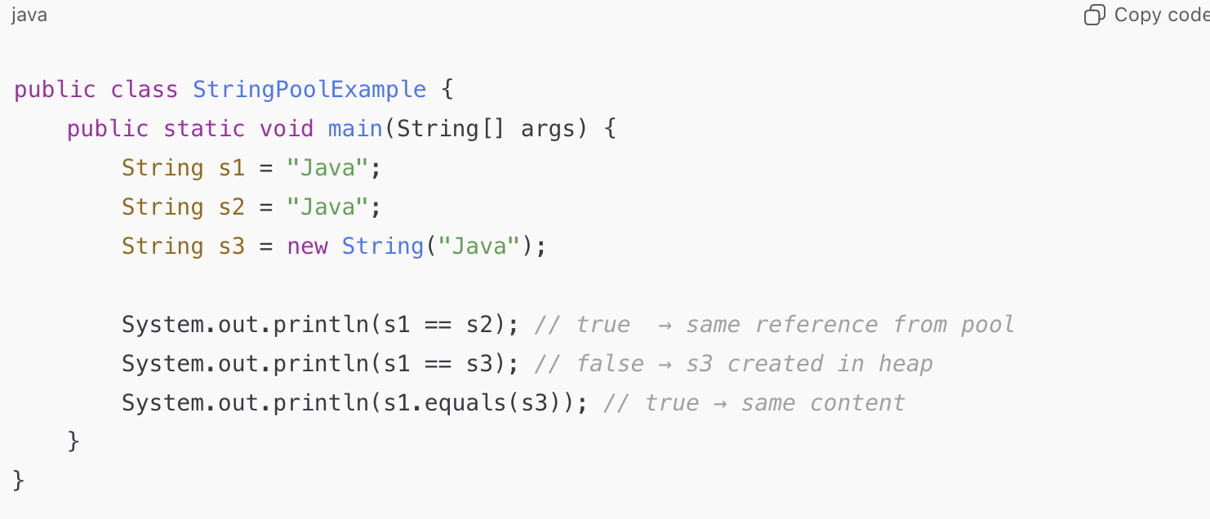
🧠 Explanation:
- "Java" literal is created in the String Pool.
- s1 and s2 point to the same pooled reference.
- new String("Java") creates a new object in the heap, not in the pool.

String Interning
You can manually move a String from heap to pool using the .intern() method:
🧠 .intern() tells JVM:
"Put this String in the pool if it’s not already there,
and return the pooled instance reference."
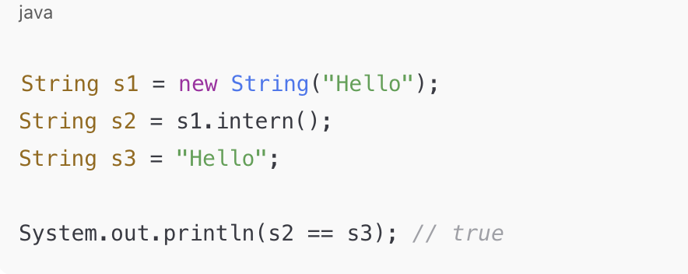

Why Immutability Enables Pooling
Let’s imagine if Strings were mutable:
String s1 = "Hello";
String s2 = "Hello";
s1.setCharAt(0, 'M'); // Suppose this was possible
Then both s1 and s2 would now become "Mello" —
which would corrupt all shared references in the pool.
Hence, immutability guarantees safety —
once a String is stored in the pool, its content will never change.

Java Memory Model — String Pool Visualization

public class StringPoolDemo {
public static void main(String[] args) {
String s1 = "Java";
String s2 = "Java";
String s3 = new String("Java");
String s4 = s3.intern();
}
}

Step-by-Step Explanation
- String s1 = "Java";
  - JVM looks in the String Pool for "Java".
  - Since it’s not there yet, it creates one and returns the reference to s1.
- String s2 = "Java";
  - JVM finds "Java" already in the pool → reuses the same reference.
  - So s1 == s2 → ✅ true.
- String s3 = new String("Java");
  - The new keyword always creates a new String object in the heap, even if "Java" exists in the pool.
  - So s1 == s3 → ❌ false, but s1.equals(s3) → ✅ true.
- String s4 = s3.intern();
  - .intern() checks the pool for "Java".
  - Since it exists, it returns the pooled instance reference.
  - So now s1 == s4 → ✅ true
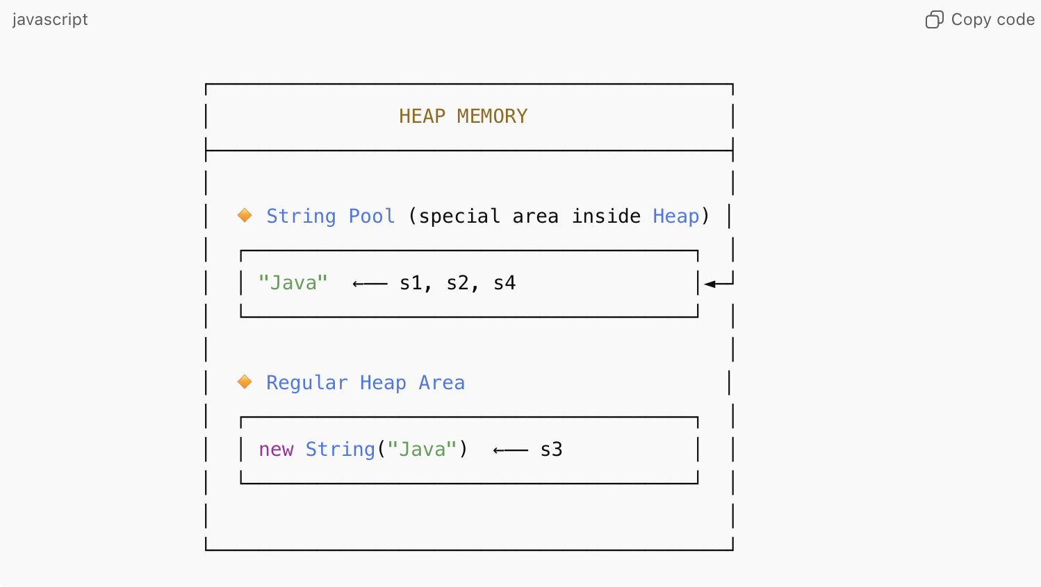

Java Memory Management

Java’s memory model is managed automatically by the Java Virtual Machine (JVM) — you don’t manually allocate or free memory like in C or C++.

Stack Memory (Thread Memory)
• Stack memory stores method calls, local variables, and references to objects (not the objects themselves).
• Each thread gets its own stack — so it’s thread-safe.
Property | Description
Speed | Very fast access — LIFO (Last In, First Out)
Scope | Exists only while the method is executing
Storage | Primitive types (int, boolean, etc.) and references to heap objects
Lifetime | Automatically cleared when a method ends
Error | If too many nested calls → StackOverflowError

Heap Memory (Object Memory)

Heap is a shared memory area used to store all Java objects (and their instance variables).
This is managed by the Garbage Collector (GC).
Property | Description
Storage | Objects and arrays
Access | Shared by all threads (so must handle synchronization)
Lifetime | Controlled by the Garbage Collector
Error | If memory exhausted → OutOfMemoryError: Java heap space

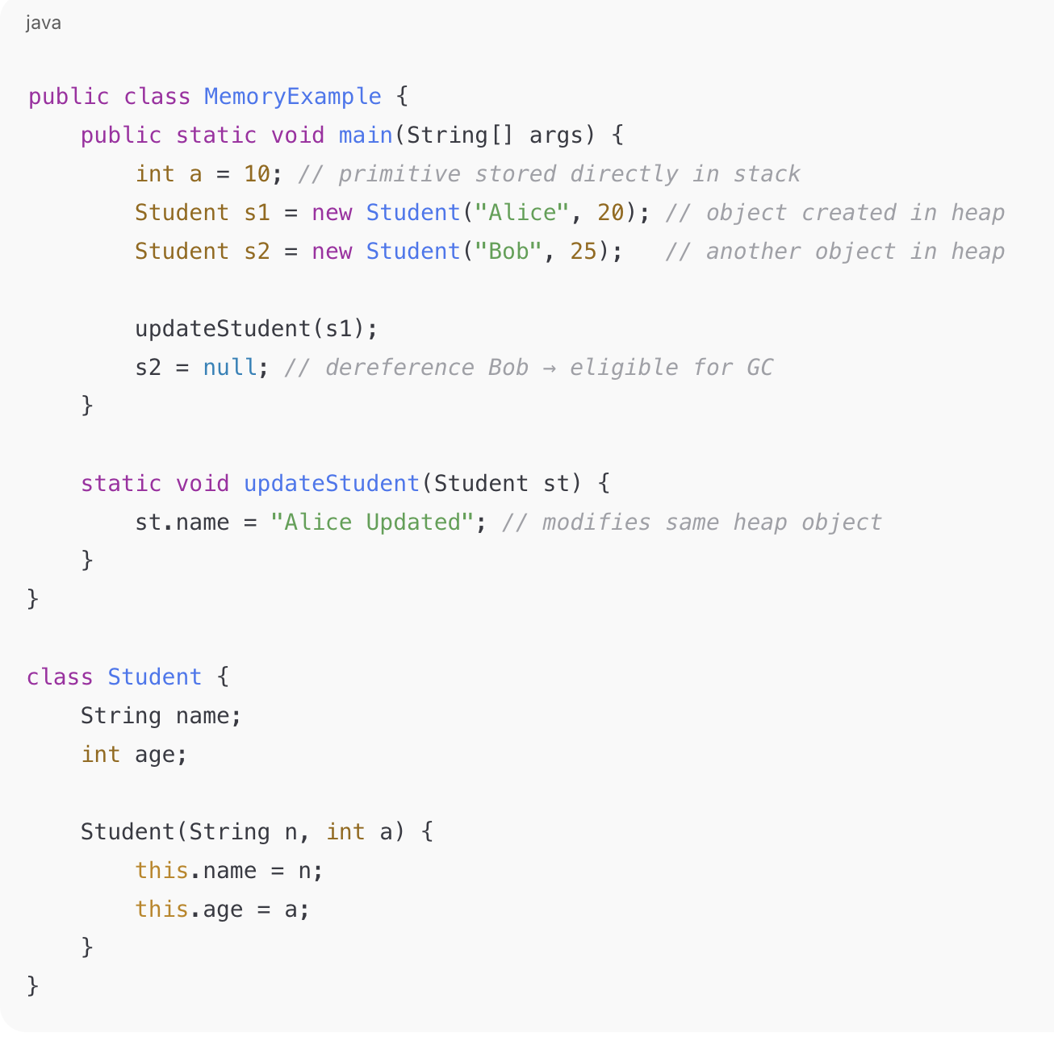

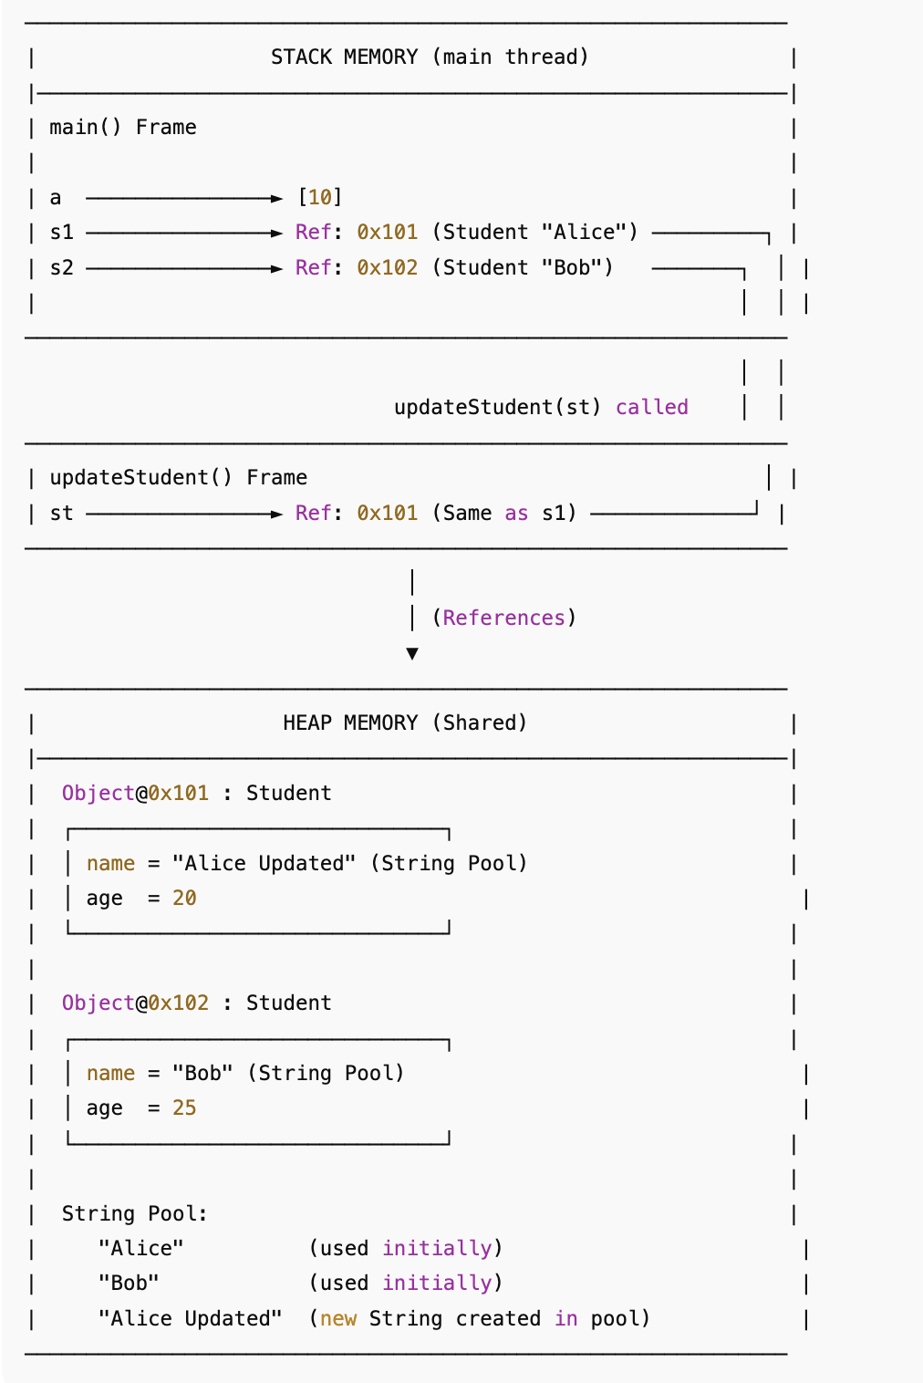

Method Area (Metaspace in Java 8+)
Stores:
- Class metadata (class name, methods, fields, static variables)
- Runtime constant pool
- Bytecode of loaded classes
🧠 Metaspace replaced PermGen from Java 8 and grows dynamically with system memory.

Object Oriented Programming

Constructor
• A constructor is a special method in a class that is used to initialize objects.
• It has the same name as the class and does not have a return type, not even void.

Default Constructor
- If no constructor is explicitly declared, the JVM automatically provides a default constructor.
- The default constructor:
  - Has no parameters.
  - Initializes objects with default values (0, null, false).

Parameterized Constructor
- A constructor that accepts parameters to initialize an object with specific values.
- Important: Once you declare any constructor, the JVM does NOT provide a default constructor.
- If you want both default and parameterized, you must declare the default constructor yourself.

Private Constructor
- A private constructor is used to restrict object creation from outside the class.
- Commonly used in Singleton design pattern.

Constructor Chaining
Constructor chaining refers to calling one constructor from another to reuse code.

A) Within the same class
- Use this() to call another constructor in the same class.
- Must be the first statement in the constructor.

B) Calling Superclass Constructor
- Use super() to call a constructor of the parent class.
- Must be the first statement in the constructor.

Access Modifiers (Access Specifiers) in Java

Modifier | Accessible Within Same Class | Same Package | Subclass (Different Package) | Everywhere
public | ✅ | ✅ | ✅ | ✅
protected | ✅ | ✅ | ✅ | ❌
default (package-private) | ✅ | ✅ | ❌ | ❌
private | ✅ | ❌ | ❌ | ❌

Access Scope Summary
- public → accessible from anywhere in the application.
- protected → accessible within the same package and also by subclasses (even in other packages).
- default (package-private) → accessible only within the same package (no keyword needed).
- private → accessible only inside the same class.

Access Hierarchy:
public > protected > default (package-private) > private

Rules for Classes
- A top-level class can only be:
  - public (accessible everywhere), or
  - default (package-private) (accessible only within the same package).
- A top-level class cannot be private or protected.
private or protected doesn’t make sense for top-level classes because:
- private → would restrict class to nothing outside itself (impossible).
- protected → would restrict access to subclasses only (but top-level class has no enclosing class to inherit protection from).

Rules for Inner Classes / Members
- Inner classes, methods, and variables can be declared as public, protected, default, or private.
- protected and private are commonly used for encapsulation within classes.
- Inner classes often use private (for example, builder or helper classes).

Protected Access Modifier in Java
Definition:
protected means the member (variable, method, or constructor) is accessible:
- Within the same package (like default/package-private).
- By subclasses, even if the subclass is in a different package.
- // Package: com.example.parent  - package com.example.parent;  - public class Parent {  - protected int protectedValue = 42;  - } | // Package: com.example.child  package com.example.child;  import com.example.parent.Parent;  public class Child extends Parent {  public void showValue() {  System.out.println(protectedValue); // Accessible because Child extends Parent  }  }

Protected Top-Level Class in Same Package
- If Java allowed a top-level class to be protected, then within the same package, you could access and extend it.
- That’s because protected includes package-level access in addition to subclass access.
So in the same package, it behaves like default (package-private) access.

Protected Top-Level Class Across Packages
- The problem arises when you try to extend it from a different package:
  - Java would allow only subclasses to access it.
  - But in order to declare the subclass, you first need visibility of the class.
  - If the class itself is protected at top-level, subclasses in another package cannot even see it to extend it.
This is why Java disallows protected for top-level classes.

Reference:
- HowToDoInJava – Java Access Modifiers
- OopsMain.java
- AccessModifierSamePackage

Abstraction

Definition
- Abstraction is the concept of hiding internal implementation details and showing only essential functionalities.
- It focuses on what an object does, not how it does it.

Key Points
- You cannot create an instance of an abstract class.
- Achieved through:
  - Abstract classes
  - Interfaces
- Allows you to define a contract for clients, while hiding the internal complexity.

Example Concept: Contracts
- Client requires two operations: get() and put().
- Client does not care how these methods are implemented internally.
- This is exactly abstraction: exposing only what is needed, hiding the rest.

Real Java Example: Map Interface

Map<String, String> map = new HashMap<>();
map.put("key1", "value1"); // Client uses put() to insert data
String val = map.get("key1"); // Client uses get() to retrieve data

• Client only sees get() and put() methods.
• Internal implementation (like HashMap, LinkedHashMap, or TreeMap) is hidden.
• This is abstraction in action.

Encapsulation
• Encapsulation is the wrapping of data (variables) and methods that manipulate that data into a single unit (class).
• It hides the internal state of the object and allows access only through methods.
• Often achieved using:
- Private instance variables (data hiding)
- Public getter and setter methods (controlled access)

A Java class, where all instance variables are private and only the methods within the class can manipulate those variables, is an example of an encapsulated class.

Key Points
- Encapsulation = Data Hiding + Implementation Hiding
  - Data hiding: Variables are private
  - Implementation hiding: Logic to manipulate data is hidden
- Abstraction vs Encapsulation:
  - Abstraction: “What” the class can do → Ex: put() and get() methods in Map
  - Encapsulation: “How” it does it → Ex: HashMap logic to store/retrieve values
Example 1: Age calculated from Date of Birth
- DobEncapsulation.java

Example 2: Password Encoding/Decoding
- PasswordEncapsulation.java

Reference
- EncapsulatedClassUser.java
- https://howtodoinjava.com/java/oops/encapsulation-in-java-and-its-relation-with-abstraction/

Important Notes
- All instance variables should be private.
- Access through public getter/setter methods.
- Use final for fields that shouldn’t change.
- Changes to implementation won’t affect clients.
  - Ex: Changing the password encoding algorithm doesn’t affect the User class users.
- Interfaces + Encapsulation:
  - You can define getters/setters in an interface and implement them in your encapsulated class.
  - Example: List interface with ArrayList implementation.
- Combine with abstraction: hide implementation details while exposing necessary functionality.
- Immutability
- Immutable classes are closely related to encapsulation.
- All fields are private and final, no setters provided.
- Example: String class in Java.
- Benefits: Thread-safe, easier to maintain.

Inheritance

- Inheritance is an IS-A relationship between classes.
- A child class (subclass) inherits all non-private fields and methods from the parent class (superclass).
- Purpose: Promote code reusability and logical hierarchy
- Member fields are accessed from reference type class.
- Member methods are accessed from actual instance types.
- ReferenceClass variable = new ActualClass()
- ParentClass p = new ChildClass();

IS-A relationship:
- Car IS-A Vehicle → class Car extends Vehicle
Observation
- Fields are not overridden, they are hidden. Access depends on reference type.
- Methods can be overridden, executed based on actual object type.

Important Notes
- Private fields/methods in parent cannot be inherited.
- Constructors are not inherited, but you can call super() to invoke parent constructor.
- Multiple inheritance via classes is not allowed, but can be achieved using interfaces.
Reference:
- InheritanceMain.java
Polymorphism
Definition:
Polymorphism allows an object to take many forms — i.e., the same method name or operator can behave differently based on context.

Types of Polymorphism

Compile-time Polymorphism (Static Binding / Method Overloading)
Rules for Overloading:
- Method signature must vary (number, type, or order of parameters)
- Changing only return type → ❌ Not considered overloading
- Changing only access modifier or exception → ❌ Not considered overloading
- Can overload static, final, or private methods (they belong to class)
- Refer : MethodOverLoadingRules.java

Runtime Polymorphism (Dynamic Binding / Method Overriding)
Rules for Overriding:
- Same method name, same argument list
- Return type can be same or covariant (child of parent’s return type)
- private, static, and final methods → ❌ cannot be overridden
- Access modifier cannot be reduced (e.g., public → protected)
- Checked Exception in child cannot be broader than parent
- Child class method should have same or compatible access level
- Refer : MethodOverRidingRulesChild.java

Operator Overloading
- Java does not support custom operator overloading like C++.
- Only + operator is overloaded — for numbers (addition) and strings (concatenation).

Interface vs Abstract Class

Core Purpose
Concept | Purpose
Abstract Class | To share common behavior and state (fields + methods) among subclasses
Interface | To define contracts — i.e., what a class must do, not how it does it

Evolution Timeline
Java Version | Major Interface Feature
Before Java 8 | Only abstract methods (no body) and constants allowed
Java 8 | Introduced default methods (with body) and static methods  -->Default methods can be overridden  -->Default can be public and cannot be protected ,private  --> only public, abstract, default, static and strictfp are permitted in interface  For Ex : ForEach feature is introduced as default method in java 8
Java 9 | Introduced private methods (to reuse logic inside interface)  For example, if two default methods needed to share code, a private interface method would allow them to do so,  but without exposing that private method to it’s implementing classes.
Java 15+ | Sealed interfaces introduced (limit which classes can implement)

Feature Comparison Table

Feature | Abstract Class | Interface (Old Java ≤7) | Interface (Java 8+)
Keyword | abstract class | interface | interface
Methods | Can have abstract and non-abstract methods | Only abstract methods | Abstract + Default + Static + Private
Access Modifiers (methods) | Can be public/protected/private | All methods are implicitly public abstract | Same, but default/static/private allowed
Fields / Variables | Can have instance & static variables | Only public static final (constants) | Same
Constructors | ✅ Allowed | ❌ Not allowed | ❌ Not allowed
Multiple Inheritance | ❌ (Only one class) | ✅ (Multiple interfaces) | ✅
When to use | When you need partial implementation or shared state | When you need to enforce a contract | Same, with extra flexibility
Default Implementation | ✅ Possible in abstract class | ❌ (till Java 7) | ✅ (using default methods)
Static Methods | ✅ Allowed | ❌ (till Java 7) | ✅ Allowed
Private Methods | ✅ Allowed | ❌ (till Java 8) | ✅ (Java 9 onwards)

Example of abstract Class:
- Abstract classes let you define some behaviors;
HttpServelet is abstract class which defines all life cycle methods( i.e. initialization, service, and destruction)
So that we can concentrate only on business

Example of Interface :
- Map is an interface implemented by Hashmap ,treemap, hashtable, weekhashmap

Abstract Class vs Interface — When to Use What

Design Intent | Prefer Abstract Class | Prefer Interface
Core Purpose | To share common state + behavior among related classes | To define a contract for unrelated classes
"Is-A" Relationship | When there’s a clear is-a relationship (inheritance hierarchy) | When you just need capability/behavior (e.g., “can-do”)
State (fields) | You need instance variables or shared logic | No instance data — only constants or pure behavior
Partial Implementation | Some code is already implemented; subclasses customize the rest | Only default logic or helper utilities (lightweight)
Constructor | You need to initialize fields or perform setup | No object construction or internal state
Extensibility | A class can extend only one abstract class | A class can implement multiple interfaces (composition of behaviors)
Backward Compatibility / API Evolution | Adding new methods can break subclasses | Adding new default methods does not break existing implementations (Java 8+)
Versioning Stability | When API will not change often | When API may evolve frequently over time
Example (Retail Domain) | Base class PaymentGateway has common fields (merchantId, key, etc.) | Interface Refundable, Auditable, Trackable — independent abilities

Mnemonics to Remember

- Interface → Capability
“Can do” something
e.g. Refundable, Searchable, Printable, Serializable
- Abstract Class → Base Identity
“Is a” type with shared identity
e.g. PaymentGateway, UserAccount, Vehicle

Reference:
- https://howtodoinjava.com/java/oops/exploring-interfaces-and-abstract-classes-in-java/
- https://howtodoinjava.com/java9/java9-private-interface-methods/
- PrivateMethodInterfaceMain.java
- PaymentDemoJava7, PaymentDemoJava8, PaymentDemoJava9

Multiple Inheritance
Multiple Inheritance means:
A class can inherit features (methods) from more than one parent type.
In C++, you can extend multiple classes — but Java does not allow multiple class inheritance because of ambiguity problems (the “Diamond Problem”).
However, Java allows multiple inheritance through interfaces — because interfaces only define method contracts (no instance state).

Why Java Disallows Multiple Class Inheritance

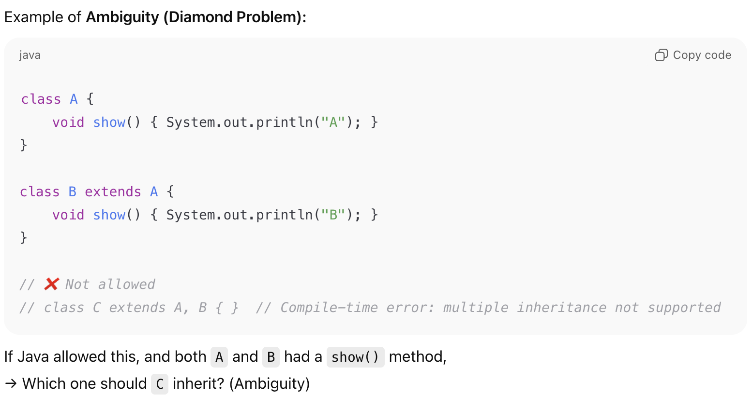

How Java Supports Multiple Inheritance via Interfaces
A class can implement multiple interfaces, and there is no ambiguity if:
- Only method signatures are inherited (no implementation conflict)
- Or, conflicts are explicitly resolved by the class

1. Constants (Static Final Variables)
- Variables in interfaces are implicitly public, static, and final.
- Hence, they act as constants.
- If two interfaces declare the same constant name, and both are implemented in a class,
the reference must be qualified with the interface name to avoid ambiguity.
✅ Allowed:
System.out.println(Interface1.PARAM);
System.out.println(Interface2.PARAM);
❌ Error:
System.out.println(PARAM); // The field PARAM is ambiguous

2. Abstract Methods
- Abstract methods can have the same name in multiple interfaces.
- If they have the same signature, it’s fine — the implementing class will provide a single implementation.
- If they differ by parameters or return types, they are treated as overloaded methods.
✅ Same signature allowed:
interface A { void display(); }
interface B { void display(); }

class Test implements A, B {
public void display() { System.out.println("Display logic"); }
}
✅ Overloaded allowed:
interface A { void show(int x); }
interface B { void show(String y); }

class Test implements A, B {
public void show(int x) { }
public void show(String y) { }
}

3. Default Methods
Introduced in Java 8, default methods allow interfaces to have implementation logic.
Rule:
- If two interfaces have a default method with the same signature,
and both are implemented in a class, the class must override that method explicitly.
(Otherwise, compiler throws: “duplicate default methods” error.)
✅ Must override in implementing class:
interface Idefault1 {
default void work() { System.out.println("Work from Idefault1"); }
}
interface Idefault2 {
default void work() { System.out.println("Work from Idefault2"); }
}

class DefaultRules implements Idefault1, Idefault2 {
@Override
public void work() {
// choose which to call or create new logic
Idefault1.super.work();
// or your own logic
System.out.println("Resolved conflict");
}
}

4. Static Methods
- Static methods in interfaces cannot be overridden.
- They belong to the interface itself and must be called using the interface name.
✅ Example:
interface IStatic1 {
static void greet() { System.out.println("Hello from IStatic1"); }
}
interface IStatic2 {
static void greet() { System.out.println("Hello from IStatic2"); }
}

class StaticRules implements IStatic1, IStatic2 {
void call() {
IStatic1.greet(); // must call using interface name
IStatic2.greet();
}
}

Reference
- ConstantsAndAbstraceMethod
- IstaticRules
- DefaultRules

Enums In Java
An enum (enumeration) is a special kind of class that:
- Represents a fixed set of constants (predefined values).
- Each constant is actually an object (instance) of the enum type.
- Enum values are implicitly public, static, and final.
- Enum constructors are always private (or package-private).
- Enums cannot extend other classes (because they already extend java.lang.Enum).
Before Java 5, developers used:
public static final int MONDAY = 1;
public static final int TUESDAY = 2;
But this approach wasn’t type-safe or self-documenting.
Enums solved that problem.

Basic Example
public enum Day {
MONDAY, TUESDAY, WEDNESDAY, THURSDAY, FRIDAY, SATURDAY, SUNDAY;
}
Internally, each of these (MONDAY, TUESDAY, etc.) is an instance of Day.
Java automatically makes the enum class:
- final (cannot be subclassed)
- Extends java.lang.Enum<Day>

Enum with Fields, Constructor, and Methods

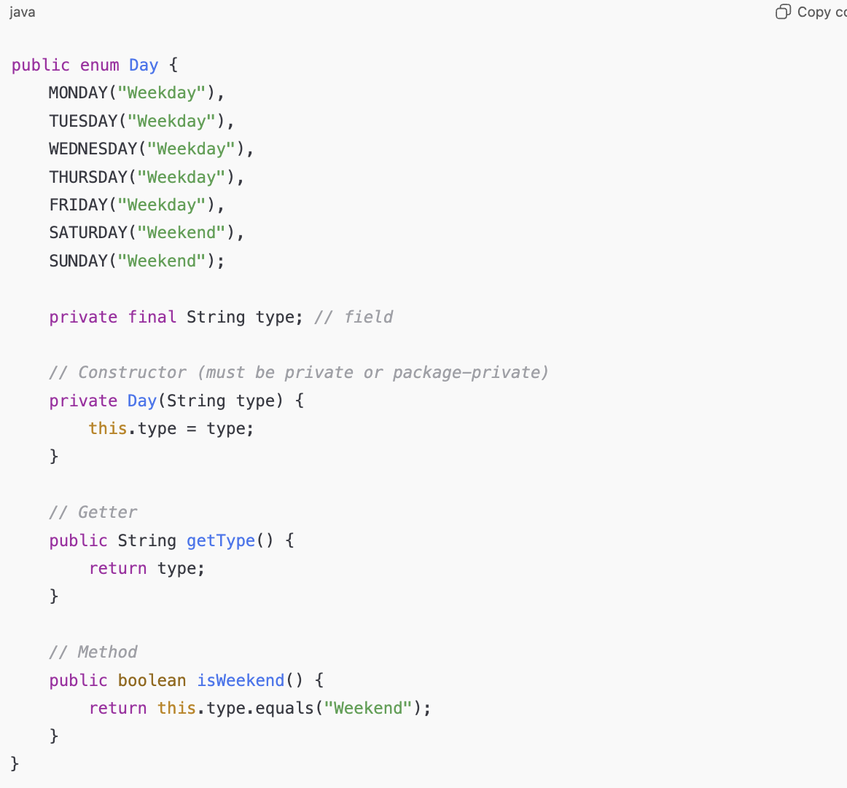

How It Works Internally

Internally, the compiler transforms the enum into a class similar to: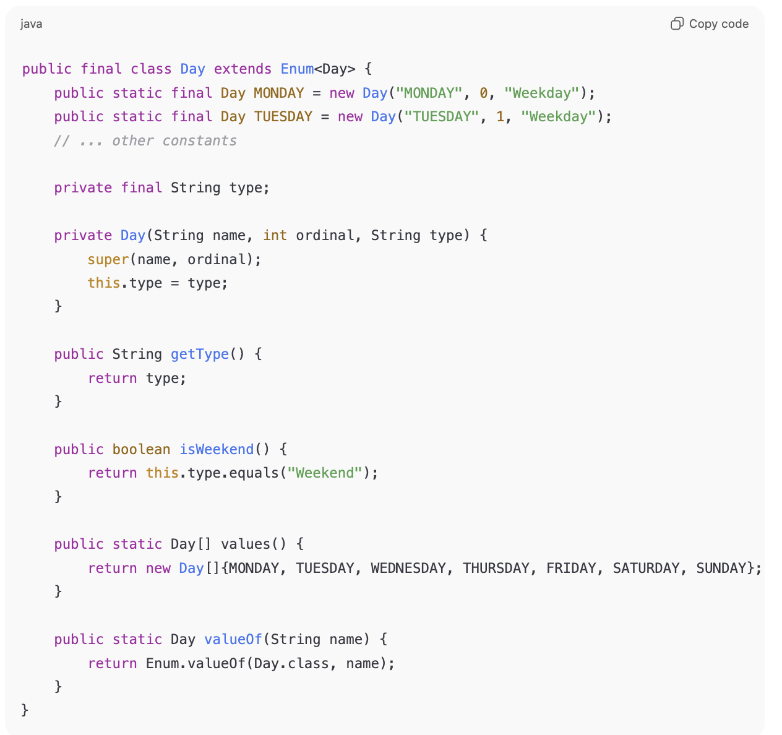

Key Internal Points:
- Each enum constant is an object (instance) of the enum class.
- ordinal — is automatically assigned starting from 0.
- Enum constructors are private to prevent new instances.
- values() and valueOf() are compiler-generated static methods.
- All enums implicitly extend java.lang.Enum — they cannot extend another class.
- ✅ Use enums instead of int or String constants.
✅ Add fields and methods when behavior differs per constant.
✅ Never use public constructors.
✅ Enums are thread-safe and singleton-like per constant.

Reference:
- EnumMain.java

When to use Enum Vs Inheritance
- Enum: OrderStatus → PLACED, SHIPPED, DELIVERED (finite states, type-safe)
- Inheritance: Payment → CardPayment, UpiPayment (different behaviors but share common interface/abstract base)
Example | Description
OrderStatus | PLACED, SHIPPED, DELIVERED, CANCELLED → finite set of order states
PaymentType | CARD, UPI, WALLET → type-safe payment modes
DiscountType | SEASONAL, CLEARANCE, FESTIVE → each type may have its own calculation
StoreType | ONLINE, OFFLINE, OUTLET → fixed store types
ShipmentMethod | STANDARD, EXPRESS, SAME_DAY → shipping options

Example | Description
Payment | Abstract class with pay() method, subclasses: CardPayment, UpiPayment → different behavior per payment type
Product | Base class: Product, subclasses: Electronics, Clothing, Groceries → each may have extra attributes or methods
Customer | Base: Customer, subclasses: RegularCustomer, PremiumCustomer → different discounts or loyalty rules
Employee | Base: Employee, subclasses: Cashier, StoreManager → different responsibilities
Delivery | Base: Delivery, subclasses: StandardDelivery, ExpressDelivery → different delivery logic

Exception Handling in Java
- Exception handling in Java is a mechanism to handle runtime errors, so that the normal flow of the program is not interrupted.
- It allows developers to detect, handle, and recover from exceptional conditions gracefully instead of the program abruptly terminating.
- We have two choices when an exception object is created in our application.
- Either we will handle it within method
- we can pass it to the caller method to let it handle

How to Explain in Interview (Concise Spoken Version)
Exception handling in Java allows us to handle runtime errors gracefully.
It prevents abnormal termination and helps maintain normal program flow.
There are two main types: Checked exceptions, which are verified at compile time (like IOException or SQLException), and Unchecked exceptions, which occur at runtime due to programming mistakes (like NullPointerException or ArithmeticException).
Errors, on the other hand, represent serious system issues that the application shouldn’t handle, like OutOfMemoryError.
We use keywords like try, catch, finally, throw, and throws to implement exception handling.

Types of Exceptions
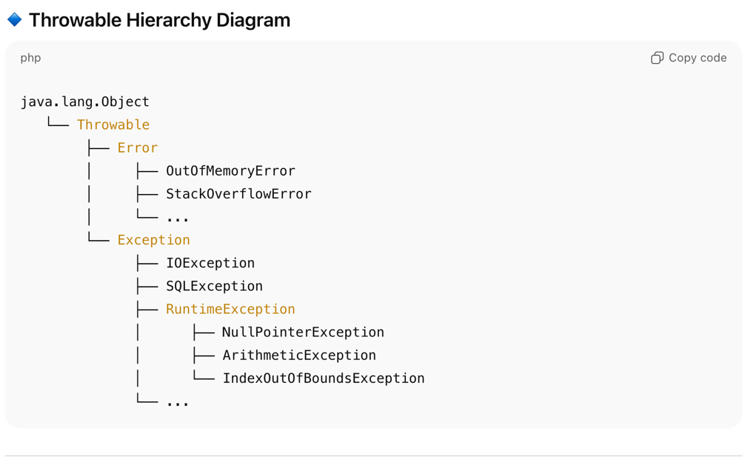

Checked Exceptions
- Checked at compile time.
- Compiler forces you to handle them using try-catch or throws.
- Usually occur due to external factors — file not found, network down, DB issue, etc.
- Subclass of Exception (but not RuntimeException).
- Example
  - IOException
  - SQLException
  - FileNotFoundException
  - ClassNotFoundException

Unchecked Exceptions (Runtime Exceptions)
- Checked at runtime.
- Not required to handle or declare explicitly.
- Occur due to programming mistakes (logic errors).
- Subclass of RuntimeException.
- Examples:
  - NullPointerException
  - ArithmeticException
  - ArrayIndexOutOfBoundsException
  - IllegalArgumentException

Errors
- Not technically exceptions — they represent serious system failures.
- Not meant to be caught or handled.
- Example: OutOfMemoryError, StackOverflowError.

Exception Handling Keywords

Keyword | Purpose
try | Block of code that may throw an exception
catch | Block used to handle the exception
finally | Block that always executes (used for resource cleanup)
throw | Used to explicitly throw an exception (throw new CustomerException())
throws | Declares exceptions a method might throw

Errors Vs Exception
- Both Error and Exception are subclasses of Throwable.
- An Error represents serious system-level problems (like JVM crashes or memory issues) that a program should not attempt to handle.
- An Exception, on the other hand, represents problems that can occur during execution but can be handled or recovered from using try-catch or throws.
- That’s why in real-world code, we typically handle Exceptions — not Errors.

Aspect | Error | Exception
Definition | Represents serious problems that occur beyond the control of the application. | Represents conditions that a program can handle and recover from.
Package | java.lang.Error | java.lang.Exception
Recoverable? | ❌ Usually not recoverable. | ✅ Usually recoverable using try-catch or throws.
Caused By | System failures — JVM issues, memory problems, hardware crash, etc. | Logical or runtime issues in code — invalid input, null references, arithmetic errors, etc.
Examples | OutOfMemoryError, StackOverflowError, VirtualMachineError | IOException, NullPointerException, SQLException, ArithmeticException
Handling | Should not be caught or handled (can cause inconsistent state). | Should be caught or declared.
Hierarchy | Subclass of Throwable but not of Exception. | Subclass of Throwable.
Occurs at | Mostly during runtime. | Checked exceptions → compile time; Unchecked → runtime.

What happens if finally block throws an exception?

- If a finally block throws an exception, it will override any exception thrown in the try or catch block.
- This means the original exception is lost, and only the one from the finally block is propagated.
- That’s why it’s generally a bad practice to throw exceptions from finally.
- If cleanup code might throw an exception, it’s better to handle it within the finally block using a nested try-catch.
In simple terms:
- The JVM ensures that the finally block always executes (unless the JVM crashes or System.exit() is called).
- If finally itself throws an exception, it suppresses or replaces the original one.
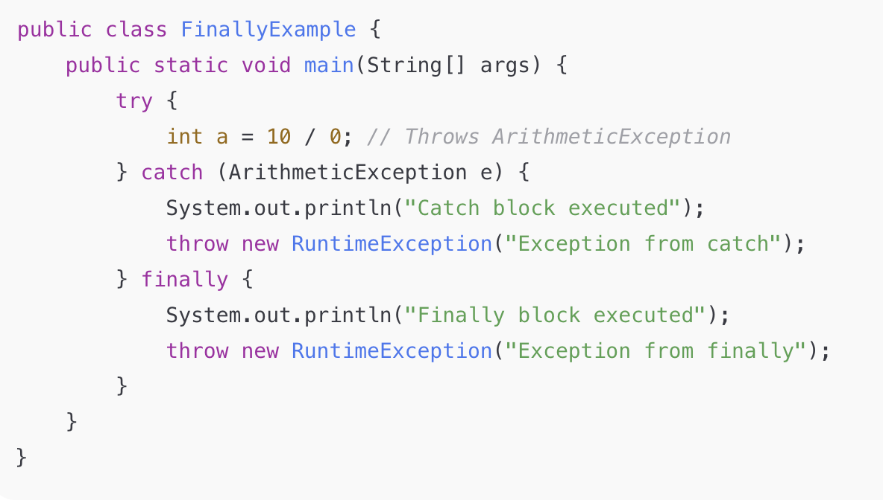

Output

Catch block executed
Finally block executed
Exception in thread "main" java.lang.RuntimeException: Exception from finally

Best Practise:
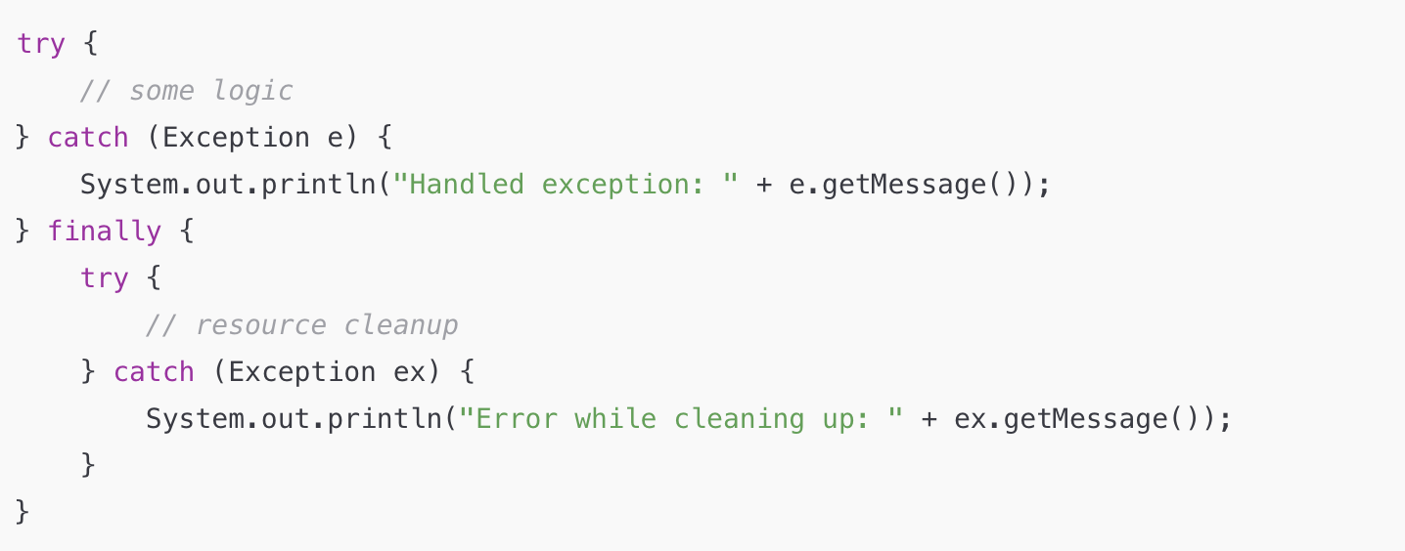

Collections

Java Collections Framework

The Java Collections Framework (JCF) is a unified architecture for representing and manipulating collections of objects. It provides:
- Interfaces – Abstract data types representing collections (e.g., List, Set, Map, Queue)
- Implementations – Concrete classes like ArrayList, HashSet, HashMap, LinkedList
- Algorithms – Static methods for sorting, searching, shuffling, etc. (in java.util.Collections)
Key Benefits
- Reduces programming effort with ready-to-use data structures
- Increases performance with high-quality implementations
- Provides interoperability between APIs via common interfaces
- Reduces effort to learn new APIs (consistent design)

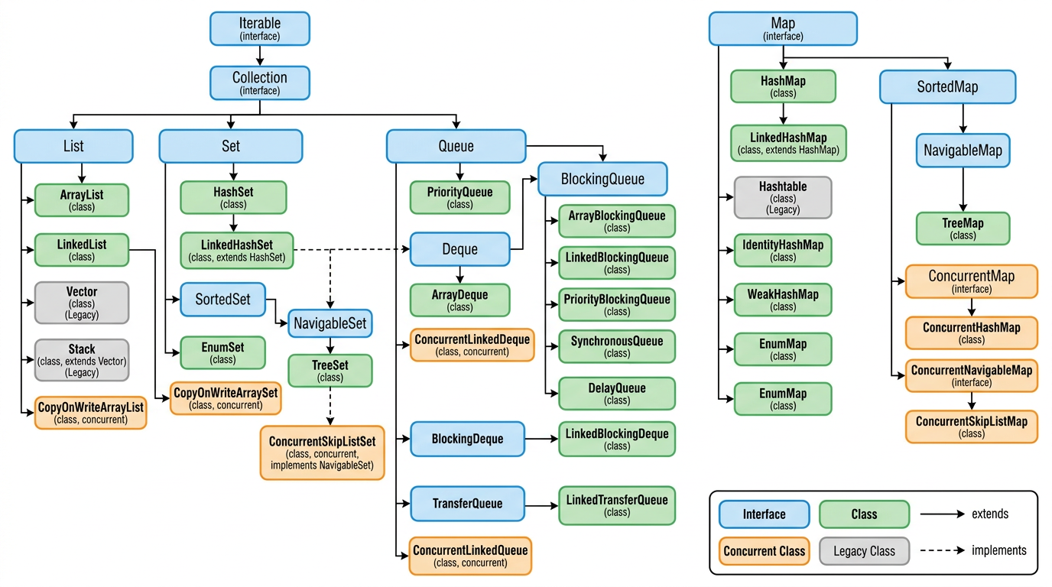

List

ArrayList vs LinkedList vs CopyOnWriteArrayList

Feature | ArrayList | LinkedList | CopyOnWriteArrayList
Description | Resizable array implementation of List. Most commonly used List. Grows by 50% when full. | Doubly-linked list implementation of List and Deque. Each element is a node with prev/next pointers. | Thread-safe variant of ArrayList. Creates a fresh copy of the underlying array on every mutation (add/set/remove).
Key Characteristic | Fast random access by index. Best for read-heavy, index-based operations. | Fast insertion/deletion at both ends. Best for frequent add/remove at head or tail. | Snapshot-based iteration. Iterators never throw ConcurrentModificationException. Best when reads vastly outnumber writes.
Internal Implementation | Backed by Object[] array. Default initial capacity = 10. Grows by (oldCapacity * 3)/2 + 1. Uses System.arraycopy() for shifting elements. | Backed by doubly-linked nodes. Each node holds item, prev, next references. No initial capacity concept. | Backed by a volatile Object[] array. Every write operation (add, set, remove) creates an entirely new copy of the array via Arrays.copyOf().
Order | Maintains insertion order. Index-based (0 to n-1). | Maintains insertion order. Can also be used as FIFO (Queue) or LIFO (Stack) via Deque interface. | Maintains insertion order. Same as ArrayList.
Duplicates | Allowed | Allowed | Allowed
Null Values | Allowed | Allowed | Allowed
Thread Safety | Not thread-safe. Use Collections.synchronizedList() or CopyOnWriteArrayList for concurrency. | Not thread-safe. Use Collections.synchronizedList() for concurrency. | Fully thread-safe. All mutative operations are synchronized internally using a ReentrantLock.
Random Access (get) | O(1) — direct array index | O(n) — must traverse from head or tail | O(1) — direct array index
Add at end | O(1) amortized (O(n) when resizing) | O(1) — just update tail pointer | O(n) — copies entire array
Add at index | O(n) — shifts elements right | O(n) — traverse + O(1) insert | O(n) — copies entire array
Remove | O(n) — shifts elements left | O(1) if node reference known, O(n) to find | O(n) — copies entire array
Search (contains) | O(n) — linear scan | O(n) — linear scan | O(n) — linear scan
Memory Overhead | Low — only the array + few fields | High — each node stores item + 2 pointers (prev, next) | High on write — entire array is cloned on each mutation
Iterator Behavior | Fail-fast — throws ConcurrentModificationException if list is modified during iteration | Fail-fast — throws ConcurrentModificationException if list is modified during iteration | Snapshot — iterates over the array snapshot taken at iterator creation time. Never throws ConcurrentModificationException.
Best Use Case | General purpose list, read-heavy, index-based access, in single-threaded or externally synchronized context | Frequent insertions/deletions at head/tail, implementing queues/stacks, when you don't need random access | Multi-threaded read-heavy scenarios like listener/observer lists, event handlers, configuration lists that rarely change
Introduced In | Java 1.2 | Java 1.2 | Java 1.5 (java.util.concurrent)

