**Influence of an Elite Scoring Presence on Team Playoff Performance**

Our research question revolved around the effect of an elite scoring presence on NHL playoff success. We used the following hypotheses as benchmarks for our analysis:

$H_{0}$: Elite goal scorers have no impact on a team’s playoff success once PDO and SRS have been considered.

$H_{A}$: Elite goal scorers have an impact on a team’s playoff success once PDO and SRS have been considered.

To account for normality issues, we first applied a square root transformation to the response. This cleared up any issues that were present with the normal probability plot and residual histogram. At this point, we were able to safely proceed under all the assumptions of linear regression. Upon running the analysis, we first found that although all three predictors were significant in a singleton model, PDO was redundant in a model that already contained SRS. More importantly, we found that the addition of the “leading scorer” predictor was also not significant at alpha=0.05 when SRS was already present in the model. Table 2 outlines this process of forward selection, as well as coefficient estimates at each step. From these results it is clear that although SRS is significant in predicting playoff performance, an elite scoring presence is not. We consequently failed to reject $H_{0}$ from above.

Table XYZ includes information about the 20 outliers produced from our model containing only SRS and leading adjusted goal scorer. 17 of these observations were teams that failed to win a single playoff game. Due to above average luck, SRS, and elite scoring, the model predicted these teams to perform much better than they did. The remaining 3 outliers were the opposite case: teams that did not have stats on their side coming into the playoffs, but made a “cinderella” run to the Stanley Cup final. The analysis identified no high leverage points or influential observations that significantly impacted the construction of the model.

Although elite scoring proved to be insignificant in our final model, we thought it would be of interest to consider the same analysis as before, but with first round data removed. Perhaps elite scoring may have more of an effect once a team advances deeper in the playoffs. From this we constructed the following hypotheses:

$H_{0}$: Elite goal scorers have no impact on a team’s playoff success after the first round, once PDO and SRS have been considered.

$H_{A}$: Elite goal scorers have an impact on a team’s playoff success after the first round, once PDO and SRS have been considered.

Using the same transformation to the response that we applied before, we were able to proceed under the assumptions of linear regression. A forward selection process yielded identical results to the previous analysis, with the singleton model containing SRS representing the only significant addition to a model containing only an intercept. Table RST accordingly summarizes the outputs from each of these new models.

Considering these two results, once SRS and PDO are accounted for, an elite scoring presence does not significantly impact the results of a playoff team, either across the entire playoffs or only after round one. In both cases, the analysis showed that a model containing only SRS is sufficient in predicting playoff wins.

**Conclusion**

Previously, we failed to reject the null hypothesis that elite scorers have no impact on playoff success. We also considered margin of victory and luck along with elite scoring in our forward selection process. We found that margin of victory alone accounts for any variation in playoff success presented by the other two features.

**Interpretation**

The exclusion of PDO and inclusion of SRS in the final model may undermine the adage that it is better to be lucky than good. There may be some credence to the idea that a team can ride a hot goalie to the Stanley Cup final, but apparently this does not usually overcome teams that are generally better. A high SRS could indicate at least three things: a high-scoring team with at least average defense, a low-scoring team with great defense, or a team that is solid at both. One idea as to why PDO is not as predictively useful is that in two of these situations, a team would feature what is likely to be a top 5 offense or defense. This means that a team could cover for its weakness and overpower any “puck luck” that may favor their opponent. The third case simply means that a team is well-rounded, which would indicate that the team is built to perform in the playoffs. There are exceptions, of course. The 2019 Tampa Bay Lightning were identified as an outlier by our final model, and rightfully so: they put together one of the greatest regular seasons in NHL history, only to fail to win a single playoff game. But generally, our model indicates that luck alone is not enough to overcome great teams.

Many successful teams in our study featured a great goal scorer. With regards to the near-significance of elite scoring in our final model, we will first note the three outliers that the model underestimated. Two of these teams won the Stanley Cup, the 2019 St. Louis Blues and 2012 Los Angeles Kings, and another made it to the Final, the 1991 Minnesota North Stars. Both the Blues and Kings were carried by hot goaltenders who more than made up for average-at-best offense. The North Stars were more of a strange case, significantly underperforming during the regular season and posting weak all-around numbers, but went on an impressive playoff run in spite of it. Additionally, there were 17 teams with strong individual scorers, like the 2003 Detroit Red Wings and the previously mentioned 2019 Lightning, who failed to win a single playoff game. Situations like these could be explained a number of ways. These teams may not have saved up enough energy come playoff time, since playoff hockey comes at a different intensity than the regular season. An opposing team may have experienced puck luck on a smaller scale. Although we identified that PDO was not a significant factor across the length of postseason, it is much more likely that it has an impact at the level of individual series, games, and/or goals. This would be enough to sway momentum towards the other team. There is also likely a psychological aspect as well. The teams that succeeded may have clutch playoff performers rostered, or those who lost may have had players who folded under pressure.

**Implications**

Based on our analysis, concentrated goal scoring alone is not sufficient for playoff success, given that the team already sports a high enough SRS. This would indicate that teams should be more focused on either making their team more balanced, or not necessarily focusing on just star offensive players to improve their team. Note that our model does not dissuade signing such players: it just does not recommend doing so above all else, regardless of the team’s situation. We would agree that many, if not all, NHL teams generally follow this methodology year in and year out: improve weaknesses before strengths. There may be some exceptions, but this means that we support conventional wisdom when it comes to team building. It is also quite likely, although not a guarantee, that our results translate to regular season success as well. Since playoff competition is guaranteed to be on average tougher than regular season competition, it seems reasonable to assume that a strategy which consistently works in the playoffs would work in the regular season; the converse appears less likely.

**Limitations**

Initially, we were interested in measuring elite scoring through an indicator variable in the model. If the team rostered a player who recorded 50 or more adjusted goals during that particular regular season, the variable would equal 1, and otherwise 0. However, this produced very sparse data, as only about 1 in 8 teams met this criterion. This variable condensed the data too much, so to fix this, we converted the variable to simply represent the leading adjusted goal scorer on each team. This would in theory show the same general results as the original, but with more predictive validity as each team was described more accurately. These updated values also proved to be much more difficult to obtain but were certainly worth it.

**Future Research**

One adjustment to this study that may improve its validity is the usage of point shares as representations of offense, defense, and goaltending in the model, instead of adjusted goals and PDO. Much in the same way that we considered the leader in adjusted goals on each team, one could also instead include the team leader in offensive points shares. This way, defense and goaltending would be more explicit in the model and could be compared to offense much more naturally. Team totals in each of these categories could also be included to address the differences between teams with more concentrated talent and more balanced squads. SRS could likely remain in the model, however, as an overall indicator of team strength.

Another slight modification of this idea would be to consider the offensive point shares contributed by the top line and defensive points shares contributed by the top pairing of defensemen instead of simply the team leader in each of these categories. This may more accurately address the contributions of a team’s top players, within the context of the team’s overall performance.

**Conclusions**

The impact of elite scorers on NHL team success is a topic that is not going away any time soon. However, our analysis indicates that their presence on a team does not indicate a better shot at winning the Stanley Cup. Rather, they are likely just a piece of the puzzle. We encourage teams to continue to use talent acquisition to address their weaknesses, whatever they may be. An elite goal scorer is unlikely to overcome the issues of a flawed team on their own, unless that problem happens to be lack of offense.

**Abstract**

NHL teams clamor each year to sign high-priced free agents, most notably great goal scorers. Even before the advent of free agency, these players were always highly regarded, which is perfectly reasonable. Scoring more goals is one way to win more games. However, the question remains whether possessing such a player significantly improves a team’s playoff outlook. To assess this claim, we recorded the leading goal scorer on every NHL playoff team since 1986, the year that the NHL switched to its current playoff format. We also measured the regular season luck and adjusted margin of victory for each team. Forward selection was applied to these predictors to determine if elite goal scoring remained useful in predicting playoff wins once luck and margin of victory were accounted for. Our analysis showed that this was not the case. Indeed, luck was also not a significant factor if adjusted margin of victory was present in the model. We therefore concluded that teams should focus on their weakness, whether that be offense, defense, or goaltending, as opposed to always improving offense. Consequently, elite goal scoring does not appear to be a sufficient condition for NHL playoff success.

**Figure 3??.**

*Normal Probability Plot from Final Model*

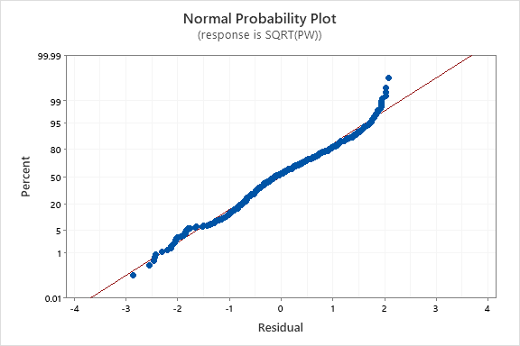

*Note.* This graph quantifies the adherence of the predictions to a normal distribution. Since many of the plotted values fall on or nearly on the red reference line, we can conclude that the square root transformation applied to the response was successful in addressing the issue with the regression assumption of normality.

**Figure 4??.**

*Histogram of Residuals from Final Model*

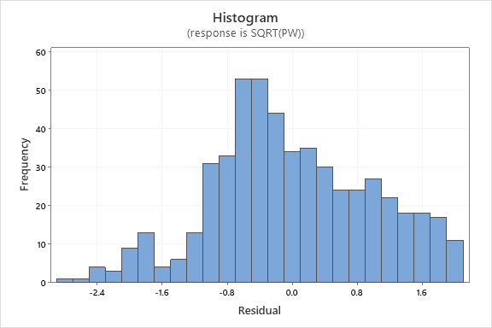

*Note.* The distribution of residuals here is not centered at zero and is skewed to the right. However, these effects are not significant enough to void our analysis.

**Table 3??.**

*Summary of Forward Selection*

|  |  |  |  |
| --- | --- | --- | --- |
| Step | Feature Considered | p-value | Kept |
| 1 | SRS | 0.000 | yes |
| 2 | PDO | 0.640 | no |
| 3 | Elite Scoring | 0.208 | no |

*Note.* This table illustrates forward with a minimum p-value for entry into the model of 0.05.

**Table 4??.**

*Summary of Forward Selection in Post Hoc Analysis*

|  |  |  |  |
| --- | --- | --- | --- |
| Step | Feature Considered | p-value | Kept |
| 1 | SRS | 0.000 | yes |
| 2 | PDO | 0.131 | no |
| 3 | Elite Scoring | 0.299 | no |

*Note.* This table illustrates forward with a minimum p-value for entry into the model of 0.05.

**Table 5??.**

*Outliers from Final Model*

|  |  |  |  |  |
| --- | --- | --- | --- | --- |
| Year | Team | SQRT(Wins) | Predicted Wins | Residual |
| 2019 | Tampa Bay Lightning | 0.000 | 2.879 | -2.879 |
| 2003 | Detroit Red Wings | 0.000 | 2.550 | -2.550 |
| 1999 | Ottawa Senators | 0.000 | 2.506 | -2.506 |
| 2001 | Ottawa Senators | 0.000 | 2.470 | -2.470 |
| 1993 | Boston Bruins | 0.000 | 2.426 | -2.426 |
| 1993 | Chicago Blackhawks | 0.000 | 2.316 | -2.316 |
| 2006 | New York Rangers | 0.000 | 2.229 | -2.229 |
| 2000 | Florida Panthers | 0.000 | 2.208 | -2.208 |
| 2018 | Los Angeles Kings | 0.000 | 2.166 | -2.166 |
| 2019 | Pittsburgh Penguins | 0.000 | 2.141 | -2.141 |
| 2017 | Chicago Blackhawks | 0.000 | 2.078 | -2.078 |
| 2000 | Los Angeles Kings | 0.000 | 2.073 | -2.073 |
| 1987 | Boston Bruins | 0.000 | 2.027 | -2.027 |
| 1994 | New York Islanders | 0.000 | 2.018 | -2.018 |
| 1999 | Mighty Ducks of Anaheim | 0.000 | 1.993 | -1.993 |
| 2015 | Winnipeg Jets | 0.000 | 1.996 | -1.996 |
| 2018 | Anaheim Ducks | 0.000 | 1.991 | -1.991 |
| 2019 | St. Louis Blues | 4.000 | 2.012 | 1.988 |
| 1991 | Minnesota North Stars | 3.742 | 1.710 | 2.031 |
| 2012 | Los Angeles Kings | 4.000 | 1.905 | 2.095 |

*Note.* This table lists the teams identified as observations from the final model containing only SRS. These entries are organized in ascending order by residual. The last three teams in this table significantly outperformed the model’s prediction; all other significantly underperformed.