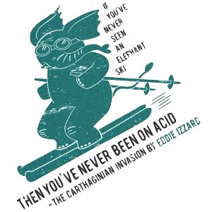



Tufts Shred and Sled is the perfect way for you to hit the slopes and get out to make some turns! If you don’t have a car to get to the slopes, this group is perfect for you! So get online, join the facebook group, follow us on twitter and check out the website for upcoming trips.

<http://www.thefrcp.com>

Facebook Group: Tufts Shred and Sled

Twitter: Tufts Shred & Sled -- @ShredAndSled