Visakha Container Terminal Private Limited (VCTPL)

Standard Operating Policy and Procedures

Terminal Operations
Introduction

A standard operating policy & procedure (SOPP) is a set of step-by-step activities compiled by an organization to help workers conduct complex as well as standard routine operations. SOPPs help to achieve efficiency, quality output and uniformity of performance while contributing to efforts that lead to process excellence.
This SOPP aims to achieve the following objectives:
1. Function as a guide and reference document to stakeholders at all levels of the organization
2. Clearly communicate activities and help to achieve consistency in operational procedures
3. Create accountability by assigning responsibilities at each stage of the lifecycle
4. Aid governance by documenting auditable processes and detailing control elements at each stage of the lifecycle

What is the Lifecycle and Process Tree?

Each SOPP follows the process tree hierarchy and covers a specific entire process.
- A process represents logical grouping of sub processes and provides detail at functional level
- A sub process represents grouping of similar activities
- An activity lists down specific tasks that have/are measurable, time bound, associated risks, mitigating controls and defined owners
The entire business lifecycle consists of several processes. An SOPP is tasked with the coverage of all sub process and activities applicable to a particular process.

Who are the Stakeholders for this SOPP?

This stakeholders for this SOPP shall primarily be activity owners and business units.
1. Activity owners (operating units) – Activity owners shall use this SOPP as a reference document while performing their activities daily.
2. Business units – Business units shall use the SOPP as a repository of all activities across the lifecycle. This will aid in identifying process improvement opportunities.

Who will use this SOPP?

This SOPP shall be used by stakeholders across the entire organization. Most notable shall be the following:
1. Risk and Governance units – Risk and Governance units shall reference the SOPP to review existing controls
2. Auditors – Auditors shall use this SOPP to check adherence to defined processes and standards. The SOPP shall help them identify any deviations to defined processes
How do you read the SOPP?
To read this SOPP, it is essential to understand the process lifecycle and its coverage. This SOPP is documented in a chronological order in line with the sequence of activities performed by activity owners. Therefore, it should be read as such.
This SOPP also provides references to various organization level policies, checklists, systems, reports etc. These have been appropriately referenced at applicable activities and attached as Annexures to this SOPP.
Each activity has an activity owner assigned to it. An activity also has the following references against it:
- Performer – Person who will execute the activity.
- Frequency – Each activity has defined period.
- Template – Reference to any template (If Any)
- System / Manual reference – Each activity is performed either manually or rooted through system.

Organization structure

The organization structure defined in the SOPP is the structure defined at the functional level. 'Activity owners' are defined are defined are those who are responsible for performing the activity. 'Business Owners' are defined as those who have oversight and ultimate ownership for the activities.
The 'roles and responsibilities' table in the SOPP lists down the 'business owners' and provides details on key activities they are responsible for. The list of 'business owners' shall form the organization structure for the SOPP and mega process.

Rules for this SOP

- This SOPP shall be reviewed on annual basis.
- Any changes in the SOPP will be approved by xx and then updated by
Document review and approval

Revision history

Version | Created By | Document Approved By | Date Approved | Revision
V1 | XX | Terminal Head | XX | XX
SOPP Number | 1
Applicable Entities
  Entity Type | Entity Name
  Container Terminal | - Visakha Container Terminal Private Limited
Process Owner | Terminal Head
IT Applications
  Entity Name | System
  Visakha Container Terminal Private Limited | Navis – N4 (TOS) , SAP Hana
Guidelines / Policy reference
SOPP Cross References

Contents

Terminal Operations 1
Abbreviations and Definitions 6
Organization Structure 9
Process Flow - Overview 10
Gate Operations 11
Planning Procedure – Vessel Planning 12
➢VIA Creation 12
➢Discharge- Import Plan 13
➢Loading – Export Plan 14
Planning Procedure – Yard Planning 15
➢Export – Import Plan 15
Planning Procedure – Rail Planning 16
➢Schedule Creation 16
➢Discharge – Export Plan 17
➢Loading - Import Plan 18
Vessel Operations 20
➢Pre Berthing 19
➢Vessel Berthing 20
➢Loading & Discharge 21
Yard Operations 24
➢Export – Import Cycle 24
Rail Operations 25
➢Export – Import Cycle 25
Key Process Activities 26
1.Gate In Process – ETV Gate Entry 26
2.Planning Procedure - Vessel Planning 28
2.1.Planning Procedure - Yard Planning 30
2.3.Planning Procedure - Rail Planning 31
3.Vessel Operations - Vessel Berthing 33
3.1.Vessels operation - Vessel Loading - Export 34
3.2.Vessels operation - Vessel Unberthing 38
4.Yard/Road Operations - Export received by Road 48
4.1.Yard/Road Operations - Import Delivery by Road 41
4.2.Yard/Road Operations - Dual Transactions 43
5.1.Rail Operations - Rail Loading Operation 47
5.2.Rail Operations - Rail Loading Operation 47
6.Gate Out Operations - ETV Exit 48
Symbols/ legends used in flowcharts 50

Abbreviations and Definitions
Abbreviations | Details
BAPLIE | Bay Plan Of Import & Export
BD | Business Development
BEX | Berth Executive
BOE | Bill Of Entry
CEO | Chief Executive Officer
CFS | Container Freight Station
CH | Channel
CHA | Customs House Agent
CHE | Container Handing Equipment
CLP | Container Load Plan
COA | Container Operating Agent
COO | Chief Operating Officer
CY | Container Yard
DC | Delivery Challan
DGM/ AGM | Deputy/ Assistant General Manager
DGS | Directorate General Of Shipping
DOA | Delegation Of Authority
VPA | Visakhapatnam Port Authority
EAL | Export Advance List
EC | Executive Committee
ECH | Empty Container Handler
EDI | Electronic Data Interchange
EIR | Equipment Interchange Receipt
ETA | Estimated Time Of Arrival
ETV | External Transport Vehicle
EWE/EWS | Export Warehouse Executive/Surveyor
F&A | Finance And Accounts
FBH | Full Body Harness
FDS | Final Draft Survey
GM | General Manager
GR /IR | Goods Receipt / Invoice Receipt
HHT | Handheld Terminal
HO | Head Office |  | General Manager
HOD | Head Of Department |  | Goods Receipt / Invoice Receipt
IAL | Import Advance List |  | HANDHELD TERMINAL
ICD | Inland Container Depots |  | General Manager
IGM | Import General Manifest |  | Goods Receipt / Invoice Receipt
IMD | India Meteorological Department |  | General Manager

Abbreviations and Definitions
Abbreviations | Details
IMO | International Maritime Organization
IPOS | Integrated Port Operating System
ITV | Internal Transport Vehicle
JO | Job Order
VCTPL | Visakha Container Terminal Private Limited
KPI | Key Performance Indicators
MACH | Marine Container Handling System
MSDS | Material Safety Data Sheet
NOC | No Objection Certificate
ODC | Over Dimension Container
OOC | Out Of Charge
OOG | Out Of Gauge
OTB | One Time Bottle
POD | Port Of Discharge
POW | Point Of Work
PPE | Personal Protective Equipment
QC | Quay Crane
RS | Reach Stacker
RTG | Rubber Tire Gantry
S/B No | Shipping Bill Number
SB | Shipping Bill
SIC | Shift In Charge
SM | Shift Manager
SMTP | Sub Manifest Transshipment Permit
SRF | Service Request Form
SSR | Special Service Request
SWL | Safe Working Load
TAT | Truck Turnaround Time
TCS | Tata Consultancy Services Limited
TH | Terminal Head
TOS | Terminal Operating System
TXR | Train Examination
VGM | Verified Gross Mass |  | General Manager
VHF | Very High Frequency |  | Goods Receipt / Invoice Receipt
VIA | Vessel Identification No |  | HANDHELD TERMINAL
VMT | Vehicle Mounted Terminal |  | General Manager
VOA | Vessel Operating Agent |  | Goods Receipt / Invoice Receipt
VP | Vice President
YEX | Yard Executive |  | General Manager

Definitions:

- Company/ Entity: Any references/ mention of “entity” or “company” in the SOP refers to “J M Baxi Group.”
- Import General Manifest (IGM): An Import General Manifest (IGM) is a legal document that lists the details of a shipment of goods entering a country. It is a mandatory document that is submitted to customs before the goods arrive. The carrier or their authorized agent prepares the IGM.
- Bill of Entry (BOE): Bill of Entry (BoE) is a legal document filed by importers or customs agents to facilitate the customs clearance process for imported goods. This document is essential for ensuring that all applicable taxes and duties are paid, and the goods comply with the importing country's regulations.
- Customs Housing Agents (CHA): A customs house agent (CHA) is a licensed professional who helps importers and exporters with customs clearance. They function as a liaison between traders and customs authorities.
- Out of Charge: A customs status that indicates that goods have been cleared for import or export.
- Vessel Draft Survey: Vessel's final draft survey measures the displacement of water before and after cargo is loaded or unloaded. The difference in displacement represents the weight of the cargo.
- Stowage Plan: Stowage plan is a map that shows where to place cargo on a ship.
- Laycan: Laycan is the agreed-upon time when a ship is expected to arrive at a port to load or unload cargo. It is an abbreviation of "lay days cancelling".

Executive Summary
The Port Terminal Operations Standard Operating Procedures (SOP) document outlines the processes, policies, and best practices that govern the efficient, safe, and compliant operation of port terminals. It is designed to ensure that all terminal activities, including cargo handling, vessel management, logistics, safety protocols, and customer service, are carried out consistently and in line with industry standards and regulatory requirements.
This SOP aims to optimize operational efficiency by defining clear workflows and responsibilities, minimizing operational risks, and enhancing customer satisfaction through streamlined processes. Key components of the SOP include:
- Cargo Handling Procedures: Guidelines for the receipt, storage, and dispatch of cargo, ensuring accurate and timely processing.
- Vessel Operations: Standard practices for the docking, unloading, loading, and departure of vessels, including safety protocols for crew and equipment.
- Equipment Maintenance and Safety: Procedures for the upkeep of port equipment and safety systems, ensuring operational readiness and risk mitigation.
- Logistics and Documentation: Standardized methods for managing the flow of goods and proper documentation to ensure legal compliance and smooth supply chain management.

Organization Structure

COO

Terminal Head
HOD- Planning & Operations

Manager – Planning
Manager – Operations

Executive – Planning
Executive–Operations

Process Flow - Overview
Planning Procedure
Vessel Operations
Yard/Road/Rail Operations
Start
End

Gate out
Gate In

Process Flow

Gate Operations – Gate in & Gate Out
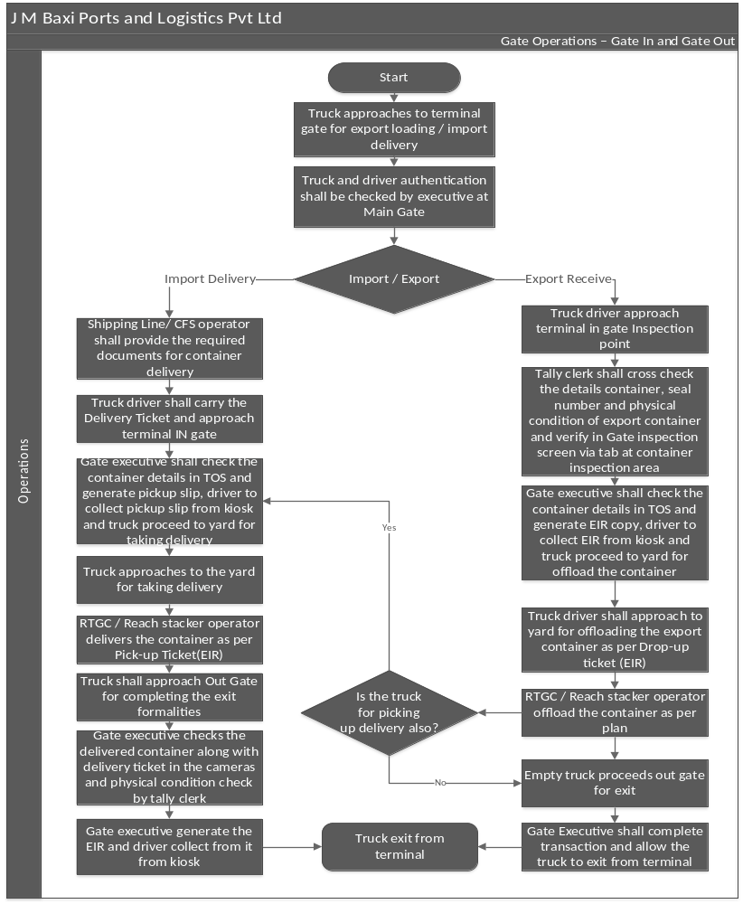

Process Flow

Planning Procedure – Vessel Planning

VIA Creation

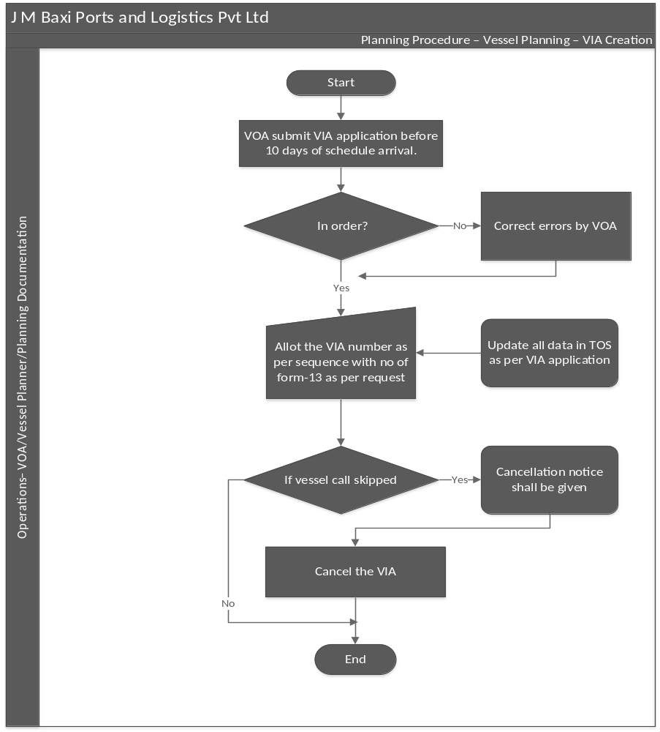

Process Flow

Planning Procedure – Vessel Planning

Discharge- Import Plan

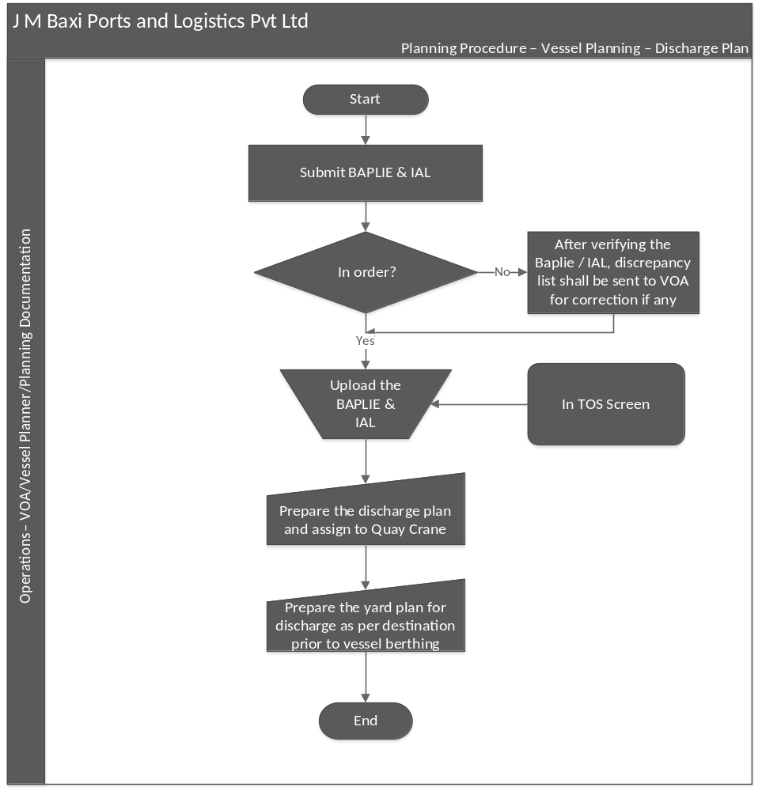

Process Flow

Planning Procedure – Vessel Planning

Loading – Export Plan

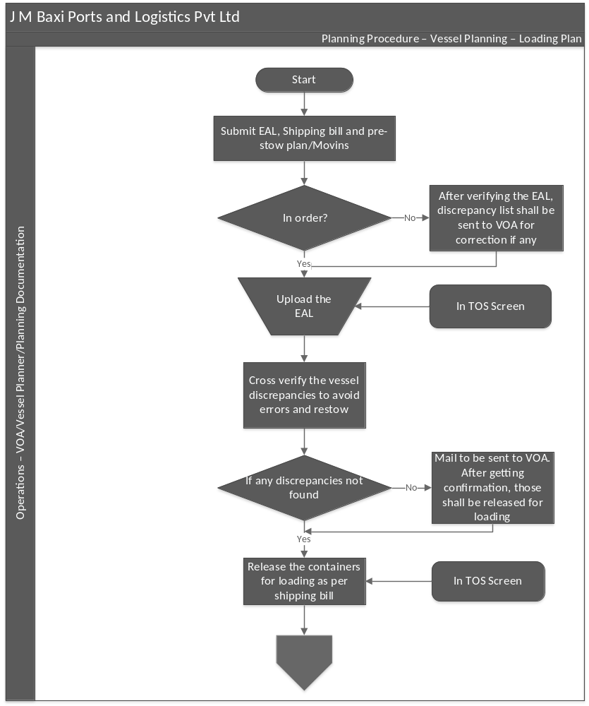

Process Flow

Planning Procedure – Yard Planning

Export – Import Plan

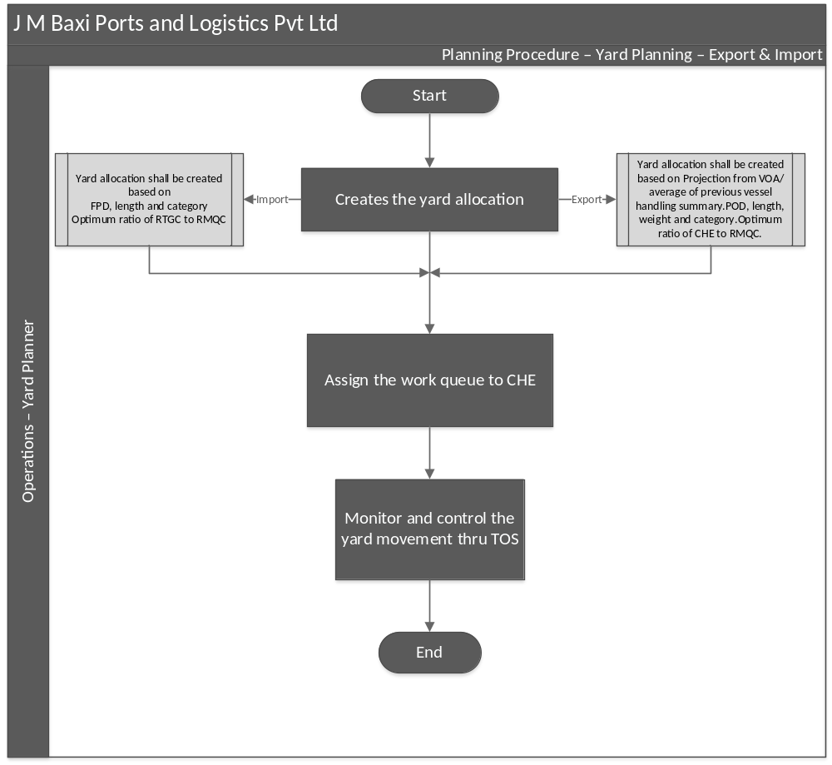

Process Flow

Planning Procedure – Rail Planning

Schedule Creation

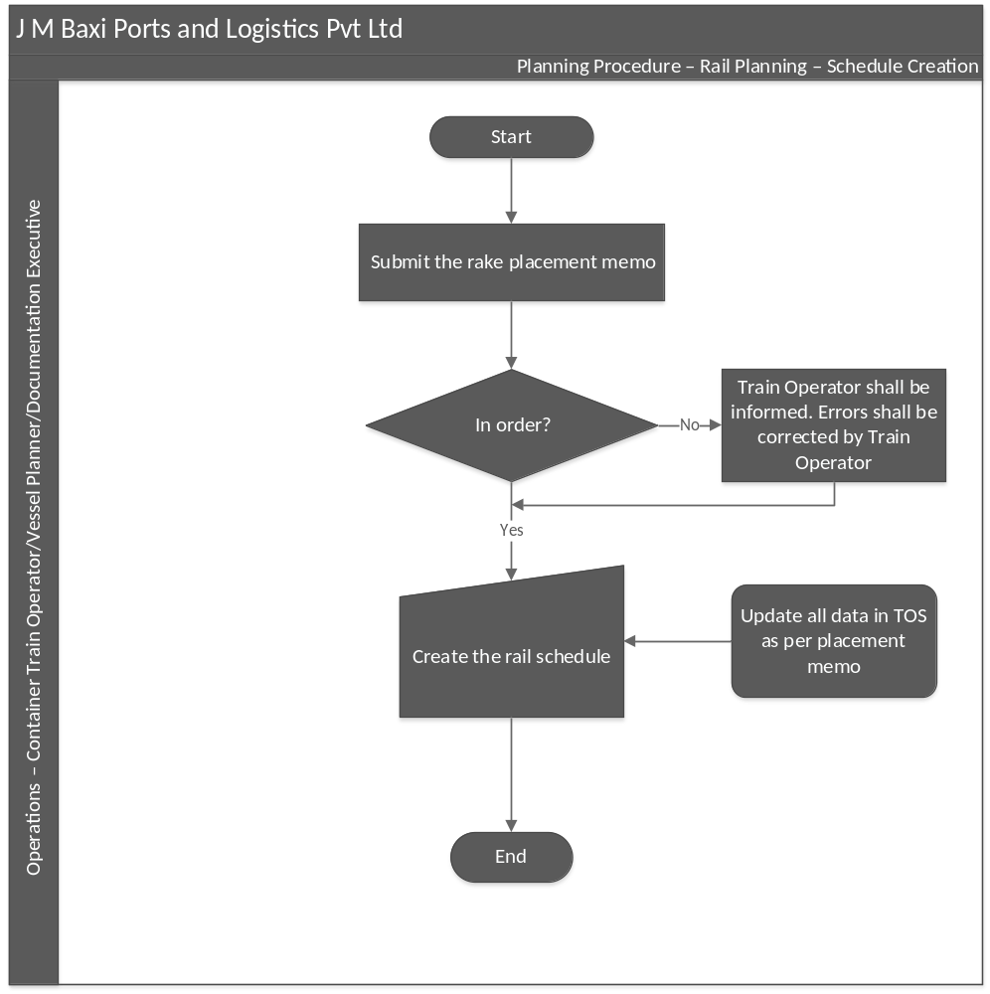

Process Flow

Planning Procedure – Rail Planning

Discharge – Export Plan

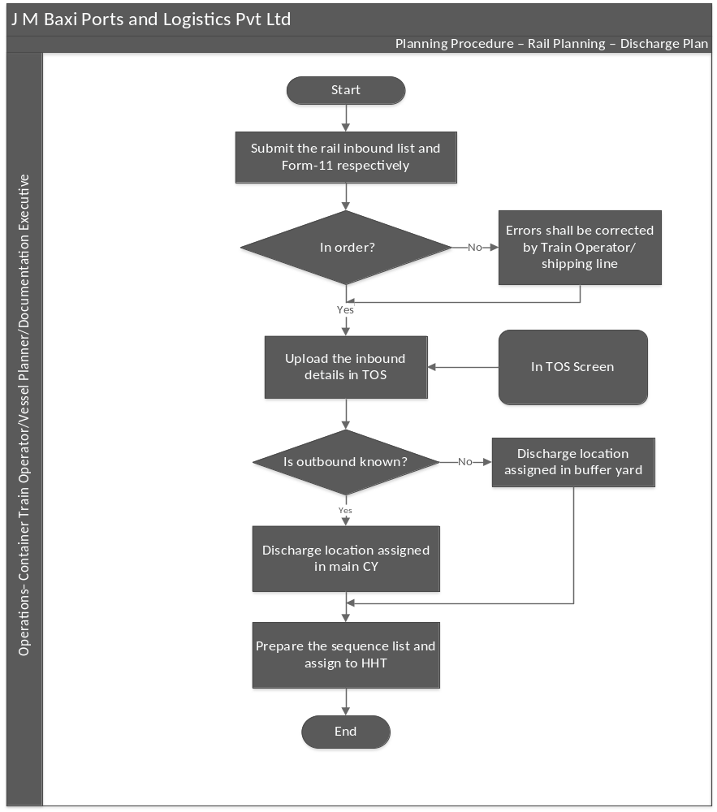

Process Flow

Planning Procedure – Rail Planning

Loading - Import Plan
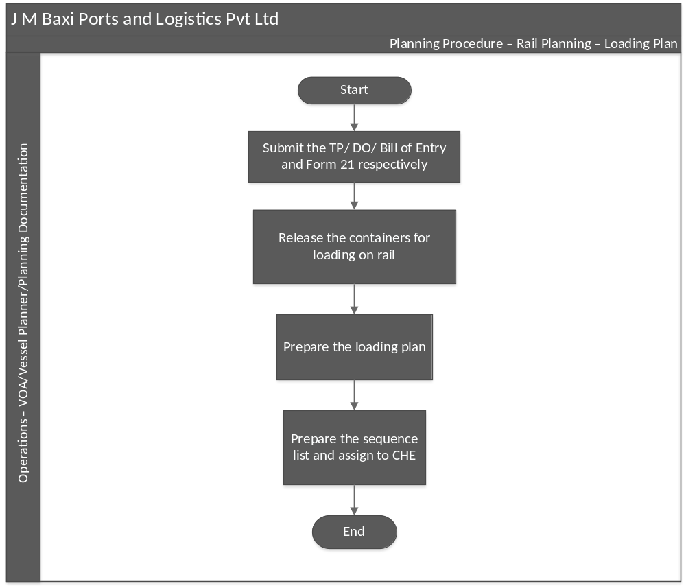

Process Flow

Vessel Operations

Pre Berthing
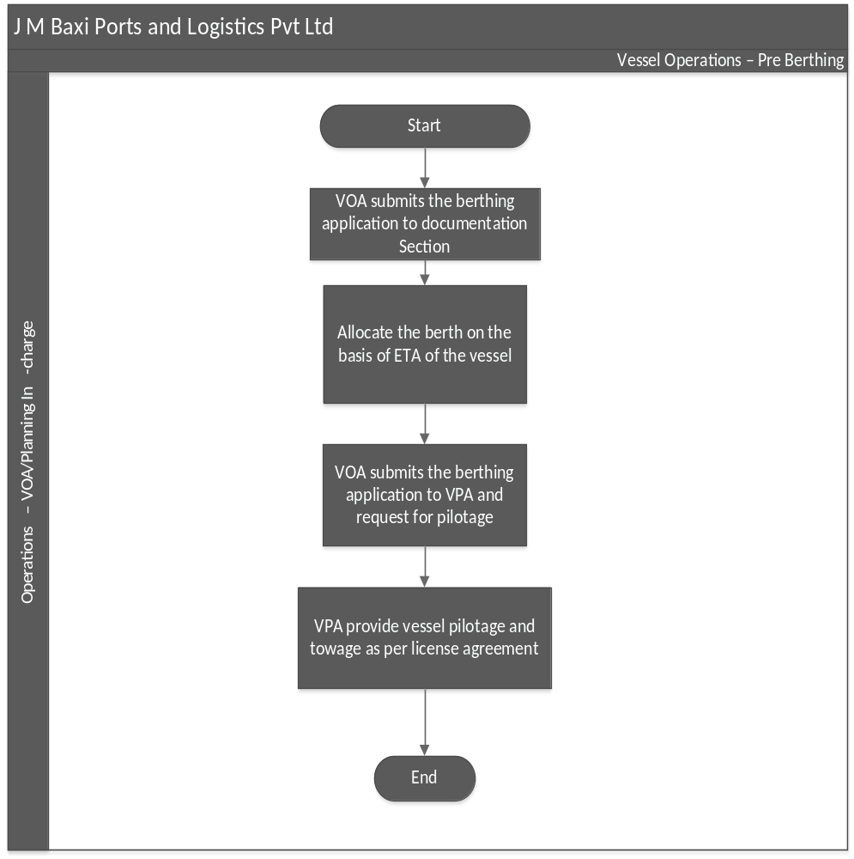

Process Flow

Vessel Operations

Vessel Berthing

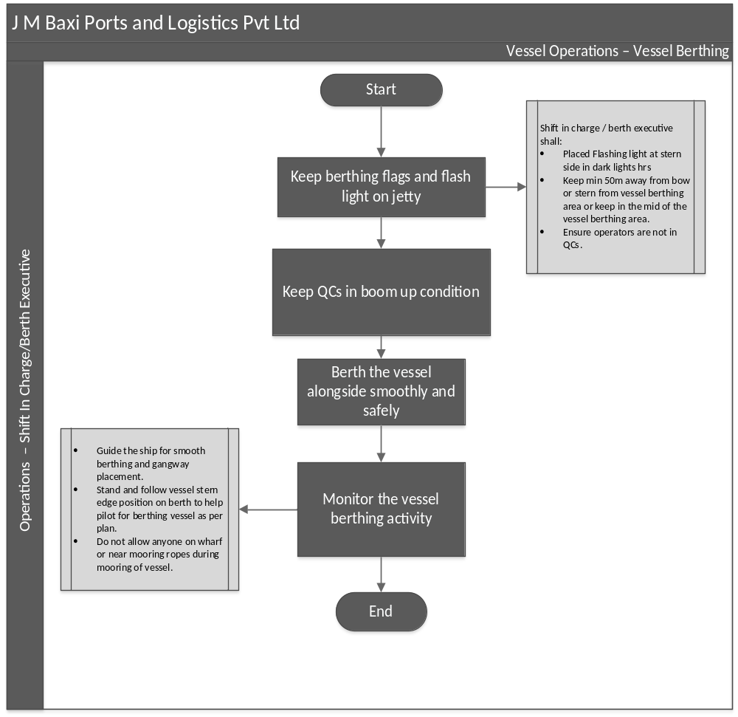

Process Flow

Vessel Operations

Loading & Discharge

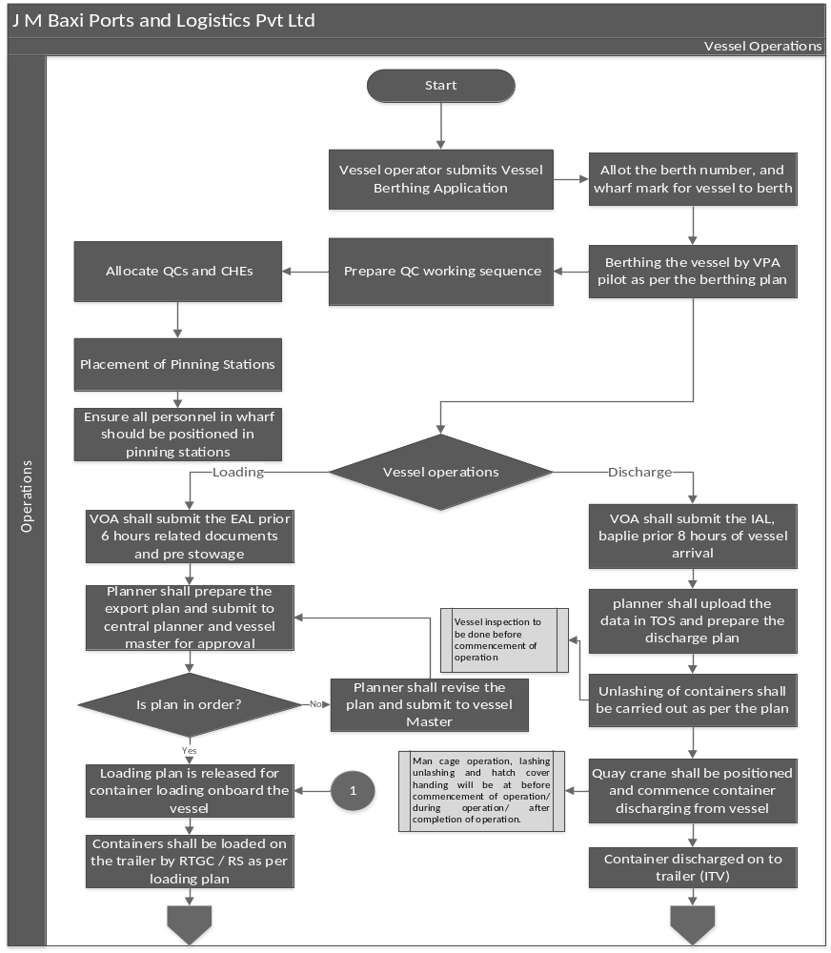

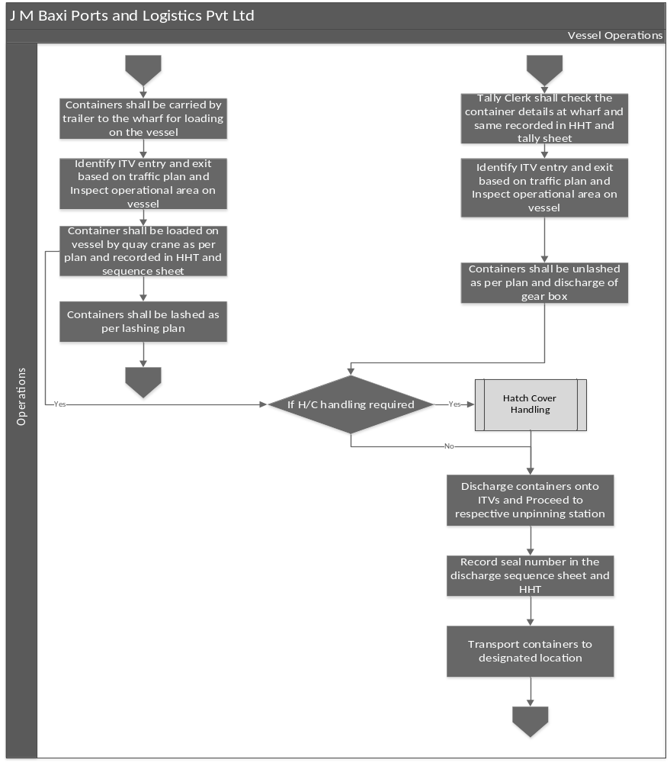

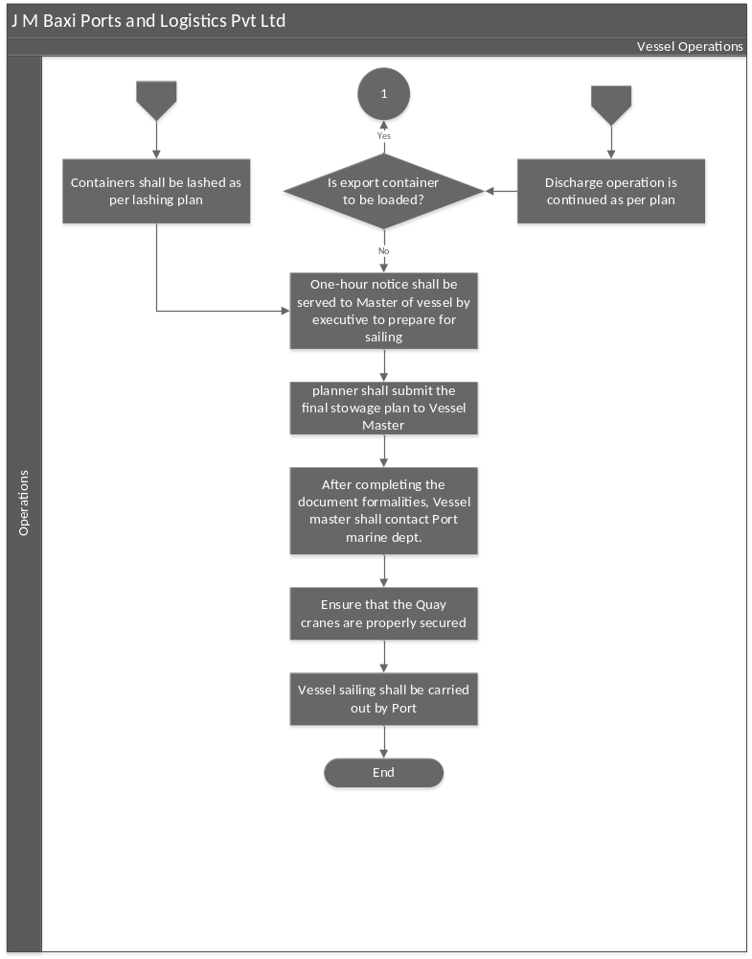

Process Flow

Yard Operations

Export – Import Cycle

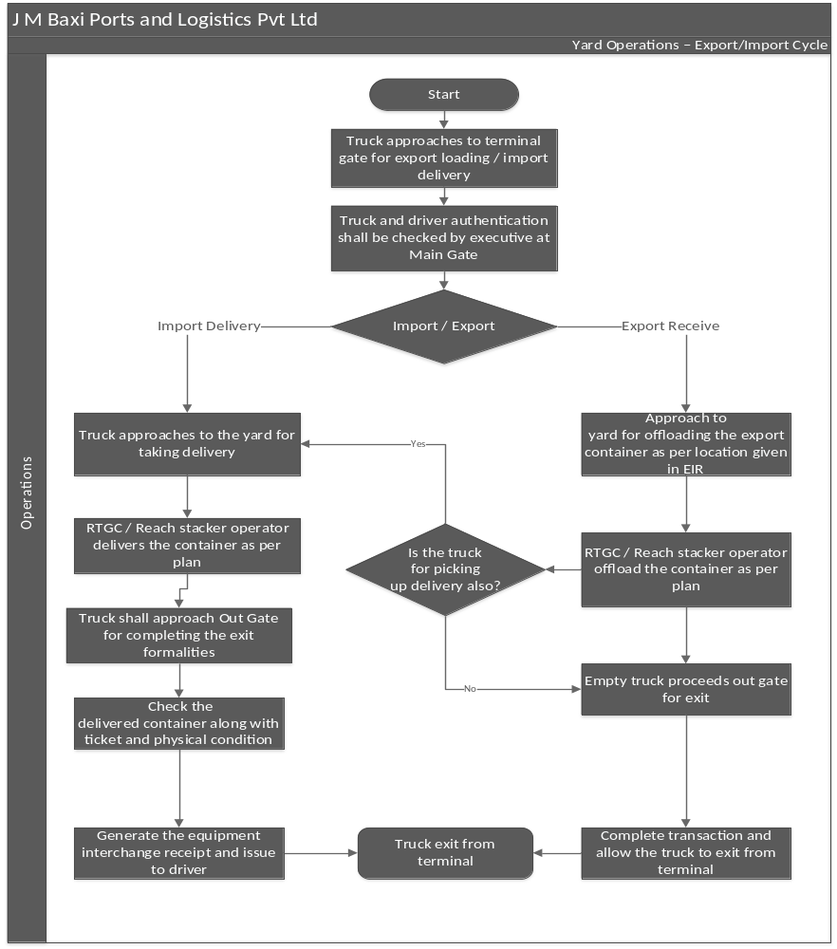

Process Flow

Rail Operations

Export – Import Cycle

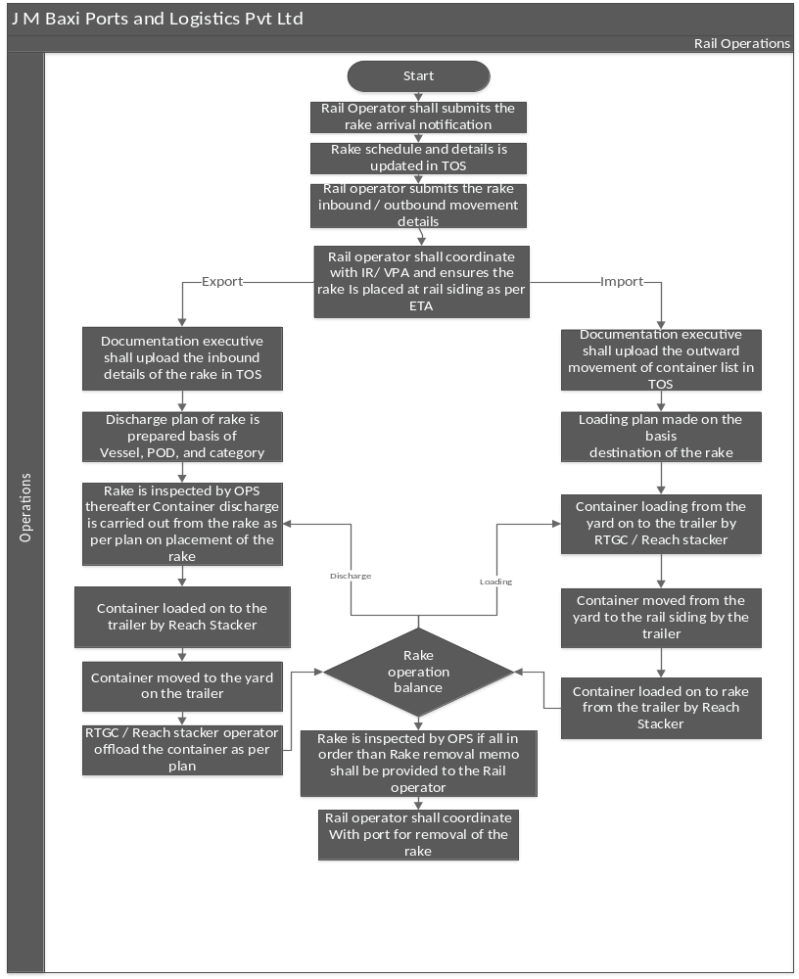

Key Process Activities

Gate In Process – ETV Entry

Process Narrative
Description | Responsibility | Accountability | Frequency | System / Manual
- ETV Gate Entry  - ETV enters Terminal inspection point through approach road - Trail drivers follow road traffic/ safety signage’s/ posters which are displayed along the approach road Security guard shall carry out security checks. Further, Trail driver shall position the trailer at inspection point.  - Positioning of trailer - Security Guard shall carry out security check and see if everything is in order. Tally clerk shall carry out the tally checks. If not in order, send trailer to ETV parking for further instructions. Inform gate not to allow any transactions for the trailer.  - Check container no. and seal no. physically - Tally clerk checks container no and seal no. physically and for Exports, check pre-gate/ cut off/ seal intactness status/ seal number matching.  - Scan export container RFID seals/ issue delivery ticket - Tally clerk checks if everything is in order. If not, Inform GEX and send trailer to parking. GEX shall issue out gate pass. If yes, Customs personnel/ transport  supervisor Scan export container RFID seals/ issue delivery ticket.  - ETV shall enter gate complex lane - Customs personnel/ transport supervisor scan export container RFID seals/ issue delivery ticket is in order. If yes, ETV shall enter gate complex lanes, and this shall be indicated through traffic light located at the entry point of each lane. If not, send trailer to ETV parking for further instructions. Inform gate not to allow any transactions for the trailer.  - Generate EIR/ pick up ticket from printer located at the kiosk in each lane - Trailer driver show delivery ticket/ BAT no. to the camera on KIOSK and gate executive check details in the TOS by using camera images. Further, Generate EIR/ pick up ticket from printer located at the kiosk in each lane. EIR soft copy shall be sent to respective liner from the TOS by email.  - Collect the printed EIR/ pick up ticket from KIOSK -Trailer driver collect the printed EIR/ pick up ticket from KIOSK.  - Start engine and proceed to nominated CYs - Gate executive press boom barrier up button of that lane. Trailer driver start engine and proceed to nominated CYs. Boom barrier shall automatically close after entire trailer moves out from the lane. Follow road/ safety signages/ posters.  - Terminal Traffic Management Traffic Plan – ETV Route -Trailer drivers reach particular CY per traffic Plan – ETV Route | Executive - Operations | Manager/HOD -Operations | As & When | Manual
- Trailer Entry to GCB (Empty) Yard  - Enter ETV details entered in TOS for taking delivery/ offloading containers - Gate Executive enter ETV details in TOS for taking delivery/ offloading containers and instruct the Trailer Driver about designated location for offloading and clearly communicates traffic flow if delivery is from GCB yard.  - Approach GCB gate through main gate route - Trailer driver approach GCB gate through main gate route through Terminal Traffic Management Plan – ETV Route  - Verify the EIR copy/ Pickup ticket and allow the trailer inside GCB Yard – Security guard verify the EIR/ pick up ticket and allow the ETV to GCB yard by opening the boom barrier.  - Proceed to GCB yard as mentioned in EIR copy/ pickup ticket - Trailer drivers proceed to GCB yard as mentioned in EIR copy/ pickup ticket. | Executive - Operations | Manager/HOD -Operations | As & When | Manual

Planning Procedure - Vessel Planning

Process Narrative
Description | Responsibility | Accountability | Frequency | System / Manual
2.1 Vessel Nomination/VIA Creation  - Vessel Operating Agent (VOA) submits Vessel Identification Number (VIA) application with relevant details at least 10 days before arrival.  - Documentation team verifies if submitted documents are in order.  - If correct, VIA number is allotted as per sequence using Form-13, and data is updated in Terminal Operating Software (TOS)  - If skipped, VOA is notified, VIA is cancelled with charges, and Finance is informed.  - If no skip, process concludes successfully. | Executive - Operations | Manager/HOD -Operations | As & When | Manual
- Loading Plan – Export  - VOA submits documents at least 6 hours before ETA.  - Planning Documentation team reviews EAL for discrepancies and requests corrections if needed.  - Verified EAL is uploaded into TOS by Documentation Team  - Vessel Planner checks vessel data to prevent errors and restowing.  - Discrepancies are communicated to VOA for confirmation by documentation team; containers are released for loading.  - Loading projections are automatically or manually created in TOS by Planning team.  - Containers are planned in TOS considering stability, placement, and allocation by planning team.  - Vessel Planner creates the loading plan as an EDI file within TOS.  - Loading plan is submitted to Vessel Chief Officer for approval by Vessel planner/Planning team.  - If approved, the loading sequence is prepared and assigned to CHEs by Vessel planner/Planning team.  - Final EDI is submitted to Vessel Chief Officer one hour before completion by Vessel planner/Planning team | Executive - Operations | Manager/HOD -Operations | As & When | Manual
2.3 Discharge Plan – Import

- VOA submits BAPLIE & IAL documents at least 8 hours before ETA.
- Planning Documentation team checks for discrepancies and requests corrections if needed.
- Verified documents are uploaded into TOS.
- Vessel Planner prepares the discharge plan and assigns it to the Quay Crane.
- Yard Planner prepares the yard plan based on the discharge destination.

Planning Procedure - Yard Planning

Process Narrative
Description | Responsibility | Accountability | Frequency | System / Manual
2.1.1 Receiving - Export  - Yard allocation and work que to CHE - Yard planner creates yard allocation based on the projection from VOA/ average of previous vessel handling summary, POD, length, weight and category and optimum ratio of CHE to RMQC and Assign the work queue to CHE.  - Monitor and control the yard movement thru TOS-Yard planner shall ensure that the special category containers i.e., OOG, IMDG and Reefers etc., are offloaded as per the plan made and updated in VMT by CHE operator and Monitor and control the yard movement through TOS. | Executive - Operations | Manager/HOD -Operations | As & When | Manual
- Discharge – Import  - Yard allocation and work que to CHE - Yard planner creates yard allocation based on FPD, length, category, and optimum ratio of RTGC to RMQC. and assign the work queue to CHE.  - Monitor and control the yard movement thru TOS - Yard Planner shall ensure that the special category containers i.e., OOG, IMDG and Reefers etc., are offloaded as per the plan made and updated in VMT by CHE operator, monitor and control the yard movement through TOS. | Executive - Operations | Manager/HOD -Operations | As & When | Manual

2.2 Planning Procedure - Rail Planning

Process Narrative
Description | Responsibility | Accountability | Frequency | System / Manual
- Rail Schedule Creation  - Submit the rake placement memo - Container Train operator submits the rake placement memo. Request shall be sent through mail or submit the hard copy.  - Create Rail schedule -Documentation Executive verifies if in order and creates the rail schedule. If not, Train Operator shall be informed. Errors shall be corrected by Train Operator | Executive - Operations | Manager/HOD -Operations | As & When | Manual
2.2.2. Rail Discharge Plan – Export  - Submit the rail inbound list and Form-11 respectively-Before train arrival 8 hours, Container Train Operator & Shipping Line submit the rail inbound list and Form-11, respectively.  - Upload the inbound details in TOS-Documentation Executive checks for error if no, upload the inbound details in TOS. If yes, errors shall be corrected by Train operator / shipping line.  - Discharge location assigned in main CY-If outbound known, Yard planner discharge location assigned in main CY, if not Discharge location assigned in buffer yard  - Prepare the sequence list and assign to HHT-Yard planner prepare the sequence list and assign to HHT. | Executive - Operations | Manager/HOD -Operations | As & When | Manual
- Rail Loading Plan – Import  - Submit the TP/ DO/ Bill of Entry and Form 21 respectively-8 hours before train arrival, Container Train Operator & Shipping Line submit the TP/ DO/ Bill of Entry and Form 21, respectively.  - Release the containers for loading on rail-Documentation Executive release the containers for loading on rail. He shall consider as per  • Dwell time for empty boxes  • Rail destination i.e., ICD / factory.  - Prepare the loading plan-Yard planner prepares the loading plan based on number of wagons and containers.  - Prepare the sequence list and assign to CHE-Yard Planner prepares the sequence list and assign to CHE. | Executive - Operations | Manager/HOD -Operations | As & When | Manual

Vessel Operations- Vessel Berthing

Process Narrative
Description | Responsibility | Accountability | Frequency | System / Manual
- Vessel Berthing - Pre – Berthing  - Submit Berthing Application-Vessel Operating Agent (VOA) send the berthing application to the documentation section before 24 hrs. of the vessel arrival along with the stowage Plan and pre-stow  - Allocate Berth-Planning in charge assign the berth based on the vessel's estimated time of arrival (ETA).  - Submit to VPA-Vessel Operating Agent (VOA) submits the berthing application duly signed by VCTPL representative to VPA and request pilotage.  - Provide vessel pilotage and towage-Visakhapatnam Port Authority (VPA) provides vessel pilotage and towage services as per the license agreement. | Executive - Operations | Manager/HOD -Operations | As & When | Manual
- Berthing  - Keep Berthing Flags and Flashlight-Ensure berthing flags and flashlight are placed on the jetty.  - Keep QCs in Boom-Up Condition- Shift in charge / berth executive shall:  - Placed Flashing light at stern side in dark lights hrs  - Keep min 50m away from bow or stern from vessel berthing area or keep in the mid of the vessel berthing area.  - Ensure operators are not in QCs.  - Berth Vessel-Visakhapatnam Port Authority (VPA) safely and smoothly berth the vessel alongside in the same berth length as declared in the berthing application.  - Monitor Berthing Activity-Shift In-Charge / Berth Executive guide the ship for smooth berthing and gangway placement. Stands and follow vessel stern edge position on berth to help pilot for berthing vessel as per plan. Ensures not allow anyone on wharf or near mooring ropes during mooring of vessel. Oversee and track the berthing process to ensure smooth operations. | Executive - Operations | Manager/HOD -Operations | As & When | Manual

3.1 Vessels operation - Vessel Loading - Export

Process Narrative
Description | Performed By | Accountability | Frequency | System / Manual
- Allocate Crane and Establish Working Sequence  - Prepare QC working sequence-Based on the stowage and no. of cranes allocated to the vessel, Vessel Planner Prepare QC working sequence.  - Allocate QCs and CHEs-On accessing of vessel stowage Shift In-charge allocate QCs and CHEs  - Placement of Pinning Stations-Berth Executive positions pinning station away from the working QCs, possible safest distance from POW prior commencement of discharge/ Loading operation.  - Ensure all personnel in wharf should be positioned in pinning stations-Prior commencement of discharge/loading operation. Berth Executive ensures all personnel in wharf should be positioned in pinning stations. | Executive - Operations | Manager/HOD -Operations | As & When | Manual
- Vessel Container Loading  - Take approval for export stow plan from vessel-Vessel planner confirms loading plan with vessel chief and takes approval for export stow plan from vessel  - Identify ITV entry and exit based on traffic plan-Berth executive takes approval for export stow plan from vessel and Identify ITV entry and exit based on traffic plan.  - Inspect vessel operational work area-Berth Executive Inspect vessel operational work area and prepares vessel Inspection check list.  - Load containers from CY onto the ITVs-CHE Operator As per the loading sequence in the VMT and Load containers from CY onto the ITVs.  - Transport container from CY to wharf pinning station-ITV Driver transport container from CY to wharf pinning station.  - Inspect containers in pinning station-Tally clerk inspect containers in pinning station Container number is listed in the Vessel Loading List.  - Pinning & Unpinning Twist locks-If container no. is in list tall clerk, allow lashers to put appropriate twist locks to containers. If not, stop container and inform BEX / planning. If planning confirms allow lashers to put appropriate twist locks to containers and ITV driver proceed to respective QC. If not, inform BEX and send it to CY.  - Hatch Cover Handling-If H/C handling required, hatch clerk guides operator for hatch cover handling.  - Load container in vessel slot as indicated in the vessel loading list-QC Operator load container in vessel slot as indicated in the vessel loading list. Extra care shall be taken to ensure safe loading of special containers like High Cube, OOG containers, Reefer containers and Hazardous containers  - Update sequence sheet and HHT-Tally clerk updates sequence sheet and HHT and Tick respective container in the sequence sheet.  - Man Cage Operation-If man cage ops required; berth executive arranges man cage.  - Lashing & Unlashing Containers-Lashing Supervisor lashes the containers and take acknowledgement from vessel about lashing completion and housekeeping.  - Load gear boxes - If loading ops completed, Berth Executive load gear boxes onboard the vessel as planned by vessel and ensures all bins are loaded in gear boxes after completion of vessel operations.  - Submit final Bay Plan-Vessel planner on completion of loading operation, submit final bay plan to chief officer. | Executive - Operations | Manager/HOD -Operations | As & When | Manual

3.2 Vessels operation- Vessel Discharge - Import

Process Narrative
Description | Performed By | Accountability | Frequency | System / Manual
- Allocate Crane and Establish Working Sequence  - Prepare QC working sequence-Vessel planner prepares the QC working sequence based on the stowage and no. of cranes allocated to the vessel  - Allocate QCs and CHEs-Shift In-charge allocate QCs and CHEs on accessing of vessel stowage  - Place Pinning Stations-Berth Executive places pinning stations and usually position it away from the working QCs, possible safest distance from POW prior to commencement of discharge operation.  - Ensure all personnel in wharf should be positioned in pinning stations-Berth Executive ensure all personnel in wharf should be positioned in pinning stations prior commencement of discharge operation. | Executive - Operations | Manager/HOD -Operations | As & When | Manual
- Vessel Container Discharge  - Identification of ITV entry and exit-Berth Executive identifies ITV entry and exit based on the traffic plan and place safety cones for demarcation of wharf area  - Inspect operational area on vessel-Berth Executive inspect operational area on vessel and prepares vessel inspection Check list.  - Man Cage Operation- If man cage ops required, berth executive arranges man cage.  - Lashing & Unlashing Containers-Lashing Supervisor unlashes the containers  - Discharge gear box-Berth executive discharges the gear box and places the bin at pinning/unpinning stations as per operations requirement  - Hatch Cover Handling- If H/C handling required, hatch clerk guides operator for hatch cover handling.  - Discharge containers onto ITVs-QC operator Discharge containers onto ITVs. Hatch clerk ensure discharging containers as per vessel discharge sequence List.  - Proceed to respective unpinning station-ITV Driver proceed to respective unpinning station. Make sure OOG containers should not allow into pinning stations.  - Inspect containers in unpinning station-Tally clerk inspect containers in unpinning station verifying Container no. as listed on the Discharge Sequence List / HHT, Seal No., Hazard stickers and Damage, if any.  - Stop container on the jetty and inform BEX/ Planning-If container number is not in the list tally clerk stops container on the jetty and inform BEX/ Planning. If planning does not confirm, inform BEX and restow container.  - Record seal number in the discharge sequence sheet and HHT-Once confirmed on the container no.is in the list, tally clerk Record seal number in the discharge sequence sheet and HHT, Tick respective container in the sequence sheet. If seal mismatch observed at wharf, actual seal no. will be recorded and updated under seal 2 tab of HHT. Docs to share seal mismatch list to terminal customs after completion of vessel operations if applicable.  - Fix new bottle seal to container and record seal number-Tally clerk fix new bottle seal to container and record seal number If no bottle seal for laden containers.  - Pinning & Unpinning Twist Locks-Tally clerks allow lashers to remove twist locks  - Traffic Management Plan-ITV driver transport containers to designated location as per traffic route.  - Vessel Loading-Berth Executive commence loading ops if discharge ops completed  - Short Landed containers-In case of short landed containers, vessel planner inform VOA after completion of vessel discharge operation. Further, VOA Inform planning section about action taken in this regard.  - Over Landed containers-In case of over landed containers, vessel planner Inform VOA after completion of vessel discharge operation. Further VOA provide letter with written instructions along with Customs permission. If VOA fails to respond, vessel planner restows over landed containers before completion of vessel operation | Executive - Operations | Manager/HOD -Operations | As & When | Manual

3.3 Vessels operation - Vessel Unberthing

Process Narrative

Description | Performed By | Accountability | Frequency | System / Manual
- Sailing/Unberthing of Vessel  - Submit final plan to vessel chief officer-ETC shall be informed at starting of operation. Preferably, one hour before completion of operation. Vessel planner submits final plan to vessel chief officer  - Inform vessel chief officer to give 1 hr. notice-Shift In-Charge / Berth Executive gives one hour cargo completion notice o vessel chief officer for readiness for sailing.  - Ensure vessel contacted port control in time-Agent shall submit required documents before loading ops completion. Shift In-Charge / Berth Executive ensure vessel contacted port control in time.  - Ensure necessary acknowledgements are taken from vessel chief-Shift In-Charge / Berth Executive shall ensure necessary acknowledgements are taken from vessel chief. such as  · Lashing certificate.  · Reefer manifesto.  · Import Damage Reports.  · Gear Box, Gangway, Protest letters, etc.  - Keep QCs in boom up condition-Berth Executive Keep min 50m away from bow or stern from vessel unberthing area or keep in the mid of the vessel unberthing area and ensure operators are not in QCs. Further, keeps QCs in boom condition.  - Inform port control about vessel readiness for sailing-Master/ Chief officer of the vessel Inform port control about vessel readiness for sailing and indicate its readiness by hoisting the sailing flag or switching on the sailing lights.  - Un-berth/ sail the vessel smoothly-Visakhapatnam Port Authority (VPA) Un-berth/ sail the vessel smoothly  - Monitor the vessel Unberthing Activity-Shift In-Charge / Berth Executive monitor the vessel unberthing activity. Further, do not allow unauthorized persons on wharf or near mooring ropes during unmooring of vessel. | Executive - Operations | Manager/HOD -Operations | As & When | Manual

Yard/Road Operations - Export received by Road

Process Narrative
Description | Performed By | Accountability | Frequency | System / Manual
- Export received by Road  - e - form 13 generated against each container and posted to SL and nominated CFS / CHA-Shipping line upload pre-advice file for CFS / factory stuffed export In FTP Folder (CSV file). VOA complete submit VIA application 10 days prior to arrival with container and vessel details. E-form 13 is generated and sent to shipping lines and CFS/CHA. E-form 13 contains: Container number, VIA no, Vessel name, POD, Category, type, ISO code etc.  - Update data and pre-advice the container- CFS/CHA updates system with shipping bill, seal, truck number, and driver name. If factory stuffed export, terminal pre-gate staff verifies documents and enter missing details at terminal pre-gate. Trailer driver enter into VCT container inspection point through gate complex approach road. In queue line, following traffic rules and regulations.  - Gate Inspection -Tally clerk verifies container and seal numbers, RFID seals. If seal mismatch, container shall not be received until corrections are done by customs. For RFID seals, select seal no.2 and update RFID seal no and selects 'Yes’ button in gate inspection screen. He checks physically trailer no., container condition, any hazardous stickers, any damages other than normal wear and tear, if open top container, tarpaulin cover intact condition.  - Proceed to gate complex -Trailer driver undergoes security check and customs seal scanning before proceeding. Trailer shall move after completion of security check and customs seal scanning. In case of weighment, trailer shall move to line 3.  - Gate Executive checks container condition, damage, and tarpaulin cover-Gate Executive checks container condition, damage, and tarpaulin cover intactness through cameras. If damage observed, captures damage images, and prepare damage report. Mail shall be sent to SL. If Hazardous stickers are found on non-hazardous, Instruct trailer driver to remove stickers by using scraper that is available in ETV parking area.  - Generate EIR, print the Ticket. And Raise boom barrier up-Gate Executive generates EIR, prints ticket, and directs trailer driver if everything in order. If not, container shall not be received until corrections are done by customs. Ticket contains -  • Container number & Size  • Yard location  • Vessel name and VIA  • ISO CODE  - Collect the ticket from KIOSK located individual lanes and proceed to nominated CY-Trailer driver collect the tickets from KIOSK and proceed to nominated container yard as per yard location mentioned in printed copy. CHE operator offloads containers, and update VMT. Trailer driver; picks up import container if dual transactions.  - Offload the container as per planned location and update VMT-CHE operator offloads container and updates Vehicle Mounted Terminal (VMT). Trailer driver approach to out-gate through gate complex. In case of weighment, trailer shall move to old gate complex and complete weighment process.  - Completes the transaction and allow the truck to move out-Gate executive completes the transaction and allow the trailer to move out. Trailer driver exit from the terminal through port gate. | Executive - Operations | Manager/HOD -Operations | As & When | Manual

4.1. Yard/Road Operations - Import Delivery by Road

Process Narrative
Description | Performed By | Accountability | Frequency | System / Manual
4.1.1 Containers Moving out by Road to CFS / ICD / Factory De-stuffing  - Issue ‘TSA’ to VCT Planning Section-CFS Operator or Customs issue transhipment permit application (TSA) though mail soft copy/ hard copy to Terminal Planning Section for scheduling container movements.  - Update ‘TSA’ list of containers in TOS-Documentation Executive updates TSA list in TOS and releases containers for delivery movement.  - ‘RELEASE’ containers-After checking for any 'Hold' instructions document executive ‘RELEASE’ containers. Truck Appointment Number and Import Delivery Ticket are generated by CFS operator based on the sequence list prepares and Import delivery ticket.  - Reach Terminal Inspection point with empty trailer through approach road-Trailer driver Reach Terminal Inspection point with empty trailer through approach road undergoes security checks and proceeds to gate complex.  - Check trailer details by using camera images-Gate Executive verifies trailer details such as Trailer no. Trailer condition, No. Twist locks through cameras and verifies the data with truck appointment no. / Delivery ticket. And Print pick up ticket if in order. Gate executive raise boom barrier up. Driver collects ticket from KIOSK and move trailer to move designated CY. If not in order, Inform SIC and act upon his instructions or park in ETV parking area until further instructions. Once the problem solved, driver collect pick up ticket from parking KIOSK & move trailer to designated CY.  - Collect ticket from KIOSK-Trailer driver Collect ticket from KIOSK Ticket contains -  • Container number & Size  • Yard location  • Vessel name and VIA  • ISO CODE  - Container Weighment-Shipping line submits SRF with list of containers to documentation before arrival of containers to terminal. Weigh the empty trailer in  weigh bridge lane and proceed to designate container yard and approach the designated yard location.  - Arrange CHE in that particular CYs- Yard executive arrange CHE in that particular CY’s and ensure CHE operator getting import delivery list in VMT.  - Load container on trailer and update VMT-On showing the Bat No. to CHE operator, Load container on trailer and update VMT. Then trailer approach out gate as per traffic plan.  - Collect delivery ticket from truck driver- Trailer shall be stopped for inspection at marked gate inspection point. Tally clerk Verify container details physically such as container no, seal no. and collect delivery ticket from truck driver. If CFS delivery, group shall be checked. If factory delivery, container no. shall be checked.  - Generate EIR- on physical verification of the Container No. and Seal No by tally clerk, generates EIR if in order, if not Inform Gate executive and act upon his instructions.  - Move out from Terminal along with containers through main gate- Trailer driver collect the printed EIR copy from KIOSK. During security checks at out gate, if empty import delivery, container shall be checked by opening doors whether its indeed empty or not and then strap seal shall be affixed. | Executive - Operations | Manager/HOD -Operations | As & When | Manual

Yard/Road Operations - Dual Transactions

Process Narrative
Description | Responsibility | Accountability | Frequency | System / Manual
- Dual Transactions  - Pre-advice export containers and create truck appointments for import containers-CFS/CHA pre-advises export containers and create truck appointments for import containers.  - Reach container inspection point through gate complex approach road-Trailer Reach container inspection point through gate complex approach road.  - Check seal number physically and update 2nd seal no. in tab-Tally clerk Check seal number physically and update in tab Gate Inspection Screen. Trailer drivers proceed to gate complex. OOG containers shall be allowed into OOG lane only. Weighment trailers in lane 3shall be allowed.  - Check details by using camera images- Gate Executive checks container details using camera images Trailer no, Container condition, any hazardous stickers, Any damages other than normal wear and tear. And performs weighment if required.  - Generate EIR. Print Tickets-Gate Executive generates EIR, prints ticket, and directs trailer driver if everything in order. If not container shall not be received until corrections are done by customs. Ticket contains -  • Container number & Size  • Yard location  • Vessel name and VIA  • ISO CODE  - Collect the tickets from KIOSK and proceed to nominated container yard-Trailer driver collect the tickets from KIOSK and proceed to nominated container yard as per yard location mentioned in printed  - Offload the container as per planned location. And Update VMT-CHE Operator Offload the container as per planned location. And Update VMT. Trailer driver Move to another yard location for pick up container. In case of delivery not possible, wait in trailer parking area. Use parking KIOSK to communicate with gate.  - Load container on trailer and update VMT-On showing the Bat No. to CHE operator, Load container on trailer and update VMT.  - Move out of Terminal along with the containers through Main Gate-Trailer driver Proceeds to VCT out –Gate.Tally clerk Verify details of container such as container number, seal no. If everything in order gate executive Generate EIR. Trailer driver collects EIR copy from KIOSK. If not, tally clerk Inform Gate executive and act upon his instructions. Trailer exits through Terminal-Out Gate after final security and seal checks. | Executive - Operations | Manager/HOD -Operations | As & When | Manual

5. Rail Operations- Rail Discharge Operation

Process Narrative
Description | Performed By | Accountability | Frequency | System / Manual
- Rail Discharge Operation  - Plan Containers-Yard Planner plans containers after receiving form 11 from shipping line/ agent.  - Ensures proper placement of rake in planned lane-Rail Executive escort rake / engine, close LMV lanes at port gate, place rail skids after rake placement. And ensures proper placement of rake in planned lane.  - Check container damages on the operational side of the wagon-Prior to commencing operations Tally clerk check container damages on the operational side of the wagon  - Unlock Containers-If manual Twist locks, lashers unlock containers. In case of 2 rakes, Tally clerk and Lashers position in between 2 rakes for seal checking. If not, position on the other side of rail operation. For seal checking, position on the other side (opp. to CHE) to avoid Man Machine Interface.  - Deploy CHEs and ITV-Shift In charge deploys CHEs and ITVs to discharge containers on ITVs. If 2 CHE are deployed, Rail Executive/ Yard Executive Deploy on one CHE from starting to mid and other CHE mid to end.  - Discharge containers on ITVs-CHE Operator In accordance with the discharge plan, discharge containers on ITVs.  - Inspect each container and update in HHT-Tally clerk Inspect each container and update in HHT such as Container number as listed on the Discharge Sheet / HHT, Seal No., Hazardous stickers, Damage, if any  - Container/bottle seal mismatch-If container no. mismatch, Planning Executive Inform Train operator. Act upon their instructions. If no bottle seal/ mismatch Inform SL, train operator, and inform mismatch seals to customs.  - Container Placing-Respective shipping line / agent shall affix the bottle seal after taking approval from customs. Container shall be placed separately by the yard planner. If any damage, Information shall be sent to respective shipping line through auto mail and Tally clerk Update damage details on HHT. If missing has stickers, Documentation Executive Inform respective shipping line. and act upon their instructions  - Transport container from rail siding to CY-ITV driver transports container from rail siding to CY.  - Offload containers from ITVs in CY and update VMT-CHE Operator Offload containers from ITVs in CY and update VMT.  - Rail Loading Operations-If back loading, rail executive conducts rail loading operations. If not, submits tally sheets to planning section on completion of rake operation.  - Rail removal memo-Documentation executive submits rail removal memo to train operator | Executive - Operations | Manager/HOD -Operations | As & When | Manual

5.1 Rail Operations - Rail Loading Operation

Process Narrative
Description | Performed By | Accountability | Frequency | System / Manual
- Rail Loading Operation  - Release containers-After receiving TP along with form 21 from shipping line/ agent. Documentation executive ensures that containers which are not scanned should not be released for loading.  - Plan Containers-Yard Planner plans containers after receiving form 11 from shipping line/ agent.  - Load containers on ITV’s-As per the loading list CHE operator load containers on the ITVs. ITV Driver transport containers from CY to rail siding.  - Check containers and seal numbers-Tally Clerk checks containers and seal numbers that are listed on the Load List / HHT. If any mismatch for container, inform planning& REX and send back. For seal mismatch, tally to update physical seal no. in HHT/ TAB  - Load container on the rake-Tally clerk shall update container no. and wagon no in TAB / HHT. In case of seal fixing, container door direction should be outside. CHE Operator Load container on the rake  - Rail Removal Memo-Documentation executive submits rail removal memo to train operator. | Executive - Operations | Manager/HOD -Operations | As & When | Manual

6. Gate Out Operations - ETV Exit

Process Narrative
Description | Performed By | Accountability | Frequency | System / Manual
- ETV Gate Exit  - VCT Traffic Management Plan – ETV Route-After offloading the container in the CY or loading the container from the CY, trailer shall reach out gate as per traffic plan. Trailer driver proceed through T1 gate complex  - Stop trailer at the ear marked lanes before gate complex for inspection-STOP boards are placed and marked at out gate inspection points. Trailer driver Stop trailer at the ear marked lanes before gate complex for inspection.  - Place wedges /chokes on front wheel of ETV-Security guard/Tally clerk shall place wedges/ special designed wheel chokes on front wheel of ETV  - Security checks at inspection point-Security checks shall be done at inspection point. If any discrepancy, security shall stop trailer and inform duty SO/ SIC.  - Carry out physical verification-Tally clerk shall Carry out physical verification. In case of delivery, tally clerk shall check and update container seal no. If everything in order, Gate executive generate EIR.. If not, tally clerk informs Gate Executive and act upon their instructions.  - Move out from terminal through GCB road-Security shall press boom up button after security checks. And then allow ETV to move out. Trailer driver proceeds through port gate and move out from terminal through GCB road. | Executive - Operations | Manager/HOD -Operations | As & When | Manual
- Trailer Exit To GCB(Empty) Yard  - Proceed to GCB (Empty) Yard out gate-After offloading the container in the GCB (Empty Yard) CY or loading the container from the GCB (Empty Yard) CY, trailer shall reach out gate, Trailer driver Proceed to GCB (Empty) Yard out gate.  - Stop at the ear marked lanes in front of GCB (Empty) Yard out gate for inspection-Trailer driver stops at the ear marked lanes in front of GCB (Empty) Yard out gate for inspection. Security checks shall be done at GCB (Empty Yard) out gate. If any discrepancy, security shall stop trailer and inform duty SO/ SIC.  - Check trailer/ container details and generate EIR in TOS screen-If everything in order Gate executive Check trailer/ container details and generate EIR. If not, Tally clerk, Inform Gate Executive, and act  upon their instructions  - Move out from terminal through GCB out gate road-Security shall allow ETV to move out, Trailer driver moves out from terminal through GCB out gate road. Trucks have come for offloading empties alone, shall not be allowed to terminal through port gate for next transaction. They must take delivery slip at main gate in case of dual transaction. | Executive - Operations | Manager/HOD -Operations | As & When | Manual

Symbols/ legends used in flowcharts

Start/End
Manual process activity
Decision/possibility/alternative
Alternate process
Process connecting in same page
Process connecting in other page
Output document
Flow direction

