**J M Baxi Ports & Logistics Pvt Ltd**

Standard Operating Policy and Procedures

Treasury Process

**Introduction**

A standard operating policy & procedure (SOPP) is a set of step-by-step activities compiled by J M Baxi Ports & Logistics Pvt Ltd (**“JMBPL”**) and its subsidiaries (collectively referred to as “**the Group**”) to help the employees to carry out complex as well as standard routine operations. SOPPs help to achieve efficiency, quality output and uniformity of performance while contributing to efforts that lead to process excellence.

This SOPP aims to achieve the following objectives:

1. Act as a guide and reference document to stakeholders at all levels of the organization.
2. Clearly communicate activities and help to achieve consistency in operational procedures.
3. Create accountability by assigning responsibilities at each stage of the lifecycle.
4. Aid governance by documenting auditable processes and detailing control elements at each stage of the lifecycle.

What is the Lifecycle and Process Tree?

Each SOPP follows the process tree hierarchy and covers a specific entire process.

* A process represents logical grouping of sub processes and provides detail at functional level.
* A sub process represents grouping of similar activities.
* An activity lists down specific tasks that have/are measurable, time bound, associated risks, mitigating controls and defined owners.

The entire business lifecycle consists of several processes. An SOPP is tasked with the coverage of all sub process and activities applicable to a particular process.

Who are the Stakeholders for this SOPP?

The stakeholders for this SOPP shall primarily be activity owners and business units.

1. Activity owners (operating units) – Activity owners shall use this SOPP as a reference document while performing their activities daily.
2. Business units – Business units shall use the SOPP as a repository of all activities across the lifecycle. This will aid in identifying process improvement opportunities.

Who will use this SOPP?

This SOPP shall be used by stakeholders across the entire organization. Most notable shall be the following:

1. Risk and Governance units – Risk and Governance units shall reference the SOPP to review existing controls and test their **effectiveness.**
2. Auditors – Auditors shall use this SOPP to check adherence to defined processes and standards. The SOPP shall help them identify any deviations to defined processes and standards, ensuring that corrective actions are taken promptly to address any discrepancies and improve overall compliance with established procedures.

How do you read the SOPP?

To read this SOPP, it is essential to understand the process lifecycle and its coverage. This SOPP is documented in chronological order in line with the sequence of activities performed by activity owners. Therefore, it should be read as such.

This SOPP also provides references to various organization level policies, checklists, systems, reports etc. These have been appropriately referenced at applicable activities and attached as Annexures to this SOPP.

Each activity has an activity owner assigned to it. An activity also has the following references against it:

* Performer – Person who will execute the activity.
* Frequency – Each activity has defined period.
* Template – Reference to any template (If Any)
* System reference – Each activity is performed either manually or rooted through system.

Organization structure

The organization structure defined in the SOPP is the structure defined at the functional level. 'Activity owners' are defined as those who are responsible for performing the activity. 'Business Owners' are defined as those who have oversight and ultimate ownership for the activities.  
  
The 'roles and responsibilities' table in the SOPP lists down the 'business owners' and provides details on key activities they are responsible for. The list of 'business owners' shall form the organization structure for the SOPP and mega process.

Rules for this SOP

* SOP will be reviewed every year and necessary changes if any will be updated.
* Any changes in SOP will be made by authorized person and approved by **Sr. Vice President – Corporate Finance**.

Document review and approval

Revision history

| **Version** | **Created By** | **Document Approved By** | **Date Approved** | **Revision** |
| --- | --- | --- | --- | --- |
| V1 | XX | Sr. Vice President – Corporate Finance | XX | XX |

| **SOPP number** | 1 |
| --- | --- |
| **Process owner** | Sr. Vice President – Corporate Finance |
| **IT applications** | SAP HANA |
| **Guidelines / policy reference** | NA |
| **SOPP cross references** | NA |

**Contents**

Executive summary 6

Applicability of SOPP 6

Organization Structure 6

Abbreviations 7

Key Process Activities 8

1. Opening and closing of bank account 8

2. Borrowings 11

3. Inter-company borrowings 17

4. Fund management 19

5. Updation of authorized signatory 21

6. Cash in hand 22

7. Hedging foreign exchange exposure 24

Policies, guidance and standard templates 26

## Executive summary

The Treasury Process is a strategic framework designed to optimize the organization's liquidity, funding, and financial risk management. This document outlines the processes, roles, responsibilities, and controls essential for managing cash flow, investments, debt, and financial instruments, ensuring financial stability and supporting business growth. The Treasury Process aims to enhance the organization's overall financial health, mitigate financial risks, and maintain compliance with regulatory standards and organizational policies.

The Treasury Process SOPP aims to:

* Establish a standardized approach for managing cash, funding, and financial instruments.
* Enhance accuracy, timeliness, and efficiency in treasury operations.
* Ensure compliance with internal policies, regulatory requirements, and industry best practices.
* Strengthen financial risk management to reduce exposure to market fluctuations, liquidity risks, and operational inefficiencies.
* Promote transparency and accountability in treasury activities, supporting strategic decision-making and financial sustainability.

## Applicability of SOPP

The Treasury SOPP is applicable to all the entities across the Group.

## Organization Structure

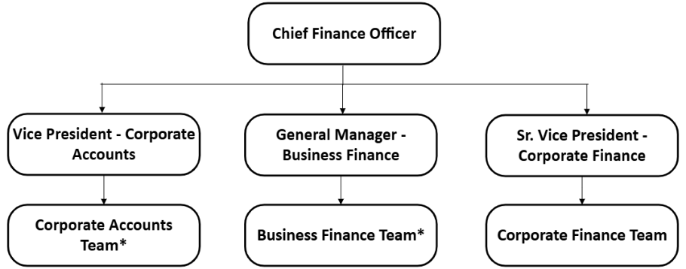

*Covered in FSCP SOPP

1. **Corporate Finance Designations: Roles defined in SOPP is as per below Matrix.**

| Corporate Actual Designations | Role | Level |
| --- | --- | --- |
| Manager/Sr. Manager | Executive | L1 |
| Assistant General Manager / General Manager / Assistant Vice President | Manager | L2 |
| Sr. Vice President/ Vice President | Vice President | L3 |
| COO / CEO/ Group CFO / CIO / National Sales Head /Corporate Function Head | COO /CEO / Group CFO / CIO / National Sales Head /Corporate Function Head | L4 |
| Managing Director | Managing Director | L5 |

## Abbreviations

|  |  |  |
| --- | --- | --- |
| **Sr. No.** | **Term** | **Description** |
|  | Authorised signatories | These are bank signatories defined for each bank account.  Matrix for Authorised Signatories:  Single Approval - JMBPL Director and Promotor  Dual Approval - For each terminal group A and group B is maintained, each transaction is approved by authorised signatories from each group i.e. 2 signatories. |
|  | Project Team | Project team is responsible for setting up any terminal and are based out of Goa and reports to Group President, Business Development. |
|  | SPV | Special purpose vehicle  Subsidiary created by JMBPL for new projects. |
|  | Corporate Legal Department | Defined under FSCP SOPP |
|  | Corporate Accounts Team | Defined under FSCP SOPP |
|  | Business Finance Team | Defined under FSCP SOPP |

## Key Process Activities

### Opening and closing of bank account

**Process flow**

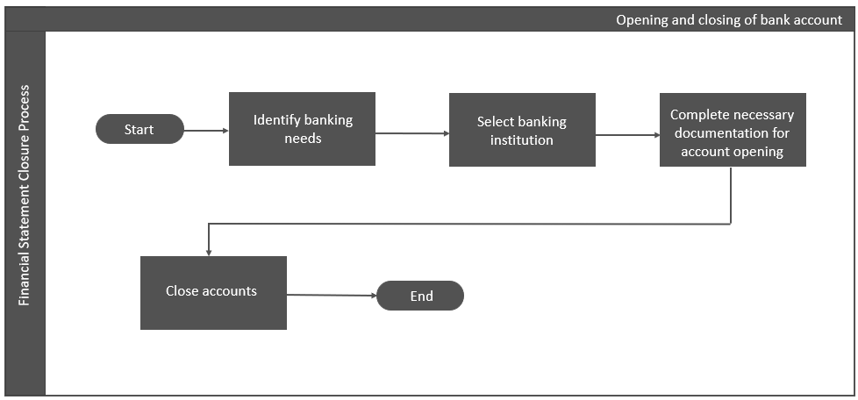

**Process narrative**

| **Description** | **Responsibility** | **Accountability** | **Frequency** | **System / Manual** |
| --- | --- | --- | --- | --- |
| 1. **Identify banking needs** 2. **Manager – Corporate Finance** assess the entity’s banking requirements, such as the types of accounts needed (e.g., checking, savings, investment), transaction volumes, and any special features or services required (e.g., online banking, foreign currency accounts, etc.) and the same will be approved by **Vice President – Corporate Finance.** | **Manager Corporate Finance** | **Vice President – Corporate Finance** | **As and when** | **Manual** |
| 1. **Select banking institutions**   Entities without borrowings:   1. **Executive – Corporate Finance** conducts research and evaluates various banking institutions based on criteria such as fees, interest rates, services offered, reputation, and customer service. The **Executive – Corporate Finance** then selects the institution that best aligns with the entity’s banking needs, which is approved by the **Manager – Corporate Finance.**   Entities with borrowings:   1. Existing lender will be preferred for additional borrowing. | **Executive – Corporate Finance** | **Manager – Corporate Finance** | **As and when** | **Manual** |
| 1. **Complete necessary documentation for account opening** 2. **Managing Director** and **Group CFO** have been authorized by the **JMBPL board** and **Entity’s Board** for opening and closing the bank accounts. 3. Account opening request letter is sent by **Executive -** **Corporate Finance** orthe **Manager -** **Finance and Accounts** of respective entityto the selected bank duly signed by the **authorized signatories**. 4. **Executive – Corporate Finance** or **Manager – Finance and Accounts** (as applicable)**,** prepares and compiles all required documentation to open a new bank account, including account application forms, Board Resolution (in consultation with secretarial department) to open the bank account, and identification documents as per the bank’s KYC norms. Once documentation is completed bank account is duly opened. 5. When new bank account is created, the **Executive – Corporate Finance** or **Manager – Finance and Accounts** (as applicable) raises the request for GL code creation with the **Manager - Corporate Accounts.**   (Refer FSCP SOPP for processesrelating tocreation of GL codes) | **Executive –Corporate Finance/ Manager – Finance and Accounts**  **Executive –Corporate Finance/ Manager – Finance and Accounts**  **Executive – Corporate Finance or Manager – Finance and Accounts** | **Authorized signatories**  **NA**  **Manager - Corporate Accounts** | **As and when**  **As and when**  **As and when** | **Manual**  **Manual**  **Manual** |
| 1. **Close accounts** 2. **Manager – Finance and Accounts** initiates bank accounts closure if the account is inactive or when new ESCROW account is opened in place of current account and accordingly current accounts is closed, approval is sought from **Finance Head** for the same. 3. Upon approval by **Finance Head, Manager – Finance and Accounts** communicates the requirement to close an existing bank account to **Executive – Corporate Finance**. Bank account closing process is done centrally by **Corporate Finance team** as explained below. 4. **Executive – Corporate Finance** initiates the process to close a bank account, after ensuring that all transactions are settled, and balance, if any, is transferred to another bank account. This includes completing any required accounting closing forms and other processes as required by the bank. The Account closing form duly signed and stamped by the entity and the **authorized signatories** are shared by **Executive – Corporate Finance** with the bank along with other required details. 5. Once bank account is closed, **Manager - Corporate Accounts** obtains a confirmation that the concerned entity’s **Manager – Finance and Accounts** has appropriately transferred the bank balance, if any, in the GL to another GL. 6. Post confirmation, **Manager - Corporate Accounts** initiatesthe process for GL code deactivation.   (Refer FSCP SOPP for processesrelating todeactivation of GL codes) | **Manager – Finance and Accounts**  **Manager – Corporate Finance**  **Executive – Corporate Finance**  **Manager – Finance and Accounts**  **Manager - Corporate Accounts** | **Finance Head**  **NA**  **Authorized signatories**  **Manager - Corporate Accounts**  **-** | **As and when**  **As and when**  **As and when**  **As and when**  **As and when** | **Manual**  **Manual**  **Manual**  **Manual**  **Manual** |

### Borrowings

**Process flow**

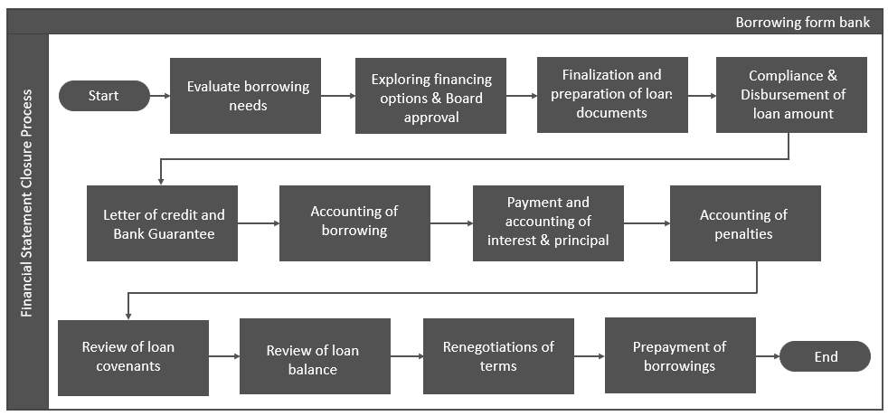

**Process narrative**

| **Description** | **Responsibility** | **Accountability** | **Frequency** | **System / Manual** |
| --- | --- | --- | --- | --- |
| 1. **Evaluate borrowing needs**   **Additional borrowing – existing projects**  (not approved in annual budget)   1. Additional fund requirement from respective entities is communicated by **Finance Head** of the respective entities to **Manager - Corporate Finance.** 2. After evaluation of fund availability and entity’s capex plan **Manager - Corporate Finance** discusses the same with **Vice President - Corporate Finance** for approval.   **Borrowing - new projects –**   1. Once a new project is awarded through a bid, a service concession agreement (SCA) is signed between the Port authority and the SPV (authorized signatory of the concerned entity). 2. Upon execution of SCA, the SPV has a period as mentioned the concession agreement to ensure financial closure (arrangement of funds). **Manager - Corporate Finance** ensures the same and initiates the further process.   **Borrowing – existing projects**  (as per approved annual budget) –   1. Borrowings which are approved as a part of capex budget are not evaluated separately. Process as explained below in (b) is directly initiated by **Manager - Corporate Finance.** | **Finance Head**  **Manager - Corporate Finance; Vice President - Corporate Finance**  **Manager - Corporate Finance**  **Manager - Corporate Finance** | **Manager – Corporate Finance**  **JMBPL Board**  **NA**  **NA** | **As and when**  **As and when**  **As and when**  **As and when** | **Manual**  **Manual**  **Manual**  **Manual** |
| 1. **Explore financing options and Board approval** 2. **Manager - Corporate Finance** collates the term sheets from multiple banks and analyses the terms and conditions and presents the same to the **Vice President - Corporate Finance** and **Group CFO** for final selection of lender. Post which, **Group CFO** approaches **JMBPL Board and Entity’s Board** for final approval. | **Manager - Corporate Finance** | **Vice President - Corporate Finance; Group CFO** | **As and when** | **Manual** |
| 1. **Finalization and preparation of loan documents** 2. The bank shares the draft documents containing all the proposed terms with **Manager - Corporate Finance** and **Vice President - Corporate Finance.**      1. **Manager – Corporate Finance** discusses the terms of the loan with the **Corporate** **Legal Department**. Basis the discussion, the terms are mutually discussed and finalised by the bank and **Manager - Corporate Finance** and the finally agreed terms are shared by the bank with **Manager - Corporate Finance** and **Vice President - Corporate Finance.** 2. **Vice President - Corporate Finance** and **Group CFO**, then approaches the **JMBPL Board** with the sanction terms for approval and execution of loan documents. | **Manager - Corporate Finance**  **Corporate Legal Department**  **Vice President - Corporate Finance; Group CFO** | **Vice President - Corporate Finance**  **Manager - Corporate Finance**  **JMBPL Board** | **As and when**  **As and when**  **As and when** | **Manual**  **Manual**  **Manual** |
| 1. **Compliance and Disbursement of loan amount** 2. Compliance as per loan documents, Service concession agreement are ensured by **Manager - Corporate Finance** and same is reviewed by **Vice President – Corporate Finance.** | **Manager - Corporate Finance** | **Vice President - Corporate Finance** | **As and when** | **Manual** |
| 1. **Letter of credit (LC) and bank guarantee (BG)** 2. LC/BG limits are approved at the time of project financing itself. Any additional requirement of LC/ BG from any entity is communicated by **Manager - Finance and Accounts** along with the relevant documentation over email to **Executive - Corporate Finance** basis which the further process is initiated **Executive - Corporate Finance.** 3. Once LC/BG is issued by the bank**,** **Executive - Corporate Finance** forwards it to **Manager - Finance and Accounts** of the respective entity. 4. **Executive - Corporate Finance** maintains an excel tracker to monitor the maturity of LC/BG. For LC/BG nearing maturity, mail is sent by **Executive - Corporate Finance** to the **Manager - Finance and Accounts** to confirm the maturity or renewal. Based on email confirmation, LC/BG is either paid off or renewed by the **Executive - Corporate Finance.** 5. On a monthly basis, the **Executive – Corporate Finance** provides a statement of Bank Guarantees, corporate guarantees, and shortfall undertakings to the **Manager – Corporate Accounts** for accounting purposes. | **Manager - Finance and Accounts**  **Manager - Finance and Accounts**  **Manager - Finance and Accounts**  **Executive – Corporate Finance** | **Executive - Corporate Finance**  **Executive - Corporate Finance**  **Executive - Corporate Finance**  **Manager – Corporate Accounts** | **As and when**  **As and when**  **As and when**  **Monthly** | **Manual**  **Manual**  **Manual**  **Manual** |
| 1. **Preparation of Stock Statements** 2. Monthly stock statements are prepared by **Executive – Finance and Accounts** based on books of accounts, as per terms mentioned in sanction letter. 3. The same is reviewed by **Finance head** to ensure that the stock statements are prepared inline sanction letter. | **Executive – Finance and Accounts** | **Finance Head** | **Monthly** | **Manual** |
| 1. **Accounting of borrowing** 2. **Executive – Finance and Accounts** prepares Loan working as guided in Accounting Process Manual (APM), the same is reviewed by **Manager – Finance and Accounts** before posting the accounting entries in SAP. 3. After review by the **Manager – Finance and Accounts**, the initial accounting entries for inflow of the loan amount are recorded by the **Executive – Finance and Accounts** and posted by the **Manager – Finance and Accounts**. 4. Accounting of Corporate guarantees are recorded in SAP as guided in Accounting Process Manual. At JMBPL, entries are initially parked by the **Executive – Corporate Accounts** and posted by the **Manager – Corporate Accounts**. At the entity level, entries are parked by the **Executive – Finance and Accounts** and posted by the **Manager – Finance and Accounts.** 5. On a monthly basis, interest as per the amortization schedule is charged to the loan account and loan repayments are made as per repayment schedule. Entries are parked by the **Executive – Finance and Accounts** and posted by **Manager – Finance and Accounts.** | **Executive – Finance and Accounts**  **Executive – Finance and Accounts**  **Executive– Corporate Accounts; Executive – Finance and Accounts**  **Executive – Finance and Accounts** | **Manager – Finance and Accounts**  **Manager – Finance and Accounts**  **Manager – Corporate Accounts; Manager – Finance and Accounts**  **Manager – Finance and Accounts** | **As and when**  **As and when**  **As and when**  **As and when** | **Manual**  **Manual**  **Manual**  **Manual** |
| 1. **Payment and accounting of interest and principal** 2. At the beginning of month, **Executive** - **Corporate Finance** Intimates **Manager - Finance and Accounts** of each entity through email for repayments to be made during the month.      1. Payments (Principal + Interest) are made in accordance with the repayment schedule or payment advice shared by the bank as per the due dates by raising manual mandate. Payment mandate is reviewed by **Finance Head** and signed by **authorized signatories.**      1. Accounting entries for the interest and principal repayment are parked by **Executive - Finance and Accounts** and the same is reviewed and posted by **Manager - Finance and Accounts.** 2. **Manager - Finance and Accounts** ensuresthat the difference between loan balance as per books and as per bank confirmation should be only on account of unamortised processing fees, if any. | **Manager - Finance and Accounts**  **Finance Head**  **Executive - Finance and Accounts**  **Manager – Finance and Accounts** | **Manager - Corporate Finance**  **Authorized signatories**  **Manager - Finance and Accounts**  **NA** | **Monthly**  **Monthly**  **Monthly**  **Monthly** | **Manual**  **Manual**  **Manual**  **Manual** |
| 1. **Accounting of penalties** 2. **Executive - Finance and Accounts** keeps a track of any penal/ additional interest charged by the banks. **Manager - Finance and Accounts** identifies the reasons/ obtains clarification for the breach of the terms and verifies the reasonableness of the amount payable and reports the same to **Finance Head.** The same is also reviewed by the **Manager - Corporate Finance.** Accordingly, the payments are settled with the bank. 3. Accounting entry for any accrual or payment of penalty / additional interest are parked by **Executive - Finance and Accounts** and posted by **Manager - Finance and Accounts.** 4. In case of regular non-compliance, new control procedures will be implemented by **Manager - Corporate Finance** to reduce / eliminate the occurrence of non-compliance. | **Executive - Finance and Accounts, Manager - Finance and Accounts**  **Executive - Finance and Accounts**  **Manager - Corporate Finance** | **Finance Head; Manager – Corporate Finance**  **Manager - Finance and Accounts**  **NA** | **As and when**  **As and when**  **As and when** | **Manual**  **Manual**  **Manual** |
| 1. **Review of financial covenants** 2. Compliances with financial covenants is tracked Quarterly/annually, as required by **Manager - Finance and Accounts.** The same is reviewed by **Finance Head** and **Manager - Corporate Finance.** Further, a Certificate of compliance by an independent Chartered Accountant is provided to the lender as per the agreement. | **Manager - Finance and Accounts** | **Finance Head; Manager - Corporate Finance** | **Quarterly /Annually** | **Manual** |
| 1. **Review of loan balance** 2. On a quarterly basis, **Manager - Finance and Accounts** checks whether the outstanding loan balance as appearing in SAP is in line with the underlying amortization schedule prepared in accordance with applicable financial reporting framework. 3. Quarterly and annually, confirmation from lender for outstanding borrowings is obtained and kept by **Executive - Finance and Accounts.** Discrepancies, if any, are intimated and discussed with the bank. All balance confirmations are reviewed by **Manager - Finance and Accounts** at the time of finalization of accounts. | **Manager - Finance and Accounts**  **Executive - Finance and Accounts** | **NA**  **Manager - Finance and Accounts** | **Quarterly**  **Quarterly/ Annually** | **Manual**  **Manual** |
| 1. **Renegotiations of terms** 2. Renegotiations are done by the **Manager - Corporate Finance** in consultation with **Vice President – Corporate Finance**, Once the negotiations are finalized and documented, the same are communicated to the **Finance Head** of respective entity through email. 3. The amortization schedule is updated accordingly based on revised terms by **Executive - Finance and Accounts** and the same is reviewed by **Manager - Finance and Accounts** based on which the subsequent accounting will be carried out. | **Manager - Corporate Finance**  **Executive - Finance and Accounts** | **Vice President – Corporate Finance**  **Manager - Finance and Accounts** | **As and when**  **As and when** | **Manual**  **Manual** |
| 1. **Prepayment of borrowings** 2. **Manager – Corporate Finance** assesses and determines the amount of borrowings that could be prepaid at entity level. **Manager – Corporate Finance** analyses and evaluates various aspects such as the terms of prepayment, waiver of prepayment charges, beneficial terms offered by different banks, etc. and presents the same to **Vice President – Corporate Finance** and **Group CFO** for approval. 3. Upon approval by **Group CFO**, the request letter for prepayment is prepared and shared by the **Manager – Corporate Finance** with the concerned bank. **Manager – Corporate Finance** intimates **Manager – Finance and Accounts** the amount to be release for prepayment accordingly, the payments will be made. 4. Accounting entry for prepayment is parked after payment is reflected in the bank statement, by **Executive - Finance and Accounts** and posted by **Manager - Finance and Accounts** in SAP. | **Manager - Corporate Finance**  **Manager – Corporate Finance**  **Executive - Finance and Accounts** | **Vice President – Corporate Finance; Group CFO**  **Group CFO**  **Manager - Finance and Accounts** | **As and when**  **As and when**  **As and when** | **Manual**  **Manual**  **Manual** |

### Inter-company borrowings

**Process flow**

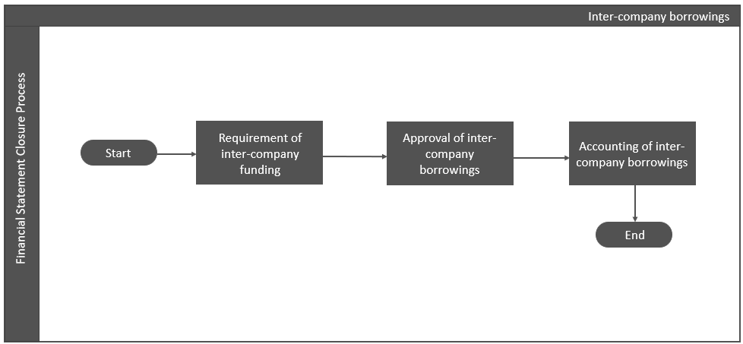

**Process narrative**

| **Description** | **Accountability** | **Responsibility** | **Frequency** | **System / Manual** |
| --- | --- | --- | --- | --- |
| 1. **Requirement of inter-company funding** 2. Inter-company borrowings are availed by group companies in the following forms:   a) Cashflow mismatch (fund requirement)  b) At the time of inception of a project as Inter-corporate deposits (ICD) that are given as a part of equity (As per loan agreement).   1. Cashflow mismatch (fund requirement) are assessed by **Finance Head** and approved by **Terminal Head/ Business Head**, post which the same is communicated by **Finance Head** to **Manager - Corporate Finance**. | **Finance Head** | **Manager - Corporate Finance** | **As and when** | **Manual** |
| 1. **Preparation of term- sheet for Inter-company borrowing** 2. Inter-company borrowings are governed by term sheets, which are duly prepared by **Manager – CS/Corporate accounts/ Corporate Finance.** Thesameis reviewed and approved by **Group CS/ Vice President – Corporate Accounts/ Vice President – Corporate Finance.** | **Manager - CS/Corporate accounts/ Corporate Finance** | **Group CS/ Vice President – Corporate Accounts/ Vice President – Corporate Finance** | **As and when** | **Manual** |
| 1. **Approval of inter-company borrowings** 2. Once reviewed term sheets are approved by **JMBPL Board** and **Entity’s Board** and if needed approval is taken from existing lenders of the entity. Approvals are initiated by **Manager – Corporate Finance.** 3. The documents are signed by the **authorized signatories** as per the Board resolution. | **Manager – Corporate Finance.** | **Authorized signatories** | **As and when** | **Manual** |
| 1. **Accounting of inter-company borrowings** 2. Accounting of Inter-company borrowings is done as per applicable financial reporting framework. 3. Initial accounting entries and monthly interest entries are parked by the **Executive – Finance and Accounts** and posted by the **Manager – Finance and Accounts**. | **Executive – Finance and Accounts** | **Manager – Finance and Accounts** | **As and when** | **Manual** |

### 

### Fund management

**Process flow**

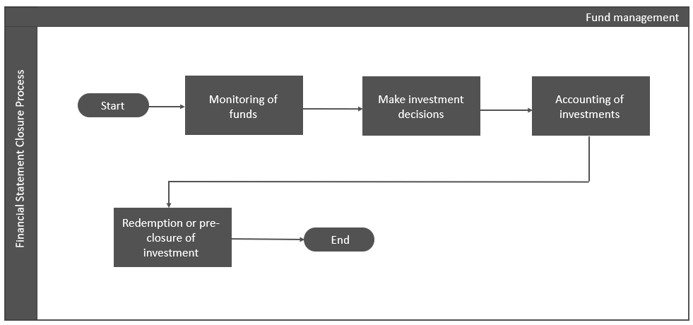

**Process narrative**

| **Description** | **Accountability** | **Responsibility** | **Frequency** | **System / Manual** |
| --- | --- | --- | --- | --- |
| 1. **Monitoring of funds** 2. For internal reporting, **Executive - Finance and Accounts** prepares a statement of cash inflows and outflows for the current month and estimated cashflows for the next month which is reviewed by **Finance Head**. 3. Within 7 days after month end, **Executive - Corporate Finance** collates the statement of cashflows from all the entities along with budgeted cashflows for the next month to prepare consolidated cashflow statement. **Executive - Corporate Finance** carries out variance analysis for deviations in actual cashflows and the estimated cashflow. Major deviations are discussed with the **Finance Head.** Consolidated cashflow is then approved by **Manager - Corporate Finance** post which the same is presented to **Vice President - Corporate Finance.**   *[Refer standard template no. 1&2]*   1. **Executive - Finance and Accounts** tracks and shares the funds available in all the bank accounts on daily basis with Executive **- Corporate Finance** for monitoring. | **Executive - Finance and Accounts**  **Manager - Corporate Finance**  **Executive - Finance and Accounts** | **Finance Head**  **Manager - Corporate Finance, Vice President – Corporate Finance**  **Manager - Corporate Finance** | **Monthly**  **Monthly**  **Daily** | **Manual**  **Manual**  **Manual** |
| 1. **Make investment decisions** 2. Based on the balance and future requirements of funds, **Finance Head** forentities and **Vice President – Corporate Finance** for JMBPL standalone entity, decides the amount and tenure for which funds are to be invested and the mode of such investment in accordance with the Group’s investment policy. Based on which, the approval from **authorised signatories** is obtained and accordingly, **Manager – Finance and Accounts** and **Manager – Corporate Finance,** invests the funds.   *[Refer policy in attachment no. 3]* | **Manager – Finance and Accounts; Manager – Corporate Finance** | **Authorized signatories** | **As and when** | **Manual** |
| 1. **Accounting of investments** 2. Classification of investment in accordance with applicable financial reporting framework is done by **Executive – Finance and Accounts** and reviewed by the **Manager - Finance and Accounts**. 3. The interest income is recognized based on the relevant supporting documents (such as interest certificates from bank, bank statements, etc.) and entry is parked in SAP by **Executive - Finance and Accounts** and posted by **Manager - Finance and Accounts.** 4. MTM statements for mutual funds are taken on monthly basis by **Executive - Finance and Accounts.** 5. Accounting entries for the above are parked by **Executive - Finance and Accounts** and posted by **Manager - Finance and Accounts** in SAP. 6. Accounting for inter-company investments is done as per group accounting policy manual. | **Executive - Finance and Accounts**  **Executive - Finance and Accounts**  **Executive - Finance and Accounts**  **Executive - Finance and Accounts**  **Manager – Corporate Accounts** | **Manager - Finance and Accounts**  **Manager - Finance and Accounts**  **NA**  **Manager - Finance and Accounts**  **Vice President – Corporate Accounts** | **As and when**  **As and when**  **Monthly**  **As and when**  **Annual** | **Manual**  **Manual**  **Manual**  **Manual**  **Manual** |
| 1. **Redemption /pre-closure of investments** 2. Based on future fund requirements, **Finance Head** forentities and **Vice President – Corporate Finance** for JMBPL standalone entitydetermines whether the investments are to be liquidated or reinvested in accordance with the process in (b) above. Basis the entry in bank statement, accounting entry for redemption is parked by **Executive - Finance and Accounts** and posted by **Manager - Finance and Accounts** for entities and parked by **Executive – Corporate Finance** and posted by **Manager – Corporate Finance** for JMBPL standalone. | **Finance Head** | **Vice President – Corporate Finance** | **As and when** | **Manual** |

### Updation of authorized signatory

**Process flow**

**Process narrative**

| **Description** | **Accountability** | **Responsibility** | **Frequency** | **System / Manual** |
| --- | --- | --- | --- | --- |
| 1. **Updation of authorized signatory** 2. As and when required updation is initiated by **Manager – Corporate Finance** through a Letter which is approved by **Managing Director & Group CFO,** or a board resolution passed by **JMBPL Board** and **Entity’s Board.** 3. Changes in **authorised signatories** are communicated to the respective banks by **Manager - Finance and Accounts** through email. 4. Bank signatories confirmation to be obtained by banks on half-yearly basis. | **NA**  **Manager - Finance and Accounts** | **Managing Director & Group CFO; JMBPL Boards**  **NA** | **As and when**  **As and when** | **Manual**  **Manual** |

### Cash in hand

**Process flow**

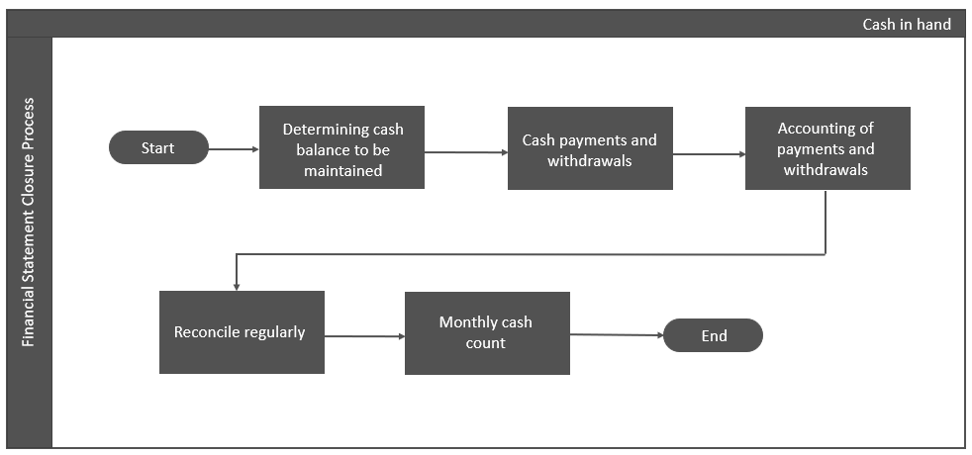

**Process narrative**

| **Description** | **Accountability** | **Responsibility** | **Frequency** | **System / Manual** |
| --- | --- | --- | --- | --- |
| 1. **Determining cash balance to be maintained** 2. **Manager – Finance and Accounts** determines the cash balance required and nature of petty expenses for which cash payment is allowed. | **Manager - Finance and Accounts** | **NA** | **As and when** | **Manual** |
| 1. **Cash payments and withdrawals** 2. **Manager - Finance and Accounts** have the custody of cash. The cash payments are made to the vendors by **Executive – Finance and Accounts**, based on vouchers approved by **Finance Head.** 3. In case of further cash requirement, **Manager - Finance and Accounts** initiates a request of withdrawals from bank, which is signed by **Finance Head.** Thesigned request is shared by **Manager - Finance and Accounts** with the bank and the cash is withdrawn. 4. **Manager - Finance and Accounts** other than the custodiankeeps a track of cash payments in SAP Cash Book. 5. **Manager – Finance and Accounts** ensures that the cash payments are in accordance with income tax provisions and payment limits. | **Executive – Finance and Accounts; Manager - Finance and Accounts** | **Finance Head** | **As and when** | **Manual** |
| 1. **Accounting of payments and withdrawals** 2. Accounting entry for the payment and withdrawals is parked based on vouchers and request for withdrawals, respectively, by **Executive - Finance and Accounts** and posted by **Manager - Finance and Accounts.** | **Executive – Finance and Accounts** | **Manager - Finance and Accounts** | **As and when** | **Manual** |
| 1. **Reconcile Regularly** 2. Cash balance is reconciled on monthly basis by **Manager – Finance and Accounts** with the SAP Cash book to ensure consistency of cash balance. | **Manager – Finance and Accounts** | **NA** | **Monthly** | **Manual** |
| 1. **Monthly Cash count** 2. **Executive - Finance and Accounts** performs cash count on a monthly basis. Cash verification certificate is signed by **Finance Head.** | **Executive – Finance and Accounts** | **Finance Head** | **Monthly** | **Manual** |

### Hedging foreign exchange exposure

**Process flow**

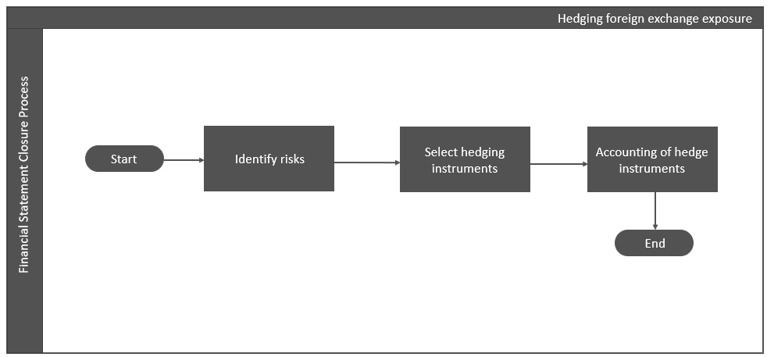

**Process narrative**

| **Description** | **Performed By** | **Frequency** | **Template** | **System / Manual** |
| --- | --- | --- | --- | --- |
| 1. **Identify risks** 2. **Manager – Finance and Accounts** in consultation with **Manager – Corporate Finance** reviews the foreign exchange exposure on LC/Buyer’s credit issued to supplier/ Bank at the time of issue of new LC/Buyer’s credit. | **Manager - Finance and Accounts** | **Manager – Corporate Finance** | **As and when** | **Manual** |
| 1. **Select hedging instruments** 2. Hedging facility is approved as a part of borrowing limit and the same is approved by **JMBPL board** along with initial borrowing limits. 3. Hedging instruments are selected basis the risk appetite of the entity by **Manager – Corporate Finance** and the same is reviewed by **Vice President – Corporate Finance** and **Group** **CFO.** 4. Hedging amount and tenure are determined based on the forex exposure, as assessed by the **Manager – Corporate Finance**, and are subsequently reviewed by the **Vice President – Corporate Finance.** 5. Foreign exchange exposure is hedged by entering into forward contract with lender bank. For this purpose, **Manager – Corporate Finance** shares the details of LC/ Buyer’s credit and foreign exchange exposure involved with the lender bank. | **Finance Head** | **Vice President – Corporate Finance and;**  **Group CFO** | **As and when** | **Manual** |
| 1. **Accounting of hedge instrument** 2. Mark-to market (MTM) statements are requested on monthly basis from lending banks by **Manager – Finance and Accounts.** 3. Accordingly, accounting entries as per Accounting Process Manual (APM), are parked in SAP by **Executive – Finance and Accounts** and posted by **Manager – Finance and Accounts.** | **Executive – Finance and Accounts** | **Manager – Finance and Accounts** | **Monthly** | **Manual** |

## Policies, guidance and standard templates

|  |  |  |
| --- | --- | --- |
| **Sr. no.** | **Sub – Process** | **Link** |
| 1. | Cashflow Format |  |
| 2. | Daily Cash balance Format |  |
| 3. | Investment Policy |  |