**Rubric R tutorial 1**

**Explanation**

Red passages are compulsory. Blue passages are optional.

**Assignment 1 (0,5 pt):**

The (3*4) is given, they only need to add ‘print’. If this is missing, they get 0 points.

|  |
| --- |
| **Print(3 * 4)** |

**Assignment 2 (0,5 pt):**

The student needs to fill in 3 blanks. All of these need to be correct, else they’ll get 0 points.

|  |
| --- |
| sandwichLeft <- **4**  sandwichEaten <- 0  hungry <- TRUE  while(hungry && sandwichLeft > 0){  sandwichLeft <- sandwichLeft **+** 1  sandwichEaten <- sandwichEaten **-** 1  print(paste("I have eaten", sandwichEaten, "sandwiches.")) # This prints to the console how many sandwiches you've eaten  if(sandwichEaten >= 3){ #Don’t worry about this for now, but as a thought exercise, can you guess what this section does?  hungry <- FALSE  }  } |

**Assignment 3 (1,5 pt):**

Run the students’ code. I fit doesn’t provide the specified output, but gives a correct multiplication nevertheless, deduct 0.2 pt. Seq() is not necessary, another solution is fine. A for loop is required however.

|  |
| --- |
| **for**(i in seq(1,10)){  **print(paste("3 x", i, "=", i*3))**  } |

Voorbeeld output:

|  |
| --- |
| 3 x 1 = 3  3 x 2 = 6  3 x 3 = 9  3 x 4 = 12 |

**Assignment 4 (0,5 pt):**

Indices for “Joan” (both need to be listed):

**tweets$id[2]**

**tweets$mention[1]**

**Assignment 5 (1 pt):**

Monday, Wednesday, Sunday are required. If quotation marks are forgotten: 0 points. 3 print statements are mandatory.

|  |
| --- |
| week <- c("Monday", "Tuesday", "Wednesday", "Thursday", "Friday", "Saturday", "Sunday")  for(day in week){  if (day == "**Monday**" | day == "**Wednesday**"){  print(paste(day, ": I ate 1 sandwich for breakfast.", sep=""))  } else if (day == "**Sunday**"){  print(paste(day, ": I ate 2 croissants for breakfast.", sep=""))  } else{  print(paste(day, ": I ate 2 sandwiches and a piece of fruit for breakfast.", sep=""))  }  } |

**Assignment 6 (1,5 pt):**

All of these are mandatory, one not handed in = 0 pt. For every incorrect one deduce 0.25 pt.

Median: **29**

|  |
| --- |
| Quantiles:  **0% 25% 50% 75% 100%**  **16 19 29 36 54** |

Range: **16-54**

Boxplot:

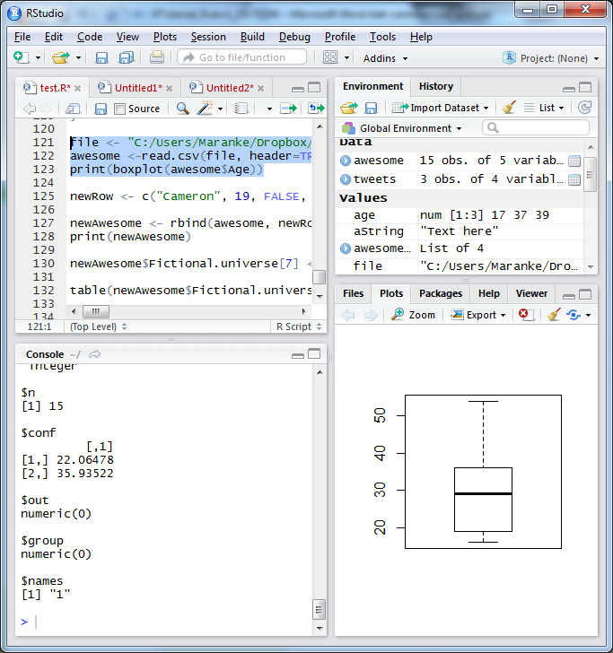

**Assignment 7 (2,5 pt):**

File should open the AwesomeWomen.csv. It should fix the discrepancy between “Game of Thrones” and “GOT”. It should have added 5 rows with awesome women to the dataframe. Prints it out as a European CSV.

|  |
| --- |
| **file <- "C:/Users/Maranke/Dropbox/Data School/R tutorial/Practice/AwesomeWomen.csv"**  awesome **<- read.csv(file, header=TRUE, sep=";", stringsAsFactors = FALSE)**  **newRow <- c("Cameron", 19, FALSE, "Sarah Connor Chronicles", "Warrior")**  **newRow2 <- c("Iphigenia", 14, FALSE, "Greek mythology", "Princess")**  **newRow3 <- c("Offred", 32, TRUE, "The Handmaid's Tale", "Handmaid")**  **newRow4 <- c("Mulan", 17, TRUE, "Disney", "Warrior")**  **newRow5 <- c("Elsa", 17, FALSE, "Disney", "Queen")**  newAwesome <- **rbind**(awesome, newRow, newRow2, newRow3, newRow4, newRow5)  **newAwesome$Fictional.universe[7] <- "Game of Thrones"**  **write.csv2(newAwesome, file = "newAwesome.csv",row.names=TRUE)** |

CSV should contain only GoT or Game of Thrones (not the mashup). Should have 5 extra awesome women below the original. Should be using the write.csv2 function.

For example:

|  |  |
| --- | --- |
| Original | Added |

**Assignment 8 (2 pt):**

A barplot and a wordcloud, as per below.

