Using Simple Models to Explain Ecosystem Patterns

Adam N. Wlostowski

2020/03/01

Table of Contents

Simple (mathematical) models are useful learning tools. Given a set of observations, we use models to explain emergent patterns in the data. In this sense, models are hypotheses in the form of equations. If a model can reproduce patterns in the data, the hypothesis might not be wrong. However, if the model cannot explain the observations, the hypothesis is rejected, and we go back to the drawing board. Either way, we learn!

In this post, I illustrate the power of simple models in the context of river ecosystems. I begin by identifying a pattern. Then, I borrow a hypothesis from the literature to explain the pattern. Finally, I mathematically formalize the hypothesis and test it by seeing if the model can recreate the pattern.

It is necessary to provide some background on stream ecology and Antarctic rivers. I apologize if the background is too dense. I’ve embedded links along the way that direct to you to sources where you can learn more.

# Background

## Nitrogen Spiraling

Nitrogen (N) is a fundamental building block of ecosystems. It is an essential nutrient for life on earth, along with carbon and phosphorous. Understanding N fate and transport provides insight into how ecosystems operate. Nutrient spiraling theory provides a framework for understanding how N moves through river ecosystems. The spiral begins with downstream transport of an inorganic N species dissolved in flowing waters. Organisms in need of inorganic N assimilate it into their organic matter. Eventually, organic matter decomposition by microbes mineralizes inorganic N back into the water column. The spiral is complete.

Nitrogen spiraling is extremely well studied. Uptake and assimilation of inorganic N is one of the best-understood parts of N cycles. This is partially because inorganic N is a pollutant, so assimilation (retention) can be beneficial. However, the fate of assimilated N remains poorly resolved, hampering our ability to close ecosystem N budgets.

## The McMurdo Dry Valleys, Antarctica

As it turns out, rivers in the McMurdo Dry Valleys of Antarctica are excellent end-member systems for studying the fate and transport of assimilated N. A few key points you need to know about Antarctic rivers:

* The McMurdo Dry Valleys are one of the coldest and driest places on earth. In this region it is too cold to rain and most snowfall sublimates before melting.
* Glacial melt is the primary source of flow in Antarctic rivers. Rivers are hydrologically disconnected from adjacent hillslopes.
* Algae are some of the only primary producers found in the region. Rivers are an ideal habitat for algae, which form in mats on the riverbed. There are three types of algae mats. Orange and green mats live in the water column. Black mats live along channel edges.
* Black mats are nitrogen fixers (i.e. they can assimilate N2 gas from the atmosphere).
* Nitrogen in the stream comes from glacier melt or in-stream N fixation (by black mats). Very little N comes from adjacent hillslopes. This is unusual. In most places on earth, streams get a lot of N (and water) from adjacent hillslopes.
* High flows scour algal mats from the streambed. This is a key mechanism controlling particulate organic matter (POM) concentration.
* Hyporheic zone interactions are extensive. Surface water is constantly mixing with shallow groundwater along the course of the stream.

## Nitrogen Isotopes

Nitrogen isotopes help to track N moving through river ecosystems. Isotopes are atoms with differing numbers of neutrons. Nitrogen has two stable isotopes; 14N and 15N. δ15N is the ratio 15N:14N. As N moves through different components of the nutrient spiral, the value of δ15N increases and decreases. This makes δ15N a useful tracer for tracking the fate and transport of N.

The nitrogen isotope profile of Antarctic rivers is constrained by two end-members. On one hand, black mats are N fixers, so they have δ15N signature near the atmospheric standard (δ15N ≅ 0 per-mil). On the other hand, atmospheric deposition is the primary source of N in glacier ice. Therefore, glacier ice is characteristically depleted in δ15N (from -9.5 to -26.2 per-mil).

# Data

Tyler Kohler, my friend and colleague, collected samples of algae along several Antarctic Rivers. He measured the δ15N signature of algae organic matter and constructed a data set of the spatial variation. He graciously provided me with these data. Read his peer reviewed paper to learn more about the data. Here, I am working with data from a river named *Relict Channel*. It flows intermittently between October and February and is freeze dried for the remainder of the year. Algal mats are abundant along the channel bottom. Eight sites were sampled along a 3 km longitudinal transect. The upstream-most site is located 1.5 km from the glacier.

# Load observations  
dat <- read.csv("relict_channel_data.csv")  
  
# look at the data  
head(dat)

## stream date_sampled time_sampled transect sample_type distance  
## 1 Relict_Channel 20-Jan-13 NA RC0 orange 1.5350  
## 2 Relict_Channel 20-Jan-13 NA RC0 orange 1.5350  
## 3 Relict_Channel 20-Jan-13 NA RC1 orange 1.5725  
## 4 Relict_Channel 20-Jan-13 NA RC1 orange 1.5725  
## 5 Relict_Channel 20-Jan-13 NA RC2 orange 1.6795  
## 6 Relict_Channel 20-Jan-13 NA RC2 orange 1.6795  
## d13C d15N CN CP NP AFDM chla AI  
## 1 -21.63033 -6.109830 9.378347 20.78049 2.215795 NA NA NA  
## 2 -20.68195 -5.511347 9.180085 14.15511 1.541937 NA NA NA  
## 3 -18.34956 -4.033698 11.165297 31.17973 2.792557 6.960352 2.353515 0.3381315  
## 4 -20.03926 -3.656960 10.689993 20.63252 1.930078 5.462555 5.652732 1.0348147  
## 5 -18.87467 -2.292846 9.213805 76.14598 8.264336 11.365639 15.217906 1.3389398  
## 6 -19.37847 -1.096627 8.987226 38.20031 4.250512 11.850220 11.279305 0.9518224

# Pattern

One pattern observed in the data is an upstream to downstream enrichment of orange mat δ15N. The pattern is asymptotic. The furthest upstream samples are depleted in δ15N and resemble glacial water. Moving downstream, samples become enriched in δ15N, and approach the signature of atmospheric N (δ15N ≅ 0 per-mil).

# mean d15N at each station  
d15N.av <- dat %>%  
 group_by(distance) %>%  
 summarize(dist = mean(distance),   
 d15N = mean(d15N))  
  
# Plot longitudinal 15N pattern  
p <- ggplot(dat, aes(x = distance*1000, y = d15N)) +  
 geom_point(size = 3, color = "orange", alpha = 0.4) +  
 geom_line(data = d15N.av, aes(x = distance*1000, y = d15N)) +  
 labs(x = "Distance (meters)")  
  
print(p)

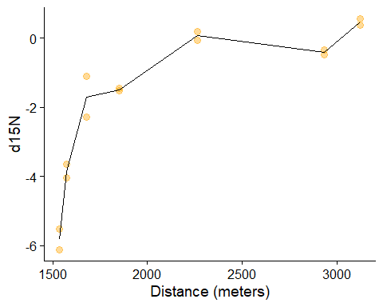

# Hypothesis

Tyler and his co-authors put forward a hypothesis to explain the asymptotic enrichment of δ15N. The hypothesis may be frames as a series of events:

First high flows scour black mats at the channel margin. Then mat-derived POM is transported downstream and stored in the hyporheic zone. Hyporheic microbes mineralize black mat POM and produce inorganic N. Finally, exchange flows flush inorganic N from the hyporheic zone into the open channel. As a result, inorganic N mineralized from black mats becomes a progressively larger source of available N with distance downstream.

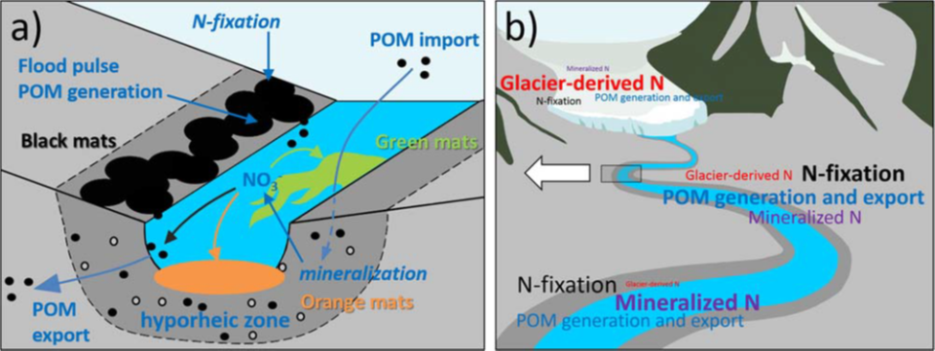

A conceptual diagram of N spiraling in Antarctic rivers.(a) N-fixing black mats grow at margins and generate POM during high flow events, which are exported downstream. POM is minearlized in the hyporheic zone, releasing inorganic N for uptake by downstream mats. (b) Upstream locations have the greatest concentrations of glacier-derived N and low mat biomass. As mat abundance increases downstream, glacier-derived N is exhausted, and N mineralized from black mats becomes the dominant N source. The relative magnitude of each processes is illustrated with text size. Figure and caption from Kohler et al., (2018)

# Model

Can this hypothesis explain the asymptotic enrichment pattern? I formalized the hypothesis with a mathematical model. The model simulates downstream changes in glacier- and black-mat derived inorganic N concentrations. It is a system of two ordinary differential equations. The Equation 1 represents the spatial rate of change in glacier-derived inorganic N. Equation 2 represents the spatial rate of change in black mat-derived inorganic N.

Where *Ng* is the concentration of glacier-derived inorganic N (micro grams per liter), *Nb* is the concentration of black mat-derived inorganic N (micro grams per liter), λ is the inorganic N uptake rate of orange mats (per meter), *ϕ* is the flux of inorganic N from the hyporheic zone to the stream (micro grams per liter per meter), and *x* is channel distance (m).

The δ15N is calculated as

Where δ15Nb is the nitrogen isotopic signature of black mat, and δ15Ng is the nitrogen isotopic signature of glacier ice.

# model equations  
model <- function(distance, state, parameters) {  
 par <- as.list(c(state, parameters))  
 with(par, {  
   
 dNg <- -lambda * (Ng^2/(Ng + Nb)) # Change is glacier-derived nitrogen with distance  
 dNb <- phi - (lambda * (Nb^2/(Nb + Ng))) # change in black mat derived nitrogen with distance  
   
 list(c(dNg, dNb))  
 })  
}

# Insights

## Model Optimization

First we need to establish the model domain, initial conditions, and δ15N signatures of glacier ice and black mats.

* **Check with Diane about value of boundary conditions, what is reasonable for glacier ice DIN (Ng)?**

# initialize the model domain, channel distance in meters  
dist = seq(1530,4000,by = 1)  
  
# initial conditions, N-species compositions at the upper boundary condition.   
init <- c(Ng = 10, # concentration of nigrogen in glacier ice (ug/L)  
 Nb = 1) # concentration of black-mat derived N at x = 0  
  
# end members: delN-15 concentrations in black mats and glacier ice  
n15g = -10   
n15b = 0

Next, we need to specify an objective function to evaluate how well the model fits the data. We will use the Root-Mean-Squared-Error (RMSE) of simulted to observed δ15N

# Objective function - root mean squared error on d15N  
RSS <- function(parameters) {  
   
 names(parameters) <- c("phi", "lambda")  
   
 # run the ode system  
 out <- ode(y = init, # initial conditions  
 times = dat$distance * 1000, # distance (converted from km to m)  
 func = model, # the system of odes  
 parms = parameters) # parameter values  
  
 fit <- data.frame(out)  
   
 fit <- fit %>%  
 mutate(n15 = ((n15g * Ng) + (n15b * Nb))/(Ng + Nb))  
   
 # return: RMSE with respect to d15N  
 sum((dat$d15N - fit$n15)^2)  
   
}

Now, we can optimize the model using the optim function from the stats package.

# optimize with some sensible conditions  
Opt <- optim(c(0.2, 1), # initial guess  
 RSS, # objective function  
 method = "L-BFGS-B", # optimization routine  
 lower = c(0, 0), # lower bound of search range  
 upper = c(1, 1)) # upper bound of search range  
  
Opt_par <- setNames(Opt$par, c("phi", "lambda")) # rename the optimal parameter set  
  
print(Opt_par)

## phi lambda   
## 0.24024553 0.03580479

**Are these parameter values reasonable? The assimilation rate is about an order of magnitude greater than that for Green Creek (McKnight et al., 2004). Maybe this is justified by the abundance of mats in Relict Channel and the fact that the channel rarely sees flow?**

Let’s plot the modeled and observed δ15N patterns.

fit <- data.frame(ode(y = init, times = dist, func = model, parms = Opt_par))  
  
fit <- fit %>%  
 mutate(n15 = ((n15g * Ng) + (n15b * Nb))/(Ng + Nb))  
  
p <- ggplot(fit, aes(time, n15)) +  
 geom_line() +  
 geom_point(data = dat, aes(x = distance*1000, y = d15N), color = "orange", size = 8, alpha = 0.3) +  
 labs(x = "Distance From Glacier (meters)",  
 y = "δ15N")  
  
print(p)

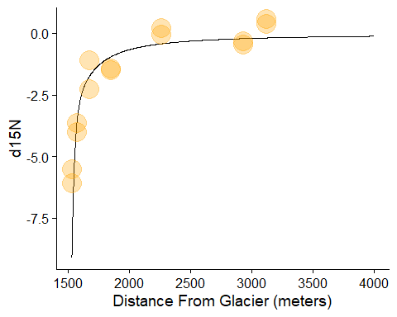

Let’s plot the modeled concentrtions of glacier- and black mat-derived inorganic nitrogen

p <- ggplot(fit, aes(time, Nb)) +  
 geom_line(color = "black", size = 2) +  
 geom_line(data = fit, aes(time, Ng), color = "blue", size = 2) +  
 labs(x = "Distance From Glacier (m)",  
 y = "Disolved Inorganic Nitrogen (ug/L)")  
  
print(p)

