## Resource QR Codes

### Audiobook

Purchasing this book provides access to a sophisticated Web App Audiobook that can accelerate your language learning.

Follow the link to open the Web App Audiobook in a suitable Web Browser.

http://bilingual-classics.awltux.trade/897e69051904/index.html

### Workbook

Purchasing this book provides access to a PDF Workbook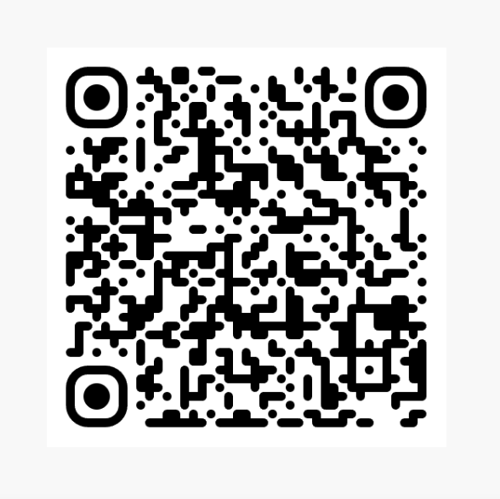 that contains fun puzzles to help consolidate your language learning. The workbook is a living document, so check for updates.

Follow the link to download the PDF Workbook.

http://bilingual-classics.awltux.trade/897e69051904/downloads/workbook.pdf

## ...and Finally

If you found value in these pages, we would be incredibly grateful if you would **consider leaving a rating or review on your regional Amazon website**.

Search for ASIN: TBD

Your feedback helps us to reach more readers and allows us to continue bringing stories like this to life.

If you know someone who might also enjoy or benefit from this book, please consider sharing it with them. Spreading the word to friends and family is **one of the greatest compliments you can give us**.

To **discover other books in the series** and to **stay up to date with new releases**, please read the ‘Additional Resources’ section at the start of the book.

***Thank you once again***

***for your***

***time and support.***