Science Week - Do now
- Complete the equation: $speed= \frac{distance}{?}$
- When a rubber band is stretched, there is an increase in its ____________ potential energy store.
- What is the 4th closest planet to the sun?
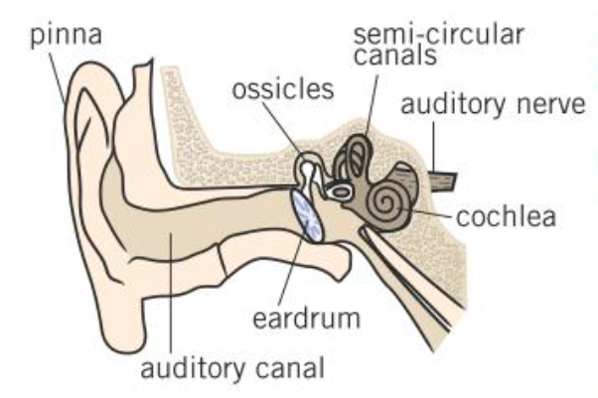
- What is the missing label on this diagram of the ear?
- When you hold two magnets close to one another, like poles repel and _____________ poles attract.
- What is the name of the phenomenon where light changes speed as it enters a medium with a different density?
- What is the missing label on this wave diagram?
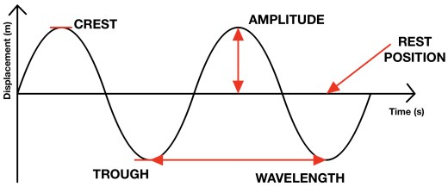
Write down the first letter of each answer and show your teacher:
Science Week - Do now
- Complete the equation: $speed= \frac{distance}{?}$
- When a rubber band is stretched, there is an increase in its ____________ potential energy store.
- What is the 4th closest planet to the sun?
- What is the missing label on this diagram of the ear?
- When you hold two magnets close to one another, like poles repel and _____________ poles attract.
- What is the name of the phenomenon where light changes speed as it enters a medium with a different density?
- What is the missing label on this wave diagram?
Write down the first letter of each answer and show your teacher:

