Introduction to the Tempora Manual

Welcome to the Tempora Manual, your comprehensive guide to operating and maintaining the spaceship "Tempora." As a crew member or captain of the Tempora, it is essential to familiarise yourself with the various systems, protocols, and maintenance procedures outlined in this manual to ensure safe and efficient space travel.

The Tempora is not just a vessel; it is a gateway to the stars, a beacon of human ingenuity and exploration. With its advanced technology and cutting-edge design, the Tempora represents the pinnacle of human achievement in space travel. From traversing distant galaxies to unravelling the mysteries of the cosmos, the Tempora is equipped to handle the challenges of deep space exploration with grace and precision.

This manual will provide you with the knowledge and tools necessary to maximise the capabilities of the Tempora and navigate the vast expanse of the universe with confidence. Whether you are a seasoned spacefarer or a novice explorer, the information contained within these pages will be invaluable to your journey aboard the Tempora.

Engine Care

The propulsion system of the Tempora is a marvel of modern engineering, capable of achieving velocities that defy conventional limits. To ensure optimal performance and longevity of the engines, regular maintenance and care are essential.

At the heart of the Tempora's propulsion system lies a fusion-powered plasma drive, harnessing the energy generated by nuclear fusion reactions to propel the spacecraft forward. This cutting-edge technology provides the Tempora with unmatched speed and efficiency in traversing the cosmos. However, with great power comes great responsibility, and it is imperative to monitor the engine parameters closely and conduct routine inspections to detect any signs of wear or malfunction.

Proper engine care begins with thorough pre-flight checks and continues throughout the duration of the mission. Crew members responsible for engine maintenance must undergo rigorous training to familiarize themselves with the intricacies of the propulsion system and perform their duties with precision and diligence.

Fuel Tank Maintenance

The fuel tanks of the Tempora store the hydrogen isotopes necessary for the fusion reactions that power the spacecraft's engines. Proper maintenance of the fuel tanks is crucial to ensure a steady supply of fuel and prevent contamination or leakage.

The fuel tanks are constructed from reinforced materials designed to withstand the extreme conditions of space travel. However, they are not immune to wear and tear, and regular inspections, leak tests, and tank purging procedures must be conducted to maintain the integrity of the fuel storage system. Any signs of corrosion, fatigue, or structural damage must be addressed promptly to prevent catastrophic failures that could jeopardize the safety of the crew and the success of the mission.

Navigation

Navigating through the vastness of space requires precision, skill, and advanced technology. The Tempora is equipped with a sophisticated navigation system that utilizes a combination of star charts, celestial navigation techniques, and artificial intelligence algorithms to plot courses and calculate trajectories.

The navigation system of the Tempora is the cornerstone of safe and efficient space travel. It provides real-time updates on the spacecraft's position, velocity, and heading, allowing the crew to navigate with confidence even in the most challenging of environments. However, the success of any mission depends not only on the reliability of the navigation system but also on the expertise of the crew responsible for interpreting its data and making informed decisions regarding course adjustments and route planning.

Time Dilation in Space Travel

Overview:
Time dilation, a consequence of Einstein's theory of relativity, is one of the most intriguing phenomena encountered during space travel. As the Tempora accelerates to relativistic speeds, time dilation causes time to pass differently for observers on the spacecraft compared to those on Earth. This phenomenon has profound implications for space exploration, affecting various aspects of mission planning, data collection, and communication.

Mathematical Formulation:
The mathematical expression for time dilation is given by the Lorentz factor:

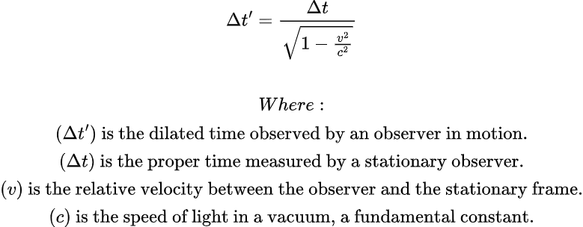

Implications for Space Exploration:
Time dilation affects various aspects of space exploration, including mission planning, navigation, and communication. As the Tempora accelerates to relativistic speeds, crew members experience time differently than observers on Earth. This time differential must be accounted for when scheduling mission events, conducting experiments, and communicating with mission control.

Onboard Systems and Compensation:
The Tempora's onboard systems are equipped with algorithms that compensate for time dilation effects, ensuring that mission objectives are met and communications remain synchronised across vast distances. These algorithms adjust timestamps, coordinate system references, and communication protocols to account for the time differential between the spacecraft and Earth.

Crew Awareness and Vigilance:
Despite the onboard systems' compensatory measures, crew members must remain vigilant and factor time dilation into their calculations and decision-making processes. This includes adjusting mission timelines, coordinating data collection efforts, and interpreting time-sensitive information accurately. By remaining aware of time dilation effects and their implications, crew members can ensure the success and safety of the mission.

Carnot Engine Theory and Application

Overview:
The Tempora spacecraft incorporates a sophisticated Carnot engine into its power generation system, a remarkable feat of engineering that leverages the principles of thermodynamics to produce electrical energy. Understanding the intricacies of Carnot engine theory is fundamental for optimizing the efficiency of the power generation system, maximizing energy output, and minimizing waste.

Principles of Carnot Engine Theory:
At its core, Carnot engine theory elucidates the fundamental principles governing the operation of heat engines. By exploiting temperature differentials between a heat source (the spacecraft) and a heat sink (the surrounding space), the Carnot engine can extract thermal energy and convert it into mechanical work. The efficiency of the Carnot engine depends on the magnitude of the temperature gradient and the ability to minimize energy losses during the conversion process.

Optimizing Efficiency:
Maximizing the temperature gradient between the spacecraft and its surroundings is paramount for enhancing the efficiency of the Carnot engine. Crew members must meticulously monitor and control temperature levels within the spacecraft to maintain an optimal operating range for the engine. Additionally, insulation and thermal management systems are employed to minimize heat loss and maximize energy transfer efficiency.

Practical Applications in Space Travel:
In the context of space travel, Carnot engine theory finds practical applications in powering critical systems and equipment aboard the Tempora spacecraft. The efficient conversion of thermal energy into electrical power ensures the continuous operation of essential systems, including life support, navigation, communication, and scientific instrumentation. Crew members responsible for maintaining the power generation system play a pivotal role in optimising Carnot engine performance and ensuring the reliability of power supply during missions.

Training and Expertise:
Crew members tasked with overseeing the operation and maintenance of the power generation system undergo rigorous training in Carnot engine theory and its practical applications in space travel. By acquiring a deep understanding of thermodynamic principles and engineering concepts, they are equipped with the knowledge and skills needed to troubleshoot issues, implement efficiency-enhancing measures, and sustain optimal performance of the Carnot engine throughout the mission duration.

Instructions for Manually Calibrating Artificial Gravity

Calibrating artificial gravity settings is crucial for maintaining crew comfort and operational efficiency during space missions. This procedure outlines steps for using a pendulum method to achieve optimal gravity simulation aboard the spaceship. By following these steps diligently, crew members ensure a comfortable and conducive environment for living and working in space.

Procedure for Artificial Gravity Calibration
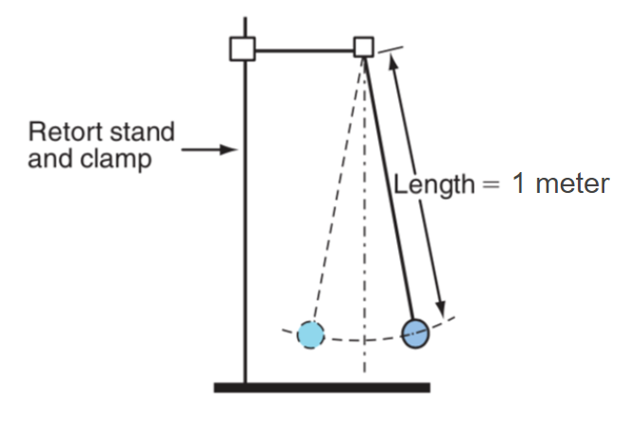
1. Prepare the Setup:

- Securely mount the pendulum on a clamp stand, ensuring it hangs freely with a precise length of 1 metre.
- Verify that the pendulum swings without obstruction and is in a stable position.

2. Initiate Pendulum Motion:

- Allow the pendulum to swing freely, observing its motion.

3. Time Measurement:
- Begin timing precisely as the pendulum reaches its highest position during a swing.
- Utilise a stopwatch to record the duration of 10 complete swings, commencing the count at "zero" for accuracy.

4. Stopwatch Stoppage:
- Halt the stopwatch upon completion of the 10th full swing, ensuring precise timing of the pendulum's oscillations.

5. Calculation:
- Calculate the average time taken for one complete swing (period) by dividing the total elapsed time by 10.

6. Adjustment of Gravity Settings:
- Utilise the calculated time to make necessary adjustments to the artificial gravity settings of the spaceship.

By following this procedure meticulously, crew members can ensure the accurate calibration of artificial gravity settings onboard the spaceship, contributing to the safety and comfort of all occupants during extended space missions.

Waste Disposal

Overview:
Effective waste disposal is essential for maintaining cleanliness, hygiene, and environmental sustainability aboard the Tempora spacecraft. As the crew goes about their daily activities, various types of waste are generated, including solid waste, wastewater, and potentially hazardous materials. Proper disposal procedures must be followed to ensure the safety and well-being of the crew, prevent contamination, and minimise the spacecraft's environmental impact.

Solid Waste Management:
Solid waste generated onboard the Tempora includes packaging materials, food scraps, and other non-recyclable items. Crew members are responsible for segregating solid waste into appropriate categories for recycling, reuse, or disposal. Recycling initiatives may involve compacting and storing recyclable materials such as plastics, metals, and paper for future processing or repurposing. Non-recyclable waste is carefully packaged and stored in designated containers for safe disposal upon return to Earth or incineration using onboard waste management system.

Hazardous Material Handling:
Certain activities onboard the Tempora may involve the use of hazardous materials, such as chemicals, fuels, and biomedical waste. Crew members must exercise caution when handling and disposing of hazardous materials to prevent accidents, spills, and contamination. Hazardous waste is collected and stored in specially designed containers equipped with safety features to prevent leakage or exposure to crew members and the spacecraft environment. Disposal of hazardous waste is conducted according to strict protocols and regulatory requirements to minimise environmental impact and ensure compliance with space safety standards.

Environmental Protection Measures:
In addition to proper waste disposal practices, the Tempora implements various environmental protection measures to minimise its ecological footprint in space. These measures may include the use of biodegradable materials, energy-efficient systems, and pollution prevention strategies to conserve resources and reduce waste generation. Crew members are encouraged to adopt sustainable habits and practices to promote environmental stewardship and preserve the pristine beauty of space for future generations.

Training and Awareness:
Crew members receive comprehensive training on waste disposal procedures, safety protocols, and environmental regulations to ensure compliance with space mission requirements. Regular awareness campaigns and educational initiatives are conducted to promote responsible waste management practices and foster a culture of environmental responsibility among the crew. By working together to minimise waste generation and maximise resource efficiency, the crew of the Tempora demonstrates their commitment to sustainability and environmental conservation in the vast expanse of space.

