
Verbio ASV Mobile Guide.

Verbio ASV.

Barcelona, December 2014

V 1.0

GUIDE CONTENT
1.Presentation 3
2.Training a new user 3
3.Verifying a user identity 5
4.Delete an existing user 6

Presentation
Verbio ASV Mobile is a mobile application with the aim to demonstrate the voice biometry technology of the company. It supports two different working modes. The Cloud mode uses an external biometry server located in the Internet. The Local mode uses an embedded version of our biometry technology. The user can train his own voice-print and check his identity verification.

Training a new user
The first step for a user is to create his account and his voice-print following the enrollment process. The user must introduce an account ID. If the ID does not exist in the system, the user will be able to start the enrollment process. Otherwise, the user will only be able to verify their identity with that account.
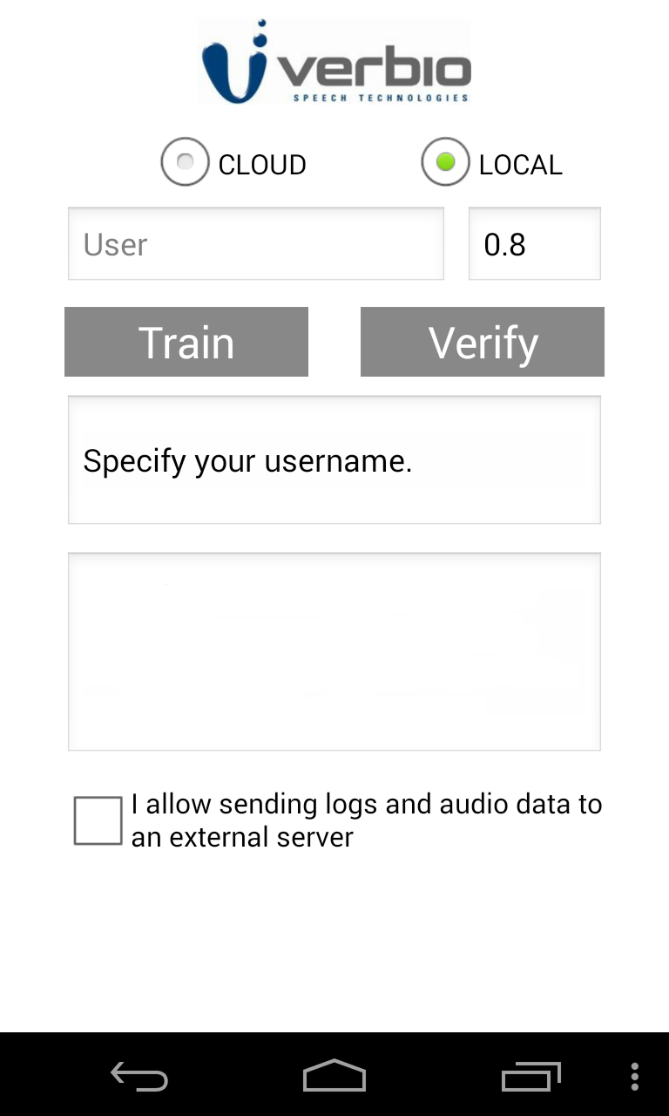Picture 1: The application interface in its first run.
To complete the enrollment process the user must repeat a concrete train phrase three times (Picture 2). Every time, the user must click the Train button and start saying the phrase. When the application is recording, the Train button will change from blue to red (Picture 3). After every sentence, the application will inform the user of the number of repetitions completed. Finally, when the enrollment is completed the user will be able to verify his identity.
In the Cloud mode it will be mandatory to mark the authorization check-box in the bottom of the application, in order to allow the company to send the user audio and activity logs to an external server.

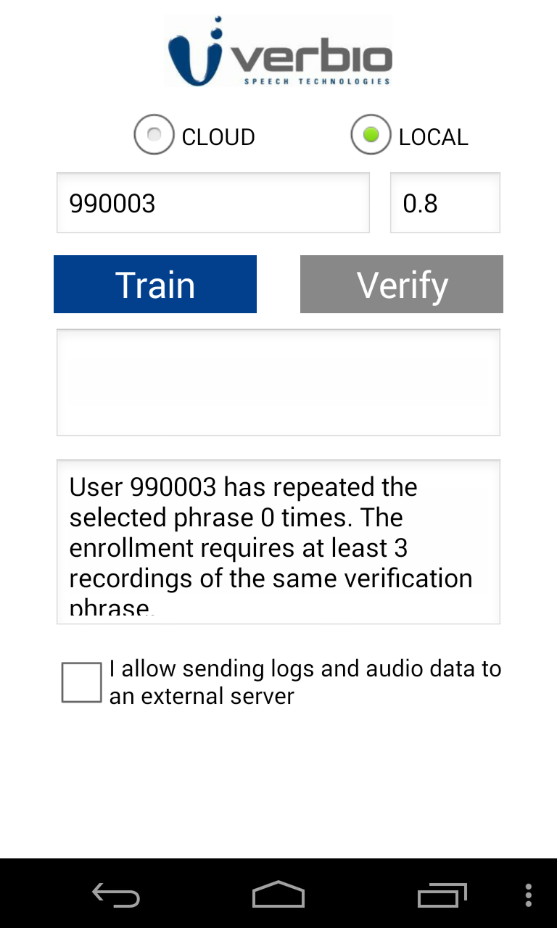Picture 2: The application with an inexistent account ID, ready to start the enrollment process.
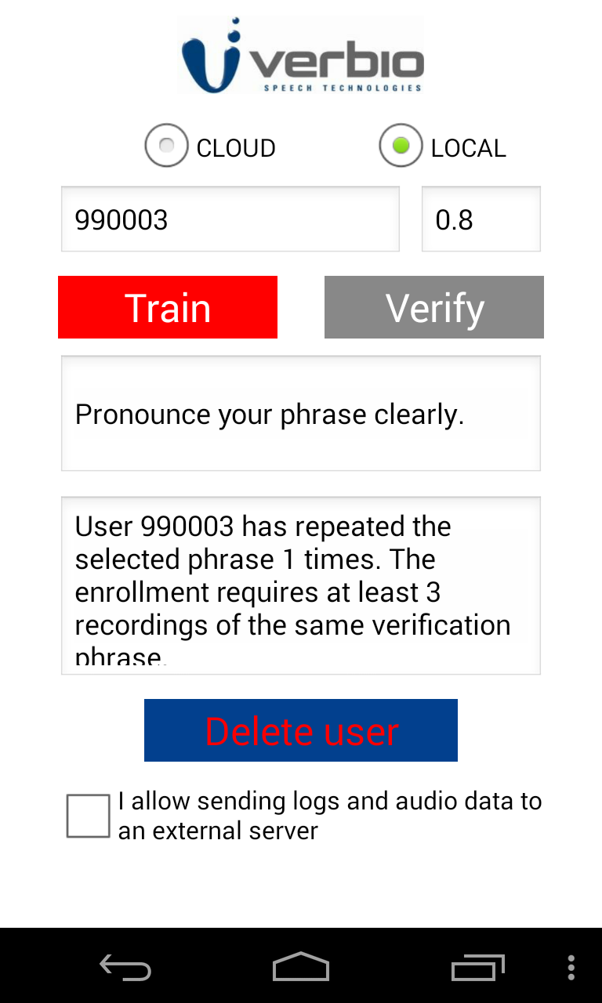Picture 3: The application recording the user voice

Verifying a user identity
When the user selects an existing account ID, the Verify button will be enabled (Picture 4). The verification process is similar to the train process. The user must pronounce a verification phrase, but only one time. Next to the account ID, the user can specify the threshold used to validate or refuse the verification. After the verification, the system will display a punctuation. If the punctuation is higher than the threshold, the verification will be valid (Picture 5). Otherwise, it will be refused (Picture 6).
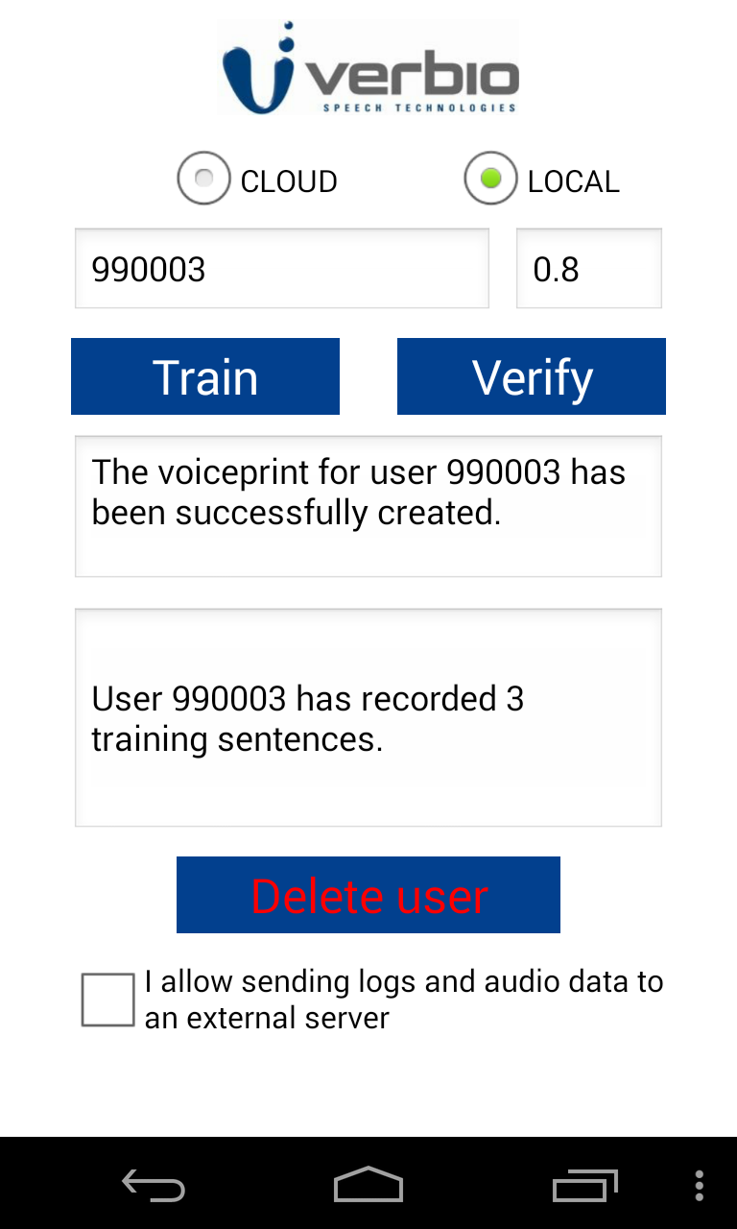Picture 4: The application with an existing user ID ready for a verification

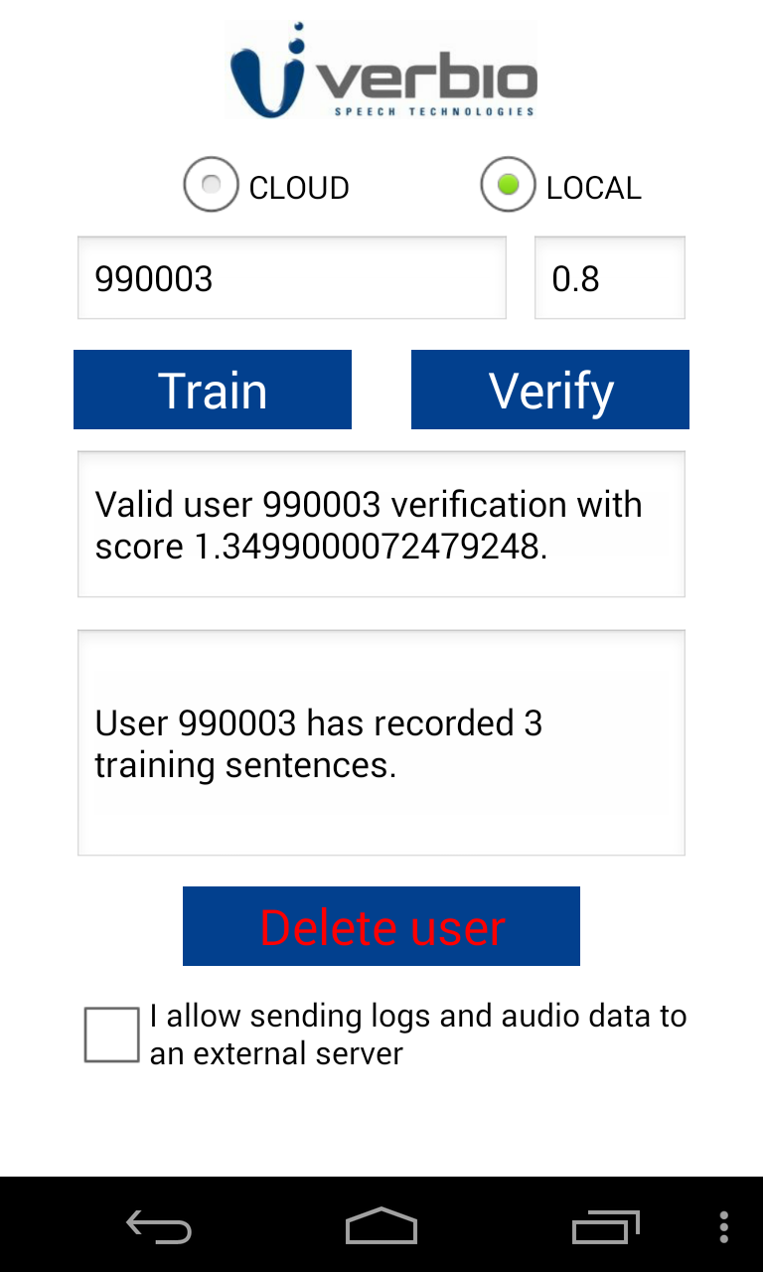Picture 5: A valid verification
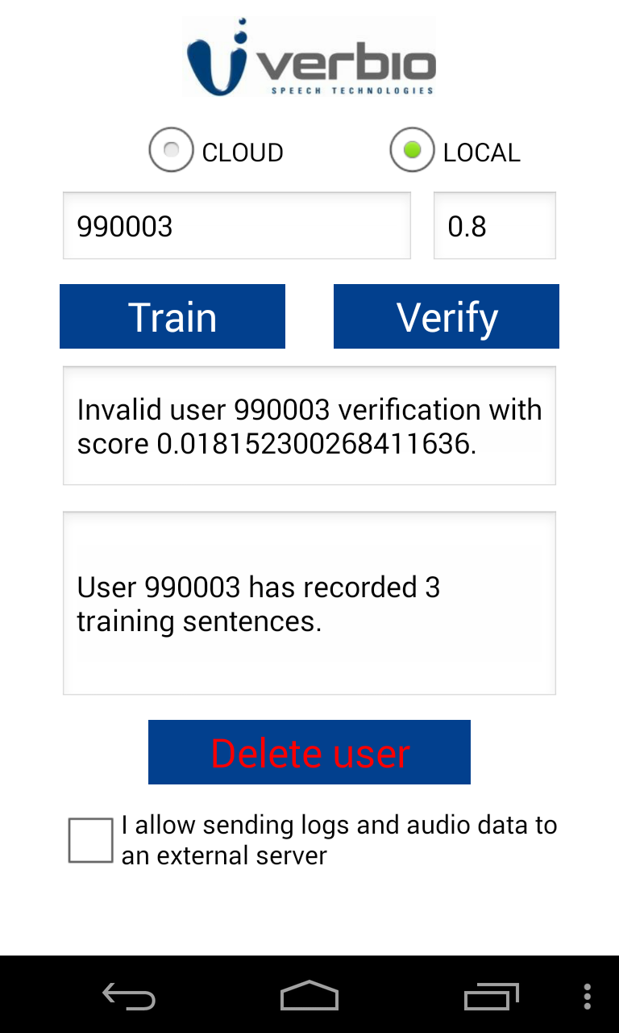Picture 6: A refused verification

Delete an existing user
When the user specifies an existing account ID, it will appear a “Delete user” button. Clicking this button will remove the user account and his voice-print from the system.

