
Verbio ASV mobile prototype for Motorola Guide

Barcelona, December 2014

V 1.0

GUIDE CONTENT

1. Introduction 3
2. Training a new user 3
3. Verifying a user identity 5
4. Delete an existing user 6

Introduction
Verbio ASV Mobile is a prototype mobile application for Motorola with the aim to demonstrate Verbio’s voice biometry technology. It works in Local mode using an embedded version of our biometric technology.
All the logs and the audios recorded while using the application will be send to Verbio Cloud servers in order to be able to improve the accuracy if needed.
The user can train its own voiceprint and check his identity.

Training a new user
The first step for a user is to create his account and his voiceprint following the enrollment process. The user must introduce an account ID. If the ID does not exist in the system, the user will be able to start the enrollment process. Otherwise, the user will only be able to verify their identity with that account.

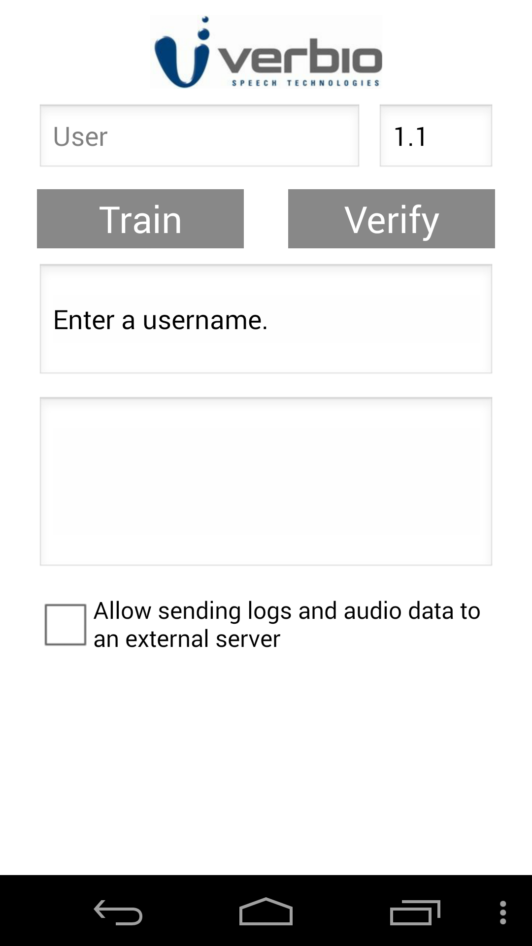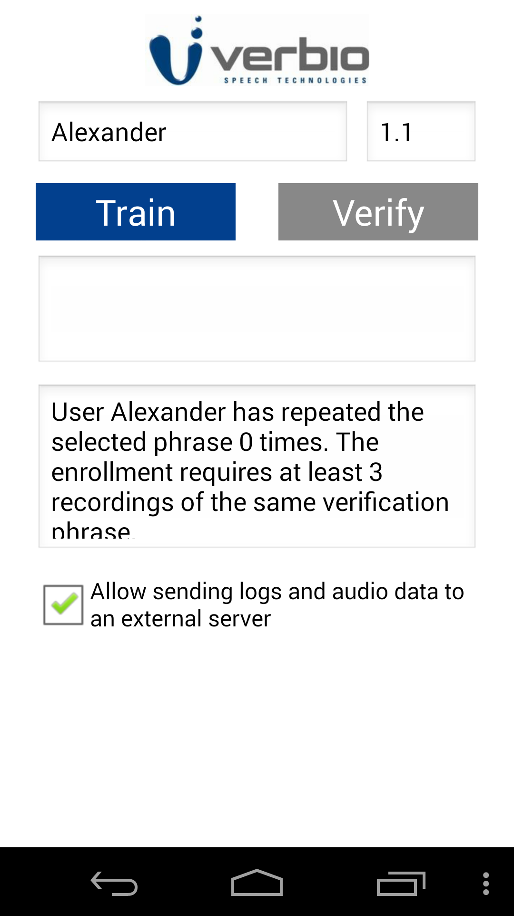

To complete the enrollment process the user must repeat a concrete train phrase three times. Every time, the user must click the Train button and start saying the phrase.
When the application is recording the Train button will change from blue to red.
After every sentence, the application will inform the user of the number of repetitions completed. Finally, when the enrollment is completed the user will be able to verify his identity.

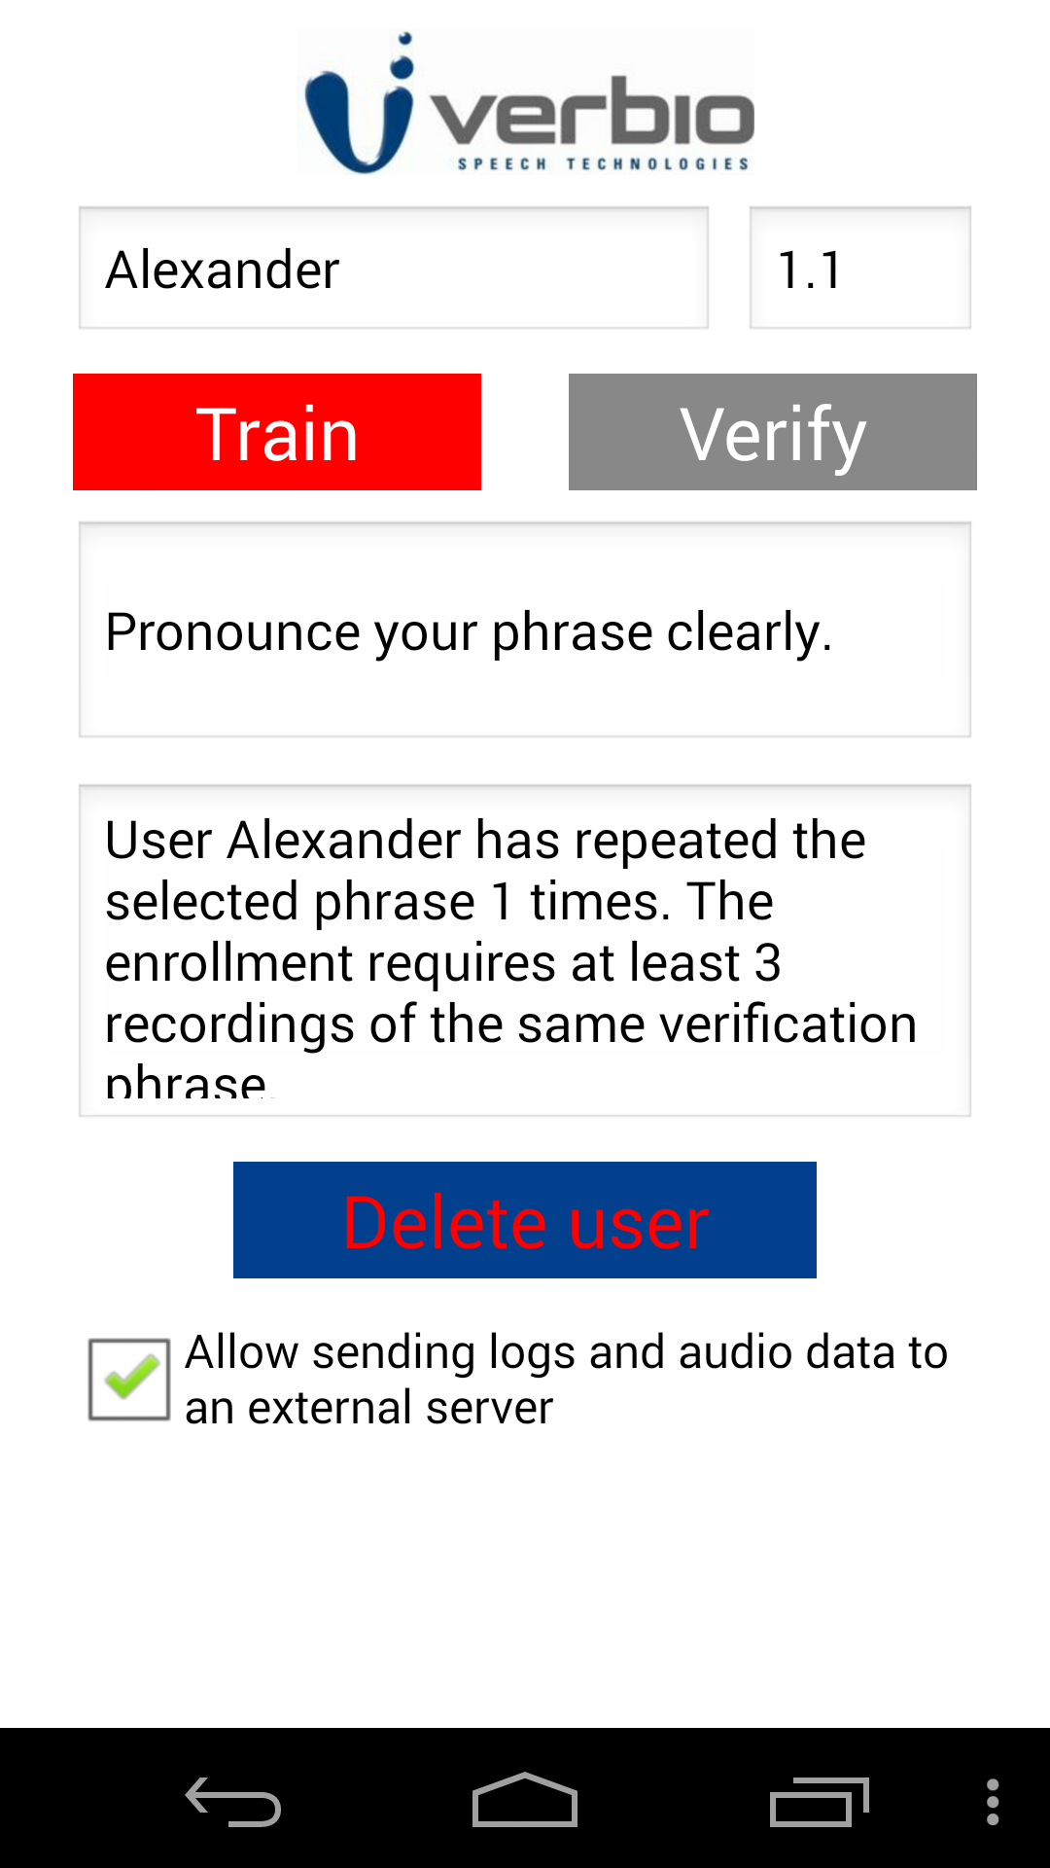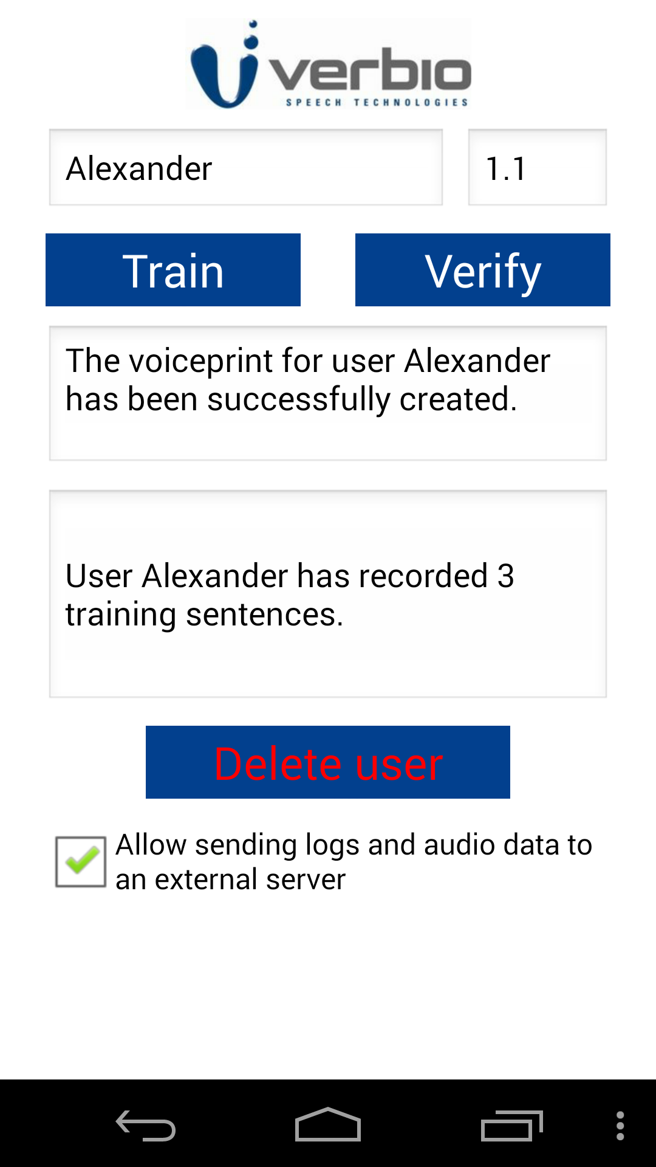

Verifying a user identity
When the user selects an existing account ID, the Verify button will be enabled.
The verification process is similar to the train process. The user must pronounce a verification phrase, but only one time.
Next to the account ID, the user can specify the threshold used to validate or refuse the verification. After the verification, the system will display a score. If the score is higher than the threshold, the verification will be valid.
Otherwise, it will be refused.

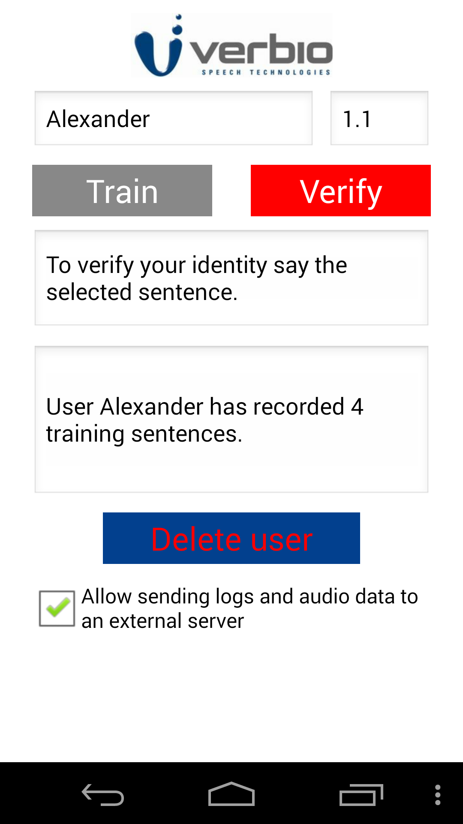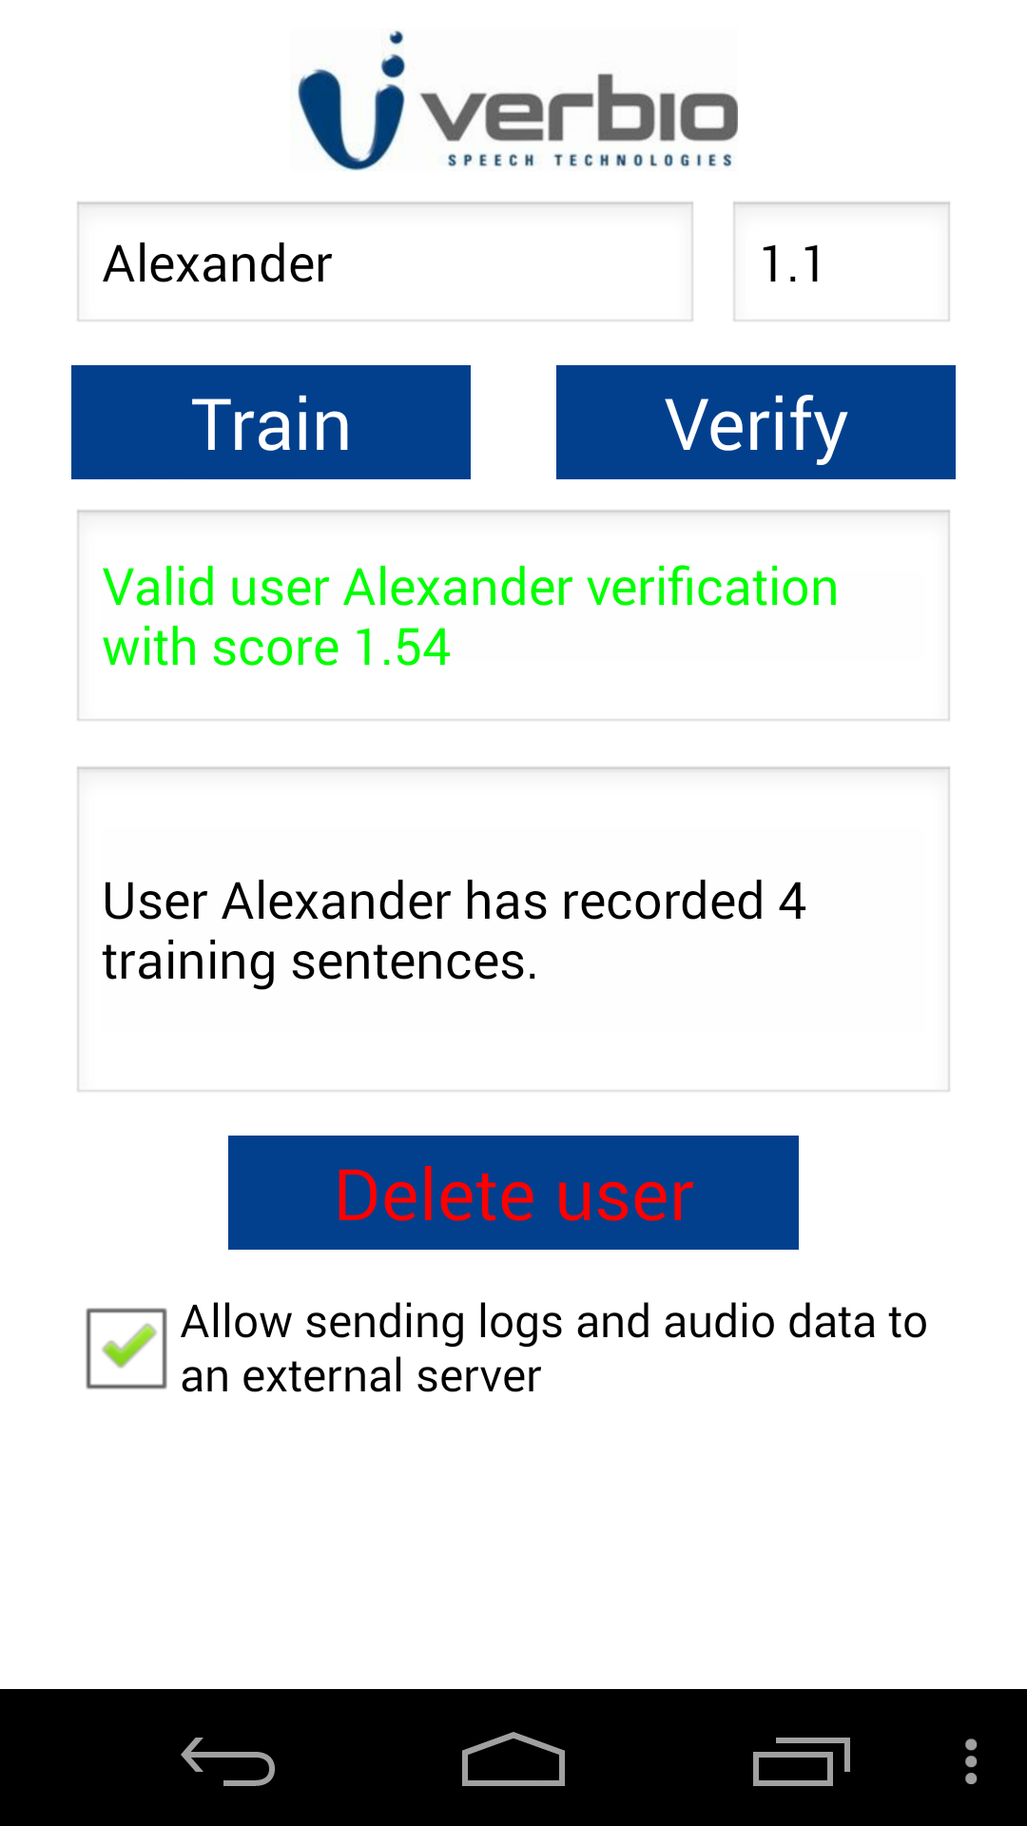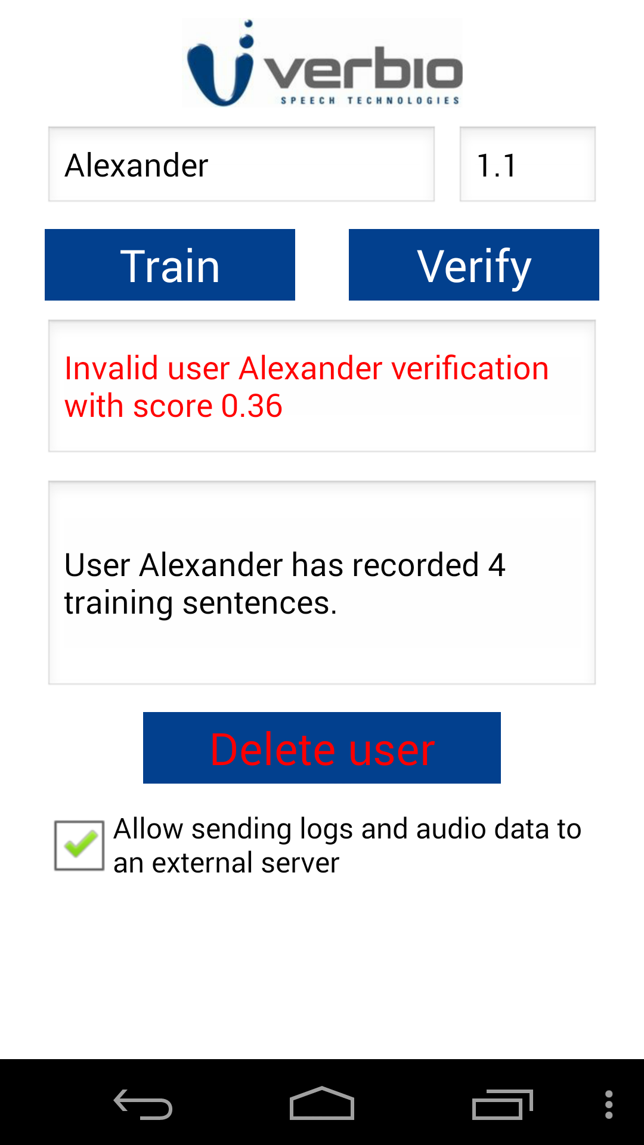

Delete an existing user
When the user specifies an existing account ID, it will appear a Delete user button. Clicking this button will remove the user account and his voiceprint from the system.

