Q-RAG: Quantum-Enhanced Retrieval for Retrieval-Augmented Large Language Models

Background
Large Language Models are capable of generating fluent and useful responses, but they may produce incorrect, outdated, or unsupported information when the required knowledge is not reliably encoded in their parameters.
Retrieval-Augmented Generation, or RAG, addresses this limitation by retrieving relevant information from an external knowledge base and supplying that information as context to the LLM.
A conventional RAG pipeline can be represented as:
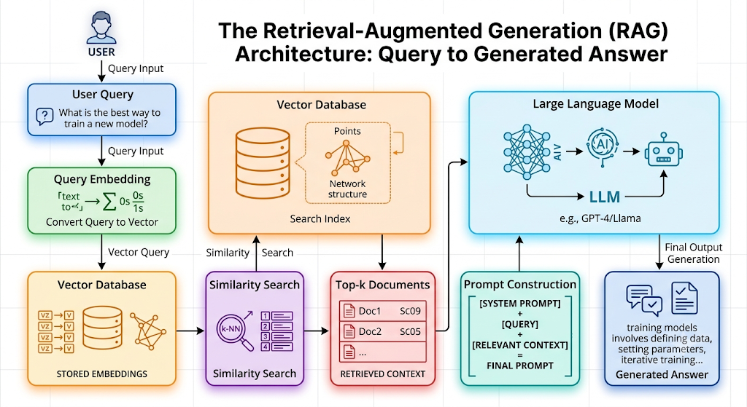
The quality of the final answer depends significantly on the quality of the documents selected during retrieval.
Traditional RAG systems typically retrieve documents using methods such as:
- cosine similarity,
- dense vector retrieval,
- BM25,
- nearest-neighbor search,
- hybrid sparse-dense retrieval.
However, simply selecting the top-k most similar documents may not always produce the best context.
The retrieved set may still contain:
- redundant passages,
- overlapping information,
- irrelevant documents,
- contradictory documents,
- excessive context,
- documents that are individually relevant but collectively suboptimal.
Therefore, retrieval can also be viewed as a combinatorial document selection problem.
This project aims to investigate whether quantum optimization techniques can improve the selection of documents supplied to an LLM.

Core Research Problem
The project will investigate the following research question:
Can a quantum-assisted retrieval strategy select a more informative and less redundant subset of documents for Retrieval-Augmented Generation than conventional top-k similarity retrieval?
The quantum component will not replace the vector database or the LLM.
Instead, the system will use a two-stage approach:
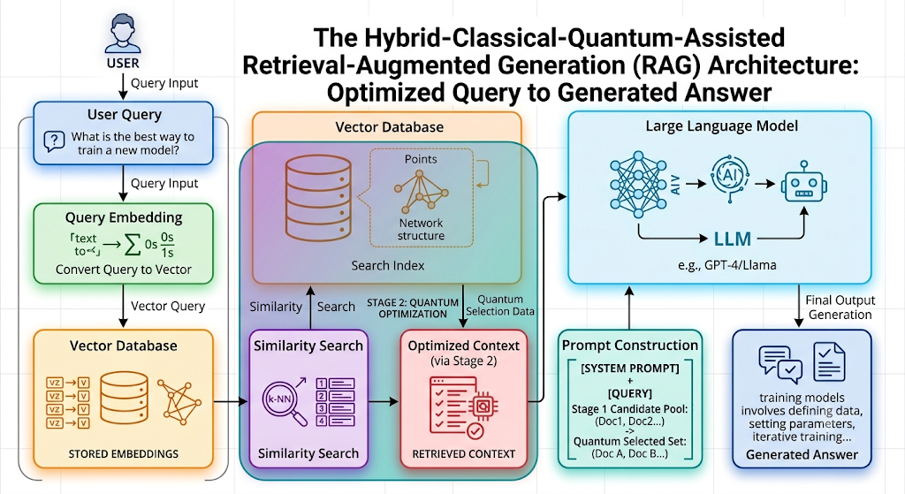
The first-stage retriever identifies a candidate pool of documents.
The quantum optimizer then chooses the best subset of those documents under constraints such as:
- relevance,
- diversity,
- redundancy,
- context-window length,
- retrieval cost.
It is required to design and implement a hybrid classical-quantum RAG framework in which the document selection stage is formulated as a combinatorial optimization problem.
For a given user query $q$, assume that a conventional retriever returns $n$ candidate documents:
$D=\{d_{1},d_{2},…,d_{n}\}$

Each candidate document $d_{i}$ has a relevance score:
$r_{i}=\text{relevance}\left(q,d_{i}\right)$
The system must select a binary decision subset $x∈\{0,1\}^{n}$, where:
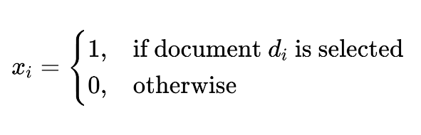
1. Constrained Multi-Objective Optimization Problem
To maximize total query relevance while penalizing pair-wise document redundancy under a strict context-length constraint, the primary objective function $f(x)$ is defined as:
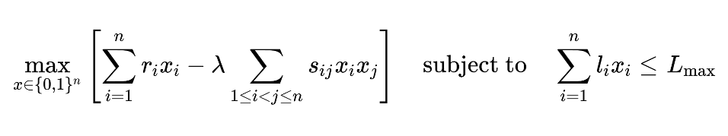
where:
- $r_{i}$ is the relevance score of document $d_{i}$ relative to query $q$.
- $s_{ij}$ measures the pairwise similarity/redundancy between documents $d_{i}$ and $d_{j}$
- $λ> 0$ is a regularization hyperparameter balancing relevance and redundancy.
- $l_{i}$ represents the token length of document $d_{i}$
- $L_{max}$ is the maximum available context length budget for the LLM prompt.
2. Conversion to Unconstrained QUBO Formulation
To map this problem onto quantum processors (such as via QAOA or Quantum Annealing), the inequality constraint must be converted into an unconstrained Quadratic Unconstrained Binary Optimization (QUBO) problem.
Using a set of $K=\left\lfloor \log_{2}\left(L_{max}\right)\right\rfloor +1$ binary slack variables $y_{k}∈\{0,1\}$ to encode the context capacity, the constraint is transformed into a quadratic penalty term:
$$H_{\text{penalty}}\left(x,y\right)=P⋅{\left(\sum_{i=1}^{n}{l_{i}x_{i}}+\sum_{k=0}^{K}{2^{k}y_{k}}-L_{max}\right)}^{2}$$

where $P > 0$ is a sufficiently large penalty factor enforcing valid context lengths.
Combining the negative of the original objective function (converted for minimization) with the penalty term yields the unconstrained QUBO cost function $H_{\text{QUBO}}\left(x,y\right)$:
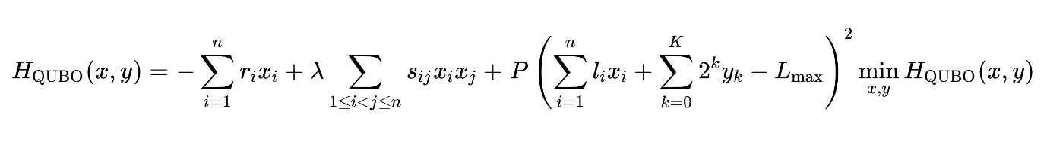
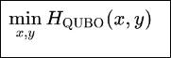
3. Quantum Mapping and Execution
The QUBO is mapped directly onto an Ising Hamiltonian by substituting each binary variable with Pauli-$Z$ operators ($x_{i}=\frac{1-Z_{i}}{2}$):
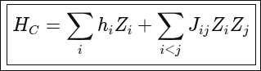
The resulting ground state of H_{C} can then be computed using algorithms like the Quantum Approximate Optimization Algorithm (QAOA) or Quantum Annealing to yield the optimal subset of selected context documents.

Primary Objective
Develop and evaluate a hybrid quantum-classical retrieval framework for RAG that optimizes the subset of documents supplied to an LLM.

Specific Objectives
- Implement a conventional RAG pipeline.
- Build an initial candidate retriever using dense retrieval and/or BM25.
- Represent document subset selection as a binary optimization problem.
- Develop a relevance-diversity optimization objective.
- Convert the optimization model into QUBO form.
- Implement QAOA-based document selection.
- Implement classical retrieval and optimization baselines.
- Compare quantum-assisted RAG with conventional RAG.
- Measure retrieval quality, answer quality, redundancy, token usage, and optimization cost.
- Analyze whether quantum-assisted retrieval offers any measurable advantage at small problem sizes.

Proposed System Architecture
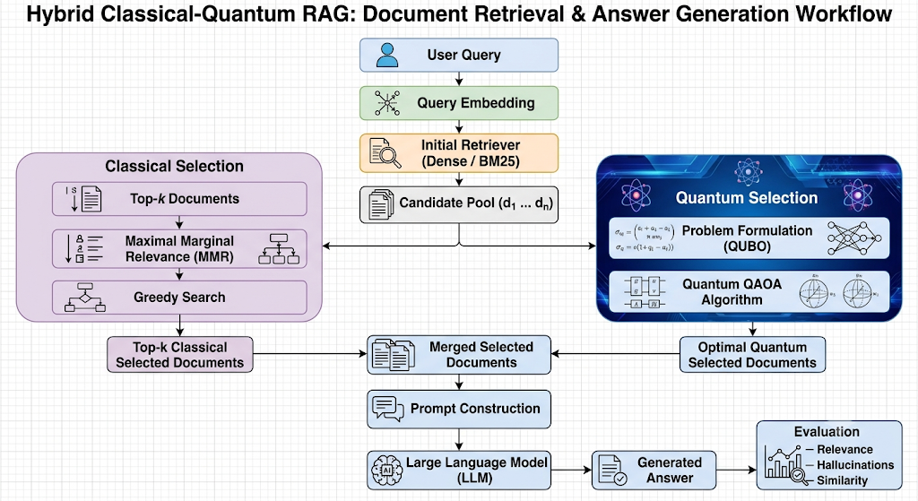

Scope Restriction
The project should not attempt to build a new vector database, train a new LLM, or develop a fault-tolerant quantum algorithm.
The core project is limited to:
Optimizing which retrieved documents are included in the final RAG context.
The LLM and embedding model should be treated as existing components.

Recommended Dataset
The project should use a question-answering dataset where each question can be associated with relevant context documents.
HotpotQA is attractive because many questions require information from multiple supporting documents.
This makes document selection meaningful.
The project can use:
- approximately 500–1,000 questions for development;
- 200–500 questions for evaluation.

Alternative Datasets
- Natural Questions
- TriviaQA
- SQuAD with synthetic retrieval corpus
- WikiQA
- MS MARCO subset
A simplified local corpus may also be created from Wikipedia passages if infrastructure is limited.

Recommended Retrieval Pipeline
The initial retriever should generate a candidate pool of approximately:
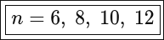
documents per query.
The candidate pool must be kept small because each binary decision variable may correspond to a qubit in the quantum formulation.
Recommended initial retrieval methods:

Dense Retrieval
Use sentence embeddings generated by a small embedding model.
Similarity can be computed using cosine similarity.

BM25
A traditional sparse baseline should also be included if time permits.

Hybrid Retrieval
Optional:
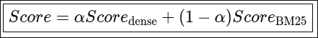

Quantum Representation
Each candidate document corresponds to one binary variable.
For example:
Document: d1 d2 d3 d4 d5 d6 d7 d8
Selection: 1 0 1 0 1 0 0 1
The bitstring means:
- include (d_1),
- exclude (d_2),
- include (d_3),
- and so on.
For eight candidate documents, the search space contains:
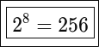
possible subsets.
For twelve documents:
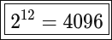
possible subsets.
This provides the basic combinatorial search problem.

Relevance Score
For each query-document pair, compute:
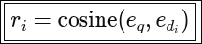
where:
- e_{q} is the query embedding;
- e_{di} is the document embedding.
Normalize all relevance scores into the range:
[0,1]

Redundancy Score
For each document pair:
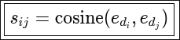
High similarity indicates potential redundancy.
If two documents contain nearly identical information, selecting both should receive a penalty.
The objective therefore rewards:
high relevance + low redundancy.

Base Optimization Function
A suitable objective is:
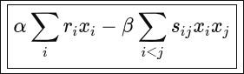
where:
- α controls relevance;
- β controls redundancy.
Students should investigate different values of:

Context-Length Constraint
A stronger version should include the token lengths of documents.
Let l_{i} represent the number of tokens in document (i).
Then:
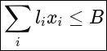
where (B) is the available context budget.
For example:
B = 1000
tokens.
The optimization problem becomes:
Select the most relevant and diverse set of passages without exceeding 1,000 tokens.
This gives the project a practical RAG motivation.

Simplified QUBO Form
Students should eventually obtain an objective of the form:
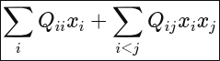
where:
- diagonal terms represent document relevance and possibly length penalties;
- off-diagonal terms represent redundancy penalties.
For example:
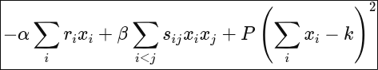
where (P) is a penalty coefficient and (k) is the desired number of retrieved documents.
Students may initially use this fixed-cardinality formulation because it is easier than handling token-budget inequalities.

Recommended Two Versions of the Problem
Students should implement the project incrementally.

Version A — Fixed-k Selection
Given (n) candidate documents, select exactly:
k=3
or
k=4
documents.
Optimize:
[Relevance - Redundancy]
This should be the mandatory implementation.

Version B — Token-Budget Selection
Select any number of documents subject to:
This should be an extension.

Quantum Algorithm
The main quantum optimization algorithm should be:

Quantum Approximate Optimization Algorithm — QAOA
Recommended initial configuration:
p=1
Then experiment with:
p=2
if computational resources permit.
The workflow should be:
Candidate Documents
↓
Relevance Scores
↓
Pairwise Similarities
↓
QUBO Matrix
↓
QAOA
↓
Best Bitstring
↓
Selected Documents
A simulator should be used for the main implementation.

Classical Baselines
The quantum method must be compared against meaningful classical methods.

Baseline 1 — Top-k Similarity Retrieval
Select the (k) documents with the highest relevance scores.
This is the basic RAG baseline.

Baseline 2 — Maximal Marginal Relevance
MMR explicitly balances relevance and diversity.
This is a particularly important baseline because it addresses the same problem as the proposed quantum method.
A typical MMR selection objective is:
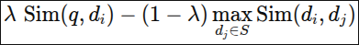

Baseline 3 — Greedy Relevance-Diversity Selection
Repeatedly select the document that maximizes:
[relevance - redundancy]

Baseline 4 — Simulated Annealing
Represent document subsets using binary strings and optimize the same objective.

Baseline 5 — Genetic Algorithm
Optional but recommended.

Baseline 6 — Exhaustive Search
For small candidate pools:
evaluate every feasible subset.
This provides the exact optimal solution for comparison.

LLM Component
Students should use a small instruction-tuned model.
Possible choices include:
- Phi family models,
- Gemma,
- Qwen,
- FLAN-T5,
- another suitable instruction model.
Only one LLM is required for the core project.
A second LLM can be used as an optional transfer experiment.

RAG Prompt Template
A simple prompt template may be used:
Use only the following retrieved context to answer the question.

Context:
{retrieved_documents}

Question:
{query}

Answer concisely and factually.
The prompt should remain constant across experiments so that retrieval quality is the main variable.

Experimental Design
We should conduct at least five experiments.

Experiment 1 — Standard RAG vs Quantum-Enhanced RAG
Compare:
- Top-k RAG
- Quantum-optimized RAG
Measure answer quality and retrieval quality.

Experiment 2 — Relevance vs Diversity
Vary the redundancy penalty:
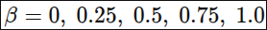
Observe how the selected document sets change.

Experiment 3 — Classical vs Quantum Selection
Compare:
- Top-k
- MMR
- Greedy
- Simulated Annealing
- QAOA
- Exhaustive Search

Experiment 4 — Effect of Candidate Pool Size
Test:
[n=6,8,10,12]
Observe:
- optimization time,
- objective value,
- retrieval quality,
- QAOA solution quality.

Experiment 5 — Effect of Number of Selected Documents
Test:
[k=2,3,4,5]
Measure whether more context actually improves answer quality.

Retrieval Evaluation Metrics
The project should evaluate retrieval independently of the LLM.

Recall@k
Measures whether relevant supporting documents were retrieved.
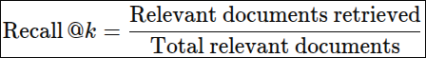

Precision@k
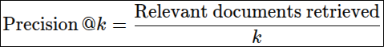

Mean Reciprocal Rank
Useful where one primary relevant passage exists.

NDCG
Optional.

Redundancy Score
Calculate the average pairwise similarity among selected documents:
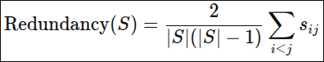
Lower values are desirable if relevance is maintained.

RAG Answer Evaluation Metrics

Exact Match
Useful for short-answer QA.

Token-Level F1
Compare generated answer tokens against reference answers.

Answer Accuracy
Manual or automatic label-based scoring where applicable.

Context Precision
Measure how much retrieved context is useful.

Context Recall
Measure whether required evidence is present.

Faithfulness
Evaluate whether the generated answer is supported by retrieved context.
We may use a simple rule-based or LLM-based evaluator if resources permit, but conventional QA metrics should remain the primary evaluation.

Efficiency Metrics
We should also measure:
- number of retrieved passages;
- total context tokens;
- retrieval latency;
- optimization latency;
- LLM generation latency;
- total pipeline latency.
A useful metric is:
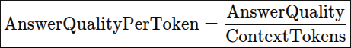
This measures how efficiently the context window is used.

Quantum-Specific Evaluation
The following should be recorded:
- number of binary variables;
- number of qubits;
- QAOA depth;
- number of shots;
- objective function value;
- probability of best solution;
- optimization runtime;
- approximation ratio.
For instances where exhaustive search is feasible:
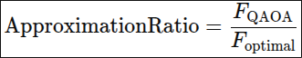
after appropriate normalization.

