CourseBoard
A web application for students to share tips and resources for their classes

Wishlist, Requirements, Design & Schema, Implementation Details, & Manual

Wishlist
- Should have a list of courses offered.
- Users can look up resources for the class they’re taking: notes with text and images, discussions, links to videos and books, etc.
- Registered users can make posts about specific courses containing text, images, links, and other files.
- Post contents should support full Markdown.
- Users should only see posts for the specific course that they’re looking under.
- Within a specific course, posts should be marked as belonging to a specific offering, eg. that of a certain professor and a certain year.
- Posts should be placed in an approval queue for a human moderator to look over, assisted by an AI tool that aids their work by ranking queued posts by validity/usefulness, boosting good posts and putting bad posts at the bottom plus flagging them.
- A user can set their language whether logged in or not and have posts automatically translated with the option to view original post always available.
- Backend: FastAPI, Auth0, SQLite
- Frontend: React, Tailwind

Requirements

User Requirements

Login/Accounts
Goals | Non-goals
Users must log in to make posts. | Two factor authentication
Users can log in with existing accounts to other websites. | Login location tracking and warnings
User registrations are manually verified by an admin. | Storing of any sensitive information
Users have a fixed user ID not visible to them but always visible to administrators. | Users cannot set a profile picture
Users can change their display name, but their display name history is publicly visible.
Users can like/dislike other users leading to a hidden score to aid moderation.

Reading
Users can read posts without logging in. | No favourite or like system, users should bookmark posts on their browser instead.
Users can reports posts as malicious or off topic.
Users can report course topics as malicious or off topic.
Sticky note/bulletin-board inspired presentation.
Responsive design adjusting to different screen sizes.

Posting
Users must be logged in to make posts. | No youtube player embed, thumbnail and title preview is enough.
Posts can contain images, text with full markdown, and links.
Posts must be to a particular topic (including to a “General” topic each course code will have)
MathJax math notation support
Posts manually approved by a moderator

Technical Requirements
Frontend should make use of React and Tailwind CSS for a modern, clean-looking user experience. | No advertisements or monetisation.
Uses Auth0 for authentication.
REST API implemented with FastAPI.
MySQL as database management system.
Python venv configured for the application.

Design and Database Schema

Web Mockups
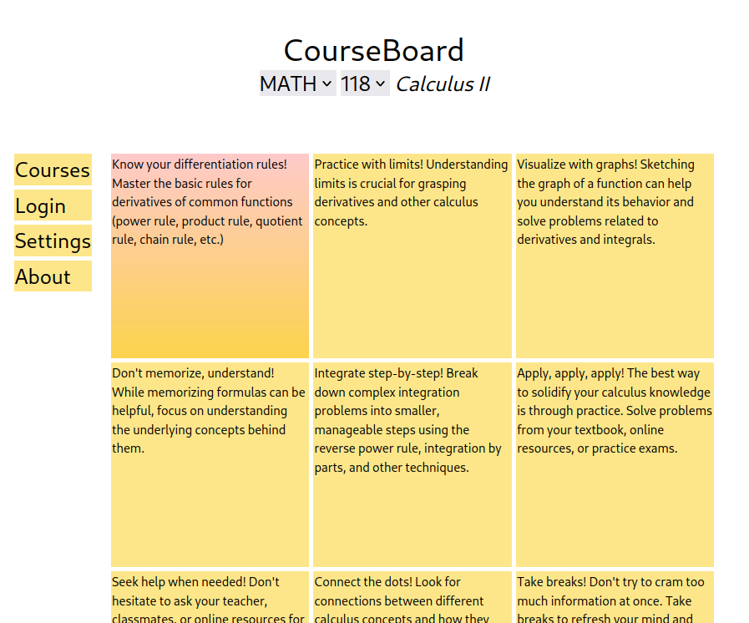
Fig. 1: Mockup 1 of main page. Note that the first sticky note about differentiation rules is hovered over.

Entity-Relationship Model
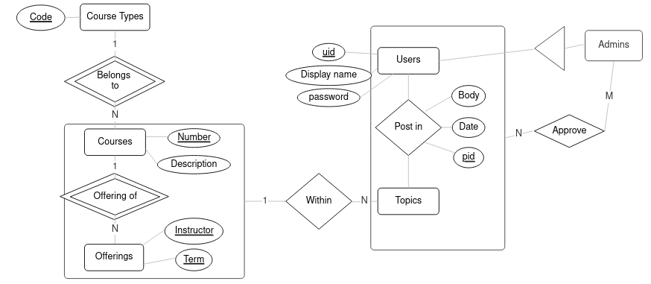

Conceptual Schema
Foreign keys marked with an asterisk and can be inferred.
Users(uid, name, email, password)
Admins(uid*)
CourseTypes(code)
Courses(code*, num, description)
Offering(code*, num*, instructor, term)
Topics(code*, num*, instructor*, term*, topicname)
Posts(pid, code*, num*, instructor*, term*, topic*, body, author*, date)

