The basic idea for what to prioritize is to understand principles and not details --- however, what is a detail to some might be a principle to me. Why programs which exhibit locality of references can exploit cache memories better is a principle --- opcodes, the number of rename registers in each register file of the 970MP, and library function parameter types and names are details. Why superscalar processors need branch prediction, rename registers, and a reorder buffer are principles.

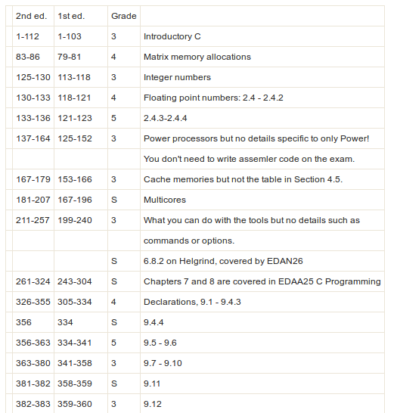
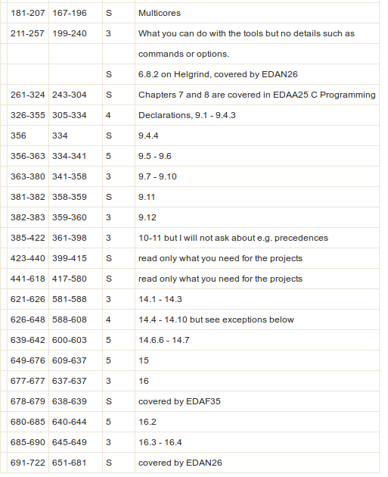
Below are advice on what is important to achieve a certain grade, i.e. if you wish to pass you should study at least those pages marked as 3.
3 = everybody should know this
4 = more advanced
5 = even more advanced
S = skip, e.g. due to it's covered by another course

 | 2nd ed. | 1st ed. | Grade
 | 1-112 | 1-103 | 3 | Introductory C
 | 83-86 | 79-81 | 4 | Matrix memory allocations
 | 125-130 | 113-118 | 3 | Integer numbers
 | 130-133 | 118-121 | 4 | Floating point numbers: 2.4 - 2.4.2
 | 133-136 | 121-123 | 5 | 2.4.3-2.4.4
 | 137-164 | 125-152 | 3 | Power processors but no details specific to only Power!
 |  |  |  | You don't need to write assemler code on the exam.
 | 167-179 | 153-166 | 3 | Cache memories but not the table in Section 4.5.
 | 181-207 | 167-196 | S | Multicores
 | 211-257 | 199-240 | 3 | What you can do with the tools but no details such as
 |  |  |  | commands or options.
 |  |  | S | 6.8.2 on Helgrind, covered by EDAN26
 | 261-324 | 243-304 | S | Chapters 7 and 8 are covered in EDAA25 C Programming
 | 326-355 | 305-334 | 4 | Declarations, 9.1 - 9.4.3
 | 356 | 334 | S | 9.4.4
 | 356-363 | 334-341 | 5 | 9.5 - 9.6
 | 363-380 | 341-358 | 3 | 9.7 - 9.10
 | 381-382 | 358-359 | S | 9.11
 | 382-383 | 359-360 | 3 | 9.12
 | 385-422 | 361-398 | 3 | 10-11 but I will not ask about e.g. precedences
 | 423-440 | 399-415 | S | read only what you need for the projects
 | 441-618 | 417-580 | S | read only what you need for the projects
 | 621-626 | 581-588 | 3 | 14.1 - 14.3
 | 626-648 | 588-608 | 4 | 14.4 - 14.10 but see exceptions below
 | 639-642 | 600-603 | 5 | 14.6.6 - 14.7
 | 649-676 | 609-637 | 5 | 15
 | 677-677 | 637-637 | 3 | 16
 | 678-679 | 638-639 | S | covered by EDAF35
 | 680-685 | 640-644 | 5 | 16.2
 | 685-690 | 645-649 | 3 | 16.3 - 16.4
 | 691-722 | 651-681 | S | covered by EDAN26

