1. Memcmp
int
memcmp (const PTR str1, const PTR str2, size_t count)
{
register const unsigned char *s1 = (const unsigned char*)str1;
register const unsigned char *s2 = (const unsigned char*)str2;
while (count-- > 0)
{
if (*s1++ != *s2++)
return s1[-1] < s2[-1] ? -1 : 1;
}
return 0;
}
variable-length array (VLA), also called variable-sized, runtime-sized, is an array data structure whose length is determined at run time (instead of at compile time).[1] In C, the VLA is said to have a variably modified type that depends on a value (see Dependent type).
The main purpose of VLAs is to simplify programming of numerical algorithms.
A bit field is a data structure used in computer programming. It consists of a number of adjacent computer memory locations which have been allocated to hold a sequence of bits, stored so that any single bit or group of bits within the set can be addressed. A bit field is most commonly used to represent integral types of known, fixed bit-width.

struct Data
{
unsigned short m_dzienTygodnia:3;
unsigned short m_dzienMiesiaca:5;
unsigned short m_miesiac:4;
};
Flexible array members were introduced in the C99 standard of the C It is a member of a struct, which is an array without a given dimension. It must be the last member of such a struct and it must be accompanied by at least one other member, as in the following example:

struct vectord {
size_t len;
double arr[]; // the flexible array member must be last
};
//The sizeof operator on such a struct gives the size of the structure as if the flexible array member was empty.
C++ does not have flexible array members.

Compound literal
A compound literal looks like a cast containing an initializer. Its value is an object of the type specified in the cast, containing the elements specified in the initializer; it is an lvalue. As an extension, GCC supports compound literals in C89 mode and in C++.
Usually, the specified type is a structure. Assume that struct foo and structure are declared as shown:
struct foo {int a; char b[2];} structure;

Here is an example of constructing a struct foo with a compound literal:
structure = ((struct foo) {x + y, 'a', 0});

This is equivalent to writing the following:
{
struct foo temp = {x + y, 'a', 0};
structure = temp;
}

6.29 Designated Initializers
1. Standard C90 requires the elements of an initializer to appear in a fixed order, the same as the order of the elements in the array or structure being initialized.
In ISO C99 you can give the elements in any order, specifying the array indices or structure field names they apply to, and GNU C allows this as an extension in C90 mode as well. This extension is not implemented in GNU C++.
To specify an array index, write ‘[index] =’ before the element value. For example,
int a[6] = { [4] = 29, [2] = 15 };
is equivalent to
int a[6] = { 0, 0, 15, 0, 29, 0 };
2. Designated initialisers come in two flavours:
1) It provides a quick way of initialising specific elements in an array:
int foo[10] = { [3] = 1, [5] = 2 };
will set all elements to foo to 0, other than index 3 which will be set to 1 and index 5 which will be set to 2.
2) It provides a way of explicitly initialising struct members. For example, for
struct Foo { int a, b; };
you can write
struct Foo foo { .a = 1, .b = 2 };
Note that in this case, members that are not explicitly initialised are initialised as if the instance had static duration.
So on a 4-way set associative cache the memory cache will have 2,048 blocks containing four lines each (8,192 lines / 4), on a 2-way set associative cache the memory cache will have 4,096 blocks containing 2 lines each and on a 16-way set associative cache the memory cache will have 512 blocks containing 16 lines each. Here we are continuing our example of a 512 KB L2 memory cache divided into 8,192 64-byte lines. Depending on the CPU the number of blocks will be different, of course.
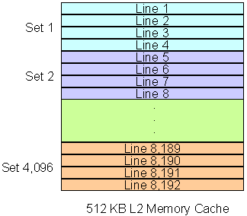Figure 7: 512 KB L2 memory cache configured as 4-way set associative.
Then the main RAM memory is divided in the same number of blocks available in the memory cache. Keeping the 512 KB 4-way set associative example, the main RAM would be divided into 2,048 blocks, the same number of blocks available inside the memory cache. Each memory block is linked to a set of lines inside the cache, just like in the direct mapped cache. With 1 GB RAM, the memory would be divided into 2,048 blocks with 512 KB each, see Figure 8.
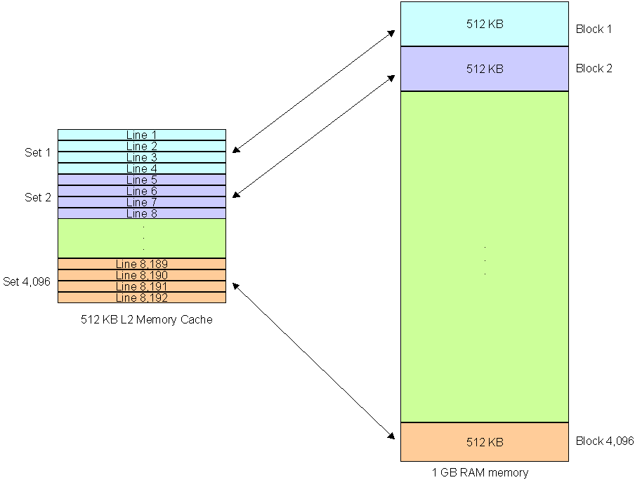
Figure 8: 512 KB L2 memory cache configured as 4-way set associative.
As you see the mapping is very similar to what happens with the direct mapped cache, the difference is that for each memory block there is now more than one line available on the memory cache. Each line can hold the contents from any address inside the mapped block. On a 4-way set associative cache each set on the memory cache can hold up to four lines from the same memory block.
With this approach the problems presented by the direct mapped cache are gone (both the collision problem and the loop problem we describe in the previous page). At the same time, the set associative cache is easier to implement than the full associative cache, since its control logic is simpler. Because of that this is nowadays the most common cache configuration, even though it provides a lower performance compared to the full associative one.
Of course we still have a limited number of available slots inside each memory cache set for each memory block – four on a 4-way configuration. After these four slots are taken, the cache controller will have to free one of them to store the next instruction loaded from the same memory block.
When we increase the number of ways a set associative memory cache has – for example, from 4-way to 8-way configuration –, we have more slots available on each set, but if we keep the same amount of cache memory the size of each memory block is also increased. Continuing our example, moving from 4-way to 8-way would make our 1 GB RAM memory to be divided into 1,024 1 MB blocks. So this move would increase the number of available slots on each set, but now each set would be in charge of a bigger memory block.
There is a lot of academic discussion regarding what is the perfect balance between the number of sets and the memory block size and there is no definitive answer – Intel and AMD use different configurations, as you will see in the next page.
So what happens if we have a bigger memory cache? Keeping the above example, if we increased the L2 memory cache from 512 KB to 1 MB (the only way to do that would be by replacing the CPU), what would happen is that we would have 16,384 64-byte lines in our memory cache, what would give us 4,096 sets with four lines each. Our 1 GB RAM memory would be divided into 4,096 256 KB blocks. So basically what happens is that the size of each memory block is lowered, increasing the chance of the requested data to be inside the memory cache – in other words, increasing the cache size lowers the cache miss rate.
However, increasing the memory cache isn’t something that guarantees increase in performance. Increasing the size of the memory cache assures that more data will be cached, but the question is whether the CPU is using this extra data or not. For example, suppose a single-core CPU with 4 MB L2 cache. If the CPU is using heavily 1 MB but not so heavily the other 3 MB (i.e., the most accessed instructions are taking up 1 MB and on the other 3 MB the CPU cached instructions are not being called so much), chance is that this CPU will have a similar performance of an identical CPU but with 2 MB or even 1 MB L2 cache.

