Assignment -1

Q1 Add your username to the sudoers list.

Ans: sudo adduser wen
sudo usermod -aG sudo wen
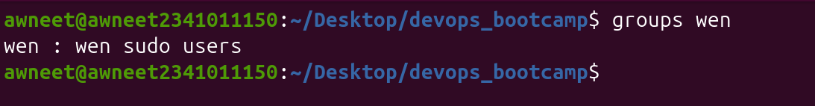
output:

Q2 : Creating and moving a file Step 1: Create a file named notes.txt using touch. Step 2: Rename notes.txt to final_report.txt and move it into a new directory named archive using mv (create the directory first if needed). Step 3: Modify the permissions of archive/final_report.txt using chmod so that the owner has read/write access, the group has read-only access, and others have no access (-rw-r-----). Step 4: Add some unsorted text to final_report.txt, then use cat to display the file's contents and copy it to another file using output redirection
Ans: touch notes.txt mkdir archive mv notes.txt archive/final_report.txt chmod 640 archive/final_report.txt echo -e "banana\napple\norange\nmango" > archive/final_report.txt cat archive/final_report.txt cat archive/final_report.txt > copied_report.txt
output :
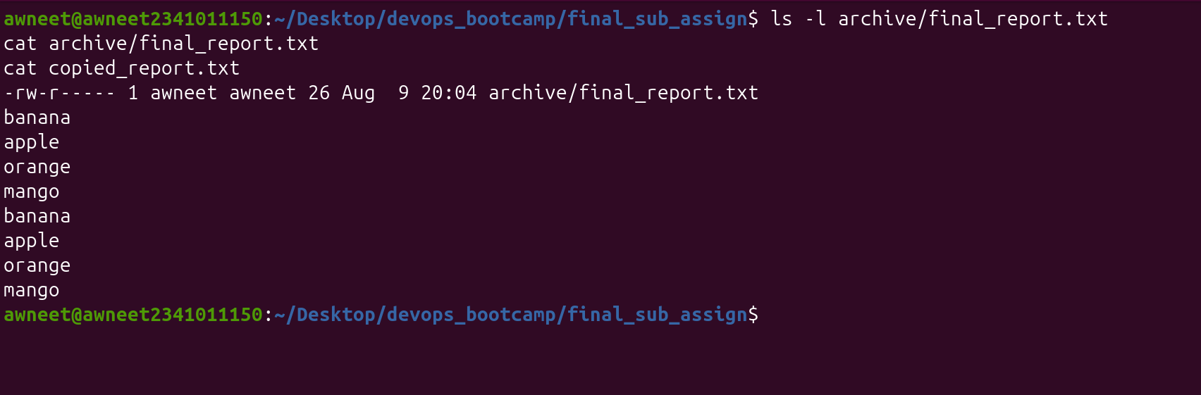
Q3:Create a server configuration file and change its permission Step 1. Using output redirection (>) create a file called server.conf that contains the following entries. SERVER_NAME=LocalHost PORT=8080 DEBUG_MODE=true MAX_CONN=100 Step 2. Create a restricted system directory /etc/test_config. Now, try to move your file there; use sudo if permissions are required: Step 3. Find the line that reads DEBUG_MODE=true and change it to DEBUG_MODE=false. Save and exit. Step 4. Secure the file using chmod so that only the root user can read and write to it, while groups and others have absolutely no access: Verify the permissions of the file and report the permissions.

Ans: echo -e "SERVER_NAME=LocalHost\nPORT=8080\nDEBUG_MODE=true\nMAX_CONN=100" > server.conf sudo mkdir -p /etc/test_config sudo mv server.conf /etc/test_config/server.conf sudo sed -i 's/DEBUG_MODE=true/DEBUG_MODE=false/' /etc/test_config/server.conf sudo chmod 600 /etc/test_config/server.conf
output:
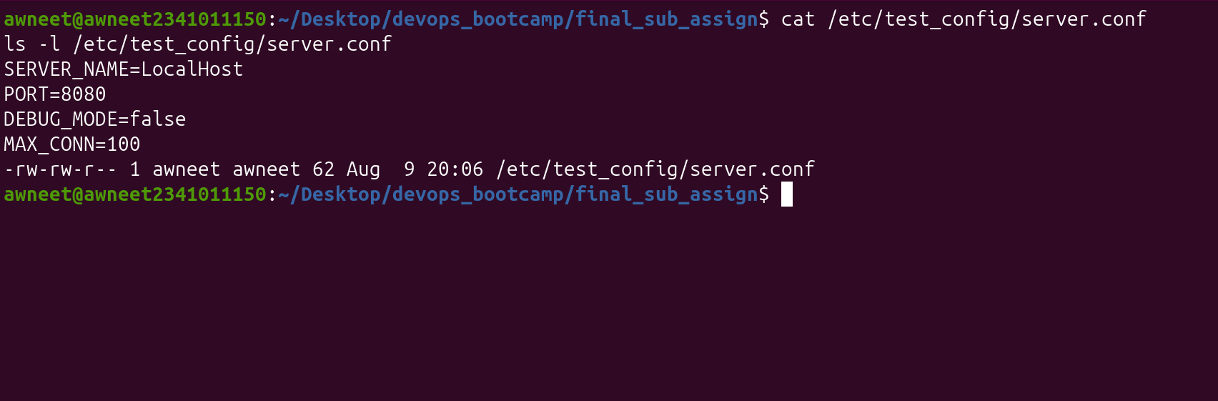
Q4: Find and Kill a rogue Process Step 1: Before you can hunt it, spin up a fake background threat by running this exact command (it creates a harmless, idle background loop): a. ping 127.0.0.1 > /dev/null & Step 2: Use the ps command to find the Process ID (PID) of your background task. Step 3: Locate the PID from the output and use the kill command to stop it:
Ans: ping 127.0.0.1 > /dev/null &
ps -ef | grep "ping 127.0.0.1"
kill 11412
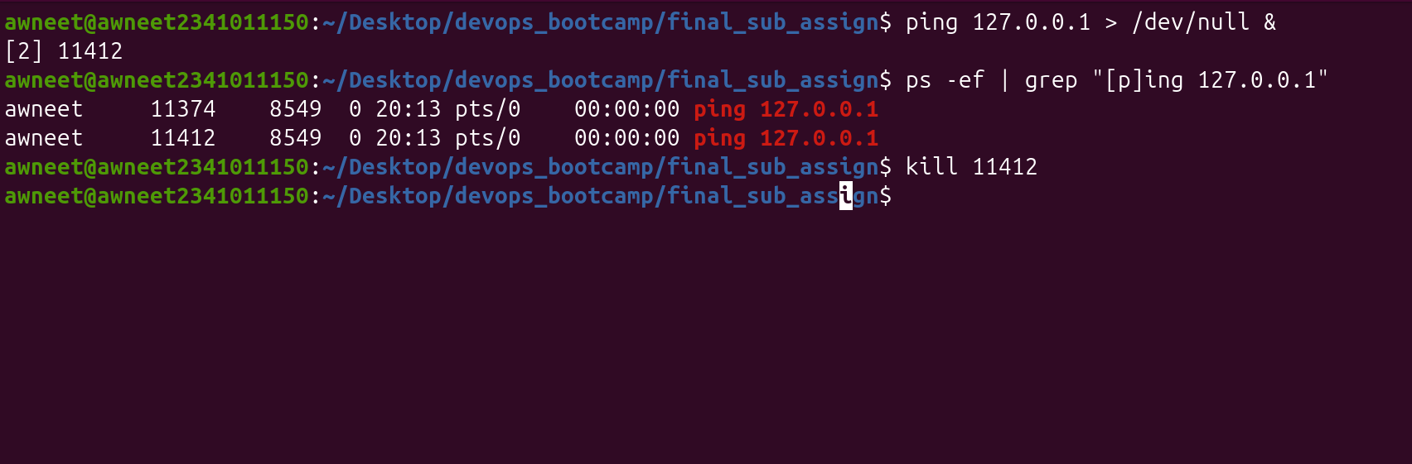
output :

Q5: Workspace Restoration & Web Networking a. Use cp to make a safe backup copy of your system configuration file back to your home directory, naming it server.conf.bak: b. Use curl to verify your server's outbound network connection is fully restored after the breach. Ping www.google.com using curl

Ans:cp /etc/test_config/server.conf ~/server.conf.bak
curl -I https://www.google.com
output:
