Assignment – 2

Q1
Create a directory logs_practice and populate it with these sample files mkdir logs_practice && cd logs_practice cat > sales_jan.csv << 'EOF' 101,Rahul Verma,North,45000,Active 102,Sneha Reddy,South,52000,Active 103,Amit Joshi,East,38000,Inactive 104,Divya Nair,West,61000,Active 105,Karan Mehta,North,29000,Inactive EOF cat > sales_feb.csv << 'EOF' 106,Pooja Iyer,South,55000,Active 107,Vikram Rao,East,42000,Active 108,Neha Gupta,West,33000,Inactive EOF touch summary.txt notes.md archive.tar.gzAnswer the following using the specified tools: ● (ls) List all files in logs_practice and count how many of them are .csv files, without opening any file. ● (wc) For each .csv file, print the number of lines (records) it contains. Then find the total number of records across both CSV files in a single command. ● (cut) From sales_jan.csv, extract only the name and region (2nd and 3rd fields) for every record. ● (awk) Print full records from both CSV files combined where the status is Active and salary is greater than 40000. ● (awk + regex) Print only the names of employees whose name starts with a vowel (A, E, I, O, U — case-insensitive). ● (sed) In a single command, replace all occurrences of Inactive with Terminated across both CSV files, printing the result to the terminal (do not modify the original files). ● (cut + sort + wc) Extract just the region field from both files combined, and count how many unique regions appear in total. ● (Pipeline: cat + awk + sed + wc) Combine both CSV files, use awk to filter only Active employees, use sed to strip out the employee ID (1st field), and finally use wc -l to count how many such trimmed records remain.

Ans: mkdir logs_practice && cd logs_practice
cat > sales_jan.csv << 'EOF' 101,Rahul Verma,North,45000,Active 102,Sneha Reddy,South,52000,Active 103,Amit Joshi,East,38000,Inactive 104,Divya Nair,West,61000,Active 105,Karan Mehta,North,29000,Inactive EOF
cat > sales_feb.csv << 'EOF' 106,Pooja Iyer,South,55000,Active 107,Vikram Rao,East,42000,Active 108,Neha Gupta,West,33000,Inactive EOF
touch summary.txt notes.md archive.tar.gz
ls | grep '.csv$' | wc -l
wc -l *.csv
cut -d',' -f2,3 sales_jan.csv
awk -F',' '$5=="Active" && $4>40000' *.csv
awk -F',' 'tolower($2) ~ /^[aeiou]/ {print $2}' *.csv
sed 's/Inactive/Terminated/g' *.csv
cut -d',' -f3 *.csv | sort | uniq | wc -l
cat .csv | awk -F',' '$5=="Active"' | sed 's/^[^,],//' | wc -l

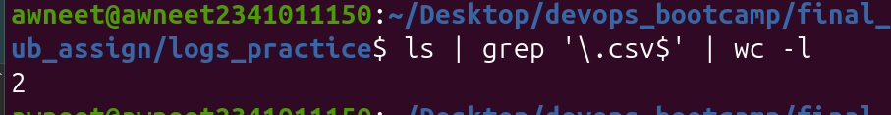
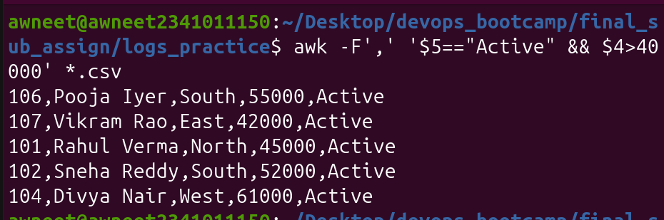

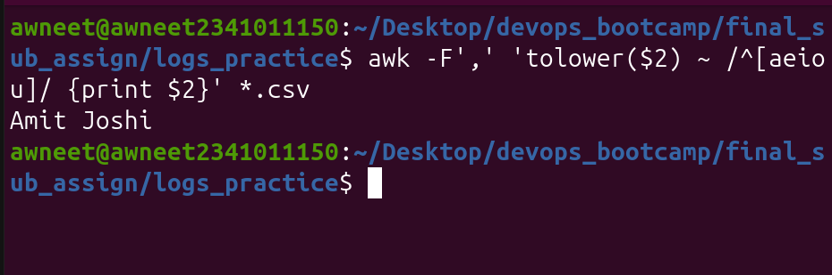

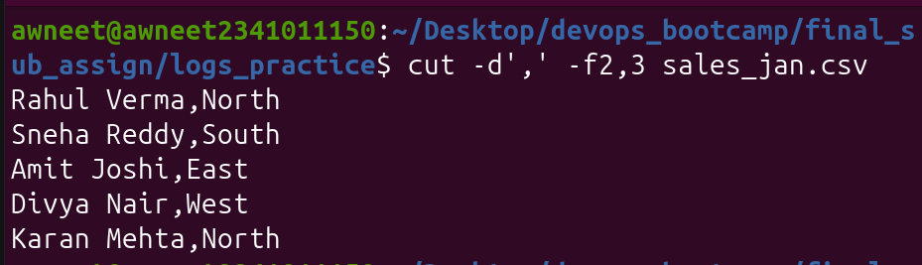
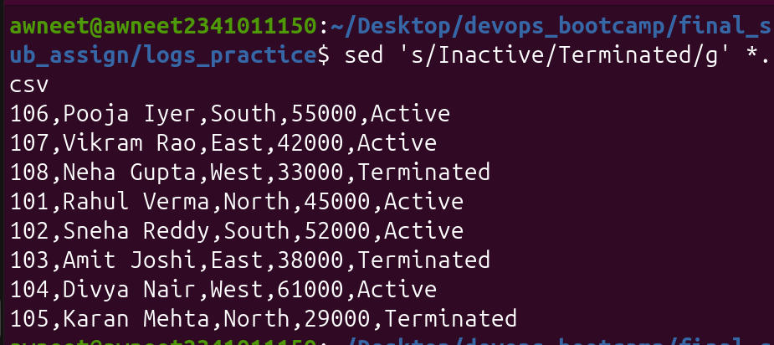
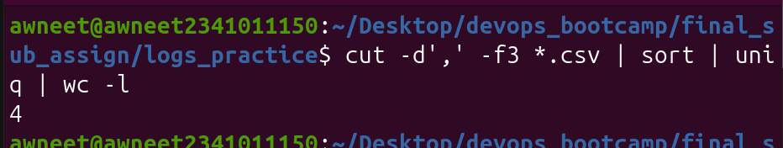
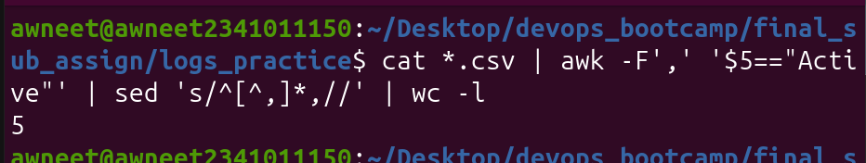

Q2:
Print all lines in /etc/passwd containing the word root. Use -i to case-insensitively search for the string ROOT, and compare the output with question 1 — are they the same? Why or why not? Use -c to count how many lines contain /bin/bash as the login shell (without printing the actual lines). Use -n to print matching lines along with their line numbers for any user whose shell is /usr/sbin/nologin. Use -v to print all lines that do NOT contain nologin — i.e., users with an actual usable shell. Use -E (extended regex) to find all lines where the shell is either /bin/bash or /bin/sh (use the | alternation operator). Use -w to search for the exact word bin (matching only the whole word, not substrings like sbin or bin inside another word). Use grep -E with a regex to find lines where the UID (3rd field) is a 3-digit number (e.g., 100–999), by matching the pattern around the colons. Use grep with ^ and $ anchors to find lines where the username starts with s and print only those lines.Use ls -l /etc/ piped into grep to list only files/directories whose names contain the word conf. Use cat /etc/passwd piped into grep, then piped further into wc -l, to count how many total user accounts exist on the system. Combine ps aux | grep to find all running processes related to ssh (hint: this will also match the grep process itself — how would you exclude it from the output?). Use history | grep (or cat /etc/passwd | grep) combined with cut to extract just the usernames of accounts matching a grep filter for shell /bin/bash. Explain the difference between grep, egrep, and grep -E. Are they functionally equivalent today?

Ans:
grep 'root' /etc/passwd
grep -i 'ROOT' /etc/passwd
grep -c '/bin/bash' /etc/passwd
grep -n '/bin/bash' /etc/passwd
grep -v 'nologin' /etc/passwd
grep -E ':/bin/(bash|sh)$' /etc/passwd
grep -w 'bin' /etc/passwd
grep -E '^([^:]*:)[0-9]{3}:' /etc/passwd
grep '^s' /etc/passwd
ls -l /etc | grep 'conf'
cat /etc/passwd | grep '' | wc -l
ps aux | grep ssh
cat /etc/passwd | grep '/bin/bash' | cut -d':' -f1

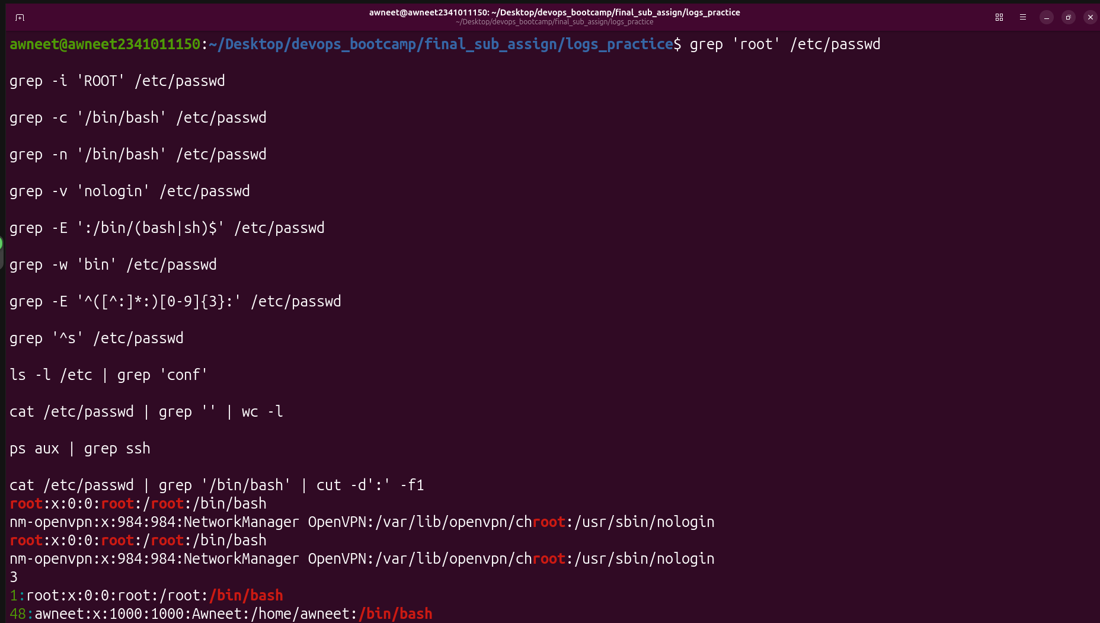

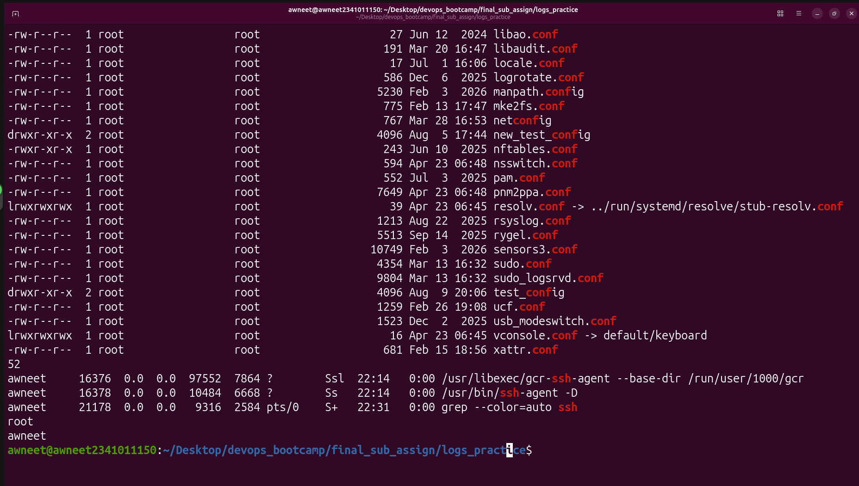

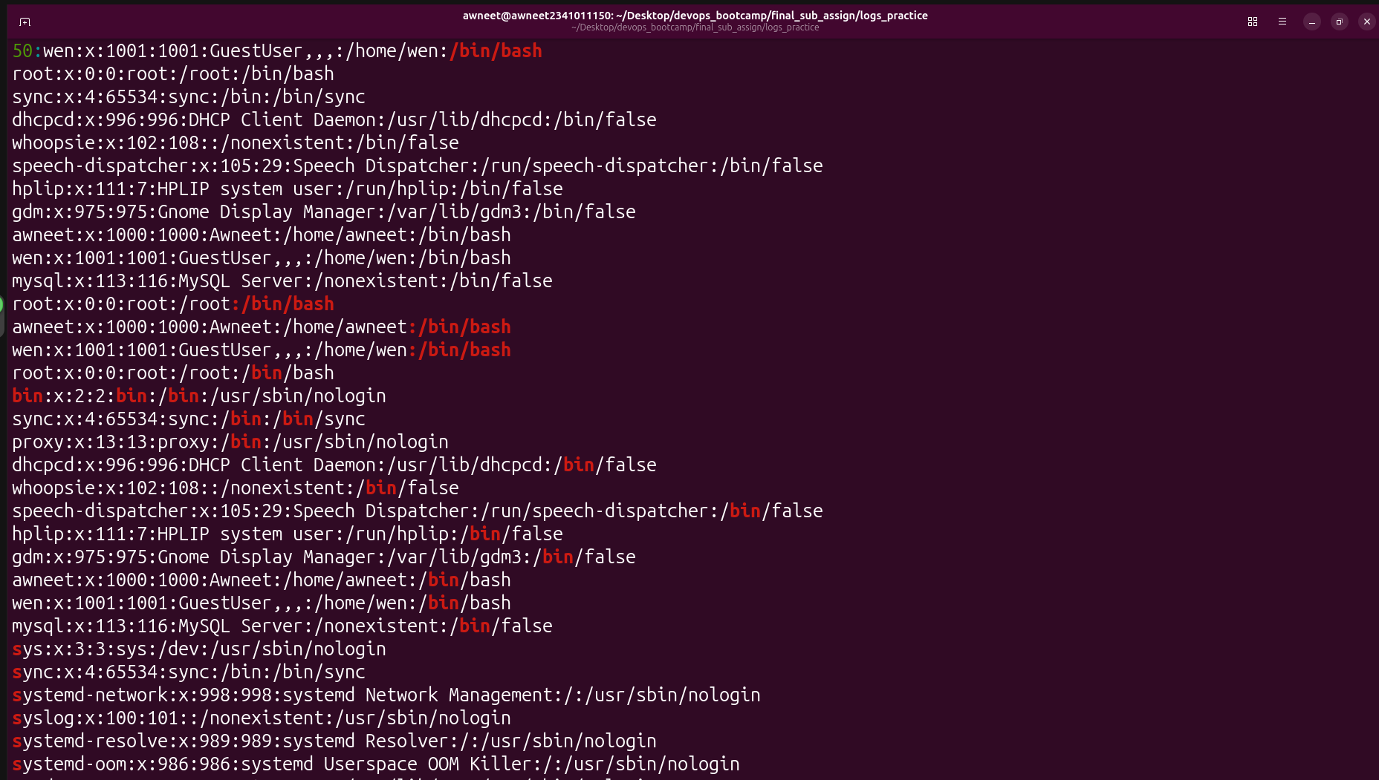

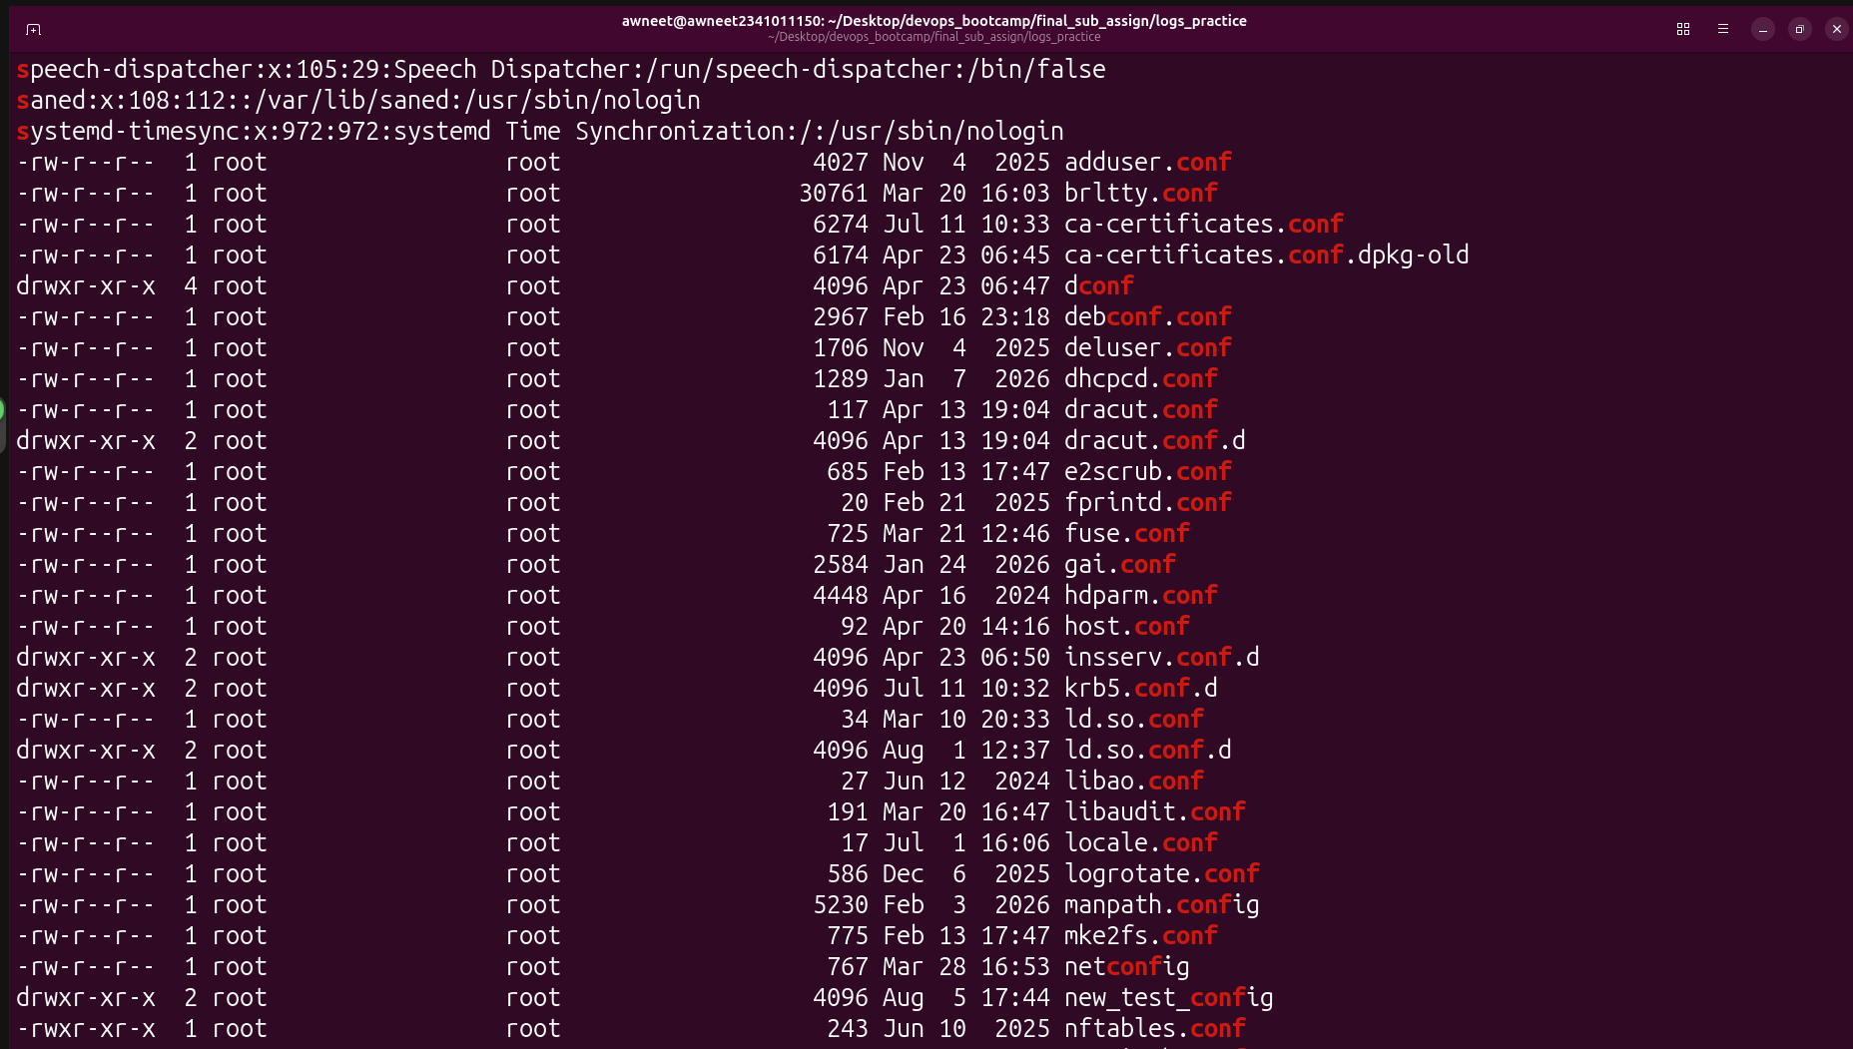

Difference between grep, egrep, and grep -E
- grep uses Basic Regular Expressions (BRE).
- egrep uses Extended Regular Expressions (ERE), allowing operators like |, +, ?, and ().
- grep -E also uses Extended Regular Expressions and is functionally equivalent to egrep.

Q3: Create a sample log file with 20 lines: Answer the following: (head) Print the first 5 lines of events.log. (tail) Print the last 5 lines of events.log. (head with negative-style usage) Print all lines except the last 3 using head. (tail with +N) Print all lines starting from line 15 to the end, using tail. (tail -f, conceptual + practical) What does tail -f events.log do differently from a plain tail events.log? When would you use it in real-world sysadmin work? (Combining head and tail) Using a pipeline of head and tail together, print only line 10 of the file. (Combining with grep) Print the last 3 FAIL events in the file (hint: filter first, then take the tail). (wc + tail) Without hardcoding the number 20, write a command that prints the last 25% of lines in the file dynamically (hint: use wc -l to compute the count first).

Ans: head -n 5 events.log
tail -n 5 events.log
head -n -3 events.log
tail -n +15 events.log
grep 'FAIL' events.log | tail -n 3
head -n 10 events.log | tail -n 1
tail -n $(( $(wc -l < events.log) / 4 )) events.log
output:



