Assignment - 3

Question1 — Create the VPC Create a VPC with CIDR 10.0.0.0/16 using the AWS CLI. Tag it appropriately and capture the returned VpcId into vars.env. Verify with if the VPC was created and report
2 — Create Public and Private Subnets Inside the VPC from 1, create a public subnet (10.0.1.0/24) and a private subnet (10.0.2.0/24) in the same Availability Zone. Capture both SubnetIds into vars.env file
3 —Create an Internet Gateway and attach it to the VPC. This is the first half of giving the public subnet internet access — explain in one line why an IGW alone isn't enough yet.
4 —Create a route table, add a route 0.0.0.0/0 → IGW, and associate it with the public subnet. Verify the association using CLI commands (and queries) to print only the route table ID and destination CIDR.
5 —Launch a t3.micro in the public subnet with auto-assign public IP enabled, using user-data to install and start nginx. Confirm it's reachable over HTTP from your machine.
6 —Allocate an Elastic IP, create a NAT Gateway in the public subnet, then create a second route table with 0.0.0.0/0 → NAT Gateway, associated with the private subnet. This mirrors Bit 3–4 but for outbound-only private traffic.
7 —Launch a t2.micro in the private subnet with no public IP. From the Bit 5 public instance, SSH-hop into it (bastion pattern) and confirm it can reach the internet (e.g., curl to a public endpoint) via the NAT Gateway but has no direct inbound path.
9 — Automate with a Skeleton Script Consolidate Bits 1–8 into provision_vpc.sh using the function-stub pattern below, making it idempotent (each function checks via describe-* before creating):
create_vpc() { :; }
create_subnets() { :; }
setup_igw_and_route() { :; }
setup_nat_and_route() { :; }
launch_instances() { :; }

Answer:
#!/bin/bash
set -e

============================================================

SECURE VPC ARCHITECTURE

AWS CLI + VERIFICATION OUTPUT

============================================================
REGION="ap-southeast-2"
VPC_CIDR="10.0.0.0/16" PUBLIC_CIDR="10.0.1.0/24" PRIVATE_CIDR="10.0.2.0/24"
VPC_NAME="secure-vpc" PUBLIC_SUBNET_NAME="public-subnet" PRIVATE_SUBNET_NAME="private-subnet"
PUBLIC_RT_NAME="public-route-table" PRIVATE_RT_NAME="private-route-table"
IGW_NAME="secure-vpc-igw" NAT_NAME="secure-vpc-nat" SG_NAME="secure-vpc-sg"
KEY_NAME="custom-key-pair"
VARS_FILE="vars.env"

============================================================

HELPER FUNCTION

============================================================
save_var() {
local NAME="$1"
local VALUE="$2"
if grep -q "^${NAME}=" "$VARS_FILE" 2>/dev/null; then
sed -i "s|^${NAME}=.*|${NAME}=${VALUE}|" "$VARS_FILE"
else
echo "${NAME}=${VALUE}" >> "$VARS_FILE"
fi
}

============================================================

1. CREATE VPC

============================================================
create_vpc() {
echo
echo "============================================================"
echo "1. CREATE VPC"
echo "============================================================"
VPC_ID=$(aws ec2 create-vpc \
--region "$REGION" \
--cidr-block "$VPC_CIDR" \
--query "Vpc.VpcId" \
--output text)
aws ec2 create-tags \
--region "$REGION" \
--resources "$VPC_ID" \
--tags Key=Name,Value="$VPC_NAME"
echo "Created VPC: $VPC_ID"
save_var "VPC_ID" "$VPC_ID"
echo
echo "VPC OUTPUT:"
aws ec2 describe-vpcs \
--region "$REGION" \
--vpc-ids "$VPC_ID" \
--query "Vpcs[0].[VpcId,CidrBlock,State]" \
--output table
}

============================================================

2. CREATE PUBLIC AND PRIVATE SUBNETS

============================================================
create_subnets() {
echo
echo "============================================================"
echo "2. CREATE PUBLIC AND PRIVATE SUBNETS"
echo "============================================================"
AZ=$(aws ec2 describe-availability-zones \
--region "$REGION" \
--filters Name=state,Values=available \
--query "AvailabilityZones[0].ZoneName" \
--output text)
echo "Availability Zone: $AZ"
# --------------------------------------------------------
# PUBLIC SUBNET
# --------------------------------------------------------
PUBLIC_SUBNET_ID=$(aws ec2 create-subnet \
--region "$REGION" \
--vpc-id "$VPC_ID" \
--cidr-block "$PUBLIC_CIDR" \
--availability-zone "$AZ" \
--query "Subnet.SubnetId" \
--output text)
aws ec2 create-tags \
--region "$REGION" \
--resources "$PUBLIC_SUBNET_ID" \
--tags Key=Name,Value="$PUBLIC_SUBNET_NAME"
echo "Created public subnet: $PUBLIC_SUBNET_ID"
aws ec2 modify-subnet-attribute \
--region "$REGION" \
--subnet-id "$PUBLIC_SUBNET_ID" \
--map-public-ip-on-launch
# --------------------------------------------------------
# PRIVATE SUBNET
# --------------------------------------------------------
PRIVATE_SUBNET_ID=$(aws ec2 create-subnet \
--region "$REGION" \
--vpc-id "$VPC_ID" \
--cidr-block "$PRIVATE_CIDR" \
--availability-zone "$AZ" \
--query "Subnet.SubnetId" \
--output text)
aws ec2 create-tags \
--region "$REGION" \
--resources "$PRIVATE_SUBNET_ID" \
--tags Key=Name,Value="$PRIVATE_SUBNET_NAME"
echo "Created private subnet: $PRIVATE_SUBNET_ID"
save_var "AZ" "$AZ"
save_var "PUBLIC_SUBNET_ID" "$PUBLIC_SUBNET_ID"
save_var "PRIVATE_SUBNET_ID" "$PRIVATE_SUBNET_ID"
echo
echo "SUBNET OUTPUT:"
aws ec2 describe-subnets \
--region "$REGION" \
--subnet-ids "$PUBLIC_SUBNET_ID" "$PRIVATE_SUBNET_ID" \
--query "Subnets[*].[SubnetId,CidrBlock,AvailabilityZone]" \
--output table
}

============================================================

3 & 4. INTERNET GATEWAY + PUBLIC ROUTE TABLE

============================================================
setup_igw_and_route() {
echo
echo "============================================================"
echo "3 & 4. INTERNET GATEWAY + PUBLIC ROUTE"
echo "============================================================"
# --------------------------------------------------------
# INTERNET GATEWAY
# --------------------------------------------------------
IGW_ID=$(aws ec2 create-internet-gateway \
--region "$REGION" \
--query "InternetGateway.InternetGatewayId" \
--output text)
aws ec2 create-tags \
--region "$REGION" \
--resources "$IGW_ID" \
--tags Key=Name,Value="$IGW_NAME"
echo "Created Internet Gateway: $IGW_ID"
aws ec2 attach-internet-gateway \
--region "$REGION" \
--internet-gateway-id "$IGW_ID" \
--vpc-id "$VPC_ID"
echo "Internet Gateway attached to VPC"
save_var "IGW_ID" "$IGW_ID"
# --------------------------------------------------------
# PUBLIC ROUTE TABLE
# --------------------------------------------------------
PUBLIC_RT_ID=$(aws ec2 create-route-table \
--region "$REGION" \
--vpc-id "$VPC_ID" \
--query "RouteTable.RouteTableId" \
--output text)
aws ec2 create-tags \
--region "$REGION" \
--resources "$PUBLIC_RT_ID" \
--tags Key=Name,Value="$PUBLIC_RT_NAME"
echo "Created Public Route Table: $PUBLIC_RT_ID"
# --------------------------------------------------------
# PUBLIC DEFAULT ROUTE
# --------------------------------------------------------
aws ec2 create-route \
--region "$REGION" \
--route-table-id "$PUBLIC_RT_ID" \
--destination-cidr-block "0.0.0.0/0" \
--gateway-id "$IGW_ID"
# Associate public subnet
aws ec2 associate-route-table \
--region "$REGION" \
--route-table-id "$PUBLIC_RT_ID" \
--subnet-id "$PUBLIC_SUBNET_ID"
save_var "PUBLIC_RT_ID" "$PUBLIC_RT_ID"
# --------------------------------------------------------
# OUTPUT
# --------------------------------------------------------
echo
echo "INTERNET GATEWAY OUTPUT:"
aws ec2 describe-internet-gateways \
--region "$REGION" \
--internet-gateway-ids "$IGW_ID" \
--query "InternetGateways[0].[InternetGatewayId,Attachments[0].VpcId]" \
--output table
echo
echo "PUBLIC ROUTE TABLE OUTPUT:"
echo "Route Table ID:"
aws ec2 describe-route-tables \
--region "$REGION" \
--route-table-ids "$PUBLIC_RT_ID" \
--query "RouteTables[0].RouteTableId" \
--output text
echo
echo "Routes:"
aws ec2 describe-route-tables \
--region "$REGION" \
--route-table-ids "$PUBLIC_RT_ID" \
--query "RouteTables[0].Routes[*].[DestinationCidrBlock,GatewayId]" \
--output table
}

============================================================

6. ELASTIC IP + NAT GATEWAY + PRIVATE ROUTE TABLE

============================================================
setup_nat_and_route() {
echo
echo "============================================================"
echo "6. ELASTIC IP + NAT GATEWAY + PRIVATE ROUTE"
echo "============================================================"
# --------------------------------------------------------
# ELASTIC IP
# --------------------------------------------------------
EIP_ALLOC_ID=$(aws ec2 allocate-address \
--region "$REGION" \
--domain vpc \
--query "AllocationId" \
--output text)
aws ec2 create-tags \
--region "$REGION" \
--resources "$EIP_ALLOC_ID" \
--tags Key=Name,Value="$NAT_NAME"
echo "Allocated Elastic IP: $EIP_ALLOC_ID"
save_var "EIP_ALLOC_ID" "$EIP_ALLOC_ID"
# --------------------------------------------------------
# NAT GATEWAY
# --------------------------------------------------------
NAT_ID=$(aws ec2 create-nat-gateway \
--region "$REGION" \
--subnet-id "$PUBLIC_SUBNET_ID" \
--allocation-id "$EIP_ALLOC_ID" \
--query "NatGateway.NatGatewayId" \
--output text)
aws ec2 create-tags \
--region "$REGION" \
--resources "$NAT_ID" \
--tags Key=Name,Value="$NAT_NAME"
echo "Created NAT Gateway: $NAT_ID"
echo
echo "Waiting for NAT Gateway to become available..."
aws ec2 wait nat-gateway-available \
--region "$REGION" \
--nat-gateway-ids "$NAT_ID"
echo "NAT Gateway is available."
save_var "NAT_ID" "$NAT_ID"
# --------------------------------------------------------
# PRIVATE ROUTE TABLE
# --------------------------------------------------------
PRIVATE_RT_ID=$(aws ec2 create-route-table \
--region "$REGION" \
--vpc-id "$VPC_ID" \
--query "RouteTable.RouteTableId" \
--output text)
aws ec2 create-tags \
--region "$REGION" \
--resources "$PRIVATE_RT_ID" \
--tags Key=Name,Value="$PRIVATE_RT_NAME"
echo "Created Private Route Table: $PRIVATE_RT_ID"
# --------------------------------------------------------
# PRIVATE ROUTE -> NAT
# --------------------------------------------------------
aws ec2 create-route \
--region "$REGION" \
--route-table-id "$PRIVATE_RT_ID" \
--destination-cidr-block "0.0.0.0/0" \
--nat-gateway-id "$NAT_ID"
# --------------------------------------------------------
# ASSOCIATE PRIVATE SUBNET
# --------------------------------------------------------
aws ec2 associate-route-table \
--region "$REGION" \
--route-table-id "$PRIVATE_RT_ID" \
--subnet-id "$PRIVATE_SUBNET_ID"
save_var "PRIVATE_RT_ID" "$PRIVATE_RT_ID"
# --------------------------------------------------------
# OUTPUT
# --------------------------------------------------------
echo
echo "ELASTIC IP OUTPUT:"
aws ec2 describe-addresses \
--region "$REGION" \
--allocation-ids "$EIP_ALLOC_ID" \
--query "Addresses[0].[AllocationId,PublicIp]" \
--output table
echo
echo "NAT GATEWAY OUTPUT:"
aws ec2 describe-nat-gateways \
--region "$REGION" \
--nat-gateway-ids "$NAT_ID" \
--query "NatGateways[0].[NatGatewayId,State,SubnetId]" \
--output table
echo
echo "PRIVATE ROUTE TABLE OUTPUT:"
echo "Route Table ID:"
aws ec2 describe-route-tables \
--region "$REGION" \
--route-table-ids "$PRIVATE_RT_ID" \
--query "RouteTables[0].RouteTableId" \
--output text
echo
echo "Routes:"
aws ec2 describe-route-tables \
--region "$REGION" \
--route-table-ids "$PRIVATE_RT_ID" \
--query "RouteTables[0].Routes[*].[DestinationCidrBlock,NatGatewayId]" \
--output table
}

============================================================

5 & 7. LAUNCH EC2 INSTANCES

============================================================
launch_instances() {
echo
echo "============================================================"
echo "5 & 7. LAUNCH EC2 INSTANCES"
echo "============================================================"
# --------------------------------------------------------
# FIND UBUNTU AMI
# --------------------------------------------------------
AMI_ID=$(aws ec2 describe-images \
--region "$REGION" \
--owners 099720109477 \
--filters \
"Name=name,Values=ubuntu/images/hvm-ssd-gp3/ubuntu-noble-24.04-amd64-server-*" \
"Name=state,Values=available" \
--query "sort_by(Images,&CreationDate)[-1].ImageId" \
--output text)
echo "AMI ID: $AMI_ID"
# --------------------------------------------------------
# SECURITY GROUP
# --------------------------------------------------------
SG_ID=$(aws ec2 create-security-group \
--region "$REGION" \
--group-name "$SG_NAME" \
--description "Security group for secure VPC assignment" \
--vpc-id "$VPC_ID" \
--query "GroupId" \
--output text)
echo "Created Security Group: $SG_ID"
# --------------------------------------------------------
# HTTP
# --------------------------------------------------------
aws ec2 authorize-security-group-ingress \
--region "$REGION" \
--group-id "$SG_ID" \
--protocol tcp \
--port 80 \
--cidr 0.0.0.0/0
# --------------------------------------------------------
# SSH
# --------------------------------------------------------
aws ec2 authorize-security-group-ingress \
--region "$REGION" \
--group-id "$SG_ID" \
--protocol tcp \
--port 22 \
--cidr 0.0.0.0/0
save_var "SG_ID" "$SG_ID"
# --------------------------------------------------------
# USER DATA FOR NGINX
# --------------------------------------------------------
cat > user-data.sh <<'EOF'
#!/bin/bash
apt-get update -y apt-get install -y nginx
systemctl enable nginx systemctl start nginx
echo "Public EC2 - Secure VPC" > /var/www/html/index.html EOF
# --------------------------------------------------------
# PUBLIC INSTANCE
# t3.micro
# --------------------------------------------------------
PUBLIC_INSTANCE_ID=$(aws ec2 run-instances \
--region "$REGION" \
--image-id "$AMI_ID" \
--instance-type t3.micro \
--key-name "$KEY_NAME" \
--security-group-ids "$SG_ID" \
--subnet-id "$PUBLIC_SUBNET_ID" \
--associate-public-ip-address \
--user-data file://user-data.sh \
--tag-specifications \
'ResourceType=instance,Tags=[{Key=Name,Value=public-nginx}]' \
--query "Instances[0].InstanceId" \
--output text)
echo "Created public instance: $PUBLIC_INSTANCE_ID"
save_var "PUBLIC_INSTANCE_ID" "$PUBLIC_INSTANCE_ID"
# --------------------------------------------------------
# PRIVATE INSTANCE
# t3.micro
# --------------------------------------------------------
PRIVATE_INSTANCE_ID=$(aws ec2 run-instances \
--region "$REGION" \
--image-id "$AMI_ID" \
--instance-type t3.micro \
--key-name "$KEY_NAME" \
--security-group-ids "$SG_ID" \
--subnet-id "$PRIVATE_SUBNET_ID" \
--no-associate-public-ip-address \
--tag-specifications \
'ResourceType=instance,Tags=[{Key=Name,Value=private-instance}]' \
--query "Instances[0].InstanceId" \
--output text)
echo "Created private instance: $PRIVATE_INSTANCE_ID"
save_var "PRIVATE_INSTANCE_ID" "$PRIVATE_INSTANCE_ID"
# --------------------------------------------------------
# WAIT FOR INSTANCES
# --------------------------------------------------------
echo
echo "Waiting for instances to reach running state..."
aws ec2 wait instance-running \
--region "$REGION" \
--instance-ids "$PUBLIC_INSTANCE_ID" "$PRIVATE_INSTANCE_ID"
echo "Both instances are running."
# --------------------------------------------------------
# OUTPUT
# --------------------------------------------------------
echo
echo "EC2 INSTANCE OUTPUT:"
aws ec2 describe-instances \
--region "$REGION" \
--instance-ids "$PUBLIC_INSTANCE_ID" "$PRIVATE_INSTANCE_ID" \
--query "Reservations[*].Instances[*].[InstanceId,InstanceType,State.Name,PrivateIpAddress,PublicIpAddress]" \
--output table
}

============================================================

FINAL VERIFICATION

============================================================
final_verification() {
echo
echo
echo "############################################################"
echo "# FINAL VERIFICATION #"
echo "############################################################"
# --------------------------------------------------------
# VPC
# --------------------------------------------------------
echo
echo "---------------- VPC ----------------"
aws ec2 describe-vpcs \
--region "$REGION" \
--vpc-ids "$VPC_ID" \
--query "Vpcs[0].[VpcId,CidrBlock,State]" \
--output table
# --------------------------------------------------------
# SUBNETS
# --------------------------------------------------------
echo
echo "---------------- SUBNETS ----------------"
aws ec2 describe-subnets \
--region "$REGION" \
--subnet-ids "$PUBLIC_SUBNET_ID" "$PRIVATE_SUBNET_ID" \
--query "Subnets[*].[SubnetId,CidrBlock,AvailabilityZone]" \
--output table
# --------------------------------------------------------
# INTERNET GATEWAY
# --------------------------------------------------------
echo
echo "---------------- INTERNET GATEWAY ----------------"
aws ec2 describe-internet-gateways \
--region "$REGION" \
--internet-gateway-ids "$IGW_ID" \
--query "InternetGateways[0].[InternetGatewayId,Attachments[0].VpcId]" \
--output table
# --------------------------------------------------------
# PUBLIC ROUTE TABLE
# --------------------------------------------------------
echo
echo "---------------- PUBLIC ROUTE TABLE ----------------"
echo "Route Table ID:"
aws ec2 describe-route-tables \
--region "$REGION" \
--route-table-ids "$PUBLIC_RT_ID" \
--query "RouteTables[0].RouteTableId" \
--output text
echo
echo "Routes:"
aws ec2 describe-route-tables \
--region "$REGION" \
--route-table-ids "$PUBLIC_RT_ID" \
--query "RouteTables[0].Routes[*].[DestinationCidrBlock,GatewayId]" \
--output table
# --------------------------------------------------------
# ELASTIC IP
# --------------------------------------------------------
echo
echo "---------------- ELASTIC IP ----------------"
aws ec2 describe-addresses \
--region "$REGION" \
--allocation-ids "$EIP_ALLOC_ID" \
--query "Addresses[0].[AllocationId,PublicIp]" \
--output table
# --------------------------------------------------------
# NAT GATEWAY
# --------------------------------------------------------
echo
echo "---------------- NAT GATEWAY ----------------"
aws ec2 describe-nat-gateways \
--region "$REGION" \
--nat-gateway-ids "$NAT_ID" \
--query "NatGateways[0].[NatGatewayId,State,SubnetId]" \
--output table
# --------------------------------------------------------
# PRIVATE ROUTE TABLE
# --------------------------------------------------------
echo
echo "---------------- PRIVATE ROUTE TABLE ----------------"
echo "Route Table ID:"
aws ec2 describe-route-tables \
--region "$REGION" \
--route-table-ids "$PRIVATE_RT_ID" \
--query "RouteTables[0].RouteTableId" \
--output text
echo
echo "Routes:"
aws ec2 describe-route-tables \
--region "$REGION" \
--route-table-ids "$PRIVATE_RT_ID" \
--query "RouteTables[0].Routes[*].[DestinationCidrBlock,NatGatewayId]" \
--output table
# --------------------------------------------------------
# EC2 INSTANCES
# --------------------------------------------------------
echo
echo "---------------- EC2 INSTANCES ----------------"
aws ec2 describe-instances \
--region "$REGION" \
--instance-ids "$PUBLIC_INSTANCE_ID" "$PRIVATE_INSTANCE_ID" \
--query "Reservations[*].Instances[*].[InstanceId,InstanceType,State.Name,PrivateIpAddress,PublicIpAddress]" \
--output table
# --------------------------------------------------------
# PUBLIC IP
# --------------------------------------------------------
PUBLIC_IP=$(aws ec2 describe-instances \
--region "$REGION" \
--instance-ids "$PUBLIC_INSTANCE_ID" \
--query "Reservations[0].Instances[0].PublicIpAddress" \
--output text)
echo
echo "---------------- PUBLIC IP ----------------"
echo "$PUBLIC_IP"
# --------------------------------------------------------
# HTTP TEST
# --------------------------------------------------------
echo
echo "---------------- HTTP TEST ----------------"
echo "Testing nginx at: http://$PUBLIC_IP"
echo "Waiting for nginx..."
for i in {1..6}; do
if curl -s --connect-timeout 5 "http://$PUBLIC_IP"; then
echo
echo "HTTP test successful."
break
fi
echo "Nginx not ready yet. Waiting..."
sleep 10
done
# --------------------------------------------------------
# SAVED VARIABLES
# --------------------------------------------------------
echo
echo "---------------- SAVED VARIABLES ----------------"
cat "$VARS_FILE"
echo
echo "############################################################"
echo "# PROVISIONING COMPLETE #"
echo "############################################################"
}

============================================================

MAIN

============================================================
echo echo "############################################################" echo "# SECURE VPC ARCHITECTURE #" echo "# AWS CLI #" echo "############################################################"
echo echo "Region: $REGION" echo "VPC CIDR: $VPC_CIDR" echo "Public Subnet: $PUBLIC_CIDR" echo "Private Subnet: $PRIVATE_CIDR"
create_vpc
create_subnets
setup_igw_and_route
setup_nat_and_route
launch_instances
final_verification
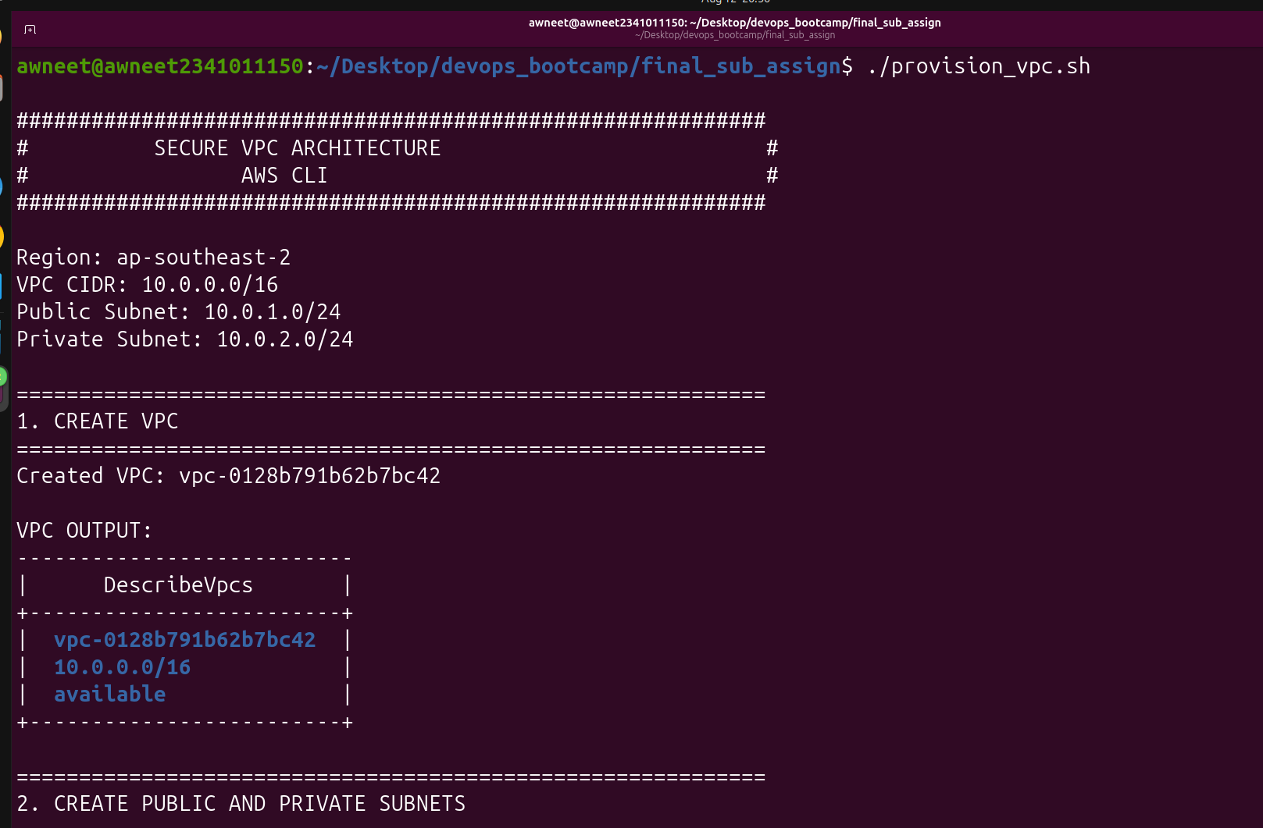
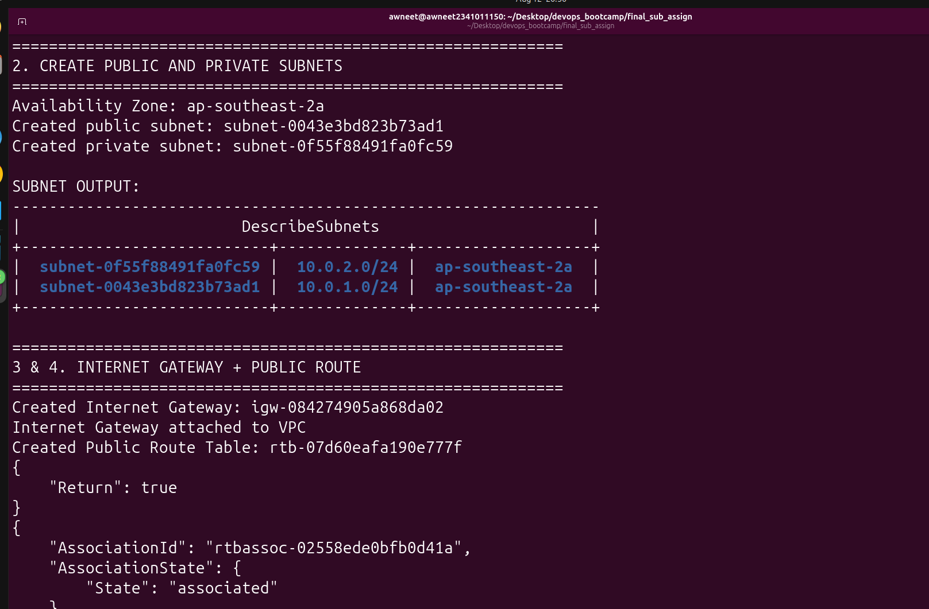
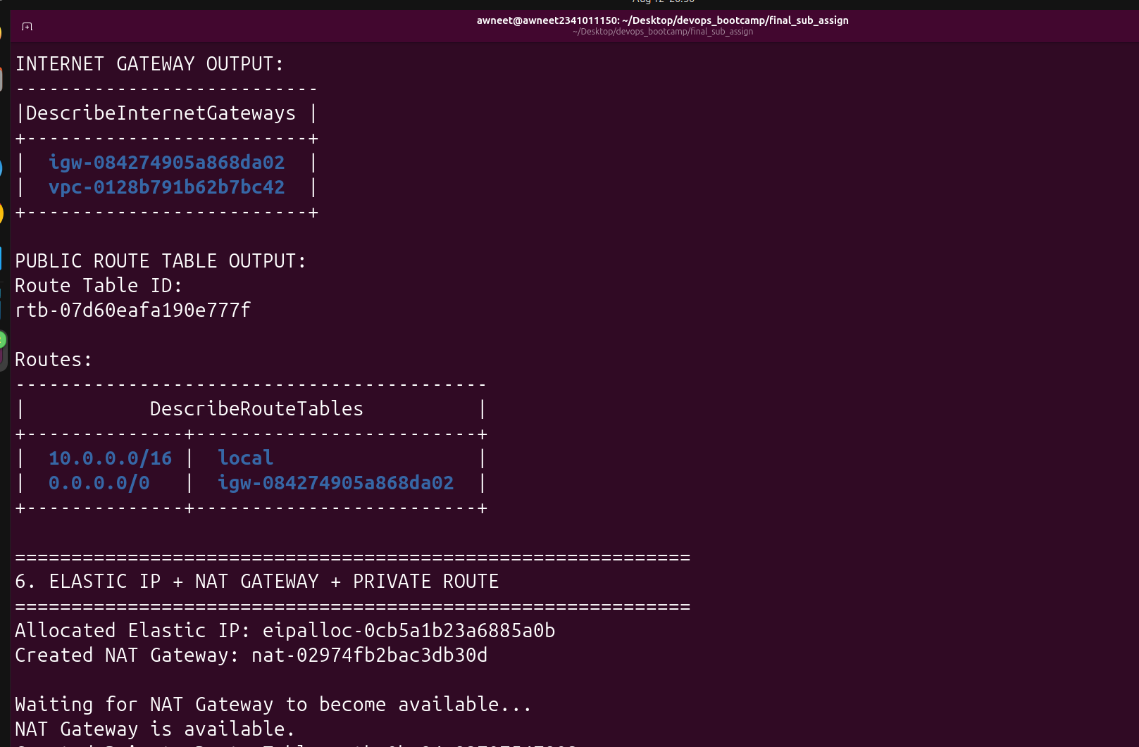

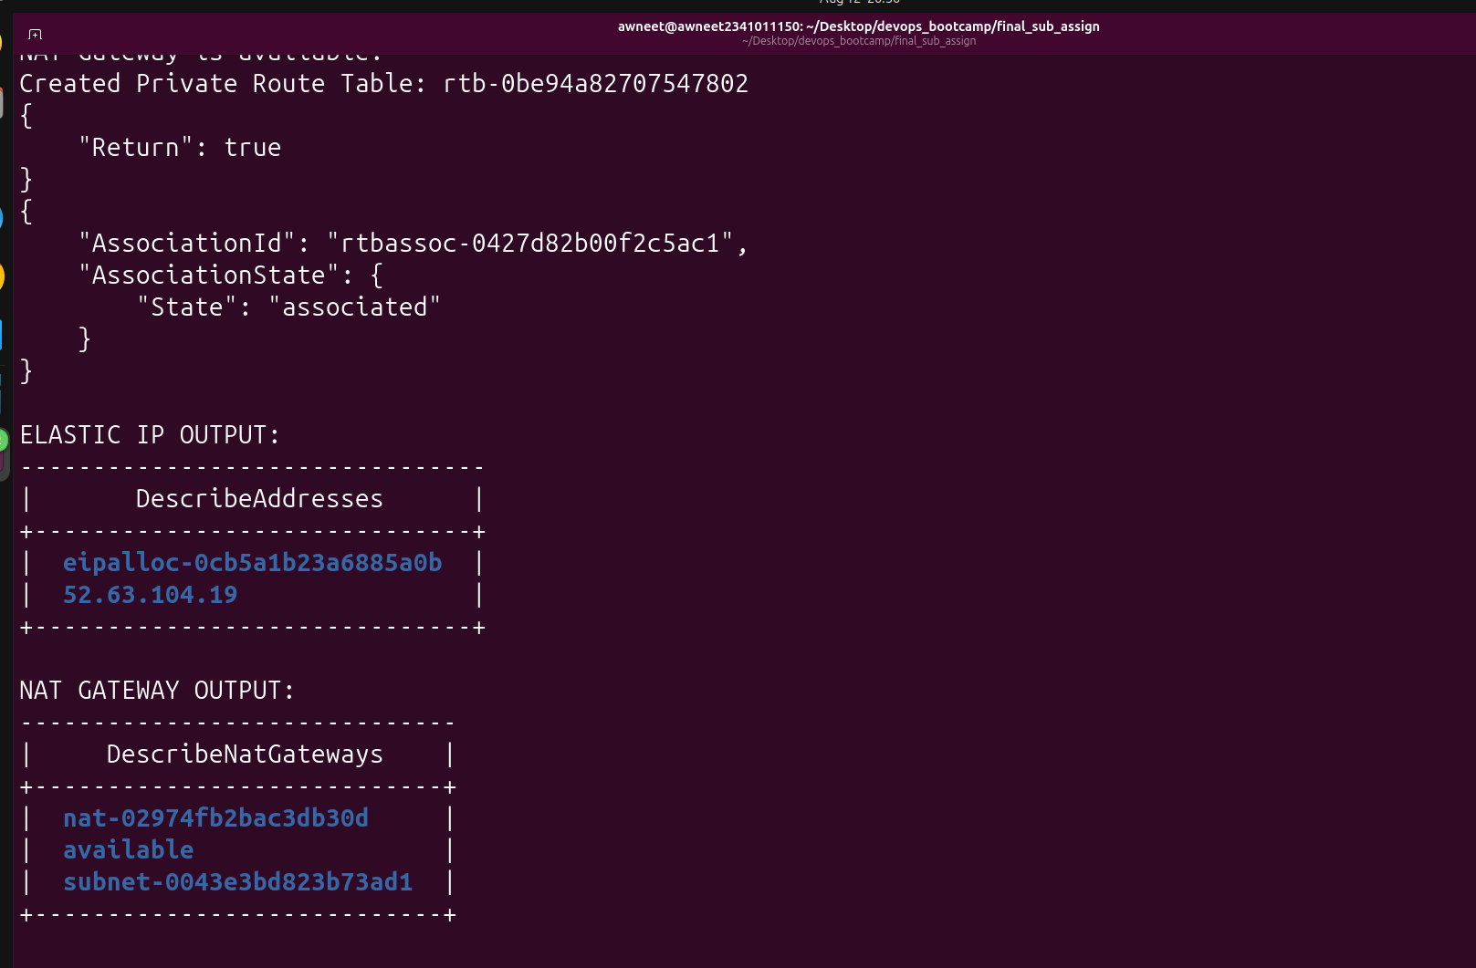

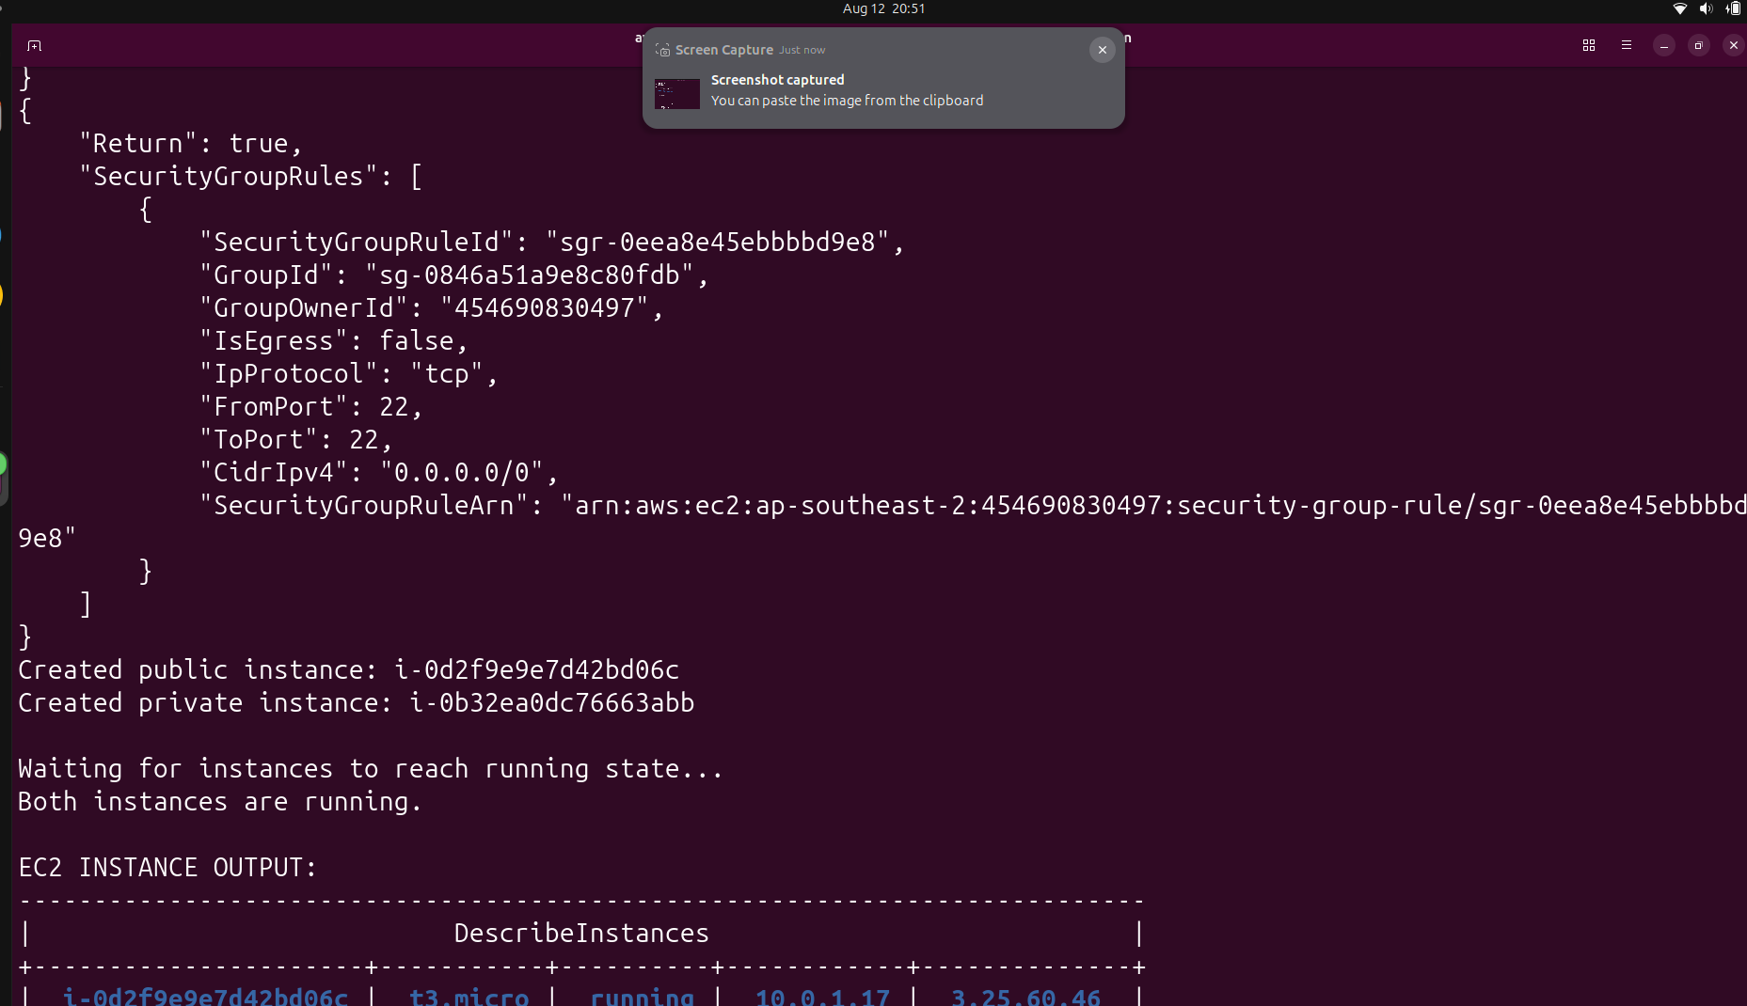
a

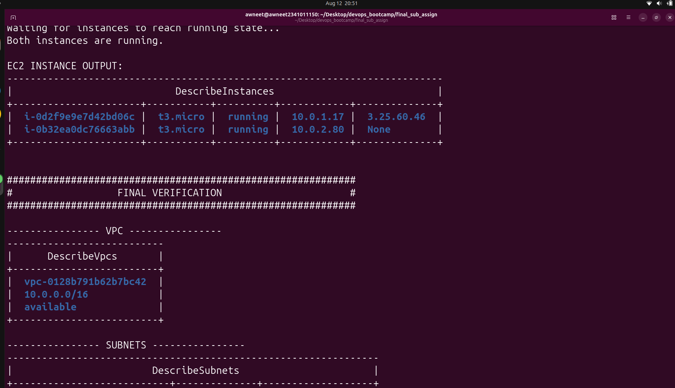
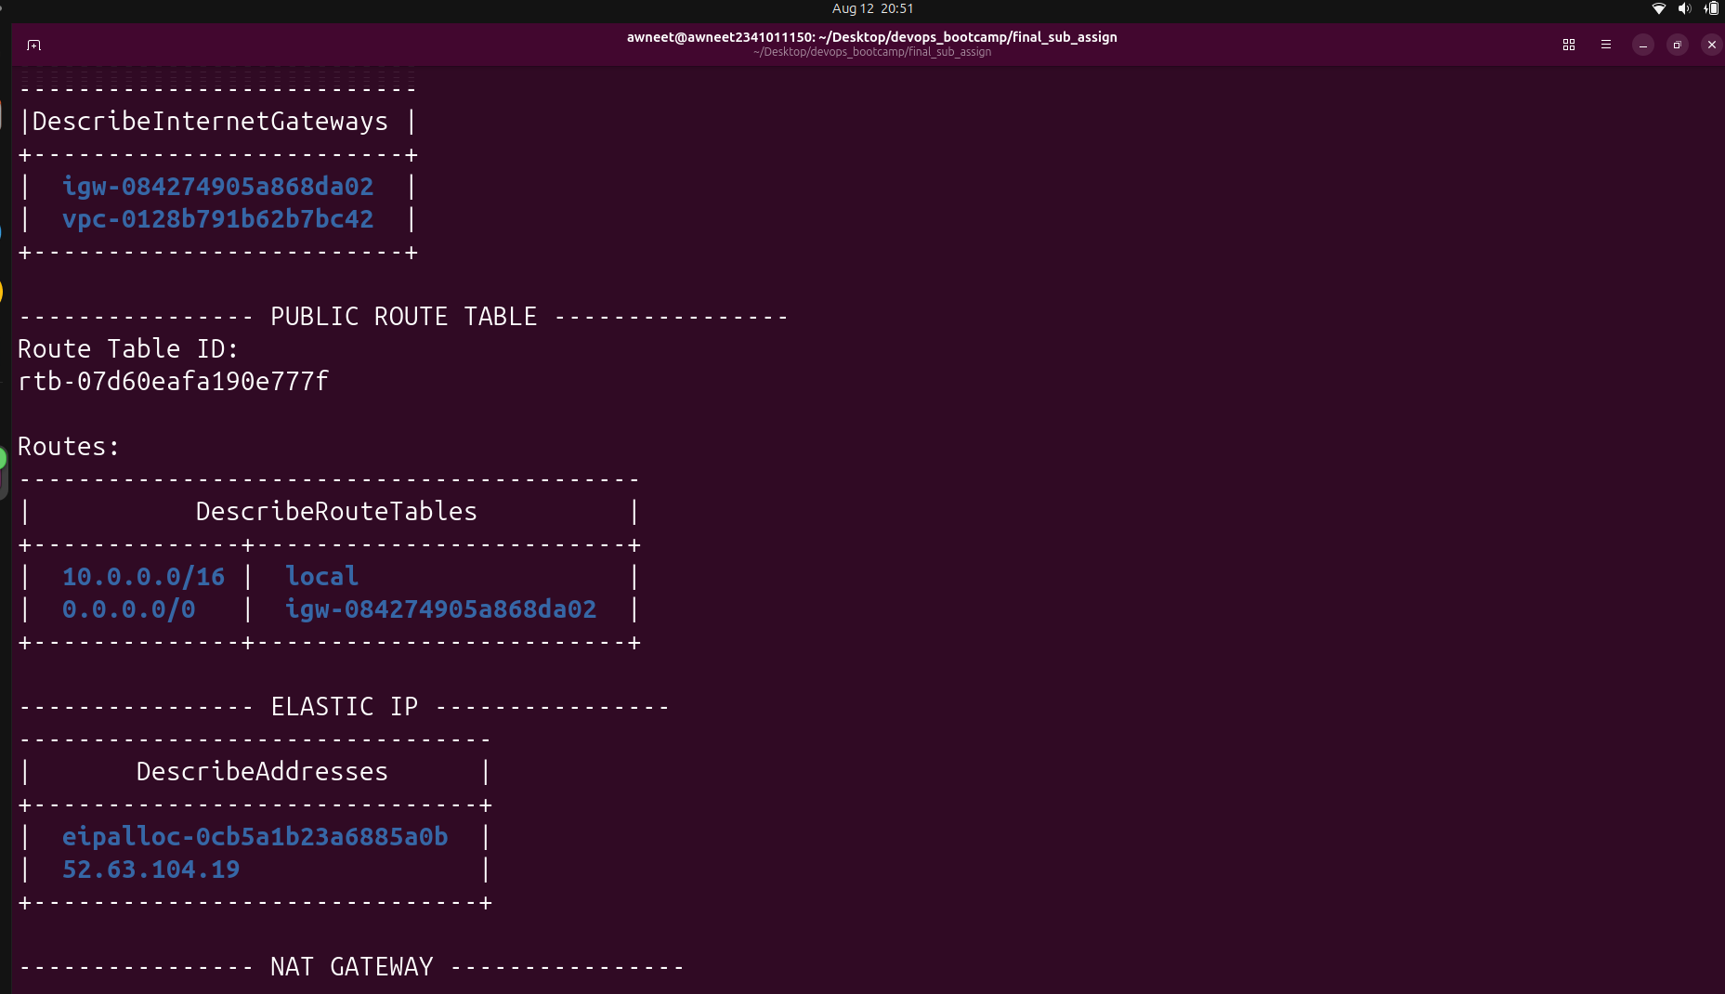

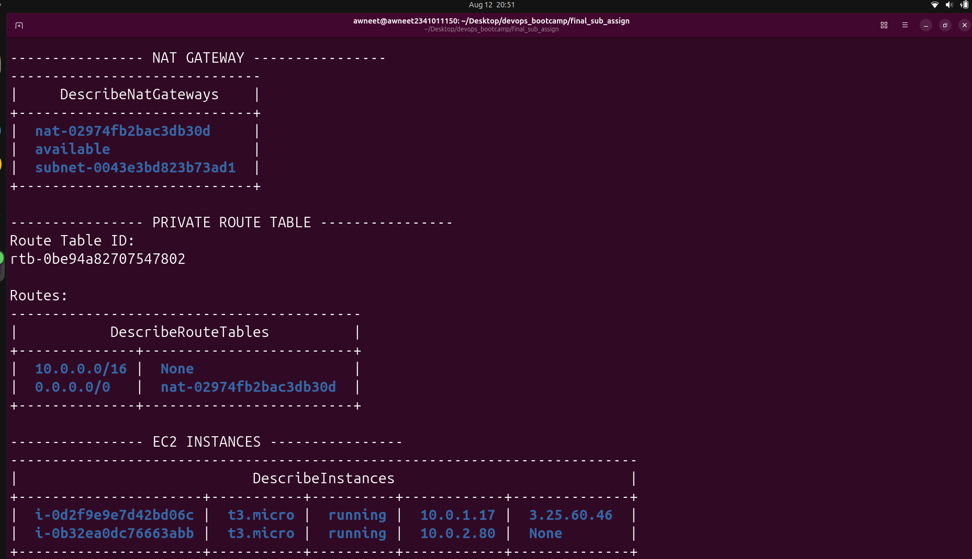
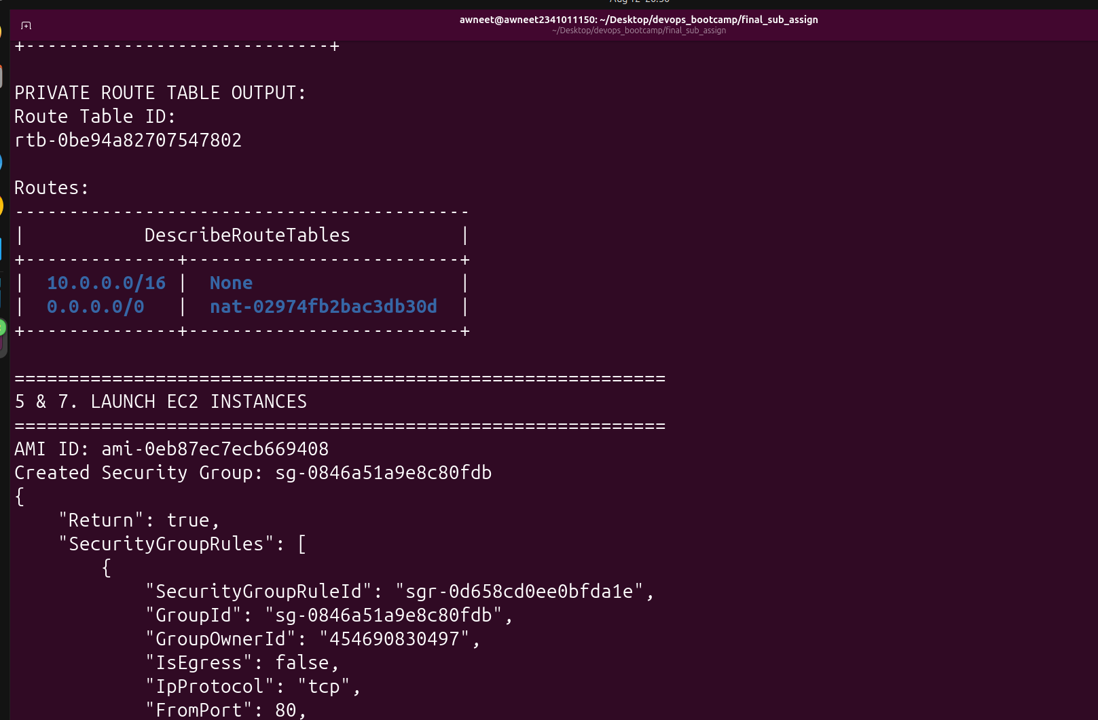
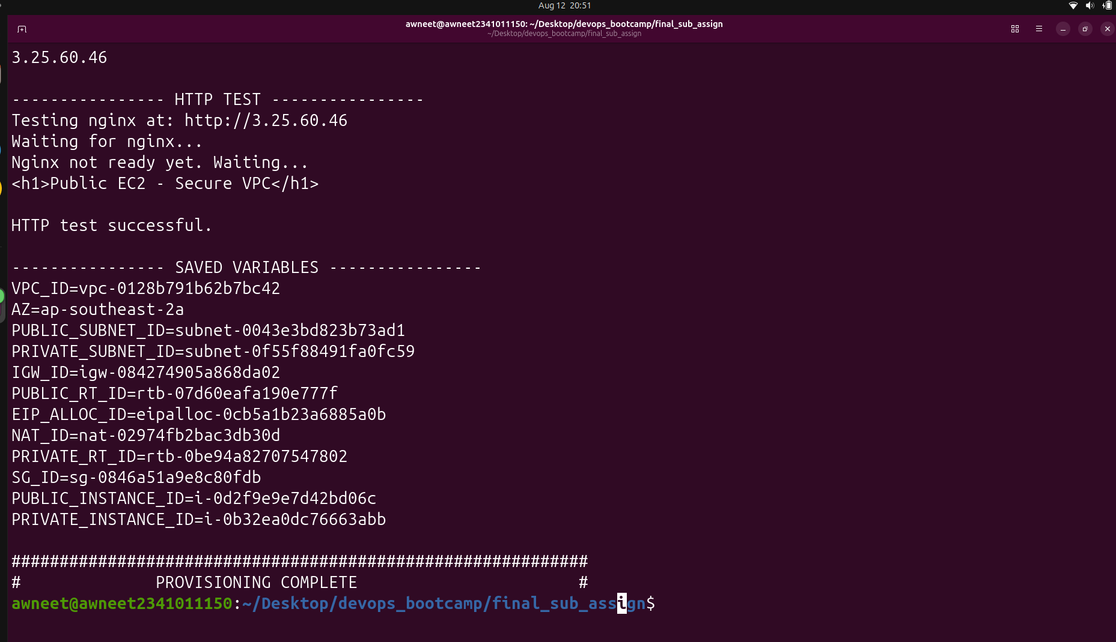

Report questions:

1. Why does the private route table point to the NAT Gateway, not the IGW? (Bits 3 vs 6)
A private instance does not have a public IP address, so it cannot communicate directly with the internet through the Internet Gateway (IGW). The NAT Gateway acts as an intermediary that allows instances in the private subnet to make outbound internet connections while preventing direct inbound connections from the internet. The NAT Gateway itself is placed in the public subnet and uses the IGW to reach the internet. Therefore, the private route table sends 0.0.0.0/0 traffic to the NAT Gateway rather than directly to the IGW.

2. Why does the S3 Gateway Endpoint reduce cost/security exposure vs. routing through NAT? (Bit 8)
An S3 Gateway Endpoint allows traffic from the VPC to reach Amazon S3 without going through the NAT Gateway. This reduces cost because NAT Gateway data-processing charges are avoided for that S3 traffic. It also improves security because the traffic stays within the AWS network instead of requiring the private subnet's S3 traffic to travel through a NAT Gateway and its public internet path. The endpoint can also be associated with specific route tables, limiting which subnets can use it.

3. If your awk HTTP-500 filter returns nothing despite errors existing, what's the likely field/delimiter issue? (Bit 10)
The most likely problem is that awk is looking at the wrong field because the log's format or delimiter is different from what the script expects. For example, if the HTTP status code is actually in $9 but the script checks $5, it will not find 500. Similarly, if the log is comma-separated but awk is treating it as whitespace-separated, the fields will be parsed incorrectly. The solution is to check the actual log format and use the correct field number and delimiter, such as -F',' for comma-separated data.

4. What would you see in describe-route-tables output if someone mistakenly added 0.0.0.0/0 → IGW to the private route table? How would your Bit 10 audit script catch it?
The private route table would show a default route similar to:

Destination Gateway
0.0.0.0/0 igw-xxxxxxxx

This would be incorrect because the private subnet should use the NAT Gateway for its default route:

0.0.0.0/0 nat-xxxxxxxx

The Bit 10 audit script would inspect the private route table and check the target of the 0.0.0.0/0 route. If it finds an Internet Gateway (igw-...) instead of a NAT Gateway (nat-...), it would flag the configuration as a security violation because the private subnet would have a direct route to the internet.

