Assignment – 4

1. create a vpc using terraform, attach a subnet to that vpc and attach a routing table to the subnet with 0.0.0.0 path/route. create an ec2 instance inside the subnet.

Ans: main.tf

terraform { required_providers { aws = { source = "hashicorp/aws" version = "~> 6.0" } } }
provider "aws" { region = "ap-south-1" }

-------------------------

1. Create VPC

-------------------------
resource "aws_vpc" "assignment_vpc" { cidr_block = "10.0.0.0/16" enable_dns_support = true enable_dns_hostnames = true
tags = { Name = "assignment-vpc" } }

-------------------------

2. Create Subnet

-------------------------
resource "aws_subnet" "assignment_subnet" { vpc_id = aws_vpc.assignment_vpc.id cidr_block = "10.0.1.0/24" availability_zone = "ap-south-1a" map_public_ip_on_launch = true
tags = { Name = "assignment-subnet" } }

-------------------------

3. Create Internet Gateway

-------------------------
resource "aws_internet_gateway" "assignment_igw" { vpc_id = aws_vpc.assignment_vpc.id
tags = { Name = "assignment-igw" } }

-------------------------

4. Create Route Table

-------------------------
resource "aws_route_table" "assignment_route_table" { vpc_id = aws_vpc.assignment_vpc.id
route { cidr_block = "0.0.0.0/0" gateway_id = aws_internet_gateway.assignment_igw.id }
tags = { Name = "assignment-route-table" } }

-------------------------

5. Attach Route Table to Subnet

-------------------------
resource "aws_route_table_association" "assignment_route_association" { subnet_id = aws_subnet.assignment_subnet.id route_table_id = aws_route_table.assignment_route_table.id }

-------------------------

6. Create Security Group

-------------------------
resource "aws_security_group" "assignment_sg" { name = "assignment-security-group" description = "Security group for assignment EC2" vpc_id = aws_vpc.assignment_vpc.id

Allow SSH
ingress { description = "Allow SSH" from_port = 22 to_port = 22 protocol = "tcp" cidr_blocks = ["0.0.0.0/0"] }

Allow all outbound traffic
egress { from_port = 0 to_port = 0 protocol = "-1" cidr_blocks = ["0.0.0.0/0"] }
tags = { Name = "assignment-security-group" } }

-------------------------

7. Find Ubuntu AMI

-------------------------
data "aws_ami" "ubuntu" { most_recent = true owners = ["099720109477"]
filter { name = "name" values = ["ubuntu/images/hvm-ssd-gp3/ubuntu-noble-24.04-amd64-server-*"] }
filter { name = "virtualization-type" values = ["hvm"] }
filter { name = "root-device-type" values = ["ebs"] } }

-------------------------

8. Create EC2 Instance

-------------------------
resource "aws_instance" "assignment_ec2" { ami = data.aws_ami.ubuntu.id instance_type = "t3.micro"
subnet_id = aws_subnet.assignment_subnet.id
vpc_security_group_ids = [ aws_security_group.assignment_sg.id ]
tags = { Name = "assignment-ec2" } }

-------------------------

9. Display Outputs

-------------------------
output "vpc_id" { value = aws_vpc.assignment_vpc.id }
output "subnet_id" { value = aws_subnet.assignment_subnet.id }
output "route_table_id" { value = aws_route_table.assignment_route_table.id }
output "ec2_instance_id" { value = aws_instance.assignment_ec2.id }
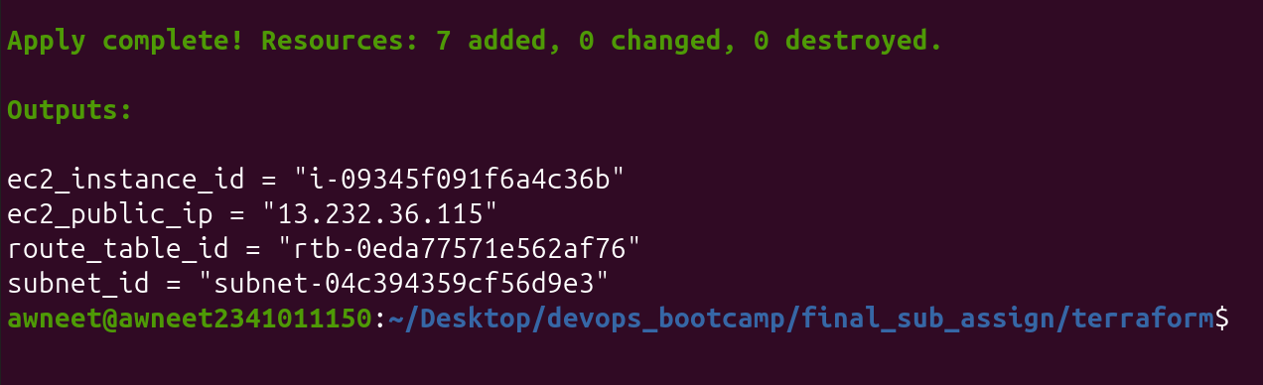
output "ec2_public_ip" { value = aws_instance.assignment_ec2.public_ip }

2. Using terraform create an s3 bucket and host a static website in it.

Main.tf
terraform { required_providers { aws = { source = "hashicorp/aws" version = "~> 6.0" } } }
provider "aws" { region = "ap-southeast-2" }

1. Create S3 Bucket
resource "aws_s3_bucket" "website_bucket" { bucket = "awneet-terraform-static-website-2026"
tags = { Name = "Terraform Static Website" } }

2. Disable Block Public Access
resource "aws_s3_bucket_public_access_block" "website_access" { bucket = aws_s3_bucket.website_bucket.id
block_public_acls = false block_public_policy = false ignore_public_acls = false restrict_public_buckets = false }

3. Configure Static Website
resource "aws_s3_bucket_website_configuration" "website" { bucket = aws_s3_bucket.website_bucket.id
index_document { suffix = "index.html" }
error_document { key = "error.html" } }

4. Upload index.html
resource "aws_s3_object" "index" { bucket = aws_s3_bucket.website_bucket.id key = "index.html" source = "index.html" content_type = "text/html" }

5. Upload error.html
resource "aws_s3_object" "error" { bucket = aws_s3_bucket.website_bucket.id key = "error.html" source = "error.html" content_type = "text/html" }

6. Allow Public Read Access
resource "aws_s3_bucket_policy" "website_policy" { bucket = aws_s3_bucket.website_bucket.id
depends_on = [ aws_s3_bucket_public_access_block.website_access ]
policy = jsonencode({ Version = "2012-10-17"
Statement = [
{
Sid = "PublicReadGetObject"
Effect = "Allow"
Principal = "*"
Action = "s3:GetObject"
Resource = "${aws_s3_bucket.website_bucket.arn}/*"
}
]
}) }

7. Output Website URL
output "website_url" { value = aws_s3_bucket_website_configuration.website.website_endpoint }

index.html
<!DOCTYPE html>
<html>
<head>
<title>Terraform S3 Website</title>
</head>
<body>
<h1>Hello from AWS S3!</h1>
<p>This static website was created and hosted using Terraform.</p>
</body>
</html>

error.html
<!DOCTYPE html>
<html>
<head>
<title>Error</title>
</head>
<body>
<h1>Page Not Found</h1>
<p>The requested page does not exist.</p>
</body>
</html>
output

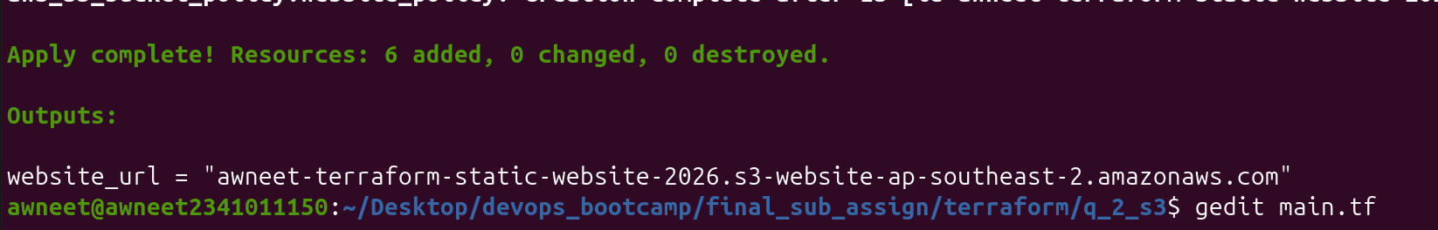
3. Using terraform create an IAM user that has the administrative access and ec2 full access.

Main.tf

terraform { required_providers { aws = { source = "hashicorp/aws" version = "~> 6.0" } } }
provider "aws" { region = "ap-southeast-2" }

1. Create IAM User
resource "aws_iam_user" "devops_user" { name = "terraform-devops-user"
tags = { Name = "Terraform DevOps User" } }

2. Attach Administrator Access
resource "aws_iam_user_policy_attachment" "admin_access" { user = aws_iam_user.devops_user.name policy_arn = "arn:aws:iam::aws:policy/AdministratorAccess" }

3. Attach EC2 Full Access
resource "aws_iam_user_policy_attachment" "ec2_full_access" { user = aws_iam_user.devops_user.name policy_arn = "arn:aws:iam::aws:policy/AmazonEC2FullAccess" }

4. Output IAM User Name
output "iam_user_name" { value = aws_iam_user.devops_user.name }

output
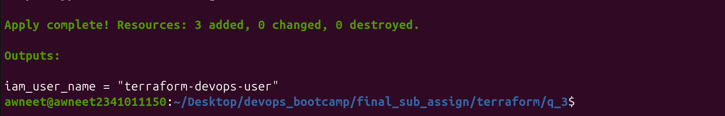

4. Using terraform create an ec2 instance and pass a file called provisioners.sh and the .sh file should contain steps to create a webserver using nginx.

Provisioners.sh

#!/bin/bash

sudo apt update
sudo apt install -y nginx

sudo systemctl start nginx
sudo systemctl enable nginx

sudo systemctl status nginx –no-pager

main.tf

terraform { required_providers { aws = { source = "hashicorp/aws" version = "~> 6.0" } } }
provider "aws" { region = "ap-southeast-2" }

Find the latest Ubuntu 24.04 AMI
data "aws_ami" "ubuntu" { most_recent = true
owners = ["099720109477"]
filter { name = "name" values = ["ubuntu/images/hvm-ssd-gp3/ubuntu-noble-24.04-amd64-server-*"] }
filter { name = "virtualization-type" values = ["hvm"] }
filter { name = "architecture" values = ["x86_64"] } }

Create Security Group
resource "aws_security_group" "webserver_sg" { name = "terraform-webserver-sg" description = "Allow SSH and HTTP traffic"
ingress { description = "SSH" from_port = 22 to_port = 22 protocol = "tcp" cidr_blocks = ["0.0.0.0/0"] }
ingress { description = "HTTP" from_port = 80 to_port = 80 protocol = "tcp" cidr_blocks = ["0.0.0.0/0"] }
egress { from_port = 0 to_port = 0 protocol = "-1" cidr_blocks = ["0.0.0.0/0"] }
tags = { Name = "Terraform Webserver SG" } }

Create EC2 Instance
resource "aws_instance" "webserver" { ami = data.aws_ami.ubuntu.id instance_type = "t2.micro"
key_name = "custom-key-pair"
vpc_security_group_ids = [ aws_security_group.webserver_sg.id ]
tags = { Name = "Terraform Nginx Webserver" }

Wait until SSH is available
connection { type = "ssh" user = "ubuntu" private_key = file("custom-key-pair.pem") host = self.public_ip }

Copy provisioners.sh to the EC2 instance
provisioner "file" { source = "provisioners.sh" destination = "/home/ubuntu/provisioners.sh" }

Execute provisioners.sh
provisioner "remote-exec" { inline = [ "chmod +x /home/ubuntu/provisioners.sh", "sudo /home/ubuntu/provisioners.sh" ] } }

Output public IP
output "public_ip" { value = aws_instance.webserver.public_ip }

Output website URL
output "website_url" { value = "http://${aws_instance.webserver.public_ip}" }

output:
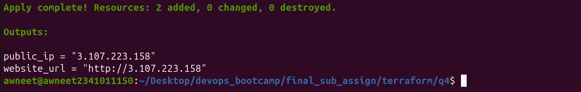

5. Find all the options on the command - plan init

terraform plan -help

terraform init -help

