ASSIGNMENT – 5

Q1 Write a Terraform script that creates a security group for an Nginx web server, then creates an EC2 instance and attaches the security group to the instance. Using a file provisioner, send a file named script.sh to the EC2 instance, and use a remote-exec provisioner to execute the script on the instance. The script.sh file should contain the steps to install Docker on the EC2 instance and pull the Nginx image onto the EC2 instance.

Main.tf

terraform { required_providers { aws = { source = "hashicorp/aws" version = "~> 5.0" } } }
provider "aws" { region = "ap-southeast-2" }

Get the latest Ubuntu 24.04 LTS AMD64 AMI
data "aws_ssm_parameter" "ubuntu_ami" { name = "/aws/service/canonical/ubuntu/server/24.04/stable/current/amd64/hvm/ebs-gp3/ami-id" }

Security Group for Nginx Web Server
resource "aws_security_group" "nginx_sg" { name = "nginx-webserver-sg" description = "Security group for Nginx web server"

Allow SSH
ingress { from_port = 22 to_port = 22 protocol = "tcp" cidr_blocks = ["0.0.0.0/0"] }

Allow HTTP
ingress { from_port = 80 to_port = 80 protocol = "tcp" cidr_blocks = ["0.0.0.0/0"] }

Allow all outbound traffic
egress { from_port = 0 to_port = 0 protocol = "-1" cidr_blocks = ["0.0.0.0/0"] } }

EC2 Instance
resource "aws_instance" "nginx_server" { ami = data.aws_ssm_parameter.ubuntu_ami.value instance_type = "t3.micro"

AWS EC2 key pair name
key_name = "custom-key-pair"

Attach Security Group
security_groups = [aws_security_group.nginx_sg.name]

Send script.sh to the EC2 instance
provisioner "file" { source = "script.sh" destination = "/home/ubuntu/script.sh"
connection {
type = "ssh"
user = "ubuntu"
private_key = file("custom-key-pair.pem")
host = self.public_ip
}
}

Execute script.sh on the EC2 instance
provisioner "remote-exec" { inline = [ "chmod +x /home/ubuntu/script.sh", "sudo /home/ubuntu/script.sh" ]
connection {
type = "ssh"
user = "ubuntu"
private_key = file("custom-key-pair.pem")
host = self.public_ip
}
}
tags = { Name = "Nginx-Web-Server" } }

Output EC2 public IP
output "public_ip" { value = aws_instance.nginx_server.public_ip }

Output Nginx website URL
output "website_url" { value = "http://${aws_instance.nginx_server.public_ip}" }

script.sh
#!/bin/bash

Update package lists
sudo apt-get update -y

Install Docker
sudo apt-get install -y docker.io

Start Docker service
sudo systemctl start docker

Enable Docker to start automatically
sudo systemctl enable docker

Pull Nginx Docker image
sudo docker pull nginx

Run Nginx container
sudo docker run -d --name nginx-server -p 80:80 nginx

terraform init
terraform plan
terraform apply
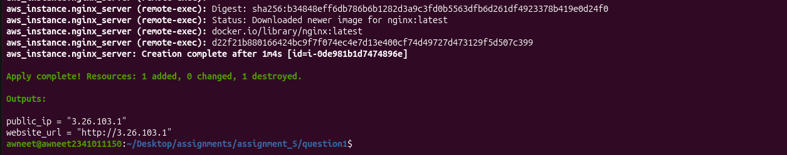
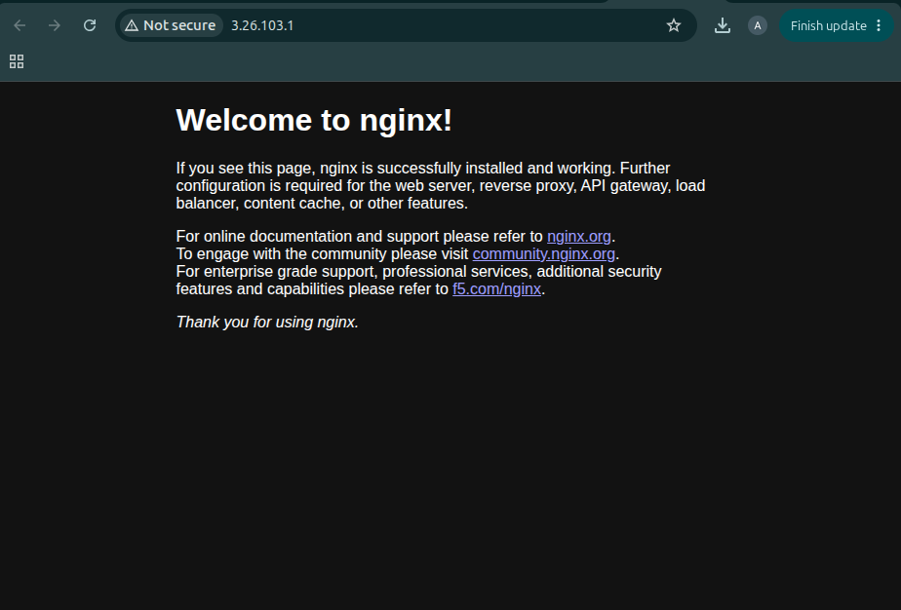
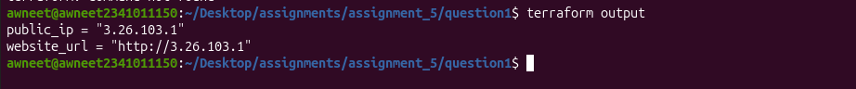
Q2 Write the docker command to run the myssql container

docker run --name mysql-container -e MYSQL_ROOT_PASSWORD=root -d mysql
