PROJECT

Task A: Manual Deployment

The NimbusCart project directory was first created with separate directories for the frontend, Express REST API, and Terraform infrastructure configuration.
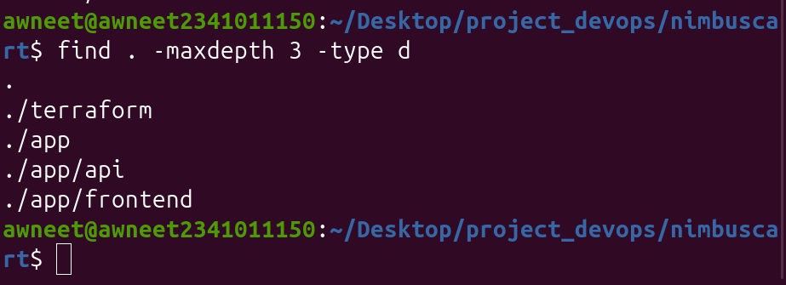

Figure 1: Initial NimbusCart project directory structure

Local PostgreSQL Database Setup

A PostgreSQL database container was created locally using Docker. A named Docker volume was attached to the container so that the database data remains persistent independently of the container lifecycle.
docker volume create nimbuscart_pgdata

docker run -d \
--name nimbuscart-db \
-e POSTGRES_USER=nimbus \
-e POSTGRES_PASSWORD=nimbus123 \
-e POSTGRES_DB=nimbuscart \
-p 5432:5432 \
-v nimbuscart_pgdata:/var/lib/postgresql/data \
postgres:16
docker ps

‘

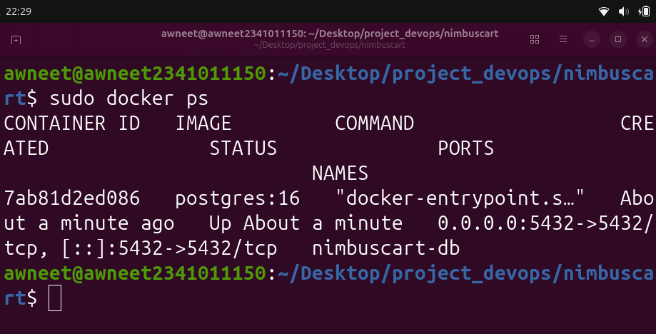

Figure 2: PostgreSQL database container running locally using Docker

Creating the Express API

An Express.js REST API was developed for the NimbusCart application. The API connects to the local PostgreSQL database and automatically creates the required products table when the application starts. The API provides endpoints for application health checking, retrieving products, and adding new products.

Code 1: Express REST API implementation (server.js)

const express = require("express"); const cors = require("cors"); const { Pool } = require("pg");
const app = express(); const PORT = process.env.PORT || 8080;
app.use(cors()); app.use(express.json());
const pool = new Pool({
host: process.env.DB_HOST || "localhost",
port: process.env.DB_PORT || 5432,
user: process.env.DB_USER || "nimbus",
password: process.env.DB_PASSWORD || "nimbus123",
database: process.env.DB_NAME || "nimbuscart",

ssl:
process.env.DB_SSL === "true"
? {
rejectUnauthorized: false,
}
: false,
});
async function initializeDatabase() { try { await pool.query(CREATE TABLE IF NOT EXISTS products ( id SERIAL PRIMARY KEY, name VARCHAR(255) NOT NULL, price DECIMAL(10, 2) NOT NULL, stock INTEGER NOT NULL ); );
console.log("Database initialized successfully.");
} catch (error) { console.error("Database initialization failed:", error.message); } }
app.get("/health", (req, res) => { res.status(200).json({ status: "ok", }); });
app.get("/items", async (req, res) => { try { const result = await pool.query( "SELECT id, name, price, stock FROM products ORDER BY id" );
res.status(200).json(result.rows);
} catch (error) { console.error(error); res.status(500).json({ error: "Unable to fetch products", }); } });
app.post("/items", async (req, res) => { const { name, price, stock } = req.body;
if ( !name || price === undefined || stock === undefined ) { return res.status(400).json({ error: "name, price and stock are required", }); }
try { const result = await pool.query( INSERT INTO products (name, price, stock) VALUES ($1, $2, $3) RETURNING id, name, price, stock, [name, price, stock] );
res.status(201).json(result.rows[0]);
} catch (error) { console.error(error); res.status(500).json({ error: "Unable to add product", }); } });
app.listen(PORT, async () => { console.log(NimbusCart API running on port ${PORT}); await initializeDatabase(); });

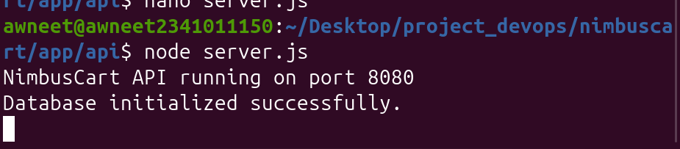
Figure 3: Express API successfully connected to PostgreSQL and initialized the database schema
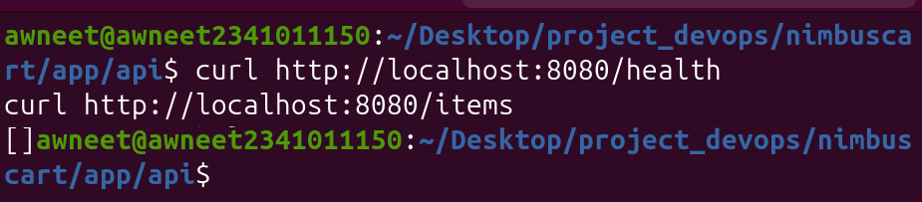
Figure 4: Local testing of GET /health and GET /items endpoints

Testing Product Insertion Using POST /items

The POST /items endpoint was tested by sending product information as a JSON request. The Express API inserted the product into the PostgreSQL products table and returned the newly created product. A subsequent GET /items request confirmed that the inserted product could be retrieved from the database.

curl -X POST http://localhost:8080/items \
-H "Content-Type: application/json" \
-d '{"name":"Laptop","price":899.99,"stock":10}'

curl http://localhost:8080/items

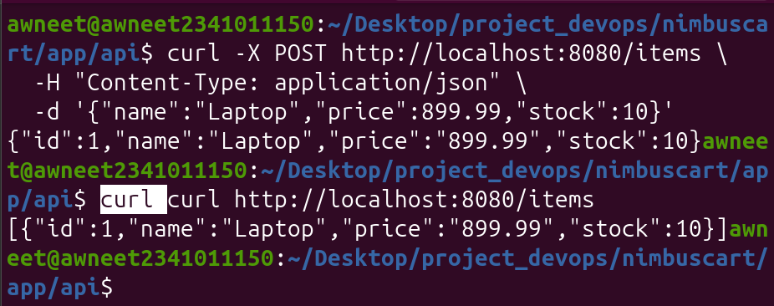
Figure 5: Testing POST /items and retrieving the inserted product using GET /items

Verification of PostgreSQL Products Table

sudo docker exec -it nimbuscart-db psql -U nimbus -d nimbuscart
\dt
SELECT * FROM products;

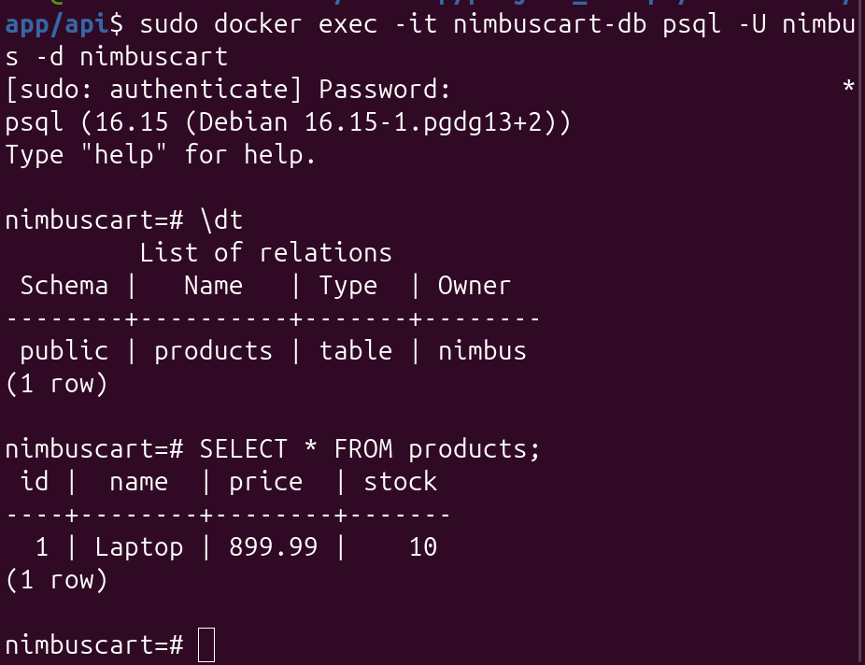
Figure 6: Verification of the products table and stored data using PostgreSQL psql client
Creating the Frontend

A static frontend was developed for NimbusCart using HTML, CSS, and JavaScript. The frontend retrieves products from the Express REST API and displays them in a table containing the product name, price, and stock. An Add Product form sends new product information to the API using a POST request and automatically refreshes the product table after a successful insertion

index.html
<h1>NimbusCart Product Catalog</h1>
<div id="error"></div>
<h2>Add Product</h2>
<form id="productForm">
<input
type="text"
id="name"
placeholder="Product name"
required
>
<input
type="number"
id="price"
placeholder="Price"
step="0.01"
min="0"
required
>
<input
type="number"
id="stock"
placeholder="Stock"
min="0"
required
>
<button type="submit">Add Product</button>
</form>
<h2>Products</h2>
<table>
<thead>
<tr>
<th>Name</th>
<th>Price</th>
<th>Stock</th>
</tr>
</thead>
<tbody id="productTable">
</tbody>
</table>

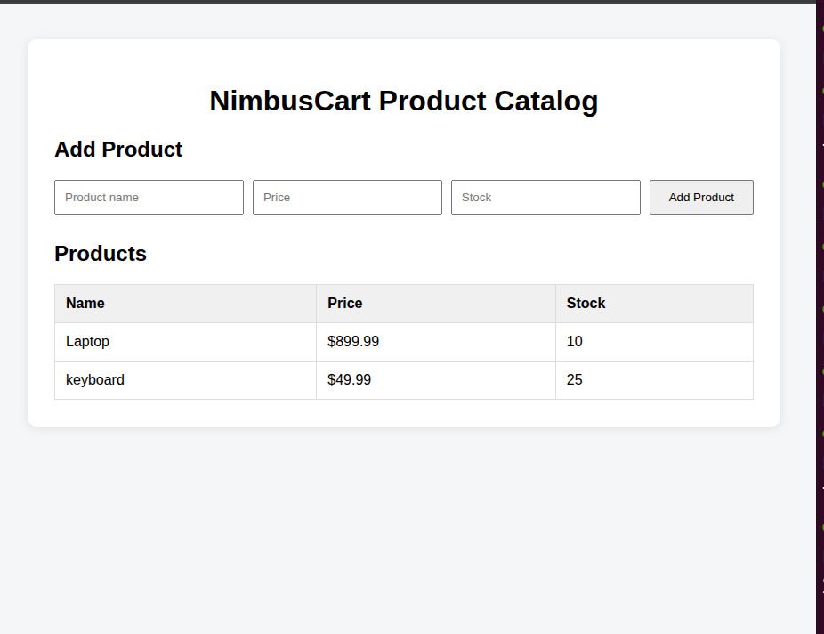
Figure 7: NimbusCart frontend displaying products retrieved from the Express API

Frontend Error Handling

he Express API was temporarily stopped to simulate an API failure. After refreshing the frontend, the application displayed a visible error message instead of silently failing. This confirms that the frontend provides an appropriate error state when the REST API is unavailable.
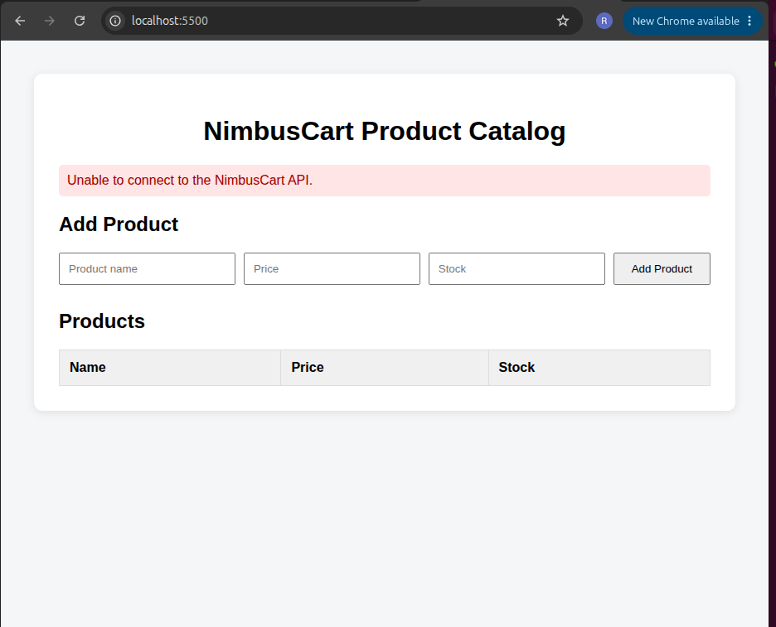
Figure 8: NimbusCart frontend displaying an error state when the Express API is unavailable

Dockerize the Express API
The NimbusCart REST API was containerized using Docker. A Dockerfile was created using a Node.js base image, and the Express application was built into the nimbuscart-api Docker image. A custom Docker network was used so that the API container could communicate with the PostgreSQL database container using the database container name.
FROM node:22-alpine
WORKDIR /app
COPY package*.json ./ Code 3: Dockerfile for the NimbusCart Express REST API
RUN npm install --omit=dev
COPY server.js ./
EXPOSE 8080
CMD ["node", "server.js"]

sudo docker network create nimbuscart-network
sudo docker network connect nimbuscart-network nimbuscart-db
sudo docker build -t nimbuscart-api .
\
--name nimbuscart-api \
--network nimbuscart-network \
-p 8080:8080 \
-e DB_HOST=nimbuscart-db \
-e DB_PORT=5432 \
-e DB_USER=nimbus \
-e DB_PASSWORD=nimbus123 \
-e DB_NAME=nimbuscart \
nimbuscart-api

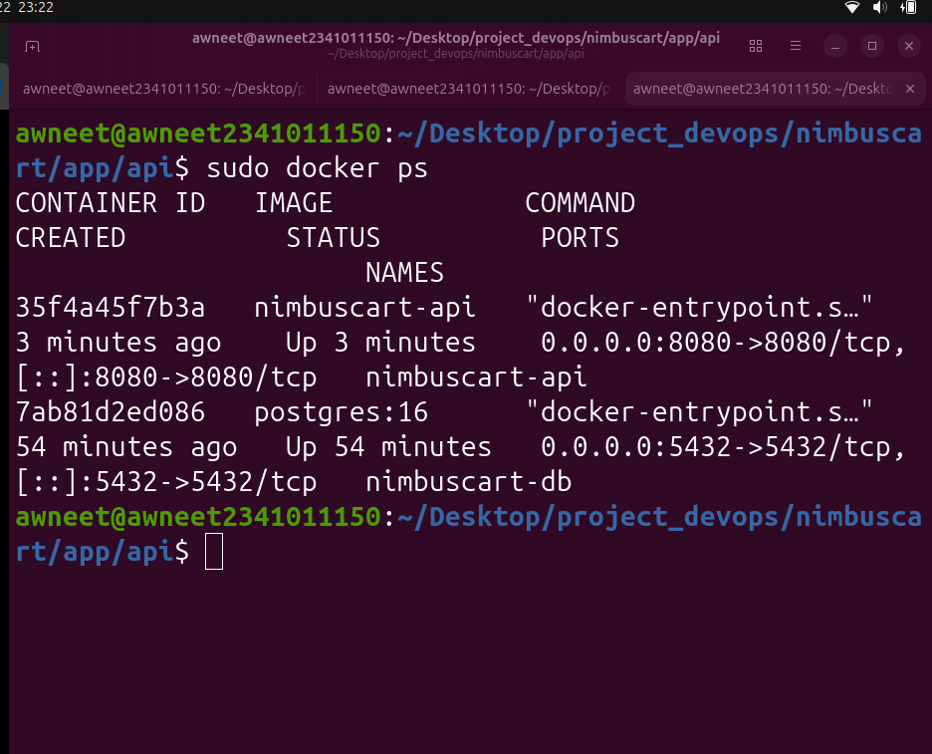
Figure 9: NimbusCart API and PostgreSQL containers running locally using Docker

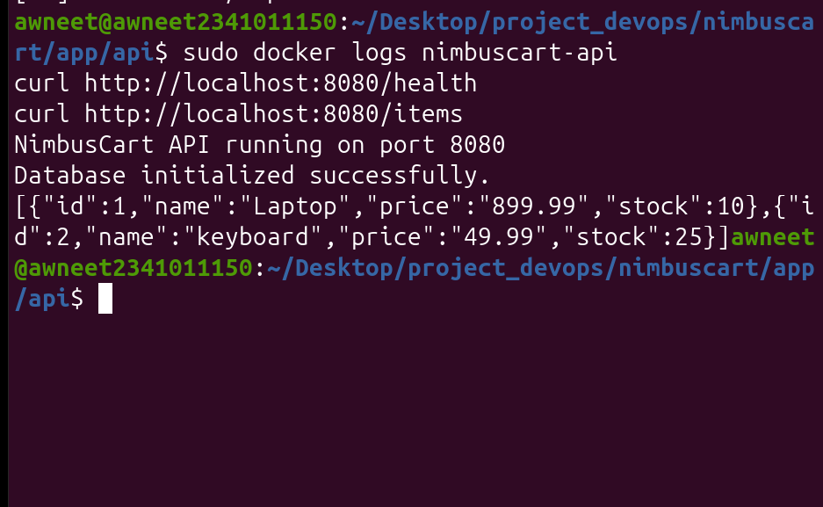
Figure 10: Verification of the Dockerized Express API and database connectivity

Verify /health Works Without the Database
To verify that the API health endpoint operates independently of the database, the PostgreSQL container was temporarily stopped while the Express API container remained running. A request to the /health endpoint continued to return HTTP status 200, confirming that the health endpoint does not depend on database availability.
sudo docker stop nimbuscart-db
sudo docker ps
curl -i http://localhost:8080/health

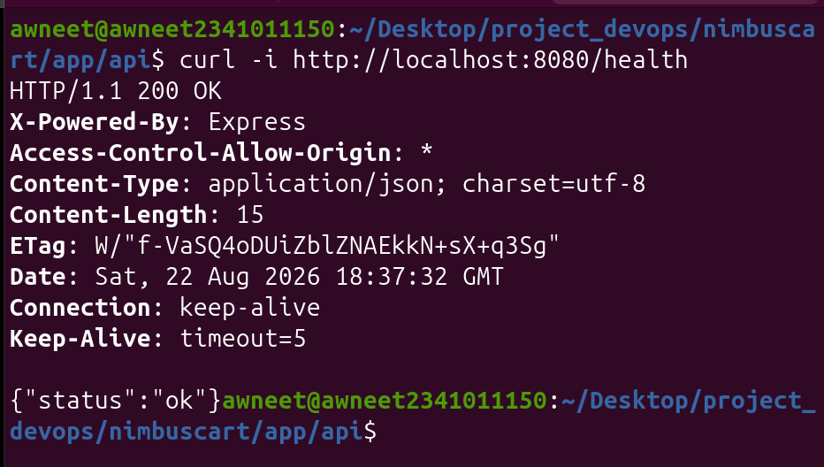
Figure 11: Verification that GET /health returns HTTP 200 while PostgreSQL is unavailable

Manual AWS VPC Peering Experiment
Before automating the AWS infrastructure using Terraform, two temporary VPCs were created manually in the AWS Management Console. These VPCs are used to demonstrate VPC peering connectivity and the effect of a missing return route.

Creation of Temporary VPCs
Two non-overlapping VPCs were created for the manual networking experiment. The manual-app-vpc uses the CIDR block 10.0.0.0/16, while the manual-data-vpc uses the CIDR block 10.1.0.0/16.

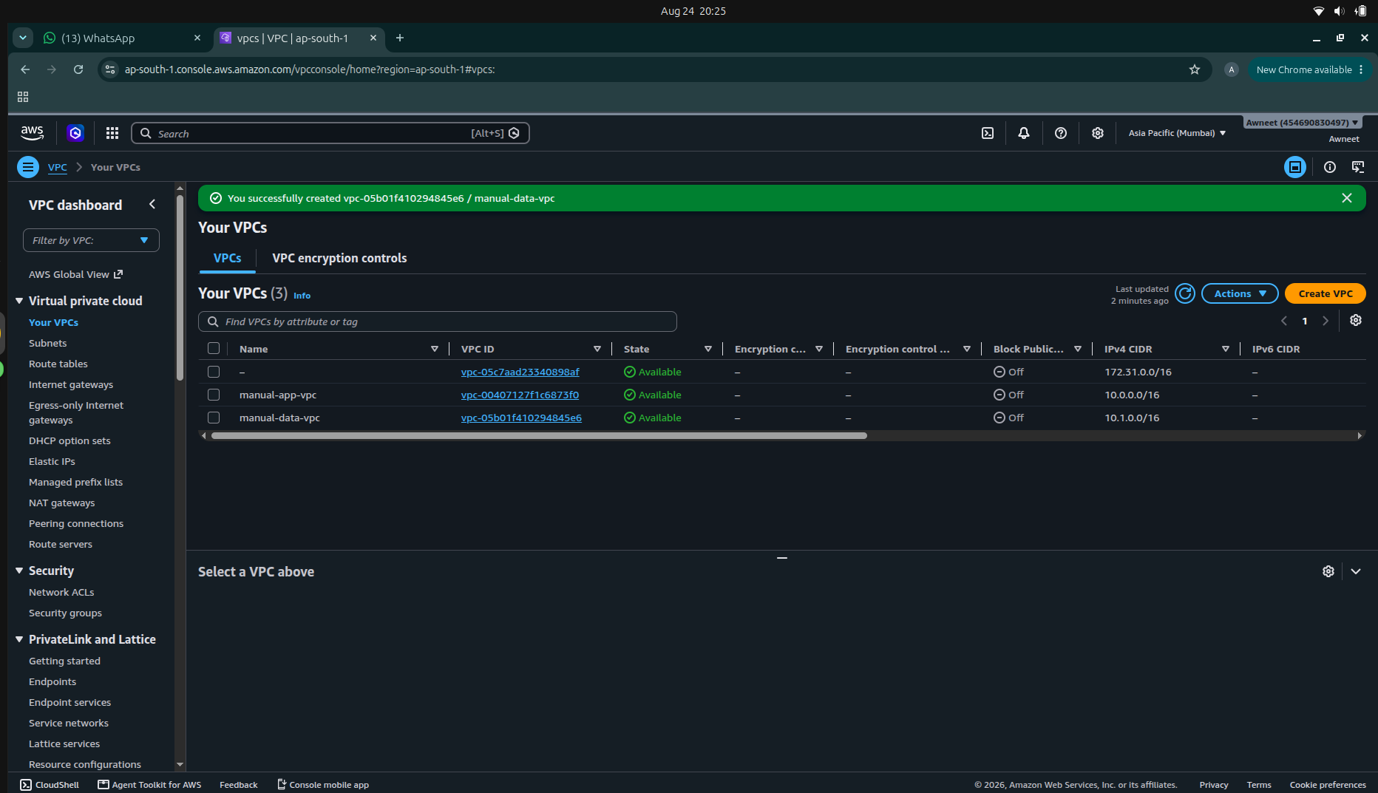
Figure 12: Temporary application and data VPCs created manually in AWS

Creation of Temporary Subnets
A subnet was created inside each temporary VPC in the ap-south-1 AWS Region. The application subnet manual-app-subnet uses CIDR block 10.0.1.0/24, while the data subnet manual-data-subnet uses CIDR block 10.1.1.0/24. These subnets will be used to test communication between the two VPCs through VPC peering.
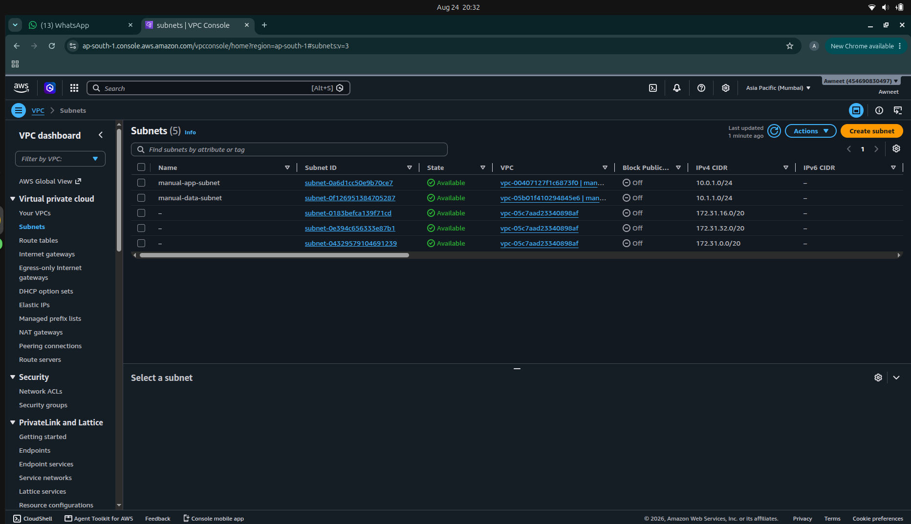
Figure 13: Temporary application and data subnets created in the two VPCs
Creation of VPC Peering Connection
A VPC peering connection named manual-app-data-peering was created between manual-app-vpc and manual-data-vpc. The application VPC was configured as the requester and the data VPC as the accepter. The peering request was accepted to establish a private network connection between the two VPCs.
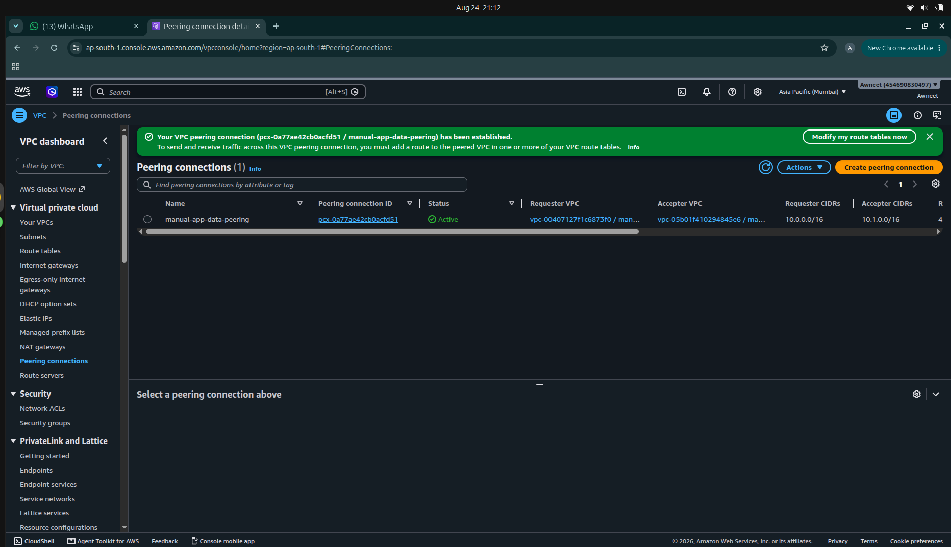
Figure 14: Active VPC peering connection between the application and data VPCs
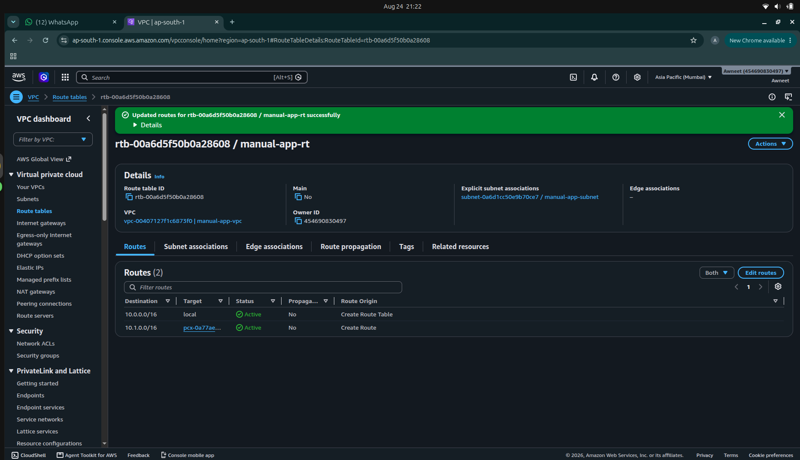
Figure 15: Application route table configured to route data VPC traffic through VPC peerin
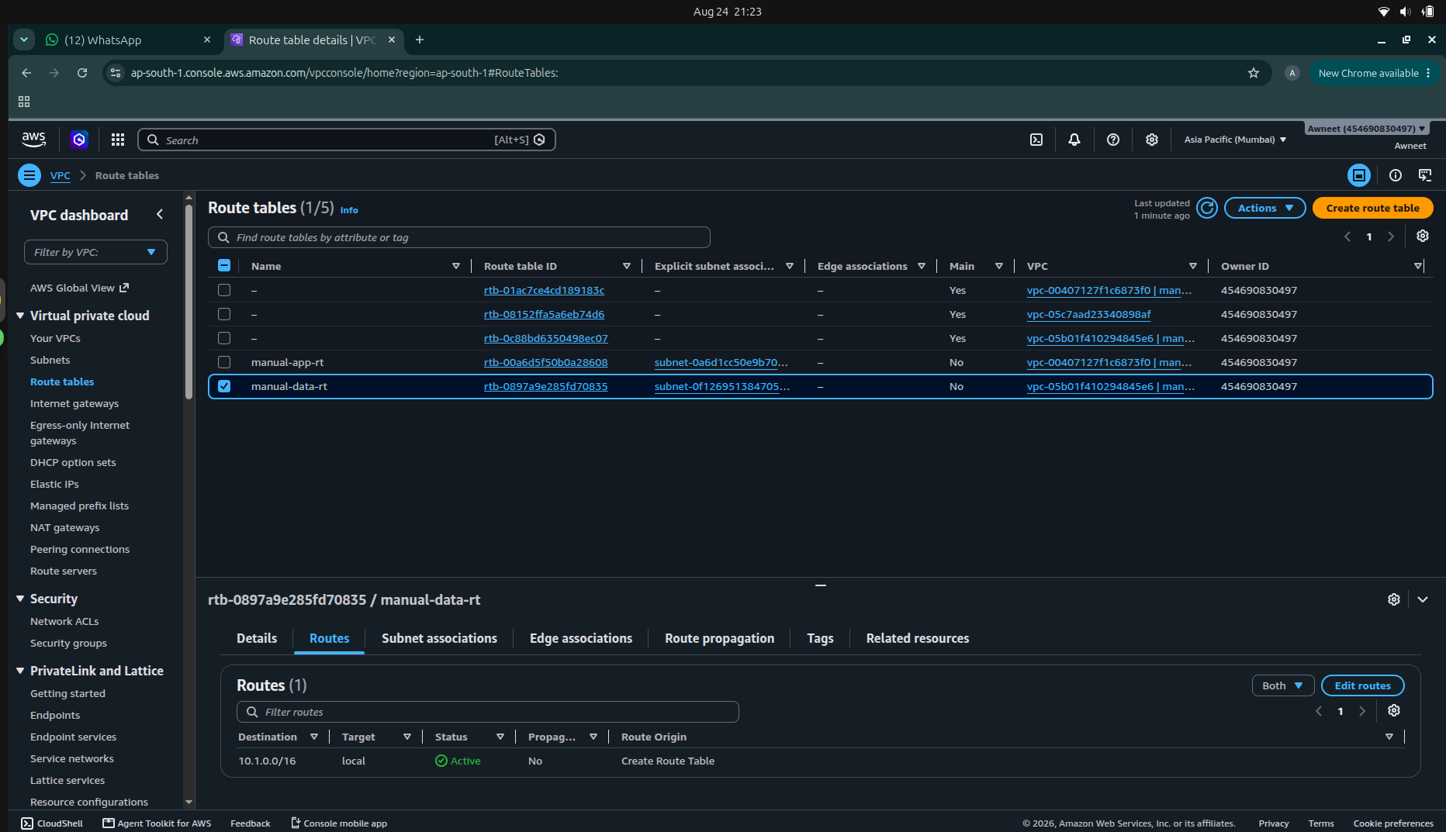
Figure 16: Data route table with the return route intentionally omitted

Demonstration of Missing Return Route
Two temporary EC2 instances were launched to test communication across the VPC peering connection. The application test instance was assigned private IP address 10.0.1.94, while the data test instance was assigned private IP address 10.1.1.72. A route from the application VPC to the data VPC was configured through the peering connection, while the corresponding return route in the data VPC was intentionally omitted.
ping -c 4 10.1.1.72
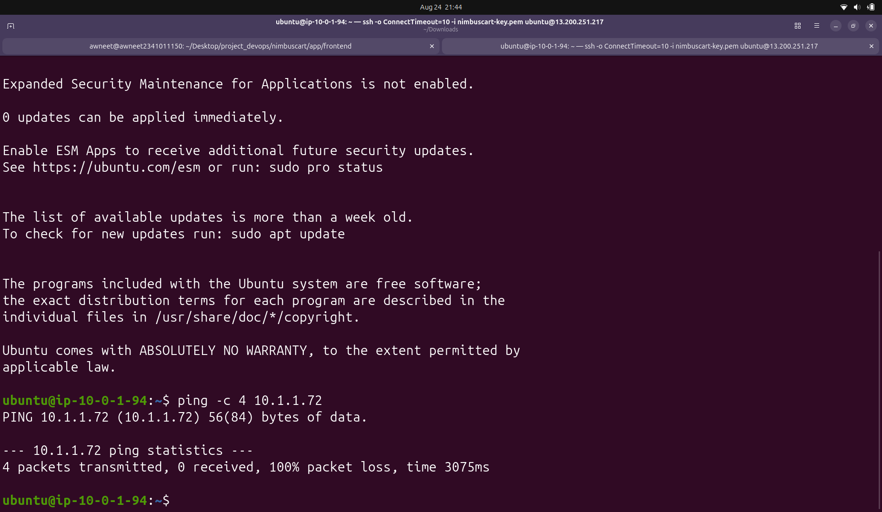
Figure 17: Failed communication across VPC peering due to the missing return route

Correction of the Missing Return Route
To restore bidirectional communication, a return route was added to the data VPC route table. Traffic destined for the application VPC CIDR 10.0.0.0/16 was configured to use the existing VPC peering connection.
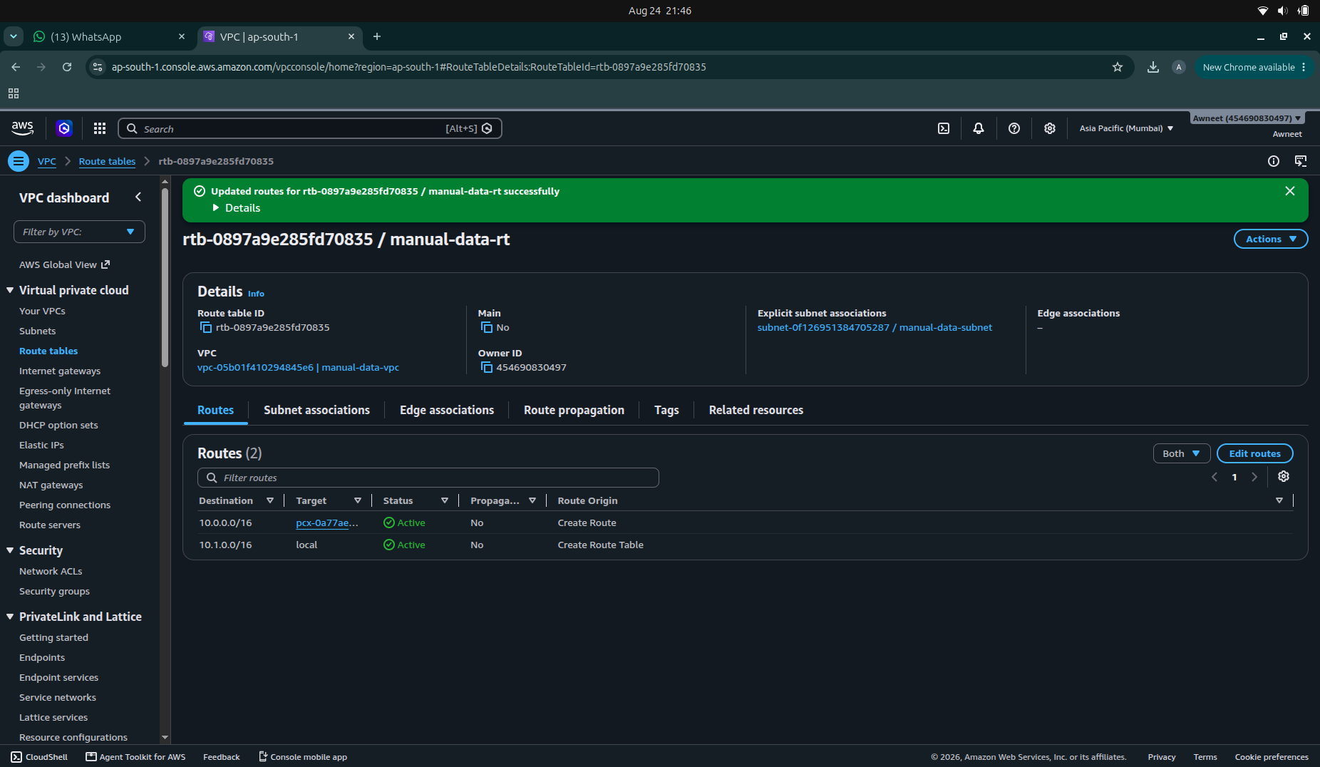
Figure 18: Data VPC route table after adding the return route through VPC peering

After adding the missing return route, the connectivity test was repeated from the application instance to the data instance using the same private IP address. The ping was now successful, with all four packets received and 0% packet loss. This confirms that VPC peering requires routes in both directions for successful bidirectional communication.
ping -c 4 10.1.1.72
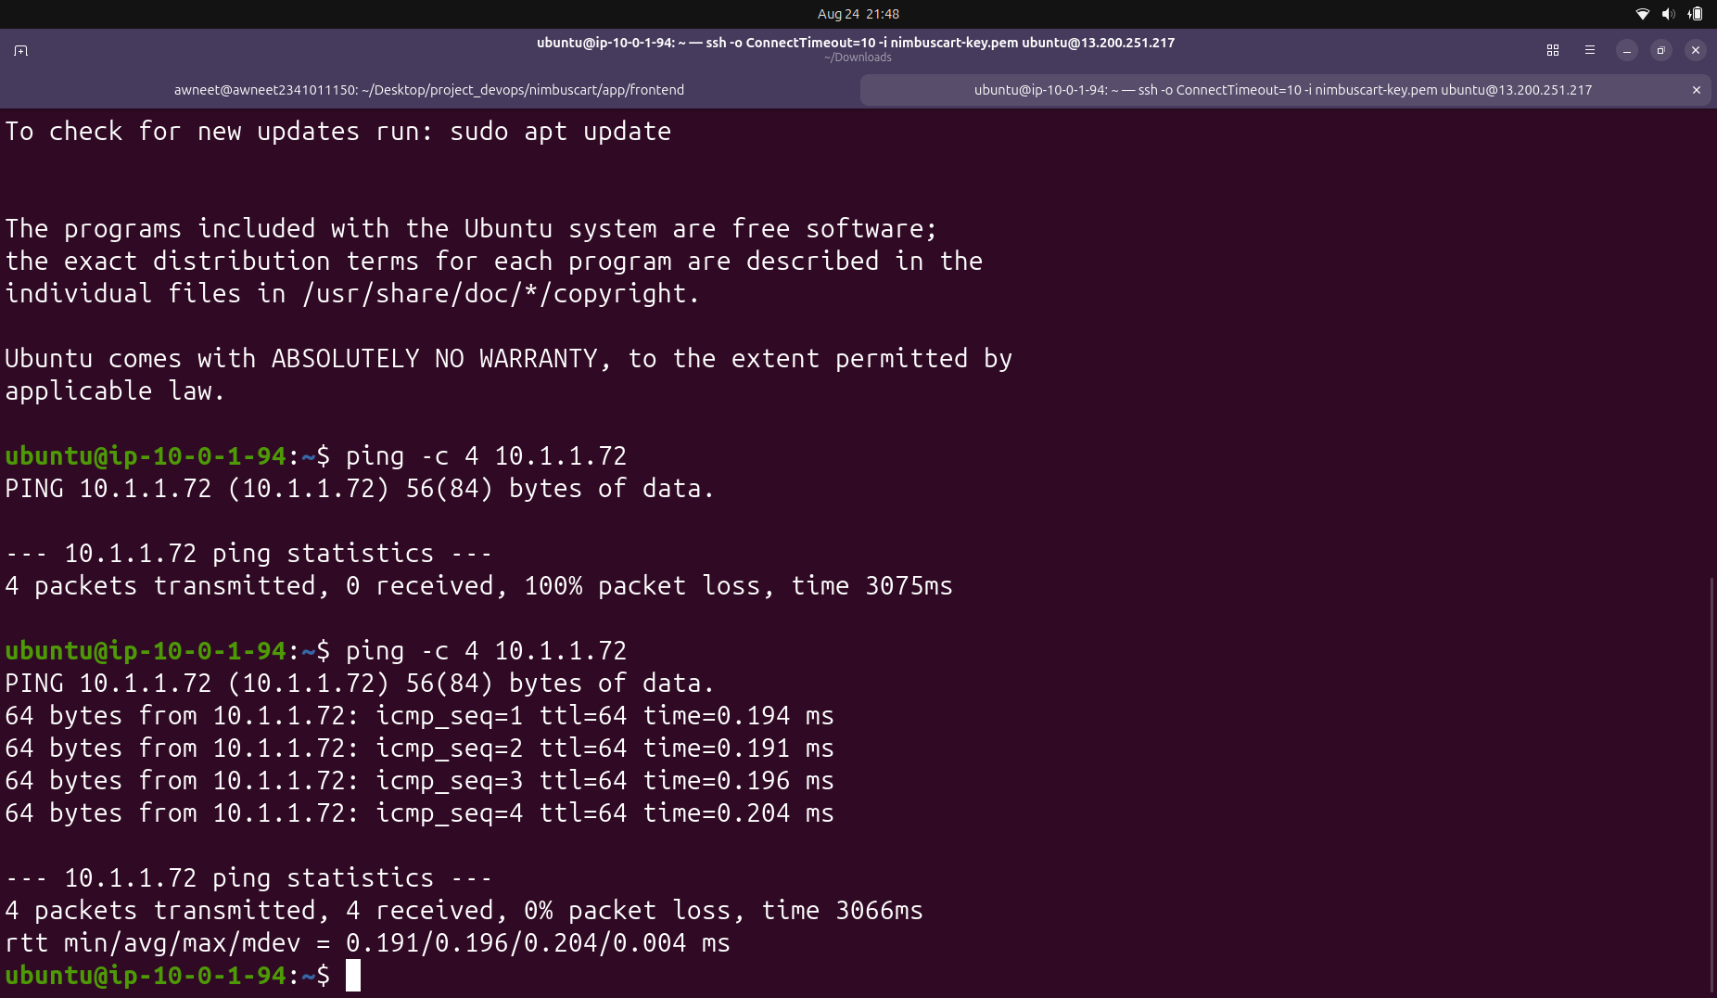
Figure 19: Successful communication after configuring the return route, compared with the previous failed test

Why the Database Subnet Does Not Require a NAT Gateway
The database subnet does not require a NAT Gateway because the database does not need to initiate connections to the public Internet. The application tier reaches the database using private networking through the VPC peering connection. Once the correct routes exist in both VPC route tables and the required security rules permit the traffic, the application can initiate a connection to the database and the database can return the response through the peering connection.
“Reachable from” and “can initiate connections to” describe different networking requirements. The database must be reachable from the application tier because the application initiates database connections. This does not mean that the database itself needs to initiate connections to the Internet. A NAT Gateway would provide an outbound path for private resources to initiate Internet connections, but that capability is unnecessary for the isolated database subnet in this architecture.
Therefore, the database can remain isolated without a NAT Gateway while still being reachable from the application VPC through VPC peering.

Task B: Scripting and Automation

Terraform and Bash scripting were used to automate the deployment of the NimbusCart three-tier infrastructure. Terraform variables were defined to make the AWS region, VPC CIDR blocks, subnet CIDRs, EC2 configuration, database configuration, and application port reusable and configurable.

Terraform Variables Configuration
Terraform input variables for NimbusCart infrastructure
variable "aws_region" { description = "AWS region for NimbusCart" type = string default = "ap-south-1" }
variable "app_vpc_cidr" { description = "CIDR block for the application VPC" type = string default = "10.0.0.0/16" }
variable "public_subnet_cidr" { description = "CIDR block for the public web/NAT subnet" type = string default = "10.0.1.0/24" }
variable "app_private_subnet_cidr" { description = "CIDR block for the private application subnet" type = string default = "10.0.2.0/24" }
variable "data_vpc_cidr" { description = "CIDR block for the isolated data VPC" type = string default = "10.1.0.0/16" }
variable "db_subnet_a_cidr" { description = "CIDR block for the first database subnet" type = string default = "10.1.1.0/24" }
variable "db_subnet_b_cidr" { description = "CIDR block for the second database subnet" type = string default = "10.1.2.0/24" }
variable "availability_zone_a" { description = "First availability zone" type = string default = "ap-south-1a" }
variable "availability_zone_b" { description = "Second availability zone" type = string default = "ap-south-1b" }
variable "instance_type" { description = "EC2 instance type" type = string default = "t3.micro" }
variable "key_name" { description = "Existing AWS EC2 key pair name used for SSH" type = string default = "nimbuscart-key" }
variable "private_key_path" { description = "Local path to the PEM file used by Terraform provisioners" type = string default = "~/Downloads/nimbuscart-key.pem" }
variable "db_name" { description = "PostgreSQL database name" type = string default = "nimbuscart" }
variable "db_username" { description = "PostgreSQL master username" type = string default = "nimbus" }
variable "db_password" { description = "PostgreSQL master password" type = string sensitive = true }
variable "app_port" { description = "Port used by the Express API" type = number default = 8080 }

variable "ssh_cidr" {
description = "CIDR block allowed to SSH into the Web tier"
type = string
}
Internet Gateway, NAT Gateway and Route Tables
An Internet Gateway was attached to the application VPC to provide Internet connectivity to the public subnet. A public route table was configured with a default route (0.0.0.0/0) through the Internet Gateway. A NAT Gateway with an Elastic IP address was deployed in the public subnet, and the private application subnet was associated with a separate route table that sends outbound Internet traffic through the NAT Gateway. This allows the private application tier to initiate outbound connections without assigning it a public IP address.

nternet Gateway, NAT Gateway and route-table configuration

============================================================

INTERNET GATEWAY

============================================================
resource "aws_internet_gateway" "app_igw" { vpc_id = aws_vpc.app_vpc.id
tags = { Name = "nimbuscart-app-igw" } }

============================================================

PUBLIC ROUTE TABLE

============================================================
resource "aws_route_table" "public_rt" { vpc_id = aws_vpc.app_vpc.id
route { cidr_block = "0.0.0.0/0" gateway_id = aws_internet_gateway.app_igw.id }
tags = { Name = "nimbuscart-public-rt" } }
resource "aws_route_table_association" "public_subnet_association" { subnet_id = aws_subnet.public_subnet.id route_table_id = aws_route_table.public_rt.id }

============================================================

NAT GATEWAY

============================================================
resource "aws_eip" "nat_eip" { domain = "vpc"
tags = { Name = "nimbuscart-nat-eip" }
depends_on = [aws_internet_gateway.app_igw] }
resource "aws_nat_gateway" "app_nat" { allocation_id = aws_eip.nat_eip.id subnet_id = aws_subnet.public_subnet.id
tags = { Name = "nimbuscart-app-nat" }
depends_on = [aws_internet_gateway.app_igw] }

============================================================

PRIVATE APPLICATION ROUTE TABLE

============================================================
resource "aws_route_table" "app_private_rt" { vpc_id = aws_vpc.app_vpc.id
tags = { Name = "nimbuscart-app-private-rt" } }
resource "aws_route" "app_private_nat_route" { route_table_id = aws_route_table.app_private_rt.id destination_cidr_block = "0.0.0.0/0" nat_gateway_id = aws_nat_gateway.app_nat.id }
resource "aws_route_table_association" "app_private_subnet_association" { subnet_id = aws_subnet.app_private_subnet.id route_table_id = aws_route_table.app_private_rt.id }

VPC Peering and Inter-VPC Routing
A VPC peering connection was created between the application VPC and the isolated data VPC. The private application route table was configured with a route to the data VPC CIDR through the peering connection, while the data VPC route table was configured with the corresponding return route to the application VPC. Both database subnets were associated with the data VPC route table, enabling bidirectional private communication between the application and database tiers.

VPC peering and bidirectional routing configuration

============================================================

VPC PEERING

============================================================
resource "aws_vpc_peering_connection" "app_data_peering" { vpc_id = aws_vpc.app_vpc.id peer_vpc_id = aws_vpc.data_vpc.id auto_accept = true
tags = { Name = "nimbuscart-app-data-peering" } }

============================================================

APP VPC ROUTE TO DATA VPC

============================================================
resource "aws_route" "app_to_data" { route_table_id = aws_route_table.app_private_rt.id destination_cidr_block = var.data_vpc_cidr vpc_peering_connection_id = aws_vpc_peering_connection.app_data_peering.id }

============================================================

DATA VPC ROUTE TABLE

============================================================
resource "aws_route_table" "data_rt" { vpc_id = aws_vpc.data_vpc.id
route { cidr_block = var.app_vpc_cidr vpc_peering_connection_id = aws_vpc_peering_connection.app_data_peering.id }
tags = { Name = "nimbuscart-data-rt" } }
resource "aws_route_table_association" "db_subnet_a_association" { subnet_id = aws_subnet.db_subnet_a.id route_table_id = aws_route_table.data_rt.id }
resource "aws_route_table_association" "db_subnet_b_association" { subnet_id = aws_subnet.db_subnet_b.id route_table_id = aws_route_table.data_rt.id }

Security Group Configuration

Security groups were configured to enforce communication between the three application tiers. The Web tier permits HTTP and HTTPS traffic from the Internet and restricts SSH access to the administrator's IP address. The private App tier accepts Express API traffic on port 8080 only from the Web-tier security group. SSH access to the App tier is permitted only from the Web tier so that it can be accessed through the Web instance as a bastion host. The database security group allows PostgreSQL traffic on port 5432 only from the App-tier security group.

Security groups for the Web, App and Database tiers

============================================================

WEB TIER SECURITY GROUP

============================================================
resource "aws_security_group" "web_sg" { name = "nimbuscart-web-sg" description = "Security group for NimbusCart Web tier" vpc_id = aws_vpc.app_vpc.id
tags = { Name = "nimbuscart-web-sg" } }

Allow HTTP from the Internet
resource "aws_vpc_security_group_ingress_rule" "web_http" { security_group_id = aws_security_group.web_sg.id
cidr_ipv4 = "0.0.0.0/0" from_port = 80 ip_protocol = "tcp" to_port = 80 }

Allow HTTPS from the Internet
resource "aws_vpc_security_group_ingress_rule" "web_https" { security_group_id = aws_security_group.web_sg.id
cidr_ipv4 = "0.0.0.0/0" from_port = 443 ip_protocol = "tcp" to_port = 443 }

Allow SSH only from the administrator's IP
resource "aws_vpc_security_group_ingress_rule" "web_ssh" { security_group_id = aws_security_group.web_sg.id
cidr_ipv4 = var.ssh_cidr from_port = 22 ip_protocol = "tcp" to_port = 22 }

Allow all outbound traffic from Web tier
resource "aws_vpc_security_group_egress_rule" "web_outbound" { security_group_id = aws_security_group.web_sg.id
cidr_ipv4 = "0.0.0.0/0" ip_protocol = "-1" }

============================================================

APPLICATION TIER SECURITY GROUP

============================================================
resource "aws_security_group" "app_sg" { name = "nimbuscart-app-sg" description = "Security group for NimbusCart App tier" vpc_id = aws_vpc.app_vpc.id
tags = { Name = "nimbuscart-app-sg" } }

Allow Express API traffic only from Web tier
resource "aws_vpc_security_group_ingress_rule" "app_api" { security_group_id = aws_security_group.app_sg.id
referenced_security_group_id = aws_security_group.web_sg.id
from_port = var.app_port ip_protocol = "tcp" to_port = var.app_port }

Allow SSH to App tier only through Web tier
resource "aws_vpc_security_group_ingress_rule" "app_ssh" { security_group_id = aws_security_group.app_sg.id
referenced_security_group_id = aws_security_group.web_sg.id
from_port = 22 ip_protocol = "tcp" to_port = 22 }

Allow all outbound traffic from App tier
resource "aws_vpc_security_group_egress_rule" "app_outbound" { security_group_id = aws_security_group.app_sg.id
cidr_ipv4 = "0.0.0.0/0" ip_protocol = "-1" }

============================================================

DATABASE SECURITY GROUP

============================================================
resource "aws_security_group" "db_sg" { name = "nimbuscart-db-sg" description = "Security group for NimbusCart PostgreSQL database" vpc_id = aws_vpc.data_vpc.id
tags = { Name = "nimbuscart-db-sg" } }

Allow PostgreSQL only from App tier
resource "aws_vpc_security_group_ingress_rule" "db_postgres" { security_group_id = aws_security_group.db_sg.id
referenced_security_group_id = aws_security_group.app_sg.id
from_port = 5432 ip_protocol = "tcp" to_port = 5432
depends_on = [ aws_vpc_peering_connection.app_data_peering ] }

Allow database responses/outbound traffic
resource "aws_vpc_security_group_egress_rule" "db_outbound" { security_group_id = aws_security_group.db_sg.id
cidr_ipv4 = "0.0.0.0/0" ip_protocol = "-1" }

RDS PostgreSQL Database Configuration

An Amazon RDS PostgreSQL instance was configured inside the isolated data VPC. A DB subnet group containing two private database subnets in different Availability Zones was created for RDS. The database was configured as non-publicly accessible and associated with the database security group, which permits PostgreSQL traffic only from the application tier. The database schema is not created by Terraform; the Express API creates the required products table automatically when it starts.

RDS PostgreSQL database and DB subnet group configuration

============================================================

RDS DB SUBNET GROUP

============================================================
resource "aws_db_subnet_group" "nimbuscart_db_subnet_group" { name = "nimbuscart-db-subnet-group"
subnet_ids = [ aws_subnet.db_subnet_a.id, aws_subnet.db_subnet_b.id ]
tags = { Name = "nimbuscart-db-subnet-group" } }

============================================================

RDS POSTGRESQL DATABASE

============================================================
resource "aws_db_instance" "nimbuscart_db" { identifier = "nimbuscart-db"
engine = "postgres"
instance_class = "db.t3.micro"
allocated_storage = 20
db_name = var.db_name username = var.db_username password = var.db_password
port = 5432
db_subnet_group_name = aws_db_subnet_group.nimbuscart_db_subnet_group.name
vpc_security_group_ids = [ aws_security_group.db_sg.id ]
publicly_accessible = false
skip_final_snapshot = true
deletion_protection = false
tags = { Name = "nimbuscart-db" } }

ECR Repository and App-Tier IAM Configuration
An Amazon Elastic Container Registry (ECR) repository was configured to store the Docker image for the NimbusCart Express API. An IAM role and instance profile were also created for the private App-tier EC2 instance. The IAM role grants read-only access to ECR so that the App instance can authenticate to ECR and pull the API image without storing AWS credentials on the server.

ECR repository and IAM configuration for the App tier

============================================================

ECR REPOSITORY

============================================================
resource "aws_ecr_repository" "nimbuscart_api" { name = "nimbuscart-api" image_tag_mutability = "MUTABLE"
image_scanning_configuration { scan_on_push = true }
tags = { Name = "nimbuscart-api" } }

============================================================

IAM ROLE FOR APP EC2

============================================================
resource "aws_iam_role" "app_ec2_role" { name = "nimbuscart-app-ec2-role"
assume_role_policy = jsonencode({ Version = "2012-10-17"
Statement = [
{
Effect = "Allow"
Principal = {
Service = "ec2.amazonaws.com"
}
Action = "sts:AssumeRole"
}
]
}) }

Allow the App EC2 instance to pull Docker images from ECR
resource "aws_iam_role_policy_attachment" "app_ecr_readonly" { role = aws_iam_role.app_ec2_role.name policy_arn = "arn:aws:iam::aws:policy/AmazonEC2ContainerRegistryReadOnly" }
resource "aws_iam_instance_profile" "app_instance_profile" { name = "nimbuscart-app-instance-profile" role = aws_iam_role.app_ec2_role.name }

EC2 Instance Configuration
Two EC2 instances were defined for the application architecture. The Web EC2 instance is deployed in the public subnet and is assigned a public IPv4 address so that the web tier can receive Internet traffic. The App EC2 instance is deployed in the private application subnet without a public IP address. Communication between the Web and App tiers is controlled using their respective security groups. The App instance is also associated with the IAM instance profile created previously, allowing it to access required AWS services without storing AWS credentials directly on the instance.

EC2 instances for the Web and App tiers

============================================================

EC2 INSTANCES

============================================================

------------------------------------------------------------

WEB EC2 INSTANCE

------------------------------------------------------------
resource "aws_instance" "web" { ami = data.aws_ami.ubuntu.id instance_type = var.instance_type subnet_id = aws_subnet.public_web.id vpc_security_group_ids = [aws_security_group.web.id] associate_public_ip_address = true key_name = var.key_name
tags = { Name = "nimbuscart-web" } }

------------------------------------------------------------

APP EC2 INSTANCE

------------------------------------------------------------
resource "aws_instance" "app" { ami = data.aws_ami.ubuntu.id instance_type = var.instance_type subnet_id = aws_subnet.app_private.id vpc_security_group_ids = [aws_security_group.app.id] key_name = var.key_name
iam_instance_profile = aws_iam_instance_profile.app.name
tags = { Name = "nimbuscart-app" } }

Web and App Tier Deployment Scripts
Shell scripts were created to configure the Web and App tiers after the EC2 instances are provisioned. The Web-tier script installs nginx, deploys the static NimbusCart frontend, and configures nginx to reverse-proxy /api/* requests to the private App-tier EC2 instance on port 8080. The App-tier script installs Docker and the AWS CLI, authenticates to Amazon ECR, pulls the NimbusCart API image, and runs the Express API container using the RDS PostgreSQL connection information.

Web-tier nginx deployment script (web.sh)
#!/bin/bash set -e
APP_PRIVATE_IP=$1
sudo apt-get update -y sudo apt-get install -y nginx
sudo cp /tmp/index.html /var/www/html/index.html
sudo tee /etc/nginx/sites-available/default > /dev/null <<EOF server { listen 80 default_server; listen [::]:80 default_server;
root /var/www/html;
index index.html;
location / {
try_files \$uri \$uri/ =404;
}
location /api/ {
proxy_pass http://${APP_PRIVATE_IP}:8080/;
proxy_http_version 1.1;
proxy_set_header Host \$host;
proxy_set_header X-Real-IP \$remote_addr;
proxy_set_header X-Forwarded-For \$proxy_add_x_forwarded_for;
proxy_set_header X-Forwarded-Proto \$scheme;
}
} EOF
sudo nginx -t sudo systemctl enable nginx sudo systemctl restart nginx
echo "NimbusCart Web tier configured successfully."

App-tier Docker deployment script (app.sh)
#!/bin/bash set -e
AWS_REGION=$1 ECR_REPOSITORY=$2 DB_HOST=$3 DB_NAME=$4 DB_USER=$5 DB_PASSWORD=$6 APP_PORT=$7
sudo apt-get update -y sudo apt-get install -y docker.io awscli
sudo systemctl enable docker sudo systemctl start docker
aws ecr get-login-password --region "${AWS_REGION}"
| sudo docker login
--username AWS
--password-stdin "$(echo "${ECR_REPOSITORY}" | cut -d/ -f1)"
sudo docker pull "${ECR_REPOSITORY}:latest"
sudo docker rm -f nimbuscart-api 2>/dev/null || true
sudo docker run -d
--name nimbuscart-api
--restart unless-stopped
-p "${APP_PORT}:${APP_PORT}"
-e PORT="${APP_PORT}"
-e DB_HOST="${DB_HOST}"
-e DB_PORT="5432"
-e DB_USER="${DB_USER}"
-e DB_PASSWORD="${DB_PASSWORD}"
-e DB_NAME="${DB_NAME}"
-e DB_SSL="true"
"${ECR_REPOSITORY}:latest"

echo "NimbusCart API container started successfully."

Terraform Provisioners and Automated Application Deployment
Terraform provisioners were used to automate application deployment after the infrastructure resources were created. A local-exec provisioner builds the Express API Docker image on the local machine, authenticates to Amazon ECR, and pushes the image to the ECR repository. The private App EC2 instance is then accessed through the public Web EC2 instance acting as a bastion host. A Terraform file provisioner transfers app.sh to the private App instance, and remote-exec executes the script to install Docker, authenticate to ECR, pull the API image, and start the container. The frontend index.html and web.sh files are similarly copied to the Web EC2 instance, where remote-exec configures nginx and the /api/ reverse proxy.
terraform local-exec, file and remote-exec provisioners for automated deployment

============================================================

BUILD AND PUSH API IMAGE TO ECR

============================================================
resource "terraform_data" "build_and_push_api" {
triggers_replace = [ aws_ecr_repository.nimbuscart_api.repository_url, filesha256("../app/api/Dockerfile"), filesha256("../app/api/server.js"), filesha256("../app/api/package.json"), filesha256("../app/api/package-lock.json") ]
provisioner "local-exec" { command = <<-EOT set -e
aws ecr get-login-password --region ${var.aws_region} \
| docker login \
--username AWS \
--password-stdin ${split("/", aws_ecr_repository.nimbuscart_api.repository_url)[0]}
docker build \
-t nimbuscart-api:latest \
../app/api
docker tag \
nimbuscart-api:latest \
${aws_ecr_repository.nimbuscart_api.repository_url}:latest
docker push \
${aws_ecr_repository.nimbuscart_api.repository_url}:latest
EOT
}
depends_on = [ aws_ecr_repository.nimbuscart_api ] }

============================================================

DEPLOY APP TIER

============================================================
resource "terraform_data" "provision_app" {
triggers_replace = [ aws_instance.app.id, aws_db_instance.nimbuscart_db.address, terraform_data.build_and_push_api.id, filesha256("${path.module}/app.sh") ]
connection { type = "ssh" user = "ubuntu" private_key = file(pathexpand(var.private_key_path))
host = aws_instance.app.private_ip
bastion_host = aws_instance.web.public_ip
bastion_user = "ubuntu"
bastion_private_key = file(pathexpand(var.private_key_path))
}
provisioner "file" { source = "${path.module}/app.sh" destination = "/tmp/app.sh" }
provisioner "remote-exec" { inline = [ "chmod +x /tmp/app.sh",
"sudo /tmp/app.sh '${var.aws_region}' '${aws_ecr_repository.nimbuscart_api.repository_url}' '${aws_db_instance.nimbuscart_db.address}' '${var.db_name}' '${var.db_username}' '${var.db_password}' '${var.app_port}'"
]
}
depends_on = [ terraform_data.build_and_push_api, aws_instance.web, aws_instance.app, aws_nat_gateway.app_nat, aws_db_instance.nimbuscart_db, aws_route.app_to_data, aws_vpc_security_group_ingress_rule.db_postgres ] }

============================================================

DEPLOY WEB TIER

============================================================
resource "terraform_data" "provision_web" {
triggers_replace = [ aws_instance.web.id, aws_instance.app.private_ip, filesha256("../app/frontend/index.html"), filesha256("${path.module}/web.sh") ]
connection { type = "ssh" user = "ubuntu" private_key = file(pathexpand(var.private_key_path)) host = aws_instance.web.public_ip }
provisioner "file" { source = "../app/frontend/index.html" destination = "/tmp/index.html" }
provisioner "file" { source = "${path.module}/web.sh" destination = "/tmp/web.sh" }
provisioner "remote-exec" { inline = [ "chmod +x /tmp/web.sh", "sudo /tmp/web.sh '${aws_instance.app.private_ip}'" ] }
depends_on = [ terraform_data.provision_app ] }

Terraform Outputs
Terraform outputs were defined to display the key information required after deployment. These outputs include the Web-tier public IP address, App-tier private IP address, RDS database endpoint, VPC peering connection ID, NAT Gateway public IP address, and the frontend URL constructed from the Web-tier public IP.
Required Terraform outputs
output "web_public_ip" { description = "Public IPv4 address of the Web EC2 instance" value = aws_instance.web.public_ip }
output "app_private_ip" { description = "Private IPv4 address of the App EC2 instance" value = aws_instance.app.private_ip }
output "db_endpoint" { description = "RDS PostgreSQL endpoint" value = aws_db_instance.nimbuscart_db.address }
output "peering_connection_id" { description = "VPC peering connection ID" value = aws_vpc_peering_connection.app_data_peering.id }
output "nat_gateway_public_ip" { description = "Elastic IP address associated with the NAT Gateway" value = aws_eip.nat_eip.public_ip }
output "frontend_url" { description = "Public URL for the NimbusCart frontend" value = "http://${aws_instance.web.public_ip}" }

Remote Terraform Backend Bootstrap
A separate bootstrap Terraform configuration was created to provision the remote-state infrastructure. It creates a private, versioned and encrypted Amazon S3 bucket for storing Terraform state and a DynamoDB table for state locking. The backend resources are created separately because Terraform cannot use an S3 backend before that backend exists; attempting to create the backend from the same state that depends on it would create a circular bootstrapping dependency.

Terraform bootstrap configuration for S3 remote state and DynamoDB locking
terraform { required_providers { aws = { source = "hashicorp/aws" version = "~> 6.0" } }
required_version = ">= 1.5.0" }
provider "aws" { region = "ap-south-1" }

============================================================

S3 BUCKET FOR TERRAFORM STATE

============================================================
resource "aws_s3_bucket" "terraform_state" { bucket = "nimbuscart-terraform-state-CHANGE-ME"
tags = { Name = "nimbuscart-terraform-state" } }
resource "aws_s3_bucket_versioning" "terraform_state_versioning" { bucket = aws_s3_bucket.terraform_state.id
versioning_configuration { status = "Enabled" } }
resource "aws_s3_bucket_server_side_encryption_configuration" "terraform_state_encryption" { bucket = aws_s3_bucket.terraform_state.id
rule { apply_server_side_encryption_by_default { sse_algorithm = "AES256" } } }
resource "aws_s3_bucket_public_access_block" "terraform_state_public_access" { bucket = aws_s3_bucket.terraform_state.id
block_public_acls = true block_public_policy = true ignore_public_acls = true restrict_public_buckets = true }

============================================================

DYNAMODB TABLE FOR STATE LOCKING

============================================================
resource "aws_dynamodb_table" "terraform_locks" { name = "nimbuscart-terraform-locks" billing_mode = "PAY_PER_REQUEST" hash_key = "LockID"
attribute { name = "LockID" type = "S" }
tags = { Name = "nimbuscart-terraform-locks" } }

Bootstrap Terraform outputs
output "state_bucket_name" { description = "S3 bucket used for Terraform remote state" value = aws_s3_bucket.terraform_state.bucket }
output "lock_table_name" { description = "DynamoDB table used for Terraform state locking" value = aws_dynamodb_table.terraform_locks.name }

Main Terraform Remote Backend Configuration
The main NimbusCart Terraform configuration was configured to use the previously bootstrapped S3 bucket as its remote backend. The Terraform state file is stored under the nimbuscart/terraform.tfstate key in S3, while the DynamoDB table is used for state locking. Server-side encryption is enabled for the remote state.
Terraform S3 remote backend configuration (backend.tf)

terraform {
backend "s3" {
bucket = "nimbuscart-terraform-state-awneet-20"
key = "nimbuscart/terraform.tfstate"
region = "ap-south-1"
dynamodb_table = "nimbuscart-terraform-locks"
encrypt = true
}
}

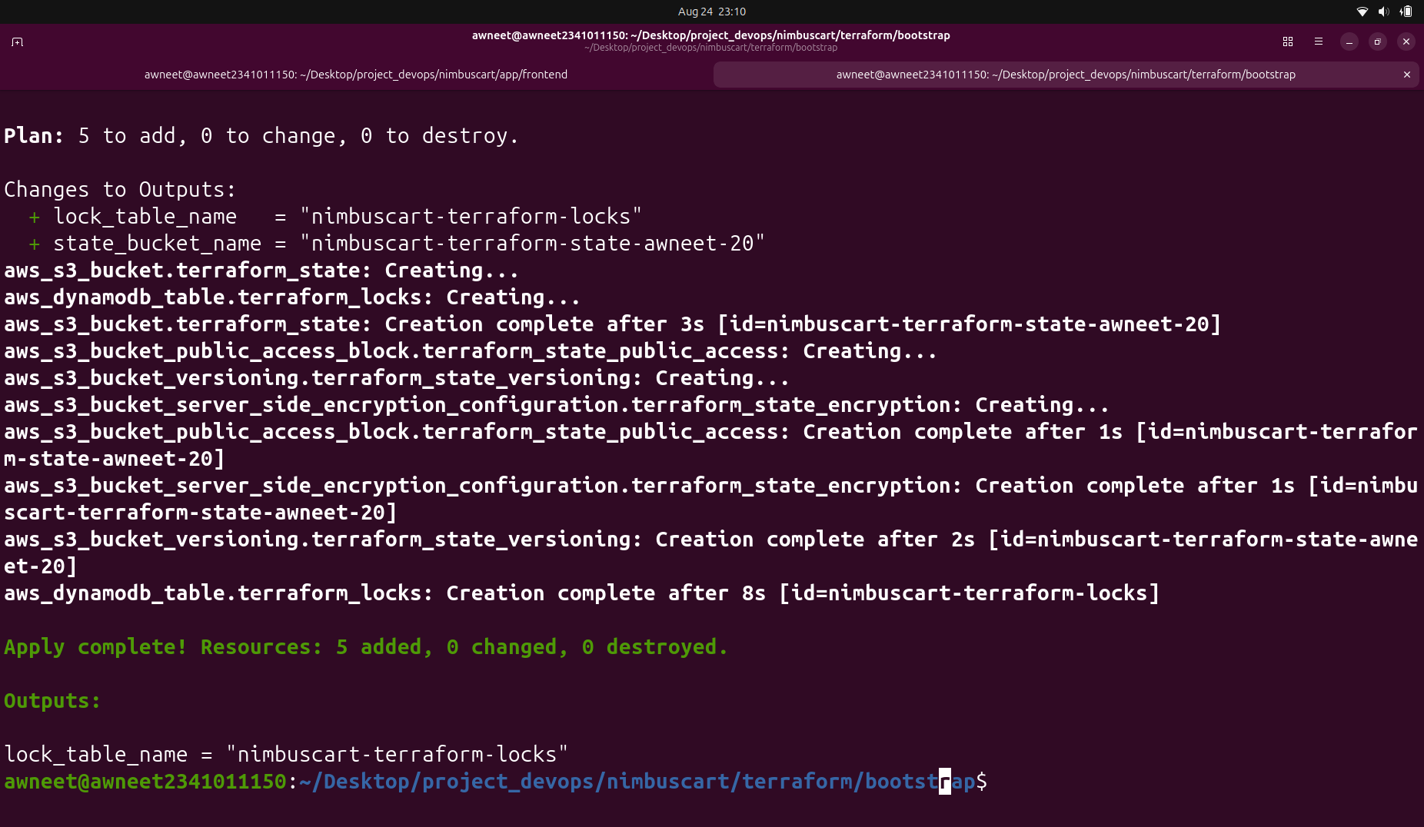
Figure 20: Successful creation of the S3 remote-state bucket and DynamoDB lock table

Deploy the Three-Tier Infrastructure
After configuring the Terraform remote backend, the main NimbusCart infrastructure was deployed using Terraform. The deployment created separate web, application, and database tiers. The web tier was deployed in a public subnet, while the Express application tier was placed in a private subnet. Amazon RDS for PostgreSQL was used for the database tier.
The application EC2 instance does not require direct public internet exposure. Outbound internet access from the private application subnet is provided through a NAT Gateway, while communication between the application and database networks is enabled through VPC peering and controlled using security groups.
The infrastructure was deployed using:

terraform init
terraform plan
terraform apply

After deployment, Terraform produced the important infrastructure values including the application private IP address, database endpoint, frontend URL, NAT Gateway public IP address, and VPC peering connection ID.

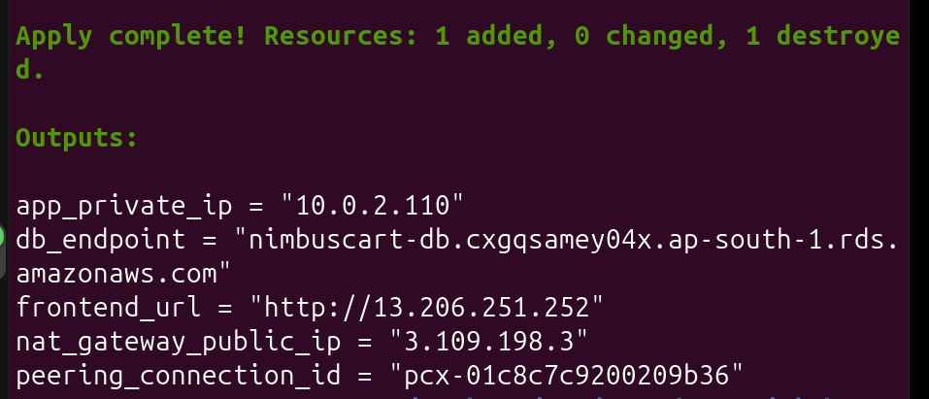
Figure 21: Successful deployment of the NimbusCart three-tier AWS infrastructure using Terraform

Deploy the Express API to the Private Application Tier
The NimbusCart Express API was containerized using Docker and stored in Amazon ECR. During deployment, the application EC2 instance authenticates with ECR, pulls the latest API image, and starts the container.
The application container is configured using environment variables for the RDS database connection:

sudo docker run -d \
--name nimbuscart-api \
--restart unless-stopped \
-p "${APP_PORT}:${APP_PORT}" \
-e PORT="${APP_PORT}" \
-e DB_HOST="${DB_HOST}" \
-e DB_PORT="5432" \
-e DB_USER="${DB_USER}" \
-e DB_PASSWORD="${DB_PASSWORD}" \
-e DB_NAME="${DB_NAME}" \
-e DB_SSL="true" \
"${ECR_REPOSITORY}:latest"

SSL was enabled for the PostgreSQL connection because the RDS PostgreSQL database requires an encrypted connection from the application.
The Node.js PostgreSQL connection pool was therefore configured to enable SSL when DB_SSL=true:

Configure the Web Tier with Nginx
The public EC2 instance acts as the web tier. Nginx serves the static NimbusCart frontend and also operates as a reverse proxy for requests to the private Express API.
The browser sends API requests using the /api path. Nginx forwards these requests to the Express application running on the private application EC2 instance.

Verify the Express API
The API health endpoint was tested through the public Nginx server:

curl -i http://13.206.251.252/api/health

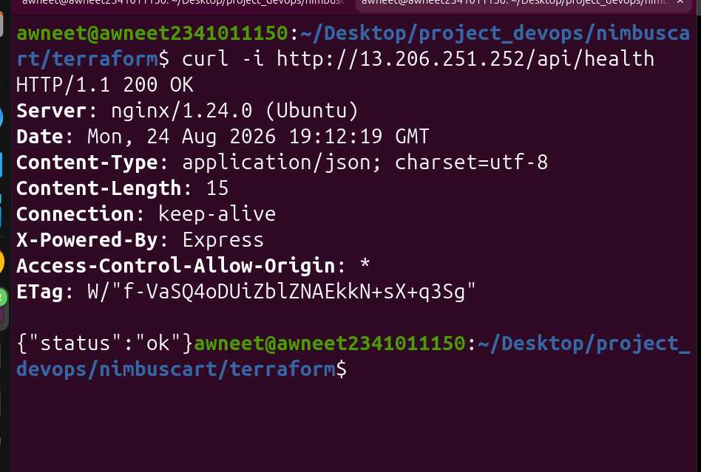
Figure 22: Successful health check through Nginx to the Express API running in the private application tier

Verify Database Connectivity
he /items API endpoint was tested to verify connectivity between the Express application and the PostgreSQL RDS database:

curl -i http://13.206.251.252/api/items

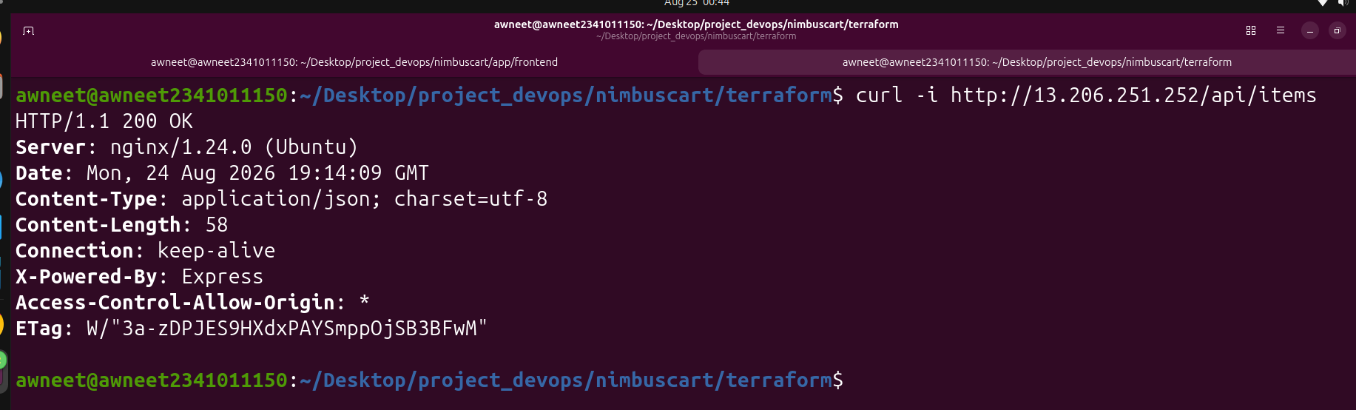
Figure 23: Successful retrieval of product data from the PostgreSQL RDS database through the Express API

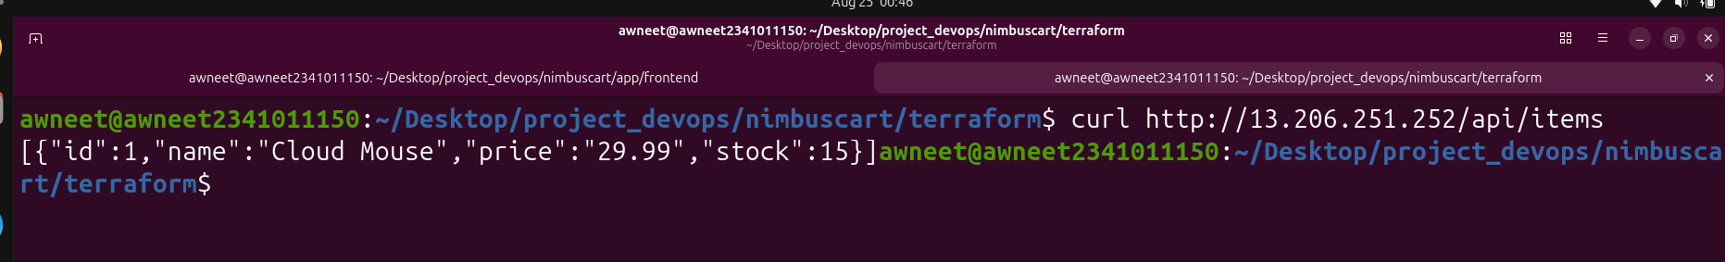
Figure 24: Successful retrieval of the Cloud Mouse product stored in the PostgreSQL RDS database

The completed NimbusCart application was tested through the public web interface. The frontend was accessed using the public IP address of the web-tier EC2 instance:

http://13.206.251.252

The frontend successfully displayed the Cloud Mouse product with a price of $29.99 and stock quantity of 15.
The product displayed by the frontend was retrieved through the complete three-tier architecture. The browser requested the /api/items endpoint from Nginx on the public web-tier EC2 instance. Nginx forwarded the request to the Express API running inside a Docker container on the private application-tier EC2 instance. The Express application queried the PostgreSQL database hosted on Amazon RDS and returned the product data to the frontend.

Figure 25: NimbusCart frontend successfully displaying product data retrieved from the PostgreSQL RDS database
Figure 25: NimbusCart frontend successfully displaying product data retrieved from the PostgreSQL RDS database
Figure 25: NimbusCart frontend successfully displaying product data retrieved from the PostgreSQL RDS database

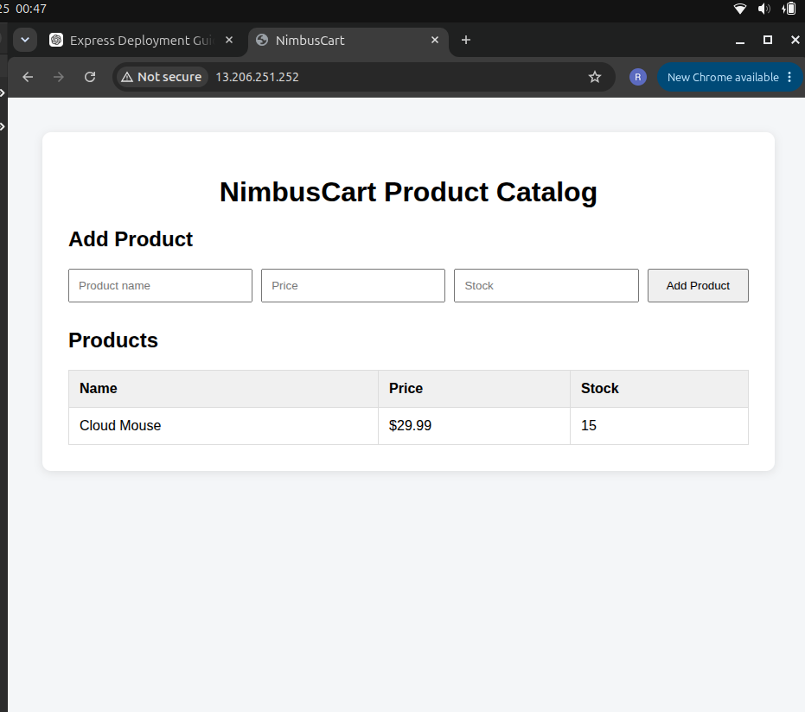
Figure 25: NimbusCart frontend successfully displaying product data retrieved from the PostgreSQL RDS database
The final verification confirmed that:
- The public Nginx web server successfully served the NimbusCart frontend.
- Nginx successfully reverse-proxied /api requests to the private application EC2 instance.
- The Express API successfully ran as a Docker container.
- The application successfully established an encrypted connection to the PostgreSQL RDS database.
- Product data could be written to and retrieved from the database.
- The retrieved database data was successfully displayed through the public NimbusCart frontend.
Therefore, the NimbusCart three-tier application was successfully deployed on AWS using Terraform, with separate web, application, and database tiers and end-to-end connectivity between all componen
Conclusion
The NimbusCart project successfully demonstrates the deployment of a containerized three-tier web application on AWS using Terraform and DevOps practices. The infrastructure was provisioned using Infrastructure as Code, allowing the AWS resources and their relationships to be defined and managed through Terraform configuration.
The final architecture separates the application into a public web tier, a private application tier, and a database tier. Nginx serves the frontend and reverse-proxies API requests to the Dockerized Express application running on the private EC2 instance. The Express API communicates securely with the PostgreSQL database hosted on Amazon RDS.
Docker was used to containerize the Express API, while Amazon ECR was used to store the application image. Networking components including VPCs, subnets, route tables, an Internet Gateway, a NAT Gateway, security groups, and VPC peering were configured to provide the required connectivity while keeping the application and database tiers isolated from direct public access.
Terraform remote state was configured using Amazon S3, with state locking configured for the project. This allows Terraform infrastructure state to be stored remotely rather than relying only on local state.
End-to-end testing confirmed that the public frontend could communicate with the private Express API, the API could communicate with the PostgreSQL RDS database, and product information stored in the database could successfully be retrieved and displayed on the NimbusCart frontend.
Therefore, the project successfully demonstrates the use of Terraform, AWS, Docker, Nginx, Node.js/Express, PostgreSQL, and supporting networking services to deploy and operate a functional three-tier cloud application.

Task C: Conceptual Questions

1. Why must the DB subnet group span multiple Availability Zones even for a Single-AZ RDS instance? What breaks if it does not?
AWS requires an RDS DB subnet group to contain subnets in at least two Availability Zones. This gives RDS alternative locations for maintenance, recovery, and future Multi-AZ deployment. If the subnet group does not meet this requirement, creation of the RDS instance can fail.

2. Contrast VPC Peering with a Transit Gateway for this use case. At what point would you recommend switching?
VPC Peering provides direct private communication between two VPCs and is suitable for NimbusCart because only a small number of VPCs need to communicate. However, peering is non-transitive and becomes difficult to manage as the number of VPCs grows.
AWS Transit Gateway acts as a central networking hub for connecting many VPCs. I would switch to Transit Gateway when the architecture grows to several VPCs and managing individual peering connections and routes becomes complex.

3. The app tier has no public IP. Explain how it authenticates to ECR and pulls the image.
The private application EC2 instance accesses AWS services through the NAT Gateway in the public subnet. Its attached IAM role provides temporary AWS credentials.
The deployment script uses:

aws ecr get-login-password

to authenticate Docker with Amazon ECR and then:

docker pull "${ECR_REPOSITORY}:latest"

to download the API image. Therefore, the IAM role provides authentication, while the NAT Gateway provides outbound network connectivity.

4. Security groups are stateful, NACLs are not. Give one scenario where incorrect NACL rules cause failure.
Security groups automatically allow response traffic for an established connection because they are stateful. NACLs are stateless, so inbound and outbound traffic must be allowed separately.
For example, an NACL might allow the app EC2 instance to connect to PostgreSQL on port 5432 but block the database's return traffic on the client's ephemeral port. The database connection would then fail even if the security groups were configured correctly.

5. Why is local-exec discouraged in production Terraform, and why is it acceptable for the image-build step here?
local-exec runs commands on the machine executing Terraform. Terraform cannot fully track the side effects of commands such as docker build and docker push, making them less reliable and reproducible than provider-managed resources.
In production, Docker builds are normally handled by a CI/CD pipeline. For NimbusCart, local-exec is acceptable because it provides a simple way to automatically build, tag, and push the API image to ECR as part of the project demonstration.

6. Why does the backend configuration not live in the same state it configures?
The S3 backend must already exist before Terraform can use it to store state. If the same Terraform state were responsible for creating its own backend, a circular dependency would occur: Terraform would need the backend before it could create the backend.
Therefore, the remote-state infrastructure is created separately first. The main NimbusCart configuration can then use that existing backend to safely store its Terraform state.

