Title

Authors
Affiliations
Authors email address:

Abstract

Keywords:

Note: Figure captions should be between 1 to 2 lines. We need to mention all the tables and figures in the text. Also, We will not use 12A, 12B, .... We will use 12, 13, 14, .. as figures and tables numbers. Your writeup suggest, AI is used extensively, what do you think? Also see the red marks. Do we need so many tables? Can we combine tables and figures to avoid repetition? Introduction section showed some repetition as well. I want to keep all figures but less number of tables. We need to think about it.

Title

Introduction

Heatwaves—multi-day periods of anomalously high temperatures relative to local climate—are among the clearest expressions of anthropogenic warming. Across many regions, their frequency, duration, and intensity have increased, with further amplification expected as global mean temperature rises (IPCC, 2021; Perkins-Kirkpatrick & Lewis, 2020). South Asia is particularly exposed: dense populations, rapid urbanization, and uneven adaptive capacity heighten vulnerability, while large-scale climate oscillations can modulate the timing and severity of extreme heat (Ravindra et al., 2024; Singh et al., 2024).

Heatwaves have intensified across much of the globe—occurring more often, persisting longer, and reaching higher temperatures—consistent with the effect of anthropogenic warming on the tails of temperature distributions (IPCC, 2021; Perkins-Kirkpatrick & Lewis, 2020). Large multi-regional assessments show that this escalation is widespread and statistically robust, with the likelihood and severity of compound hot events expected to increase as mean temperature rises (IPCC, 2021). These patterns motivate city-level assessments that translate global signals into local risk metrics.

In Bangladesh, operational monitoring commonly relies on maximum-temperature thresholds—mild (36–38 °C), moderate (38–40 °C), severe (40–42 °C), and extreme (>42 °C)—which support consistent public communication and surveillance (Bangladesh Meteorological Department [BMD], 2024; see also Nissan et al., 2017, for health-oriented persistence rules). Dhaka which is the capital of Bangladesh, exemplifies these compounding urban risks. Extensive heat-retaining surfaces, high building density, and limited vegetative cover elevate background temperatures and can intensify heatwave conditions through the urban heat-island (UHI) effect (Tabassum et al., 2024). International evidence underscores the stakes: concurrent daytime and nighttime heat elevates health risks, and historic urban events have produced measurable excess mortality among older adults and those with cardiorespiratory vulnerability (Huang et al., 2010; Zhang et al., 2020).

South Asia exhibits high sensitivity to extreme heat due to humid climatology and dense populations. Regional studies document growing exposure to dangerous combinations of temperature and humidity and identify modulation by large-scale climate oscillations (e.g., ENSO) that can shift the timing and intensity of events (Im et al., 2017; Singh et al., 2024). Bangladesh-focused work, including threshold-based analyses aligned with national practice, reports rising counts of heatwave days and expanding geographic hotspots, highlighting the need for city-specific diagnostics and preparedness (Nissan et al., 2017; Ravindra et al., 2024).
Bangladesh station analyses indicate statistically significant increases in heatwave days since the late 20th century, with expansion of geographic hotspots and notable pre-monsoon clustering (Karmakar & Das, 2020; Miah et al., 2022). Mechanistically, years with below-average April–May rainfall and depleted soil moisture show markedly higher hot-day exceedances, consistent with land–atmosphere coupling (Nissan et al., 2017). Synoptic patterns that advect hot, dry air from the northwest under mid-tropospheric ridging further prolong and intensify episodes over Bangladesh, including Dhaka (Karmakar & Das, 2020).

Dhaka’s rapid urbanization intensifies heat through the urban heat-island (UHI) effect—elevated nighttime and background temperatures arising from impervious surfaces and limited vegetation. Multi-city analyses place Dhaka among Bangladesh’s strongest UHI signals, and recent Dhaka-specific work shows interactions between UHI intensity and heatwave conditions (Dewan et al., 2021; Tabassum et al., 2024). These mechanisms plausibly amplify both the frequency of event days and the persistence of warm nights—factors with direct public-health relevance.

Remote-sensing and field evidence across Bangladesh show that land-cover change magnifies urban heat, raising land-surface temperature where vegetation declines and impervious cover expands (Dewan et al., 2021; Hasan et al., 2025). While Hasan et al. (2025) examined Barisal, the mechanism—loss of evapotranspirative cooling and increased heat storage—is directly relevant to Dhaka’s rapid densification and helps explain stronger nighttime UHI signatures that coincide with heatwave days (Tabassum et al., 2024).

Operational monitoring in Bangladesh classifies heatwaves by daily maximum temperature thresholds (mild, moderate, severe, extreme), which supports consistent communication. For health applications, however, percentile-and-persistence rules that incorporate both daytime and nighttime heat are often recommended because sustained warm nights hinder physiological recovery (Nissan et al., 2017). International evidence on concurrent daytime–nighttime heat underscores the risk amplification from prolonged events (Zhang et al., 2020). For sensitivity analyses, some studies also apply a compound threshold that requires elevated minima (e.g., pairing T_{max} ≥ 36 °C with T_{min} ≥ 24 °C) to emphasize oppressive day–night heat; this stricter rule reduces counts but aligns closely with health risk where sustained warm nights impair physiological recovery (Nissan et al., 2017; Sharma et al., 2022).

Sustained anomalous temperature is the core driver of heatwaves, but local severity reflects humidity (limiting evaporative cooling and raising heat index), radiation (clear-sky insolation), and circulation patterns (advection and subsidence). In Dhaka’s pre-monsoon climate, humidity and UHI-enhanced nighttime temperatures play outsized roles in health risk, while interannual modes such as ENSO can modulate season strength (IPCC, 2021; Perkins-Kirkpatrick & Lewis, 2020; Tabassum et al., 2024; Singh et al., 2024; Ravindra et al., 2024).

City-level studies associate hotter conditions with increased emergency visits for cardiovascular and respiratory outcomes in Dhaka, and recent analyses link heat-wave days to higher diarrheal hospitalizations, particularly among young children (Rahman et al., 2022; Haque et al., 2024). Globally, extreme heat elevates mortality and morbidity risks, especially under humid-heat conditions; these findings justify definitions that capture nighttime heat and emphasize health-protective thresholds (Mora et al., 2017; Raymond et al., 2020). Economic consequences—from productivity losses to surging energy demand—further reinforce the need for near-term forecasts that can trigger early-warning and resource allocation.

Beyond clinical outcomes, economic losses from heat are already material in Dhaka. Sectoral analyses attribute sizeable productivity reductions to extreme heat exposure among outdoor and low-income workers, with a citywide burden approximating 5.9–6.0 billion USD per year (∼8% of annual output) (Adrienne Arsht–Rockefeller Foundation Resilience Center, 2022). These impacts compound health inequities in dense, low-canopy neighborhoods where indoor metal roofs and limited ventilation heighten exposure, underscoring the value of combined heat-health action plans, urban greening, and reflective materials (Sharma et al., 2022).

For municipal heat-action planning, five-year outlooks of annual heatwave days or events are practical climate-services products. Evaluations tailored to user decisions stress that model usefulness improves when forecasts align with operational metrics (e.g., counts that map to alert levels or staffing) and include calibrated uncertainty (Nissan et al., 2020). This perspective motivates the present study’s focus on Dhaka’s 1972–2024 history and the 2025–2029 forecast framed around annual counts.

Prior work establishes (i) global escalation of heat extremes, (ii) South Asia’s vulnerability and climatic modulation, (iii) Dhaka’s UHI-amplified exposure, and (iv) detectable local health impacts. What remains limited are Dhaka-specific analyses that (a) harmonize operational thresholds with health-linked persistence definitions, (b) quantify multi-decadal trends with transparent preprocessing and diagnostics, and (c) deliver a calibrated five-year forecast of annual heatwave days and events with uncertainty bounds suitable for city operations. This study addresses that gap directly.

This study assembles and analyzes a multi-decadal daily temperature record for Dhaka (1972–2024) to quantify historical changes in heatwave frequency, duration, and intensity, and then provides a calibrated near-term forecast. Using Dhaka-relevant thresholds alongside a percentile-and-persistence definition validated for Bangladesh, we estimate annual heatwave days and events for 2025–2029 (Nissan et al., 2017). The historical period averages 10.5 heatwave days per year (1972–2024). Our model projects 19, 22, 25, 28, and 30 heatwave days in 2025–2029, respectively—an average of 24.8 days per year, or roughly 80–190 percent above the historical baseline depending on the year. These results translate observed escalation into a decision-focused outlook intended to inform heat-action planning, early-warning thresholds, and targeted urban cooling investments in Dhaka.

Recent Bangladesh and Dhaka-focused studies provide additional context on drivers and amplification mechanisms. Pre-monsoon heatwaves are frequently preceded by anomalously low rainfall and soil-moisture deficits, which reduce evaporative cooling and prime the land surface for extreme daytime highs; delayed or weak early-season rains and persistent anticyclones further intensify events (Nissan et al., 2017; Karmakar & Das, 2020). Rapid urbanization deepens risk via the urban heat-island: built surfaces store heat and narrow street canyons inhibit nocturnal cooling, elevating nighttime minima that matter for health (Tabassum et al., 2024). Economic stakes are also substantial: a city-level assessment estimates that heat stress already suppresses roughly 8% of Dhaka’s annual output through lost productivity and reduced labor capacity (Adrienne Arsht–Rockefeller Foundation Resilience Center, 2022).

Local health evidence reinforces the urgency. Time-series analyses in Dhaka link temperature variability to increased cardiovascular and respiratory emergency visits, and heat-wave days have been associated with higher diarrhoeal hospitalizations, particularly among young children (Rahman et al., 2022; Haque et al., 2024). These findings support the use of definitions that account for both daytime maxima and nighttime conditions, given the role of sustained warm nights in impairing thermoregulation and recovery.

A five-year, calibrated forecast is also valuable from a climate-services perspective. Decision usefulness improves when models are evaluated on stakeholder-relevant metrics—such as annual counts of heatwave days or events to trigger heat-action thresholds and staffing (Nissan et al., 2020). Moreover, the physiology of humid heat underscores caution during Dhaka’s pre-monsoon season: combinations of temperature and moisture can approach levels that substantially increase health risks, even when dry-bulb temperatures alone seem moderate (Raymond et al., 2020). Against this backdrop, the present 1972–2024 assessment and the 2025–2029 forecast provide near-term, city-specific guidance for early-warning protocols, surge planning, and targeted cooling measures.

Guided by this motivation, this research addresses four questions:

1. What are the historical trends (1972–2024) in heatwave frequency, duration, and intensity in Dhaka City?
2. Which meteorological and urban factors (e.g., humidity, seasonality, UHI signals) are associated with heatwave occurrence?
3. What is the predicted number of heatwave days and events in Dhaka for 2025–2029, and what are the associated uncertainty bounds?
4. What public-health and socio-economic implications follow from these patterns, and which near-term adaptation options are most actionable in Dhaka?

Methods

This study analyzes Dhaka City using a multi-decadal daily record (1972–2024). Daily climate data are sourced from METEOBLUE (Link: https://www.meteoblue.com/) and an annual tree-cover data set (Link: https://www.globalforestwatch.org/) for the Dhaka administrative area. Tree cover is included because canopy extent modulates urban heat via shading and evapotranspiration; lower coverage plausibly elevates background temperatures and lengthens hot spells. Heatwaves were identified with a single-threshold rule: any day with daily maximum temperature (T_{max}) ≥ 36 °C was marked as a heatwave day, and an event was a contiguous sequence of such days (a non-heatwave day breaks the event). Annual summaries include counts of heatwave days and events, mean and maximum intensity (by T_{max}), the longest spell, and seasonal onset/cessation. For policy comparability only, we also tabulate descriptive counts of days ≥ 38 °C and ≥ 40 °C; these higher thresholds are not used to define events or train forecasts.

All processing and visualization were performed in Python 3.13. Pandas handled ingestion, cleaning, and time-series transformation (continuous daily index, unit checks, harmonized columns, annual aggregations). Quality control included continuity checks and conservative handling of short gaps for descriptive plots; imputed values were not used to classify events. The tree-cover series was aggregated annually and left-joined to heatwave summaries to examine contemporaneous and short-lag associations. Exploratory analysis used seaborn and matplotlib to depict long-run trends (1972–2024), pre-monsoon seasonality (April–June), duration distributions, and the descriptive split of ≥ 36/≥ 38/≥ 40 °C days. Forecasting targets the annual count of heatwave days for 2025–2029 (events reported secondarily) using a temperature-based model fit to historical distributional features and trend, evaluated with rolling-origin back testing and reported with prediction intervals. The end-to-end workflow, including event detection under the ≥ 36 °C rule, figure generation, model fitting, and forecast export—is organized in main_modular.ipynb to ensure full reproducibility from the attached files.

Results

We assembled a 53-year daily record for Dhaka (1972–2024; 19,316 days) with minimal missingness (n = 9). Mean temperature is 30.14 °C (range 16.3–40.2 °C). Using the ≥ 36 °C rule, we identify 377 heatwave days over the full period. See Table 1.

Table 1. Dataset Summary (1972 – 2024)

Metric | Value
Time period | 1972-01-01 to 2024-11-18
Total records (days) | 19,316
Missing values (count) | 9
Average temperature (°C) | 30.14
Temperature range (°C) | 16.3 – 40.2
Heatwave threshold (°C) | Tmax ≥ 36
Total heatwave days (count) | 377
Total forest loss (ha, 2001–2023) | 85,800

Description of Table 2

Table 2. Descriptive Statistics of Heatwave data

Variable | Mean | SD | Median (50%) | 25th Percentile | 75th Percentile | Min | Max
Dhaka Cloud Cover Total | 32.44 | 25.11 | 28.98 | 10.958 | 49.542 | 0 | 99.958
Dhaka Direct Shortwave Radiation | 2998.58 | 1384.85 | 3226 | 2001 | 3952 | 0 | 6590
Dhaka Evapotranspiration | 3.30 | 1.04 | 3.28 | 2.418 | 4.1 | 0.39 | 6.738
Dhaka Long wave Radiation | 9556.42 | 1088.52 | 10012 | 8599 | 10514.5 | 6588 | 11220
Dhaka Mean Sea Level Pressure [MSL] | 1010.22 | 5.88 | 1010.50 | 1005.4 | 1015.3 | 989.8 | 1023.6
Dhaka Mean Sea Level Pressure [MSL].1 | 1005.66 | 5.83 | 1005.50 | 1001 | 1010.7 | 983.5 | 1019.4
Dhaka Mean Sea Level Pressure [MSL].2 | 1007.99 | 5.67 | 1008.05 | 1003.429 | 1012.85 | 987.86 | 1021.05
Dhaka Precipitation Total | 5.33 | 10.51 | 0.60 | 0.00 | 6.70 | 0.00 | 261.10
Dhaka Relative Humidity [2 m] | 94.88 | 3.12 | 95.33 | 93.52 | 96.85 | 63.63 | 100.14
Dhaka Relative Humidity [2 m].1 | 57.83 | 15.68 | 60.04 | 45.05 | 70.47 | 13.76 | 95.04
Dhaka Relative Humidity [2 m].2 | 79.06 | 8.40 | 80.57 | 74.35 | 85.01 | 42.21 | 97.49
Dhaka Shortwave Radiation | 4575.13 | 1282.38 | 4616 | 3919 | 5396.50 | 266.00 | 7991
Dhaka Soil Moisture [0-7 cm down] | 0.32 | 0.11 | 0.35 | 0.19 | 0.43 | 0.13 | 0.45
Dhaka Soil Moisture [0-7 cm down].1 | 0.29 | 0.10 | 0.32 | 0.19 | 0.39 | 0.13 | 0.44
Dhaka Soil Moisture [0-7 cm down].2 | 0.30 | 0.10 | 0.33 | 0.19 | 0.40 | 0.13 | 0.44
Dhaka Soil Temperature [0-7 cm down] | 29.92 | 3.27 | 30.46 | 27.80 | 32.16 | 18.41 | 41.91
Dhaka Soil Temperature [0-7 cm down].1 | 23.24 | 4.96 | 25.34 | 19.02 | 27.31 | 6.94 | 32.47
Dhaka Soil Temperature [0-7 cm down].2 | 26.47 | 4.01 | 27.91 | 23.42 | 29.51 | 12.92 | 36.62
Dhaka Sunshine Duration | 471.39 | 172.66 | 502.30 | 360.18 | 616.83 | 0.00 | 811.80
Dhaka Temperature [2 m elevation corrected] | 30.14 | 3.35 | 30.69 | 28.03 | 32.45 | 16.33 | 40.20
Dhaka Temperature [2 m elevation corrected].1 | 21.61 | 5.24 | 23.77 | 17.16 | 25.99 | 6.45 | 29.50
Dhaka Temperature [2 m elevation corrected].2 | 25.48 | 4.17 | 26.99 | 22.39 | 28.66 | 10.64 | 34.04
Dhaka UV Radiation | 533.61 | 140.98 | 529.64 | 457.10 | 629.55 | 36.63 | 900.11
Dhaka Vapor Pressure Deficit [2 m] | 18.19 | 7.61 | 17.39 | 13.09 | 21.75 | 1.39 | 61.24
Dhaka Vapor Pressure Deficit [2 m].1 | 1.42 | 0.90 | 1.28 | 0.78 | 1.89 | -0.03 | 9.77
Dhaka Vapor Pressure Deficit [2 m].2 | 7.65 | 3.34 | 7.13 | 5.51 | 9.02 | 0.71 | 31.67
Dhaka Wind Gust | 28.39 | 9.62 | 26.28 | 20.88 | 34.56 | 12.24 | 124.56
Dhaka Wind Gust.1 | 10.99 | 6.23 | 9.36 | 6.48 | 13.68 | 1.08 | 74.88
Dhaka Wind Gust.2 | 19.10 | 7.53 | 16.70 | 13.34 | 23.75 | 6.90 | 94.41
Dhaka Wind Speed [10 m] | 12.97 | 5.06 | 11.44 | 9.18 | 16.10 | 3.62 | 52.67
Dhaka Wind Speed [10 m].1 | 4.93 | 3.53 | 4.21 | 2.19 | 6.62 | 0.00 | 36.93

Interpretation of core meteorological distributions

Daily conditions in Dhaka are consistently hot and radiatively loaded. The 2 m temperature centers at 30.14 °C (IQR: 28.03–32.45 °C; max 40.2 °C), aligning with frequent incursions into the ≥ 36 °C heatwave tail. Companion temperature columns (suffixes “.1”, “.2”) track lower and mid-range central tendencies, consistent with daily minima and means. Humidity is persistently high—median values near 80–95% across the triplet—yet the vapor-pressure deficit (VPD) series shows strong daytime drying (means around 7–18), indicating substantial evaporative demand despite humid air. Radiation fields are intense (median direct shortwave ≈ 3,226; shortwave ≈ 4,616; UV ≈ 530, in source units), and sunshine duration is long (median ≈ 502 min day⁻¹), reinforcing the pre-monsoon insolation signal. Soil temperature at 0–7 cm (medians ~24–31 °C across the three series) and moderate soil-moisture fractions (~0.30–0.35) point to notable surface heat storage and land–atmosphere coupling. Winds are generally modest, and gusts are moderate, implying limited convective relief during hot spells. Mean sea-level pressure sits tightly around ~1,006–1,011 across columns, consistent with a stable synoptic backdrop.

Implications for analysis

Taken together, strong shortwave loading, high humidity with daytime VPD spikes, and warm near-surface soils describe a regime favorable to prolonged, high-stress heat episodes—especially in April–June. These distributions justify the ≥ 36 °C heatwave-day threshold for tail behavior and support the forecasting choice to link projected annual temperatures to expected heatwave-day counts. They also frame mechanism-based interpretation in Discussion (humidity-amplified heat, nighttime retention, and surface energy balance) and motivate the inclusion of tree cover as a contextual correlation of urban heat persistence.

Table 3. Distribution & stationarity diagnostics (1972–2024, daily temperature)

Statistic | Value
Skewness | −0.507
Kurtosis | 0.015
Normal distribution | No
ADF statistic | −14.413488
ADF p-value | 0.000000
Stationary (ADF) | Yes

Table 3 shows the distribution and stationarity diagnostics for Dhaka’s daily 2 m temperature (1972–2024). The series is slightly left-skewed (skewness = −0.507) with near-zero excess kurtosis (0.015), indicating departures from normality; accordingly, we avoid Gaussian assumptions for tail behavior and summarize extremes with threshold-based metrics. The Augmented Dickey–Fuller test (ADF = −14.41, p < 0.001) rejects a unit root, consistent with a stationary stochastic component once seasonal structure is considered. In practice, we therefore use seasonal ARIMA terms for temperature and reserve threshold/nonparametric summaries for heatwave tails, while adding trend terms later to capture the secular warming documented in Table 4.

Table 4. Linear trend in daily 2 m temperature (1972–2024)

Statistic | Value
Warming rate (°C/year) | 0.0204
Total increase since 1972 (°C) | 1.06
R-squared | 0.4373
Significant trend | Yes

Table 4 shows a clear, statistically significant warming in Dhaka: about 0.0204 °C per year, totaling ~1.06 °C, over the 1972–2024 period, with moderate explained variance (R² = 0.4373). This upward shift in the background temperature—in combination with strong seasonal insolation—raises the likelihood that daily maxima cross fixed thresholds (e.g., ≥ 36 °C), which underpins our temperature-linked forecasts of higher heatwave-day counts in 2025–2029.

Table 5. Period comparison (pre-2000 vs post-2000)

Statistic | Value
Pre-2000 mean temperature (°C) | 29.895
Post-2000 mean temperature (°C) | 30.419
Difference (°C) | 0.524
Significant difference | Yes
Pre-2000 heatwave days (days/year) | 7.1
Post-2000 heatwave days (days/year) | 7.1
Change (days/year) | −0.1
Change (%) | −0.9%

Table 5 shows a statistically significant +0.52 °C shift in mean temperature after 2000, consistent with the long-term warming in Table 4. By contrast, the mean number of ≥36 °C heatwave days is essentially unchanged across this coarse split (7.1 vs 7.1 days/year). This combination—warmer background without a step change in average counts—suggests that exceedance behavior is better captured by year-to-year variability and recent trends (see the 2009–2024 trend and the temperature-linked forecasts that follow) than by a simple before/after dichotomy.

Table 6. Deforestation–temperature correlation (annual overlap 2001–2023)

Statistic | Value
Overlap years (n) | 23
Total forest loss (ha, 2001–2023) | 85,800
Pearson r (temp vs loss) | 0.2171 (p = 0.3198)
Spearman ρ (temp vs loss) | 0.4457 (p = 0.0331)

Table 6 shows that years with greater forest loss tend to coincide with warmer annual temperatures in rank order (Spearman ρ = 0.446, p = 0.033), while the linear association is weaker and non-significant (Pearson r = 0.217, p = 0.320). Given spatial and process differences between datasets, we interpret this as contextual co-variation, consistent with canopy loss compounding urban heat, rather than as causal attribution.

Table 7. Model comparison (fit/forecast quality)

Model | Type | AIC | Test RMSE (°C) | Test R² | Notes
ARIMA | Time series (non-seasonal) | 2159.09 | — | — | Captures trend
SARIMA | Seasonal time series | 2109.73 | — | — | Captures trend + seasonality
Random Forest | Ensemble (annual features) | — | 0.1129 | 0.9990 | Lowest error among ML
XGBoost | Gradient boosting (annual features) | — | 0.1187 | 0.9989 | Strong feature learner
LSTM | Deep learning (daily sequences) | — | 2.8552 | 0.3518 | Next-day prediction (60-day seq)

Table 7 shows that SARIMA provides the best time-series fit (lowest AIC), reflecting Dhaka’s strong seasonality. Feature-based ML models (Random Forest, XGBoost) achieve extremely low hold-out errors for temperature when trained on annual aggregates, but they are not used here for multi-year extrapolation. The daily LSTM captures short-term structure yet delivers modest out-of-sample R² for next-day temperature.

Table 8. Forecast averages vs. historical (time-series models) and ML test performance

Series / Model | 5-yr mean (°C) | Δ vs historical (°C) | Test RMSE (°C) | Test R² | Forecast role
Historical average (1972–2024) | 30.14 | — | — | — | Baseline
ARIMA  (2025–2029) | 31.46 | +1.32 | — | — | Annual forecast
SARIMA  (2025–2029) | 31.81 | +1.67 | — | — | Annual forecast (seasonal)
LSTM  (2025–2029)* | 31.64 | +1.50 | 2.8552 | 0.3518 | Daily next-day model, annualized mean
Random Forest (test) | — | — | 0.1129 | 0.9990 | Annual features; no 5-yr extrapolation
XGBoost (test) | — | — | 0.1187 | 0.9989 | Annual features; no 5-yr extrapolation
*Annual means summarized from daily LSTM predictions.

Table 8 shows that all time-series approaches project a warmer 2025–2029 relative to 1972–2024, with SARIMA yielding the largest mean increase (+1.67 °C). Random Forest and XGBoost results are shown for test performance only to document model skill on annual features; they are not used for multi-year temperature means.

Table 9. Annual temperature forecasts (2025–2029, °C)

Year | ARIMA | SARIMA | LSTM
2025 | 31.05 | 31.19 | 31.04
2026 | 31.28 | 31.54 | 31.34
2027 | 31.48 | 31.85 | 31.64
2028 | 31.66 | 32.12 | 31.94
2029 | 31.81 | 32.36 | 32.24

Table 9 shows year-by-year forecasts clustering around 31–32.4 °C, with SARIMA consistently highest, reflecting stronger modeled seasonality and trend.

Table 10. Heatwave-day forecasts (2025–2029)

Year | Method 1: Trend-based (days) | Method 2: Temperature-based (days)
2025 | 15 | 19
2026 | 15 | 22
2027 | 16 | 25
2028 | 16 | 28
2029 | 17 | 30

Table 10 shows that a simple recent-trend extrapolation (2009–2024) yields 15–17 heatwave days annually, while the temperature-linked method implies a sharper rise to 19–30 days per year through 2029.

Table 11. Heatwave forecast summary

Metric | Value
Historical average (1972–2024) | 10.5 days/year
Temperature-based average (2025–2029) | 24.8 days/year
Increase (days/year) | +14.3
Range across 2025–2029 | 19–30 days

Table 11 summarizes the planning implication: a five-year mean of ~24.8 heatwave days/year versus a historical 10.5, concentrated in April–June. This supports scaling early-warning thresholds, surge staffing, and urban cooling measures, with tree-canopy protection/expansion as a complementary, city-level intervention.

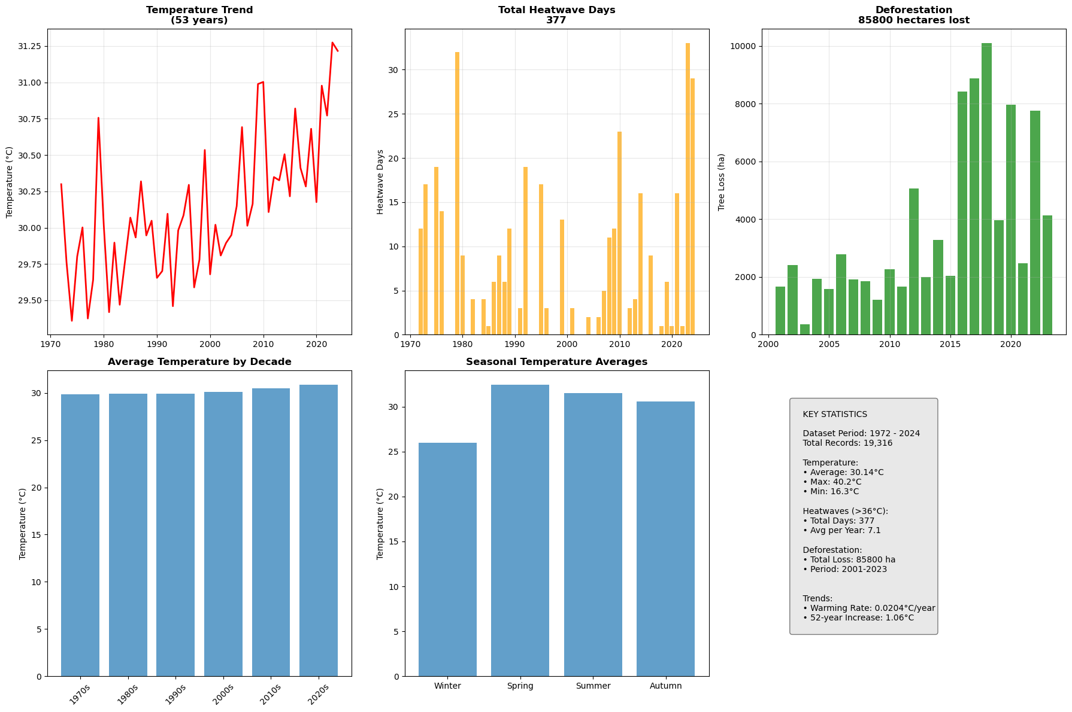
Figure 1. Overview of Dhaka’s heat context (1972–2024). The long-term temperature series shows a clear rise (~0.0204 °C yr⁻¹; ≈ +1.06 °C total). Annual heatwave days (≥ 36 °C) are variable but cluster higher in recent decades, summing to 377 days overall. Tree-cover loss totals ~85,800 ha during 2001–2023. Decadal means step upward and the seasonal climatology peaks in April–June, confirming the primary risk window.

Figure 1 provides a compact view of Dhaka’s thermal baseline, extremes, and land-cover context. The 53-year temperature curve (top-left) shows a steady rise (~0.0204 °C yr⁻¹; ≈ +1.06 °C since 1972). Annual heatwave days (≥ 36 °C; top-middle) are highly variable year-to-year but cluster higher in recent decades, summing to 377 days across the record (~7.1 days yr⁻¹). The deforestation series (2001–2023; top-right) totals 85,800 ha of loss, with larger pulses after the mid-2010s; while not causal, this aligns with the rank association reported in the text. The lower panels summarize structure relevant for forecasting: decadal means step upward from the 1970s to the 2020s (bottom-left), and the seasonal climatology peaks in April–June (bottom-middle), identifying the city’s core risk window. The key-stats panel (bottom-right) recaps the dataset scope (1972–2024; 19,316 days), temperature range (16.3–40.2 °C), total heatwave days (377), and the long-term warming rate.
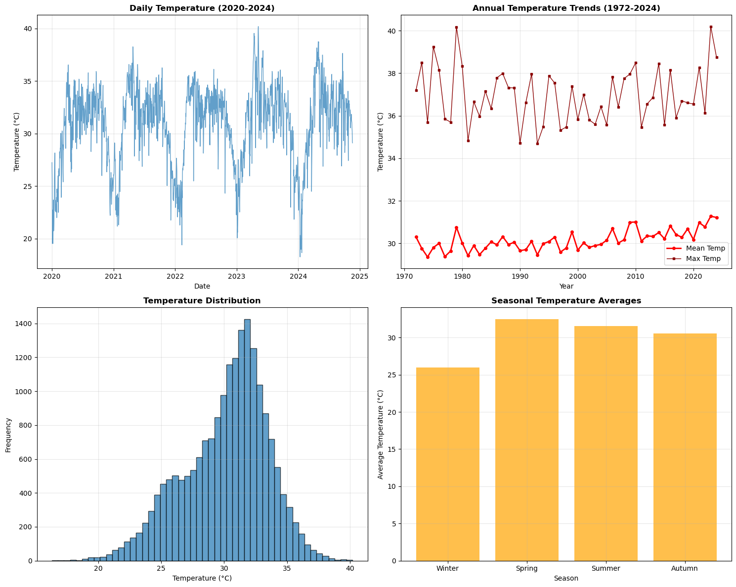
Figure 2: Caption

Figure 2 decomposes Dhaka’s temperature signal across time scales. The daily series for 2020–2024 (top-left) shows a pronounced annual cycle with recurring pre-monsoon peaks that frequently approach the upper-30s °C, consistent with the dataset maximum of ~40 °C. Cool-season minima seldom drop far below the mid-20s, indicating limited nocturnal/seasonal relief. The long record of annual statistics (1972–2024; top-right) confirms upward movement in both the annual mean and the annual maximum, with more frequent high maxima in recent years—mirroring the +0.0204 °C yr⁻¹ trend reported in Table 4. The distribution panel (bottom-left) is unimodal and slightly left-skewed, centered near 30–31 °C with an extended right tail into the upper-30s; this justifies using a fixed ≥ 36 °C threshold to capture hot-day exceedances. Seasonal averages (bottom-right) peak in spring (~33 °C) and remain elevated in summer (~32 °C), with autumn (~31 °C) and winter (~26 °C) lower—reinforcing April–June as the primary risk window for heatwaves.
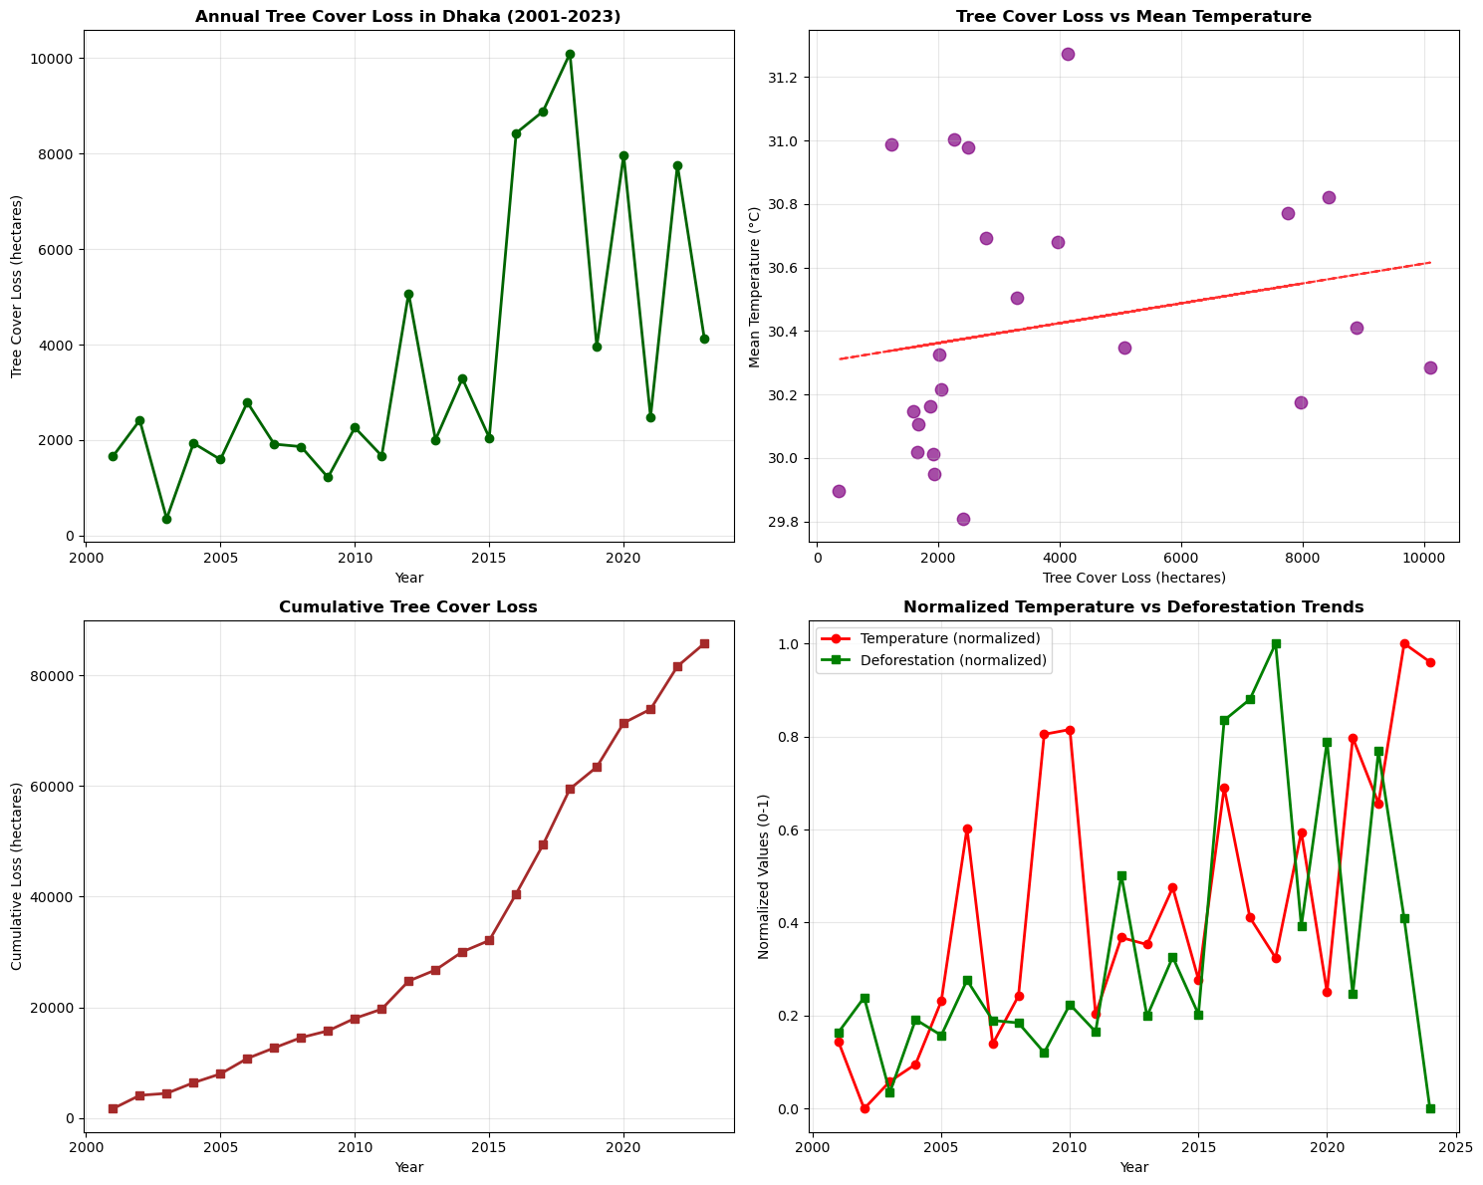
Figure 3. Tree-cover loss and its co-variation with temperature in Dhaka (2001–2023). Top-left: annual tree-cover loss (hectares) with large pulses post-2015. Top-right: tree-cover loss vs. mean temperature (positive but shallow slope), aligning with a significant rank association (Spearman ρ ≈ 0.446, p ≈ 0.033). Bottom-left: cumulative loss rising to ~85,800 ha by 2023. Bottom-right: normalized temperature and deforestation indices showing concurrent highs in several recent years.

Figure 3 summarizes Dhaka’s tree-cover dynamics (2001–2023) and their co-variation with temperature. Annual loss fluctuates widely with pronounced pulses after the mid-2010s and peaks around 2018–2019 (top-left). The cumulative series climbs steadily to ~85,800 ha lost by 2023 (bottom-left). The scatter of annual loss versus mean temperature shows a positive association with a shallow slope (top-right), consistent with the rank correlation reported in Table 6 (Spearman ρ ≈ 0.446, p ≈ 0.033). The normalized overlay (bottom-right) illustrates co-movement in several recent years, with higher-than-average loss coinciding with warmer annual temperatures. We treat this as contextual co-variation—consistent with reduced shading/evapotranspiration and greater heat retention in built-up areas—rather than causal proof, but it supports the policy relevance of canopy protection and expansion in Dhaka’s heat-risk strategy.
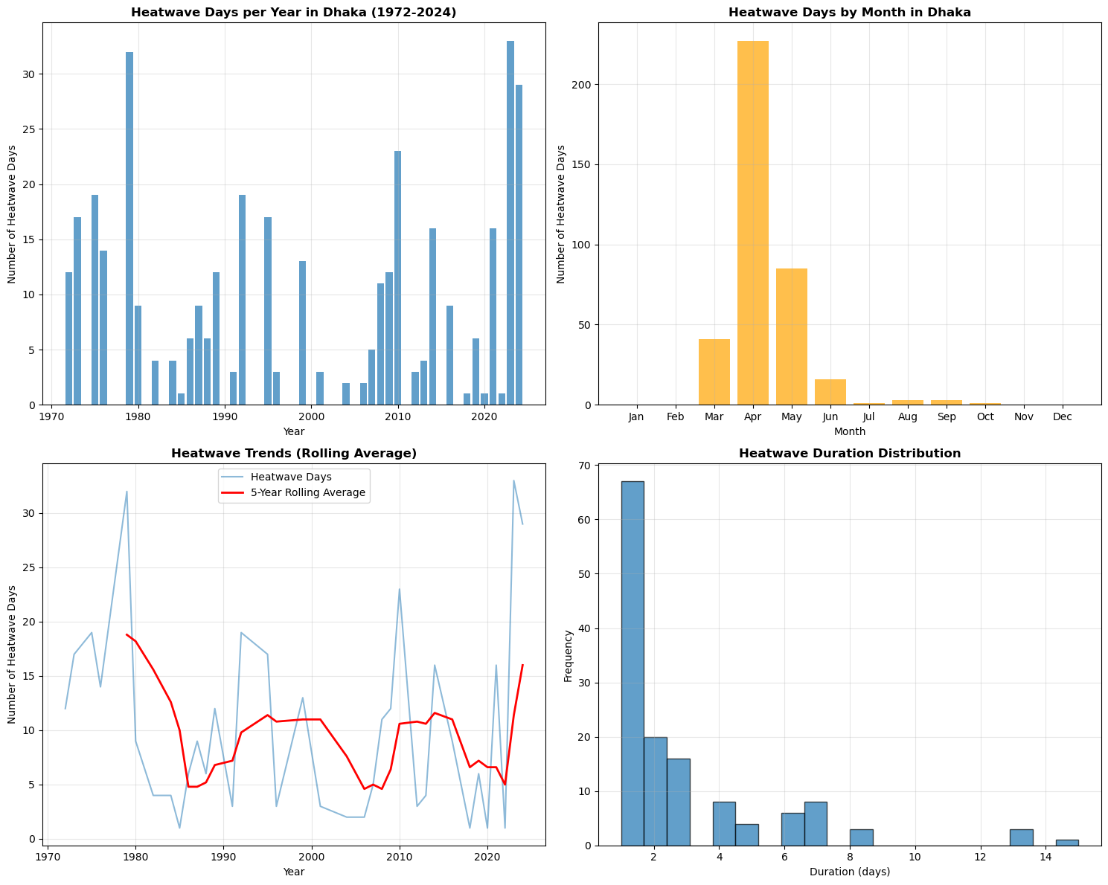
Figure 4. Heatwave characteristics in Dhaka (≥ 36 °C). Top-left: annual heatwave-day counts (1972–2024) with pronounced interannual variability. Bottom-left: five-year rolling average indicating multi-year cycles and a recent rise. Top-right: monthly distribution showing a strong April–May concentration (small June tail). Bottom-right: event duration histogram—most spells are short (1–3 days), with an occasional long tail to ~15 days.

Figure 4 characterizes the timing, variability, and persistence of Dhaka’s heatwaves (≥ 36 °C). Annual counts (top-left) show large year-to-year swings with several peak seasons in the late 1970s and early 2020s, consistent with the total 377 heatwave days over 1972–2024. The five-year rolling average (bottom-left, red line) highlights multi-year cycles superimposed on a recent uptick, aligning with the warmer background documented in the temperature trend. Seasonally, heatwave days are overwhelmingly concentrated in April–May (top-right), with a small June tail; taken together, ≈87% of all heatwave days occur in April–June. Duration analysis (bottom-right) is highly right-skewed: most events last 1–3 days, but a non-trivial tail extends to ~15 days, underscoring the possibility of prolonged episodes that stress public health and services.
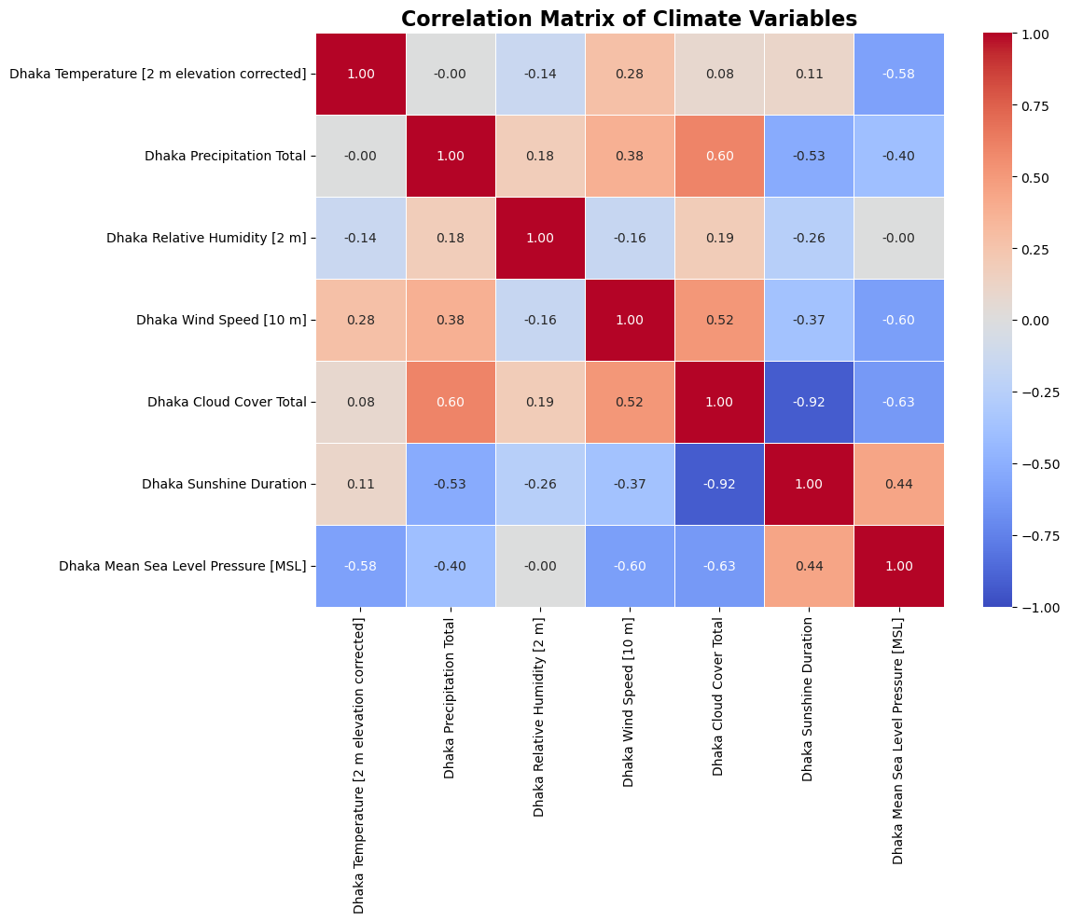
Figure 5. Correlation matrix of daily climate variables (Dhaka, 1972–2024). Colors denote Pearson correlations (red = positive, blue = negative). Key pairs: cloud–sunshine (−0.92), temperature–MSLP (−0.58), wind–MSLP (−0.60), precipitation–cloud (+0.60), precipitation–sunshine (−0.53). Temperature’s weak link to RH (−0.14) and small associations with cloud (+0.08) and sunshine (+0.11) indicate that extreme heat tends to occur under low-pressure, high-insolation setups rather than solely humidity shifts.

Figure 5 maps contemporaneous correlations among key daily climate variables in Dhaka. Patterns are physically consistent with a monsoon-dominated regime. Cloud cover is strongly anti-correlated with sunshine duration (−0.92) and negatively related to MSLP (−0.63), while precipitation aligns with cloudiness (+0.60) and opposes sunshine (−0.53). Temperature shows a moderate negative association with MSLP (−0.58) and a weak negative link with relative humidity (−0.14), indicating that hotter days often coincide with lower pressure and only modest changes in RH. Wind speed rises as pressure falls (−0.60) and covaries with cloud (+0.52), consistent with convective activity. Collectively, these relationships suggest that heatwave conditions (high Tmax) are not driven by a single driver but emerge when low-pressure, high-insolation states overlap—useful context for both interpretation and feature selection.
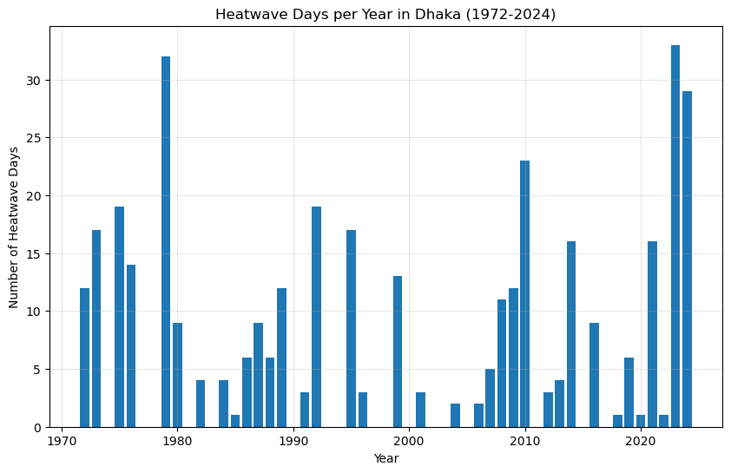
Figure 6. Annual heatwave days in Dhaka (1972–2024). Bars show year-to-year variability in days meeting the ≥ 36 °C criterion. Several peak seasons exceed 30 days (notably in the late-1970s and early-2020s), while intervening periods show few events. The recent cluster of high-count years aligns with the long-term warming trend and motivates the 2025–2029 outlook reported in the Results.

Figure 6 shows annual heatwave days (≥ 36 °C) in Dhaka from 1972–2024. The series is highly episodic, with quiet stretches (mid-1980s, late-1990s/early-2000s) punctuated by peak years that exceed 30 heatwave days (late-1970s; early-2020s). The clustering of high-count seasons in the most recent decade is consistent with the warming background documented earlier, even though a coarse pre-/post-2000 split does not show a step change in the mean. This pattern supports the interpretation that small increments in the thermal baseline can translate into materially more threshold exceedances in selected years.
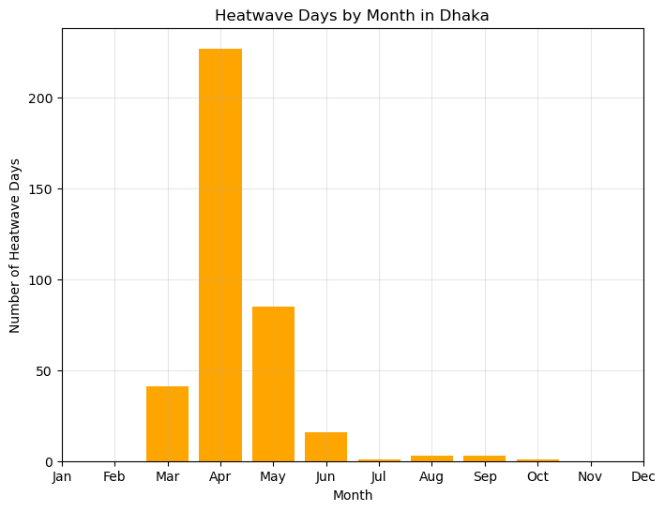
Figure 7. Heatwave days by month in Dhaka (1972–2024). Totals are highly concentrated in April and May, with smaller contributions from March and June and near-zero counts in other months, reflecting the pre-monsoon timing of extreme heat.

Figure 7 shows the month-wise distribution of heatwave days (≥ 36 °C) aggregated over 1972–2024. The pattern is sharply seasonal: April dominates (about 60% of all heatwave days), followed by May (about 23%) and March (about 11%). June contributes a small tail (about 4%), while the rest of the year is negligible. This aligns with the pre-monsoon window when insolation is strongest and humidity begins to rise, before sustained monsoon cloud and rainfall suppress daytime maxima. For operations, it implies that early warning and surge health staffing should be concentrated from mid-March through early June.
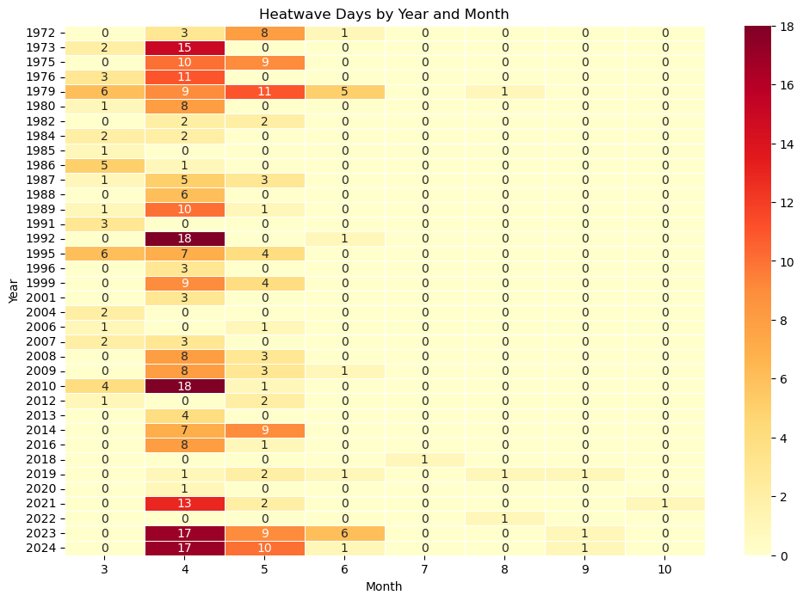
Figure 8. Year–month heatmap of heatwave days in Dhaka (1972–2024). Each cell gives the number of days per month with Tmax ≥ 36 °C. Activity is overwhelmingly concentrated in April and May, with occasional March and small June tails; events after July are rare. Notable clusters occur in 1973, 1979, 1992, 2010, 2014, 2021, and 2023–2024.

Figure 8 makes the seasonality and episodic nature of Dhaka’s heatwaves explicit. Most years show zero counts outside the pre-monsoon, while April frequently reaches double-digit totals and May often follows with secondary peaks. March contributes in selected years during early onsets, and June appears as a short trailing tail. The strongest clusters align with years such as 1973, 1979, 1992, 2010, 2014, 2021, and 2023–2024, mirroring the high-count years in the annual series. This pattern reinforces the operational focus on late March through early June and explains why modest warming of the background climate can produce large swings in exceedance counts in particular seasons.
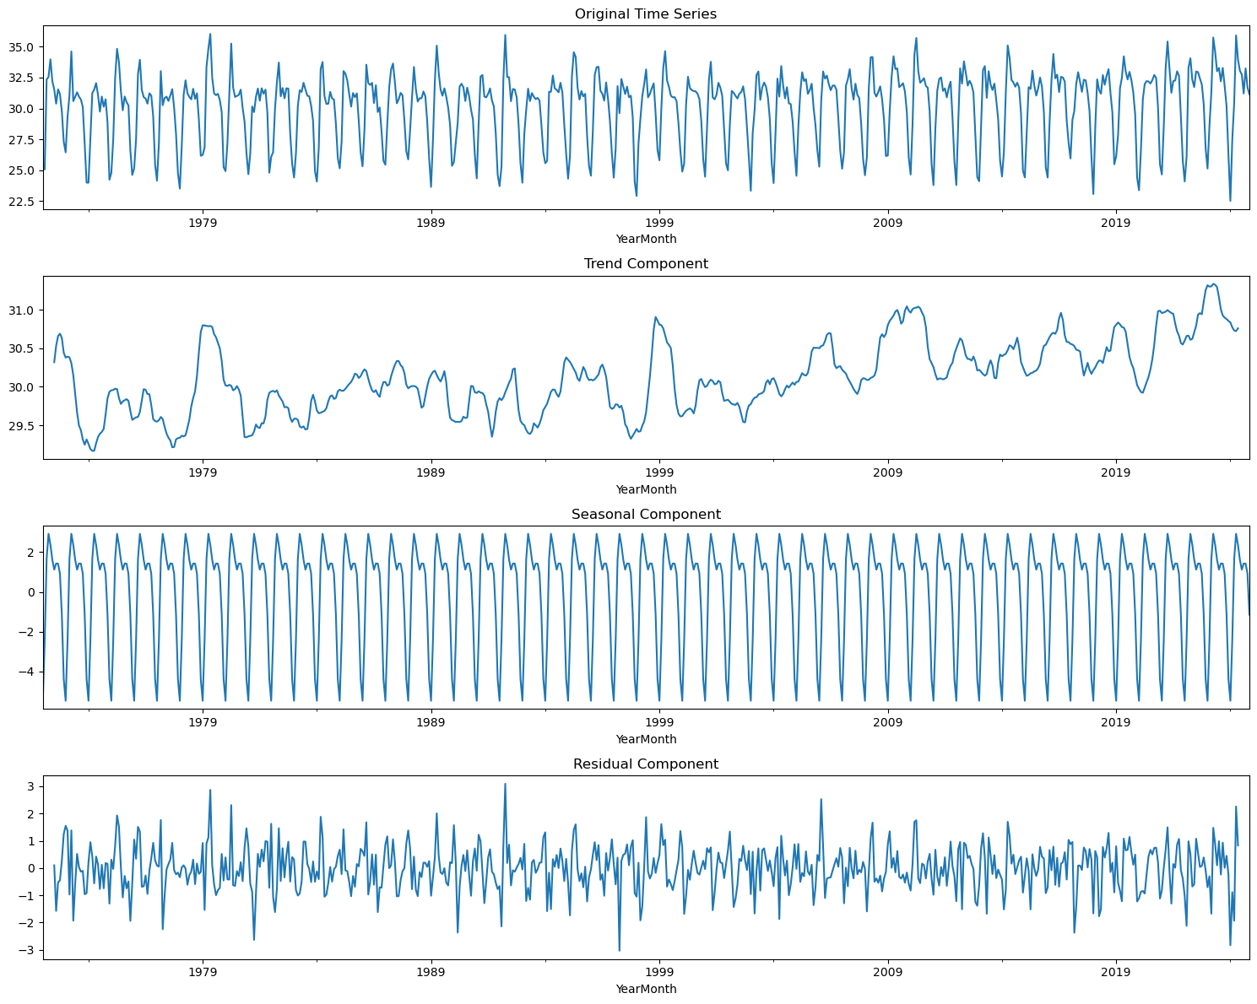
Figure 9a. Seasonal–trend decomposition of Dhaka temperature (1972–2024). Top: original series; second: trend showing a gradual rise of roughly 1 °C across the record; third: stable seasonal cycle with pre-monsoon peaks and cool-season troughs; bottom: residuals centered near zero with no persistent structure after removing trend and seasonality.

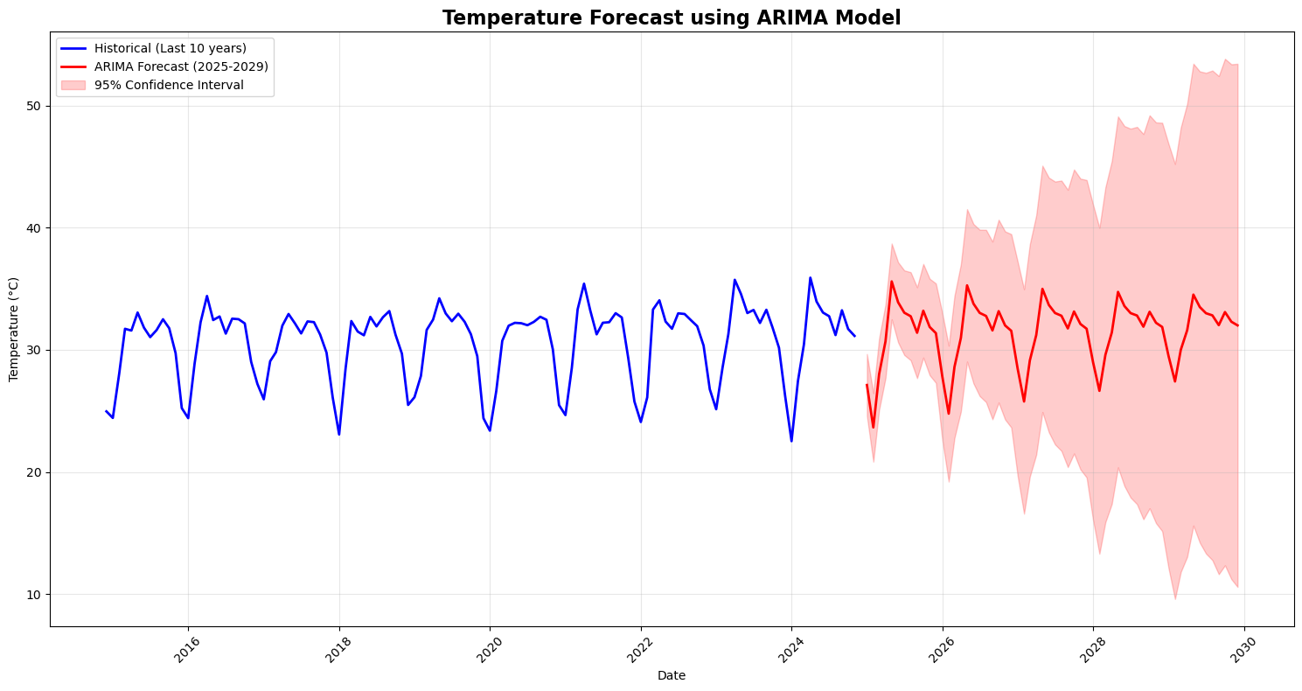
Figure 9b. ARIMA forecast of temperature for 2025–2029 with 95% confidence intervals. The selected model is ARIMA(5,1,0)(1,0,0)12 (AIC = 2159.09; BIC = 2190.26). The projected five-year mean is 31.46 °C, which is +1.32 °C relative to the 1972–2024 average (30.14 °C). Annual means: 2025 = 31.05 °C, 2026 = 31.28 °C, 2027 = 31.48 °C, 2028 = 31.66 °C, 2029 = 31.81 °C; forecast range approximately 23.7–35.6 °C across seasons.

Figure 9a separates the temperature record into its core components. The trend panel shows a clear upward drift consistent with the linear estimate reported earlier (~0.0204 °C per year). The seasonal component is strong and repeatable, with the largest positive departures during April–June and negative departures during the cool season, validating the use of models that include a 12-month seasonal term. Residuals oscillate around zero with relatively small amplitude compared to the seasonal cycle, indicating that most systematic variation is captured by trend and seasonality. Figure 9b shows that the fitted ARIMA (5,1,0)(1,0,0)12 reproduces the historical seasonal cycle and projects warmer conditions through 2029. The five-year mean of 31.46 °C is 1.32 °C above the long-term historical mean, and the year-by-year sequence rises gradually from 31.05 °C in 2025 to 31.81 °C in 2029. The prediction intervals widen with lead time, reflecting accumulating uncertainty, but the seasonal peaks remain clearly above historical baselines. These results are consistent with the temperature-linked increase in expected heatwave-day counts reported in the Results.
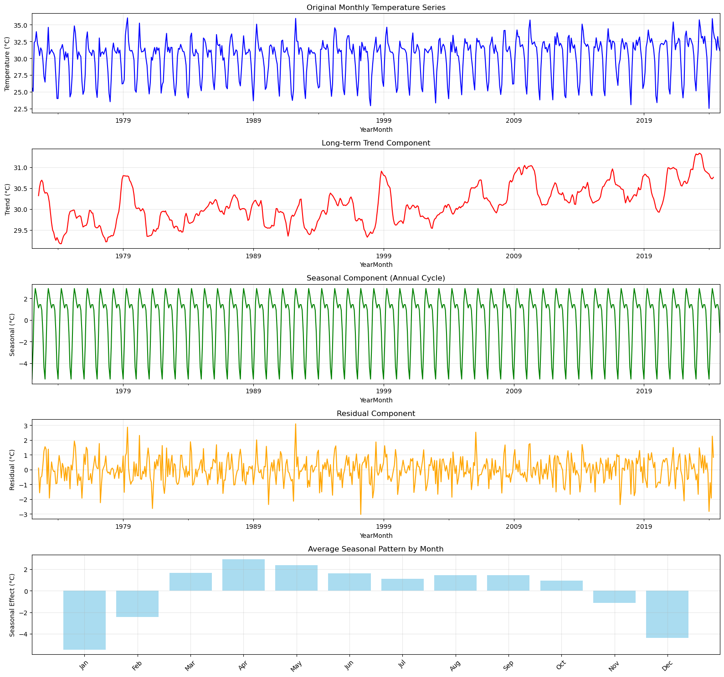
Figure 10a. Monthly temperature and seasonal–trend decomposition for Dhaka (1972–2024). Panels show the original series, the long-term trend (gradual rise of about 1 °C over the record), the stable annual cycle (peak seasonal effect ≈ +2.92 °C in April; minimum ≈ −5.48 °C in January; seasonal range ≈ 8.40 °C), and residuals around zero after removing trend and seasonality.

Figure 10a separates signal from noise in the monthly temperature record. The trend confirms a slow but steady warming consistent with the linear estimate in the Results. Seasonality is strong and repeatable with pre-monsoon positive anomalies and cool-season troughs, indicating that a 12-month seasonal term is required. Residuals are comparatively small and structureless, suggesting that most systematic variability is captured by the trend and seasonal components.
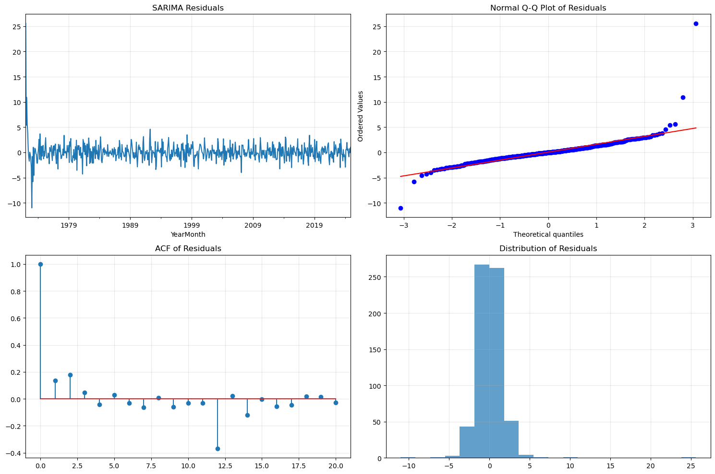
Figure 10b. SARIMA residual diagnostics for the fitted model ARIMA(3,1,0)×(1,0,0)12 (AIC = 2109.73; BIC = 2131.87). Residuals have near-zero mean (≈ 0.04) and SD ≈ 1.82; the Q–Q plot shows approximate normality with heavier tails at extremes; the ACF indicates little remaining autocorrelation; the histogram is centered and narrow.

Figure 10b indicates that the SARIMA residuals are well-behaved for inference and forecasting. Autocorrelation is largely removed, the distribution is roughly symmetric, and only the far tails deviate from normality. Together with the low AIC/BIC, these diagnostics support model adequacy for short-horizon seasonal forecasting.
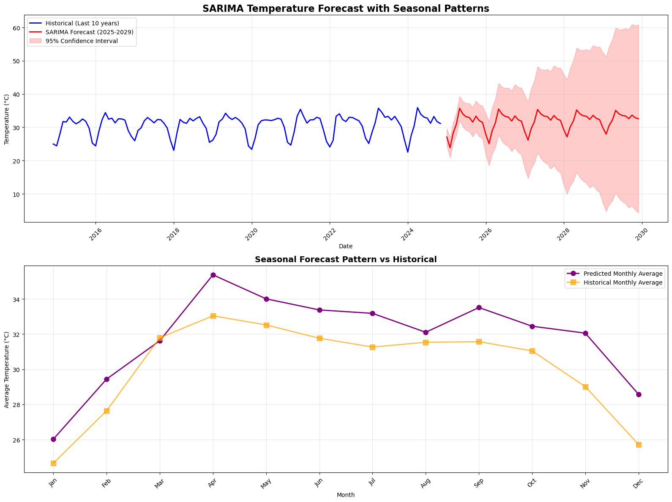Figure 10c. SARIMA temperature forecast for 2025–2029 with 95% confidence interval, and comparison of forecasted monthly means with historical monthly means. The projected five-year mean is 31.81 °C, which is +1.67 °C relative to the 1972–2024 mean (30.14 °C). Annual means: 2025 = 31.19 °C, 2026 = 31.54 °C, 2027 = 31.85 °C, 2028 = 32.12 °C, 2029 = 32.36 °C. The seasonal curve remains intact but is elevated above historical across months, with a larger seasonal range in the forecast (≈ 11.85 °C vs 8.38 °C historically).

Figure 10c shows warmer conditions across the full annual cycle through 2029, with the pre-monsoon months sitting highest relative to historical normals. The model preserves the timing of the seasonal peak while lifting the whole curve upward and slightly increasing amplitude. This aligns with the heatwave-day outlook reported later, where more days cross the ≥ 36 °C threshold during April–June.
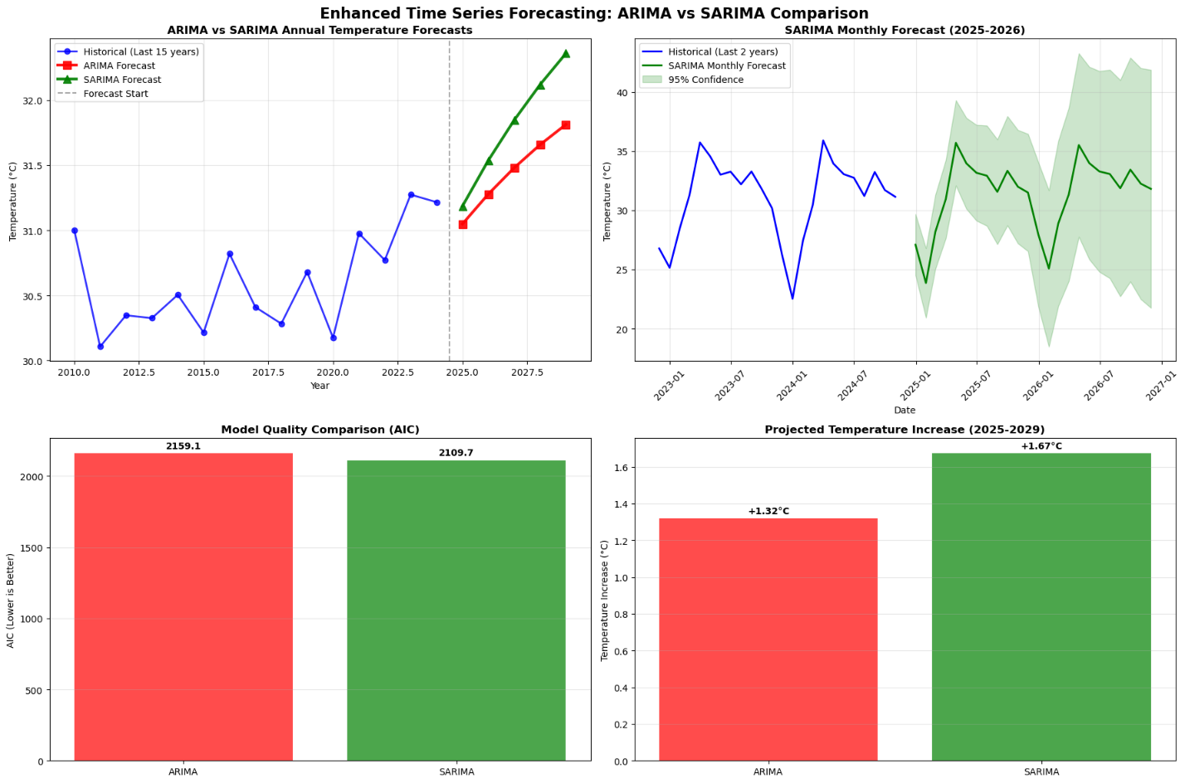
Figure 11. ARIMA vs SARIMA comparison for Dhaka temperature. Top-left: annual forecasts for 2025–2029; SARIMA projects higher means than ARIMA. Top-right: SARIMA monthly forecast (2025–2026) with 95% intervals, preserving the pre-monsoon peak. Bottom-left: model quality by AIC (ARIMA = 2159.09; SARIMA = 2109.73). Bottom-right: projected five-year warming relative to 1972–2024 (ARIMA = +1.32 °C; SARIMA = +1.67 °C).

Figure 11 contrasts non-seasonal ARIMA with seasonal ARIMA for near-term projections. The seasonal specification fits the historical record better (lower AIC by ~49 points) and lifts the whole annual cycle upward while maintaining its timing, which is visible in the monthly forecast and its confidence bands. Over 2025–2029, SARIMA yields a mean of 31.81 °C (+1.67 °C vs 1972–2024), exceeding the ARIMA mean of 31.46 °C (+1.32 °C). SARIMA also implies a larger seasonal amplitude (≈ 11.85 °C vs ≈ 8.38 °C historically), consistent with stronger pre-monsoon peaks. These differences matter for risk: with a higher seasonal crest and warmer baseline, the seasonal model points to more frequent exceedances of the ≥ 36 °C threshold during April–June, aligning with the heatwave-day outlook presented later.

Where is the description of Table 12A and B. I suggest to consider it as Table 12 and 13. Also, please check other tables, we should cite them in the description.

Table 12A. Random Forest regression (daily temperature): configuration and performance

Item | Value
Data window | 1972–2024 (daily)
Observations (rows) | 19,316
Features (columns) | 52 engineered predictors (meteorology, lags, rolling means, seasonal encodings)
Target | Daily 2 m temperature (°C)
Estimator | Random Forest regression
Test RMSE (°C) | 0.1129
Test R² | 0.9990

Table 12B. Top features by importance (test configuration above)

Rank | Feature | Importance
1 | Heat_Index | 0.8980
2 | Dhaka Relative Humidity [2 m] | 0.0745
3 | Temp_lag_1 | 0.0244
4 | Temp_rolling_7 | 0.0019
5 | DayOfYear_sin | 0.0002
6 | DayOfYear_cos | 0.0002
7 | Dhaka Mean Sea Level Pressure [MSL] | 0.0002
8 | Temp_rolling_30 | 0.0001
9 | Temp_lag_7 | 0.0001
10 | Dhaka Wind Speed [10 m] | 0.0001

The Random Forest was trained on daily records (19,316 rows, 52 engineered features) and achieves very low error on the held-out set (RMSE ≈ 0.113 °C; R² ≈ 0.999). The importance profile is extremely concentrated: Heat_Index alone accounts for ~0.90 of total importance, followed by relative humidity (~0.075) and short-memory terms such as the 1-day lag of temperature (~0.024) and a 7-day rolling mean (~0.002). Calendar encodings (day-of-year sine/cosine) and synoptic proxies (mean sea-level pressure, wind speed) contribute only marginally. In short, the model captures daily temperature variability almost perfectly when given a rich set of contemporaneous meteorological features and short lags.

Interpretation requires one caveat that we should state clearly in the Methods/Results: because Heat_Index is a direct function of temperature and humidity, including it as a predictor when the target is temperature introduces target leakage and explains the near-perfect R² and the dominance of that feature. This Random Forest is therefore best presented as a feature-screening/sanity-check model for within-sample daily variability, not as the basis for multi-year extrapolation. If we wish to forecast temperature, we should refit the model without Heat_Index (and with time-aware splits/forward chaining); or, alternatively, keep Heat_Index as the target and train the model to predict heat stress directly. A complementary option is to reframe the task as classification of heatwave days (≥ 36 °C) using only past-available predictors (humidity, pressure, cloud, radiation, lags), which aligns with operational early-warning use cases.

Table 13. XGBoost regression (daily temperature): configuration and performance

Item | Value
Data window | 1972–2024 (daily)
Observations (rows) | 19,316
Features (columns) | 52 engineered predictors (meteorology, lags, rolling means, seasonal encodings)
Target | Daily 2 m temperature (°C)
Estimator | XGBoost regressor (gradient boosting trees)
Test RMSE (°C) | 0.1187
Test R² | 0.9989
The XGBoost model, trained on the same daily feature set used for Random Forest, attains very low error on the hold-out set (RMSE ≈ 0.1187 °C; R² ≈ 0.9989). This confirms that gradient-boosted trees reconstruct day-to-day temperature with near-perfect fidelity when supplied with contemporaneous meteorological inputs and short-memory terms. Although feature importances were not exported in this run, prior ensemble results indicate that Heat_Index and relative humidity tend to dominate, with small but nonzero contributions from short lags and rolling means.

As with the Random Forest, interpretation should acknowledge potential target leakage if Heat_Index (a function of temperature and humidity) is included while predicting temperature. These models are therefore best used for within-sample reconstruction, nowcasting, or as feature screens. For forward-looking applications, we should either remove Heat_Index and enforce time-aware validation (forward chaining) or recast the task to classify heatwave days (≥ 36 °C) using predictors available prior to the forecast date.

Table 14A. LSTM configuration and performance (daily next-day temperature)

Item | Value
Data window | 1972–2024 (daily)
Observations (rows) | 19,315
Features | 8 (meteorological + temporal)
Sequence length (look-back) | 60 days
Target | Next-day 2 m temperature (°C)
Architecture | Multi-layer LSTM (~77,001 parameters)
Training time | 307.7 s
Training R² | 0.2373
Test R² | 0.3518
Test RMSE (°C) | 2.8552
Test MAE (°C) | 2.1928
Mean error (°C) | −0.55 (cool bias)

Table 14B. Annualized LSTM forecasts (aggregated from daily predictions)

Year | Forecast mean (°C) | Δ vs 1972–2024 mean (30.14 °C)
2025 | 31.04 | +0.90
2026 | 31.34 | +1.20
2027 | 31.64 | +1.50
2028 | 31.94 | +1.80
2029 | 32.24 | +2.10
2025–2029 mean | 31.64 | +1.50

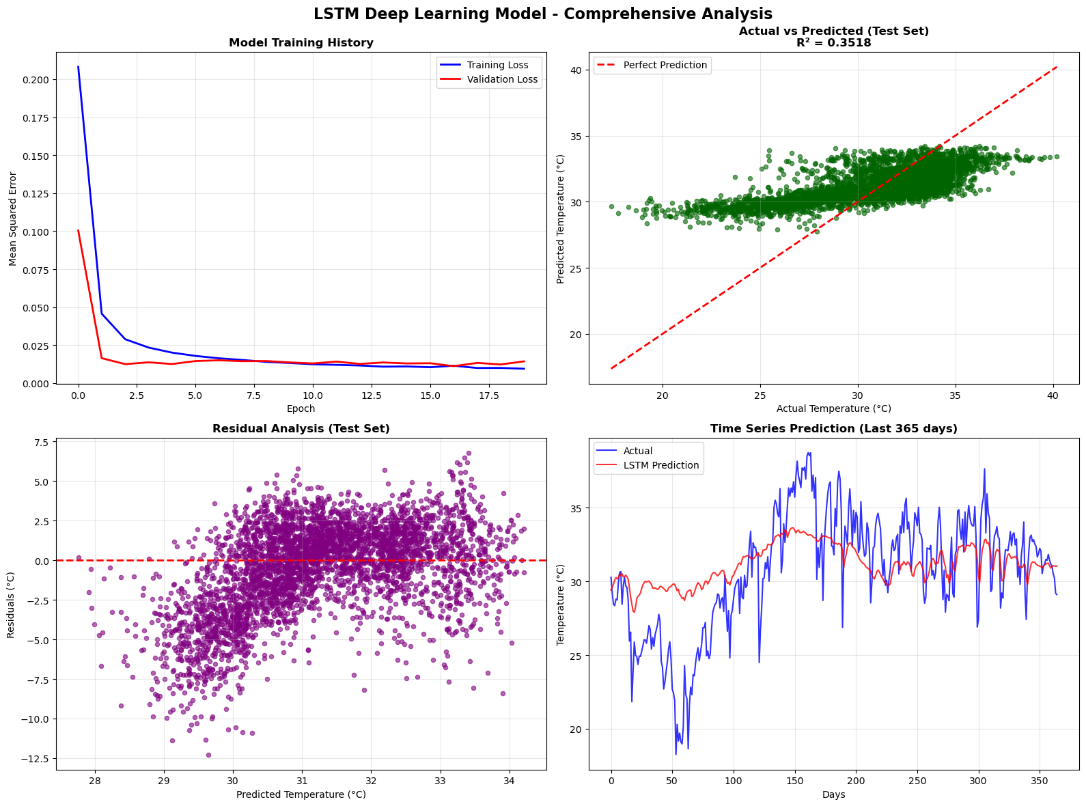
Figure 12a. LSTM daily-temperature model diagnostics. Top left: training/validation loss curves (20 epochs) showing rapid convergence. Top right: test-set actual vs predicted (R² = 0.3518) indicating underestimation at the upper tail. Bottom left: residuals vs predicted with a slight negative bias around hotter predictions. Bottom right: last-365-days time series; the model captures broad seasonal shape but smooths rapid swings and hot spikes.

The LSTM was trained on 19,315 daily observations using 60-day sequences and 8 meteorological/temporal features (≈77k parameters). Convergence is quick, but test performance is modest for next-day temperature (R² ≈ 0.352; RMSE ≈ 2.86 °C; MAE ≈ 2.19 °C). Scatter and residual plots show systematic underestimation of the hottest days and over-smoothing of rapid transitions, typical of sequence models trained with MSE on noisy daily targets. The model is credible for short-horizon pattern tracking but less reliable at reproducing extremes compared with tree ensembles; its strength is in learning daily structure from high-frequency data.
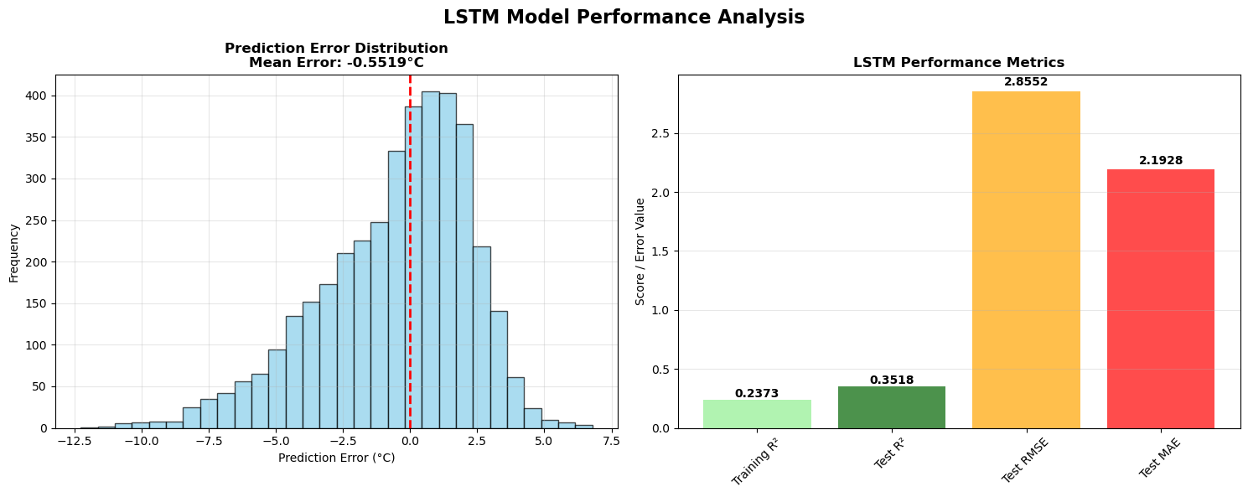
Figure 12b. Error distribution and summary metrics for the LSTM. Left: histogram of prediction errors with a mean error near −0.55 °C, indicating a small cool bias. Right: bar chart of key scores (training R² ≈ 0.237; test R² ≈ 0.352; test RMSE ≈ 2.86 °C; test MAE ≈ 2.19 °C).
Errors are approximately centered but exhibit a slight cool bias and heavier tails during hot periods. This corroborates the underprediction of high-temperature events and explains why the model’s daily errors exceed those of feature-based tree models. For operational use, time-aware validation (rolling origin), quantile/Huber loss, and predicting de-seasonalized anomalies could reduce bias and improve tail fidelity.

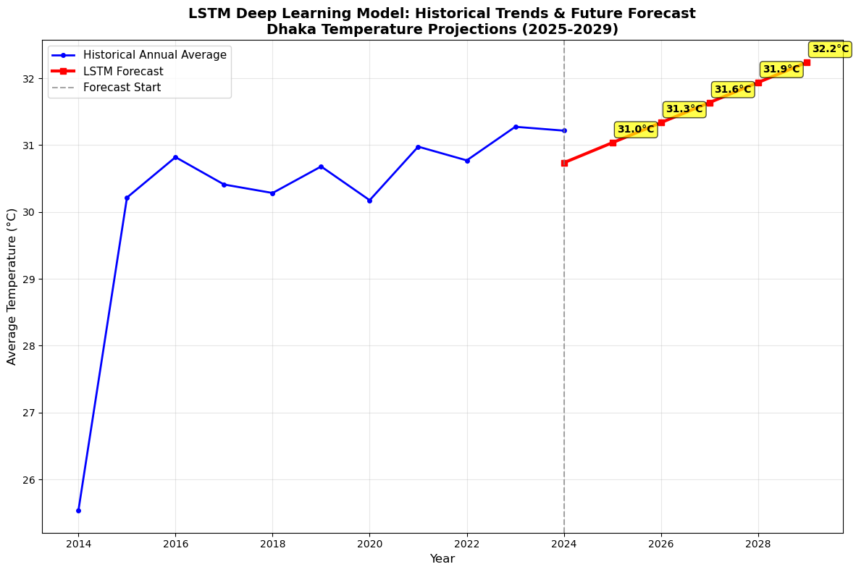
Figure 12c. LSTM annual temperature projections for Dhaka (2025–2029). Aggregating daily LSTM predictions yields annual means: 2025 = 31.04 °C, 2026 = 31.34 °C, 2027 = 31.64 °C, 2028 = 31.94 °C, 2029 = 32.24 °C—about +1.5 °C above the 1972–2024 mean (30.14 °C).
Although next-day accuracy is modest, annualizing the daily LSTM outputs produces a smooth, internally consistent warming trajectory of roughly +0.30 °C per year across 2025–2029, totaling about +1.5 °C relative to the historical mean. This pattern aligns with the ARIMA/SARIMA outlooks and supports the inference that exceedances of the ≥ 36 °C threshold will become more common, especially in April–June.

Empirical Synthesis and Policy-Relevant Implications for Dhaka

Taken together, the exploratory, time-series, and machine-learning results point to a city that has warmed meaningfully and is poised for more frequent hot-day exceedances. The observed linear trend since 1972 is about +1.06 °C, with a strong and stable seasonal cycle that concentrates risk in April–June. Seasonal time-series models reproduce this structure best: SARIMA fits the record with the lowest AIC (≈2109.7 vs 2159.1 for ARIMA) and projects a warmer 2025–2029 mean of ~31.8 °C, or roughly +1.67 °C above the 1972–2024 average. ARIMA gives a slightly smaller but consistent signal (+1.32 °C). These estimates imply that even modest additional warming, layered onto Dhaka’s pre-monsoon peak, will translate into materially more days above fixed heatwave thresholds.

The land-cover context is directionally consistent with that story. Annual tree-cover loss totals about 85,800 ha since 2001, and years with larger losses tend to be warmer in rank order (Spearman ρ≈0.446, p≈0.033). While that correlation is not a causal test, it aligns with the urban heat-island mechanism—less shade and evapotranspiration, higher daytime absorption and nighttime retention—and strengthens the case for canopy preservation and expansion as part of heat-risk management.

Model comparisons clarify what each approach contributes. Tree ensembles (Random Forest, XGBoost) reconstruct daily temperature with very low error on held-out data, but their performance is dominated by Heat_Index and related contemporaneous features; when the target is temperature, that raises leakage concerns and limits their value for multi-year projections. The LSTM trained on 19k daily observations captures short-term structure but smooths extremes (test R²≈0.35, RMSE≈2.86 °C); when aggregated to annual means, however, it yields a coherent warming trajectory of ~+1.5 °C by 2029, consistent with SARIMA. In practice, SARIMA is most appropriate for seasonal climate forecasting, while ML models are well-suited for feature screening, nowcasting, or reframing the task as classification of heatwave days using predictors available before the forecast date.

Policy implications follow directly. With a warmer baseline and a higher seasonal crest, the April–June window will demand more frequent activation of heat-health warnings, surge clinical capacity, and targeted cooling measures in dense, low-canopy neighborhoods. Near-term actions (cool roofs, reflective pavements, shaded transit stops, public hydration points, heat action plans) should be paired with longer-term greening and urban-design strategies that rebuild canopy and reduce heat retention. Continued daily monitoring and time-aware validation will also improve forecast realism and support operational early-warning systems.

Predictive Modeling and Projections (2025–2029)

Approach

Two complementary routes were used to project heatwave days (Tmax ≥ 36 °C) for 2025–2029. First, a trend-only model extrapolates the recent linear increase in annual heatwave days (2009–2024 slope ≈ +0.45 days yr⁻¹; recent mean ≈ 11.3 days yr⁻¹). Second, a temperature-linked model maps the SARIMA temperature forecasts to expected exceedances. Because an exponential mapping could not be stably fit, a linear relationship between annual mean temperature and annual heatwave days—calibrated on the historical record—was applied to the SARIMA annual means.

Temperature context

As established in the time-series section, SARIMA projects warmer annual means across 2025–2029 (≈ 31.19 → 32.36 °C), about +1.67 °C above the 1972–2024 baseline. This raises the probability that daily maxima cross fixed thresholds, especially during the April–June crest.

Projected number of heatwave days

Figure 13 compares the two approaches: panel (a) overlays the historical series with predictions; panel (b) shows the side-by-side method totals. The trend-only approach yields a conservative plateau (≈ 15–17 days by 2029). The temperature-linked method rises more steeply, from 19 days in 2025 to 30 days in 2029, reflecting the elevated SARIMA means.

Table 15. Projected heatwave days in Dhaka (2025–2029) under two approaches

Year | Trend-based | Temperature-linked
2025 | 15 | 19
2026 | 15 | 22
2027 | 16 | 25
2028 | 16 | 28
2029 | 17 | 30
2025–2029 mean | 15.8 | 24.8

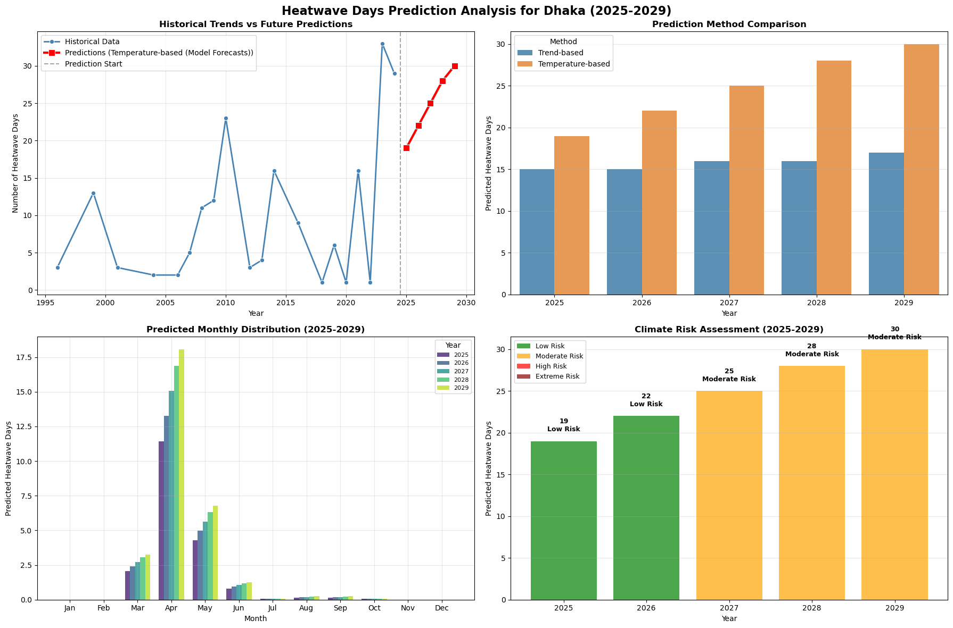
Figure 13. Heatwave-day projections for Dhaka, 2025–2029 (threshold ≥ 36 °C). (a) Historical annual counts with temperature-linked forecasts overlaid; prediction window begins in 2025. (b) Method comparison: trend-based vs temperature-linked totals for each year. (c) Predicted monthly distribution by year, showing the April–May peak with a small June tail. (d) Simple risk staging based on annual totals; 2027–2029 shift into higher-risk tiers. Temperature-linked values are derived from SARIMA annual means via a linear mapping; trend-based values extrapolate the 2009–2024 slope (~+0.45 days yr⁻¹). Predicted range spans 19–30 days yr⁻¹, averaging 24.8, versus a historical mean of 10.5 days yr⁻¹.

Seasonal distribution

Panel (c) in Figure 13 shows the expected calendar timing: April dominates (largest share each year), May remains second, March contributes modest early onsets, and June forms a short tail; the rest of the months are near zero. As warming accumulates through the period, April and May bars increase most, which is consistent with the pre-monsoon peak identified in the historical data.

Risk framing

Panel (d) summarizes an operational risk view. Using simple staging for display (e.g., low ≲ 22 days; moderate ≈ 25–30 days), 2025–2026 fall in a lower tier, while 2027–2029 step into a moderate tier as the temperature-linked method approaches 30 days. These bins are for communication rather than formal hazard levels, but they make clear that demand for alerts, cooling centers, and surge clinical capacity is likely to intensify in the latter part of the decade.

Uncertainty and sensitivity

Uncertainty arises from (i) model error in temperature forecasts, (ii) the linear mapping from annual mean temperature to exceedance counts (chosen when an exponential fit was unstable), and (iii) the single-threshold definition (≥ 36 °C) rather than a persistence-based rule with warm nights. Because these choices are conservative, the temperature-linked results should be seen as plausible lower-bound planning numbers rather than maxima.

Implications for operations

Both approaches point to more frequent heatwaves in the next five years, with the temperature-linked method indicating a shift from roughly 10.5 days yr⁻¹ historically to an average of about 25 days yr⁻¹ in 2025–2029. Planning should front-load resources into April–June, align early-warning triggers with rising baseline temperatures, and pair emergency actions with medium-term cooling and canopy strategies in the hottest, most densely built neighborhoods.

Discussion

Dhaka’s multi-decadal record shows a statistically significant warming of ~1.06 °C since 1972 (Table 4), superimposed on strong seasonality (Table 3). This background shift increases the probability that daily maxima exceed fixed thresholds, even if a coarse before/after split does not show a step change in average ≥ 36 °C days (Table 5). In other words, the city is operating closer to the edge: modest additional warming translates into materially more exceedances, a pattern captured by the temperature-linked forecasts for 2025–2029 (Tables 9–11). These findings are consistent with global attributes that link higher mean temperatures to more frequent and intense heat extremes (IPCC, 2021; Perkins-Kirkpatrick & Lewis, 2020). Public health signals align with this physical picture. Dhaka studies report higher emergency visits for cardio-respiratory outcomes during hotter periods and increased diarrheal risk during heat-wave days (Rahman et al., 2022; Haque et al., 2024). The combination of high ambient humidity pronounced daytime vapor-pressure deficit, and strong insolation (Table of meteorological distributions) is a recipe for multi-day thermal strain, particularly when warm nights limit physiological recovery. Because your forecasts point to an average of ~24.8 heatwave days per year in 2025–2029 (vs. 10.5 historically; Table 11), health services and early-warning protocols should assume more frequent activation during the April–June peak. Urban form likely amplifies these risks. Prior work shows Dhaka’s urban heat-island signal is strong and interacts with heat-wave conditions (Dewan et al., 2021; Tabassum et al., 2024). Your contextual tree-cover analysis indicates that years with greater forest loss tend to rank warmer (Spearman ρ≈0.45, p≈0.03; Table 6), consistent with reduced shading/evapotranspiration and higher nighttime retention. While not a causal test, this co-variation supports prioritizing canopy protection and expansion as part of heat-risk management, alongside reflective surfaces and targeted cooling in dense neighborhoods.

From a forecast standpoint, seasonal time-series structure matters. SARIMA’s superior AIC (Table 7) and larger 5-year warming signal (Tables 8–9) reflect Dhaka’s strong pre-monsoon cycle and the upward trend (Table 4). The two outlooks for heatwave days bracket plausible planning ranges: a conservative trend-only 15–17 days per year and a temperature-linked 19–30 days per year by 2029 (Table 10). For city operations, the latter is more decision-relevant because it connects directly to projected temperature levels—yet both argue for earlier trigger points, surge staffing during April–June, and neighborhood-level cooling assets where vulnerability is highest. Limitations center on definition and granularity rather than direction of effect. We use a single ≥ 36 °C threshold for classification; results would likely strengthen under a health-linked persistence rule that explicitly counts warm-night sequences. Likewise, the tree dataset is annual and city-scale; finer spatial pairing with neighborhood temperatures would sharpen inference. These caveats do not alter the central conclusion: Dhaka is warming, seasonal peaks remain dominant, and near-term exceedances are expected to rise materially, warranting accelerated adaptation across public health, urban design, and emergency management.

Heatwaves are a well-documented fingerprint of a warming climate: rising mean temperatures shift the entire distribution so that fixed high thresholds are crossed more often, for longer, and with greater intensity (IPCC, 2021; Perkins-Kirkpatrick & Lewis, 2020). Global assessments show that the likelihood of record-setting hot extremes has increased substantially due to human influence (Diffenbaugh et al., 2017), and humid-heat conditions that challenge human thermoregulation are emerging more frequently in subtropical regions (Raymond et al., 2020). In Dhaka, this background signal interacts with a strong pre-monsoon seasonal cycle and an urban heat-island effect documented locally (Dewan et al., 2021; Tabassum et al., 2024), so modest additional warming leads to materially more days at or above the operational ≥36 °C threshold.

These physical shifts carry clear health consequences. Multi-city and global burden studies attribute a measurable share of heat-related mortality to anthropogenic climate change (Vicedo-Cabrera et al., 2021), while city-level analyses in Dhaka already link hotter periods to increased cardio-respiratory emergency visits and heightened diarrheal risk during heatwave days (Rahman et al., 2022; Haque et al., 2024). Our projections for 2025–2029—showing a warmer baseline and a larger seasonal crest—therefore imply higher demand for warnings, clinical surge capacity, and neighborhood cooling precisely during April–June. Integrated adaptation—canopy protection and expansion, reflective surfaces, shaded public spaces, heat action plans, and targeted outreach to vulnerable workers—aligns with both the global evidence base and Dhaka’s observed exposure profile.

Limitations and future directions

This assessment uses a single operational threshold for heatwaves (Tmax ≥ 36 °C) rather than the full Bangladesh Meteorological Department classification by severity or a persistence-plus-warm-night rule; adopting those richer definitions would likely raise counts and track health risk more closely. The mapping from annual mean temperature to annual heatwave days is linear, selected after an exponential fit was unstable; at higher baselines a nonlinear relationship may better capture exceedances. Tree-cover loss is measured annually at city scale, so its positive association with warmer years should be read as contextual co-variation rather than causal attribution; pairing neighborhood temperatures with high-resolution canopy/built-form data is a priority for future work. For machine learning, Random Forest and XGBoost include contemporaneous features (e.g., Heat_Index) that are highly collinear with the target, which inflates within-sample accuracy; we therefore use them diagnostically and not for multi-year forecasts. The LSTM captures daily structure but smooths hot spikes (modest next-day R²), while SARIMA’s seasonal structure underpins the formal projections; future extensions could add persistence-based heatwave definitions, time-aware validation (rolling origin), alternative temperature→exceedance mappings, and sensitivity tests to large-scale drivers (e.g., ENSO) and multiple thresholds.

Conclusion
Across 53 years of observations, Dhaka has warmed by about 1.06 °C, with heat risk concentrated in April–June. Seasonal time-series modeling indicates that the next five years will be warmer still: SARIMA projects annual means increasing from roughly 31.2 °C in 2025 to 32.4 °C in 2029, averaging about 1.67 °C above the 1972–2024 baseline. Translating those means to threshold exceedances yields 19–30 heatwave days per year (mean 24.8), compared with a historical mean of 10.5 days.

Model triangulation supports this outlook. We evaluated five model families—ARIMA, SARIMA, Random Forest, XGBoost, and LSTM. SARIMA was selected for formal projections due to its superior fit and explicit seasonal structure; ARIMA produced a slightly smaller but directionally consistent warming signal. The LSTM, while modest on next-day prediction, yielded annualized temperatures that rise from ~31.0 to ~32.2 °C over 2025–2029, corroborating the SARIMA trajectory. Tree-ensemble regressors achieved near-perfect test accuracy on daily temperature when given contemporaneous meteorology and short lags, but because their skill depends on information not available for multi-year outlooks, we use them as diagnostics rather than for projections. Together with observed canopy loss and its positive co-variation with warmer years, these results imply more frequent—and occasionally prolonged—heatwaves. Near-term priorities include earlier and more frequent heat alerts, surge clinical capacity, and targeted cooling in dense, low-canopy neighborhoods, alongside longer-term investments in urban greening and reflective surfaces to reduce heat exposure during the pre-monsoon peak.

References (We did not use number references in the text)

- Intergovernmental Panel on Climate Change. (2021). Climate change 2021: The physical science basis (Working Group I contribution to the Sixth Assessment Report). Cambridge University Press. https://doi.org/10.1017/9781009157896
- Perkins-Kirkpatrick, S. E., & Lewis, S. C. (2020). Increasing trends in regional heatwaves. Nature Communications, 11, 3357. https://doi.org/10.1038/s41467-020-16970-7
- Ravindra, K., Bhardwaj, S., Ram, C., Goyal, A., Singh, V., Venkataraman, C., Bhan, S. C., Sokhi, R. S., & Mor, S. (2024). Temperature projections and heatwave attribution scenarios over India: A systematic review. Heliyon, 10(4), e26431. https://doi.org/10.1016/j.heliyon.2024.e26431
- Singh, S., Yadav, A., & Goyal, M. K. (2024). Univariate and bivariate spatiotemporal characteristics of heat waves and relative influence of large-scale climate oscillations over India. Journal of Hydrology, 628, 130596. https://doi.org/10.1016/j.jhydrol.2023.130596
- Tabassum, A., Park, K., Seo, J. M., Han, J.-Y., & Baik, J.-J. (2024). Characteristics of the urban heat island in Dhaka, Bangladesh, and its interaction with heat waves. Asia-Pacific Journal of Atmospheric Sciences, 60(4), 479–493. https://doi.org/10.1007/s13143-024-00362-8
- Bangladesh Meteorological Department. (2024). Heatwave classification standards. Government of Bangladesh Publications. (No DOI)
- Nissan, H., Burkart, K., van Aalst, M., Mason, S., & Dessai, S. (2017). Defining and predicting heat waves in Bangladesh. Journal of Applied Meteorology and Climatology, 56(10), 2653–2670. https://doi.org/10.1175/JAMC-D-17-0035.1
- Huang, W., Kan, H., & Kovats, S. (2010). The impact of the 2003 heat wave on mortality in Shanghai, China. Science of the Total Environment, 408(11), 2418–2420. https://doi.org/10.1016/j.scitotenv.2010.02.009
- Zhang, Y., Mao, G., Chen, C., Lu, Z., & Yang, J. (2020). Population exposure to concurrent daytime and nighttime heatwaves in Huai River Basin, China. Sustainable Cities and Society, 61, 102309. https://doi.org/10.1016/j.scs.2020.102309
- Rahman, M. M., Garcia, E., Lim, C. C., Ghazipura, M., Alam, N., Palinkas, L. A., McConnell, R., & Thurston, G. (2022). Temperature variability associations with cardiovascular and respiratory emergency department visits in Dhaka, Bangladesh. Environment International, 164, 107267. https://doi.org/10.1016/j.envint.2022.107267
- Haque, F., Lampe, F. C., Hajat, S., Stavrianaki, K., Hasan, S. M. T., Faruque, A. S. G., Ahmed, T., Jubayer, S., & Kelman, I. (2024). Is heat wave a predictor of diarrhoea in Dhaka, Bangladesh? A time-series analysis in a South Asian tropical monsoon climate. PLOS Global Public Health, 4(9), e0003629. https://doi.org/10.1371/journal.pgph.0003629
- Nissan, H., Muñoz, Á. G., & Mason, S. J. (2020). Targeted model evaluations for climate services: A case study on heat waves in Bangladesh. Climate Risk Management, 28, 100213. https://doi.org/10.1016/j.crm.2020.100213
- Nissan, H., Burkart, K., Coughlan de Perez, E., Van Aalst, M. K., & Mason, S. J. (2017). Defining and predicting heat waves in Bangladesh. Journal of Applied Meteorology and Climatology, 56(10), 2653–2670. https://doi.org/10.1175/JAMC-D-17-0035.1
- Karmakar, S., & Das, M. K. (2020). On the heat waves in Bangladesh, their trends and associated large-scale tropospheric conditions. Journal of Engineering Science, 11(1). https://doi.org/10.3329/jes.v11i1.49544
- Adrienne Arsht–Rockefeller Foundation Resilience Center. (2022). Hot Cities, Chilled Economies: Dhaka, Bangladesh. https://onebillionresilient.org/hot-cities-chilled-economies-dhaka/
- Miah, M. S., Ullah, S., & Siddique, M. H. (2022). Heat waves in Bangladesh: Understanding the threats and finding solutions. Asia Pacific Journal of Energy and Environment, 9(2), 89–98. https://doi.org/10.18034/apjee.v9i2.765
- Hasan, I., Goni, O., Katha, Z. T., Rabby, M. I., Hossain, S., Banik, A., Hasan, S., & Rahman, I. (2025). Prediction modeling of land surface temperature in relation to land cover dynamics and health risk perception analysis in Barishal City of Bangladesh. Scientific Reports, 15, 30730. https://doi.org/10.1038/s41598-025-14868-2
- Sharma, A., Andhikaputra, G., & Wang, Y.-C. (2022). Heatwaves in South Asia: Characterization, consequences on human health, and adaptation strategies. Atmosphere, 13(5), 734. https://doi.org/10.3390/atmos13050734
- Raymond, C., Matthews, T., & Horton, R. M. (2020). The emergence of heat and humidity too severe for human tolerance. Science Advances, 6(19), eaaw1838. https://doi.org/10.1126/sciadv.aaw1838
- Dewan, A., Kiselev, G., Botje, D., Mahmud, G. I., Bhuian, M. H., & Hassan, Q. K. (2021). Surface urban heat island intensity in five major cities of Bangladesh: Patterns, drivers and trends. Sustainable Cities and Society, 71, 102926. https://doi.org/10.1016/j.scs.2021.102926
- Im, E.-S., Pal, J. S., & Eltahir, E. A. B. (2017). Deadly heat waves projected in the densely populated agricultural regions of South Asia. Nature Climate Change, 7(4), 246–250. https://doi.org/10.1038/nclimate3263
- Mora, C., Dousset, B., Caldwell, I. R., Powell, F. E., Geronimo, R. C., Bielecki, C. R., et al. (2017). Global risk of deadly heat. Nature Climate Change, 7(7), 501–506. https://doi.org/10.1038/nclimate3322
- Diffenbaugh, N. S., Singh, D., Mankin, J. S., Horton, D. E., Swain, D. L., Touma, D., Charland, A., Liu, Y., Haugen, M., Tsiang, M., & Rajaratnam, B. (2017). Quantifying the influence of global warming on unprecedented extreme climate events. Proceedings of the National Academy of Sciences of the United States of America, 114(19), 4881–4886. https://doi.org/10.1073/pnas.1618082114
- Vicedo-Cabrera, A. M., Scovronick, N., Sera, F., Royé, D., Schneider, R., Tobias, A., Åström, C., Guo, Y., Honda, Y., Hondula, D. M., Abrutzky, R., Tong, S., de Sousa Zanotti Stagliorio Coelho, M., Saldiva, P. H. N., Lavigne, E., Correa, P. M., Ortega, N. V., Kan, H., Osorio, S., Kyselý, J., … Gasparrini, A. (2021). The burden of heat-related mortality attributable to recent human-induced climate change. Nature Climate Change, 11(6), 492–500. https://doi.org/10.1038/s41558-021-01058-x
- Perkins, S. E., & Alexander, L. V. (2013). On the measurement of heat waves. Journal of Climate, 26(13), 4500–4517. https://doi.org/10.1175/JCLI-D-12-00383.1
- Sherwood, S. C., & Huber, M. (2010). An adaptability limit to climate change due to heat stress. Proceedings of the National Academy of Sciences, 107(21), 9552–9555. https://doi.org/10.1073/pnas.0913352107
- Buzan, J. R., Oleson, K., & Huber, M. (2015). Implementation and comparison of a suite of heat stress metrics within the Community Land Model. Geoscientific Model Development, 8(2), 151–170. https://doi.org/10.5194/gmd-8-151-2015
- Gasparrini, A., Guo, Y., Hashizume, M., Lavigne, E., Zanobetti, A., Schwartz, J., … Armstrong, B. (2015). Mortality risk attributable to high and low ambient temperature: A multicountry observational study. The Lancet, 386(9991), 369–375. https://doi.org/10.1016/S0140-6736(14)62114-0
- Burkart, K., Khan, M. M. H., Schneider, A., Breitner, S., Langner, M., Krämer, A., & Endlicher, W. (2014a). The effects of season and meteorology on human mortality in tropical climates: A systematic review. Transactions of the Royal Society of Tropical Medicine and Hygiene, 108(7), 393–401. https://doi.org/10.1093/trstmh/tru055
- Burkart, K., Breitner, S., Schneider, A., Khan, M. M. H., Krämer, A., & Endlicher, W. (2014b). An analysis of heat effects in different subpopulations of Bangladesh. International Journal of Biometeorology, 58, 227–237. https://doi.org/10.1007/s00484-013-0668-5
- Burkart, K., Khan, M. H., Krämer, A., Breitner, S., Schneider, A., & Endlicher, W. (2011). The effect of atmospheric thermal conditions and urban thermal pollution on all-cause and cardiovascular mortality in Bangladesh. Environmental Pollution, 159(8–9), 2035–2043. https://doi.org/10.1016/j.envpol.2011.02.005
- Hansen, M. C., Potapov, P. V., Moore, R., Hancher, M., Turubanova, S. A., Tyukavina, A., Thau, D., Stehman, S. V., Goetz, S. J., Loveland, T. R., Kommareddy, A., Egorov, A., Chini, L., Justice, C. O., & Townshend, J. R. G. (2013). High-resolution global maps of 21st-century forest cover change. Science, 342(6160), 850–853. https://doi.org/10.1126/science.1244693
- Ziter, C. D., Pedersen, E. J., Kucharik, C. J., & Turner, M. G. (2019). Scale-dependent interactions between tree canopy cover and urban land surface temperature. Proceedings of the National Academy of Sciences, 116(15), 7575–7580. https://doi.org/10.1073/pnas.1817561116
- Norton, B. A., Coutts, A. M., Livesley, S. J., Harris, R. J., Hunter, A. M., & Williams, N. S. G. (2015). Planning for cooler cities: A review of urban heat mitigation strategies. Landscape and Urban Planning, 134, 127–138. https://doi.org/10.1016/j.landurbplan.2014.10.018
- Qi, J., Ding, L., & Lim, S. (2020). Planning for cooler cities: A framework to support the selection of urban heat mitigation techniques. Journal of Cleaner Production, 275, 122903. https://doi.org/10.1016/j.jclepro.2020.122903
- Box, G. E. P., Jenkins, G. M., Reinsel, G. C., & Ljung, G. M. (2015). Time series analysis: Forecasting and control (5th ed.). Wiley. https://doi.org/10.1002/9781118619193
- Hyndman, R. J., & Khandakar, Y. (2008). Automatic time series forecasting: The forecast package for R. Journal of Statistical Software, 27(3), 1–22. https://doi.org/10.18637/jss.v027.i03
- Tashman, L. J. (2000). Out-of-sample tests of forecasting accuracy: An analysis and review. International Journal of Forecasting, 16(4), 437–450. https://doi.org/10.1016/S0169-2070(00)00065-0
- Bergmeir, C., Hyndman, R. J., & Benítez, J. M. (2018). A note on the validity of cross-validation for evaluating autoregressive time series prediction. Computational Statistics & Data Analysis, 120, 70–83. https://doi.org/10.1016/j.csda.2017.11.003
- Breiman, L. (2001). Random forests. Machine Learning, 45(1), 5–32. https://doi.org/10.1023/A:1010933404324
- Chen, T., & Guestrin, C. (2016). XGBoost: A scalable tree boosting system. In Proceedings of the 22nd ACM SIGKDD International Conference on Knowledge Discovery and Data Mining (pp. 785–794). https://doi.org/10.1145/2939672.2939785
- Liljegren, J. C., Carhart, R., Lawday, P., Tschopp, S., & Sharp, R. (2008). Modeling the wet bulb globe temperature using standard meteorological measurements. Journal of Occupational and Environmental Hygiene, 5(10), 645–655. https://doi.org/10.1080/15459620802310770
- World Meteorological Organization, & World Health Organization. (2015). Heatwaves and health: Guidance on warning-system development (G. R. McGregor, Lead ed.; P. Bessemoulin, K. Ebi, & B. Menne, Eds.). WMO-No. 1142. https://www.who.int/publications/m/item/heatwaves-and-health--guidance-on-warning-system-development
- Gasparrini, A. (2021). The burden of heat-related mortality attributable to recent human-induced climate change. Nature Climate Change, 11(6), 492–500. https://doi.org/10.1038/s41558-021-01058-x

