Exploratory Data Analysis and Forecasting of Air Quality in Dhaka, Bangladesh: AQI and Major Pollutant Projections through 2030
Awnon Bhowmik¹, Mahmudul Hasan², Goutam Saha^{2, 3,*}
¹College of Engineering & Computer Science, Colorado Technical University, Colorado Springs, CO 80907, USA
²Department of Mathematics, University of Dhaka, Dhaka 1000, Bangladesh
³Miyan Research Institute, International University of Business Agriculture and Technology, Uttara, Dhaka-1230, Bangladesh
*Corresponding Author’s Email:
gsahamath@du.ac.bd (Goutam Saha)

Author’s Email address:
Awnon Bhowmik: awnonbhowmik@outlook.com
Mahmudul Hasan: mahmudul-2016713604@math.du.ac.bd
Goutam Saha: gsahamath@du.ac.bd
Exploratory Data Analysis and Forecasting of Air Quality in Dhaka, Bangladesh: AQI and Major Pollutant Projections through 2030

Abstract
Air pollution remains a major environmental and public health challenge in Dhaka, Bangladesh, where rapid urbanization, traffic growth, industrial activity, and seasonal atmospheric conditions contribute to persistent degradation in air quality. This study presents an original data-driven analysis of Dhaka’s air quality by combining exploratory data analysis with predictive modeling using monthly observations from 2017 to 2025. The analytical framework focuses on Air Quality Index (AQI), fine particulate matter (PM2.5), nitrogen dioxide (NO2), and sulfur dioxide (SO2), while PM10 is included as a supporting particulate indicator and interpreted in relation to the observed particulate structure of the study dataset. Exploratory analyses were used to characterize descriptive statistics, temporal trends, seasonal variability, pollutant interrelationships, rainfall associations, and the broader development context. Forecasting performance was evaluated using multiple approaches, including ordinary least squares regression, exponential smoothing, SARIMA, Prophet, and ensemble modeling, with predictive accuracy assessed through mean absolute error, root mean square error, and mean absolute percentage error. Final models were retrained on the full 2017–2025 series and used to generate projections through 2030. The study is designed to identify recurrent pollution peaks, examine the relative behavior of major pollutants, and provide forward-looking evidence on Dhaka’s likely air-quality trajectory under recent historical patterns. By integrating exploratory analysis with forecasting, the study offers a reproducible framework for understanding urban air-quality dynamics in Dhaka and provides evidence relevant to environmental monitoring, pollution mitigation, and public health planning.
Keywords
Dhaka; air quality; Air Quality Index (AQI); PM2.5; PM10; nitrogen dioxide (NO2); sulfur dioxide (SO2); exploratory data analysis; time-series forecasting; predictive analytics
Exploratory Data Analysis and Forecasting of Air Quality in Dhaka, Bangladesh: AQI and Major Pollutant Projections through 2030

Abstract

Air pollution remains a major environmental and public health challenge in Dhaka, Bangladesh, where rapid urbanization, traffic growth, industrial activity, and seasonal atmospheric conditions contribute to persistent degradation in air quality. This study presents an original data-driven analysis of Dhaka’s air quality by combining exploratory data analysis with predictive modeling using monthly observations from 2017 to 2025. The analytical framework focuses on Air Quality Index (AQI), fine particulate matter (PM2.5), nitrogen dioxide (NO2), and sulfur dioxide (SO2), while PM10 is included as a supporting particulate indicator and interpreted in relation to the observed particulate structure of the study dataset. Exploratory analyses were used to characterize descriptive statistics, temporal trends, seasonal variability, pollutant interrelationships, rainfall associations, and the broader development context. Forecasting performance was evaluated using multiple approaches, including ordinary least squares regression, exponential smoothing, SARIMA, Prophet, and ensemble modeling, with predictive accuracy assessed through mean absolute error, root mean square error, and mean absolute percentage error. Final models were retrained on the full 2017–2025 series and used to generate projections through 2030. The study is designed to identify recurrent pollution peaks, examine the relative behavior of major pollutants, and provide forward-looking evidence on Dhaka’s likely air-quality trajectory under recent historical patterns. By integrating exploratory analysis with forecasting, the study offers a reproducible framework for understanding urban air-quality dynamics in Dhaka and provides evidence relevant to environmental monitoring, pollution mitigation, and public health planning.

Keywords
Dhaka; air quality; Air Quality Index (AQI); PM2.5; PM10; nitrogen dioxide (NO2); sulfur dioxide (SO2); exploratory data analysis; time-series forecasting; predictive analytics

1. Introduction

Air pollution remains one of the most serious environmental and public health threats worldwide. The World Health Organization (WHO) identifies particulate matter and gaseous pollutants such as PM2.5, PM10, nitrogen dioxide (NO2), and sulfur dioxide (SO2) as priority pollutants because exposure to these contaminants is associated with elevated risks of respiratory disease, cardiovascular disease, stroke, chronic obstructive pulmonary disease, lung cancer, and premature mortality (World Health Organization [WHO], 2021). The WHO global air quality guidelines further emphasize that adverse health effects occur even at relatively low pollutant concentrations, reinforcing the need for more effective monitoring, interpretation, and mitigation of urban air pollution (WHO, 2021). In rapidly growing cities, these concerns are intensified by traffic emissions, industrial activity, waste burning, construction dust, and seasonal atmospheric conditions, making air-quality analysis both an environmental and a public health priority.

This concern is especially acute in Bangladesh, where air pollution continues to impose a substantial burden on population health. Drawing on the State of Global Air 2024 report, UNICEF Bangladesh reported that air pollution was responsible for more than 235,000 deaths in Bangladesh in 2021, including more than 19,000 deaths among children under five years of age (UNICEF Bangladesh, 2024). Such figures underscore the severity of the air-pollution crisis in the country and its disproportionate effects on vulnerable populations. More broadly, recent global evidence has continued to highlight the interconnected nature of air pollution, fossil-fuel dependence, and climate-related health risks, reinforcing the importance of timely, locally grounded studies that can support public-health protection and environmental decision-making (Romanello et al., 2025).

Within Bangladesh, Dhaka provides a particularly important case for urban air-quality analysis. As the capital and largest metropolitan center, Dhaka experiences intense pressure from population growth, rapid urbanization, traffic congestion, construction activity, industrial emissions, and seasonal meteorological variability. These interacting pressures contribute to frequent deterioration in air quality, especially during the dry season. Recent local reporting further illustrates the severity of the problem. On 1 March 2025, Dhaka was reported to have reached an AQI of 304, a level categorized as hazardous (Bangladesh Pratidin, 2025). Later in the same year, Dhaka again recorded an AQI of 304 on 5 December 2025, while additional winter reports documented AQI values of 260 and 216 on separate late-December mornings (Begum, 2025; Dhaka Tribune, 2025; The Daily Star, 2025). Although such reports do not replace structured observational datasets, they highlight the continued recurrence of high-pollution episodes and the public visibility of the city’s air-quality burden.

Previous research has already demonstrated that air pollution in Dhaka and the greater Dhaka region follows strong temporal and seasonal patterns. Rahman and Kabir (2023) found that air-quality indicators in the greater Dhaka region were highest during the dry season and lowest during the monsoon period, and they also showed that seasonal autoregressive integrated moving average approaches could be used to forecast AQI. Their study is particularly important because it established both the spatiotemporal character of air pollution in the Dhaka region and the feasibility of local forecasting. At the same time, the findings imply that Dhaka’s air quality is not random, but structured by recurring seasonal processes and pollutant dynamics that can be explored more deeply through integrated descriptive and predictive analysis (Rahman & Kabir, 2023).

Pollutant-specific studies further clarify the environmental and health significance of this burden. Salam et al. (2021) showed that wintertime air quality in Dhaka is strongly affected by black carbon aerosols and that regional biomass burning contributes substantially to fine particulate pollution during the high-pollution season. More recently, Nayem et al. (2025) reported that wintertime black carbon exposure in Dhaka was associated with elevated cancer and mortality risk indicators, reinforcing the concern that particulate pollution in the city is not only severe but also consequential for long-term health. These findings are especially important because they move beyond generalized AQI descriptions and point toward pollutant-specific mechanisms that help explain why winter air in Dhaka is particularly hazardous (Nayem et al., 2025; Salam et al., 2021).

The health implications of this exposure burden are also biologically plausible at the level of respiratory deposition. Studies outside Dhaka have shown that carbonaceous particles can accumulate in the respiratory system and serve as indicators of long-term pollution exposure. For example, Takano et al. (2019) found that pleural anthracosis in São Paulo was associated with lifetime exposure to urban traffic-related air pollution, while Tejwani et al. (2022) reported that black carbon content in airway macrophages was associated with worse respiratory morbidity and severe exacerbations in chronic obstructive pulmonary disease. These findings do not justify claiming that most or all Dhaka residents would show visible soot deposition on imaging. However, they do support a more cautious and scientifically defensible conclusion: in a highly polluted urban setting such as Dhaka, chronic exposure to particulate and black carbon pollution raises credible concerns about cumulative respiratory deposition and associated pulmonary harm (Takano et al., 2019; Tejwani et al., 2022).

Recent clinical evidence also suggests that variation in air quality in Dhaka may be directly relevant to respiratory morbidity. In a recent preprint, Ahmed and Hossain (2025) reported that AQI variability and pollutant concentrations in Dhaka were significantly associated with hospital admissions for lung diseases, with PM2.5 showing particularly strong relationships with respiratory admissions. Although this evidence remains preprint-based and therefore warrants cautious interpretation, it further supports the public-health relevance of Dhaka’s air-pollution dynamics and the need for analytical frameworks that can inform prevention, preparedness, and mitigation (Ahmed & Hossain, 2025).

Despite the growing literature on air pollution in Dhaka, important gaps remain. Much of the existing work has focused either on descriptive pollution patterns, source-specific particulate studies, or narrower forecasting exercises. Fewer studies have combined a recent multi-year pollutant dataset with exploratory data analysis and forward projection within a single reproducible framework designed to examine both historical dynamics and likely future trajectories. For Dhaka, such an approach is especially important because effective policy response requires more than showing that pollution is severe; it also requires understanding long-term temporal change, seasonal concentration patterns, pollutant interrelationships, meteorological associations, and probable near-term futures under continued urban and environmental pressure.

Against this background, the present study combines exploratory data analysis with predictive modelling to examine the historical behavior and likely future trajectory of air quality in Dhaka, Bangladesh, through 2030. Using monthly observations of AQI and major pollutants, the study evaluates long-term trends, seasonal variation, pollutant relationships, rainfall associations, and the broader development context, while also comparing alternative forecasting approaches and scenario-based projections. In line with these objectives, the article addresses the following research questions:

- How has Dhaka’s air quality changed over the historical observation period?
- Which seasons or months are associated with the highest pollution burden in Dhaka?
- How are AQI and major pollutants related to one another within the study dataset?
- How does rainfall relate to pollutant concentrations and AQI in Dhaka?
- What broad relationship exists between development-related indicators and air-quality patterns in Dhaka?
- Which forecasting approach performs most reliably for Dhaka’s air-quality series?
- What trajectory do the forecasts and scenario projections suggest for AQI and major pollutants in Dhaka through 2030?

2. Materials and Methods
2.1. Study Design
This study was designed as an original research article combining exploratory data analysis and predictive time-series modelling to examine the historical behavior and likely future trajectory of air quality in Dhaka, Bangladesh. The analytical framework was developed to address two complementary aims. First, the study used exploratory data analysis to characterize long-term trends, seasonal variation, pollutant interrelationships, rainfall associations, and selected development-related contextual patterns in the Dhaka air-quality record. Second, it applied and compared multiple forecasting approaches in order to evaluate predictive performance and generate forward projections of AQI and major pollutants through 2030. The choice to combine descriptive exploration with forecasting was informed by prior Dhaka-region work showing both strong spatiotemporal structure and the feasibility of time-series AQI prediction in the greater Dhaka region (Rahman & Kabir, 2023).
The study used a monthly time-series structure spanning January 2017 to December 2025 as the historical observation period. This period was selected because it provides a recent and sufficiently long temporal window for both descriptive interpretation and forecast training. The forecasting component was designed to compare alternative models using a held-out recent validation period before retraining the selected models on the full historical series and generating projections through 2030. In addition to baseline forecasting, the broader analytical workflow also considered scenario-oriented interpretation in order to examine how the future burden of air pollution in Dhaka may evolve under continued urban and environmental pressure.
This design treats Dhaka’s air quality as a dynamic urban system rather than a purely descriptive environmental record. In this framework, pollutant concentrations, seasonal structure, temporal persistence, rainfall-related variation, and selected development indicators can be examined jointly in order to better understand both historical dynamics and future risk. Such a design is especially relevant for Dhaka because the city experiences repeated high-pollution episodes, pronounced dry-season peaks, and persistent public-health concerns related to degraded ambient air quality (Rahman & Kabir, 2023; Salam et al., 2021).
2.2. Study Area
The study focuses on Dhaka, the capital city of Bangladesh and one of the largest and most densely populated urban agglomerations in South Asia. Dhaka is a rapidly expanding megacity characterized by intense traffic congestion, widespread construction activity, industrial emissions, brick-kiln influence, dense settlement patterns, and strong seasonal variation in atmospheric conditions. These features make Dhaka a particularly important setting for air-quality research and an appropriate case for city-level temporal analysis (Rahman & Kabir, 2023; Worldometer, 2026).
The city’s pollution burden is shaped by both local and regional processes. Locally, vehicular exhaust, road dust, construction materials, industrial activity, waste burning, and combustion-related emissions contribute to persistent deterioration in ambient air quality. Regionally, wintertime atmospheric stability and the transport of carbonaceous aerosols can intensify pollution episodes. By contrast, monsoon rainfall and stronger atmospheric mixing often reduce pollutant concentrations during wetter months. This seasonal contrast has been documented in Dhaka-region research and in Bangladesh Department of Environment assessments of ambient air quality (Department of Environment, 2025a; Rahman & Kabir, 2023; Salam et al., 2021). As a result, Dhaka provides a highly relevant urban case for studying both pollutant variability and forecastable seasonal structure within a single city-level monthly analytical system.
Because of its demographic concentration, rapid urban growth, and recurrent air-quality alerts, Dhaka is also an important public-health case. Air-quality conditions in the city affect a large exposed population and may be especially consequential for children, older adults, and individuals with existing respiratory or cardiovascular disease. These characteristics justify the city’s selection as the sole study area for a focused original analysis of historical air-quality patterns and forward projections.
2.3. Data Sources and Variables
The study used a compiled monthly dataset for Dhaka containing observed and derived information on air quality, pollutant concentrations, rainfall-related variation, and selected contextual development indicators. The final analytical dataset spans January 2017 through December 2025 and serves as the basis for both exploratory analysis and forecasting.
The principal air-quality variables were Air Quality Index (AQI), fine particulate matter (PM2.5), coarse particulate matter (PM10), nitrogen dioxide (NO2), and sulfur dioxide (SO2). AQI was treated as the principal composite indicator of ambient air quality, while PM2.5, PM10, NO2, and SO2 were used as pollutant-specific variables for descriptive interpretation and predictive analysis. AQI and PM2.5 were central to the study because of their strong public-health relevance and their consistent analytical importance in the Dhaka context. NO2 and SO2 were included as major gaseous pollutants associated with combustion, traffic, and industrial activity. PM10 was retained as a supporting particulate indicator in the compiled dataset and was interpreted alongside the other pollutant series. The pollutant framework used in the study is consistent with the Bangladesh Department of Environment’s monitoring and reporting practice, which disseminates AQI and major particulate indicators through continuous air-quality monitoring stations and periodic reporting (Department of Environment, 2025a, 2025b).
The temporal structure of the dataset was monthly. Each record corresponds to a monthly observation period and includes calendar fields such as year, month, and month name. The monthly structure was selected because it provides a stable unit of analysis for long-term descriptive assessment, seasonality analysis, and forecasting, while also reducing the noise and incompleteness that may be more pronounced in higher-frequency observational records. The underlying air-quality records were compiled from hourly Bangladesh observations in a national dataset that includes AQI and pollutant measurements across 103 cities and notes that earlier records are concentrated in major metropolitan areas such as Dhaka (Paul, 2026).
In addition to pollutant variables, the study included rainfall-related information in order to assess meteorological association. Rainfall was included because precipitation and wet deposition are known to influence pollutant concentrations, especially particulate matter, in monsoon-affected urban environments such as Dhaka (Department of Environment, 2025a; Rahman & Kabir, 2023). The dataset also incorporated selected development-related contextual variables, including population, urban population, rural population, urban share, human development index, and poverty rate. These variables were not treated as direct chemical determinants of AQI; rather, they were used as structural and contextual indicators reflecting broader urbanization and development conditions that may help interpret long-term air-quality patterns. For 2025 contextual enrichment, population and urban-population values were aligned with Bangladesh estimates reported from the United Nations population revision as presented by Worldometer, the HDI value was taken from the 2025 Human Development Report statistical tables, and the poverty estimate followed the World Bank’s 2025 microsimulation-based update for Bangladesh (Romanello et al., 2025; United Nations Development Programme [UNDP], 2025; World Bank, 2025; Worldometer, 2026).
Accordingly, the final analytical dataset consisted of two broad classes of variables. The first class comprised air-quality and pollutant variables used for trend analysis, seasonal assessment, interrelationship analysis, and forecasting. The second class comprised rainfall and development-related contextual variables used to support associative and interpretive analysis. This structure allowed the study to examine not only how air quality changed over time, but also how pollutant behavior related to rainfall and the broader urban-development context of Dhaka.
2.3.1. Data Provenance and Source Integration
The analytical dataset was assembled from multiple sources rather than drawn from a single pre-packaged file. A primary processed dataset provided the monthly Dhaka series used for analysis, while supplementary sources were used to verify provenance, interpret variable meaning, support contextual enrichment, and document the origin of specific indicators. Because the study relied on a compiled dataset structure, source integration was treated as an important methodological step.
The core monthly air-quality series for Dhaka was derived from compiled observational records covering AQI and major pollutants over the 2017–2025 period. These records provided the main time-series foundation for AQI, PM2.5, PM10, NO2, and SO2 and were built from a broader Bangladesh hourly AQI dataset that follows the US EPA AQI standard and documents location-dependent coverage differences, missingness due to maintenance or transmission issues, and pollutant availability across cities (Paul, 2026). The monthly structure used in the final analysis therefore reflects an aggregated and cleaned city-level analytical dataset rather than raw unprocessed observations.
Supplementary public sources were used for verification and contextual support. Official Bangladesh Department of Environment resources, including the monthly air-quality report archive and the broader ambient air-quality report, were consulted to support interpretation of observed AQI conditions, pollutant definitions, and the institutional monitoring context in Bangladesh (Department of Environment, 2025a, 2025b). Public air-quality reporting interfaces were also consulted for contextual cross-checking of Dhaka conditions where necessary, but these were not treated as the primary analytical dataset (AQICN, n.d.).
Development-related contextual variables, including population, urban population, rural population, urban share, human development index, and poverty rate, were integrated from separate annual data sources and aligned to the monthly air-quality series by calendar year. Population-related values for 2025 were drawn from Bangladesh estimates based on the United Nations World Population Prospects as presented by Worldometer (Worldometer, 2026). The HDI value was taken from the Human Development Report 2025 statistical annex (UNDP, 2025), and the poverty estimate used in the contextual panel followed the World Bank’s Bangladesh microsimulation update for 2025 (World Bank, 2025). These contextual indicators were therefore merged as annual background variables rather than directly observed monthly environmental measures.
Because the final dataset integrates observed pollutant records, contextual annual indicators, and source-specific interpretive support, some variables should be understood as directly observed while others should be understood as derived, aligned, or contextual. This distinction is important for interpretation. AQI and pollutant measures were treated as the core observational series, whereas rainfall and development-related indicators functioned as explanatory or contextual variables. All source integration decisions were made with the objective of preserving a coherent monthly Dhaka panel suitable for exploratory and predictive analysis, while avoiding unnecessary fabrication of missing values and maintaining transparency regarding the multi-source nature of the dataset.
2.4. Data Preprocessing

The analytical workflow was designed to transform compiled air-quality and contextual records into a coherent monthly panel suitable for exploratory analysis and forecasting. Because the underlying data originated from multiple sources and operated at different temporal resolutions, preprocessing focused on temporal standardization, variable harmonization, contextual alignment, and transparency in the treatment of derived fields.

First, all records were organized into a monthly time-series structure covering January 2017 through December 2025. Calendar fields such as year, month, and month name were standardized to ensure chronological ordering and compatibility across descriptive, seasonal, and forecasting analyses. The monthly resolution was retained because it provides a stable unit of analysis for medium-term air-quality assessment and reduces irregularity associated with higher-frequency records, particularly where hourly or daily observations may contain gaps or inconsistent monitoring coverage (Paul, 2026; Rahman & Kabir, 2023).

Second, the pollutant variables were normalized into a common analytical schema. AQI, PM2.5, PM10, NO2, and SO2 were retained as the principal air-quality variables, with each monthly record corresponding to a single city-level observation period for Dhaka. Where multiple source files or sheets contributed overlapping information, the processing workflow prioritized the structured compiled Dhaka monthly series as the primary analytical base. Source inconsistencies were resolved conservatively, with preference given to observed values over inferred values and with no silent overwriting of conflicting observations. This approach was especially important because the broader Bangladesh AQI dataset documents variability in city-level data completeness and acknowledges that some records may be affected by maintenance interruptions, calibration issues, or transmission-related missingness (Paul, 2026).

Third, duplicate records and impossible values were screened before analysis. Exact duplicate rows were removed where identified, and variables were inspected for formatting inconsistencies, missingness, and implausible values. Missing monthly observations were not artificially imputed into the core pollutant series unless an external validation step had already been incorporated into the processed dataset prior to analysis. This decision was made to preserve the observational integrity of the analytical panel and to avoid introducing model-driven artifacts into the descriptive and forecasting stages. Where contextual supplementation had already been incorporated into the compiled monthly dataset, such values were retained with source notes and interpreted cautiously in later analysis.

Fourth, annual contextual variables were aligned to the monthly air-quality series by calendar year. Population, urban population, rural population, urban share, human development index, and poverty rate were not treated as monthly observations; instead, they were merged as annual contextual indicators and repeated across the months of the corresponding year. This procedure was methodologically appropriate because these indicators are structural background measures rather than short-interval environmental signals. Population values were aligned using Bangladesh population estimates derived from the United Nations revision as reported by Worldometer, HDI values were aligned from the Human Development Report statistical annex, and the poverty estimate used for the 2025 contextual row was aligned with the World Bank microsimulation-based update for Bangladesh (United Nations Development Programme [UNDP], 2025; World Bank, 2025; Worldometer, 2026). These variables were therefore used for contextual interpretation rather than for strong causal claims about short-term pollutant fluctuation.

Fifth, rainfall-related information was aligned to the monthly panel in order to support meteorological association analysis. Because Dhaka’s particulate pollution is known to decline during wetter periods and intensify during the dry season, rainfall was retained as a key environmental covariate for exploratory analysis and interpretation (Department of Environment, 2025a; Rahman & Kabir, 2023; Salam et al., 2021). Rainfall was not treated as a direct pollutant input in all forecasting configurations; rather, it was used primarily to help interpret seasonal variation and the extent to which wet-period conditions corresponded to lower pollution levels.

Sixth, PM10 was handled cautiously throughout preprocessing and modelling. In the descriptive panel, PM10 was retained as a supporting particulate indicator alongside AQI, PM2.5, NO2, and SO2. However, because PM10 did not function identically to the core modeled series throughout the analytical workflow, it was interpreted in relation to the observed particulate structure of the compiled dataset rather than assumed to be an entirely independent forecast target in every modeling stage. This distinction was preserved in order to avoid overstating the independence or predictive status of PM10 where its treatment in the processed workflow differed from that of AQI, PM2.5, NO2, and SO2.

Finally, the monthly panel was partitioned for predictive analysis. Historical observations from 2017 through 2023 were used as the principal training window, while 2024 through 2025 were retained as a recent validation period for model comparison before final retraining and projection to 2030. This design allowed the forecasting stage to assess predictive performance on unseen recent data before generating final forward projections. The resulting preprocessed dataset therefore served as a common foundation for both exploratory data analysis and predictive modelling.

2.5. Exploratory Data Analysis

Exploratory data analysis was conducted to characterize the historical structure of Dhaka’s air-quality series before formal forecasting. The objective of this stage was not merely descriptive summary, but systematic investigation of long-term trends, seasonal behavior, pollutant co-movement, rainfall associations, and selected contextual relationships that could inform both interpretation and predictive model design.

The exploratory workflow began with descriptive statistics for AQI, PM2.5, PM10, NO2, and SO2, including measures of central tendency, variability, and range. These summaries were used to identify the relative magnitude and dispersion of pollutant series over the full historical period. Monthly and annual summaries were then produced to examine long-run directional change and to identify historically high- and low-pollution periods. This stage was especially important for establishing whether Dhaka’s air-quality burden had remained stable, worsened, or fluctuated across the study period.

Temporal visualization formed a central part of the exploratory analysis. Monthly line plots, annual summaries, and year-by-year distribution plots were used to examine historical AQI and pollutant dynamics. Particular attention was given to identifying winter concentration peaks, lower-pollution monsoon periods, and any abrupt changes in the structure of the series. This temporal emphasis was consistent with earlier Dhaka-region research showing that AQI and pollutant concentrations are strongly shaped by seasonal and meteorological processes (Rahman & Kabir, 2023; Salam et al., 2021).

Seasonal analysis was conducted by aggregating observations by calendar month across years. This approach was used to evaluate whether recurring seasonal patterns were visible in AQI and the pollutant series and to identify the months associated with the greatest average burden. Given the strong dry-season pollution signatures previously documented in Dhaka, this step was particularly important for confirming whether the compiled dataset exhibited the same general structure as prior regional studies (Rahman & Kabir, 2023; Nayem et al., 2025; Salam et al., 2021). In practical terms, the seasonal analysis allowed the study to distinguish between short-term irregularity and recurring concentration patterns that may be useful for forecasting.

Pollutant interrelationships were also examined through correlation analysis and comparative visualization. AQI was analyzed in relation to PM2.5, PM10, NO2, and SO2 in order to determine which pollutant series showed the strongest associations within the study dataset. Because AQI is itself a composite air-quality indicator, these associations were interpreted carefully and not treated as independent causal discoveries. Rather, they were used to understand co-movement, relative pollutant behavior, and the extent to which particulate and gaseous pollutants tracked broader deterioration in air quality. This step also informed the interpretation of forecast outputs and the relative prominence of different pollutants in the historical series.

Meteorological association analysis focused primarily on rainfall. Monthly rainfall-related information was examined alongside AQI and pollutant values to assess whether wetter conditions tended to coincide with lower pollution levels. This choice was motivated by both Dhaka-region evidence and the practical visibility of monsoon-driven pollutant reductions in Bangladesh air-quality reporting (Department of Environment, 2025a; Rahman & Kabir, 2023). Rainfall was interpreted as a seasonally important environmental correlate rather than a deterministic driver of monthly pollutant concentration.

Finally, exploratory analysis examined selected contextual development-related indicators, including population, urban share, human development index, and poverty rate. These variables were incorporated to support broad associative interpretation of how air-quality patterns coexist with urban growth and development pressures. Because these indicators were annual and structural rather than monthly environmental observations, they were not interpreted as short-run causal variables. Instead, they were used to support ecological interpretation and to situate Dhaka’s air-quality trajectory within a wider development context.

Overall, the exploratory stage served three methodological functions. First, it established the historical structure of the Dhaka air-quality series. Second, it identified recurring seasonal and pollutant patterns relevant to substantive interpretation. Third, it informed the design and evaluation of the subsequent forecasting stage by clarifying the persistence, variability, and relative behavior of the target series.

2.6. Forecasting Models

Following exploratory analysis, the study applied multiple forecasting approaches to evaluate predictive performance and generate forward projections of AQI and major pollutants through 2030. The forecasting stage was designed to compare models with different statistical assumptions and levels of temporal flexibility in order to determine which approach most reliably captured the structure of Dhaka’s monthly air-quality series.

The core forecast targets were AQI, PM2.5, NO2, and SO2. These variables were selected because they formed the most analytically consistent pollutant series in the processed dataset and because they were central to the study’s substantive aims. PM10 was retained as a supporting particulate indicator in the descriptive workflow and interpreted alongside the broader pollutant system, but its treatment in the projection stage was handled more cautiously than the principal modeled targets.

Five forecasting approaches were evaluated: ordinary least squares regression, exponential smoothing, seasonal autoregressive integrated moving average (SARIMA), Prophet, and an ensemble approach. These models were selected because together they represent a useful range of linear, smoothing-based, classical time-series, decompositional, and combined forecasting strategies commonly used in applied air-quality prediction studies (Agbehadji & Obagbuwa, 2024; Rahman & Kabir, 2023).

Ordinary least squares regression was used as a baseline predictive method. In the forecasting framework, regression-based models provided a transparent benchmark against which more specialized time-series methods could be compared. Exponential smoothing was included because it is well suited to level and seasonal structure in monthly environmental series and often performs strongly when recent observations carry more predictive weight than distant values. SARIMA was included because prior Dhaka-region work demonstrated its usefulness for AQI forecasting and because the monthly Dhaka series exhibited visible seasonality and temporal dependence, both of which align well with seasonal autoregressive modeling logic (Rahman & Kabir, 2023). Prophet was included because it provides a flexible decompositional framework for trend and seasonality and has become common in applied forecasting contexts where interpretable components are desirable. Finally, an ensemble strategy was used to combine predictive signals across models in order to reduce reliance on any single modelling assumption and to examine whether pooled forecasts improved overall stability.

Model development was guided by the time-series structure identified during exploratory analysis. Long-term trend, seasonality, and relative persistence in AQI and pollutant concentrations justified the use of models capable of handling monthly periodicity and structured temporal dependence. At the same time, the inclusion of a simpler regression benchmark ensured that more complex approaches would be evaluated against a transparent baseline rather than assumed superior by default. This comparative design reflects current forecasting practice in environmental analytics, where multiple model classes are often evaluated before selecting a preferred forecasting framework (Agbehadji & Obagbuwa, 2024).

After comparative evaluation on the validation period, the selected models were retrained on the full 2017–2025 historical series and used to generate monthly projections through 2030. These forecasts formed the basis for subsequent interpretation of Dhaka’s likely near-term air-quality trajectory under continuation of recent historical patterns. Where scenario-oriented projections were considered, they were interpreted as analytical extensions of the baseline forecasting exercise rather than as direct observations.

2.7. Model Evaluation

Model evaluation was conducted to determine which forecasting approach most reliably captured the structure of Dhaka’s monthly air-quality series and therefore provided the most credible basis for forward projection through 2030. The evaluation framework was designed to assess predictive performance on recent unseen observations rather than relying only on in-sample fit. This approach was adopted because strong in-sample agreement does not necessarily imply reliable forecasting ability in environmental time-series applications.

The historical monthly series was divided into a training period and a validation period. Observations from 2017 through 2023 were used as the principal training window, while 2024 through 2025 were reserved as a held-out validation period. This split allowed each model to be trained on the earlier portion of the series and then tested against recent observations that were not used in model fitting. The use of a temporally ordered validation strategy was appropriate because the study dealt with sequential time-series data rather than independent cross-sectional observations.

Model performance was evaluated separately for the principal forecast targets, namely AQI, PM2.5, NO2, and SO2. This target-specific comparison was important because the pollutant series did not necessarily exhibit identical temporal behavior, variability, or seasonal structure. A model that performed well for AQI, for example, might not perform equally well for NO2 or SO2. Accordingly, forecasting performance was assessed for each series individually before broader interpretation of the results.

Three standard predictive accuracy metrics were used for comparison: mean absolute error (MAE), root mean square error (RMSE), and mean absolute percentage error (MAPE). MAE was used to measure the average magnitude of forecast error in the original unit of the variable, providing an interpretable indicator of average prediction deviation. RMSE was used to emphasize larger forecast errors because squaring the deviations gives more weight to larger misses. MAPE was used to express predictive error as a percentage, allowing more intuitive comparison across series with different scales. Together, these three metrics provided a balanced evaluation of model performance in terms of average error, sensitivity to large deviations, and relative proportional accuracy.

The preferred forecasting approach was selected on the basis of overall validation performance rather than on a single metric alone. In practice, this meant that no model was judged superior merely because it performed best on one criterion while performing poorly on others. Instead, model selection considered the consistency of performance across MAE, RMSE, and MAPE, together with the plausibility and stability of the resulting forecasts. This strategy was adopted to reduce the risk of selecting a model that appeared numerically strong under one measure but produced unstable or substantively implausible predictions.

In addition to numerical error metrics, the study also considered interpretive adequacy. Forecasts were inspected to determine whether they preserved reasonable temporal behavior, such as seasonality, relative pollutant structure, and continuity with the historical record. This step was especially important because environmental forecasts can sometimes achieve acceptable numerical scores while still producing unrealistic trajectories or exaggerated turning points. The final selected models were therefore those that combined acceptable quantitative performance with interpretable and stable forecast behavior.

After the validation-stage comparison was completed, the selected forecasting models were retrained on the full historical series from 2017 through 2025. These full-series models were then used to generate forward monthly projections through 2030. In this way, the evaluation stage served as a methodological filter before final projection, ensuring that the forecasts presented in the study were based on models that had already demonstrated reasonable predictive performance on recent unseen data.

2.8. Scenario Projections

After model evaluation and final retraining, the study extended the forecasting stage through scenario-oriented projections to 2030. The baseline forecast represented the continuation of recent historical behavior as captured by the selected models. In this baseline configuration, projected AQI and pollutant trajectories were interpreted as business-as-usual extensions of the observed historical structure rather than as deterministic predictions of future reality.

Scenario projections were used to support forward-looking interpretation rather than to claim certainty about future environmental conditions. In practical terms, these scenarios were designed to explore how Dhaka’s future air-quality burden might evolve under alternative assumptions about continuity, moderation, or mitigation. Because such projections depend on modeled assumptions rather than observed future outcomes, they were interpreted cautiously and presented as analytical scenarios rather than as fixed forecasts guaranteed to occur.

The baseline scenario was anchored in the observed monthly series and preserved the trend and seasonality captured by the preferred models. Additional scenario-oriented interpretation was then used to examine how a relatively more favorable or less favorable future path might compare with the baseline trajectory. These scenario comparisons were useful for policy interpretation because they illustrate the extent to which Dhaka’s projected air-quality burden remains sensitive to continued historical patterns versus hypothetical improvement pathways.

Scenario analysis was especially relevant in the Dhaka context because air quality is shaped by a combination of urban growth, traffic density, particulate emissions, atmospheric seasonality, and policy response. A purely single-line forecast would provide useful information, but scenario-based interpretation adds value by allowing the study to discuss whether projected deterioration or improvement appears modest, substantial, or insufficient relative to historical burden. In this sense, the scenario framework complements the predictive stage by connecting statistical projection with broader public-health and environmental interpretation.

At the same time, the scenario projections in this study should not be interpreted as mechanistic policy simulations. They do not model all future determinants of air quality, such as major regulatory changes, structural economic shifts, abrupt meteorological anomalies, or unforeseen emission events. Instead, they are best understood as structured forward-looking extensions of the historical data pattern. Their purpose is to support interpretation of plausible near-term futures through 2030, not to substitute for a full causal environmental simulation model.

2.9. Software and Reproducibility

All data preparation, exploratory analysis, forecasting, and figure generation were conducted in a reproducible Python-based workflow. The analytical process used structured scripts and notebook-based execution to support transparent preprocessing, model comparison, and export of outputs such as cleaned datasets, summary tables, and publication-ready figures. This workflow allowed the study to maintain consistency across descriptive analysis, validation, and forecasting.

Spreadsheet-based source files and compiled monthly records were first organized into an analysis-ready panel, after which the main workflow was executed in Python. Standard data-analysis libraries were used for data manipulation, summary statistics, and reshaping of the monthly panel. Time-series and forecasting procedures were then implemented using appropriate statistical and modelling libraries, while visual outputs were generated through programmatic plotting routines. This structure ensured that data transformation, forecasting, and visualization could be reproduced directly from the analysis code rather than reconstructed manually.

The reproducibility strategy also relied on preserving a clear separation between raw or source-informed input files, processed monthly analytical data, and exported outputs. Cleaned datasets, annual summaries, seasonal summaries, correlation outputs, and figures were generated from the same underlying workflow rather than prepared independently. This reduced the risk of inconsistencies between tables, graphs, and reported statistics. It also improved transparency by ensuring that the outputs used in the paper could be traced back to a single analytical pipeline.

Because the final dataset integrates observed pollutant records with contextual annual indicators and processed monthly alignment, reproducibility was treated as especially important. The workflow therefore emphasized explicit preprocessing steps, transparent model comparison, and exportable outputs that could be inspected independently. This approach is consistent with good practice in environmental data analysis, where multi-source integration and time-series modeling can otherwise make it difficult to track how final results were produced.

Overall, the software and reproducibility framework was intended to support methodological transparency, analytical consistency, and future reuse. By maintaining a reproducible code-based workflow, the study enables the descriptive and predictive results to be re-examined, extended, or updated as additional Dhaka air-quality data become available.

3. Results

3.1. Descriptive Statistics and Data Structure
The final analytical dataset contained 108 monthly observations spanning January 2017 through December 2025. The dataset included monthly values for AQI, PM2.5, PM10, NO2, and SO2, together with rainfall-related and development-context variables used for interpretive analysis.
Descriptive statistics showed that Dhaka experienced a persistently elevated pollution burden across the study period (Table 1). The mean AQI was 172.69, while mean PM2.5 and PM10 were 110.62 µg/m³ and 312.14 µg/m³, respectively. Mean NO2 and SO2 were 47.30 µg/m³ and 43.28 µg/m³, indicating that both particulate and gaseous pollutants remained environmentally important throughout the study period.
The dispersion of the monthly series was substantial. AQI ranged from 44.48 to 263.21, and PM2.5 ranged from 11.80 µg/m³ to 213.41 µg/m³, reflecting strong temporal variability across years and seasons. PM10, NO2, and SO2 also exhibited wide ranges. Normality testing indicated that the monthly pollutant series were not normally distributed, consistent with strong seasonality and episodic concentration peaks.
Table 1. Descriptive statistics of AQI and major pollutants in Dhaka, 2017–2025
Statistic | AQI | PM2.5 | PM10 | NO2 | SO2
n | 108 | 108 | 108 | 108 | 108
Mean | 172.69 | 110.62 | 312.14 | 47.30 | 43.28
SD | 53.27 | 55.46 | 149.72 | 20.24 | 20.08
Min | 44.48 | 11.80 | 102.50 | 16.80 | 14.00
Q1 | 140.70 | 57.51 | 147.75 | 26.65 | 26.98
Median | 186.84 | 122.97 | 320.60 | 49.00 | 40.90
Q3 | 201.03 | 142.39 | 417.72 | 62.42 | 56.38
Max | 263.21 | 213.41 | 617.40 | 86.60 | 88.00
Skewness | -0.615 | -0.124 | 0.144 | 0.179 | 0.490
Kurtosis | -0.205 | -0.874 | -1.142 | -1.078 | -0.658
Shapiro-Wilk p | 0.0000 | 0.0002 | 0.0000 | 0.0002 | 0.0004

3.2. Long-Term Temporal Trends
The monthly time-series plots showed clear long-term variation in AQI and pollutant concentrations, with substantial recurring peaks and troughs over the study period (Figure 1). Visual inspection indicated that AQI and PM2.5 were especially elevated in the earlier years of the series, particularly around 2021–2022, while NO2 and SO2 followed different temporal patterns. The visual pattern was confirmed by both nonparametric and parametric trend analyses (Table 2).
Trend testing showed that AQI, PM2.5, and PM10 exhibited statistically significant downward trends over the study period, whereas NO2 and SO2 showed statistically significant upward trends. For AQI, the Mann–Kendall test indicated a significant decreasing trend (z = -4.407, p < .001), and the OLS estimate suggested an annual slope of -12.598 units. PM2.5 also showed a strong decreasing trend, with a Mann–Kendall z value of -4.439 (p < .001) and an estimated annual slope of -13.574 µg/m³. PM10 showed a statistically significant Mann–Kendall decline, although its OLS slope was not statistically significant.
By contrast, NO2 and SO2 increased over time. NO2 showed a significant increasing trend (z = 3.056, p = .0022) and an OLS slope of 2.295 µg/m³ per year. SO2 also increased significantly, with a Mann–Kendall z value of 4.086 (p < .001) and an OLS slope of 3.489 µg/m³ per year. These results show that the city’s long-term air-quality trajectory differed across pollutant classes.
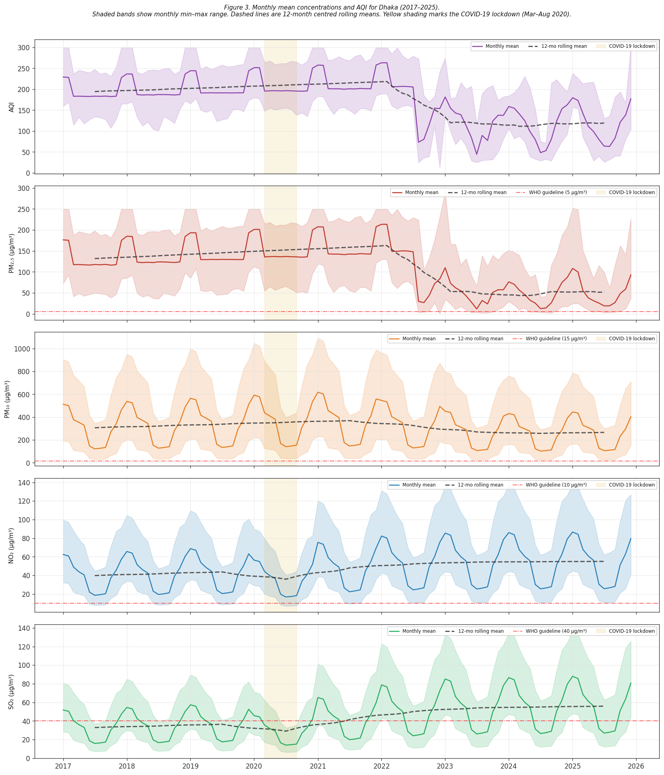
Figure 1. Monthly time series of AQI and major pollutants in Dhaka, 2017–2025

Table 2. Mann–Kendall and OLS trend summary for AQI and major pollutants
Statistic | AQI | PM2.5 | PM10 | NO2 | SO2
MK S | -1661 | -1673 | -824 | 1152 | 1540
MK z | -4.407 | -4.439 | -2.185 | 3.056 | 4.086
MK p | 0.0000 | 0.0000 | 0.0289 | 0.0022 | 0.0000
MK trend | Decreasing | Decreasing | Decreasing | Increasing | Increasing
OLS slope/year | -12.598 | -13.574 | -8.603 | 2.295 | 3.489
OLS SE | 1.575 | 1.604 | 5.543 | 0.724 | 0.671
OLS p | 0.0000 | 0.0000 | 0.1237 | 0.0020 | 0.0000
OLS R² | 0.376 | 0.403 | 0.022 | 0.086 | 0.203

3.3. Seasonal and Monthly Patterns
Seasonality was one of the clearest features of the Dhaka air-quality record. The year × month AQI heatmap and seasonal box plots showed that pollution concentrations were consistently highest during the dry winter months and lowest during the monsoon period (Figures 2 and 3). This repeated seasonal structure indicates that Dhaka’s air-quality burden is strongly organized by the annual dry-season–monsoon cycle.
Monthly climatology confirmed that January and February were the most polluted months on average, whereas August and September were the least polluted (Table 3). Mean AQI was 222.46 in January and 218.09 in February, compared with 137.55 in August and 142.30 in September. PM2.5 followed the same pattern, peaking at 163.48 µg/m³ in January and 157.49 µg/m³ in February, while falling to 82.60 µg/m³ in August and 83.74 µg/m³ in September. PM10, NO2, and SO2 also showed the same broad winter-high, monsoon-low structure.
Rainfall displayed an inverse seasonal profile. The normalized rainfall index was lowest in January (0.01) and highest in July (0.70), indicating that periods of heavier rainfall broadly coincided with lower air-pollution levels. This seasonal contrast is visible in both the monthly climatology and the rainfall-focused visualization.
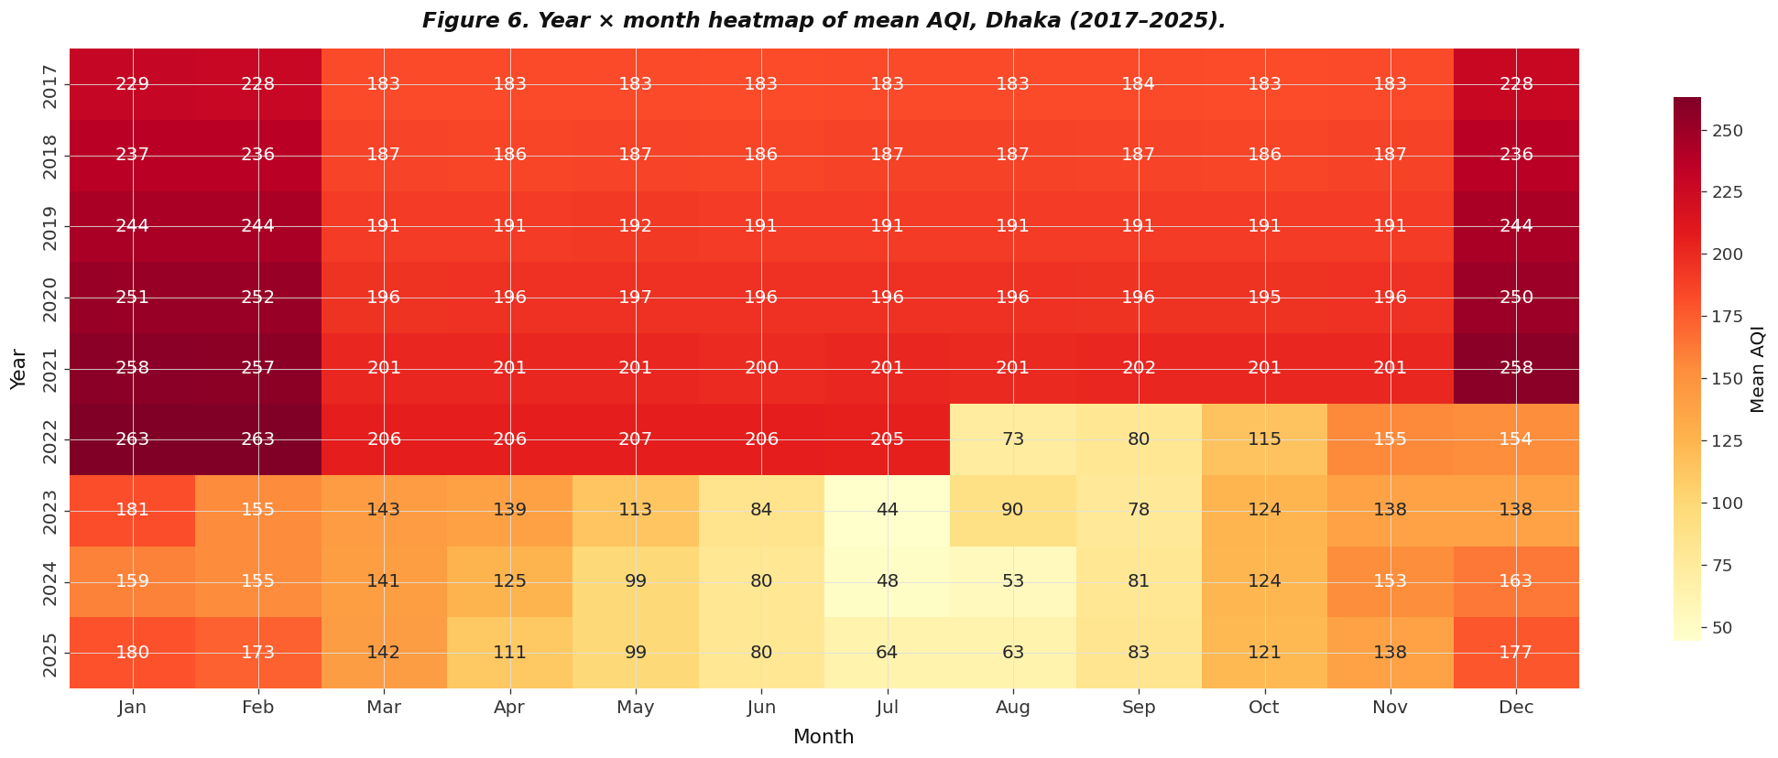
Figure 2. Year × month AQI heatmap for Dhaka, 2017–2025
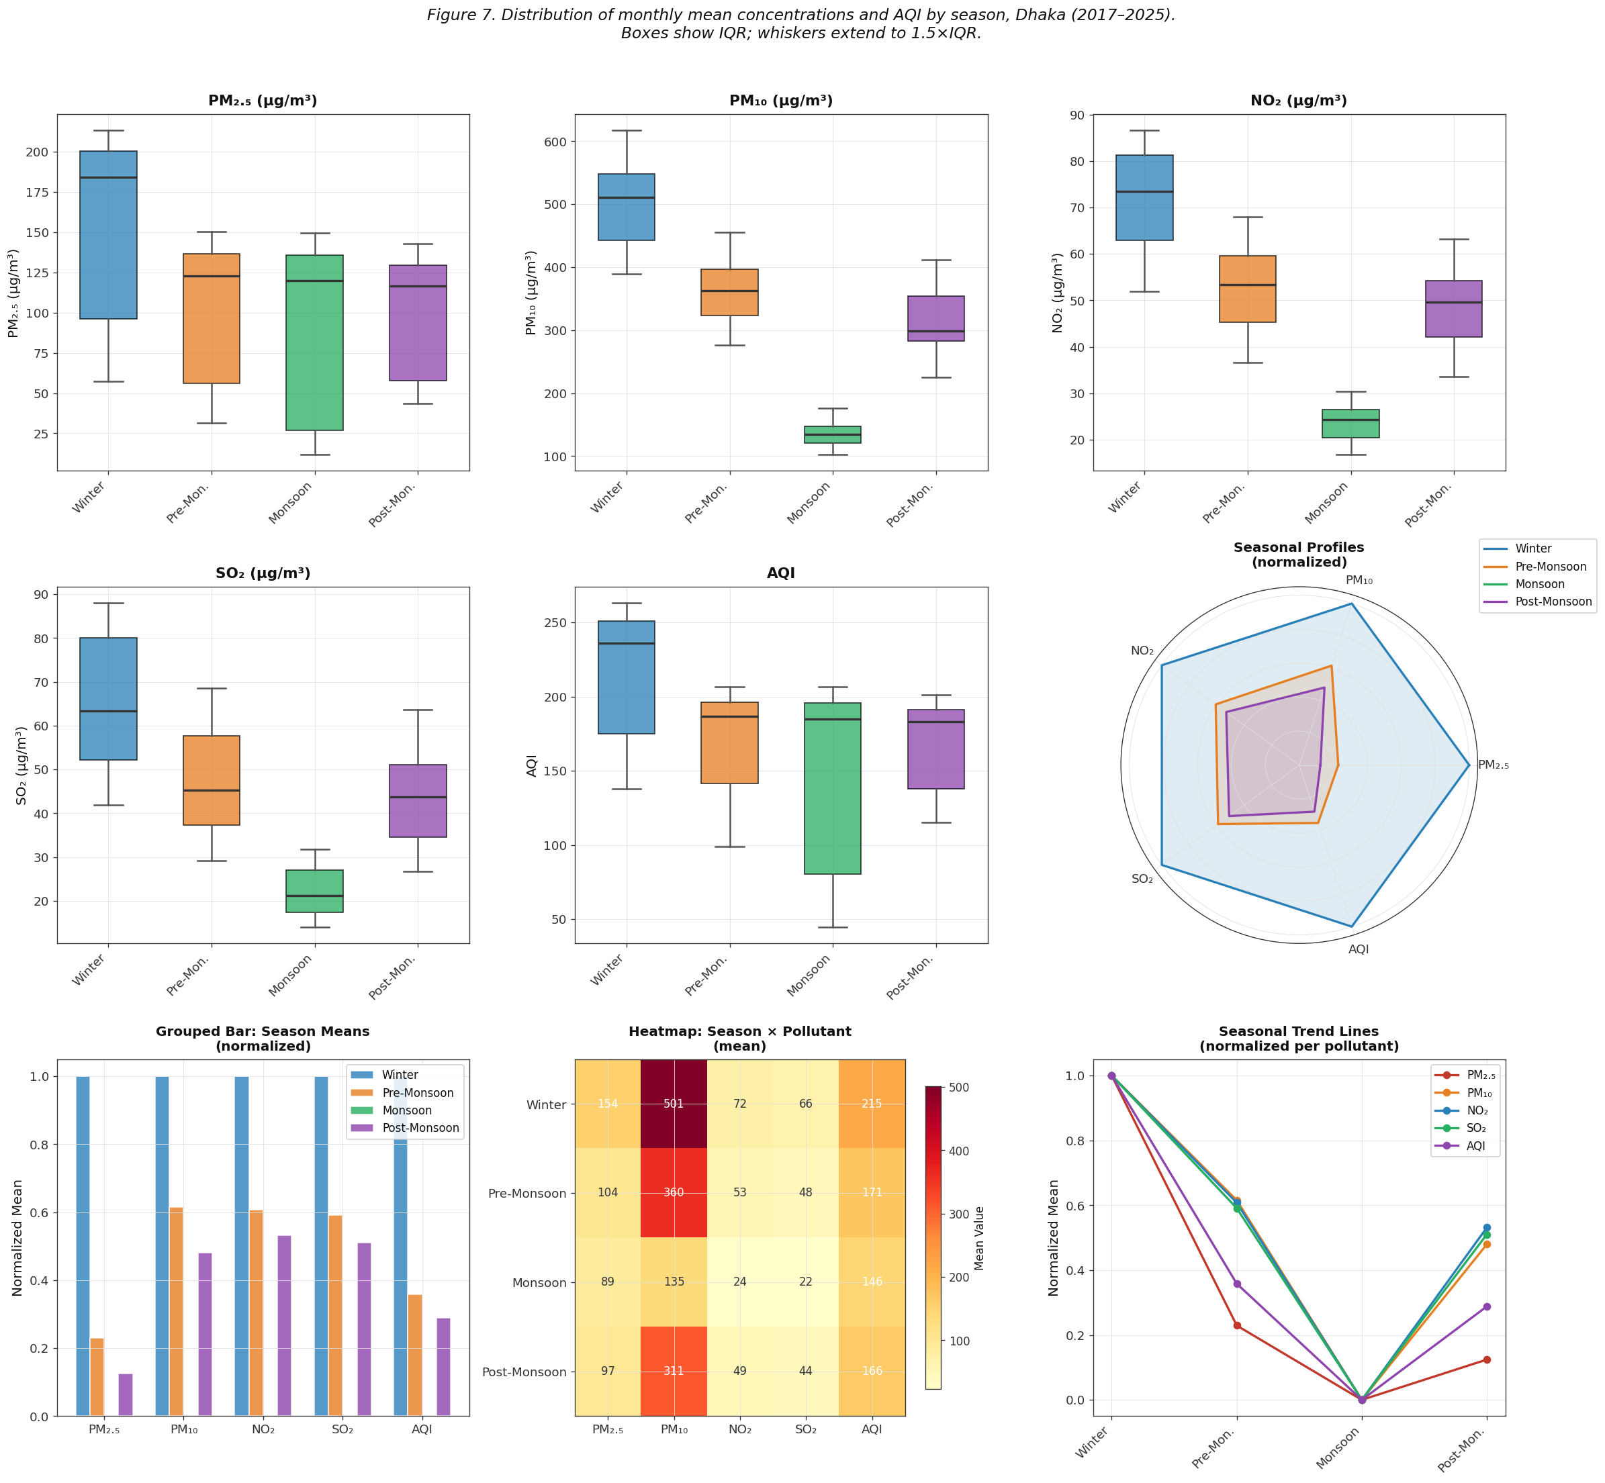
Figure 3. Seasonal box plots of AQI and major pollutants

Table 3. Monthly climatology of AQI, major pollutants, and rainfall

Month | AQI | PM2.5 | PM10 | NO2 | SO2 | Normalized rainfall
Jan | 222.46 | 163.48 | 521.97 | 74.37 | 68.12 | 0.01
Feb | 218.09 | 157.49 | 509.52 | 72.36 | 66.24 | 0.05
Mar | 176.74 | 107.93 | 385.26 | 58.29 | 53.00 | 0.06
Apr | 171.11 | 103.97 | 360.41 | 52.26 | 47.32 | 0.31
May | 164.07 | 100.64 | 335.56 | 48.24 | 43.52 | 0.45
Jun | 156.22 | 97.07 | 149.13 | 26.12 | 24.60 | 0.63
Jul | 146.87 | 93.55 | 124.28 | 22.11 | 20.82 | 0.70
Aug | 137.55 | 82.60 | 129.24 | 22.92 | 21.59 | 0.49
Sep | 142.30 | 83.74 | 136.72 | 24.12 | 22.71 | 0.31
Oct | 160.09 | 93.35 | 273.41 | 44.24 | 39.74 | 0.38
Nov | 171.48 | 101.33 | 347.98 | 54.28 | 49.21 | 0.04
Dec | 205.31 | 142.27 | 472.26 | 68.34 | 62.46 | 0.07

3.4. Pollutant Interrelationships and Rainfall Association
Because several variables were non-normally distributed, associations were interpreted primarily using Spearman rank correlations. The correlation analysis showed strong interrelationships among the major air-quality variables, with particulate pollution playing a dominant role in the structure of AQI variation (Figure 4; Table 4).
AQI was most strongly associated with PM2.5 (r = 0.980), indicating that monthly AQI conditions in Dhaka closely tracked fine particulate pollution. AQI also showed a positive association with PM10 (r = 0.634), although this relationship was weaker than that observed for PM2.5.
Rainfall-related analysis was limited to the portion of the dataset for which normalized monthly rainfall was available. Within that restricted period, rainfall showed negative associations with major pollutants, indicating that wetter conditions generally corresponded to lower pollution concentrations. This pattern is illustrated in Figure 8, which covers the 2017–2021 period and shows inverse relationships between normalized monthly rainfall and PM2.5, PM10, NO2, and SO2. These results are consistent with the broader seasonal structure observed in the full dataset, although the rainfall-specific figure should be interpreted as a partial-period analysis rather than a full-period result.
Several contextual development-related variables also showed moderate associations with AQI and PM2.5. Population total, urban share, and HDI were negatively associated with AQI and PM2.5 in the compiled panel. Because these were annual contextual variables rather than monthly environmental measures, they are reported here as broad associations within the panel rather than as direct short-term drivers.

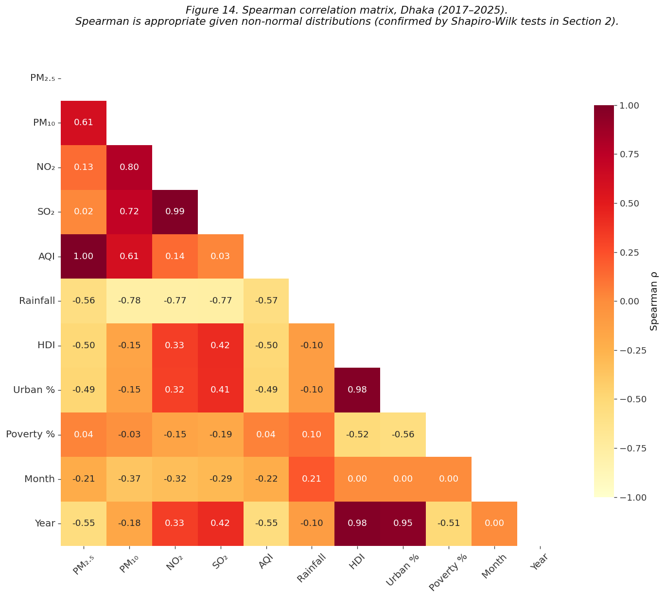
Figure 4. Spearman rank correlation matrix of AQI, pollutants, rainfall, and contextual variables, Dhaka (2017–2025)

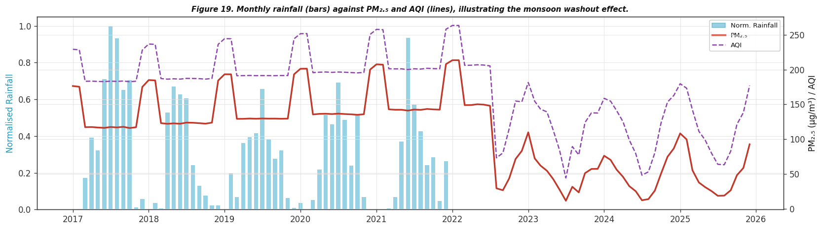
Figure 8. Dual-axis monthly rainfall and PM₂.₅/AQI overlay, Dhaka (2017–2021). Bars = normalized rainfall; lines = pollutant concentrations.

Table 4. Strongest associations with AQI and PM2.5
Target variable | Associated variable | Correlation (r) | Direction
AQI | PM2.5 | 0.980 | Positive
AQI | Population total | -0.646 | Negative
AQI | PM10 | 0.634 | Positive
AQI | Normalized rainfall | -0.530 | Negative
AQI | Urban share | -0.524 | Negative
AQI | HDI | -0.505 | Negative
PM2.5 | Population total | -0.671 | Negative
PM2.5 | PM10 | 0.600 | Positive
PM2.5 | Urban share | -0.539 | Negative
PM2.5 | Normalized rainfall | -0.536 | Negative
PM2.5 | HDI | -0.516 | Negative
PM2.5 | Poverty rate | 0.235 | Positive

3.5. Guideline Exceedance and Pollution Burden
The exceedance analysis showed that Dhaka’s air-quality burden remained substantially above international guideline levels throughout the study period (Table 5; Figure 7). Mean PM2.5 concentration was 110.6 µg/m³, which is 22.1 times the WHO annual guideline of 5 µg/m³. Mean PM10 concentration was 312.1 µg/m³, or 20.8 times the WHO annual guideline of 15 µg/m³. NO2 averaged 47.3 µg/m³, which is 4.7 times the WHO comparison value used in the table, while SO2 averaged 43.3 µg/m³, slightly above its WHO comparison value.
In terms of monthly exceedance frequency, PM2.5, PM10, and NO2 exceeded the relevant WHO guideline in 100% of months. SO2 exceeded the WHO comparison value in 50.9% of months. Even relative to the broader EPA-based thresholds used in the compiled summary, PM2.5 and PM10 remained above reference levels in a substantial proportion of months.
Figure 7 complements Table 5 by showing the persistent monthly exceedance of PM2.5 relative to both WHO and EPA thresholds and the overall exceedance rates for PM2.5, PM10, NO2, and SO2 across the study period. Together, these results show that air-pollution levels in Dhaka were not only episodically severe, but chronically elevated relative to health-based reference thresholds.
Figure 7. (a) Monthly PM2.5 concentrations relative to WHO and EPA thresholds in Dhaka, 2017–2025; (b) percentage of monthly observations exceeding WHO and EPA reference thresholds for PM2.5, PM10, NO2, and SO2.
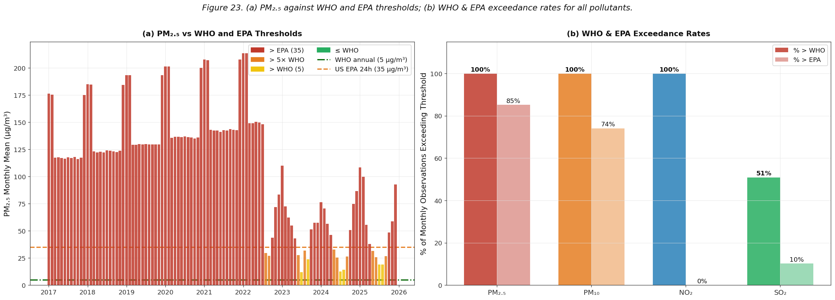
Table 5. WHO guideline exceedance summary
Pollutant | WHO guideline (µg/m³) | Dataset mean (µg/m³) | × WHO guideline | % months > WHO | % months > EPA
PM2.5 | 5.0 | 110.6 | 22.1 | 100.0 | 85.2
PM10 | 15.0 | 312.1 | 20.8 | 100.0 | 74.1
NO2 | 10.0 | 47.3 | 4.7 | 100.0 | 0.0
SO2 | 40.0 | 43.3 | 1.1 | 50.9 | 10.2

3.6. Forecasting Performance
Forecasting models were evaluated on a held-out test period covering 2024–2025 (Table 6; Figure 5). The comparison showed that no single model performed best across all target variables, indicating that pollutant-specific temporal structures differed meaningfully within the Dhaka series.
For AQI, the ETS model performed best overall, with MAE = 23.60, RMSE = 28.63, and MAPE = 22.56%. For PM2.5, the ensemble model showed the strongest overall performance, with MAE = 22.27, RMSE = 29.36, and MAPE = 42.08%. For NO2 and SO2, Prophet produced the lowest percentage errors, with MAPE = 2.85% for NO2 and MAPE = 5.02% for SO2.
Based on overall validation performance, ETS was retained as the preferred AQI forecasting model, the ensemble model was retained for PM2.5, and Prophet was retained for NO2 and SO2. The OLS and SARIMA models provided useful benchmarks, but their performance was less consistent across the full set of forecast targets.
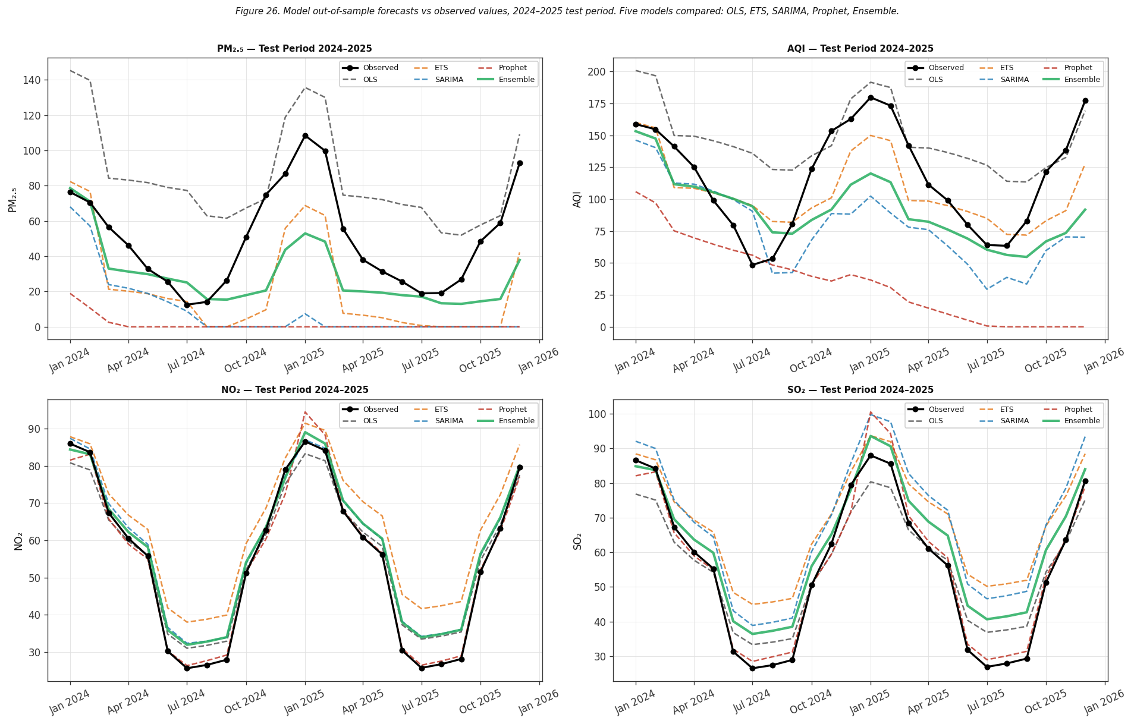
Figure 5. Multi-model forecasting performance on the 2024–2025 validation period
Table 6. Model evaluation on held-out test period (2024–2025)
Metric | OLS | ETS | SARIMA | Prophet | Ensemble
AQI MAE | 32.01 | 23.60 | 43.97 | 82.22 | 33.15
AQI RMSE | 39.64 | 28.63 | 51.13 | 93.78 | 40.60
AQI MAPE% | 40.11 | 22.56 | 38.54 | 67.83 | 28.46
PM2.5 MAE | 34.95 | 29.53 | 40.69 | 48.52 | 22.27
PM2.5 RMSE | 39.49 | 34.00 | 50.42 | 55.57 | 29.36
PM2.5 MAPE% | 116.76 | 67.14 | 81.25 | 98.15 | 42.08
NO2 MAE | 3.50 | 8.96 | 3.84 | 1.72 | 3.86
NO2 RMSE | 4.24 | 9.90 | 4.68 | 2.64 | 4.60
NO2 MAPE% | 9.53 | 23.69 | 11.12 | 2.85 | 10.93
SO2 MAE | 5.33 | 12.77 | 12.55 | 2.75 | 6.95
SO2 RMSE | 6.26 | 14.32 | 13.27 | 3.97 | 8.01
SO2 MAPE% | 12.73 | 33.34 | 29.60 | 5.02 | 18.34

3.7. Projections through 2030
After model evaluation, the selected forecasting approaches were retrained on the full 2017–2025 series and used to generate projections through 2030 (Figure 6). The forecast results showed that Dhaka is likely to continue experiencing an elevated air-pollution burden under business-as-usual conditions, although projected trajectories differed by pollutant.
Scenario-oriented summary results are presented in Table 7. For NO2 and SO2, the 2030 business-as-usual projections remained substantially elevated relative to guideline values, with projected annual means of 68.0 µg/m³ and 74.7 µg/m³, respectively. Alternative scenarios suggested that lower 2030 values could be achieved under more favorable conditions, but even the moderate scenario left both pollutants at environmentally concerning levels.
The PM2.5 business-as-usual projection for 2030 produced a physically implausible negative value, indicating that unconstrained extrapolation of the fitted trend is not suitable for literal interpretation. Accordingly, the PM2.5 business-as-usual result should be read as a model limitation rather than as an interpretable environmental forecast. The broader scenario comparison nevertheless indicates that particulate pollution remains an important concern and that realistic improvement would require substantial mitigation rather than simple continuation of recent patterns.
Overall, the forecast and scenario results show that while some components of Dhaka’s pollution burden may moderate, other pollutant pressures remain persistently high. The forward projection therefore supports the conclusion that Dhaka is likely to continue facing serious air-quality challenges through 2030 without stronger intervention.
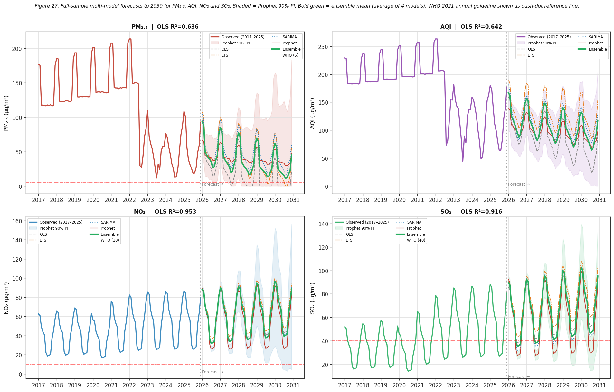
Figure 6. Forecasts and scenario projections of AQI and major pollutants through 2030
Table 7. Scenario summary for projected 2030 annual mean concentrations
Note. The negative PM2.5 business-as-usual value reflects unconstrained model extrapolation and is not physically interpretable as a literal concentration. It is retained here only to illustrate a model limitation.
Variable | 2025 actual | BAU 2030 | vs WHO | Moderate scenario | Ambitious scenario
PM2.5 (µg/m³) | 52.0 | -11.6 | -2.3× WHO | 4.5 | 26.0
AQI | 119.4 | 59.3 | — | 75.3 | 59.7
NO2 (µg/m³) | 55.1 | 68.0 | 6.8× WHO | 63.1 | 27.5
SO2 (µg/m³) | 55.9 | 74.7 | 1.9× WHO | 68.1 | 28.0

4. Discussion

4.1. Seasonal Dominance and Winter Pollution Peaks

The most consistent finding of this study is the extreme and recurring seasonal contrast in Dhaka's air-quality burden. Mean AQI in January (222.5) was approximately 1.6 times that observed in August (137.6), and PM₂.₅ concentrations in winter months exceeded monsoon values by factors of nearly two. This seasonal structure, confirmed by Kruskal–Wallis testing (H = 18.5, p < .001) and Dunn's post-hoc comparison, is consistent with a well-documented pattern across South Asian megacities in which dry-season atmospheric stability and boundary-layer compression concentrate near-surface pollutants (Islam et al., 2022; Khatun et al., 2024). Rahman and Kabir (2023) similarly identified a pronounced dry-season AQI peak in the greater Dhaka region, and Salam et al. (2021) attributed winter particulate intensification partly to regional biomass burning and transboundary transport of carbonaceous aerosols. The present study corroborates these findings at the monthly aggregate level over a longer and more recent observation window spanning 2017–2025.

The seasonal washout role of monsoon rainfall was clearly supported. Normalized monthly rainfall peaked at 0.70 in July while PM₂.₅ fell to its lowest seasonal average, and Pearson correlations between rainfall and major pollutants were consistently negative over the 2017–2021 analysis window. This pattern reflects the well-established wet-deposition mechanism, whereby precipitation scavenges particulate matter and soluble gaseous pollutants from the atmospheric column (Zhao et al., 2022; Stirnberg et al., 2021). The incomplete coverage of rainfall data after 2021 represents a notable gap that limits extension of this finding to the most recent years, underscoring the need for continuous meteorological monitoring alongside pollutant observation in future data infrastructure for Dhaka.

4.2. Divergent Trends: Declining Particulates, Rising Gaseous Pollutants

A structurally important finding is the divergence in long-term trends between particulate and gaseous pollutants. While AQI, PM₂.₅, and PM₁₀ exhibited statistically significant decreasing trends over 2017–2025 (Mann–Kendall z = −4.41, −4.44, and −2.19 respectively), NO₂ and SO₂ increased significantly (z = 3.06 and 4.09). Post-lockdown industrial recovery, rising traffic volumes, and expanding fossil-fuel combustion infrastructure have been associated with gaseous emission growth in rapidly urbanizing South Asian cities, even where particulate levels have partially moderated (Sarwar et al., 2023; Hasan et al., 2025).

The COVID-19 lockdown period (March–August 2020) provided a natural experiment that clarified this structural separation. NO₂ and SO₂ declined by 31.6% and 33.0% respectively during the lockdown, with large effect sizes (Cohen's d = 0.91 and 0.98), consistent with near-complete suppression of vehicular and industrial combustion. PM₂.₅ declined by only 3.9% (d = 0.26), reflecting its dependence on sources beyond road traffic, including biomass burning, construction dust, and regional transport (Hossain et al., 2024; Sharma et al., 2020). The post-lockdown rebound in NO₂ and SO₂ exceeded pre-COVID levels by 22.0% and 41.7% respectively, indicating that economic recovery brought an intensification driven by suppressed demand being released into an expanded industrial base.

The PM₂.₅/PM₁₀ ratio provides additional interpretive leverage. Annual mean ratios above 0.53 from 2017 through 2021 indicate a fine-particle-dominant aerosol profile consistent with combustion-derived particles, whereas the ratio dropped markedly to around 0.19 after 2022. This shift warrants further investigation through source apportionment or chemical speciation analysis (Sarwar et al., 2023; Pavel et al., 2021).

4.3. Pollutant Interrelationships and AQI Drivers

The Spearman correlation analysis showed that PM₂.₅ was overwhelmingly the dominant driver of monthly AQI variation in Dhaka (ρ = 0.980), confirming that the composite AQI index in this dataset is de facto a fine particulate index under current Dhaka conditions. This finding aligns with global evidence that PM₂.₅ constitutes the primary AQI-determining pollutant in high-burden South Asian urban environments where annual mean concentrations routinely exceed WHO guideline values by an order of magnitude (Gurjar et al., 2021; Landrigan et al., 2018; Nayem et al., 2025).

The negative associations between contextual development indicators and AQI should be interpreted carefully. The formal Environmental Kuznets Curve test yielded a negative but statistically non-significant quadratic HDI term (p = 0.154), indicating insufficient evidence of a turning point in this sample. This is consistent with the broader literature suggesting that EKC dynamics in lower-middle-income economies are context-specific and temporally uncertain (Sarkodie & Strezov, 2019; Bento & Moreira, 2019).

4.4. Forecasting Performance and Model Selection

The comparative evaluation of five forecasting approaches on the 2024–2025 held-out validation period revealed meaningful variation in model performance across pollutant series. No single model dominated across all targets, consistent with the broader environmental forecasting literature (Agbehadji & Obagbuwa, 2024; Samal et al., 2019). ETS was best for AQI (MAPE = 22.6%), the ensemble for PM₂.₅ (MAPE = 42.1%), and Prophet for NO₂ (MAPE = 2.9%) and SO₂ (MAPE = 5.0%). Prophet's advantage for gaseous pollutants likely reflects its flexible trend decomposition accommodating the structural post-2020 upward shift better than SARIMA or ETS (Taylor & Letham, 2018). The high MAPE values for PM₂.₅ across all models reflect the well-known limitation of MAPE in series with near-zero monsoon values; absolute errors were more reasonable (MAE = 22.3, RMSE = 29.4 for the ensemble; Hyndman & Koehler, 2006).

4.5. Projections and Policy Implications

Forward projections to 2030 show a mixed picture. Under business-as-usual conditions, the ensemble model projects AQI declining to approximately 93 (from 119 in 2025) and PM₂.₅ to roughly 27 µg/m³, representing improvement but still more than five times the WHO annual guideline of 5 µg/m³. Meanwhile, NO₂ and SO₂ are projected to reach 66.6 and 73.0 µg/m³ respectively under the same scenario. These trajectories are consistent with patterns in comparable South and Southeast Asian cities where vehicle fleet expansion and industrial growth have driven persistent gaseous pollutant accumulation even as particulate burdens have partially moderated (Chen et al., 2020; Gurjar et al., 2021).

Even the ambitious scenario (50% absolute reduction by 2030) would leave all pollutants substantially above WHO guidelines, reinforcing that meaningful improvement requires transformative intervention across multiple emission sectors simultaneously. The COVID-19 lockdown demonstrated that vehicular and industrial reductions can produce rapid measurable changes in NO₂ and SO₂ (31–33% within months), suggesting that sustained traffic management, fleet electrification, and industrial emission controls could deliver substantial reductions within a policy-relevant horizon (Hossain et al., 2024; Sharma et al., 2020; Department of Environment, 2024). The estimated PM₂.₅-attributable mortality burden further underscores the public-health stakes: even the 2030 BAU projection implies concentrations well above the threshold at which health effects are expected to be minimal (Burnett et al., 2018; UNICEF Bangladesh, 2024; Landrigan et al., 2018).

5. Conclusion

This study combined exploratory data analysis with multiple forecasting approaches to examine the historical dynamics and likely future trajectory of air quality in Dhaka, Bangladesh, using monthly observations from January 2017 through December 2025. Across the study period, Dhaka experienced a persistently severe pollution burden, with mean AQI of 172.7, mean PM₂.₅ of 110.6 µg/m³ (22 times the WHO annual guideline), and 100% of months exceeding the WHO guideline for PM₂.₅, PM₁₀, and NO₂.

Seven key conclusions emerge. First, winter is the dominant pollution season, with January and February AQI values approximately 60% higher than monsoon averages. Second, PM₂.₅ is the overwhelmingly dominant driver of AQI variation (ρ = 0.980), making fine particulate control the highest-leverage intervention target. Third, a structural divergence exists between declining particulate and rising gaseous pollutant trends, reflecting post-COVID industrial and traffic emission recovery. Fourth, monsoon rainfall provides a measurable seasonal washout effect, though the incomplete rainfall record after 2021 limits full meteorological interpretation. Fifth, the COVID-19 lockdown produced large but temporary reductions in NO₂ and SO₂ (31–33%), with full rebound and subsequent overshoot by end of 2025. Sixth, no single forecasting model dominated across all pollutant series: ETS performed best for AQI, the ensemble for PM₂.₅, and Prophet for NO₂ and SO₂. Seventh, business-as-usual projections to 2030 show continued improvement in AQI and PM₂.₅, but NO₂ and SO₂ are projected to rise further, and even an ambitious mitigation scenario would leave all pollutants well above WHO guidelines.

These findings carry clear implications for policy and future research. Emission control strategies must address both particulate and gaseous sources simultaneously. Vehicular fleet electrification, stricter industrial emission standards, brick-kiln modernization, and continuous monitoring infrastructure are especially high-priority interventions. Future research should extend meteorological data coverage, pursue source apportionment analysis, and examine spatial heterogeneity within the city to move beyond aggregate city-level assessment toward neighborhood-scale risk characterization. This study provides a reproducible, data-driven baseline for environmental monitoring, pollution mitigation planning, and public-health protection in one of South Asia's most severely polluted urban environments.

References

- Agbehadji, I. E., & Obagbuwa, I. C. (2024). Systematic review of machine learning and deep learning techniques for spatiotemporal air quality prediction. Atmosphere, 15(11), 1352. https://doi.org/10.3390/atmos15111352
- Ahmed, M. T., & Hossain, M. R. (2025). Association between Air Quality Index (AQI) variability and hospital admissions for lung diseases: A longitudinal study [Preprint]. medRxiv. https://doi.org/10.1101/2025.06.03.25328871
- AQICN. (n.d.). Bangladesh Department of Environment station, Dhaka: Real-time air quality index. World Air Quality Index Project. Retrieved March 14, 2026, from https://aqicn.org/station/bangladesh-dhaka-department-of-environment/
- Bangladesh Pratidin. (2025, March 1). Dhaka tops global list with hazardous air quality.
- Begum, S. (2025, December 5). Dhaka tops global list again. The Daily Observer.
- Bento, J. P. C., & Moreira, A. C. (2019). A global analysis of the relationship between energy use, economic growth, and environmental pollution. Energy, 172, 924–938. https://doi.org/10.1016/j.energy.2019.02.027
- Burnett, R., Chen, H., Szyszkowicz, M., Fann, N., Hubbell, B., Pope, C. A., Apte, J. S., Brauer, M., Cohen, A., Weichenthal, S., Coggins, J., Di, Q., Brunekreef, B., Frostad, J., Lim, S. S., Kan, H., Walker, K. D., Thurston, G. D., Hayes, R. B., … Krewski, D. (2018). Global estimates of mortality associated with long-term exposure to outdoor fine particulate matter. Proceedings of the National Academy of Sciences, 115(38), 9592–9597. https://doi.org/10.1073/pnas.1803222115
- Chen, Z., Chen, D., Zhao, C., Kwan, M., Cai, J., Zhuang, Y., Zhao, B., Wang, X., Chen, B., Yang, J., Li, R., He, B., Gao, B., Wang, K., & Xu, B. (2020). Influence of meteorological conditions on PM₂.₅ concentrations across China: A review of methodology and mechanism. Environment International, 139, 105558. https://doi.org/10.1016/j.envint.2020.105558
- Department of Environment. (2024). National Air Quality Management Plan 2024–2030. Government of the People’s Republic of Bangladesh.
- Department of Environment. (2025a). Ambient air quality in Bangladesh. Government of the People’s Republic of Bangladesh.
- Department of Environment. (2025b). Monthly air quality report. Government of the People’s Republic of Bangladesh.
- Dhaka Tribune. (2025, December 26). Dhaka records second-worst air quality in the world Friday morning.
- Gurjar, B. R., Nagpure, A. S., & Kumar, P. (2021). Gaseous emissions from megacities. In B. R. Gurjar, L. T. Molina, & C. S. P. Ojha (Eds.), Air pollution: Health and environmental impacts (pp. 73–106). CRC Press. https://doi.org/10.1201/9781003099543
- Hasan, M. M., Hossain, S., Sanjidah, S., & Islam, M. D. (2025). Spatiotemporal distribution of air pollutants and COVID-19 pandemic in Dhaka Division, Bangladesh. Dysona – Applied Science, 6(1), 8–28. https://doi.org/10.30493/DAS.2025.476898
- Hossain, M. F., Islam, M. A., Islam, M. R., & Bhuiyan, M. A. H. (2024). COVID-19 pandemic and environmental sustainability: Impact of lockdown on air pollution in Bangladesh. Heliyon, 10(3), e25084. https://doi.org/10.1016/j.heliyon.2024.e25084
- Hyndman, R. J., & Koehler, A. B. (2006). Another look at measures of forecast accuracy. International Journal of Forecasting, 22(4), 679–688. https://doi.org/10.1016/j.ijforecast.2006.03.001
- Islam, M. M., Rana, M. M., Yusuf, M. A., Uddin, M. K., & Al-Mamun, M. R. (2022). Spatio-temporal variation and meteorological influence on particulate matter pollution in Dhaka, Bangladesh. Aerosol and Air Quality Research, 22(5), 220062. https://doi.org/10.4209/aaqr.220062
- Khatun, R., Luo, Z., Islam, M. M., & Ahasan, M. (2024). Spatiotemporal distribution of PM₂.₅ and meteorological linkages in the Dhaka metropolitan region. Atmosphere, 15(2), 193. https://doi.org/10.3390/atmos15020193
- Landrigan, P. J., Fuller, R., Acosta, N. J. R., Adeyi, O., Arnold, R., Baldé, A. B., Bertollini, R., Bose-O’Reilly, S., Boufford, J. I., Breysse, P. N., Chiles, T., Mahidol, C., Coll-Seck, A. M., Cropper, M. L., Fobil, J., Fuster, V., Greenstone, M., Haines, A., Hanrahan, D., … Zhong, M. (2018). The Lancet Commission on pollution and health. The Lancet, 391(10119), 462–512. https://doi.org/10.1016/S0140-6736(17)32345-0
- Nayem, A. K. M., Zaman, S. U., Begum, F., & Salam, A. (2025). Wintertime black carbon assessment in Dhaka, Bangladesh: Integrated health risk analysis. Heliyon, 11(2), e41809. https://doi.org/10.1016/j.heliyon.2025.e41809
- Paul, T. (2026). Bangladesh Air Quality Index (AQI) dataset (2000–2025): Historical hourly air pollution data across 103 cities (Version 2) [Data set]. Mendeley Data. https://doi.org/10.17632/9j447cynb9.2
- Pavel, M. d. E. H., Hossain, M. A., & Begum, B. A. (2021). Long-term air quality and health consequence assessment in Dhaka, Bangladesh (2003–2019). Frontiers in Environmental Science, 9, 760464. https://doi.org/10.3389/fenvs.2021.760464
- Qin, S., Liu, F., Wang, J., & Sun, B. (2019). Analysis and forecasting of the particulate matter (PM) concentration levels over four major cities of China using hybrid models. Atmospheric Environment, 98, 665–675. https://doi.org/10.1016/j.atmosenv.2014.10.075
- Rahman, R.-R., & Kabir, A. (2023). Spatiotemporal analysis and forecasting of air quality in the greater Dhaka region and assessment of a novel particulate matter filtration unit. Environmental Monitoring and Assessment, 195(7), 824. https://doi.org/10.1007/s10661-023-11370-y
- Romanello, M., Walawender, M., Hsu, S.-C., Moskeland, A., Palmeiro-Silva, Y., Scamman, D., Smallcombe, J. W., Abdullah, S., Ades, M., Al-Maruf, A., Ameli, N., Angelova, D., Ayeb-Karlsson, S., Ballester, J., Basagaña, X., Bechara, H., Beggs, P. J., Cai, W., Campbell-Lendrum, D., … Costello, A. (2025). The 2025 report of the Lancet Countdown on health and climate change: Climate change action offers a lifeline. The Lancet, 406(10521), 2804–2857. https://doi.org/10.1016/S0140-6736(25)01919-1
- Salam, A., Andersson, A., Jeba, F., Haque, M. I., Khan, M. D. H., & Gustafsson, Ö. (2021). Wintertime air quality in megacity Dhaka, Bangladesh strongly affected by influx of black carbon aerosols from regional biomass burning. Environmental Science & Technology, 55(18), 12243–12249. https://doi.org/10.1021/acs.est.1c03623
- Samal, K. K. R., Panda, A. K., Babu, K. S., & Das, S. K. (2019). An improved pollution forecasting model with meteorological impact using multiple time series. In Proceedings of the International Conference on Information Technology and Computer Communications (ITCC 2019) (pp. 41–46). ACM. https://doi.org/10.1145/3355402.3355418
- Sarkodie, S. A., & Strezov, V. (2019). A review on Environmental Kuznets Curve hypothesis using bibliometric and meta-analysis. Science of the Total Environment, 649, 128–145. https://doi.org/10.1016/j.scitotenv.2018.08.276
- Sarwar, G., Fahad, S., Shah, A. N., Jiang, H., & Wahid, F. (2023). Chemical characterization of PM₂.₅ at the United States Embassy in Dhaka, Bangladesh: Implications for source identification. Atmospheric Environment, 295, 119551. https://doi.org/10.1016/j.atmosenv.2022.119551
- Sharma, S., Zhang, M., Anshika, Gao, J., Zhang, H., & Kota, S. H. (2020). Effect of restricted emissions during COVID-19 on air quality in India. Science of the Total Environment, 728, 138878. https://doi.org/10.1016/j.scitotenv.2020.138878
- Stirnberg, R., Cermak, J., Kotthaus, S., & Haeffelin, M. (2021). Meteorology-driven variability of air pollution (PM₁) revealed with explainable machine learning. Atmospheric Chemistry and Physics, 21(5), 3919–3948. https://doi.org/10.5194/acp-21-3919-2021
- Takano, A. P. C., Justo, L. T., Santos, N. V., Marquezini, M. V., de André, P. A., da Rocha, F. M. M., Pasqualucci, C. A., Barrozo, L. V., Singer, J. M., de André, C. D. S., Saldiva, P. H. N., & Veras, M. M. (2019). Pleural anthracosis as an indicator of lifetime exposure to urban air pollution: An autopsy-based study in São Paulo. Environmental Research, 173, 23–32. https://doi.org/10.1016/j.envres.2019.03.006
- Taylor, S. J., & Letham, B. (2018). Forecasting at scale. The American Statistician, 72(1), 37–45. https://doi.org/10.1080/00031305.2017.1380080
- Tejwani, V., Woo, H., Liu, C., Tillery, A. K., Gassett, A. J., Kanner, R. E., Hoffman, E. A., Martinez, F. J., Woodruff, P. G., Barr, R. G., Fawzy, A., Koehler, K., Curtis, J. L., Freeman, C. M., Cooper, C. B., Comellas, A. P., Pirozzi, C., Paine, R., Tashkin, D., … Hansel, N. N. (2022). Black carbon content in airway macrophages is associated with increased severe exacerbations and worse COPD morbidity in SPIROMICS. Respiratory Research, 23(1), 310. https://doi.org/10.1186/s12931-022-02225-0
- The Daily Star. (2025, December 28). Dhaka ranks third worst globally for air quality as AQI hits 216.
- United Nations Development Programme. (2025). Human Development Report 2025 statistical annex: Table 1, Human Development Index and its components.
- UNICEF Bangladesh. (2024, June 20). The disease burden of air pollution on children continues to rise in Bangladesh, according to latest State of Global Air 2024 report.
- World Health Organization. (2021). WHO global air quality guidelines: Particulate matter (PM2.5 and PM10), ozone, nitrogen dioxide, sulfur dioxide and carbon monoxide. World Health Organization.
- World Bank. (2025, December 9). Going beyond growth: How Bangladesh can tackle poverty and inequality through job creation.
- Worldometer. (2026). Bangladesh population (1950–2025).
- Zhao, H., Zheng, Y., & Li, T. (2022). Relationship between PM₂.₅ and meteorological factors in eastern China: A review. Atmospheric Pollution Research, 13(4), 101356. https://doi.org/10.1016/j.apr.2022.101356

