GUI Calculator Project Report
This project is a simple GUI-based calculator developed using Python and the Tkinter library. The application performs basic arithmetic operations through an easy-to-use graphical interface.

Objectives
- Develop a user-friendly calculator interface.
- Implement arithmetic operations.
- Demonstrate GUI programming using Python.

Features
- Addition (+)
- Subtraction (-)
- Multiplication (*)
- Division (/ and \)
- Exponentiation (^)
- Modulus (%)
- Clear Function (C)

Source Code Description
The project uses Tkinter widgets such as Entry, Button, and Frame to create the calculator interface. The eval() function processes the arithmetic expressions entered by the user.

Application Screenshot
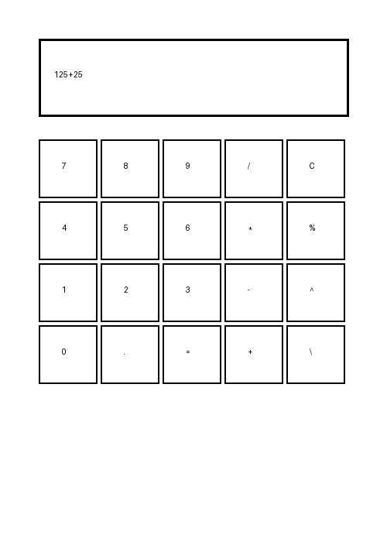

Conclusion
The calculator project successfully demonstrates the use of Python GUI development for building desktop applications.

