Login Authentication Web Application Report
This project is a responsive web-based login authentication application developed using HTML, CSS, and JavaScript.

Objectives
- Develop a user-friendly login interface.
- Implement input validation.
- Display appropriate success and error messages.
- Create a responsive design.

Features
- Username and Password fields
- Login Button
- Reset/Cancel Button
- Input Validation
- Responsive Design

Screenshot
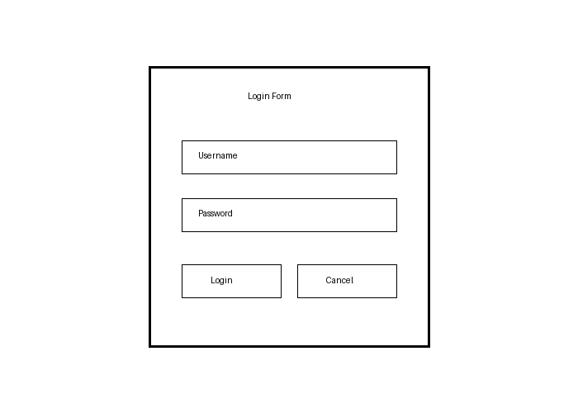

Conclusion
The project successfully demonstrates front-end authentication logic using JavaScript and responsive web design techniques.

