🌱 Gardening Guide Database
VCE Applied Computing — Unit 1: Data Analysis
Student Workbook
Student Name: | Evan
Class: | Applied Computing Unit 1 and 2
Date: | 19/03/2026
Teacher: | Mr Mckenzie

About this workbook
- You will build a Gardening Guide database in Microsoft Access.
- Follow each step carefully and complete all tasks and reflection questions.
- Screenshots are required — look for the 📷 screenshot boxes.
- Use the writing spaces provided to record your observations and answers.

 | Task | Marks | Done
Part A | Building the Database (Steps 1–6) | 20 | ☐
Part B | SQL Queries (Queries 1–4) | 20 | ☐
 | Documentation & Screenshots | 10 | ☐
 | TOTAL | 50

PART A — Building the Database

Step 1: Create a New Database
Create a new blank database in Microsoft Access to hold your gardening data.

Follow these steps:
- Open Microsoft Access.
- Click Blank database.
- Name the file: GardeningGuide.accdb
- Choose a save location on your computer.
- Click Create.

✏ Why do you think it is important to name database files clearly? Give an example of a confusing filename and a better one.
Proper naming of a database is essential for organisation and clarity. A unclear filename would be “Garden”, a clearer one would be “Garden Access Database”

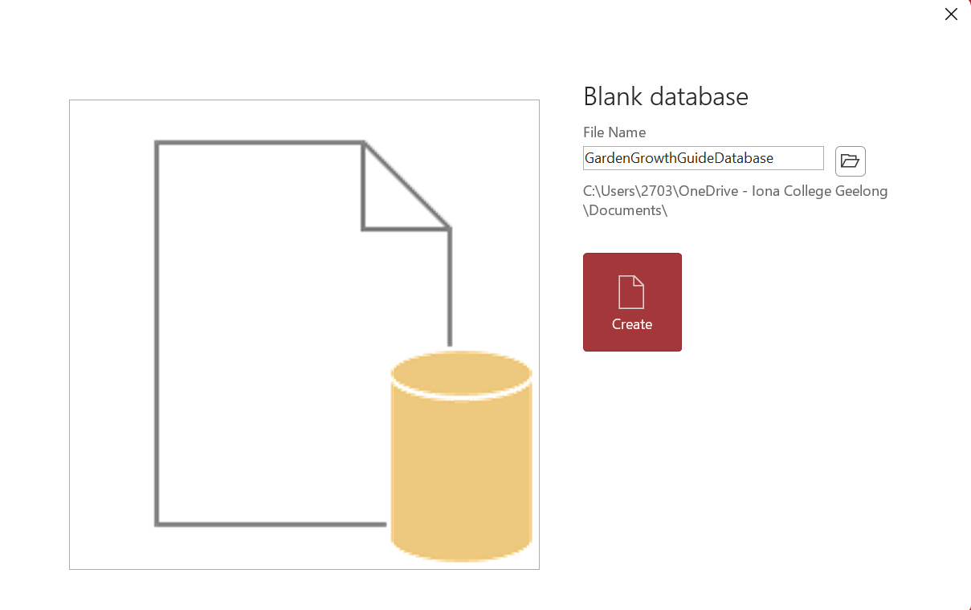

Step 2: Create the ClimateZone Table
Tables store data in rows and columns. Each field has a name and a data type that controls what kind of data can be entered.

2.1 Create the table
- Go to the Create tab.
- Click Table Design.
- Save the table as: ClimateZone

2.2 Add fields and data types
Enter the following fields in Design View:

Field Name | Data Type | Description
ClimateZoneID | Number | Zone number (1–5)
ZoneDescriptor | Short Text | Description of climate
MinTempC | Number | Minimum temperature (°C)
MaxTempC | Number | Maximum temperature (°C)
Humidity | Short Text | Humidity level

2.3 Set the Primary Key
- Click the row for ClimateZoneID.
- Click the Primary Key button in the ribbon.

2.4 Add a validation rule
- Click the ClimateZoneID field.
- In the Field Properties panel at the bottom, find Validation Rule.
- Enter: Between 1 And 5

✏ What is the purpose of a primary key? In your own words, explain why ClimateZoneID is a good choice for a primary key in this table.
The purpose of a primary key is to be able to quickly associate data from different tables. ClimateZoneID is a good for a primary key as it is a identification number and can be used to identify the climate zones needed for certain plants.

✏ What would happen if someone tried to enter a ClimateZoneID of 6? Why does the validation rule prevent this?
If someone tried to enter a ClimateZoneID of 6 it woulnd’t be recognised and there would be an error. The validation rule prevents this as there are only 5 available climates, thus the numbers associated with each climate only go to five so 6 would be invalid.

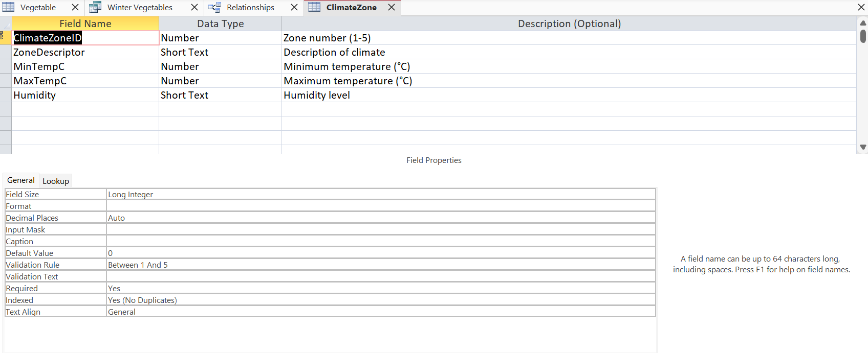

Step 3: Enter Climate Zone Data
Switch to Datasheet View and enter the following records:

ClimateZoneID | ZoneDescriptor | MinTempC | MaxTempC | Humidity
1 | Tropical zone | 20 | 30 | Very high
2 | Arid zone | 20 | 45 | Low
3 | Temperate zone | -5 | 45 | High
4 | Continental zone | -20 | 30 | Moderate
5 | Polar zone | -50 | 0 | Moderate

✏ Which climate zone best matches where you live? Explain your reasoning using the temperature ranges.
The climate that matches the closest to my region would be the “Continental zone”, this is because our humidity is quite moderate, while temperatures in Australia can range from the high 30s to low 20s in certain parts of Australia.

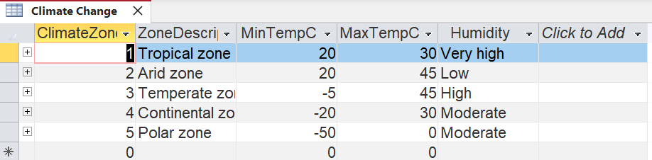

Step 4: Create the Vegetable Table
Now create a second table for vegetables. This table will link to your ClimateZone table.

Create a new table in Design View with these fields:

Field Name | Data Type | Description
VegetableID | AutoNumber | Unique ID — Access fills this in automatically
VegetableName | Short Text | Name of the vegetable
PlantingSeason | Short Text | Spring, Summer, Autumn, or Winter
DaysToHarvest | Number | How many days until harvest
Sunlight | Short Text | Shade, Partial Sun, or Full Sun
SoilType | Short Text | Loamy, Sandy, or Clay
ClimateZoneID | Number | Must match a value in ClimateZone

Set VegetableID as the Primary Key.

✏ Why does the Vegetable table also have a ClimateZoneID field? What is the connection between the two tables?
The Vegetable table also has a ClimateZoneID to connect the two tables, the climate table and the plant table. The connection between the tables shows the climate zone needed for a specific plant.

✏ AutoNumber is used for VegetableID but Number is used for ClimateZoneID. Why do you think a different data type was chosen for each?
“AutoNumber” is used for VegetableID as the number’s numerical value is irrelevant for Vebetable ID so it can be automatically generated, whereas ClimateZoneID needs a specific number that’s relevant as it represents a specific climate zone,

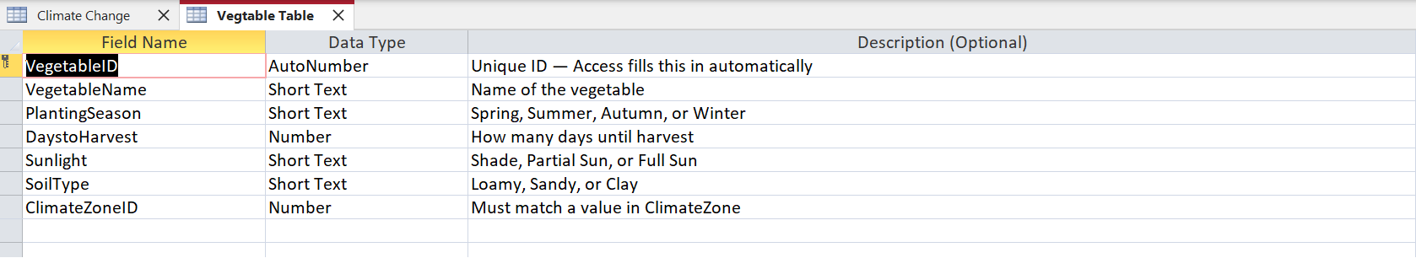

Step 5: Create the Relationship
Relationships connect tables so data stays consistent and duplicates are prevented.

Follow these steps:
- Go to Database Tools → Relationships.
- Click Show Table and add both ClimateZone and Vegetable.
- Drag ClimateZoneID from the ClimateZone table onto ClimateZoneID in the Vegetable table.
- In the Edit Relationships dialog, tick "Enforce Referential Integrity".
- Click Create.

What is referential integrity?
- Referential integrity means you cannot add a vegetable with a ClimateZoneID that does not exist in the ClimateZone table.
- It prevents orphaned records — records that refer to something that no longer exists.
- Access will show a line between the two tables to indicate a one-to-many relationship.

✏ In your own words, explain why referential integrity is important. Give an example of what could go wrong without it.
Referential integrity serves as an insurance to make sure graphs can not have incorrect data. An example of this may be a vegetable being added into the vegetable graph with a ClimateZoneID of 6, this wouldn’t be prevented without referential integrity and when interpreting this data the climate zone of the plant would be unknown since it’s number is invalid.

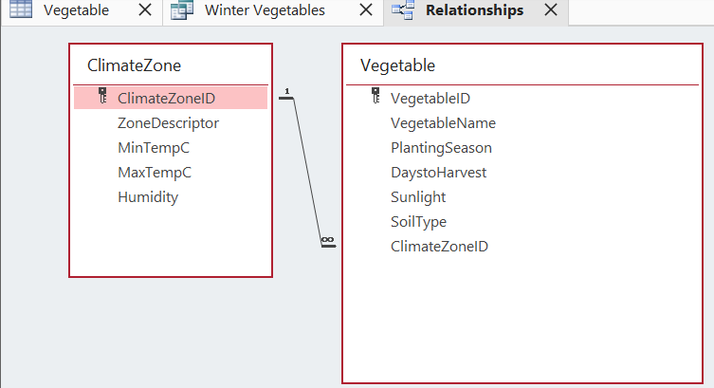
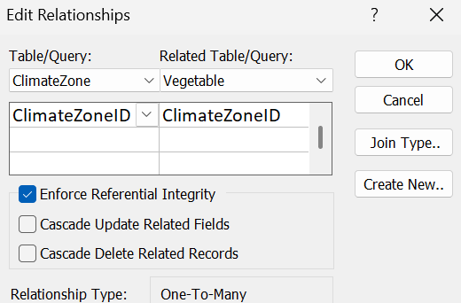

Step 6: Enter Vegetable Data
Enter 30 realistic vegetables into the Vegetable table. Make sure you include a good variety across all climate zones, soil types, sunlight levels, and planting seasons.

Tips for your data
- Include vegetables from all 5 climate zones (ClimateZoneID 1 through 5).
- Vary soil types: use Loamy, Sandy, and Clay.
- Vary sunlight: use Full Sun, Partial Sun, and Shade.
- Use realistic DaysToHarvest values — for example, lettuce takes around 45 days; pumpkin around 90.
- Make sure PlantingSeason is one of: Spring, Summer, Autumn, Winter.

✏ List 5 of the vegetables you chose and explain why they suit the climate zone you assigned them.
Example: Tomato — assigned to Zone 3 (Temperate) because they grow well in warm summers with mild winters.
1. I assigned carrots to Zone 1 (Tropical) because carrots grow most optimally at around 24 degrees Celsius and need at least 6 hours of full sun to grow.
2. I assigned spinach to Zone 3 (Temperature) as they require a lower temperature and a high humidity
3. I assigned garlic to Zone 4 (Continental) as they appreciate higher climate conditions around 32 – 50 degrees Celsius
4. I assigned silver beet to Zone 4 (Continental) as they need a temperature for around 16-18 degrees Celsius and a moderate humidity
5. I assigned lettuce to Zone 4 (Continental) as they require a cool temperature with mild humidity, with temperatures from 10-20 degrees.

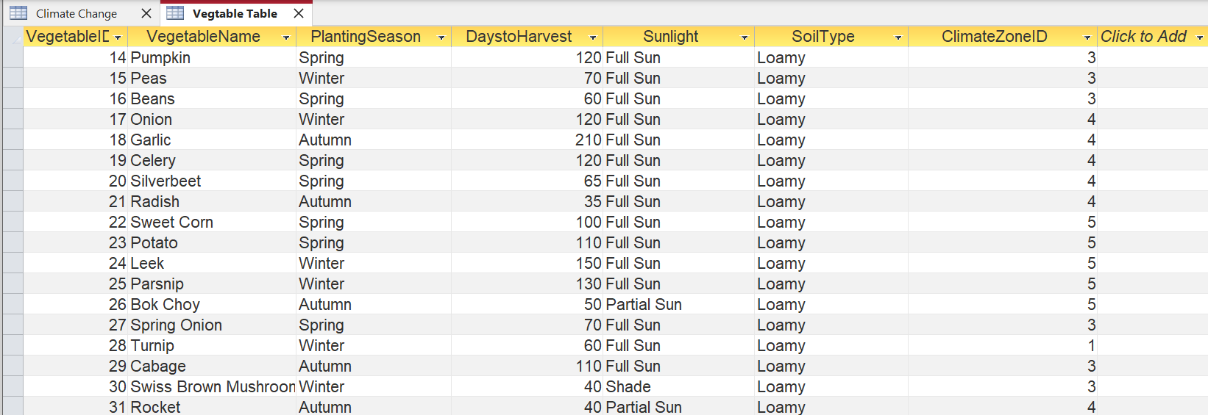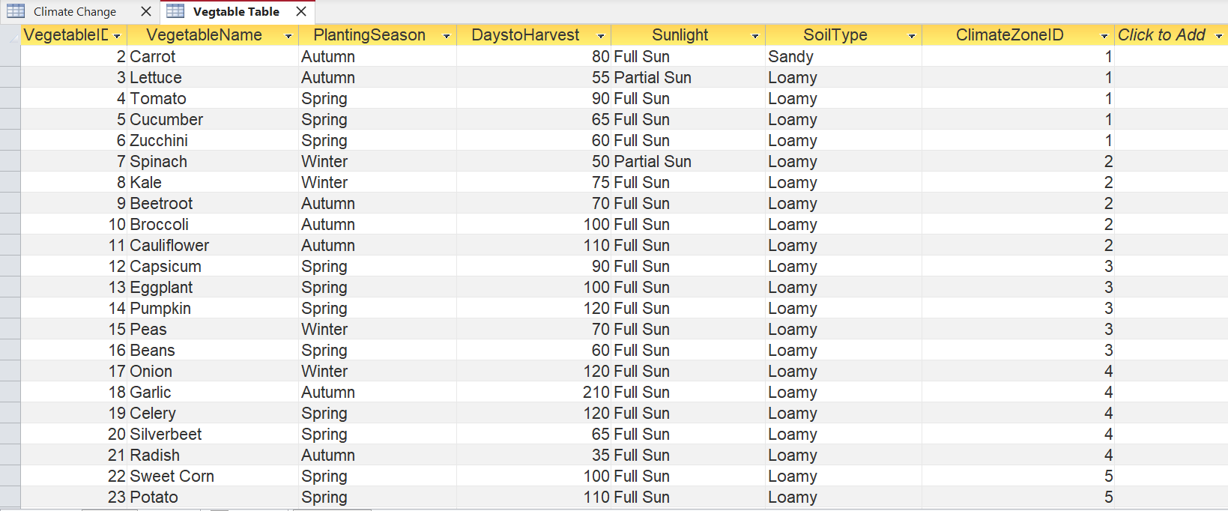

PART B — SQL Queries

In this section you will run SQL queries against your database. For each query you will:
- Read and understand what the query does.
- Run it in Access using the Query Design view — switch to SQL View to enter the code.
- Record your results below.
- Take a screenshot of the results.

How to run a SQL query in Access
- Go to Create → Query Design.
- Close the Show Table dialog without adding anything.
- Click the SQL View button (Home tab → View → SQL View).
- Paste or type your SQL code.
- Click Run (the red ! button).
- Save the query with a meaningful name.

Query 1 — Filter by Climate Zone
This query retrieves all vegetables that are suited to Climate Zone 4 (Continental zone).

SELECT *
FROM Vegetable
WHERE ClimateZoneID = 4;

✏ Before you run the query, predict: how many records do you expect to see? Why?
I predict to see seven vegetables to appear as this code is selecting from the vegetable table and retrieving all the vegetables with a ClimateZoneID of 4 and there are 7 vegetables that are located there.

✏ After running the query: how many records were returned? Were you correct?
After running the query 7 records of vegetables returned, this proved my analysis was correct.

✏ What does the asterisk (*) mean in "SELECT *"? What would change if you wrote "SELECT VegetableName" instead?
The asterisk in SELECT * means select all the described table. If the code was changed it doesn’t work and access doesn’t allow it to occur.

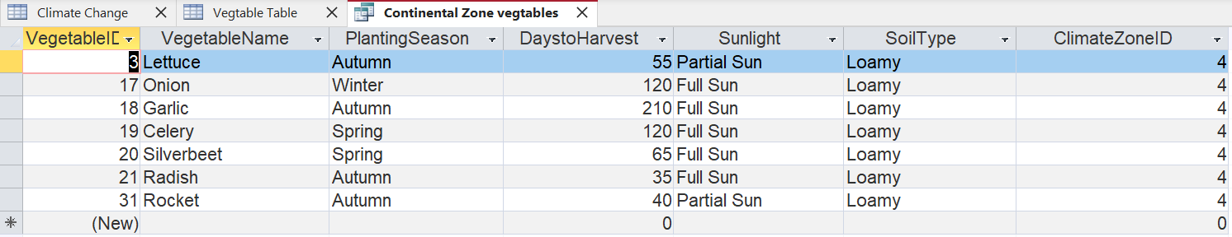

Query 2 — JOIN Query
This query joins the two tables together so you can see the zone description alongside each vegetable.

SELECT Vegetable.VegetableName, Vegetable.PlantingSeason,
Vegetable.DaysToHarvest, Vegetable.Sunlight,
Vegetable.SoilType, ClimateZone.ZoneDescriptor
FROM ClimateZone
INNER JOIN Vegetable
ON ClimateZone.ClimateZoneID = Vegetable.ClimateZoneID;

✏ What does INNER JOIN do? Why do we need it here instead of just using SELECT * FROM Vegetable?
INNER JOIN returns records that have matching data in two or more tables. This allows the records generated to include specific data related to other data. SELECT * is not as precise as INNER JOIN.

✏ The ON clause specifies how the two tables are connected. What would happen if the ClimateZoneID values did not match between the two tables?
If the ClimateZoneID values didn’t match between the two then it the INNER JOIN wouldn’t be able to connect the data between the two tables and generate the records.

✏ How many records did this query return? Is that what you expected? Explain.
The query returned 30 records, I had expected this as I did 30 vegetables as instructed and there wasn’t anymore vegetables that matched the specific criteria of the query so it wasn’t returned.

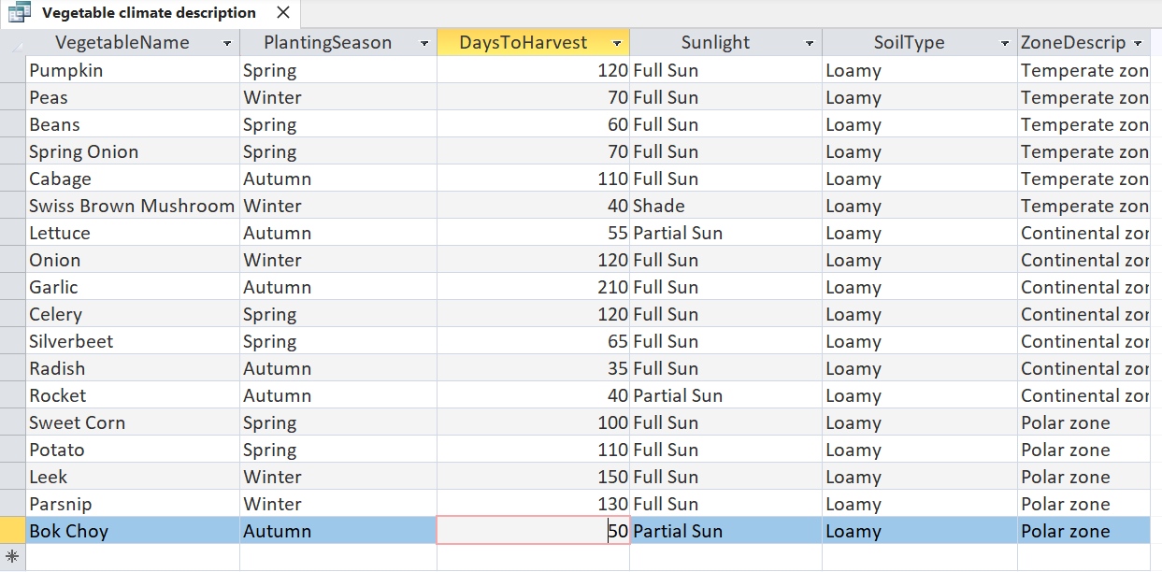

Query 3 — Filter by Soil Type
This query returns all vegetables that grow in loamy soil.

SELECT *
FROM Vegetable
WHERE SoilType = 'Loamy';

✏ Why are single quotes used around 'Loamy' but not around a number like 4 in Query 1?
Since “Loamy” is a string it require quotation marks, unlike 4 as it is an int or integer, which is a whole number.

✏ How would you modify this query to also show vegetables that grow in Sandy soil? Write the modified SQL below.
Hint: look up the SQL OR operator or the IN operator.
To modify this query to also return vegetables in sandy soil is to go into a line under “WHERE” and say “AND Soiltype “Sandy””.

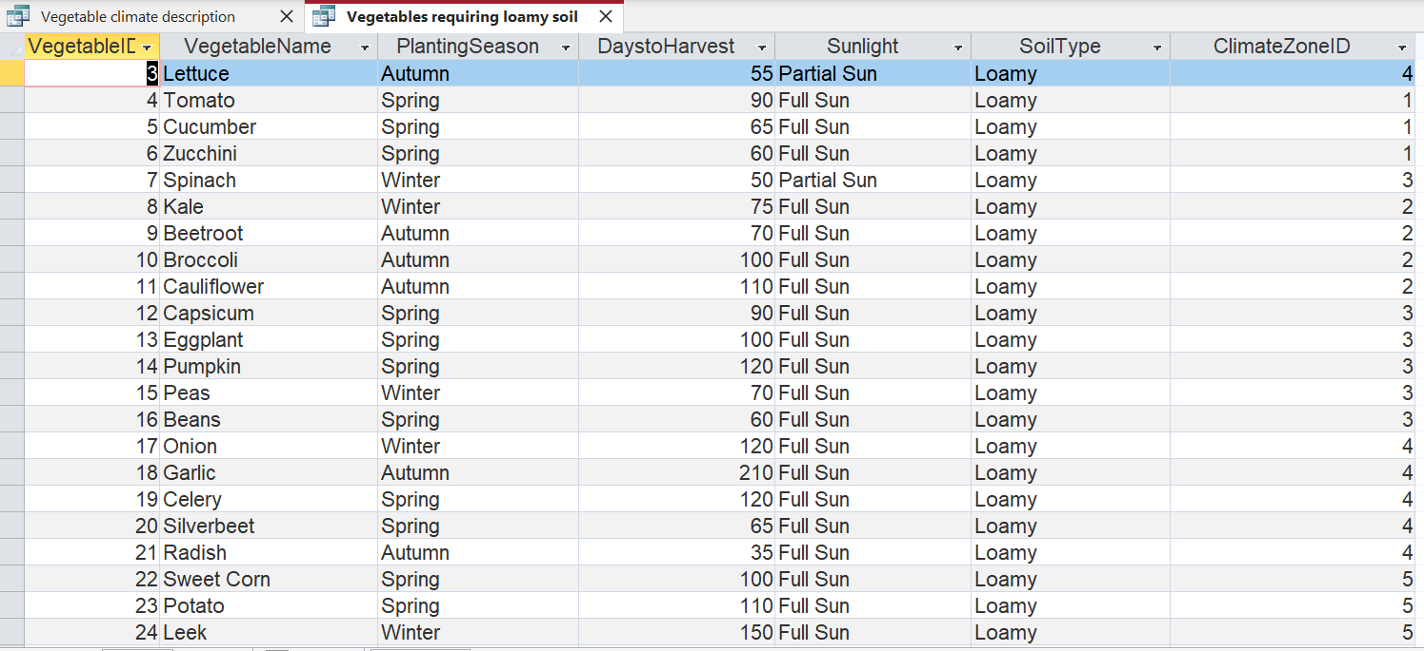

Query 4 — Multiple Conditions
This query finds vegetables in the Tropical zone that are planted in Spring — using two conditions together.

SELECT *
FROM Vegetable
WHERE ClimateZoneID = 1
AND PlantingSeason = 'Spring';

✏ How does the AND operator work? What would change if you used OR instead of AND?
The AND operator returns records that share both qualities of the said criteria however OR would return records share either of the said qualities, likely returning more data than AND.

✏ If this query returns 0 results, what might that tell you about your data? What would you do to fix it?
If this query returned 0 results this tell me my data isn’t very diverse and would need more vegetables with different zones and times of the year. It also could mean my data isn’t accurate as a vegetable that likes spring would generally also like Zone 1. To fix this you could add more vegetable data.

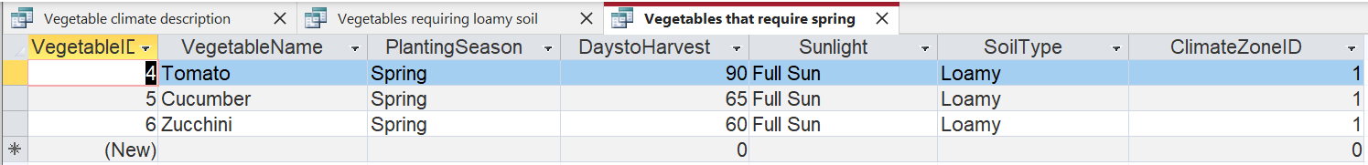

EXTENSION — Write Your Own Query

Design and run a SQL query of your own. It should use at least one WHERE condition and retrieve meaningful information from your database.

✏ Describe in plain English what your query will find. What question are you trying to answer?
My query will attempt to find all the plants that grow in cold conditions, this query tries answer how many vegetables in my database thrive in the winter so I can prepare for the coming season.

✏ Write your SQL query here:
Remember to save the query in Access with a meaningful name.
SELECT *
FROM Vegetable
WHERE ClimateZoneID = 5
AND PlantingSeason = “Winter”;

✏ What were the results? Were they what you expected? Explain any surprises.
The query gave two records, one for leeks and one for parsnips. I had expected to have around 5 vegetables in records, I also had to remove the brackets around “Winter” in my query after Access automatically added them to my query, I also had to learn how set perimeters for my strings.

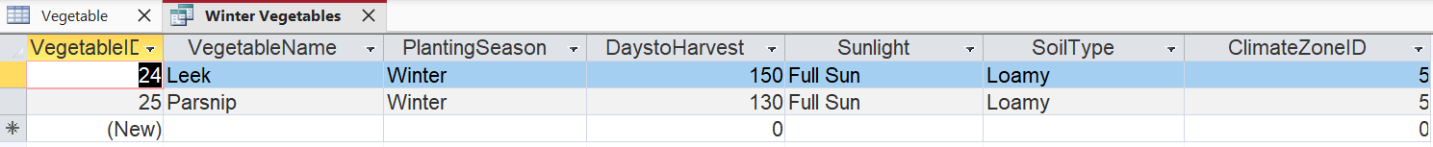

REFLECTION — What Did You Learn?

✏ Describe one thing you found challenging in this activity and how you worked through it.
I found writing my own SQL code very hard as I have little experience with it personally. I worked through this by using the previous queries as reference for my own, copying their structure. I also found it challenging to find 30 vegetables for my database that have a good variety, I worked through this by outsourcing some of the work (15 vegetables) for AI to find.

✏ How are databases like spreadsheets? How are they different? Use examples from this activity.
Databases and spreadsheets both represent data in a table with rows and columns, however they differ in intuitiveness as spreadsheets are easier to use and can be aesthetically designed in contrast databases are harder to use yet have more features like, SQL queries and having relations.

✏ Can you think of a real-world system that would use a database similar to this one? Describe it.
I believe a bakery could benefit from having their recipes set up in a database such as this. For specials they could make a query in which it finds the best pastries that specialise in certain “zones” of weather. For example a nice hot chocolate would sell best in cold weather and thus change the menu accordingly.

MARKING RUBRIC

Criteria | Excellent (4–5) | Satisfactory (2–3) | Needs Work (0–1)
Table Structure | All fields have correct names, data types, and primary key set properly. | Most fields correct; minor errors in data types or key. | Several fields missing or incorrect data types used.
Relationship | Relationship created with referential integrity enforced correctly. | Relationship created but referential integrity missing. | Relationship not created or incorrect.
Data Quality | 30 records with realistic, varied values across all zones and types. | 25–29 records; some lack variety. | Fewer than 25 records or data is unrealistic/repetitive.
SQL Queries | All 4 queries run correctly and return expected results. | 3 queries work correctly. | 2 or fewer queries work.
Documentation | All 10+ screenshots included with clear descriptions and answers. | Most screenshots present; some answers incomplete. | Screenshots or answers mostly missing.
Reflection | Thoughtful, detailed responses showing genuine understanding. | Responses are adequate but brief. | Minimal effort in reflection questions.

Total marks: _____ / 50
Teacher comment: _______________________________________________

