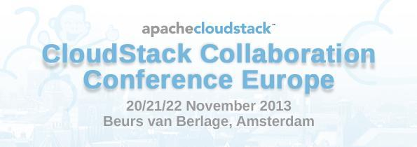

# 

# Reference: Invitation to Cloudstack Collaboration EU 2013

Amsterdam, 1 October 2013

To whom it may concern,

Herewith we invite:

Visitor details:

<First, Last Name>

Title: <title>

Date of Birth: <Day Month Year>

Nationality: <Nationality>

Address: <Street address, ZIP, City, Country>

to attend the CloudStack Collaboration event to be held on the 20th November till 22nd November at the Beurs van Berlage, Damrak 243, Amsterdam, The Netherlands.

Our details:

Organization CloudStack Collaboration Conference Europe

<ORGANIZER NAME>, Mission Critical Engineer @ Schuberg Philis B.V.

Boeing Avenue 271

1119 PD Schiphol-Rijk

+31 6 14008293

[<ORGANIZER](mailto:hboertien@schubergphilis.com) EMAIL>

Kind regards,

<NAME>

Organiser of CloudStack Collaboration Conference EU 2013

# The following documents can be requested by the Dutch IND:

(See also <http://www.ind.nl/en/Customer-Information/Documents/8022.pdf> )

* Your passport (valid 3 months beyond your stay, not older then 10 years)
* Plausible case for your travel purpose (letter of invitation, letter of your employee)
* Sufficient means of support
* Your hotel-reservation
* Adequate and valid travel medical insurance coverage
* See for details the above mentioned URL

# About Apache CloudStack

Apache CloudStack is open source software designed to deploy and manage large networks of virtual machines, as a highly available, highly scalable Infrastructure as a Service (IaaS) cloud computing platform. CloudStack is used by a number of service providers to offer public cloud services, and by many companies to provide an on-premises (private) cloud offering, or as part of a hybrid cloud solution.

# Apache CloudStack Collaboration Conference in Amsterdam

The European CloudStack conference will continue with the best ideas from the previous conferences and feature a varied set of presentations. Aimed at users, developers and everybody else interested in cloudstack, this will be the place to learn more about cloudstack or join the developers to discuss the past, present and future.

Collaboration is key to keep our community vibrant and growing. A lot of the talks and events at the conference will provide ample opportunity to meet with the cloudstack community and engage in deep discussions with developers and users. The hack day will provide an excellent opportunity to turn ideas into practice together with the committers.