**Correlates of Extinction Risk in European and North American Amphibians**

**INTRODUCTION**

In recent years the decline and extinction of global amphibian populations has been of rising concern among conservation biologists. The IUCN’s 2016 global biodiversity assessment provided a best estimate of the percentage of threatened species across various taxonomic groups (IUCN, 2016). Approximately 42% of amphibian species worldwide are threatened, in comparison to 25% of mammals and 13% of birds (IUCN, 2016).

Previous research has focused on potential causes for this global amphibian decline including overexploitation, habitat loss and land use change, invasive species, increased UV radiation, global warming, pesticide use, and infectious diseases (Collins & Storfer, 2003), but the interactions among these factors are often complex and susceptibility to these threats may vary across geography and taxonomy groups. Thus identifying traits that may cause species to be more susceptible to these threats is an important goal of conservation biology, that will allow for more proactive and targeted conservation efforts.

Thus far, the study of extinction risk correlates has been largely focused on mammals and birds. Amphibians and especially reptiles have often been neglected due to lack of data. Amphibian extinction risk research has primarily been small-scale and regionally limited to areas such as Central America and Australia (Hero et al., 2005; Lips et al., 2003; Murray & Hose, 2005; Hero & Morrison, 2012), rarely reaching a global scale (Cooper et al., 2008). As these relationships may vary geographically, the results obtained from these studies might not be relevant to North American and European amphibians. More research needs to be done to test the validity of these extinction risk correlate relationships in North American and European amphibian populations. Additionally the majority of amphibian extinction risk research has focused on frogs (Anura), while salamanders (Urodela) are left out due to lack of data, thus any conclusions about how extinction risk patterns may differ between these orders is unknown.

Previous extinction risk research has analyzed a variety of correlates spanning morphology, life history, and ecological attributes. At a global scale, Cooper et al. (2008) found that geographic range size is the predominant correlate of extinction risk for frogs, while body size and fecundity only impact extinction risk through range size. At regional scales studies of central American and Australian frog populations have found small geographic ranges, high habitat specialism, high minimum elevations, large body sizes, and low fecundities to correlate with population declines or extinction risk (Hero et al., 2005; Lips et al., 2003; Murray & Hose, 2005; Hero & Morrison, 2012).

Further research is needed to investigate the validity of these correlations and to determine whether these correlations apply to North American and European frogs, or to salamanders. Therefore I will examine the relationships between the conservation status of North American frogs, European frogs, and European salamanders and four potential correlates: body size, fecundity, habitat specificity, and minimum elevation. I hypothesize that body size will correlate positively with threat status as species with larger body size have been found to have slower life histories, lower population densities, larger home ranges, and higher rates of exploitation, all traits which seem to increase extinction (Cooper et al., 2008; Purvis et al., 2000; McKinney, 1997; Cardillo, 2003). Secondly I hypothesize that fecundity will negatively correlate with threat status because species with smaller clutch sizes are less able to compensate for any increases in mortality (MacArther & Wilson, 1967). In terms of habitat specificity, I hypothesize that habitat breadth will negatively correlate with threat status because specialist species are more at risk to threats that minimize niche availability such as habitat loss (Owens & Bennett, 2000; Purvis et al., 2000). Lastly, I hypothesize that minimum elevation and threat status will be positively correlated. Higher minimum elevations suggest ranges restricted to mountainous regions (Davies et al., 2006) and small geographic range size is a well-documented correlate of extinction risk across taxa (Cooper et al., 2008; McKinney, 1997; Purvis et al., 2000; Hero & Morrison, 2012; Jones et al., 2003).

In addition to assessing the validity of these correlations I will investigate the role of geographic and phylogenetic variation on their relative strength. I will explore the role of geographic variation through the comparison of North American and European frogs. I hypothesize that the correlations will differ between North American and European frog populations because the influence of correlates on extinction risk often depends on the presence of specific threats, which may differ with geographic variation (Fritz, Bininda-Emonds, & Purvis, 2009). I will examine phylogenetic variation through the comparison of European frogs and salamanders. Here I hypothesize that the correlations will differ between European frogs and salamanders because many traits show phylogenetic structuring and threats may impact taxonomic groups differently (Purvis, Cardillo, Grenyer & Collen, 2005; Fritz et al. 2009).

**METHODS**

**Data**

All European data were obtained from a data paper published by Trochet and colleagues (2014). They compiled data for a variety of morphological and behavioral life history traits in addition to diet distribution and threat data, for 86 different European amphibian species. Included in this dataset were mean snout-vent length, mean clutch size, habitat preferences, and minimum elevation. The dataset contained 2 orders of amphibians, 50 Anura species and 36 Urodela species, spanning 11 families total.

For North American amphibians, I compiled trait data for 65 species of anurans, spanning 9 families. In selecting species, I collected data for all threatened species native to the continental United States that had available data. For each threatened species I determined the most closely related non-threatened species using timetree.org (Hedges et al., 2015) and Yuan et al. (2006) and collected trait data for it as well. This resulted in 19 closely related species pairs that differed in threat status. For the general linear models I also collected data for additional non-threatened species from families containing no threatened species, in order to get an accurate representation of the phylogenetic variation present within North America.

For each North American species I obtained data on their body size, clutch size, habitat preferences, elevation requirements, threat status and taxonomy. This data was obtained from the IUCN Red List (IUCN, 2016) and AmphibiaWeb websites (AmphibiaWeb 2017). Extinction risk assessments were obtained from the IUCN Red List of Threatened Species (IUCN, 2016). IUCN ranks species’ conservation status as data deficient, least concern, near threatened, vulnerable, endangered, critically endangered, extinct in the wild, or extinct. Excluding species ranked as data deficient or extinct, I created an ordinal ranking of 1-6 from least concern to extinct in the wild in order to treat conservation status as a continuous variable in statistical analyses. Habitat data was also obtained from the IUCN red list website (IUCN, 2016). Habitat specificity was measured in terms of habitat breadth, or the number of different habitats occupied by the species.

AmphibiaWeb aims to coordinate future research on amphibian declines and conservation by providing individual species accounts containing taxonomic information, species description, life history information, and distributional data. This data is all compiled from primary scientific literature. In my analyses mean snout-vent-length (mm), mean clutch size (number of eggs), and minimum elevation (m) were used to measure body size, fecundity, and elevation respectively, and all of these values were obtained from AmphibiaWeb (AmphibiaWeb, 2017). If a range of values for SVL or clutch size were provided I recorded both the minimum and maximum and calculated the mean of those values. If only one was present it was used as the mean. If both male and female values were provided for SVL I recorded both and calculated the mean of those values. Again, if only one was present it was used as the mean SVL value. If values from multiple studies were present I averaged those values.

**Statistical Analyses**

All statistical analyses were performed in R version 2.1. Clutch size was the only variable log-transformed because the distribution was right-skewed and the number of eggs per clutch ranged from 14-28000 in North American amphibians and from 2-16000 in European amphibians. I first performed univariate linear regressions to investigate the effects of each variable on IUCN threat status and determine if they are correlated. Each was performed separately for North American frogs, European frogs, and European salamanders and then compared to assess the impacts of geography and taxonomy.

Aware that these variables likely show phylogenetic structuring and thus risk pseudoreplication when species are treated independently (Harvey & Pagel, 1991), I supplemented the regression analyses with paired Wilcoxon signed rank tests between threatened species and their most closely related non-threatened species. This was only conducted for North American frogs due to lack of sufficient pairs in the European dataset. Ideally a paired analysis would be completed for European frogs and salamanders as well because it removes the potentially confounding effects of phylogenetic pattern on the correlation.

**RESULTS**

**North American vs. European Frogs: Linear Models**

Figure 1 visualizes the relationship between threat status and snout-vent length (SVL), clutch size, habitat breadth, and minimum elevation for North American and European (frogs). For North American frogs, only habitat breadth and minimum elevation were able to explain any variation in threat status (Table 1). Habitat breadth was negatively correlated with threat status (P = 8.35x10-5, r2 = 0.22), while minimum elevation was positively correlated with threat status (P = 5.49x10-3, r2 = 0.18). Threat status was largely independent of SVL (P = 0.634, r2 = 0.0037) and clutch size (P = 0.940, r2 = 1.0x10-4). In comparison, for European frogs minimum elevation resulted in the only statistically significant correlation. Minimum elevation was found to positively correlate with threat status (P = 2.07x10-5, r2 = 0.39). No significant correlations were found with SVL (P = 0.336, r2 = 0.020), clutch size (P = 0.120, r2 = 0.050), and habitat breadth (P = 0.084, r2 = 0.047). Not only was the lack of a habitat breadth correlation a major difference between North American and European frogs, but also the minimum elevation correlation was also a lot stronger in the European frogs (r2 = 0.39) than that of the North American frogs (r2 = 0.18).

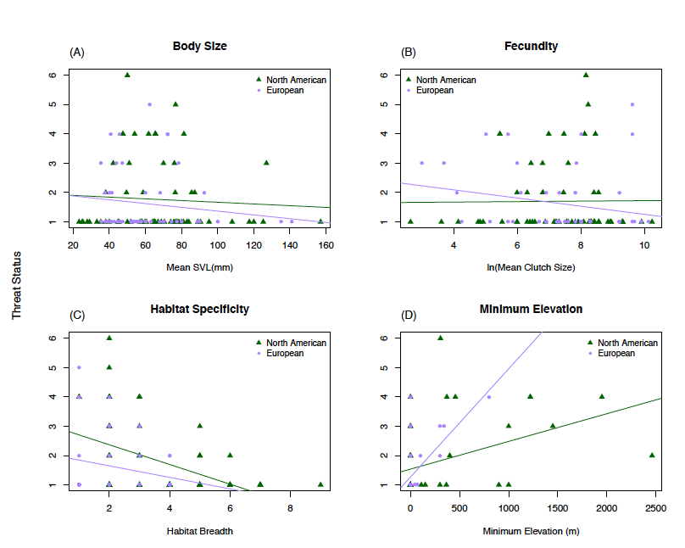

Figure 1: Linear regressions of threat status vs. (A) SVL, (B) logged clutch size, (C) habitat breadth, and (D) minimum elevation comparing North American frogs (green) and European frogs (purple).

|  |  |  |
| --- | --- | --- |
|  | **P-value** | **R2** |
| **North American Frogs** |  |  |
| Mean SVL | 0.634 | 0.0037 |
| Ln(Mean Clutch Size) | 0.940 | 1.0x10-4 |
| Habitat Breadth | 8.35x10-5 * | 0.22 |
| Minimum Elevation | 5.49x10-3 * | 0.18 |
| **European Frogs** |  |  |
| Mean SVL | 0.336 | 0.020 |
| Ln(Mean Clutch Size) | 0.120 | 0.050 |
| Habitat Breadth | 0.084 | 0.047 |
| Minimum Elevation | 2.07x10-5 * | 0.39 |
| **European Salamanders** |  |  |
| Mean SVL | 0.433 | 0.02 |
| Ln(Mean Clutch Size) | 8.92x10-4 * | 0.28 |
| Habitat Breadth | 0.255 | 0.048 |
| Minimum Elevation | 0.292 | 0.037 |

Table 1: P-values and R2 values for all linear regressions in Figures 1 and 2 predicting threat status from mean SVL, natural logged clutch size, habitat breadth, and minimum elevation. Statistically significant p-values are noted with a *.

**European Frogs vs. Salamanders: Linear Models**

Figure 2 visualizes the relationship between threat status and SVL, clutch size, habitat breadth, and minimum elevation for European frogs (Anura) and salamanders (Urodela). As discussed previously, minimum elevation was the only statistically significant correlate of extinction risk for European frogs (P = 2.07x10-5, r2 = 0.39). In contrast, clutch size was found to be the only significant correlate for salamanders. The natural log of clutch size was found to negatively correlate with threat status (P = 8.92x10-4, r2 = 0.28). No significant correlation was found for SVL (P = 0.433, r2 = 0.02), habitat breadth (P = 0.255, r2 = 0.048), and minimum elevation (P = 0.292, r2 = 0.037).

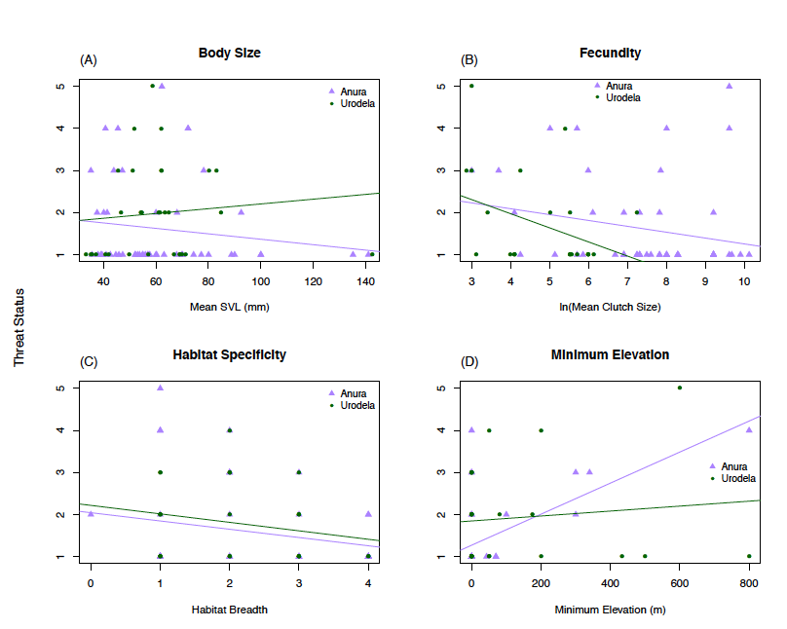

Figure 2: Linear regressions of threat status vs. (A) SVL, (B) logged clutch size, (C) habitat breadth, and (D) minimum elevation comparing European frogs (purple) and salamanders (green).

**North American Frogs: Paired Wilcoxon Test**

For North American frogs, I performed a paired Wilcoxon signed rank test, comparing each of the four traits of interest between threatened species and their closest non-threatened relative. This was repeated for all four variables, each time with a null hypothesis that there is no difference in threatened and non-threatened species’ SVL, clutch size, habitat breadth or minimum elevation. All variables were log-transformed. Figure 3 visualizes this analysis by plotting boxplots of the ratio of the non-threatened species value to the threatened one.

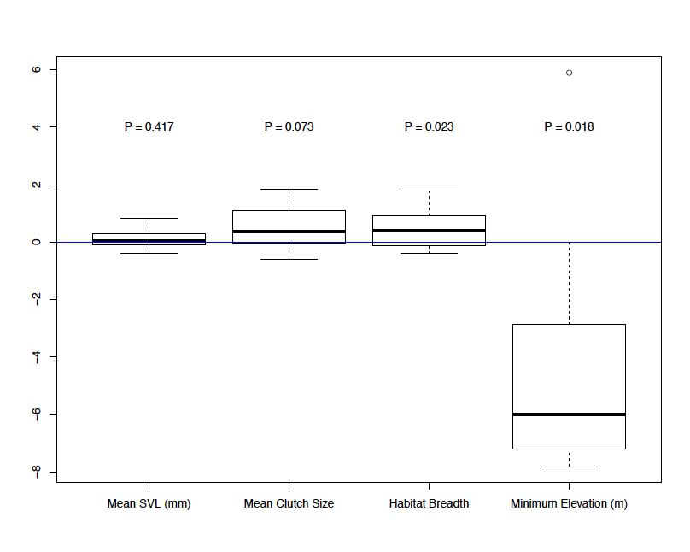Figure 3: Boxplots visualizing variation in ratios for the paired Wilcoxon signed rank test. Pairs consisted of threatened species and their most closely related non-threatened species. Ratios calculated by dividing the natural-logged non-threatened species SVL, clutch size, habitat breadth, and minimum elevation values by the threatened species values.

As shown in figure 3, only habitat breadth (P = 0.023) and minimum elevation (P = 0.018) had statistically significant p-values. I could thus reject their null hypotheses, concluding that the habitat breadth and minimum elevation of threatened and non-threatened North American frogs differ. Looking at figure 3 the mean of the logged habitat breadth boxplot is above zero indicating a ratio greater than zero, implying that non-threatened species (numerator) have greater habitat breadths than non-threatened species. The mean of the logged minimum elevation boxplot is below zero implying the threatened species (denominator of the ratio) have greater minimum elevations than the non-threatened species. Both implications support the results of the North American frogs’ linear regressions from the first analysis that habitat breadth negatively correlates and minimum elevation positively correlates threat status.

**DISCUSSION**

My analyses aimed to examine SVL, clutch size, habitat breadth, and minimum elevation as potential correlates of extinction risk in North American and European amphibians. Some results corroborated past findings, while others departed from previous literature conclusions. Habitat breadth, minimum elevation, and clutch size all showed successful correlations for at least one of the amphibian groups I studied, but they differed among groups. None were found to be successful correlates in all groups, indicating potential geographic and taxonomic affects on extinction risk correlation.

Large body size is one of the most commonly cited extinction risk correlates for many taxa such as mammals (Cardillo, 2003), reptiles (Tingley, Hitchmough, & Chapple, 2013), and fish (Reynolds, Dulvy, Goodwin, & Hutchings, 2005). Surprisingly snout-vent-length was not found to be a successful correlate of extinction risk in North American frogs, European frogs, or European salamanders. This contradicted previous findings that SVL is a correlate of extinction risk for amphibians in Central America (Lips et al., 2003), but agreed with other literature that found no correlation in Australian frogs (Murray & Hose, 2005). This indicates that body size might not impact amphibian threat status, or if it does the correlation could be regional and not global. Since many biological correlates of extinction risk are threat-specific, the Central American amphibians could be exposed to a particular threat that has a greater affect on larger amphibians.

Habitat specificity, measured by habitat breadth was found to negatively correlate with threat status in North American frogs in both linear regression and paired test analyses. This corroborates previous studies of amphibian extinction risk (Cooper et al., 2008; Williams & Hero, 1998) as well as other studies that found habitat specialism to be a successful correlate of risk across variable taxa such as butterflies (Koh, Sodhi, & Brook, 2004) birds (Owens & Bennett, 2000), and squamate reptiles (Tingley et al., 2013; Bohm et al., 2016). Species with small habitat breaths and thus high habitat specificity are more at risk. This follows the idea that having high habitat specificity makes it harder for species to withstand habitat modification (Purvis et al., 2000) and they are thus more susceptible to habitat loss and climate change (Cooper et al., 2008).

But the strength of this correlation between habitat specificity and risk could also be magnified due to the influence of geographic range size correlations, not directly included in my research. Geographic range size has been well-documented as one of the most influential correlates of extinction risk across taxa (Cooper et al., 2008; McKinney, 1997; Purvis et al., 2000; Hero & Morrison, 2012; Jones, Purvis, & Gittleman, 2003), and has been shown to correlate with habitat specificity (Slayter, Hirst, & Sexton, 2013). So the correlation between threat status and habitat breadth that I found in North American frogs, could be due to geographic range size. In future research it would be beneficial to further analyze this relationship and tease apart the impacts of both variables.

Although habitat breadth was found to negatively correlate with extinction risk in North American frogs, no correlation was found for European frogs or salamanders.

But the lack of any significant correlation in European amphibians is interesting. This could be a sign of geographic variation’s influence on correlation success. As mentioned with body size previously, species declines are often threat-specific, and predominant threats in North America and Europe may differ. One source, Stuart et al. (2014) suggests the dominant cause for decline in the western United States is reduced habitat. Reduced habitat and enigmatic decline are common causes across North America (Stuart et al., 2014). But, they also found that habitat reduction was also the predominant cause of amphibian decline in Europe, so this does not explain the variation in my results. Potentially threats not included in this study such as infectious disease and pollution are playing a larger role.

Minimum elevation was found to positively correlate with threat status in both North American and European frogs. The paired t-test in North American frogs verified this correlation. This correlation agrees with previous findings (Lips et al., 2003; Hero & Morrison, 2012). Many other life history traits correlate with elevation and could be impacting this relationship. According to Hero and Morrison (2012) amphibians living at higher elevations tend to produce fewer clutches per year, have shorter breeding periods, and reach sexual maturity later. These are all traits that make it harder for a species to bounce back from mortality increases (MacArthur & Wilson, 1967). Once again though it is important to note the connection between minimum elevation and geographic range size. Higher minimum elevation suggests restricted range sizes (Davies et al., 2006) and small geographic range size is often correlated with amphibian threat status. It is impossible to distinguish the amount of correlation in my research actually due to elevation and that which is due to geographic range size. This is something that should be addressed in future research.

Although minimum elevation was positively correlated with extinction risk in European frogs, no correlation was found for European salamanders. Minimal salamander data has been included in previous amphibian extinction risk research, and never analyzed alone. So this result cannot be compared to previous literature. The presence of a significant correlation for frogs but not salamanders could be a sign of the taxonomic variation in the importance of elevation as a biological correlate. Elevation and the life history traits correlated with it could not have a major impact on the threats salamanders face. Or, they could but there isn’t enough quality data to observe these results, which I will discuss later on.

Clutch size was only found to be a successful correlate of extinction risk for European salamanders. Due to lack of data, I did not perform analyses on North American salamanders so it is unknown whether or not they too show clutch size correlations.

It is found to be successful in various taxa such as mammals (Cardillo, 2003; Purvis et al., 2000) and frogs (Williams & Hero, 1998). This correlation makes sense as species with low fecundity have a harder time recovering from population declines (Hero & Morrison, 2012) and recently infectious diseases such as *Batrachochytrium salamandrivorans* have caused great declines in European salamander populations (Stegen et al., 2017). Once again, clutch size has been shown to correlate with geographic range size (Hero et al., 2005), and studies have even concluded that clutch size only impacts extinction risk indirectly through range size (Cooper et al., 2008).

Although not a direct variable in my analyses, geographic range size likely plays a role in all three of the significant correlations I found. Many previous studies have found it to be the most successful correlate of extinction risk (Bohm et al., 2016; Purvis et al., 2000; Cooper et al., 2008; Jones et al., 2003; McKinney, 1997; Hero & Morrison, 2012). Additionally it has been found to positively correlate with body size, clutch size and negatively correlate with elevation (Hero & Morrison, 2012). So further research is needed to tease apart geographic range size influences from the habitat breadth, minimum elevation, and clutch size extinction risk correlations. Geographic range size is also a criteria for critically endangered, endangered, and vulnerable threat status designations (IUCN, 2016), so this introduces the potential for circularity in my data analysis. In future analyses, if the dataset is large enough, removing threatened species listed due to the small range size designations could avoid this circularity.

Future research could also benefit from larger sample sizes. A large limiting factor in my research was data availability and quality. More data needs to be collected on amphibians, especially salamanders. Current available data is concentrated in certain geographic areas such as North America, and of the available data a large portion of it is for least concern species. Less data is available for rare species. Once more data is available it makes it easier to perform phylogenetically independent analyses to avoid pseudoreplication. It could also be beneficial for future research to further subdivide the species by threat type before performing these analyses, as many sources have suggested that certain correlates are threat-specific (Bohm et al., 2016). But regardless, these results do provide valuable information that could improve targeted conservation practices.

My results indicate that it could be beneficial for conservation efforts to focus on protecting areas containing North American frog species with low habitat breadths and high minimum elevations, European frogs with high minimum elevations and European salamanders with small clutch sizes. Further research will only improve upon these assessments.

**REFERENCES**

AmphibiaWeb (2017). Retrieved from http://amphibiaweb.org. University of California, Berkeley, CA, USA.

Böhm, M., Williams, R., Bramhall, H. R., McMillan, K. M., Davidson, A. D., Garcia, A., Bland, L. M., Bielby, J., & Collen, B. (2016). Correlates of extinction risk in squamate reptiles: the relative importance of biology, geography, threat and range size. *Global Ecology and Biogeography*, 25: 391–405. doi:10.1111/geb.12419

Cardillo, M. (2003). Biological determinants of extinction risk: why are smaller species less vulnerable. *Animal Conservation*, 6, 63–69.

Collins, J. P., & Storfer, A. (2003). Global amphibian declines: sorting the hypotheses. *Diversity and Distributions*, 9: 89–98. doi:10.1046/j.1472-4642.2003.00012.x

Cooper, N., Bielby, J., Thomas, G. H., & Purvis, A. (2008). Macroecology and extinction risk correlates of frogs. *Global Ecology and Biogeography*, 17: 211–221. doi:10.1111/j.1466-8238.2007.00355.x

Davies, R.G., Orme, C.D.L., Olson, V., Thomas, G.H., Ross, S.G., Ding, T.-S., Rasmussen, P.C., Stattersfield, A.J., Bennett, P.M.,Blackburn, T.M., Owens, I.P.F., & Gaston, K.J. (2006). Human impacts and the global distribution of extinction risk. *Proceedings of the Royal Society B: Biological Sciences*, 273, 2127–2133.

Fritz, S.A., Bininda-Emonds, O.R.P., & Purvis, A. (2009). Geographical variation in predictors of mammalian extinction risk: big is bad, but only in the tropics. *Ecology Letters*, 12, 538–549.

Harvey, P.H., & Pagel, M. (1991). *The comparative method in evolutionary biology*. Oxford University Press, Oxford.

Hedges, S.B., Marin, J., Suleski, M., Paymer, M., & Kumar, S. (2015). Tree of Life Reveals Clock-Like Speciation and Diversification. *Molecular Biology and Evolution*, 32, 835-845.

Hero, J.M., & Morrison, C. (2012). Life history correlates of extinction risk in amphibians. In H. Heatwole (Ed.), *Amphibian Biology: Conservation and decline of amphibians: Ecological aspects, effect of humans, and management* (Vol. 10, pp. 3567–3576). Australia: Surrey Beatty and Sons.

Hero, J.M., Williams, S.E., & Magnusson, W.E. (2005). Ecological traits of declining amphibians in upland areas of eastern Australia. *Journal of Zoology London*, 267, 221–232.

IUCN (2016), *The IUCN Red List of Threatened Species. Version 2016-3*. Retrieved from http://www.iucnredlist.org

Jones, K.E., Purvis, A., & Gittleman, J.L. (2003). Biological Correlates of Extinction Risk in Bats. *The American Naturalist,* 161(4), 601-614.

Koh, L.P., Sodhi, N.S., & Brook, B.W. (2004). Ecological Correlates of Extinction Proneness in Tropical Butterflies. *Conservation Biology*, 18, 1571–1578. doi:10.1111/j.1523-1739.2004.00468.x

Lips, K.R., Reeve, J.D., & Witters, L.R. (2003). Ecological traits predicting amphibian population declines in Central America. *Conservation Biology*, 17, 1078–1088.

MacArthur, R.H., & Wilson, E.O. (1967). *The theory of island biogeography*. Princeton University Press, Princeton, NJ.

McKinney, M.L. (1997). Extinction vulnerability and selectivity: combining ecological and paleontological views. *Annual Review of Ecology & Systematics*, 28, 495–516.

Murray, B.R., & Hose, G.C. (2005). Life-history and ecological correlates of decline and extinction in the endemic Australian frog fauna. *Austral Ecology*, 30, 564–571.

Owens, I.P.F., & Bennett, P.M. (2000). Ecological basis of extinction risk in birds: Habitat loss versus human persecution and introduced predators. *Proceedings of the National Academy of Sciences USA*, 97, 12144–12148.

Purvis, A., Gittleman, J.L., Cowlishaw, G., & Mace, G.M. (2000). Predicting extinction risk in declining species. *Proceedings of the Royal Society B: Biological Sciences*, 267, 1947–1952.

Purvis, A., Cardillo, M., Grenyer, R., & Collen, B. (2005). Correlates of extinction risk: phylogeny, biology, threat and scale. *Phylogeny and conservation* (ed. by A.Purvis, T.M.Brooks and J.L.Gittleman), pp. 295–316. Cambridge University Press, Cambridge.

Reynolds, J. D., Dulvy, N. K., Goodwin, N. B., & Hutchings, J. A. (2005). Biology of extinction risk in marine fishes. *Proceedings of the Royal Society B: Biological Sciences*, *272*(1579), 2337–2344. http://doi.org/10.1098/rspb.2005.3281

Slayter, R.A., Hirst, M., & Sexton, J.P. (2013). Niche breadth predicts geographical range size: a general ecological pattern. *Ecology Letters*, 16, 1104–1114.

Stegen, G., Pasmans, F., Schmidt, B.R., Rouffaer, L.O., Praet, S.V., Schaub, M., Canessa, S., Laudelout, A., Kinet, T., Adriaensen, C., Haesebrouck, F., Bert, W., Bossuyt, F., & Martel, A. (2017). Drivers of salamander extirpation mediated by *Batrachochytrium salamandrivorans.* *Nature,* 544, 353–356.

Stuart, S.N., Chanson, J.S., Cox, N.A., Young, B.E., Rodrigues, A.S.L., Fischman, D.L., & Waller, R.W. (2005). Status and Trends of Amphibian Declines and Extinctions Worldwide. *Science,* 306(5702), 1783-1786.

Tingley, R., Hitchmough, R.A., & Chapple, D.G. (2013). Life-history traits and extrinsic threats determine extinction risk in New Zealand lizards. *Biological Conservation*, 165, 62-68.

Williams, S.E. & Hero, J.M. (1998). Rainforest frogs of the Australian wet tropics; Guild classification an the ecological similarity of declining species. *Proc. R. Soc. Lond*, 265, 597-602.

Yuan, Z.Y., Zhou, W.W., Chen, X., Poyarkov, N.A. Jr., Chen, H.M., Jang-Liaw, N.H., Chou, W.H., Matzke, N.J., Iizuka, K., Min, M.S., Kuzmin, S.L., Zhang, Y.P., Cannatella, D.C., Hillis, D.M., Che, J. (2016). Spatiotemporal Diversification of the True Frogs (Genus *Rana*): A Historical Framework for a Widely Studied Group of Model Organisms. *Systematic Biology,* 65(5), 824-842. doi: 10.1093/sysbio/syw055