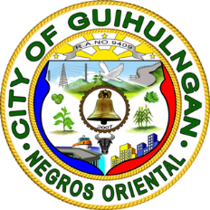Republic of the Philippines

Province of Negros Oriental

City of Guihulngan

**OFFICE OF THE SANGGUNIANG BARANGAY**

**BARANGAY POBLACION**

(035) 410-4922

**CERTIFICATION**

**TO WHOM IT MAY CONCERN:**

This is to **CERTIFY** that **[NAME]**, [AGE] years of age, is a bonafide resident of [ADDRESS], Barangay Poblacion, City of Guihulngan, Province of Negros Oriental, Philippines.

This is to **CERTIFY** further that **[NAME]** is known to me to be a SOLO PARENT in this Barangay.

This **CERTIFICATION** is issued upon verbal request of [NAME] in compliance with her application for SOLO PARENT with the City Social Welfare and Development, Guihulngan City, Negros Oriental.

Given this [DAY] day of [MONTH], [YEAR] at the Barangay Poblacion, City of Guihulngan, Province of Negros Oriental, Philippines.

**[CAPTAIN]**

Barangy Captain

O. R. NO.: **[OR_NUMBER]**

Date: **[DATE]**