**EForT-EFTT- Empowered Forex Traders Trend Trading**

**Fall 2019**

Aaron Albiza

Joel De La Cruz

Contents

**Overview** 2

**Tech Stack** 2

Background 2

**Detailed Design** 4

DLC Bullish Cross Signal 6

Simple Cross MA 7

BigDaddyRubberBandExpert 8

CashBullExpert 8

BigBoiExpert 9

Expert Advisor Year Profit 12

Graph Analysis 13

**Sprint Roadmap** 14

Meetings 14

**Overview**

**Project Summary**  
We needed to design and implement an expert trader based on the Big Daddy Rubberband Strategy. Throughout the course of this project, we will focus on using the progress made previously on this adviser as well as doing our best to improve upon it. The end result should be an expert advisor that is able to make profitable decisions on the market.

After analyzing how the RubberBandExpert worked. I understood that pattern-detecting signals like the Head and Shoulders signal depended on the trend-detecting signal SignalMA, which is a simple MA cross. It does not accurately determine the trend of security. So I researched deeply into trend-detection methods and eventually determined that supplementing the SignalMA with a bullish/bearish cross would heavily increase our trend-detection accuracy and therefore cascade into pattern-detection accuracy, and profits!

Learn more: <https://dev.azure.com/FA19-EForT-EFTT/FA19-EForT-EFTT/_wiki/wikis/FA19-EForT-EFTT.wiki/5/DLC-Bullish-Cross-Signal-and-the-BigBoiExpert-CashBullExpert>

**Tech Stack**

**Planning and Development:**

1. Azure DevOps(CI/CD, Planning, Packaging)
2. Git(Version Control)

**MetaTrader Expert Advisor**

1. MQL5

# ****Background****

**Security**  
A security is a fungible, negotiable financial instrument that holds some type of monetary value.

**Moving average**  
A moving average is an average price for a security using a specified time period.

Moving averages are used by many traders to not only identify a current trend but also as an entry and exit strategy.

**Whipsaw**  
Whipsaws are abrupt moves in the opposite and unexpected direction

**Faster-moving average**  
A faster-moving average is a moving average that is more sensitive. Usually, the period will be less than 20. A faster moving average can give an early signal. This enables the trader to be able to take action faster.

However, it has a downside. Faster moving averages tend to have more abrupt moves in the opposite and unexpected direction.

**Slower-moving average**  
A slower-moving average is a moving average that is less sensitive. It usually involves periods longer than 20. This makes the signal given slower but it helps to reduce whipsaws.

Examples of slower-moving averages are 50 MA, 100 MA or 200 MA.

**Expert Advisors**  
An Expert Advisor is an automated trading system linked to a chart. An Expert Advisor contains event handlers to manage predefined events which activate execution of appropriate trading strategy elements. For example, an event of program initialization and deinitializtion, new ticks, timer events, changes in the Depth of Market, chart and custom events.

They are capable of performing any action following the instructions of a trader, without his direct involvement. All tasks are performed automatically or mechanically, which is why the advisors are called experts or mechanical trading systems.

**MQL5**  
MetaQuotes Language 5 (MQL5) is a specialized high-level object-oriented programming language that allows creating trading robots and technical indicators. It is based on the concepts of the well-known and popular C++ programming language. However, due to its narrow specialization, MQL5 thrives in financial market programming challenges.

MQL5 allows for the creation and usage of forex expert advisors. These advisors can then be given signals and further customized with weights and other variables to automatically make trades. It also allows for the testing of your expert advisor using a testing account which mimics real world usage of the expert advisor in order to test if the advisor is profitable.

MQL5 also contains an expert advisor creation wizard allowing for an endless amount of unique advisors to be created. This creation tool allows for the expert advisors signals code to be auto generated and then further edited to meet your needs.

# ****Detailed Design****

After analyzing how the RubberBandExpert worked. I understood that pattern-detecting signals like the Head and Shoulders signal depended on the trend-detecting signal SignalMA, which is a simple MA cross. It does not accurately determine the trend of security. So I researched deeply into trend-detection methods and eventually determined that supplementing the SignalMA with a bullish/bearish cross would heavily increase our trend-detection accuracy and therefore cascade into pattern-detection accuracy, and profits!

**Simple MA Cross Signal**  
The security's open price crossed above or below the moving average, indicating an upward trend.

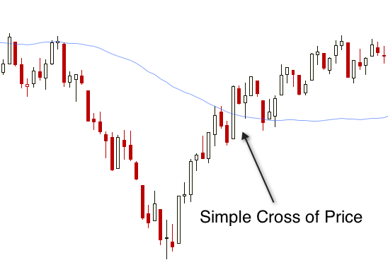

**Bullish Cross Signal**  
A bullish cross happens when a faster-moving average crosses a slower moving average.

When the faster moving average moves above the slower moving average, it can often give us an early signal of a potential new bullish uptrend.

**Example**

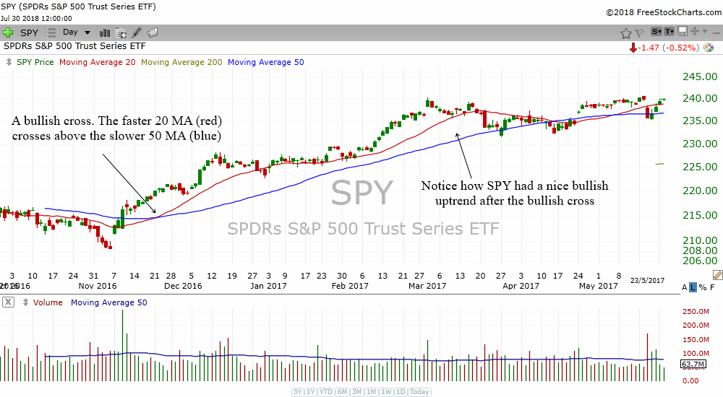

# ****DLC Bullish Cross Signal****

The DLC Bullish Cross Signal is a trend-detecting signal. It will ultimately be used to drive the pattern-detecting signals in the final, improved expert advisor.

It merges the two above signals into one highly optimized signal that accurately determines trends.

**Diagram**

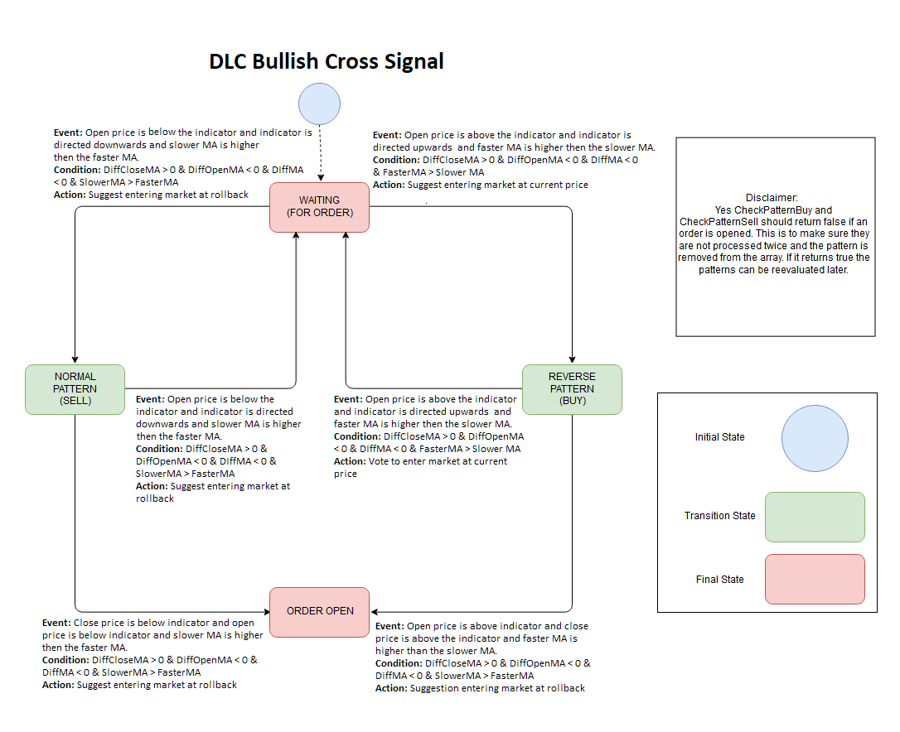

# ****Simple Cross MA****

The Simple Cross MA or SignalMA is a signal that makes use of a moving average and then checks whether our moving average is currently above or currently bellow the price. This will then influence whether we would like to buy or sell.

**Diagram**

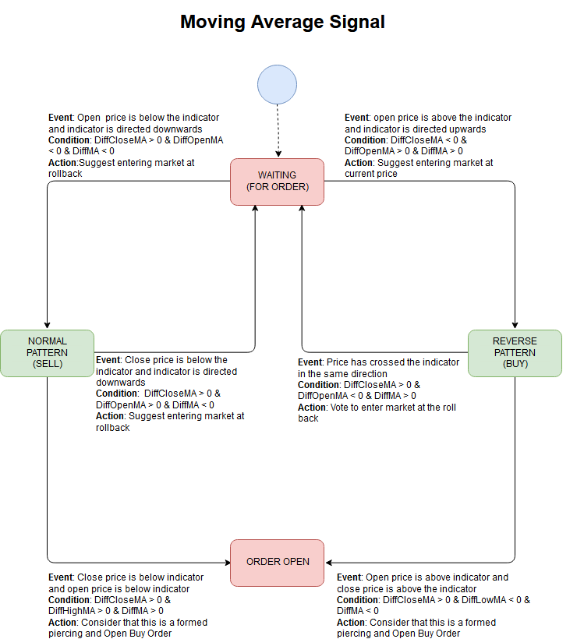

**Best Periods**  
There is no one size fits all answer to this question.

We need to test around and find the best one for us. We will make periods for our MAs easily configurable.

# ****BigDaddyRubberBandExpert****

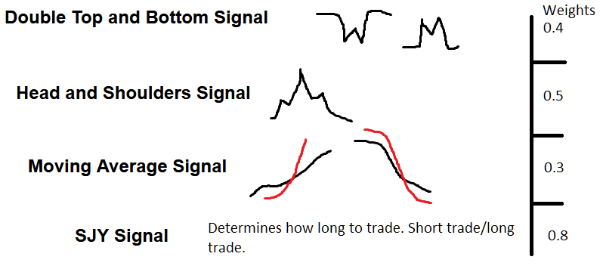

Double Top and Bottom Signal – Predicts and identifies W and M shapes on the graph.  
Head and Shoulders Signal – Predicts and identifies mountain-like shape like shown above.  
It shows a minor peak, then a minor peak, then a major drop.  
Moving Average Signal – Checks if the given moving average is above the current sell price.

# ****CashBullExpert****

The replaces the SignalMA from the BigDaddyRubberbandExpert with the DLC Bullish Cross, and sets the weights to 0.3. Keeping the previous weights for the Double Top and Bottom Signal, Head and Shoulders Signal and SJY signal.

# ****BigBoiExpert****

The BigBoiExpert is the same architecture as the CashBullExpert but uses a longer moving average which resulted in an increase in profits form the CashBullExpert by 143.74 %. This expert advisor, however, produces fewer sales and is, therefore, harder to present and analyze.

**Class Diagram - BigBoiExpert/CashBullExpert**

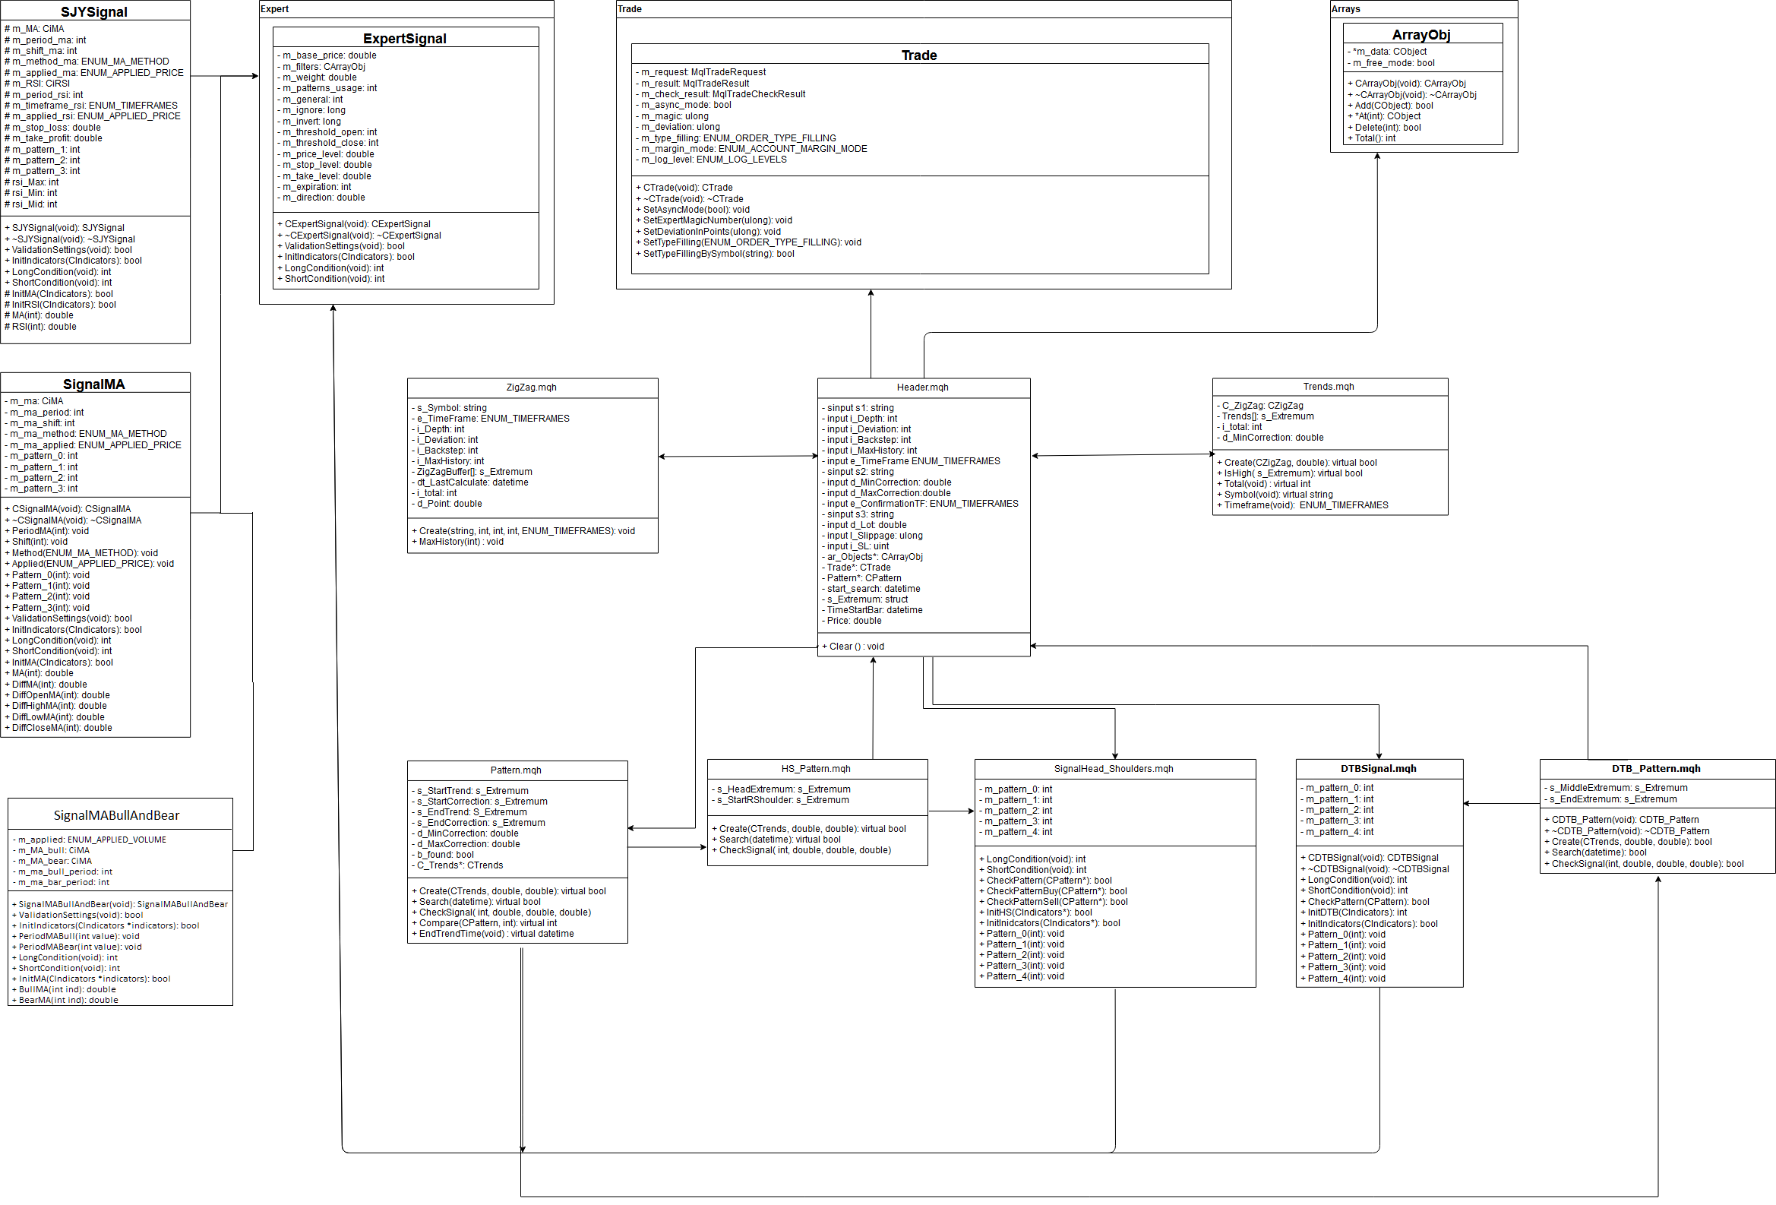

**Sequence Diagram - MA BullAndBear**

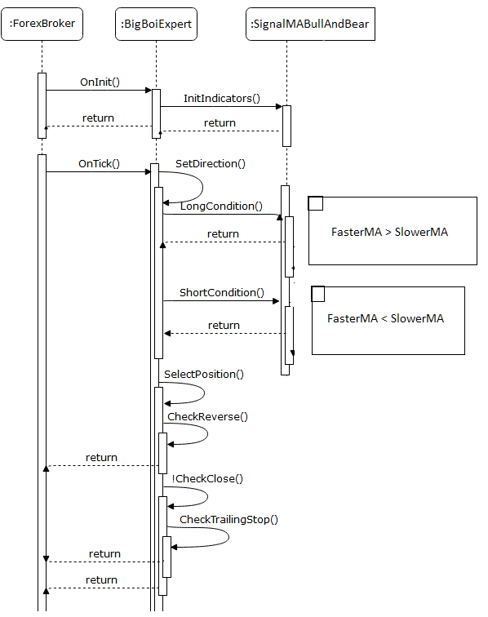

**Sequence Diagram – Signal MA**

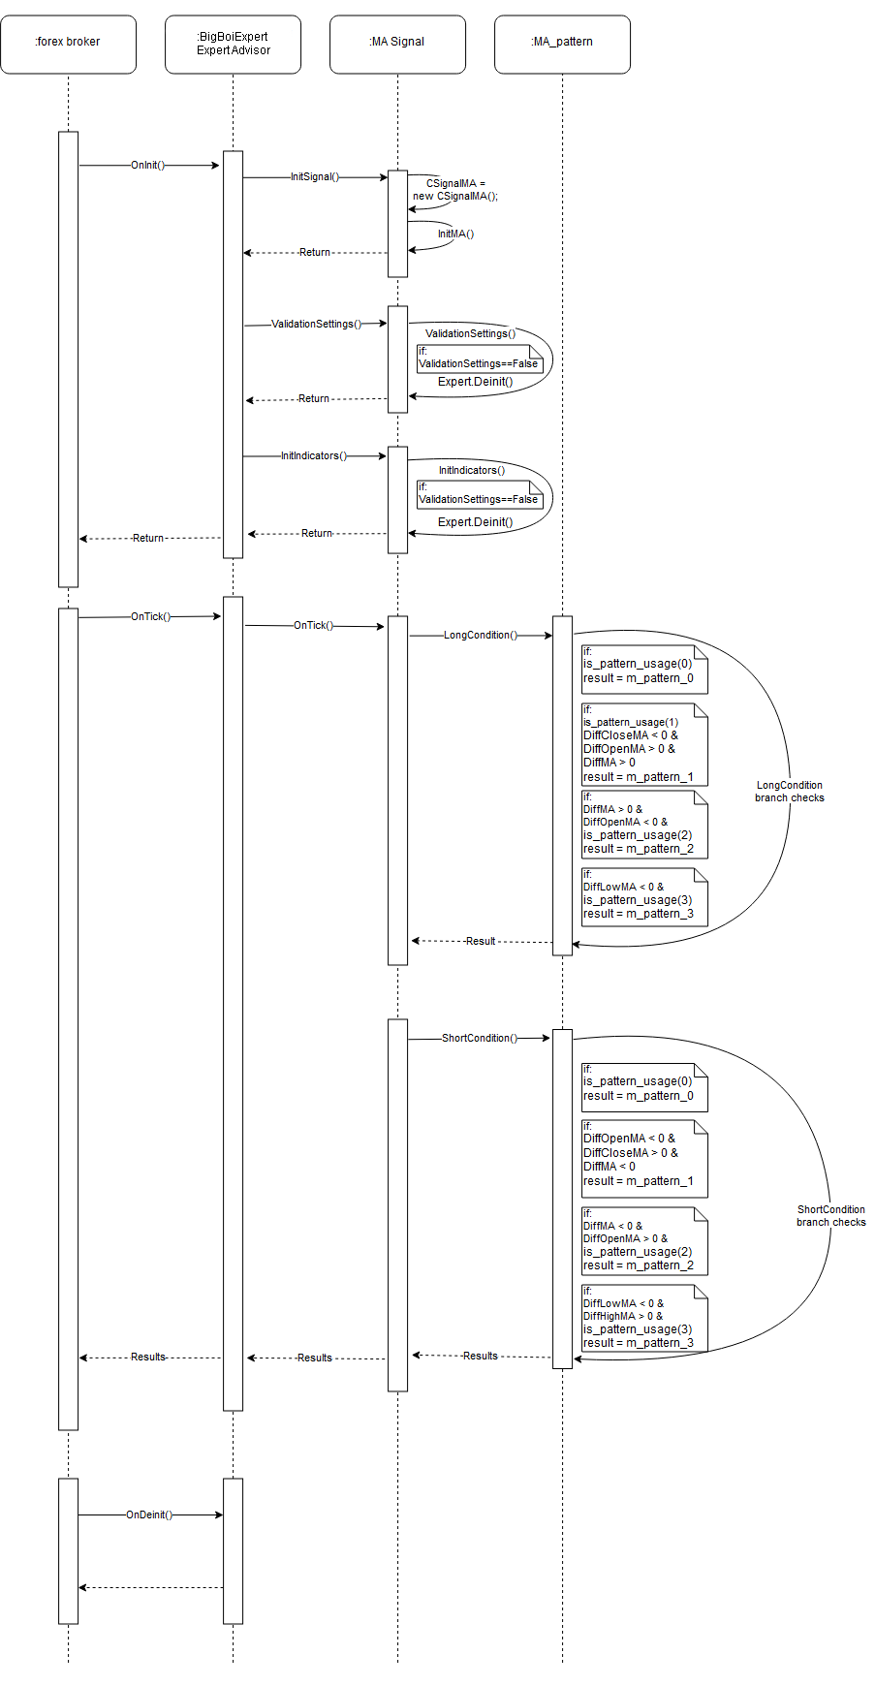

**Architecture Diagram**

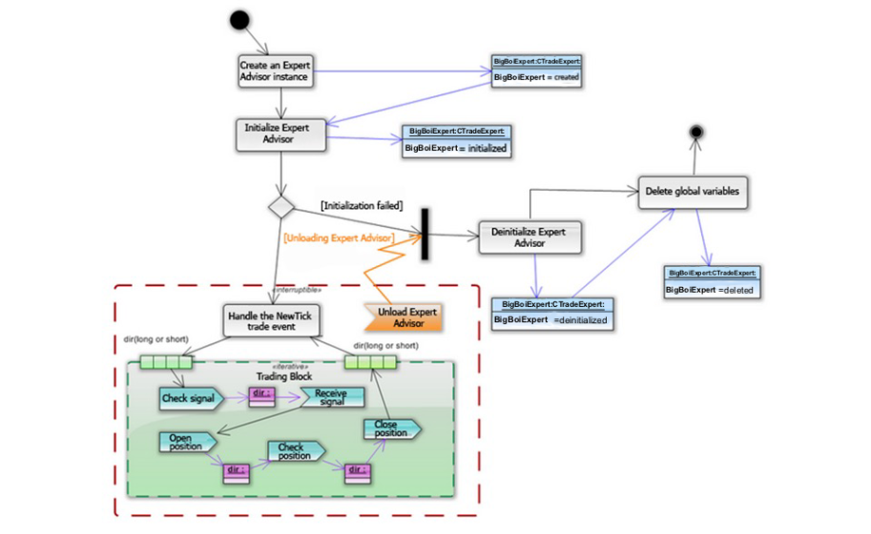

**Expert Advisor Year Profit**

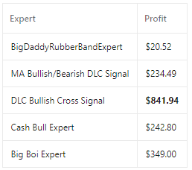

# **Graph Analysis**

**Signal Bull And Bear DLC Signal**

Notices how it buys during a bullish cross and sells during a bearish cross.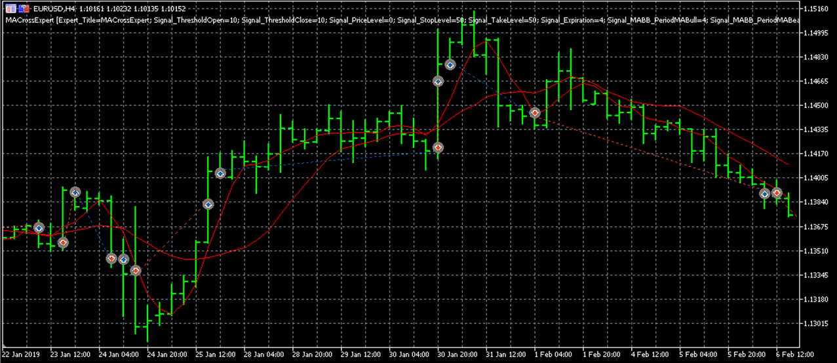

**Cash Bull Expert**  
Notice as it buys during a head and shoulders pattern with a bullish cross and sells at a peak.

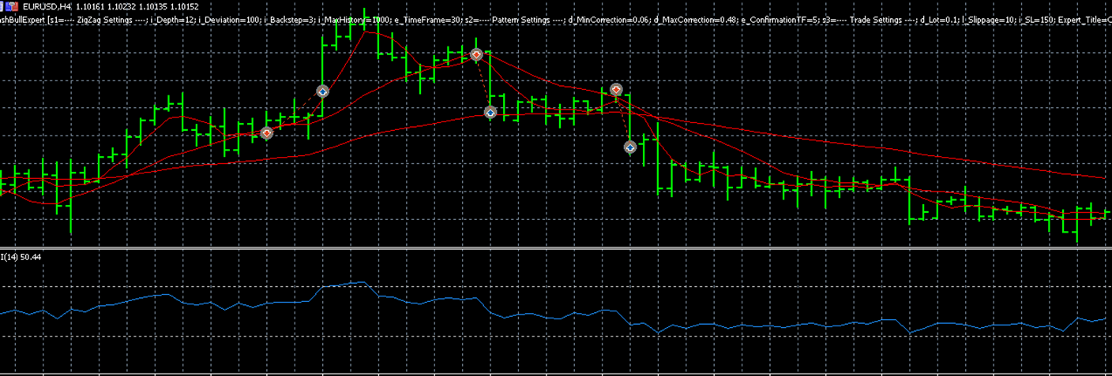

**Big Boi Expert**

We can see here that the trades this expert makes are very scarce. Amounting to an overall profit.

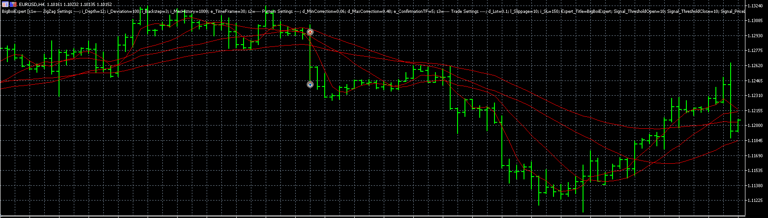

# ****Sprint Roadmap****

| **Sprint** | **Start Date** | **End Date** | **Epic Assigned** |  |
| --- | --- | --- | --- | --- |
| 1 | 9/10 | 9/23 | Create & groom documentation for the DLC Bullish Cross Signal |  |
| 2 | 9/24 | 10/07 | Create the DLC Bullish Cross Signal |  |
| 3 | 10/08 | 10/21 | Create the DLC Bullish Cross Signal |  |
| 4 | 10/22 | 11/04 | Integrate the DLC Bullish Cross into the BigDaddyExpert |  |
| 5 | 11/05 | 11/18 | Test & Refine the DLC Bullish Cross Signal |  |
| 6 | 11/19 | 12/02 | Create & groom documentation for the DLC Bullish Cross Signal |  |

# ****Meetings****

Total Meeting Time Per Sprint: 6 hours

| **Meeting** | **Weekday** | **Start** | **End** |
| --- | --- | --- | --- |
| Daily Stand-Up | Monday-Friday | 1:50pm | 2:05pm |
| Sprint Planning | Tuesday(Start of sprint) | 3:20pm | 4:00pm |
| Sprint Review | Monday(End of Sprint) | 2:50pm | 3:50pm |
| Sprint Retrospective | Monday(End of Sprint) | 3:50pm | 4:50pm |
| Sprint Grooming | Monday(Middle of Sprint) | 3:50pm | 4:50pm |

**Daily Stand-Up Instructions**

1. What have you completed?
2. What are you doing today?
3. Any impediments?
4. How can we resolve the impediments?

**Sprint Planning Instructions**

1. Add from backlog to new Sprint, planning for 40 hours worth of work. Consider the epic for the sprint.

**Sprint Review + Retrospective Instructions**

1. What did we finish?
2. What did we not finish?
3. What did we do well?
4. What did we do poorly?
5. What should we start doing to do better next sprint?
6. What should we continue doing to do well next sprint?
7. What should we stop doing to do better next sprint?