The script’s comment should tell you all there is to know. Although, here are some elements that may be useful.

* With no dedicated time to maintain the system, I designed it to be easy to update. Therefore, the current version is the one that requires the least time to maintain and offers the best stability. I let some element of alternative versions in the script (it mentions if the line does nothing). It is up to you if you want to make some changes, some parts may as well be replace with a function.
* Mars offers some challenges. It is not possible to add a note or a picture without opening the document in mars. You need a human to do so.
* Mars will also easily refuse to open a .mrs file. The all system is built around it. Other options, like sending the file with slack or by email, don’t work.

Set up of the system:

* Deploying a server: if you already got one, that’s great. Otherwise, the simplest (and the cheapest) option is to go with AWS. It’s free for 12 month and pretty easy to set up (<https://towardsdatascience.com/how-to-run-rstudio-on-aws-in-under-3-minutes-for-free-65f8d0b6ccda>). The main downside is there is no server location in Switzerland (one in Zurich should be added in 2022).
* Creating a dropbox account. You need to share the folder with the end user (the list of user is at the end of this document). I use rdrop2 library in R. You need to create a “token.rds” file with the key to access your dropbox for R. (don’t remember how I’ve done it but wasn’t really hard).
* You may have to create the mrs files (I will also transfer them via dropbox). Those are difficult. You can save it on your computer and then upload them on Rstudio in AWS and it works fine, also by dropbox. Although it fails if I put them on RStudio on my computer. Any tries via email or slack also make the file unreadable by Mars

Scheduling when the scripts run:

* The cron-schedule.R file is where the scheduling happens, at least with my linux based server. Be aware it’s the UTC time, so you must take that into account when scheduling, as well as time change (summer/winter). You need to make a quick update when that happens in March and October.

The scripts

I tried to comment as much as possible in the code. So, you should get all the necessary information. The ofsp one is the most detailed, the two loto one are pretty similar, with some more complexity for the swiss loto.

Covid numbers:

* The ofsp-automation.R file manage the covid numbers for the 3 languages
* It uses 3 differents url, the daily data for 14 days, the data since the beginning of the coronavirus and the page about variants (although I also retrieve the percentage from the main page, and it’s not currently in the text, but can be added back easily). Any changes to those can affect the outcome.
* It uses index (table indexes and then indexes in the table) to get the number, it’s quick to update in case of change.
* A bunch of functions are at the beginning of the script. The Italian version of the text uses a different function than the fr and de versions, because it’s shorter and hasn’t been changed as much as the two other languages.

Euro millions:

* The first automated script I made. Some things are not as optimized at they could be, but it’s running very smoothly for months.

Swiss Loto:

* Same base as euro millions, but more possible outcome. It covers most of them, but I may not have considered all the possible results, it’s always possible to update it with very unlikely results.
* Be aware that the swiss loto is updated in a messy way. They often update first the next cash prize, then the result, then the joker’s result.

List of email to add to the shared dropbox folder for covid:

benoit.studer@keystone-ats.ch

christian.rovere@gmail.com

clara.sidler@keystone-ats.ch

[cornelia.jost@hotmail.com](mailto:cornelia.jost@hotmail.com)

delphine.gasche@keystone-ats.ch

laina.berclaz@keystone-ats.ch

nene.vai@gmail.com

e_schaeppi@yahoo.com

emmanuelle.clerc@keystone-ats.ch

federico.bragagnini@keystone-ats.ch

benno.lichtsteiner@keystone-sda.ch

gerald.hammel@keystone-ats.ch

ats.redazione.italiana@gmail.com

inland@keystone-sda.ch

kimi_dego@hotmail.com

luca.nessi@keystone-ats.ch

martin.oesch@keystone-ats.ch

nicola.wenger@keystone-ats.ch

tania.buri@keystone-ats.ch

valerie.favez@keystone-ats.ch

vera.pagnoni@bluewin.ch

yoan.veya@keystone-ats.ch

List of email to add to the shared dropbox folder for loto:

benoit.studer@keystone-ats.ch

christian.rovere@gmail.com

clara.sidler@keystone-ats.ch

emmanuelle.clerc@keystone-ats.ch

fanny.scuderi@keystone-ats.ch

federico.bragagnini@keystone-ats.ch

gerald.hammel@keystone-ats.ch

kimi_dego@hotmail.com

martin.oesch@keystone-ats.ch

tania.buri@keystone-ats.ch

valerie.favez@keystone-ats.ch

yoan.veya@keystone-ats.ch

Structure of mrs file:

The catchword and the metadata are still in the original file, for the catchword it can be made into the script, but for the metadata I’m not so sure.

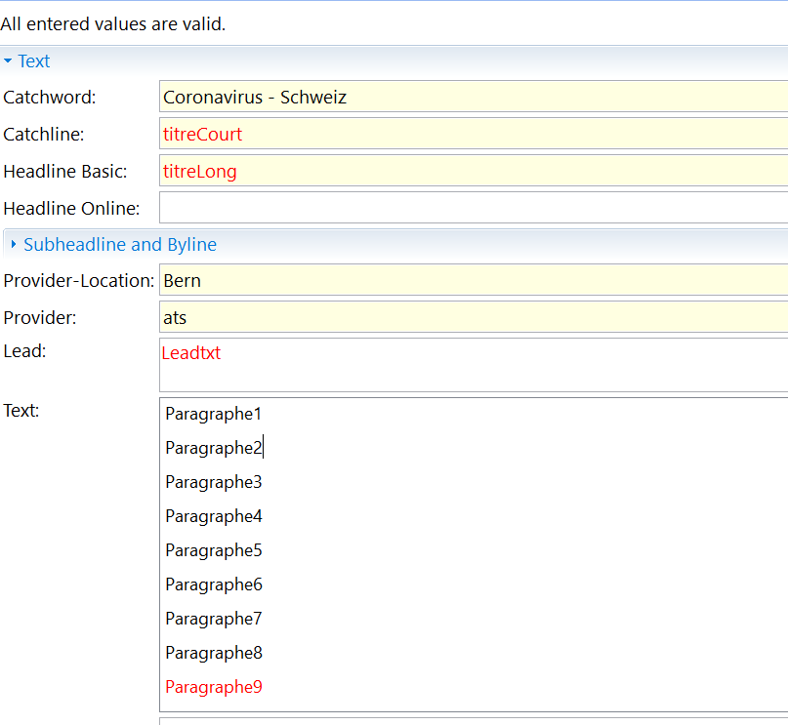

For the loto:

