**JAYPEE INSTITUTE OF INFORMATION TECHNOLOGY**

**DEPARTMENT OF CSE & IT**



**B. TECH 7TH SEMESTER, 2020**

**MAJOR PROJECT MID EVALUATION REPORT**

**Automated Testcase generation along with VSCODE Extension**

**Submitted By:**

1. **Abhishek Srivastava (17103334)**
2. **Rishabh Kejariwal (17103355)**
3. **Tanmay Agrawal (17103350)**

**Supervised By:**

**Mrs. Deepti Singh**

**TABLE OF CONTENTS**

**Chapter No. Topics Page No.**

**Chapter-1 Introduction** 5 - 6

1.1 Problem Statement 5 1.2 Frameworks to be used 5

1.3 Tools to be used 5

1.4 Project Repository Link 5

1.5 Work Distribution 6

1.6 Problem Significance 6

1.7 Familiarity with the tools and equipment’s used 6

**Chapter-2 Literature Review** 7 - 12

2.1 Summary of Each Paper

**Chapter-3 Problem Formulation** 13 - 15

3.1 Proposed Approach 13

3.2 Implementation Details 13

3.3 Database Schema Diagram 13

3.3 ER Diagram 14

3.4 Flowchart 15

**Chapter-4 Results** 16

4.1 Results Measuring Metric to be used 16

4.2 Expected Result 16

**Chapter-5 Conclusion and Identified Research Gaps**

3.1 Conclusion 17

3.2 Future Work 17

**Chapter- 6 References** 18

**Abstract:**

Testing is generally done on programming and additionally in web for testing customer and server engineering. Program testing is one of the major and essential procedures for accomplishing high quality software. Testing is accomplished to identify nearness of faults, which cause programming failures.

However, programming testing is a tedious and costly task. It expends practically half of the product frame work assets required for system development. Programming testing can likewise be characterized as procedure of confirming and validating program software to guarantee that product meets the specialized and in addition business necessities as expected in terms of technology.

Software testing is a major portion of software development process, so inspired by this thought we are trying to create a website where user can come and interact with the website and the website will help them to create testcases for their programming problems.

Like user can come and request testcases for graph or and array or a character array and side by side we are also giving them an api which they can use in their VSCODE to get the outputs for the inputs generated automatically.

Companies like **InterviewBit**, **Codechef**, **Codeforces**, **GeeksForGeeks**, **Atcoder** hire problem setters to create variety of programming problems for coding contest and their product library, the main issue faced here is the testcase generation.

We are trying to reduce this gap as to help the users to get the desired testcases in minutes.

This idea if implemented successfully can be a great help to above mentioned companies, also any user who is stuck on any coding problem can use this website to generate large testcases for the problem and test his or her solution with it.

**LIST OF FIGURES**

|  |  |  |
| --- | --- | --- |
| **Figure No.** | **Figure Name** | **Page Number** |
| Fig 1 | Database Schema Diagram | 13 |
| Fig 2 | ER Diagram | 14 |
| Fig 3 | Flow Chart | 15 |

**LIST OF ACRONYMS**

|  |  |  |
| --- | --- | --- |
| **S. No.** | **Acronyms** | **Representation** |
| 1. | HTML | Hypertext Markup Language |
| 2. | CSS | Cascading Style Sheet |
| 3. | JS | JavaScript |
| 4. | ROR | Ruby on Rails |
| 5. | ER | Entity Relationship |

**Problem Statement:**

To generate testcases on the server-side according to user preferences and then helping the user to generate the output files using VSCODE Extension.

Software testing is a major portion of software development process, so inspired by this thought we are trying to create a website where user can come and interact with the website and the website will help them to create testcases for their programming problems and also create an API which will help them to generate output files for the testcases they created by running the code on the user machines directly.

Like user can come and request testcases for graph or and array or a character array and side by side we are also giving them an api which they can use in their VSCODE to get the outputs for the inputs generated automatically.

**Languages/Frameworks to be Used:**

1. **Front-end:**

   

1. **Back-end:**

 **OR** 

**Tools Used:**

  

**Project Repository Link:**

<https://github.com/awpCode/MajorProject>

**Work Distribution:**

Tanmay Agrawal and Rishabh Kejariwal will work on the Backend design and complete implementation of the Backend and Abhishek Srivastava will mainly focus on the UI or the Front-end design of the Project and the integration of the Project with the VSCODE Extension

**Problem Significance:**

E-Learning is learning utilizing electronic technologies to access educational curriculum outside of a traditional classroom.  In most cases, it refers to a course, program or degree delivered completely online.

**For example:**

Consider companies like Codechef, GeeksForGeeks, InterviewBit, Codeforces help their users to practice competitive programming and also them to prepare for the interviews.

Major part of the brain storming is done by solving DSA Problems on their website, motivated by the problems users try to innovate and think of a new problem which they can create but they get stuck when it comes to testcase generation, We know this because we have worked as Problem Setters in those companies.

So, this project will mainly help those companies and those users to create testcases as of their choice in second also the api will help them to generate outputs on their local machines.

**Familiarity with the tools and equipment’s used:**

In Front-end we have experience in working with HTML, CSS, JS, Bootstrap and in Backend we have worked with Django, Ruby on Rails.

**Some Relevant Projects Created by us:**

1. <https://github.com/tanmay2904/Shared-Docs>
2. <https://github.com/awpCode/Drum-Kit>
3. <https://github.com/awpCode/Blogging-Website>
4. <https://github.com/awpCode/MessageMe>

**LITERATURE SURVEY:**

1. **Comparative study on test case generation [1]**

In this paper, applications of Genetic Algorithm in different types of program testing is discussed. It is found that by using Genetic Algorithm, the performance and the outcomes of testing can be highly improved.

Firstly, they generate test case generation using model-based testing, random based testing, genetic algorithm and test scenarios from the activity diagram and then for each scenario the corresponding sequence diagram should be generated. After analysing and investigating each category, its critical values and constraints are produced and particular test cases are determined. Test coverage criteria achieved is another advantage of their approach.

1. **Automatic Software Test Case Generation [2]**

Software testing is the process of executing a program in order to find faults. Testing is a very important, though expensive phase in software development and maintenance; it has been estimated that software testing entails between 30 percent and 50 percent of software development [1].

A challenging part of this phase entails the generation of test cases. This generation is crucial to the success of the test because it is impossible to achieve a fully tested program given that the number of test cases needed for fully testing a software program is infinite, and a suitable design of test cases will be able to detect a great number of faults. For these reasons, the techniques for automatic generation of test cases try to efficiently find a small set of cases that allow an adequacy criterion to be fulfilled, thus reducing the cost of software testing and resulting in more efficient testing of software products.

A test case is a set of tests performed in a sequence and related to a test objective, which will produce a number of tests comprising specific input values, observed output, expected output, and any other information needed for the test to run, such as environment prerequisites [2].

In this paper we represented two different classification frameworks for the existing automatic test case generation approaches, and also have a brief look at each one. We described how to evaluate generated test cases, and introduce a classification of evaluation approaches. The results show that different approaches should be selected based on types of applications, features of software we want to test, technique’s complexity, and other features. Although there have been lots of researches on automatic test case generation problem, but for real world systems more researches are still needed.

# Content Management in Ruby on Rails [3]

Web development is currently driven by model-view-controller (MVC) frameworks. How has content management adapted to this scenario? This paper reviews content management features in Ruby on Rails framework and its most popular plug-ins. These features are distributed among the different layers of the MVC architecture.

How has content management adapted to the arrival of web development frameworks? Using frameworks for web development has become a common practice. Model-view-controller (MVC) patterns facilitate development. They hide complexity, give structure and consistence and promote best practices. Their code is better tested. Finally, a framework becomes popular if it has something useful to offer.

# Content management features keep up with Ruby on Rails development framework. Most of them are integrated in the framework itself, while others are distributed as plug-ins. However, some of them are more popular than others, even than the most popular full-featured content management solution. Content management features are transversal to the MVC architecture, they use some or even all the layers.

# New technologies for web development [4]

# The paper gives an overview of the new features of web technologies. The general idea of the new version of HTML (Hyper Text Mark-up Language), i.e. HTML5, and other tools presented in this paper is the formal specification and the establishment of uniform solutions for technologies and functionalities which have already been in use through various hacks and plug-ins proposed by web developers. Many of these functionalities will now be implemented in browsers. The applications can access these functionalities through newly defined application programming interfaces. The latter include support for multimedia, dynamic graphic rendering, geolocation, multithreading local data storage etc. HTML5 also introduces semantic mark-up, which can be used for marking the document structure as well as its elements and data. The new version of HTML enforces strict separation of the page content from its style. The styling can only be done using CSS (Cascading Style Sheets) language. The new CSS version, i.e. CSS3, has a modular structure, in which different modules define different styling features. The development cycles of the individual modules are independent as well as their support and implementation in various browsers. The general idea of HTML5 and other tools presented in this paper is the formal specification and the establishment of uniform solutions for technologies and functionalities which have already been in use through various hacks and plug-ins proposed by web developers.

1. **A Django Based Educational Resource Sharing Website [5]**

Technological Implementations in the field of Academics has helped Students as well as Professionals in very important ways. The availability of all educational resources helps the students a lot in their educational life. The paper illustrates a website model with the help of which Students can be able to access class notes, previous year question papers, syllabus, and can sell their old books from the same digital platform as well. The paper also describes the role of software engineering in project development. The project is developed on Django Framework; the backend development is in Python, Jinja2 and SQLite. The frontend consists of HTML, CSS and Java. Appropriate SDLC Model and Testing techniques have been used in the development process. Each step of the SDLC Model (Iterative Model) is described thoroughly and respective ER Diagrams and Flow Charts have been shown. The project developed is highly efficient, user-friendly and simple.

After analyzing the results obtained by the authors, the project developed can be considered satisfiable. It can be concluded that the website will be very helpful to students in their educational life as it provides all educational resources required in a college or school life. As the project works as an Educational cum E-Commerce Website and thus students can donate or sell their old books too.

1. **Agile Development using Ruby on Rails Framework [6]**

Since Ruby on rails was established in 2004, ruby on rails is speedily becoming a powerful and standard framework for building web application. Rails is a development tool which gives web developers framework, providing structure for all the code they write. The Rails framework helps developers to build websites and applications, because it abstracts and simplifies common repetitive tasks. One of key principles of Ruby on Rails development is convention over configuration. This means that the programmer does not have to spend a lot of time configuring files in order to get setup, Ruby on Rails comes with a set of conventions which help speed up development. In this research paper we included detail information about Ruby on Rails like advantages of Ruby on Rails, MVC Architecture of Rails, Rails Framework and component of Ruby on Rails. Then explained Agile in detail. In agile we explained Agile Approach in Ruby on Rails, Agile Web Development Process, and explained Agile Development Methodology in Ruby on Rails for developing application. Then researcher has explained the web application which is develop in Ruby on Rails this application is develop by researcher.

Ruby on Rails is an open source web application development framework focused on Ruby programming languages and used extensively by agile programmer team has been popular for rapid web application development. The interesting aspect of ROR is programmer specify unusual configuration and as well as information used is unique and not duplicate. Rails is a perfect platform for Agile development practices. Ruby on Rails is extraordinary framework for creating web applications writing very little code in comparison.

1. **On the Analysis of Cascading Style Sheets [7]**

Developing and maintaining cascading style sheets (CSS) is an important issue to web developers as they suffer from the lack of rigorous methods. Most existing means rely on validators that check syntactic rules, and on runtime debuggers that check the behaviour of a CSS style sheet on a particular document instance. However, the aim of most style sheets is to be applied to an entire set of documents, usually defined by some schema. To this end, a CSS style sheet is usually written w.r.t. a given schema. While usual debugging tools help reducing the number of bugs, they do not ultimately allow to prove properties over the whole set of documents to which the style sheet is intended to be applied.

In this paper authors propose a novel approach to fill this lack. They introduce ideas borrowed from the fields of logic and compile-time verification for the analysis of CSS style sheets. They present an original tool based on recent advances in tree logics. The tool is capable of statically detecting a wide range of errors (such as empty CSS selectors and semantically equivalent selectors), as well as proving properties related to sets of documents (such as coverage of styling information), in the presence or absence of schema information. This new tool can be used in addition to existing runtime debuggers to ensure a higher level of quality of CSS style sheets.in comparison.

1. **Responsive Web Design and Web Development Using Bootstrap Framework [8]**

Responsive Web design and Web Development which is aimed to provide design and development should respond to the user’s behavior and environment based on screen size, platform and orientation. A web design implementation consists of a mix of flexible grids and layouts, images and an intelligent use of HTML5 & CSS3 media queries. The web site layout changes based on the size and capabilities of the device. As the user switches from their laptop to Smartphone or any other such devices like iPad, iPhone, Tablet, etc., the website should automatically switch to provide accommodation for resolution, image size and scripting abilities. The website should have the technology to automatically respond to the user’s preferences. It is worth putting extra consideration that, this would remove the need for a different design and development phase for each new gadget on the market. Responsive web design (RWD) is a web design approach basically aimed at crafting sites to provide an optimal viewing experience. In this paper also discuss about twitter bootstrap and angularJS framework which is an important toolkit for responsive web development (such as easy reading and navigation with a minimum of resizing, panning, and scrolling — across a wide range of devices from desktop computer monitors to mobile phones).

Responsive Web Design is a rising trend that involves designing websites and applications for optimal presentation across multiple devices and screen sizes using a single code base. The major advantages of Responsive Web Design consist of a single code base that provides easy and low maintenance along with a distinct version of the website that improves SEO. Therefore, if you want a solution that’s easy to maintain, makes use of existing skills, framework or tool and that you can control, then Responsive Web Design is the approach for you.

1. **Website Development Optimization Using Xampp/PHP [9]**

This research paper discussing the various useful tools and techniques that are used in a development of a website. They also discuss about the procedure follow in a website, mostly focused on a local host named Xampp tool. Next, they compare different development frameworks web application. In addition, they discuss life cycle model and framework development of web application. In this report, various review papers result also included for understanding of problems can be facing by the users. This Paper tells about the technologies used in this development, PHP and explained in result its functionality with Xampp with screenshots. It is hoped it will give a useful framework for guiding the process.

Most necessary things for a website are selecting a programming language. Mostly web design using HTML and CSS. For web designing not necessarily high-level knowledge of HTML. We can say features like as webpage formatting, designing, page layout techniques, graphics, multimedia, images and functions of multipage website should be including. After programming language to see the layout of webpage should a test server. The reason behind is developer is using programming language, if will be the expert of language but still running often these mistakes cannot be found, there is a need to execute server-side coding to see the preview by a test server. This paper discussing about the test server using in a website development named Xampp and PHP language.

1. **A Review Paper on MERN Stack for Web Development [10]**

The stacks used in web development are basically the response of software engineers to current demands. They have essentially adopted preexisting frameworks (including JavaScript) to make their lives easier. While there are many, MEAN and MERN are just two of the popular stacks that have evolved out of JavaScript. Both of these stacks are made up of open source components and offer an end-to-end framework for building comprehensive web apps that enable browsers to connect with databases. The common theme between the two is JavaScript and this is also the key benefit of using either stack. You can basically avoid any syntax errors or any confusion by just coding in one programming language, JavaScript. Another advantage of building your next web project with MEAN or MERN is the fact that you benefit from its enhanced flexibility.

React gives you freedom and simplicity. We have to write less code to do more in React, also React has better performance than Angular due to React’s implementation of a virtual DOM. ReactJS can be used for both client and server side that means you have not to learn two language for server and client side. In React the changes in Application are easy to satisfy the client need. The paper has discussed about the use of mean stack for development along with its definition and features.

1. **A Rails / Django Comparison [11]**

Ruby on Rails (“Rails”) is the dominant web programming framework for Ruby and, even outside the Ruby community, is considered the epitome of the latest generation of high productivity, open source web development tools. Django is one of many competing web development frameworks for Python. It is notable, first, for being highly regarded amongst Python programmers, and second, for being one of the few of the new generation of framework that does not ape Ruby on Rails. Both Rails and Django claim greatly enhanced productivity, compared with more traditional web development frameworks. In this paper, authors compare the two frameworks from the point of view of a developer attempting to choose one of the two frameworks for a new project.

Django and Rails aim to solve similar problems, in a similar manner, using a similar architecture. There is no clear technical benefit for an experienced Rails development team to switch to Django or for an experienced Django development team to switch to Rails. For developers not currently working with either Django or Rails, the most important consideration is the implementation language. Ruby developers would benefit from using Rails, while Python developers would benefit from using Django, allowing them to apply skills they already have. For developers who know neither (or both) languages, the “best” framework will depend on the development environment and type of application.

1. **Survey on NoSQL database [12]**

With the development of the Internet and cloud computing, there need databases to be able to store and process big data effectively, demand for high-performance when reading and writing, so the traditional relational database is facing many new challenges. Especially in large scale and high-concurrency applications, such as search engines and SNS, using the relational database to store and query dynamic user data has appeared to be inadequate. In this case, NoSQL database created. This paper describes the background, basic characteristics, data model of NoSQL. In addition, this paper classifies NoSQL databases according to the CAP theorem. Finally, the mainstream NoSQL databases are separately described in detail, and extract some properties to help enterprises to choose NoSQL.

A common misconception is that NoSQL databases or non-relational databases don’t store relationship data well. NoSQL databases can store relationship data—they just store it differently than relational databases do. In fact, [when compared with SQL databases](https://www.mongodb.com/nosql-explained/nosql-vs-sql), many find modelling relationship data in NoSQL databases to be easier than in SQL databases, because related data doesn’t have to be split between tables. NoSQL data models allow related data to be nested within a single data structure.

NoSQL databases emerged in the late 2000s as the cost of storage dramatically decreased. Gone were the days of needing to create a complex, difficult-to-manage data model simply for the purposes of reducing data duplication. Developers (rather than storage) were becoming the primary cost of software development, so NoSQL databases optimized for developer productivity.

1. **Will NoSQL Databases Live Up to Their Promise? [13]**

Many organizations collect vast amounts of customer, scientific, sales, and other data for future analysis. Traditionally, most of these organizations have stored structured data in relational databases for subsequent access and analysis. However, a growing number of developers and users have begun turning to various types of nonrelational, now frequently called NoSQL-databases. Nonrelational databases, including hierarchical, graph, and object-oriented databases-have been around since the late 1960s. However, new types of NoSQL databases are being developed. And only now are they beginning to gain market traction. Different NoSQL databases take different approaches. What they have in common is that they're not relational. Their primary advantage is that, unlike relational databases, they handle unstructured data such as word-processing files, e-mail, multimedia, and social media efficiently. This paper discusses issues such as limitations, advantages, concerns and doubts regarding NoSQL databases

1. **Security Issues in NoSQL Databases [14]**

The recent advance in cloud computing and distributed web applications has created the need to store large amount of data in distributed databases that provide high avail- ability and scalability. In recent years, a growing number of companies have adopted various types of non-relational databases, commonly referred to as NoSQL databases, and as the applications they serve emerge, they gain extensive market interest.

These new database systems are not relational by definition and therefore they do not support full SQL functionality. Moreover, as opposed to relational databases they trade consistency and security for performance and scalability. As increasingly sensitive data is being stored in NoSQL databases, security issues become growing concerns.

This paper reviews two of the most popular NoSQL databases (Cassandra and MongoDB) and outlines their main security features and problems.

# Implementation and Performance Analysis of PBKDF2, Bcrypt, Scrypt Algorithms [15]

With the increase in mobile wireless technologies, security breaches are also increasing. It has become critical to safeguard our sensitive information from the wrongdoers. So, having strong password is pivotal. As almost every website needs you to login and create a password, it’s tempting to use same password for numerous websites like banks, shopping and social networking websites. This way we are making our information easily accessible to hackers. Hence, we need a strong application for password security and management.

In this paper, authors are going to compare the performance of 3 key derivation algorithms, namely, PBKDF2 (Password Based Key Derivation Function), Bcrypt and Scrypt. They have developed an android application by which we will measure the complexity and time required to generate the hash of the password. This will give us an idea about the effectiveness of these 3 algorithms. Performance comparison and analysis is also given in this paper.

**Proposed Approach and Implementation Details:**

We are currently working on the backend design and we have two frameworks with us to design our backend, we can either use **Ruby on Rails or Django**.

First task which we want to have is an **authentication system** which users needs to pass to access the website.

Without logging in they can only see the about section of the website but to perform certain action they need to login/signup on the page.

After logging in you can create new projects(problem), a form will show up and it will ask for the testcase description and as you submit it **a ruby/python script** will run on the server itself and will generate the testcases for you.

A help file will also be shown up which will help you to understand how to read the testcases. After the testcases are generated or mainly the input files are generated the heavy task remaining is to generate the output file for this we are planning to create and **VSCODE** **extension** which will help you to fetch the testcases from the website api and run the input file on the code open in you **vscode** window and generate the output file respectively.

The **database schema** we have designed till now is:

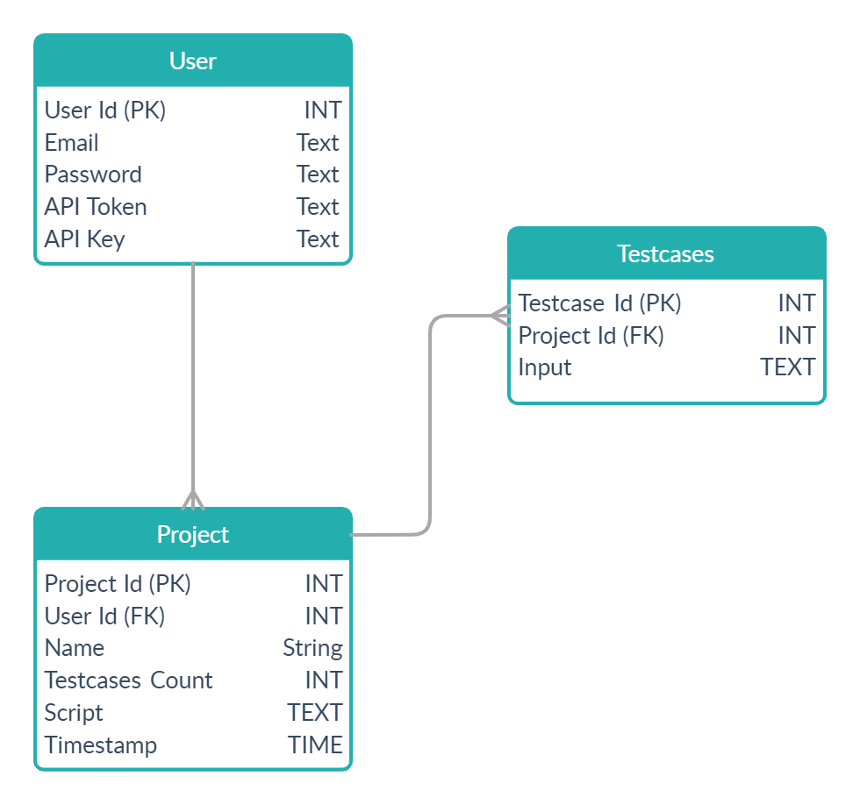

Figure-1: Database Schema Diagram

**ER Diagram:**

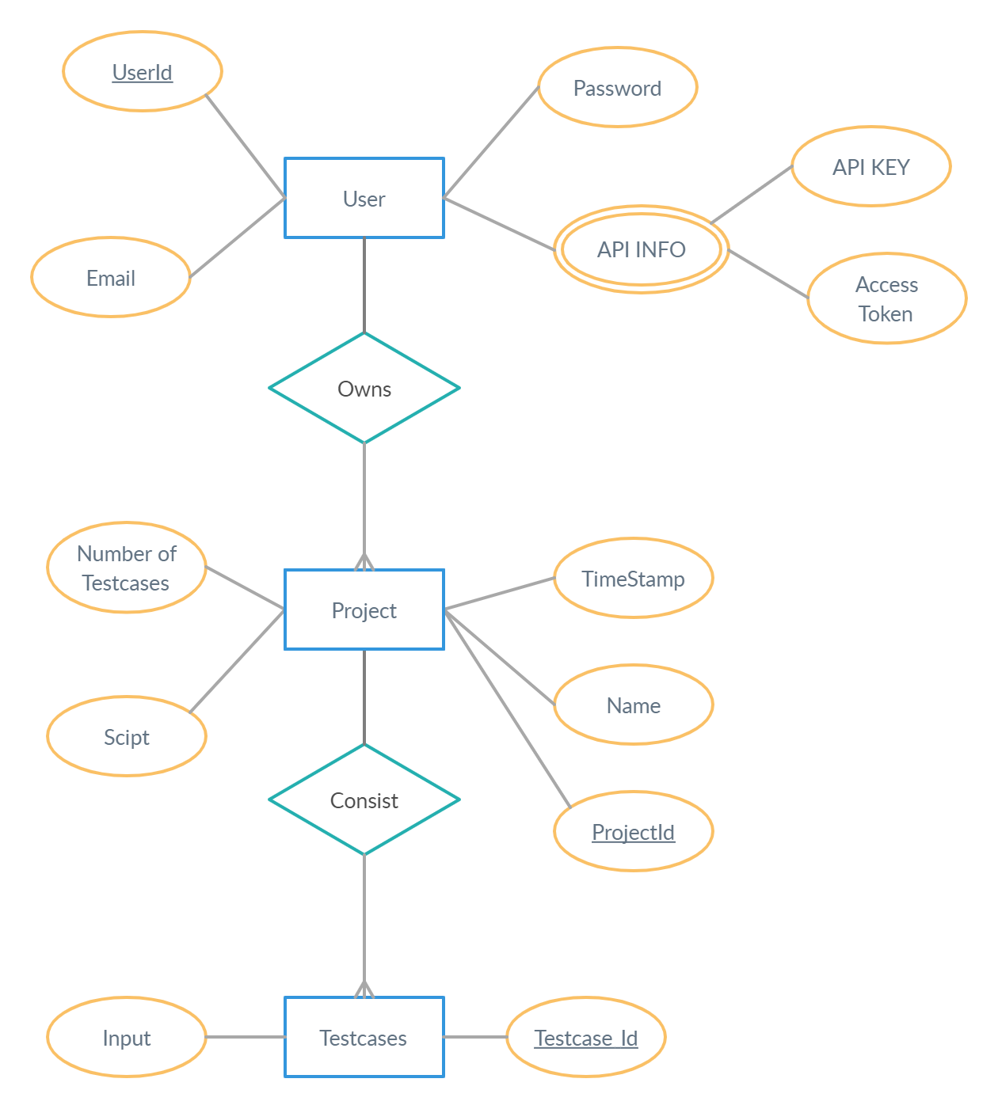

Figure-2: ER Diagram

**Flowchart:**

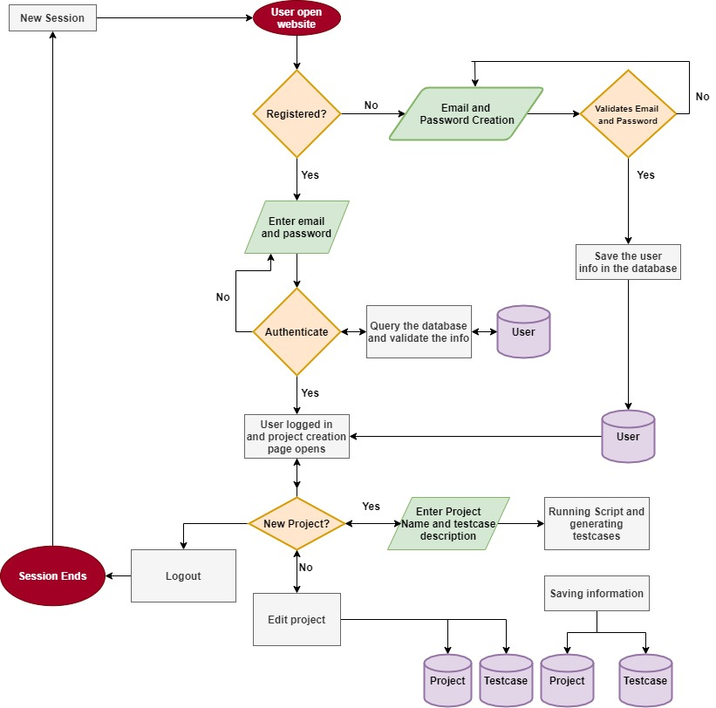

Figure-3: Flowchart

**Result Metric to be used:**

As this is completely a Dev Based Project the main metric to measure that whether we have created something fruitful or not is by measuring **User Satisfaction.**

**Other Metrics we are planning to use:**

### **Page Load Time**

This is one of the key metrics in web performance monitoring since everything today is about speed. Milliseconds translate into dollars earned or lost. Page load time measures the time it takes to load content on a webpage when the user clicks on a link or types in a web address.

### **Bounce Rate**

Bounce rates measure the percentage of site visitors who navigate away from the site after viewing only one page. A high bounce rate usually indicates that visitors are making it to your site but the slow page speeds are damaging their user experience. Poor content and lacklustre design can also affect bounce rates.

### **Overall asset count**

The number of assets you have obviously affects your website's overall weight, but it's important to **differentiate between asset count and weight**. Every asset, no matter how small or compressed, has the potential to add more time to the loading process. Your overall asset count includes your total JavaScript, CSS and image counts.

**Expected Result:**

1. Testcase generation process must be quick.
2. Add enough options to modify testcases as much as user wants.
3. VSCODE Extension to be working smoothly without disturbing the user local machine environment.
4. Getting Access to API must be a simple process.
5. API key must be unique for each user and must be encrypted.

**Conclusion till Now:**

We have successfully created the prototype of front-end design and currently working on the designing of architecture.

The front-end design research papers we studied helped us in thinking of the different structures available to design our website.

Overall, we think this is an innovative idea as no such site exists which helps users in the way we are doing.

**Future Work:**

1. We were unable to find relevant papers for testcase generation of a graph, like a graph can take many forms like **Dense Graph, Bipartite Graph, Disconnected Graph etc.**
2. Choice of testcases can vary from user to user and no such research paper consider this parameter while constructing testcases.
3. If user uploads a pre written code on a website and requests for testcases for the code he uploaded. In this case we need to pass through a large number of iterations to get the result for the user. This factor is also missed in the research field.

**References:**

|  |  |
| --- | --- |
| [1] | <https://www.researchgate.net/publication/321482764_Comparative_study_on_test_case_generation_a_survey> |
| [2] | <https://www.researchgate.net/publication/288645078_Automatic_software_test_case_generation_An_analytical_classification_framework> |
| [3] | <https://www.researchgate.net/publication/230868377_Content_Management_in_Ruby_on_Rails> |
| [4] | <https://www.researchgate.net/publication/228742449_New_technologies_for_web_development> |
| [5] | <https://www.researchgate.net/publication/339197695_A_Django_Based_Educational_Resource_Sharing_Website_Shreic> |
| [6] | <https://irejournals.com/formatedpaper/1701034.pdf> |
| [7] | <https://www.researchgate.net/publication/254008906_On_the_Analysis_of_Cascading_Style_Sheets> |
| [8] | <https://www.ijarse.com/images/fullpdf/1498735993_GOA_1005_ijarse.pdf> |
| [9] | <http://www.ijarcs.info/index.php/Ijarcs/article/view/3792> |
| [10 | <http://www.ijircce.com/upload/2018/april/67_A%20Review.pdf> |
| [11] | <https://core.ac.uk/download/pdf/230921159.pdf> |
| [12] | <https://ieeexplore.ieee.org/abstract/document/6106531> |
| [13] | <https://ieeexplore.ieee.org/abstract/document/5410700/> |
| [14] | <https://ieeexplore.ieee.org/abstract/document/6120863> |
| [15] | <http://worldcomp-proceedings.com/proc/p2016/ICW3865.pdf> |
| [16] | R. Blanco, J.Tuya and B. Adenso-Díaz, “Automated test data generation using scatter-search approach”, Information and Software technology, vol. 51, Issue 4, **(2009)**, pp. 708-720 |
| [17] | B. N. Biswal, S. S. Bar panda and D. P. Mohapatra, International Journal of Computer Applications, vol. 1, Issue 14, **(2010)**. |
| [18] | Kuhlman, D. (2011). A Python Book: Beginning Python, Advanced Python, and Python Exercises. Platypus Global Media |
| [19] | Holovaty, A., & Kaplan-Moss, J. (2008). The Definitive Guide to Django: Web development done right. Après. |
| [20] | <https://docs.python.org/3/tutorial/index.html> |
| [21] | <https://www.w3schools.com/TAGS/default.ASP> |
| [22] | <https://www.oreilly.com/library/view/the-ruby-programming/9780596516178/> |
| [23] | <https://selenium-python.readthedocs.io/> |
| [24] | <https://www.w3schools.com/css/> |
| [25] | <https://rubyonrails.org/> |
| [26] | <https://www.javascript.com/> |
| [27] | <https://docs.djangoproject.com/en/3.1/> |

Thank You